The Commonwealth Accessible Australia Initiative

Increasing Inclusion in Australian Communities

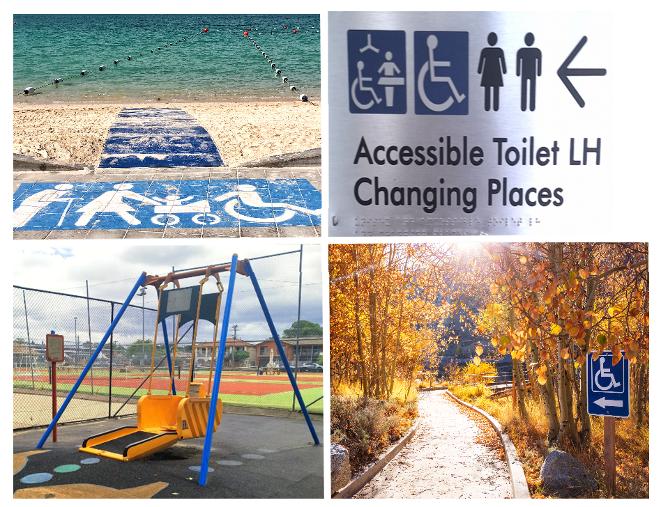

|  |  |
| --- | --- |
| Australian Government logo with Department of Social Services underneath | The Australian Government Department of Social Services wrote this.  We say **DSS** for short.  When you see the word **we** it means DSS. |
| A person holding a white book with easy read on the cover | We wrote this in an easy to read way.  We use pictures to explain some ideas. |
| The word bold is in bold and the words not bold are in plain text | We have some words in **bold**.  This means the letters are thicker and darker.  These are important words. |
| An easy read document with pictures and lines for text. | This is an Easy Read summary of another document.  This means it has the most important ideas. |
| teal envelope | We can answer any questions by email.  Email us [AccessibleAustralia@dss.gov.au](mailto:AccessibleAustralia@dss.gov.au) |
| Two people with their arms around each other with thumbs up. | You can ask for help to read this document.  You can ask   * A friend * Family members * A support person. |
| cartoon of Aboriginal and Torres Strait Islander people with the Aboriginal and Torres Strait Islander flags in the background | We recognise Aboriginal and Torres Strait Islander people as the **Traditional Owners** of the land we live on. |
| teal map of australia | They were the **first people** to live on and use the   * Land * Waters. |

Contents

|  |  |
| --- | --- |
| What is the Commonwealth Accessible  Australia Initiative | 5 |
| The Project Coordination Fund | 9 |
| The Navigation Access and Information Management Fund | 10 |
| Changing Places | 12 |
| Inclusive beaches | 14 |
| Inclusive national parks | 16 |
| Inclusive play spaces | 19 |
| How will Accessible Australia happen | 21 |
| Contact us | 23 |

What is the Commonwealth Accessible Australia Initiative

|  |  |
| --- | --- |
| teal icon of parliament house | The Australian Government is spending lots of money to help make Australia more   * **Accessible** * **Inclusive**. |
| a person in a wheelchair in front of a ramp, stopwatch and easy read document | Accessible means everyone can use it. |
| people posing for a photo | Inclusive is when everyone   * Can **take part** * Feel like they **belong**. |
| A diverse group of five people standing together, including a woman with a guide dog. | We want to make communities better for people with disability. |
| Australian Government logo | The Australian Government set up the Commonwealth Accessible Australia Initiative.  We call it Accessible Australia for short. |
| bag with a dollar sign on the front and coins underneath it | Accessible Australia will help communities pay for different things to make communities more accessible. |
| fanned out money | The money that the government gives is called funding. |
| A green circle with a white outline on a black background. | State and Territory Governments can get funding for **up to** the whole cost to build more |
| Beach mat with the ocean in the background | * Inclusive beaches |
| wooden boardwalk in the bush with trees and plants on both sides | * Inclusive national parks |
| accessible toilet and changing place sign | * Portablechanging places.   These are also called **portable** toilets**.**  Portable means it can be moved easily. |
| A circle divided vertically into green and light grey halves. | State and Territory Governments can get funding for **up to** half of the cost to build |
| liberty swing | * Inclusive play spaces |
| an adult changing table folded up with a hoist in a changing place | * **Permanent** changing places.   Permanent means around for a long time. |
| Woman in green shirt giving thumbs-up next to a checklist with green check marks. | There are rules about what the funding can be used for. |

The Project Coordination Fund

|  |  |
| --- | --- |
| Elderly person in an orange jacket holding a clipboard and giving a thumbs-up. | The Australian Government has started the **Project Coordination Fund**.  We call it the Coordination Fund for short.  This is part of Accessible Australia. |
| fanned out money | Coordination means planning to work together.  The Coordination Fund will have a 1 time payment for State and Territory Governments. |
| White hardcover book with 'RULES' on the cover, featuring a green checkmark and a red 'X'. | There are rules about who can get the funding. |
| Diagram with a central 'Accessible Australia Project' circle connected to four smaller circles showing teamwork, money, handshake, and light bulb. | The funding can be used to help with Accessible Australia projects. |

The Navigation Access and Information Management Fund

|  |  |
| --- | --- |
| teal information icon | The Australian Government has set up the **Navigation Access and Information Management Fund**.  We call it Information Fund for short. |
| Three smiling individuals, one in a wheelchair, within a circular arrow. | We know that having information will help communities be more inclusive. |
| calendar icon with 2024 and 2025 on it | The Information Fund will have funding over financial years.  It will go over 4 financial years.  It will start in 2024 to 2025. |
| calendar icon with 2027 and 2028 on it | It will end in 2027 to 2028. |
| Man sitting at a table with a laptop showing 'WWW', looking back and smiling. | The funding will be for other government departments to make online resources.  They will work together to make the resources. |
| Laptop screen displaying a welcome message with a group of smiling people. | The resources will be on a website.  The website will be around for a long time. |
| Two women, one pointing and the other holding a folder, looking at something off-camera. | This will help more people find inclusive areas using funding from Accessible Australia. |

Changing Places

|  |  |
| --- | --- |
| accessible toilet and changing place sign | Changing Places will be able to be funded. |
| an adult change table folded up, a shower with a curtain and an accessible toilet in a changing place | They can be   * Portable * Permanent. |
| White toilet with blue seat and side safety rails. | Accessible toilets are **not** able to support everyone. |
| A clipboard with a checklist titled 'Needs' showing 8 green checkmarks and 2 red X marks. | Changing Places toilets are for people with high support needs. |
| Three people standing with a distance between them, indicated by a pink double-headed arrow and a tape measure held by the middle person. | Changing Places   * Have more space |
| Yellow patient lift with a black padded sling and wheels for mobility. | * Have extra things |
| A man in a green shirt giving a thumbs-up next to a checklist with green check marks. | * Need to follow rules |
| A man writing in a notebook and a woman examining something with a magnifying glass. | * Need to be **accredited**.   Accredited means someone has come to check that the rules have been followed. |
| Two women, one in a wheelchair and another standing beside her, sharing a joyful moment. | This will support more people with disability and their carers. |

Inclusive beaches

|  |  |
| --- | --- |
| a beach with sand and small waves | Some of the things to make beaches more accessible could be |
| beach wheelchair next to a beach mat with a wheelchair sign | * Beach wheelchairs |
| a person holding sand in their hands | The wheelchairs are made to go on   * Sand * Mud * Gravel * Uneven ground. |
| Beach mat with the ocean in the background | * Mobi matting |
| beach wheelchair next to a beach mat with a wheelchair sign | This is a mat that goes on the sand.  The mat makes the ground more stable to wheel on. |
| a beach with sand and small waves | These changes mean more people with disability could visit the beach. |

Inclusive national parks

|  |  |
| --- | --- |
| landscape with mountains and trees and flat plains in the middle | Some of the things to make National Parks more accessible could be |
| bumpy off road track with bushes on both sides | * All **terrain** wheelchairs.   Terrain is talking about the ground.  It could be   * Bumpy * Flat. |
| A young girl with Down syndrome, a smiling man, and a joyful elderly woman. | All terrain wheelchairs can be used by   * Adults * Children. |
| bumpy off road track with bushes on both sides | They help people to go on more walking trails that standard wheelchairs can **not** go on. |
| hard packed gravel path with bushes and trees on both sides | * Accessible paths. |
| winding concrete path in a park with grass and trees on both sides | The paths are   * **Temporary** * Flat * Made for people who use wheelchairs.   Temporary means it only lasts for a certain time. |
| illustration of modular path in a national park | They can be put on top of grounds like hard gravel.  This will make it easier for people with wheelchairs to access National Parks. |
| landscape with mountains and trees and flat plains in the middle | These changes mean more people with disability could visit National Parks. |

Inclusive play spaces

|  |  |
| --- | --- |
| playground | Some of the things to make play spaces more accessible could be |
| accessible swings | * Inclusive play equipment |
| All access spinner | Like   * Liberty swings * Sensory play platforms * All access spinners. |
| Lukes Place accessible map | * Visual communication toys for people who are non speaking. |
| A group of six children, two in wheelchairs, smiling and standing together against a white background. | This would give more children with disability the chance to use play spaces. |

How will Accessible Australia happen

|  |  |
| --- | --- |
| fanned out money | Funding for Accessible Australia will happen in financial years. |
| 4 calendar icons with the different financial years on them | The financial years are   * 2024 to 2025 * 2025 to 2026 * 2026 to 2027 * 2027 to 2028 |
| Woman in green shirt giving thumbs-up next to a checklist with green check marks. | We will have **funding** **agreements** witheveryone who gets funding.  Funding agreements are the rules for how the money can be spent.  It also says what needs to be done like writing reports. |
| White hardcover book with 'RULES' on the cover, featuring a green checkmark and a red 'X'. | Everyone who gets funding will need to follow the rules. |
| A man celebrating with a raised fist while holding a piece of paper. | We will give more information about the funding dates for 2024 to 2025 soon. |

## Contact us

|  |  |
| --- | --- |
| teal circle with white i in the middle | You can contact us if you **need more information.** |
| teal envelope | You can send us an email.  [AccessibleAustralia@dss.gov.au](mailto:AccessibleAustralia@dss.gov.au) |
| teal arrow with lines | You can look at our website.  [www.dss.gov.au/disability-support-services/accessible-australia](https://www.dss.gov.au/disability-support-services/accessible-australia) |

Images in this Easy Read must **not** be used or copied without permission