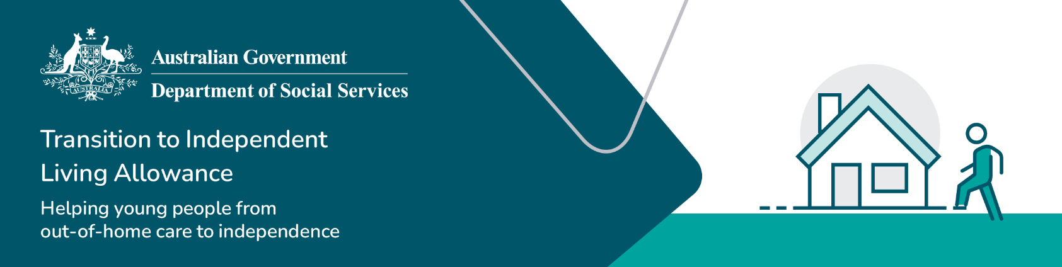

TILA application reminders

These reminders should be read in conjunction with the

[TILA Operational Guidelines](https://www.dss.gov.au/towards-adulthood/resource/transition-independent-living-allowance-tila-operational-guidelines).

Refer to the [TILA Guide for caseworkers](https://www.dss.gov.au/towards-adulthood/resource/tila-guide-caseworkers) for step-by-step instructions on processing a TILA application.

Transition to Independent Living Allowance (TILA)

Confirm a young person’s [eligibility](https://www.dss.gov.au/towards-adulthood/applying-transition-independent-living-allowance/eligibility-transition-independent-living-allowance?_gl=1*1ibbvp7*_ga*NDA3OTI3MDIuMTczNTc2NzI2OA..*_ga_9JJ1FJ00DK*MTczODcxMTYyMS41MC4xLjE3Mzg3MTQzMzUuNTcuMC4w) for the TILA payment before processing the application. Then follow these steps: