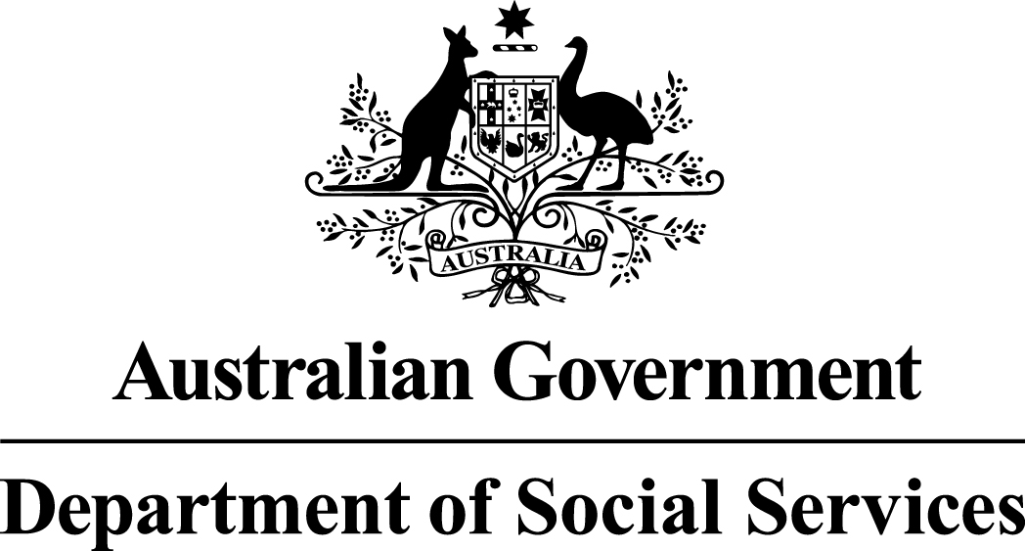

Families and Communities Programme

Stronger Relationships trial
Restricted Funding Round Summary

19 June 2014

Stronger Relationships trial
The Family and Relationship Services Sub-Activity aims to strengthen family relationships, prevent breakdown and ensure the wellbeing and safety of children through the provision of broad-based counselling and education to families of different forms and sizes.
The Stronger Relationships trial is a one year trial of providing up to 100,000 couples with $200 towards relationship education and counselling including components of parenting education, conflict resolution or financial education. The Stronger Relationships trial will operate nationally from 1 July 2014 to 30 June 2015.
The objective of the trial is to provide incentives for couples to seek support to strengthen their relationships, especially at crucial life transition points such as moving in together, getting married and the birth of children.

Selection type
This selection is a direct process made to existing providers to deliver new services in a
12 month trial.

Eligibility
The service providers approached will be:
- Not-for-profits who are providers of relationship education or counselling who have a demonstrated track record of providing services to at least 100 couples per year.

How much?
Up to $20 million is available for the one year trial.

Closing Date
Applications should be submitted by 31 March 2015.

Who to contact?
Please email your enquires to: grants@dss.gov.au

Grant objectives
The objective of the Stronger Relationships trial is to provide incentives and to assist couples with accessing relationship education, counselling including components of parenting education, conflict resolution and financial education. This will enable them to strengthen their relationship, especially at crucial life transition points such as moving in together, getting married and the birth of children.

Statement of Requirement
The Stronger Relationships trial is a one year trial providing $200 subsidies to 100,000 couples. The vouchers will assist them to access relationship education and counselling including components of parenting education, conflict resolution or financial education. The Stronger Relationships trial will operate nationally from 1 July 2014 to 30 June 2015.
The service providers will be FaRS providers who have chosen to opt in to be on the list of pre-approved providers.
The Target Group for the Stronger Relationships trial Component are couples who register via the DSS Stronger Relationships trial website and provide their reference number to the service provider.
All couples who are in committed relationships, and where both members of the couple are at least 18 years old, are eligible to participate in the Stronger Relationships trial at any stage in their relationships. This includes engaged, married, de-facto and same-sex couples.
Couples who are not eligible are encouraged to contact the Family Relationships Advice Line on 1800 050 321 or visit Family Relationships Online for information on other available services.

Selection Criteria
There are no Selection Criteria. The Application Form is designed to determine the eligibility of the applicant. To be eligible you must be an existing FaRS provider and are required to participate in the evaluation of the trial.

Multicultural Access and Equity policy
Australia’s Multicultural Access and Equity Policy: Respecting diversity. Improving responsiveness obliges Australian Government agencies to ensure that cultural and linguistic diversity is not a barrier for people engaging with government and accessing services to which they are entitled, for example, by providing access to language services where appropriate. Grant applicants should consider whether services, projects, activities or events may require the use of professional translating or interpreting services in order to communicate with non-English speakers. If your Application Form states that a budget is required, costs for translating and interpreting services should be included in your application.

Assessment
The Assessment Team may be composed of Department of Social Services (DSS) officers from each state/territory and national offices. Teams will undertake training to ensure consistent assessment for all applications received. The Assessment Team will be bound by the APS Code of Conduct and the Department’s Chief Executive Instructions.

Probity
The selection of funding recipients for the Activity must be fair, open and demonstrate the highest level of integrity, consistent with the public interest.
The following probity principles will be applied through all stages of the selection process.
(a) fairness and impartiality
(b) consistency, accountability and transparency of process
(c) security and confidentiality of information
(d) identification and resolution of conflicts of interest
(e) compliance with legislative obligations and government policy

These principles are intended to achieve an equitable, justifiable and sound process.
Adherence to the probity principles means that everyone involved with the selection process will act:
- impartially
- with integrity, including avoiding actual or perceived conflicts of interest

A Probity Advisor may be appointed for the Activity. The role of the Probity Adviser is to assist DSS meet its probity obligations in relation to the Activity by ensuring that the selection processes are defensible and will withstand external and internal scrutiny.
The role of the Probity Adviser is to independently monitor procedural aspects of the selection process to ensure compliance with the published relevant Programme Guidelines and to advise DSS in relation to such matters. The Probity Adviser plays no part in the assessment of applications.

Programme Guidelines Overview
The Programme Guidelines Overview provides the key starting point for parties considering whether to participate in the activity and form the basis for the business relationship between the Department and the funding recipient. Applicants are strongly advised to read the Programme Guidelines prior to completing an Application Form. The Programme Guidelines suite comprises of the following documents:
- Programme Guidelines Overview
- Funding Round Summary
- Application Form
- DSS Streamlined Grant Agreement template - General Grant Conditions
- Questions and Answers (provided directly to applicants)
- Operational Guidelines

How to Apply
Applications can be lodged by emailing your completed application to: grants@dss.gov.au

Grant Agreement Information
Your executed grant agreement represents the Department’s and your entire agreement in relation to each grant provided within it and the relevant Activity and supersedes all prior representations, communications, agreements, statements and understandings, whether oral or in writing.

