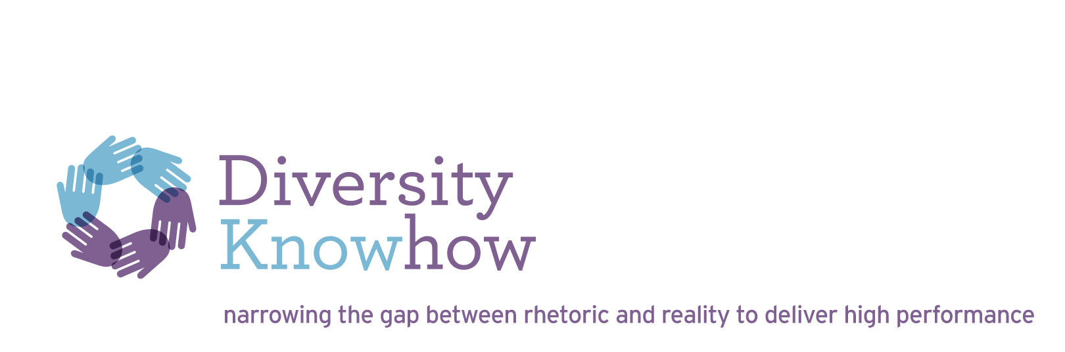
WGE Act - Consultation on reporting matters
FaHCSIA
women@fahcsia.gov.au

29 January 2013

Dear Fahcsia reviewer

COMMENTS RE: CONSULTATION ON WGE ACT REPORTING MATTERS

Thank you for the opportunity to comment on the new WGE Act reporting matters. My comments are outlined below and are based on my experience of working in and with Australian private sector, government, and not for profit organisations over the past 20 years; delivering practical outcomes for organisations and women in the workplace.

Suggested expansion to reflect the intent of the act
I would like to recommend an expansion of the second outcome: improved representation of women in leadership positions and governing bodies to include a requirement to also report on the representation of women in management in Profit and Loss (P & L) positions.
The weak female talent pipeline in Australia for P & L manager and executive positions is a critical issue that must be addressed to improve gender equality in Australian workplaces.

In my experience
- Women choose to not apply for P & L manager positions and instead move to back office or staff roles, for a range of reasons including the need for greater flexibility or a desire to progress to senior management but not being able to imagine being successful in P & L manager positions, due to a lack of female role models and lack of encouragement from management
- Line managers also make unconscious assumptions and encourage women into staff and back office roles which are not the major pipeline roles to the majority of management and executive positions .

The consequences of the low representation of women in the P & L talent pipeline for manager roles are significant and include
- An ongoing gender pay gap for women because P & L roles are usually higher paid positions with greater average bonus earning potential
- Reduced career aspirations by women who do not consider the P & L talent pipeline to management as feasible due to lack of diverse female role models in these positions
- Reduced female high potential talent pool (which currently consists of women mainly in support roles including HR, marketing, legal and to some degree finance) for business management, executive positions and CEO positions
- Reduced female talent pool for Board positions (typically consisting of highly experienced women with strategy, legal and finance experience).
Priority reporting matters – some suggestions on key measurable outcomes and priority process indicators and usefulness, impact on business, timing, assistance and industries

1. Key process data to track improvement of women’s participation across Australia
I consider the most useful outcomes to support the gender composition of the workforce measures, in addition to the extremely useful workplace profile (which every employer can now provide due to previous EOWA education), relate to the representation of men and women joining, leaving and moving up the organisation at each classification level. This requires the reporting on 3 critical HR process outcomes
- recruitment
- exits and
- promotion data
This data is most useful when tracked at a minimum of 4 levels: non manager, manager, senior manager and executive level. A very powerful way to request this data, that is also a very useful gender analysis tool for reporting organisations, is as a simple horizontally layered pyramid that shows the percentage of male and female employees moving into the organisation, out of the organisation and up in the organisation at each major management transition level.

Once employers track promotion data they will also understand the importance of also measuring the representation of women in the executive talent pipeline to determine whether career development processes are delivering the planned outcomes for women. This outcome measure could be added in 2015.

2. Gather data on women in P & L manager positions as part of improving representation of women in leadership positions and governing bodies
Further to my comments above, in order for employers to easily report on females in P & L manager positions, and for the agency to receive data that can be robustly benchmarked, the agency would need to develop a standard definition for P & L positions. This definition could be based on the P & L position definition used by the US organisation Catalyst in the global Catalyst Women in Leadership Censuses in which they track this critical measure at executive level. The majority of employers do not currently record the number of women in P & L manager positions, although their existing HR systems could record this data quite easily if required as a priority.

3. Measuring outcomes on “formal” and “informal” flexible working for women and men
Reporting on flexibility will be challenging for many employers. In my experience employers are able to measure “formal” flexibility through their HR systems e.g. permanent part timers, people working 48/ 52 working arrangements etc., but most employers currently do not gather data on “informal” flexibility. Based on my experience of diversity and flexibility surveys in companies, in good employers as many as 30-40% of the workforce may be accessing flexibility as they require it; for example accessing flexible start and finish times, working at home etc. on an “as needs” basis but this is not recorded in the HR system. This “informal” flexibility data is also crucial to understanding whether “formal” part time employees can access flexibility on an “as needs” basis, which is often not the case. Leading employers conduct a diversity and flexibility survey that provides robust data on employee access to informal flexibility as well as other key information on employee diversity demographics, access to and usage of diversity and flexibility policies, inclusive leadership capability, and a work culture of flexibility and inclusion. This type of survey would be a valuable employer tool for the WGE agency to introduce over time

An easier way for employers to provide the “informal” flexibility data is to recommend employers include several additional questions to their employee engagement surveys on access to and usage of “formal” and “informal” flexibility and leadership capability to effectively manage diversity and flexibility and culture support for working flexibly. In addition employers may need to include one additional demographic question on gender to be able to analyse the survey findings based on gender, which surprisingly a number don’t currently collect. Employers may also need to include another question on flexible working arrangement options. Again in my experience engagement survey findings, action plans and outcomes receive a high level of management attention due to their direct link with customer satisfaction, increased productivity and profit. In addition, in my experience, the best way to embed gender diversity, flexibility and inclusion is to drive it as part of an organisation’s culture program; so recommending the expansion of engagement surveys to include several diversity and flexibility questions would be a positive step for gender diversity action and outcomes; helping more managers to see gender diversity as not just a policy and HR issue – but as an organisational culture issue that if addressed strategically contributes to high business performance.

4. Measuring return to work from parental leave outcomes
I believe that the return rate of women from parental leave is a critical outcome indicator. However in my experience it’s hard to get robust return rate from parental leave trend data over time due to constantly changing definitions within the organisation. A standard definition of how employers measure the return rate from parental leave that is robust and useful for benchmarking will need to be developed by the agency to collect this very valuable outcome measure. Return from parental leave is the first critical transition where women’s career development slows down significantly if not well managed. My suggestion is to gather data on employees who have returned from parental leave and are still with the company 12 months after they have returned from parental leave. Another valuable outcome indicator that is also useful to be included over time is the number of women promoted to a higher classification level within 12 months of returning from parental leave. This outcome measure reflects gender equity progress demonstrating increased support for mother’s career development as part of building a robust female talent pipeline.

5. Expand consultation with employees on gender equality issues to require information on line manager consultation
In addition to requiring information on consultation outcomes with employees that could include for example participation and outcome contributions by women including interview, surveys and focus groups outcomes, input into diversity and inclusion strategy priorities and solutions , outcomes of women’s forums and relevant employee resource group initiatives, and outcomes from diversity events, I suggest that it would be also very valuable to gather information on consultation outcomes with line managers on gender diversity. Achieving gender equity is a leadership issue and it would be an excellent way to educate employers by asking them to report on how they have consulted with and engaged their line managers as part of the gender diversity diagnosis, business case development, strategy development and implementation phases.

6. Develop a simple dashboard of key metrics that employers can use to report on the 5 key outcomes

I suggest the agency develop a Management Dashboard of key gender outcomes (or metrics) that employers are required to report on based on the five key outcome areas. The dashboard could be a useful analysis tool for employers to use internally to set targets and monitor progress with managers, executives and boards as well as providing robust data in a format that will be easy for the agency to benchmark within and across industry sectors. Measure definitions could be included “at a click” in the web based reporting format.

A suggested gender diversity outcome dashboard for companies for the first year of outcome reporting could include the following key metrics:

MEASURE | COMPANY OUTCOME
Percentage of executive positions held by women
Percentage of senior manager positions held by women
Percentage of manager roles held by women
Percentage of P & L manager roles held by women
Percentage of executive pipeline roles held by women
Percentage of high potential management talent who are female
Percentage of graduates who are female
Percentage of men and women recruited at the 4 key classification levels
Percentage of men and women who exit at the 4 key classification levels
Percentage of women and men promoted to a higher level at the 4 key classification levels
Flexibility participation rate (formal and informal)
Parental leave retention rate (12 months after return)
Pay Equity Gap
Gender diversity score in engagement survey
Flexibility score on engagement survey

I look forward to further participating in and following the progress of implementing the WGE Act and am happy to provide further information if required.

Yours Sincerely

Fiona Krautil
Principal

