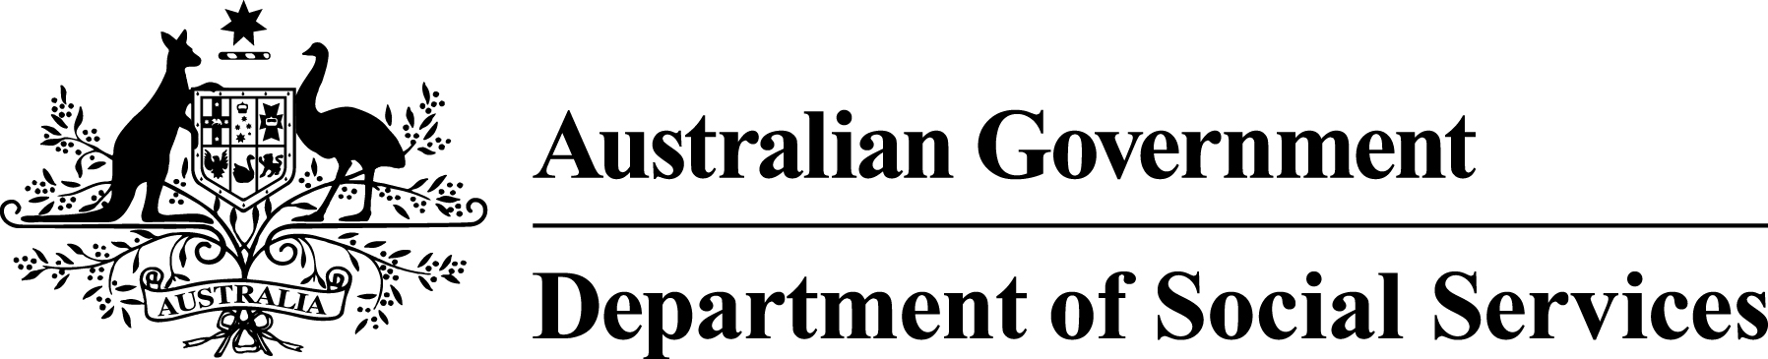

Information for workers who were paid using the BSWAT
This document is about one of the ways that people in supported employment get paid.
Supported employment is the way that government works with some businesses to create jobs for people with disability.
There are different ways to work out how much people in supported employment should get paid.
One of the tools used is called the
‘Business Services Wage Assessment Tool’. This is known as the BSWAT.
Some important changes have been happening to the BSWAT.
Last year, 2 people with disability said that they weren't being paid fairly.
Their workplace used the BSWAT. They took their case to court. They won the court case.
The judge decided that these people weren’t having their wages worked out properly.
Because the people had an intellectual disability, it was harder for them to understand the tool.
This decision is making a difference to the way that the BSWAT is being used all around Australia.
The Australian Government is thinking about what changes it can make to work out the wages of supported employees in the future.
To help us do this thinking, we have asked for more time to help supported employment workplaces start using tools other than the BSWAT.
And we are setting up a Payment Scheme.
Under this Scheme, the Australian Government will make a one-off payment to some employees who were paid using the BSWAT.
The Payment Scheme is part of making sure that supported employment workplaces can:
- continue operating well
- afford to give people jobs.
If supported employment workplaces had to make these payments on their own, without help from the government, they might go out of business.
We do not know everything about how the Payment Scheme is going to work yet.
We know some things about how it will work,
but not all things.
We think it is important to let you know that we are setting up the Payment Scheme. We will provide more information about the Payment Scheme as we get it ready.

How much will some workers receive from the Payment Scheme?
We don’t know how much the payments will be yet. We will work this out as soon as possible.

When will the Payment Scheme start?
The Payment Scheme will start soon.

Who can use the Payment Scheme?
It's important to know that not everyone who works in supported employment will be able to be paid by the Payment Scheme. People who use the Payment Scheme must at least:
- have been working for an Australian Disability Enterprise
- have had their pay calculated using the BSWAT – not a different tool
- have an intellectual disability
- have evidence, such as pay slips or bank statements, to show what they were paid.
At the moment, a large group of people with intellectual disability are going to go to court to ask for money because they were paid wages using the BSWAT.
The legal name for this is a representative proceeding, although some people call it a
class action.
You may be part of the representative proceeding without knowing it. Many people who work in supported employment will be added automatically.
People who get money from the Payment Scheme will not be able to get money from the representative proceeding as well.
We will send you more information when we know more about how the Payment Scheme is going
to work.

Where can you get more information?
You can phone us or visit our website.
1800 880 052
www.dss.gov.au/bswat/PaymentScheme

