Footprints in Time 2013 Community Feedback

Adelaide and Port Augusta

Introduction
This fact sheet gives feedback to the community from the fifth wave of Footprints in Time: The Longitudinal Study of Indigenous Children. With the help of 1,258 families like yours, we completed Wave 5 interviews in 2012. Our fifth round of interviews included 89 families from Adelaide and Port Augusta. This fact sheet compares families living in Adelaide and Port Augusta with Footprints in Time families living in other places. Thank you to those families who participated in Wave 6 interviews this year – results from these interviews will be in next year’s Community Feedback!
We would like to thank the parents and families who continue to participate in the Footprints in Time study. By allowing us to be part of your child’s life, we are learning more about what Aboriginal and Torres Strait Islander children need to have the best start in life and grow up strong.

What can children do?
Early childhood development is the most important phase for overall development throughout the lifespan. Early experiences are associated with lifelong health, education and work outcomes.
We asked parents if their child could do a range of activities to better understand how they are developing. The parents of the younger children in our study (aged 4 ½ to 6) were asked if their child can catch a small ball, hop on one foot for three steps, dress and undress themselves, hold a pencil in a writing position, run down stairs, and button up and/or undo large buttons. We found that almost all younger children could do these things, and more than three-quarters could do them well.
We also found that more than 90 per cent of older children in our study (aged 7 ½ to 9) could thread a bead, ride a bike without training wheels, write clearly and know left from right. About 85 per cent could tie a bow, and nearly two-thirds of children could tell the time using a watch or a clock with moving hands.
We asked study children all over Australia what they liked doing in their free time, outside of school. After grouping answers according to theme, the top seven activities were:
1. Playing outside (e.g. on the trampoline, sports, riding bikes or motor bikes, hunting, fishing, or going to the beach or pool)
2. Spending time with family and friends
3. Watching television, DVDs or movies
4. Playing computer or video games
5. Arts, crafts and music
6. Reading books and doing homework
7. Sleeping and resting
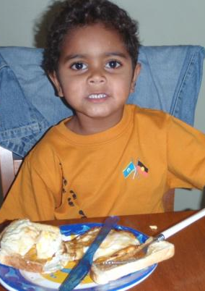
Having a strong sense of family and community is important to Footprints in Time families. We asked parents all over Australia, “What is the best thing about being Study Child’s Mum or Dad?”. Here are some responses:
“Because he’s a deadly kid and he’s going to be famous one day.”
“She is very clever, caring and loving towards all family and friends. She is very considerate and respectful towards all members. She is a very beautiful young and intelligent lady with a big future ahead of her.”
“When she wakes up she smiles at me. When we lie in bed and relax, we laugh. She makes precious moments count.”
“Just being his dad. I couldn’t limit it to just one thing.”
“Teaching her stuff, helping her with her homework and listening to her yarns.”

Dental health
Healthy teeth and gums are linked to overall health. Good brushing habits and regular check-ups are important for children because they help set good routines for later in life.
Seven out of 10 Footprints in Time children in Adelaide and Port Augusta brushed their teeth at least once a day, similar to children in other areas. Children were more likely to have visited a dentist or dental nurse in the last 12 months than children in other areas.
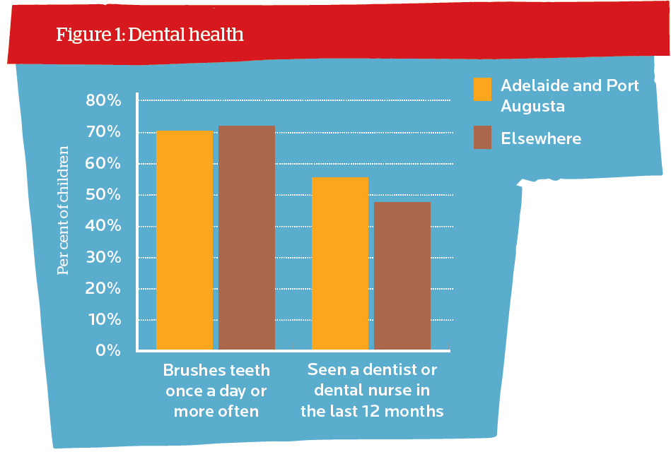

Sleeping hours
In Wave 5, we asked parents what time their child woke up and went to bed. The amount of sleep a child needs for normal development depends on the individual child, but preschool children need about 10 to 12 hours of sleep a night, while schoolchildren need around 10 hours.
Most Footprints in Time children (84 per cent) were getting at least ten hours of sleep a night. Younger children were more likely to get at least ten hours sleep than older children; 86 per cent compared to 81 per cent.

Snack consumption
We asked parents from across Australia what types of food, including snack foods, Footprints in Time children ate the day before the interview and found that almost two-thirds of children in Adelaide and Port Augusta had eaten snack foods. This is compared to just over 40 per cent of the children in other sites.

Learning about Indigenous culture
Culture remains a strong part of the lives of Footprints in Time families. In 2012, we asked the study children in the older cohort “Who helps you learn about being Aboriginal and/or Torres Strait Islander?” They could pick as many people as they wished.
Across all sites, we saw that mothers and fathers played the biggest role in passing cultural knowledge onto their children (picked in turn by 40 per cent and 31 per cent). However, children were also learning about their history from teachers or carers (21 per cent), grandmothers (21 per cent), and grandfathers (13 per cent).
In Adelaide and Port Augusta, children told us their teachers and carers were playing a key role in teaching them about being Aboriginal and/or Torres Strait Islander.
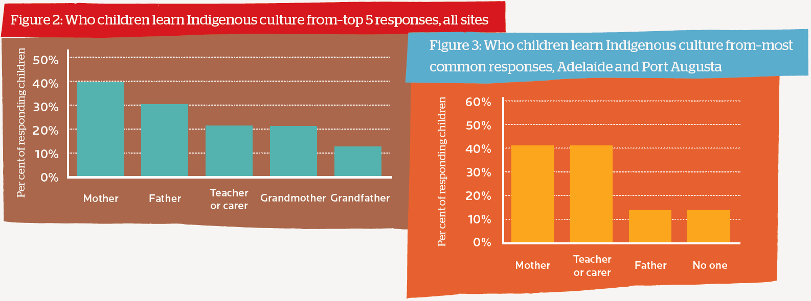

Learning languages at school
Language can be an important expression of culture. In recent years, there have been efforts to keep alive Indigenous languages that are endangered or at risk of being lost. It is encouraging to see how many Footprints in Time children are learning languages at school.
About one in five Footprints in Time children were learning a second language at preschool or school. About 10 per cent of children were learning an Indigenous language, and seven per cent were learning a foreign language. Older children were more likely to be learning a language (24 per cent) than younger children (17 per cent).
Most Footprints in Time children from Adelaide and Port Augusta who were learning a language at school were learning a foreign language.
We asked older Footprints in Time children how often they felt happy or proud of something they have done. Most children (54 per cent) said they felt happy lots of times, and 43 per cent felt happy sometimes. In addition, 59 per cent of children often felt proud of something they have done, and 36 per cent felt proud sometimes. Less than five per cent of children said they hardly ever felt happy or proud.

Life satisfaction
Studies show that there are strong links between a parent’s happiness and their child’s happiness. Raising children in a happy, supportive family environment ensures they have both a good start in life and opportunities to develop into happy and healthy adults.
Across all sites, Footprints in Time parents reported that they are usually happy with most aspects of their lives. In Wave 5, the life satisfaction score averaged 8.4 out of 10. Feeling safe ranked highest with an average score of 8.8, while happiness with relationships followed at 8.6.
Compared to parents in other areas, parents in Adelaide and Port Augusta were about as satisfied with their financial situation, amount of free time they had and their life overall.
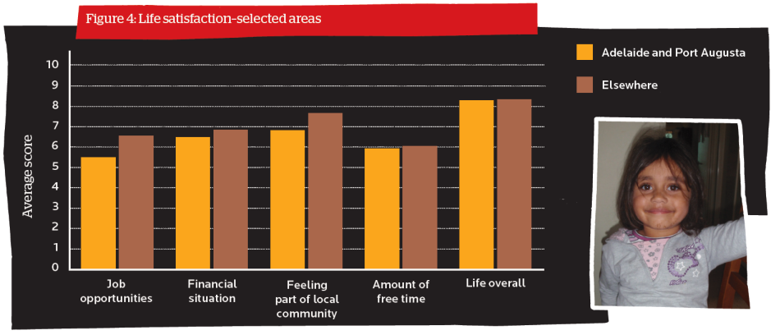

Who uses Footprints in Time data?
The data from Footprints in Time is being used to tell governments, policy makers and service providers about the lives of Aboriginal and Torres Strait Islander children and their families. To find out more about Footprints in Time, go to <www.dss.gov.au/lsic>.
Over 150 researchers are using or have used Footprints in Time data for interesting and important projects. For example, some of the current research is looking at housing conditions and children’s health; socio-demographic, family and psychosocial links with dental health; and the connection between cultural identity and school readiness.

Keeping in touch
If you are a Footprints in Time family, we need to keep in touch with you. If you have moved or are going to move, please let us know on the free-call number 1800 106 235 or contact your local RAO.

We only asked what older children ate in the morning and evening, whereas we asked what younger children ate in the morning, afternoon and evening. Snack foods include hot chips or French fries, packets of chips or salty snacks (like Twisties), sweet biscuits, doughnuts, cake, chocolate and lollies.

