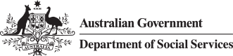

Translated Script

Using your SmartCard

- You can use your SmartCard at over one million stores around Australia. You can also use it to:
  - tap to pay

  - shop online and

  - pay bills with BPAY.

- You cannot use your SmartCard/EIM account to:

  - buy tobacco or tobacco products

  - buy pornography

  - buy alcohol or homebrew kits

  - gamble

  - buy cash-like products and some gift cards

  - get cash out.

