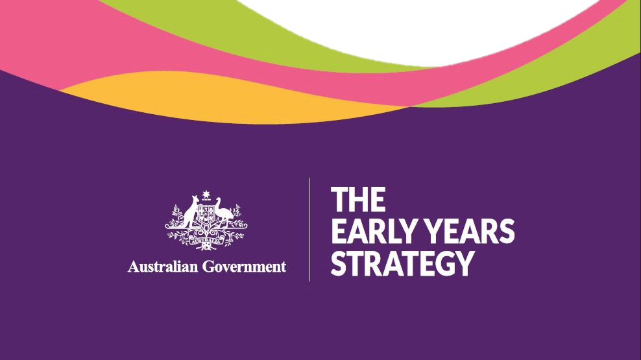

CONSULTATION REPORT

2023

Copyright notice
This document is licensed under the Creative Commons Attribution 4.0 International Licence
Licence URL: https://creativecommons.org/licenses/by/4.0/legalcode
Please attribute: © Commonwealth of Australia (Department of Social Services) 2020
Notice:
- If you create a derivative of this document, the Department of Social Services requests the following notice be placed on your derivative: Based on Commonwealth of Australia (Department of Social Services) data.
- Inquiries regarding this licence or any other use of this document are welcome. Please contact: Branch Manager, Communication Services Branch, Department of Social Services. Phone: 1300 653 227. Email: communications@dss.gov.au
Notice identifying other material or rights in this publication:
- Australian Commonwealth Coat of Arms — not Licensed under Creative Commons, see https://www.itsanhonour.gov.au/coat-arms/index.cfm
- Certain images and photographs (as marked) — not licensed under Creative Commons

Contents
Acknowledgement of Country 1
Introduction 1
1. Methodology 2
National Early Years Summit 2
Public survey 2
Public submissions 3
Roundtables 3
Children’s consultations 4
2. Children’s views 5
3. Vision 5
4. Principles 7
5. Outcomes 7
Survey responses 9
6. Priorities 10
How children, parents, families and communities are supported 10
How decisions are made 12
Enablers of effective systems 12
7. Perspectives of different stakeholder groups 14
8. Strategy structure 16
9. Scope 16
10. Next steps 17
Appendix 1 - Full list of roundtables 18

Acknowledgement of Country
The Australian Government acknowledges the traditional owners of Country throughout Australia on which we gather, live, work and stand. We acknowledge all traditional custodians, their Elders past, present, and emerging, and we pay our respects to their continuing connection to their culture, community, land, sea and water.

Introduction
The Australian Government is developing an Early Years Strategy (the Strategy) to shape its vision for the future of Australia’s children and their families.
The Australian Government has conducted a range of consultations to inform the Strategy including a National Early Years Summit, survey, public submission process, roundtables and children’s consultations. The findings from these consultations have informed the development of the Strategy and will inform the development of its Action Plans, as well as work across the Australian Government.
Responsibilities for supporting children in the early years extends to all levels of government, communities, non-government organisations and business. The views and ideas outlined are not limited to the responsibilities of the Australian Government, but all relate to the things that are important to families and children in the early years. This consultation report is a resource for all.
This consultation report synthesises the views of a range of stakeholders including children, parents, and families as well as the early years workforce (e.g. educators, maternal and child health care workers, and family support workers), service providers, academics and peak organisations.
Any reference to parents, caregivers and families in the consultation report acknowledges the diversity of people who fulfil these important relationship roles for the children in their lives, including biological mothers and fathers, adoptive and LGBTIQA+ parents, kinship and other carers, and extended family members (and many combinations of all of these).
In addition to consultations, a 14-member Advisory Panel of experts have helped inform the development of the Strategy. More information about the Advisory Panel is available at https://www.dss.gov.au/families-and-children-programs-services/early-years-strategy.
This report outlines the consultation findings.
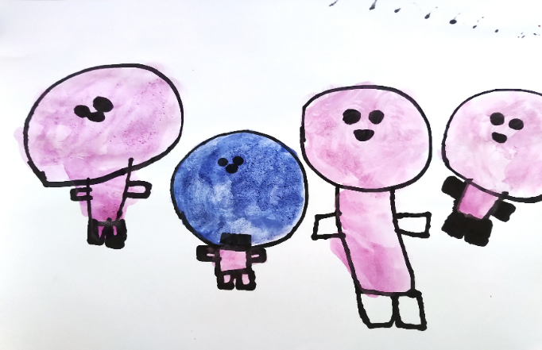
An example of the artwork activity from the children’s consultation: “That’s my Mum, that’s my Dad, that’s my brother, and that’s me as a baby sucking my dummy. Outside it’s raining just a few drops.”
Photo: The Front Project.

Methodology
The Government committed to broad and deep consultation in developing the Strategy to get an understanding of multiple perspectives on the early years, how the early years systems are working around Australia, and the Australian Government’s role in these systems.
To allow for significant and meaningful participation, the consultation approach provided multiple mechanisms over a 7-month period. Engagement on the Early Years Strategy included the following opportunities.
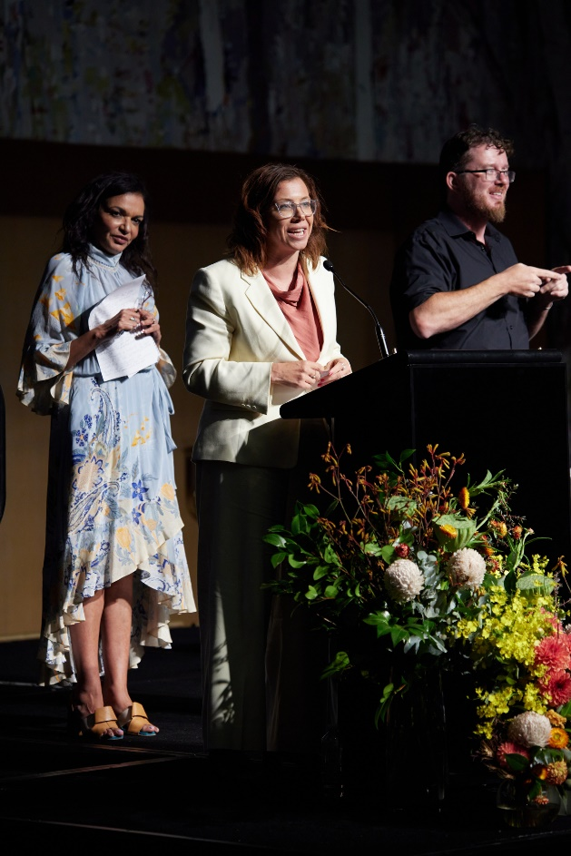

National Early Years Summit
Held on 17 February 2023 at Australian Parliament House, the National Early Years Summit brought together over 100 delegates to start the conversation about how to ensure every child in Australia has the best start in life.
The Summit comprised three sessions focused on developing a vision, principles and priorities for the Strategy. There were a mix of Question and Answer panels and workshops.
Workshops discussed:
- What does success look like in the early years?
- Identifying principles that will guide the Early Years Strategy.
- Identifying priorities for supporting children in the early years.
A summary of the Summit, including the agenda, is available at https://www.dss.gov.au/families-and-children-programs-services-early-years-strategy/national-early-years-summit-summary-and-agenda

The Hon Dr Anne Aly MP, Minister for Early Childhood Education,
and the Hon Amanda Rishworth MP, Minister for Social Services
at the National Early Years Summit.
Photo: Art Atelier Photography.

Public survey
A pulse survey, designed to seek views on what the Australian Government should focus on under the Strategy, opened on DSS Engage (engage.dss.gov.au) on 19 January 2023 and closed on 3 April 2023. The survey was anonymous and asked three key questions:
- What are your biggest hopes for children in the early years in Australia?
- What should the Australian Government focus on first in the Early Years Strategy?
- What do you think are the two most important things the Australian Government can do, or do differently, to make Australia the best place to raise and be a child?
The survey received 2,243 responses. Respondents included parents, grandparents, extended family, community members, service providers and non-government organisations.

Public submissions
Published on 4 February 2023, a discussion paper sought advice, ideas and feedback on Australia’s aspirations for our youngest children and the Australian Government’s role in the early years.
The consultation period was open over 12 weeks and closed on 30 April 2023.
A mix of individuals, peak bodies, universities and think tanks, service providers, governments and government agencies submitted a response, with 352 submissions received. Submissions broadly responded to the eight questions posed in the Discussion Paper:
- Do you have any comments on the proposed structure of the Strategy?
- What vision should our nation have for Australia’s youngest children?
- What mix of outcomes are the most important to include in the Strategy?
- What specific areas/policy priorities should be included in the Strategy and why?
- What could the Government do to improve outcomes for children – particularly those who are born or raised in more vulnerable and/or disadvantaged circumstances?
- What areas do you think the Government could focus on to improve coordination and collaboration in developing policies for children and families?
- What principles should be included in the Strategy?
- Are there gaps in existing frameworks or other research or evidence that need to be considered for the development of the Strategy?
Public submissions to the Early Years Strategy Discussion Paper are available to view at https://engage.dss.gov.au/early-years-strategy-view-public-submissions/

Roundtables
There were 39 roundtables held in-person and virtually across Australia between February 2023 and July 2023, with over 750 participants attending.
Roundtables were held in every state and territory. This included roundtables hosted by the Minister for Social Services, the Hon Amanda Rishworth MP, and the Minister for Early Childhood Education, the Hon Dr Anne Aly MP, and by some Members of Parliament.
Roundtables provided opportunities to consult with stakeholders representing a particular sector, group or topic important to the early years. This included health, research, early childhood education and care (ECEC), social services, disability, literacy and language, Aboriginal and Torres Strait Islander families, culturally and linguistically diverse (CALD) families, LGBTIQA+ families, and regional, rural and remote Australians. For a full list of roundtables please see Appendix 1.
The focus of each roundtable aligned with the proposed elements of the Strategy i.e. the identification of a vision, outcomes, priorities and principles. Discussion was framed by the following questions:
- What aspirations should our nation have for Australia’s youngest children?
- What policy priorities should be included in the Strategy and why?
- What areas do you think the Australian Government could focus on to improve coordination and collaboration?
Dandolopartners were engaged to facilitate roundtables and to synthesise the findings from the Summit, survey, submissions and roundtables. The synthesis undertaken by dandolopartners has formed the basis of this report.

Children’s consultations
Children’s consultations focused on children aged 3 to 5 years old, with 115 participants over July and August 2023.
Facilitated by the Front Project, 9 ECEC services participated in the consultation process, including: two sites each in Melbourne, Brisbane, and Launceston; and one site each in Darwin, Perth, and Wollongong.
The consultations set out to identify what matters most to children in their lives, including people, places and activities, and ask them what would make today a better day.
To capture children’s insights, methods included:
- Community painting/artwork.
Children were asked to use paint, pencils, crayons, or another medium to create an artwork that portrays the ‘person or people who is most important to you’.
- Loose materials landscape creation.
Children were prompted to create a three-dimensional construction, piece, or project that represented a place or environment that is important to them.
- Semi-structured discussion – happiest moment/memory.
Children were asked to describe their happiest day, including what they did, who they did it with, and where they were at the time.
The Front Project also provided relevant insights from data collected from 3 to 5 year old children through consultations they undertook for their own Transforming Early Learning project between November 2022 and March 2023.
Children were asked to imagine what they would like early learning to look like in the future and share their ideas and visions through two activities – choosing a postcard and constructing a model from mixed materials.

Children’s views
While there are challenges with capturing the voice of children, particularly in the early years, many stakeholders referenced the importance of including children’s voice, perspective and experience in the policies and decisions that affect them.
In particular, some stakeholders highlighted how often the voices of children are heard through the lens of the adult, recognising that adults speaking on behalf of children is not the same as genuinely listening to the voices of children.
The children’s consultation process provided an opportunity to identify what children value.
Four overarching themes came through the consultation process including:
- Connections and relationships are central to children’s lives.
Children frequently spoke about and portrayed in their creative pieces personal relationships with immediate and extended family, as well as friends, educators and teachers.
  - In the artwork activity, almost two out of every three children (65%) portrayed at least one of their parents, guardians, or siblings.
  - Around 12% of artworks portrayed other family members, including cousins, grandparents, uncles, and aunties.
- Children are attuned to the environments and settings around them.
  - The most prominent environment-related finding was that children deeply enjoy, and actively seek out, opportunities to be in natural, outdoor spaces – reflected in 62% of responses.
  - The findings also emphasised that regardless of the specific types of spaces in which they like to play, learn, or relax, children enjoy being given opportunities to have ownership, and express agency, over the environments they engage with.
- Imagination and creativity are central to children’s lives.
  - Children spoke enthusiastically about opportunities afforded to them to play make-believe, including through role-playing or dressing up in costumes. Findings also highlighted a love of toys and games, especially those that facilitate creative play.
- Children embrace opportunities to be physically active.
  - Children enjoy being active in the outdoors and with loved ones.
  - Cherished forms of physical activity vary greatly, from traditional organised sports to casual play.
Data collected by the Front Project from consultations they undertook with children aged 3 to 5 years old for their own Transforming Early Learning project highlighted similar themes with the outdoor natural environment, toys and imagination, eliciting the greatest number of comments.

Vision
Stakeholder perspectives were aligned on the Strategy’s vision, around an aspiration of a future where:
- Children and their families are thriving or flourishing (these terms were used interchangeably), and
- All children have the opportunity to reach their potential.
In particular, the twin themes of a holistic and comprehensive sense of wellbeing for children and a commitment to equity came through consistently and strongly.
When asked about the vision, stakeholders wanted to see a future where:
- All children are doing well across all domains of their wellbeing. They are healthy, learning, participating, loved and nurtured, are safe and supported, and have the material basics they need – like adequate food, housing, and clothing.
- All children have opportunities to develop and express their identity, to enjoy their childhoods (to be happy, to play and learn), and are enabled to reach their potential.
- All children are valued equally, supported, and afforded opportunity and access to services, regardless of where they are born and grow up, their cultural background, their parent’s circumstances, or their disability, vulnerability or other circumstances that mean they are at risk or require extra support.
- All families have what they need to care for, nurture, and teach their children.
- Families are resourced to have protected, quality time with their children to learn, connect, celebrate, and grow together as a family.
- All children are included in communities, everyday routines and environments that are responsive to their needs. Children’s diversity is celebrated and valued – and any barriers to participation are dismantled.
- All children are safe and secure. All children should have safe homes and culturally safe environments.
Stakeholders wanted the vision to be bold and ambitious. They wanted it to support and drive real change to the status quo and align with other strategies, such as the National Aboriginal and Torres Strait Islander Early Childhood Strategy.
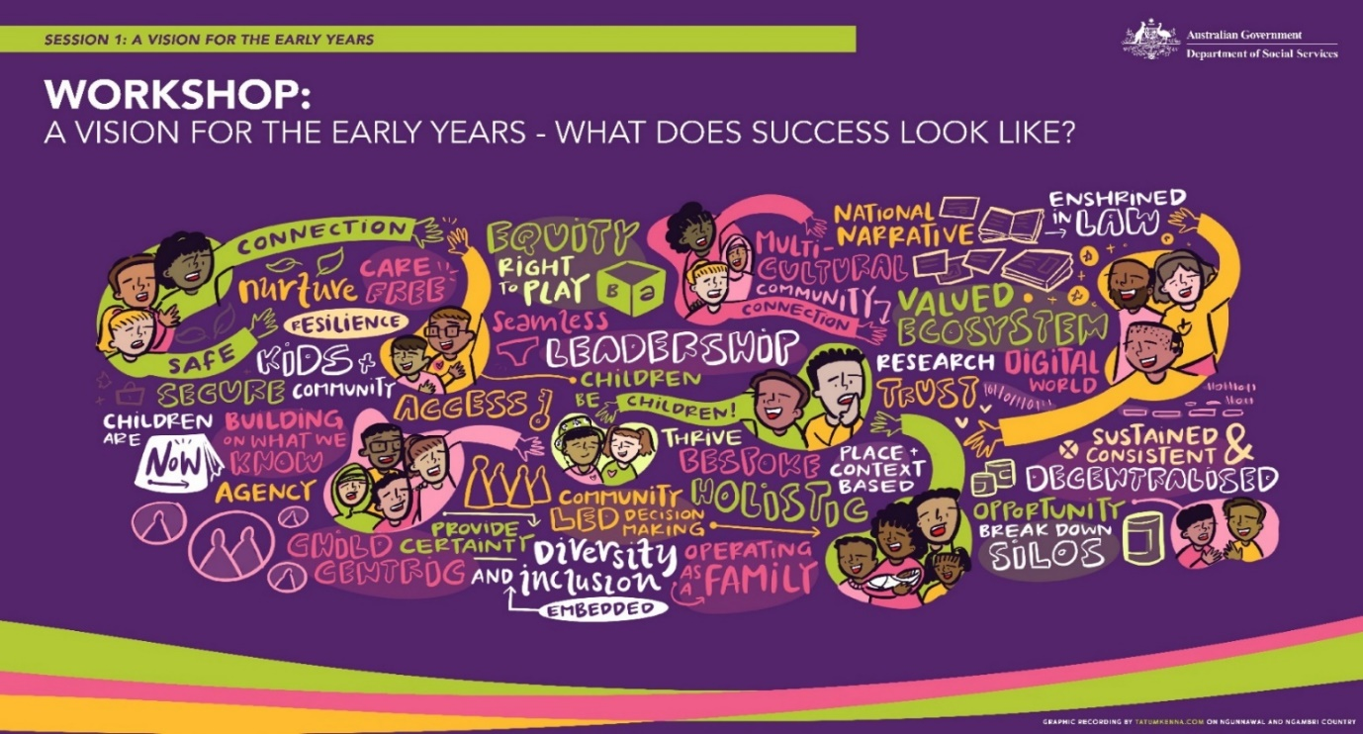
An illustration of the key themes from the National Early Years Summit Session 1 Workshop: What does success look like in the early years? Graphic recording by tatumkenna.com

Principles
Stakeholders proposed a range of ideas for the principles to guide the Strategy. Proposals included a mix of core beliefs, ways of working and explicit policy commitments. Many of these ideas were also raised in the context of the vision, outcomes and priorities.
There was acknowledgement that children’s wellbeing is holistic, and that children and families should have a voice in the policies and decisions that affect them and their experience of programs should be taken into account.
Stakeholders said that equity and inclusion is essential, and that investment should be prevention-focused. Services should be universal but not uniform, and systems and services should be evidence-informed, outcomes focused, accountable and adaptive.
Self-determination should guide work with Aboriginal and Torres Strait Islander communities and services should respect Aboriginal and Torres Strait Islander peoples ways of being, knowing and doing.

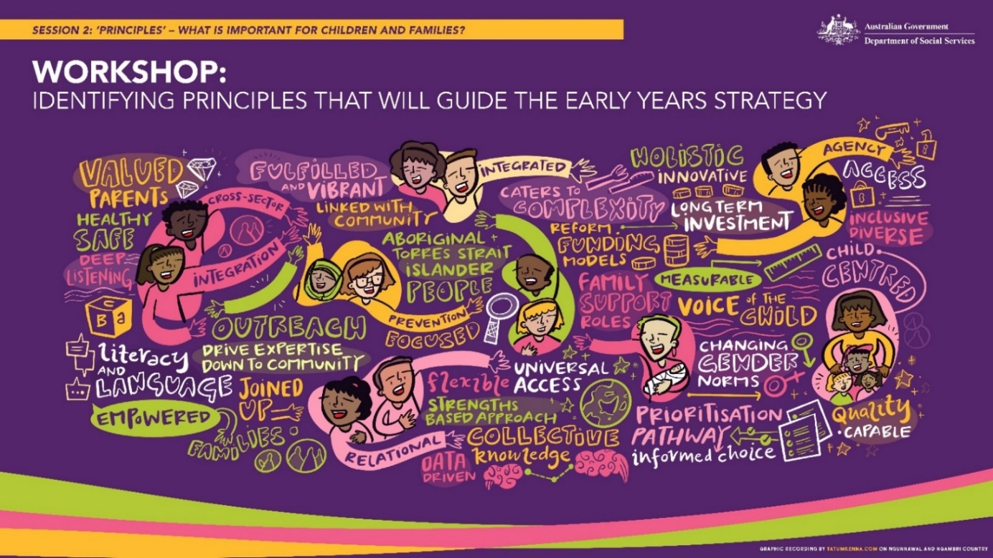
An illustration capturing conversation from the National Early Years Summit Session 2 Workshop: Identifying principles that will guide the Early Years Strategy. Graphic recording by tatumkenna.com

Outcomes
Overall, there were common views on what types of outcomes should be included in the Strategy:
- A range of outcomes for children that are holistic and support wellbeing.
- Family and community outcomes, that recognise children’s outcomes are shaped by their family’s wellbeing and resources, as well as the community they live in.
- Cross cutting outcomes like the importance of ensuring all children and families can access the support and resources they need to flourish.
When talking about outcomes people wanted:

Outcomes for children | Outcomes for families
- Happy, healthy and resilient.  - Nurtured and loved in stable, warm and responsive relationships.  - Growing up in language and learning-rich home and community environments.  - Connected to their own identity and ‘self’, their parents, their peers, their community and their culture.  - Valued as individuals, respected for who they are and celebrated for their difference.  - Not impacted by poverty and lack of access to the material basics, like food, clean water, clothing, safe housing and transport.  - Safe from violence, abuse and neglect and free from discrimination and exclusion.  - Able to exercise agency about their future, be asked about and be able to speak to their own needs.  - Ensuring children have their rights recognised and meaningfully activated. | - Feel confident, empowered, and valued.  - Are connected to family, friends, neighbours and communities, and have strong informal social and support networks.  - Can spend time with their children, with parents and caregivers able to balance work and caring responsibilities.  - Have the knowledge and skills required to confidently raise their children and navigate challenges.  - Have agency about their future and are able to speak to their own needs.  - Have the financial security and community support needed to provide positive home environments for their children.  - Take advantage of supports from all levels of Government such as Parental Leave Pay and family payments.  - Can see themselves and their families in diverse Australian media.
Outcomes for communities | Cross cutting outcomes
- Provide positive environments for raising children.  - Are recognised as essential for children’s health, wellbeing and development.  - Provide informal social networks that help parents and families to connect.  - Should be inclusive of all children and families, and provide spaces and events that bring people together (i.e. communities should be actively inclusive of all cultures, family structures and abilities).  - Support children to play. | - Services that are accessible, flexible responsive to local and family / child priorities, circumstances and characteristics, inclusive, non-discriminatory, and culturally safe.  - Readily available and easy to access services, with minimal gatekeeping and reduced complexity.  - A strong economy that creates financial security for families.  - Put the needs of children and families at the centre of decisions.

Survey responses
The survey asked respondents to identify the four outcome areas for children that the Strategy should focus on first from a list of 11 priority areas. The outcome areas that came through most strongly were:
- Emotional and mental health
- Learning and development
- Material basics like housing, clothing and food
- Strong and supportive families
- Love and nurturing (see Figure 1).
However, while some domains were identified as a lower priority (like safety and physical health), it is unlikely these were considered unimportant for children – rather, that they were of less immediate concern. Issues such as safety and physical health were raised as priorities through stakeholder submissions and roundtables.
In general, there was strong alignment between parent / family responses and those of non-parents / family (e.g. community members or people from a government, non-government or for-profit organisation). However, it is worth noting some divergence in relation to:
- The importance of play, rest and leisure, which families prioritised much higher than those who were not parents or families (35% compared to 24%).
- Love and nurturing, which families prioritised more than those who were not parents or families (43% compared to 35%).

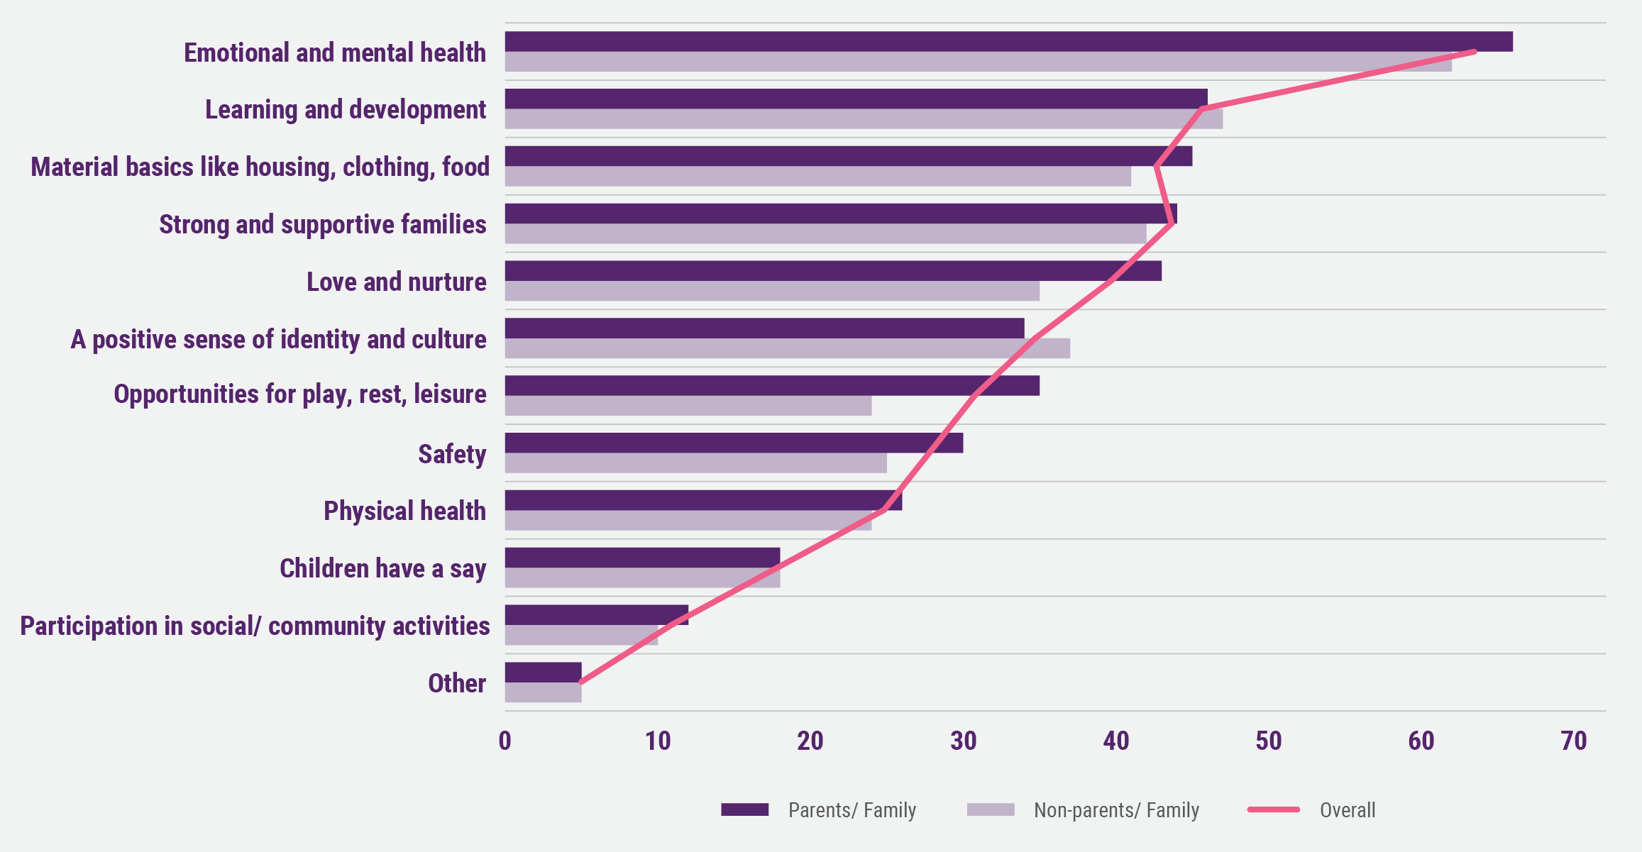
Figure 1: priority outcomes for the early years strategy based off survey responses.

Survey participants were also asked, “What are your biggest hopes for children in the early years?” Responses could be grouped into five key themes – three focused on outcomes for children (see Figure 2) and two focused on access to services and support.
For the three themes focused on outcomes for children, approximately two-thirds of responses focused on children feeling loved and safe, and children growing, learning and developing in safe and secure environments. More than half of respondents prioritised children developing the skills they need for the future.
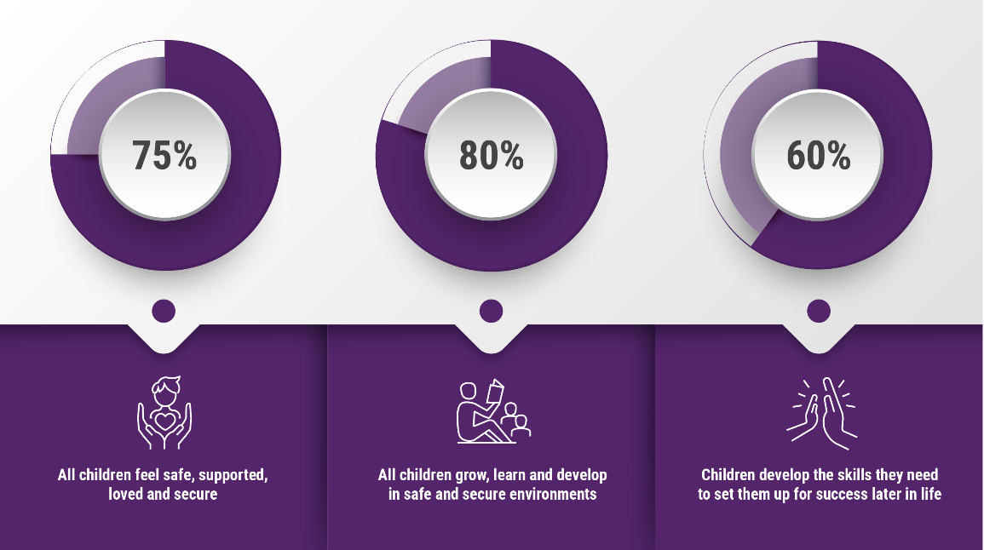
Figure 2: Survey responses to “what are your biggest hopes for children in the early years” that related to outcomes.

Priorities
Stakeholders identified many focus areas for the Strategy relating to how families are supported, how decisions are made, and the core enablers of effective systems.
Most stakeholders agreed that what is important is children, parents and families getting the support they need, when and how they need it.
There were many suggestions for how this could best be done – through large and small actions.
In line with the Australian Government’s commitment to develop a Strategy to help drive improved integration and coordination across Australian Government agencies, stakeholders clearly identified breaking down silos as a priority.
The consultation findings have been grouped into three themes with respect to priorities, expanded on in the following sections:
- How children, parents, families and communities are supported
- How decisions are made
- Enablers of effective systems.

How children, parents, families and communities are supported

Empowering and connecting families
Parents and caregivers want to be seen as the experts in their own children, and accordingly educated, empowered and supported to understand the needs, developmental milestones, and opportunities that would allow their children to thrive.
Service responses alone were not considered sufficient. Enabling strong, empowered community networks is crucial to supporting families to confidently raise their children and navigate challenges as they arise. This includes informal supports where families can learn from the experiences of other parents or families in similar situations to their own, and feel a sense of solidarity.
The importance of scaffolding to support community networks to be inclusive, safe spaces for all families, and sharing information and resources about the availability of community networks and supports was also a strong theme from the consultations.
The antenatal period was seen as a critical opportunity to engage with families and wrap support around new parent(s) prior to birth. This included by providing education for parents and families with a focus on nutrition, mental and physical health, and establishing and building communities and informal networks around families.
Parents and families in particular noted the pressures limiting their opportunities to spend quality time with children, including financial stressors and balancing work and other commitments with their role as parents and caregivers. They also noted the challenges created by culturally entrenched gender roles placing a higher burden of care and the primary parenting role on mothers, excluding or lessening the role of fathers in children’s lives, or limiting understandings of modern family structures.
In the antenatal period, families highlighted the importance of giving both parents and family members the opportunity, and financial support, to attend pregnancy-related appointments, so other caregivers could be better engaged in the pregnancy and birth.

Improving supports and services
Many stakeholders highlighted the importance of providing all children and families with access to a core package of services, with additional support based on need.
For some this included offering a core set of universal services with the capacity to provide bespoke services or greater ‘doses’ of some services scaled up based on need - ‘universal but not uniform’. Many stakeholders called for universal access to ECEC services. A high value was also placed on access to quality maternal and child health and parenting services.
There was also interest in shifting the balance of service focus from crisis to prevention. This extended to suggestions about the role of services such as ECEC in helping connect families to other supports and the impact of poverty as a driver of poor outcomes for children.
Stakeholders highlighted the importance of flipping the burden of knowledge currently requiring parents to walk through a maze to find out what is available and what is valuable. This included access to information and supports that enabled parents to make decisions for, and about, their children, that was easily located and navigable.
Stakeholders also wanted services to be easier to access by ensuring that services are affordable, flexible, have minimum ‘gatekeeping’, have soft entry points and warm referral processes, and provide information in different languages and accessible formats.
Services should also be trusted, safe places that welcome children and families no matter their circumstances – including cultural safety for Aboriginal and Torres Strait Islander and CALD families, accessibility for people with disability, and for families that are LGBTIQA+.

How decisions are made
Lack of alignment and consistency, fragmentation of effort, siloed decision-making, short-term policy and investment decisions, and the inflexible structures of government were called out as barriers to doing what is best for children.
Stakeholders noted the challenges of multiple layers of responsibility, including across different levels of government.
Stakeholders highlighted the importance of having a shared vision for the early years, meaningful engagement with the people impacted by policy decisions, accountability between and across portfolios and jurisdictions, and decision-making structures that promote outcomes and service quality.
Stakeholders wanted services that are based on evidence and principles of equity and early intervention and which leverage the strengths of each player in the services system (e.g. governments, not-for profits, philanthropy and the private market).
Similarly, stakeholders voiced the need to establish clear accountability mechanisms for the Strategy with ideas including data and reporting frameworks, legislation, and through structures of government.
There was strong support for the Australian Government taking a national leadership role in the early years, with many stakeholders seeking the involvement of all levels of government, service providers and practitioners.

Local decision-making
Policies and services that are responsive to place was a key priority for many stakeholders.
Regional, rural and remote stakeholders acknowledged geographical remoteness as a significant barrier to accessing available and responsive services that meet the needs of their communities.
Other stakeholders highlighted the challenge of policies and services that are not aligned with local needs, do not respond to community context and priorities, and that are not well-integrated – leading to services that are ineffective and inefficient.
Consultation highlighted the importance of community-level priority setting, funding models that enable local responsiveness, with clear accountability and roles and responsibilities.
This included ideas such as funding for outcomes, embedding a culture of co-design and shared decision-making, clear and easy to understand policy / program boundaries within which flexibility is permitted and encouraged, and funding models that incentivise collaboration and mutual impact, including long-term funding to allow time to drive change.

Enablers of effective systems

Data and evidence
Priorities to improve data included enhancing data sharing, inviting multiple sources of insight including the voices of children, families and communities, and enhancing demographic data (especially for remote and regional communities, CALD communities, LGBTIQA+ people and people with disability). There was feedback about the importance of Aboriginal and Torres Strait Islander data sovereignty (in line with the National Agreement on Closing the Gap, Reform Priority 4) and the need to develop appropriate protocols for the collection and use of data.
Priorities to build and share the evidence about ‘what works, for whom and in what circumstance’ included developing a culture of evaluation, systematically building evidence, and grounding decisions in evidence.
Stakeholders also raised the importance of being prepared to learn and adapt. For example, an ongoing commitment to scaling up the approaches that work and being prepared to stop, change and adapt when things are not achieving the desired outcomes.
Across the consultations, stakeholders consistently highlighted the importance of ensuring the Strategy includes a strong outcomes framework, with clear goals and objectives, and associated data collection and analysis to adequately measure progress.

Workforce
The consultation process saw strong representation from the ECEC sector, highlighting particular challenges and priorities for teachers and educators, while many voices also advocated for the wider early years workforce – including maternal and child health nurses, allied health practitioners, general practitioners (GPs), inclusion specialists, and family support workers.
Feedback included valuing the ECEC workforce as professionals, recognised through good pay, conditions and career structures, and with clear minimum qualifications that are nationally consistent and recognised. Additionally, stakeholders wanted the value of cultural knowledge, particularly Aboriginal and Torres Strait Islander ways of being, knowing and doing, to be recognised and to create roles that recognise and remunerate cultural expertise appropriately.

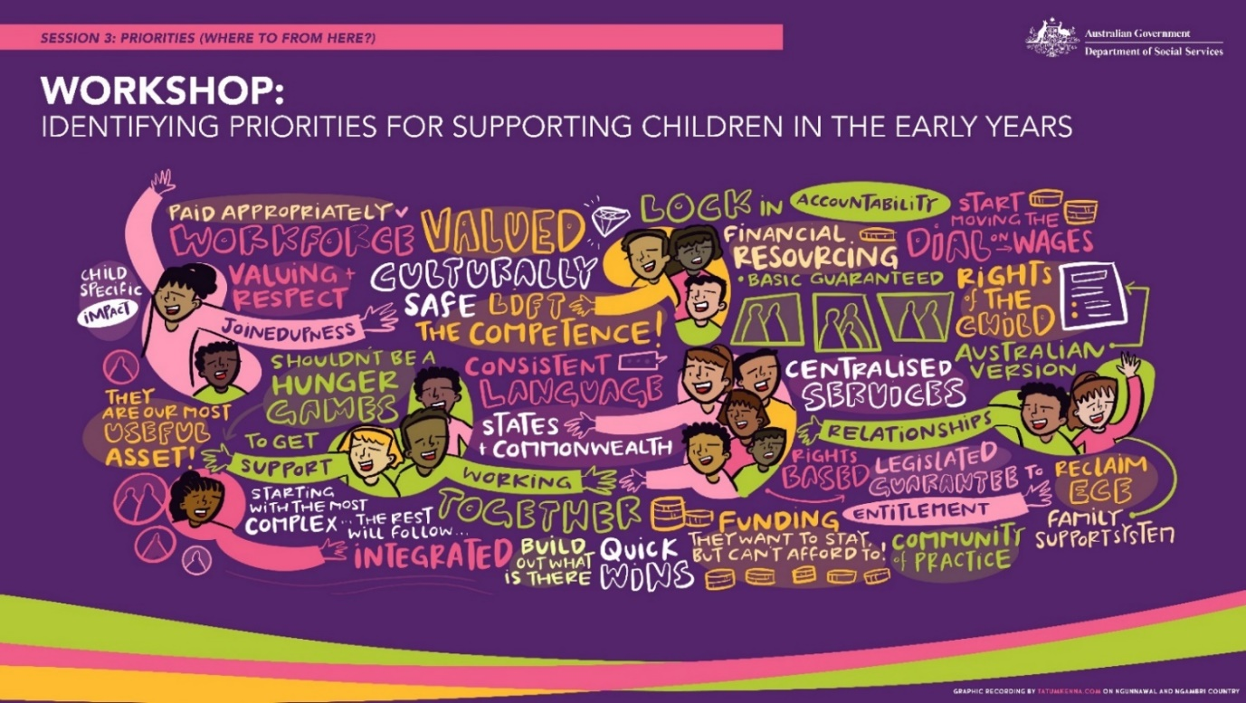
An illustration of key themes from the National Early Years Summit Session 3 Workshop: Identifying priorities for supporting children in the early years. Graphic recording by tatumkenna.com

Perspectives of different stakeholder groups
Across the consultations and in a number of targeted engagements, parents, caregivers, and stakeholders representing diverse stakeholder groups shared their unique perspectives and experiences drawn from the circumstances, contexts and communities they live in. This included Aboriginal and Torres Strait Islander children and families, children with disability and / or developmental concerns, CALD children and families, children and families in regional, rural and remote Australia, LGBTIQA+ children and families, and disadvantaged families.

Aboriginal and Torres Strait Islander children and families
Stakeholders called for the Strategy to align with the National Aboriginal and Torres Strait Islander Early Childhood Strategy and the principles and commitments in the National Agreement on Closing the Gap.
Viewed as critically important was ensuring the early years service systems work for Aboriginal and Torres Strait Islander children, their families and communities. This includes making systems culturally safe, listening to the needs and wants of Aboriginal and Torres Strait Islander clients, and embracing the knowledge of Aboriginal and Torres Strait Islander culture.
Stakeholder suggestions included ensuring services are Aboriginal and Torres Strait Islander controlled or led where possible, grounded in cultural knowledge, actively partnering with Aboriginal and Torres Strait Islander children, families and communities in service design, and providing flexible funding models that enables self-determination for communities.
Stakeholders also wanted to see Aboriginal Community Controlled Organisations (ACCO) and non-ACCO providers actively growing the Aboriginal and Torres Strait Islander workforce so that professionals come from and stay in community.
Aboriginal and Torres Strait Islander stakeholders also raised the importance of access to material basics like housing, food, clean drinking water and transport, to achieve the vision for the Strategy.

Families of children with disability and / or developmental delay
Families of children with disability and / or developmental delay and their representatives hold a vision of the future in which children with disability and their families grow within safe communities that celebrate, embrace and affirm diversity in all its forms, and prioritise inclusion rather than expecting integration or assimilation.
Barriers faced by children with disability and / or developmental delay include discrimination, stigma and bias, lack of access to services and supports, lack of support for early childhood educators working with children with disabilities, and inadequate supports for carers, parents and families.
Families of children with disability and / or developmental delay prioritised a coordinated approach to supporting children with disabilities, increasing equitable access to services and supports, empowering communities and families, and a strong and supported workforce, which has the capacity to support all children’s needs in inclusive environments.

Culturally and linguistically diverse families
CALD parents and families noted several barriers that made it harder to understand, navigate, and receive services.
This included barriers such as language and culture, legal status, impacts of trauma and a distrust of institutions often arising from experiences of, or fear of, child removal.
To address this, CALD stakeholders suggested that access to services and supports could be improved by ensuring services are less complex to understand and navigate, and used more effective communication, including greater use of resources in a range of languages.
CALD stakeholders suggested investing in community groups who help families navigate and understand service systems, and ensuring the workforce, particularly early childhood educators, understand cultural diversity, and are trauma-informed.
CALD stakeholders also wanted access to information and resources to empower their communities and families, including education about child development that builds on the strengths of traditional parenting practices.

Families in regional, rural and remote areas
For families and service providers in regional, rural and remote areas, challenges included geographical remoteness, difficulty recruiting a capable and local workforce, and being able to deliver flexible services that meet the needs of the community.
As such, these stakeholders prioritised adaptive place-based approaches, with coordinated decision-making backed by data sharing. They also prioritised policies that reflect the environmental degradation and natural disasters that they are witnessing.

LGBTIQA+ children and families
LGBTIQA+ children and families wanted to see a future in which children are supported, encouraged and celebrated in being their authentic selves, and where families and children have access to inclusive and responsive services.
However, LGBTIQA+ families faced some barriers to inclusion such as a lack of consistent legal frameworks, data collections not adequately reflecting LGBTIQA+ families, and a lack of understanding from service providers.
LGBTIQA+ families prioritised training and capacity building for front line staff or educators, legal and governance changes to reflect the diversity of genders and family structures and support for targeted services for LGBTIQA+ owned and run services.

Strategy structure
The consultation broadly sought input on the vision, outcomes, priorities and principles for the Early Years Strategy however, the Discussion Paper posed additional questions, including on the Strategy’s structure.
Of those submissions that provided commentary, many were supportive of the proposed structure although some put forward alternative structures for consideration, including:
- Considering a circular structure that reflects children and families at the centre rather than a hierarchical structure.
- Positioning evidence-based principles at the forefront of the structure of the Strategy to frame the outcomes and policy directions. Some submissions suggested that evidence used to inform the Strategy include the voices of children and families, as well as the practitioners who work closely alongside children and families – who will be critical in delivering on the aspirations set out by the Strategy.
- Establishing principles from the outset – to guide the intentions and approaches of the Strategy.
- Adding a purpose under the vision to set out the overarching aim of the Strategy in clear, plain-language terms.
- Aligning with the structure of other key frameworks in the early years and demonstrating how existing plans and initiatives will be brought together into a cohesive approach by the Australian Government.
- Adding an implementation and evaluation plan.

Scope
Feedback from all consultations suggests there is general support for the proposed scope of the Strategy, which included:
- The Strategy must be child and family centred, based on children and families’ voices, needs, interests, strengths, understandings and capacity.
- A focus on the first five years, including the antenatal period.
- It will be an Australian Government Strategy.
- It will build on, align with, and amplify existing Australian Government strategies across portfolios.
What we heard:
- The Strategy’s focus on the pre-birth to 5 years age range is strongly supported, with a small number of stakeholders suggesting a broader age range (e.g. 0 to 8 years or up to age 6) in recognition of the significance of the transition to school years.
- There was strong support for the Australian Government taking a national leadership role in the early years, but also a keen interest in a Strategy that involves all levels of government, service providers and practitioners.
- There was strong support for the Strategy to be an enduring, overarching statement of commitment by the Australian Government to Australia’s children and families for at least the next decade.
- Stakeholders strongly supported the Strategy drawing upon Australia’s international obligations, and this extended to conventions for Aboriginal and Torres Strait Islander peoples, people with disability, and the intrinsic human rights of the child as a citizen.
- Stakeholders called for the Strategy to capture the distinct ‘voice’ of children separate to that of their families and carers.
- Consultations confirmed that all parents need support and connection regardless of their socio-economic status.
- Many stakeholders canvassed the need for the Strategy (or associated Action Plans) to address the particular needs of diverse stakeholders (Aboriginal and Torres Strait Islander families, CALD families, families and children with disability, and rural/regional Australians) to maximise outcomes for all children.
- There was strong support for the Strategy to build on, and connect with, the current reform work affecting Australian children and families. Particular interest was expressed in connections to disability reforms (linking to the NDIS review and development of a National Autism Strategy), and broader place-based approaches, including tailored program co-design within a community/neighbourhood context.

Next steps
The findings from the consultation process have informed the development of the Early Years Strategy and will inform development of its Action Plans, as well as work across the Australian Government.
For more information about the Early Years Strategy visit https://www.dss.gov.au/families-and-children-programs-services/early-years-strategy

Appendix 1 - Full list of roundtables
Title/focus | Location | Date
Local community focus | Bentley, Western Australia | 20 February 2023
MP-led roundtable – local community focus | Bendigo, Victoria | 28 February 2023
Local community focus | Malvern, Victoria | 3 March 2023
Australasian Association of Parenting and Child Health (AAPCH) hosted roundtable | Canberra, Australian Capital Territory | 4 April 2023
Local community focus | Sorrell, Tasmania | 6 April 2023
Centre for Policy Development hosted roundtable | Melbourne, Victoria | 18 April 2023
Local community focus | Adelaide, South Australia | 19 April 2023
Local community focus | Ourimbah, New South Wales | 27 April 2023
Local community focus | Canberra, Australian Capital Territory | 2 May 2023
MP-led roundtable – local community focus | Sturt, South Australia | 3 May 2023
MP-led roundtable – local community focus | Murray Bridge, South Australia | 4 May 2023
Community Services #1 – Community Services Advisory Group and Providers | Virtual | 4 May 2023
Research (hosted by the Australian Institute of Family Studies) | Melbourne, Victoria | 5 May 2023
Culturally and Linguistically Diverse groups | Western Sydney, New South Wales | 12 May 2023
MP-led roundtable – local community focus | New South Wales | Early May
Local community focus | Brisbane, Queensland | 17 May 2023
Regional, Rural and Remote #1 | Cairns, Queensland | 18 May 2023
Local community focus | Gosnells, Western Australia | 19 May 2023
Community Services #2 – Families and Children (FaC) Activity providers | Virtual | 24 May 2023
ECEC #1 | Virtual | 25 May 2023
Regional, Rural and Remote # 2 | Virtual | 25 May 2023
ECEC #2 | Virtual | 26 May 2023
Parents #1 | Virtual | 29 May 2023
Health experts | Virtual | 31 May 2023
Parents #2 | Virtual | 5 June 2023
Parents #3 - of children with disability/ developmental concerns | Virtual | 6 June 2023
SNAICC leadership groups | Virtual | 6 June 2023
Community Services # 3 – HIPPY and Triple P service providers | Virtual | 7 June 2023
National Aboriginal Community Controlled Health Organisation affiliates | Virtual | 9 June 2023
Children with disability/developmental concerns | Canberra, Australian Capital Territory | 14 June 2023
Local community focus | Alice Springs, Northern Territory | 20 June 2023
Local community focus | Darwin, Northern Territory | 21 June 2023
Dietitians Australia hosted roundtable | Virtual | 26 June 2023
Grandparents | Virtual | 3 July 2023
Parents #4 | Virtual | 4 July 2023
Local community focus | Sydney, New South Wales | 5 July 2023
First Nations service providers | Virtual | 10 July 2023
Language and literacy | Virtual | 11 July 2023
LGBTIQA+ | Virtual | 12 July 2023

The NDIS Review will look at the design, operations and sustainability of the NDIS. It will also look at ways to make the market and workforce more responsive, supportive and sustainable.
The Department of Social Services is developing a National Autism Strategy, which will cover key reform areas including access to services, healthcare, education and employment.

