How To Manage Complaints – Service Providers

Disability Services and Inclusion Act 2023
In the course of your regular service provision, you will from time to time receive complaints. These may be from a service user/person with disability, a family member, carer or advocate of a person with disability, or from a worker. Complaints are a useful kind of feedback when something has gone wrong or where communication with the service has not been clear or a misunderstanding has occurred. Considering and responding to complaints shows respect and care for service users who may have been adversely affected, and provides valuable information about how to improve communication and service delivery to provide a better experience in the future.
In the first instance, you should work with the complainant to resolve their complaint, adhering to the record keeping and management requirements outlined in Disability Services and Inclusion (Complaints and Incidents Management) Rules 2023 (the Complaints and Incidents Management Rules) and any additional requirements outlined in your organisation’s complaints handling process.
There may be an instance where you are unable to resolve a complaint. This could be because the complaint is outside of the scope of your funding agreement or you have tried and failed to resolve the matter to the satisfaction of the complainant. If either of these is the case, the complaint may need to be escalated through referring the complaint on.
You can refer the complaint to the National Customer Service Line for complaints relating to Disability Employment Services, and the Complaints Resolution and Referral Service (CRRS) or the Department of Social Services Feedback and Complaint Team (DSS FCT) for any complaint. There is no wrong door for complaints and whomever you contact will assist you. The complaints body you contact will work with you to resolve the issue that caused the complaint, gathering information and making recommendations.
You are required to support this investigation according to the Complaints and Incidents Management Rules.
You are also required to implement any recommendation these complaint bodies may make. If you do not, your lack of compliance will be reported to your funding body, and this may put your funding at risk.

Your Responsibilities
Service providers can take complaints about any issue and should generally be the first point of contact when a complaint is made. Responsibilities include:
- Handle complaints that are received and escalate where complaint is unable to be resolved
- Maintain a complaints handling process and system appropriate for size
- Ensure procedural fairness for all persons involved in (or impacted by) the complaint (for example, workers)
- Actively assist the CRRS to resolve complaints by providing relevant information and access to relevant records
- Comply with any recommendations made by the CRRS or the department
- Report all complaints relating to the Code of Conduct to the DSS FCT.

Code of Conduct Complaints
As part of your complaints management system, you must ensure that you assess whether a complaint relates to the Code of Conduct or not. Code of Conduct complaints are any complaints that relate to:
- Individual freedom of expression
- Individual self-determination
- Individual decision-making
- Privacy of people with disability
- Safety, competence, care and skill when providing services and supports
- Integrity, honesty and transparency on the part of the service provider or employees
- Timeliness and responsiveness to matters that may impact the quality and safety of services
- Timeliness and responsiveness to instances or allegations of violence, abuse, neglect or exploitation of people with disability
- Taking reasonable steps to prevent violence, abuse, neglect or exploitation of people with disability
- Taking reasonable steps to prevent sexual misconduct
Complaints relating to the Code of Conduct must be reported to the department according to the terms set out in your agreement.

Additional Resources
Please visit the following web pages for further information and guidance material.
- www.dss.gov.au/dsi-act

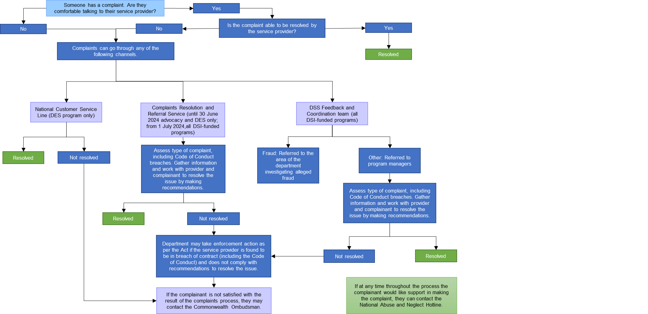
Overview of the Complaints Process

Responsibilities throughout the complaints process
A complaint is raised
Complaints should be raised with the service provider in the first instance. However, if the complainant would prefer they can raise it with the DSS FCT, CRRS or the NCSL (defined below). Complaints can be made by anyone (including anonymously) and can be made by service users/people with disability, their family member, carer or advocate, or a worker at a service provider.

Service Provider
The service provider can take complaints about any issue and should be the first point of contact when a complaint is made. Responsibilities include:
- Handle complaints that are received and escalate where complaint is unable to be resolved
- Maintain a complaints handling process and system appropriate for size
- Ensure procedural fairness for complaints relating to employees
- Comply with recommendations when made by the CRRS when complaint is escalated
- Report all complaints relating to the Code of Conduct to the DSS FCT.

Department of Social Services Feedback and Complaints Team (DSS FCT)
Responsibilities:
- Assess the nature of the complaint or incident and refer to the correct area in the department (fraud or program managers)
- Report on Code of Conduct breaches to responsible departmental team.
Department of Social Services Program Areas
Responsibilities:
- Assess the nature of the complaint or incident
- Work with complainants and service providers to resolve the issue by gathering information and making recommendations
- Enforce service provider compliance with recommendations, including those made by the CRRS, by taking measures as per the Act where required
- Refer matters to certification bodies if required
- Report all matters relating to the Code of Conduct to the responsible departmental team.

- Assess complaints against the NSDS
- Assess complaints against the Code of Conduct
- Assess other complaints that may be breaches of statutory funding conditions
- Work with service providers to remedy issues, including making recommendations
- Monitor implementation of recommendations
- Report to funding body if required

- Assess complaints against the NSDS
- Assess complaints against the Code of Conduct
- Assess other complaints that may be breaches of statutory funding conditions
- Work with service providers to remedy issues, including making recommendations
- Monitor implementation of recommendations
- Report to funding body if required

Complaints Resolution and Referral Service (CRRS)
Responsibilities:
- Assess the nature of the complaint or incident
- Work with service providers and complainant to remedy issues, including gathering information and making recommendations
- Report to DSS program area on complaints that may constitute a breach of funding conditions, including all matters relating to the Code of Conduct
- Monitor implementation of recommendations
- Refer the matter to DSS if the service provider does not implement them.

All complaints relating to breaches or alleged breaches of the DSI Code of Conduct must be identified in your complaints records
National Abuse Hotline
Responsibilities:
- Provide support for people wanting to make a complaint
- May refer to other complaints bodies.
National Customer Service Line (NCSL)
Responsibilities
- Work with complainant and service providers to resolve issues relating to the DES program
- Refer to DSS FCT if unable to resolve.

