Factsheet – How To Make A Complaint

Disability Services and Inclusion Act 2023
If you wish to make a complaint or you suspect a disability service provider has breached the Code of Conduct, you are encouraged to contact your service provider first. This gives your service provider an opportunity to resolve the concern and make improvements going forward. Your service provider is required to work with you to resolve your complaint.
If you are thinking about making a complaint or would like support to do so you can speak with your circle of support or individual advocate. You may also contact the National Disability Abuse and Neglect Hotline.
If you do not feel comfortable raising your concerns directly with your service provider, your service provider is unable to resolve your complaint or you are unhappy with the outcome, you can make your complaint to:
- The Complaints Resolution and Referral Service (CRRS)
- The Department of Social Services Feedback and Complaints Team (DSS FCT)
- The National Customer Service Line (NCLS) - for Disability Employment Services (DES) only.

Complaints Resolution and Referral Service (CRRS)
The CRRS is the central contact for complaints about disability services and supports funded by the Commonwealth that are outside the NDIS.
The CRRS will provide support to help resolve your complaint between you and the service provider. The CRRS will:
- listen and document your complaint
- get your permission to talk to the service and any others that are involved
- remain impartial – the CRRS will not take sides and does not advocate on anyone’s behalf.
If the complaint is not easily resolved, the CRRS will gather more information and make recommendations to the service provider about what they must do to resolve the situation. The CRRS will then notify you of their recommendations. They will also notify the department that funds the service provider. The CRRS will monitor the service provider to make sure they implement the CRRS’s recommendations.
If the service provider still fails to resolve the complaint, the CRRS will notify the relevant department. The department will then notify the service provider that they must comply with the CRRS’s recommendations.
If you are not satisfied with the outcome of your complaint, you can contact the Commonwealth Ombudsman.

Key Contacts
To make a complaint, contact one of these services:
- Complaints Resolution and Referral Service, 9am to 7pm AEST Monday to Friday; call 1800 880 052
- DSS Feedback and Coordination Team, 9am to 5pm AEST Monday to Friday, call 1800 634 035
- National Customer Service Line, 9am to 7pm AEST Monday to Friday, call 1800 805 260
- Commonwealth Ombudsman, 10am to 4pm AEST Monday to Friday, call 1300 362 072
- National Disability Abuse and Neglect Hotline, 9am to 7pm AEST Monday to Friday, call 1800 880 052 or email hotline@workfocus.com at any time - provides support to make a complaint.

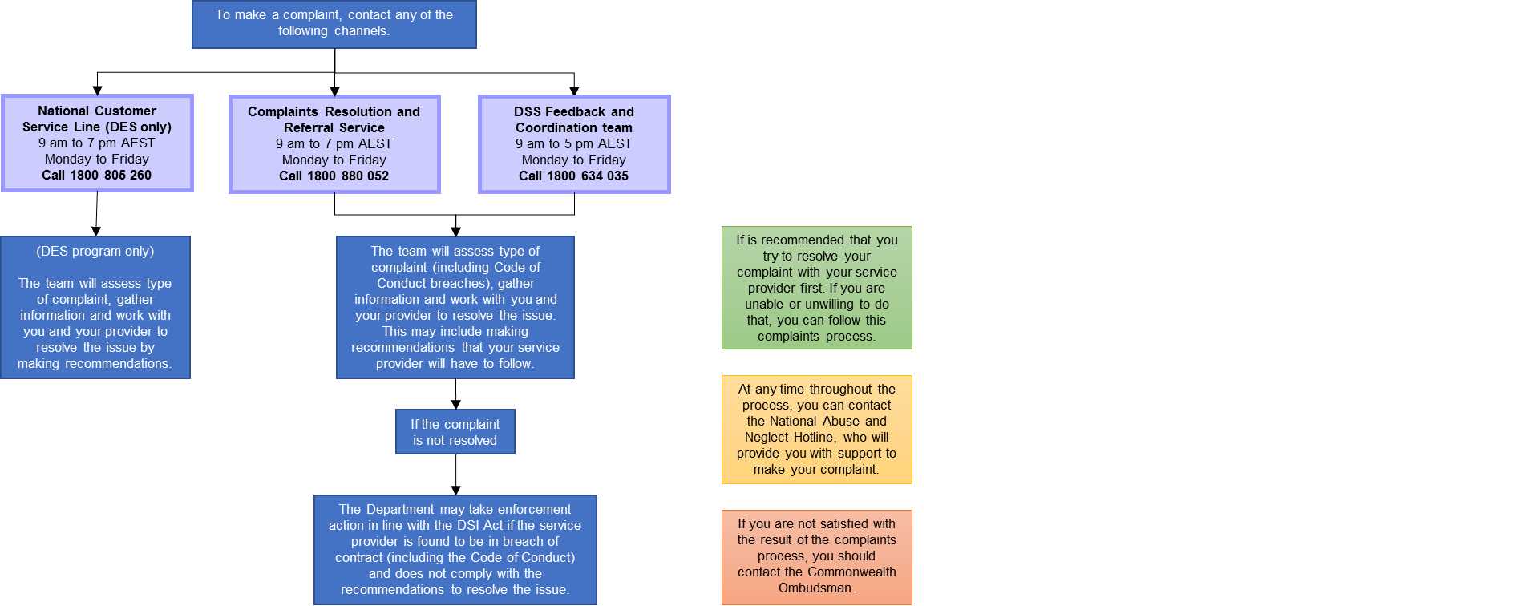
An Outline of the Complaints Process

What happens when I make a complaint

I want to make a complaint about a disability service or support.
I might be a person with disability, a family member, a carer, a disability support worker, or someone else making a complaint on behalf of a person with disability. I can complain to…
My service provider  You should make your complaint to your service provider first. If they are unable to resolve your problem, or you can’t or don’t want to talk to your provider, you can then make your complaint to someone else. | The Complaints Resolution and Referral Service (CRRS)  The CRRS is the central contact for complaints about disability services and supports funded by the Commonwealth that are outside the NDIS.
The Department of Social Services Feedback and Complaints Team (FCT)  You can make a complaint to the FCT. They will refer your complaint to the program area in the department who deals with your service provider. | The National Customer Service Line (NCLS)  If your complaint is about a DES program, you can complain to the NCLS. For other complaints, the NCLS will refer you to one of the above complaints bodies.

The complaints body will provide support
The organisation you have complained to will help resolve your complaint between you and the service provider. If the complaint is not easily resolved, the complaints body will gather additional information and make recommendations to the service provider about what they must do to resolve the situation. The complaints body will let you know their recommendations. They will monitor the service provider to make sure they implement the recommendations.

Government departments might provide follow-up
If the service provider still doesn’t resolve the situation, the complaints body will notify the relevant government department. The department will notify the service provider that they must comply with the recommendations. If they don’t, their funding might be put at risk.
If the service provider provides certain higher-risk activities (called ‘regulated activities’), a certification body might become involved too.

I am not satisfied with the results
If you are not satisfied with the outcome of your complaint, you can contact the Commonwealth Ombudsman on 1300 362 072.

