Course Gateway Bulk Enrolment & License Management Guide
------------------------------------------------------------------------------------------------
Contents
Section 1: Bulk Enrolment Process 1
Section 2: Initial Login 3
Section 3: Managing your licenses 5
Section 4: Course Completion 8

Important information
For bulk purchases over $2,000.00, invoices can be provided for your organisation upon request and must be accompanied with a purchase order.

For purchases under $2,000.00, skip to Section 2.
Section 1: Bulk Enrolment Process (for purchases over $2,000.00)
Step 1: Request an invoice from TQCourseGateway@tafeqld.edu.au and advise the number of licences you require.
Step 2: The Course Gateway team will contact you and provide a Request to Create Debtor form that is required to set your organisation up with finance so TAFE QLD can generate an invoice. For invoices over $2,000 a purchase order may be required from your organisation.
Step 3: Nominate your preferred administration account email, noting that this will need to be consistent as it will be the primary login for the administration of licences.

Step 4: Once TAFE QLD has received the debtor application and the required administration details, the Course Gateway team will create your Course Gateway administration account.

Step 5: The administration account will be handed over via email to your nominated administration email. Due to security and privacy policies, account details will only ever be discussed with the primary account holder.
Step 6: Once you receive notification from the Course Gateway team, log in to Course Gateway with your administration account user details and reset your password.

Step 7: You are now able to log in to your administration account and manage your licences. Additional licences can be purchased using this administration account email via credit card directly through the Course Gateway portal, or by requesting an additional invoice (for purchases over $2,000.00).

Section 2: Initial Login
Once your administration details have been received and your password is established, you will be able to log in by following the below steps:
Step 1: Navigate to “Login” on the top right-hand navigation panel.
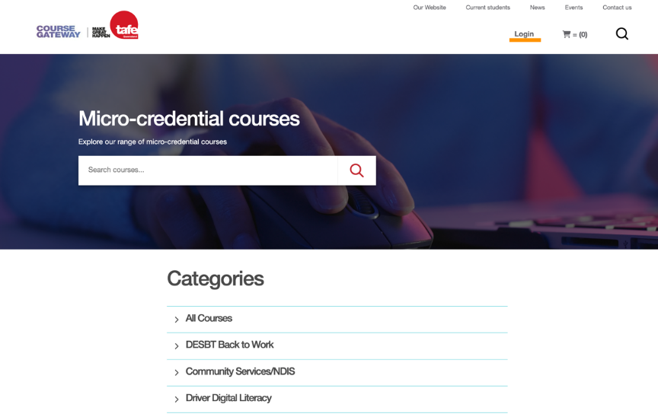

Step 2: Select the “Login” option.

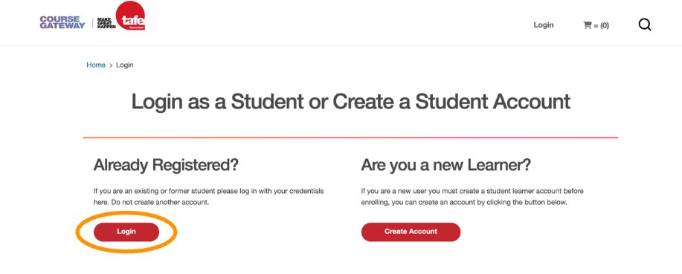

Step 3: Enter you login credentials and click “Log In”.

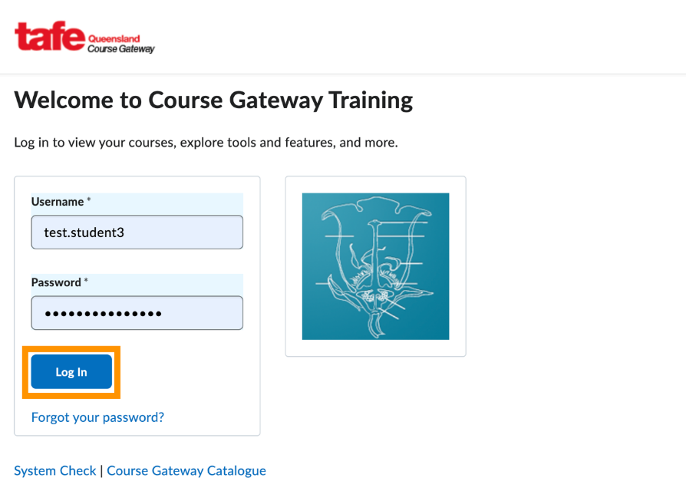

Section 3: Managing your licenses
Once you have logged in, you can start managing your licenses by following the below steps:

Step 4: Navigate to “My Account” on the top right-hand navigation panel.
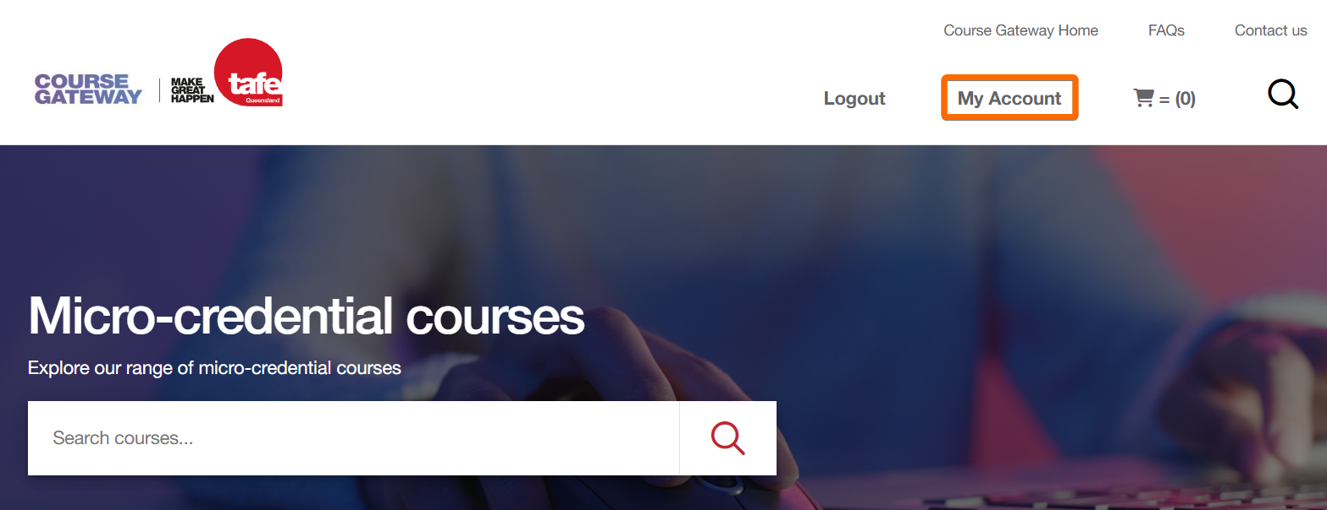

Step 5: Select the “Manage Licenses” option.
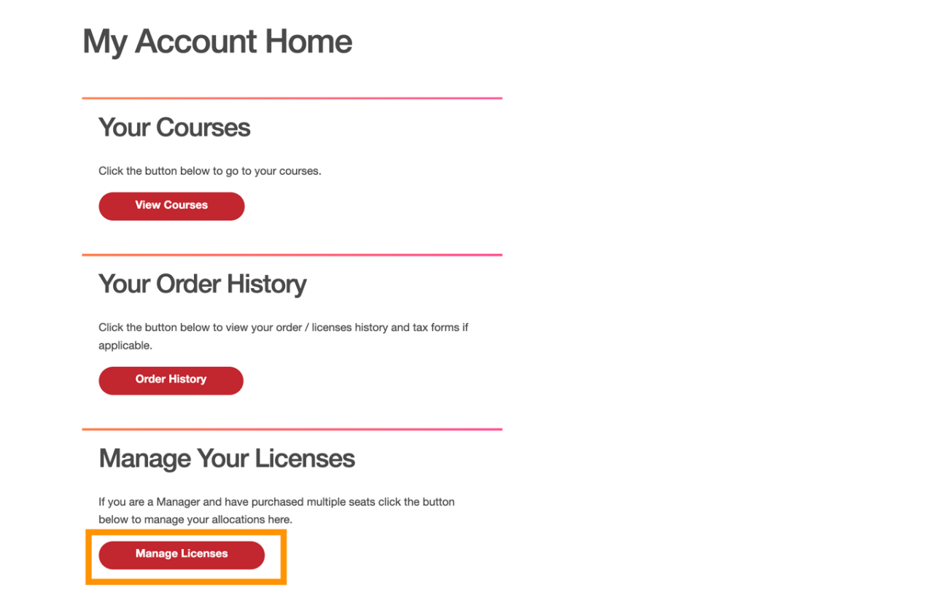
Step 6: Your Manage Licenses dashboard should look like the below with the following sections:
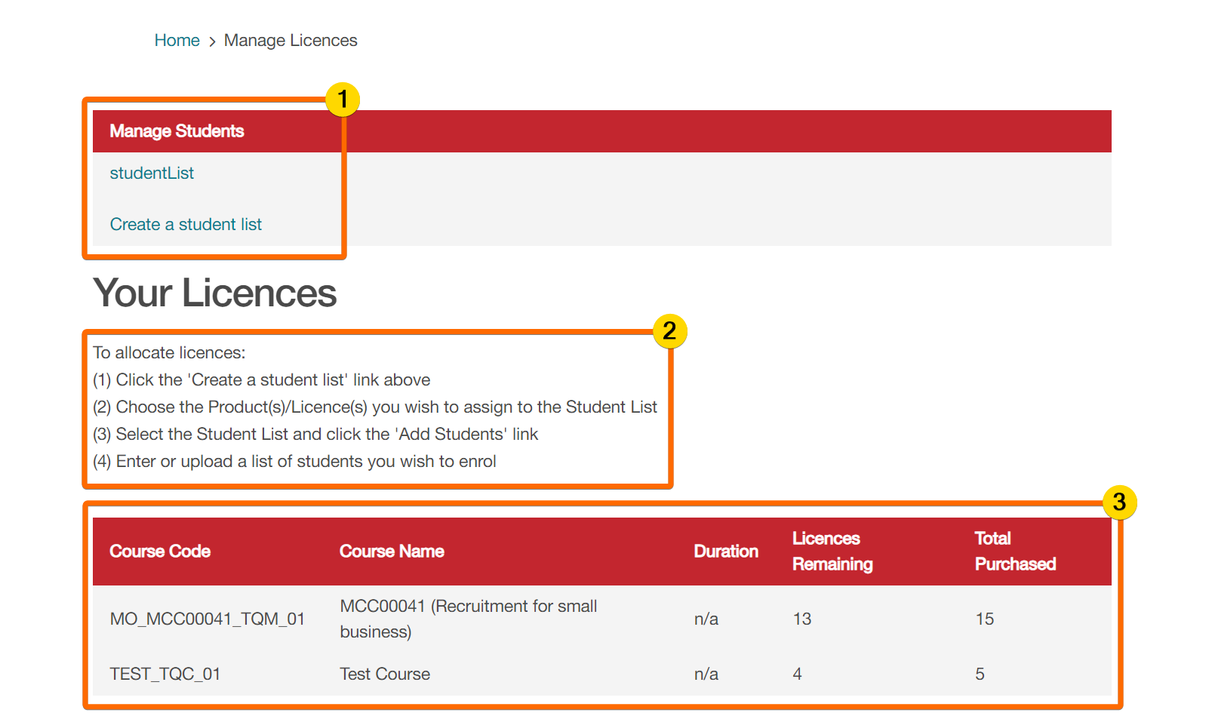
Number in the diagram above allows you to create and manage your student lists;
Number in the diagram above shows the instructions for how to allocate licences;

Number in the diagram above shows the total number of purchased licences and licences remaining for a particular course.

Step 7: Your Student List dashboard should look like the below with the following sections:
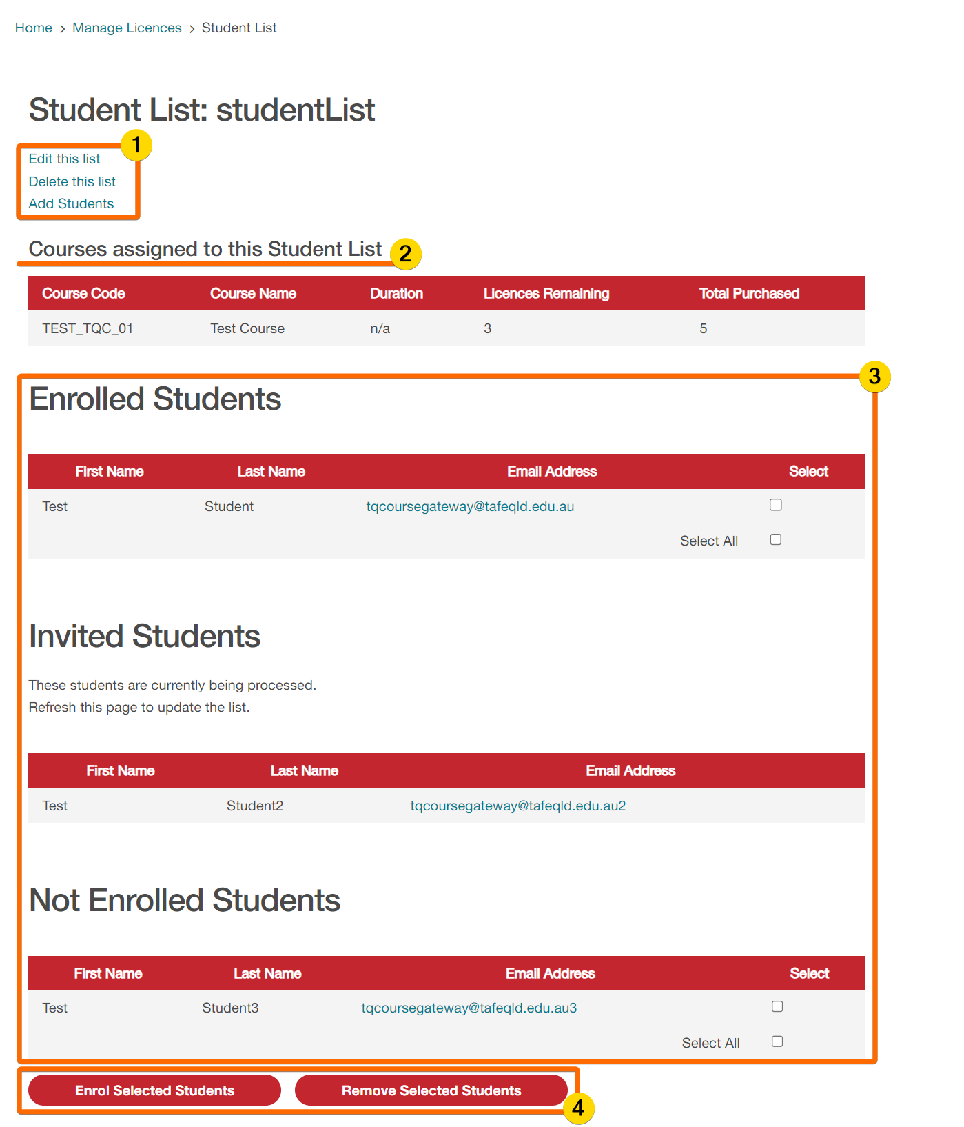

Number in the diagram above allows you to manage the selected student list;
- Edit this list: Rename the student list;
- Delete this list: Delete the student list;
❗ This action is permanent and cannot be undone. Deleted lists are no longer accessible or retrievable and any licence tokens allocated to a student will no longer be valid.
- Add Students: Three options to add students to a student list:
  - Add an individual student: Enter one student’s email address and full name;
  - Add multiple students: Enter multiple lines of student’s email addresses and full names, one line per student with each detail separated by a comma:
e.g., emailaddress, firstname, lastname;
  - Upload students: Upload a .CSV (comma delimited) file containing multiple lines of student’s email addresses and full names, one line per student with each detail separated by column; no commas:
e.g., emailaddress | firstname | lastname;

Number in the diagram above shows the list of courses assigned to the selected student list along with a brief overview of the total number of purchased licences and licences remaining;

Number in the diagram above shows the list of…
- Enrolled Students: Students who have clicked on the course invite email link and claimed the licence token to get access to the course;
- Invited Students: Students who have been allocated a licence token and sent a course invite email to claim it for access, noting that tokens cannot be reallocated once assigned;
❕ “Course enrolment invitation” emails will be sent from Course Gateway Admin <TQCourseGateway@tafeqld.edu.au> and may be redirected to Junk/Spam folders.
- Not Enrolled Students: Students who have been added to the student list but have yet to be invited or allocated a licence token;

Number in the diagram above allows you to Enrol or Remove a select student from the “Not Enrolled Students” list;
Section 4: Course Completion
Once your staff members have successfully completed the Knowledge Check to evidence their competency, they will be awarded a Digital Badge as confirmation of completing the course.
They will receive an email within a few hours of completion advising that their digital badge has been issued via our badging platform Canvas Credentials. They will be able to access, view and share their digital badge upon signing in. This digital badge will NOT be accessible within Course Gateway.
If they have not previously created a Canvas Credentials account, they may do so by clicking Create an account. Please ensure they use the same email address as the one registered to their TAFE Queensland Course Gateway account to ensure the learning management system can transfer the badge to their Canvas Badges Backpack.
They may also click the Awards link on the navigation menu of the learning management system to be directed to the Canvas Credentials website.
For more information on how to share badges, please visit the Canvas Credentials Knowledgebase.

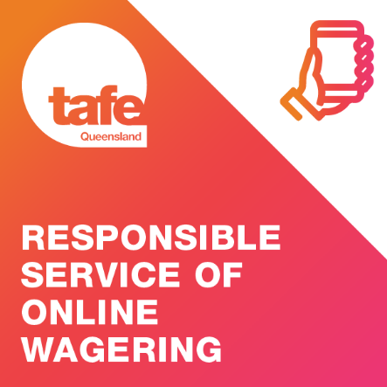
1 Example of Digital Badge

