Activity Statement prototype DSS 2782.09.22

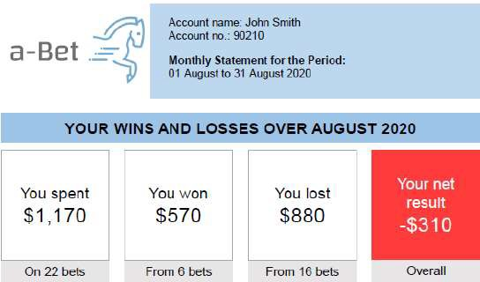

The format of the detailed transaction list is not prescribed in the National Policy Statement Principles.
The example shown opposite is compliant and considered best practice.

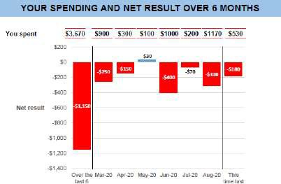
Click here for information on safe gambling support services and consumer protectin tools

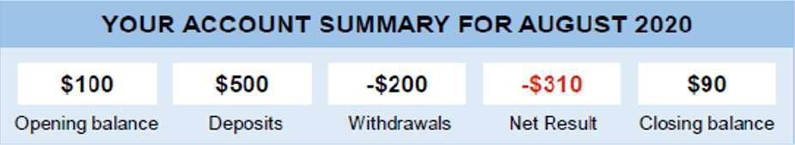
Click here for detailed transaction list
DETAILED TRANSACTION LIST
Date | Description Deposit/  Withdrawal | Free Stake  Bets | Pay Out | Net  Result | Balance
1-Aug-20 | Opening Balance |  |  |  | $100.00
2-Aug-20 | Bet Horse A | $10.00 | $190.00 | $180.00 | $280.00
2-Aug-20 | Withdrawal -$200.00 |  |  |  | $80.00
5-Aug-20 | Bet Horse B | $50.00 | $0.00 | -$50.00 | $30.00
6-Aug-20 | Bet Sport A | $30.00 | $0.00 | -$30.00 | $0.00
8-Aug-20 | Deposit $500.00 |  |  |  | $500.00
8-Aug-20 | Bet Sport B | $20.00 | $0.00 | -$20.00 | $480.00
9-Aug-20 | Bet Horse C | $50.00 | $0.00 | $0.00 | $480.00
14-Aug-20 | Bet Sport C | $30.00 | $80.00 | $50.00 | $530.00
14-Aug-20 | Bet Horse D | $50.00 | $0.00 | -$50.00 | $480.00
15-Aug-20 | Bet Sport D | $30.00 | $0.00 | -$30.00 | $450.00
18-Aug-20 | Bet Horse E | $20.00 | $100.00 | $80.00 | $530.00
19-Aug-20 | Bet Horse F | $40.00 | $120.00 | $80.00 | $610.00
19-Aug-20 | Bet Sport E | $60.00 | $0.00 | $0.00 | $610.00
20-Aug-20 | Bet Novelty A | $60.00 | $0.00 | -$60.00 | $550.00
20-Aug-20 | Bet Horse G | $40.00 | $0.00 | -$40.00 | $510.00
20-Aug-20 | Bet Sport F | $150.00 | $0.00 | -$150.00 | $360.00
21-Aug-20 | Bet Novelty B | $30.00 | $110.00 | $80.00 | $440.00
23-Aug-20 | Bet Horse H | $50.00 | $150.00 | $100.00 | $540.00
25-Aug-20 | Bet Sport G | $10.00 | $0.00 | -$10.00 | $530.00
25-Aug-20 | Bet Novelty B | $110.00 | $0.00 | -$110.00 | $420.00
25-Aug-20 | Bet Sport H | $120.00 | $0.00 | -$120.00 | $300.00
28-Aug-20 | Bet Novelty C | $140.00 | $0.00 | -$140.00 | $160.00
31-Aug-20 | Bet Sport I | $40.00 | $0.00 | -$40.00 | $120.00
31-Aug-20 | Bet Sport J | $30.00 | $0.00 | -$30.00 | $90.00
31-Aug-20 | Closing Totals | $1,170.00 |  | -$310.00 | $90.00

The National Policy Statement prescribes the requirements for activity statements shown in the prototype opposite.

