Sector Briefing
NDIS National Workforce Plan
14 December 2021
NDIS National Workforce Plan: 2021–2025

Agenda:
- Recent NDIS National Workforce Plan achievements and consultation
- Initiative 1: A Life Changing Life campaign
- Initiative 5: the Boosting the Local Care Workforce Program and workforce optimisation
- Initiative 10: Regulatory alignment and worker screening

Recent achievements
- Initiative 1: The care and support sector communications campaign,
A Life Changing Life, launched on
15 August 2021.
- Initiative 3: To coincide with the launch of the campaign, a targeted JobActive jobs board was published on the care and support jobs website: www.careandsupportjobs.gov.au
- Initiative 5: From 1 July 2021, the Boosting the Local Care Workforce program expanded its remit to the broader care and support sector to include aged and veterans’ care in addition to its current NDIS focus.
- Initiatives 6-8: Consultation on development of micro-credentials and training, developing a professional network, and establishing a skills passport.

Recent achievements continued
- Initiative 10: On 16 June 2021, the Aged Care Act 1997 was amended to recognise NDIS worker screening clearances. Information is being disseminated on the changes and enforcement. The Department of Health has established a cross-agency taskforce to progress implementation of regulatory alignment and worker screening.
- Initiative 15: Promoting available telehealth services to support allied health professionals, particularly those in rural and remote communities, to access professional support and supervision remotely.
- Initiative 16: In September 2021, it was announced that 57 organisations across Australia will receive Indigenous Business Support Funding grants, worth $22,000 each through the NDIS Ready project.
NDIS National Workforce Plan: 2021-2025 – quarterly update – October 2021 available at: www.dss.gov.au/ndisworkforceplan

Consultation
- Advisory Group on Market Oversight
  - provider peaks, participant peaks, health professionals and employment peaks
- Joint Standing Committee on NDIS: Workforce Inquiry
  - 53 submissions
  - 27 submissions on the Workforce Plan
- Regulatory alignment
  - Second stage of consultation open until 17 December 2021
  - Care and Support Sector Code of Conduct consultation has commenced
  - Findings released early 2022
- Allied health student placements
  - Universities Australia Health Professions Education Standing Group meeting
  - Australian Allied Health Leadership Forum
  - Meetings with Peaks including AHPA, SARRAH
- Disability Workforce Industry Working Group
  - Industry-led,
  - Co-chaired by National Disability Services
  - First meeting 15 December 2021
- Initial workshops with provider peaks in regard to developing a whole of care and support online demand map tool
- Consultation underway for:
  - Micro-credentials and training
  - Care and Support Worker Professional Network
  - Skills passport

Initiative 1: A Life Changing Life campaign

A Life Changing Life

An initiative of the NDIS National Workforce Plan

Campaign objectives
- Raise awareness of care and support work.
- Raise awareness of the diverse pathways into jobs and careers.
- Encourage target audiences to take action.
- Raise awareness of the support that new recruits need from employers.

Who are we talking to?

Campaign target audiences

Tertiary students
- Includes high school students considering their post-high school options.
- University and TAFE students currently studying allied health, nursing, psychology, sports medicine, social work.
- University and TAFE students studying the creative arts (music, dance and visual arts).

Searchers
- People in their late teens and 20s who are currently working in casual or ‘filler’ jobs, including hospitality and retail.
- People who are looking for work.

Transitioners
- People who are looking for a change in employment – they may be in professional careers or long-term lower skills jobs.
- Recent arrivals to Australia (recent migrants).
- People who are looking to enter the paid workforce after time caring for family (informal carers).
- People with disability.

How are we going?

Campaign check-in

Website and social stats
- Careandsupportjobs.gov.au - more than 1.3 million total views and more than 564,000 unique views.
- The most viewed webpage is the Now hiring page - 56,600 total views.
- Web users are spending the most amount of time on the What do you need to start working page at just over one minute.
- Nearly 4 million unique users have seen content (paid and organic posts) on the Care and Support Sector Australia Facebook page.

Partnerships
- Partnership with Junkee kicked off on 18 October with the first of two articles going live, followed by a video on social media.
- Partnership with Year13 went live on Wednesday 24 November with the launch of an e-learning program, plus six supporting editorials and social tiles.
  - https://year13.com.au/academy/en-able
- The second webinar with SEEK was held on 30 November. The topic was ‘How to write a good job ad’.

Case studies
- A new career a new start - Ross's aged care story | Care and Support Jobs
- A life-changing trip - Rodney and Colin's disability support story | Care and Support Jobs
- Serving those who served - Ruwan and Geoff's veterans' support and aged care story | Care and Support Jobs

Aboriginal and Torres Strait Islander Engagement
- Joint Minister Reynolds/Wyatt media release highlighting the campaign was released 30 September.
- Media coverage included interviews with Noongar radio and SBS NITV.
- Lisa and Greg’s story appeared in the Koori Mail.

Culturally and linguistically diverse audiences
- Joint Reynolds/Colbeck/Hawke media release highlighting the campaign was released 18 November.
- Jackie and Maria’s story was published in The Philippine Times (Australia).
- Case studies – disability support worker Indy (Indian), and aged care workers Hanan (Arabic) and Jackie (Filipino).

What’s next?

2022 campaign activities

2022: A Life Changing Life
- 3 x advertising bursts: late January to mid-February; late March to mid-April; mid-May to June 4.
- Out-of-home for all three, TV for Burst #3 and #5.
- 2 x Seek webinars
- Monthly sector newsletter
- More partnerships
- Career adviser toolkit
- Phase 2?

Get involved

Stay up to date with the campaign
- www.CareAndSupportJobs.gov.au
- www.facebook.com/CareandSupportAus
- careandsupportworkforce@dss.gov.au

Initiative 5: Boosting the Local Care Workforce Program – Workforce Optimisation in the Care & Support Sector

The Boosting the Local Care Workforce Program uses a regional model to connect with and support the sector

The Program has a network of 25 coordinators…
- Regional Coordinators (RCs) work with existing and prospective service providers and key stakeholders in their geographic area.
- RCs work to provide localised support, gather intelligence on local issues, facilitate workshops and connect stakeholders with complementary programs and initiatives in the disability and aged care sectors.
- Lead Regional Coordinators (LRCs) also engage regularly with local service providers in their region.
- LRCs lead and manage the RCs that are appointed in the jurisdiction in which they are operating.

…located across the country covering each state and territory…
- The geographic reach of all RCs were defined factoring in the locations of NDIS offices, LACs and aged care catchment areas.
- The diagram below lists each of the RC regions.
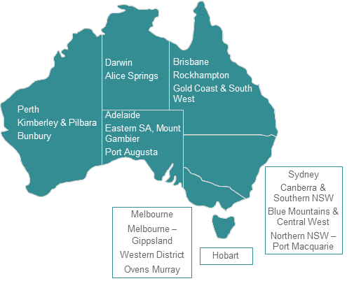

…who host events, forums, and groups to hear from and support the sector
As at 16 Nov 2021:
- 382 events hosted or co-hosted so far
- 12,903 risks and issues captured so far
- 8,952 active Care and Support Sector organisations in the CRM

Workforce attraction challenges are at all-time highs, which means it’s even more important for providers to invest in retention

The volume of online job ads has grown ~40% this year, while applications per ad has declined ~46%

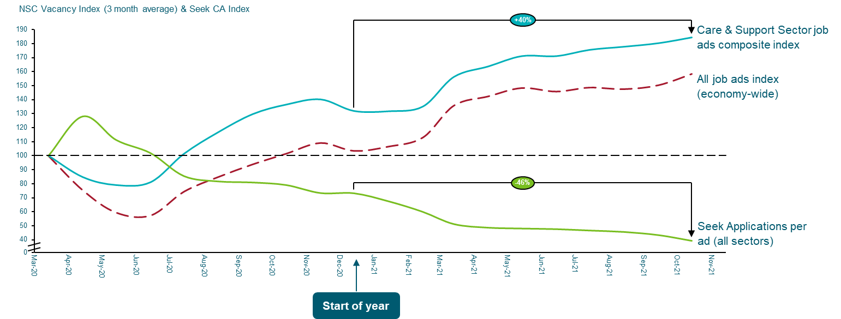
Note: ‘Trends in workforce supply & service demand’ has been sourced from the ABS Weekly Payroll Jobs and Wages in Australia. ‘Trends in workforce demand‘ has been sourced from the Labour Market Portal Monthly Vacancy Report (detailed occupations) and Seek Employment Data

A large NDIS & Aged Care provider in NSW-VIC used workforce optimisation to move from 15% permanent part time to 70% and save $200k p.a. in wages in the process

Navigator
- Provider has a visionary CEO with a growth mindset.
- Driven and motivated Human Resource Manager with experience outside the sector

Vision
- Three limbs to their vision:
  - Provide a sense of security and stability for a large portion of staff.
  - Increase retention with employment security / certainty.
  - Deliver wage savings to the business.

Thinking with intent
- A large portion of the workforce was casual with high uncertainty of hours.
- Conscious that change would need to be navigated carefully (e.g. unions).
- When participants exercised choice, provider would take on the risk (not pass it on) and retain staff and look to re-deploy.

Additional capabilities
- Provider identified capability gap in Human Resources. Took on two additional staff.
- Changes required roster administration. Recruited and employed 10 additional rostering staff to implement and manage six-monthly rostering strategy.

Initiative 10: Aligning Provider Regulation Across the Care and Support Sector

Current State
There are different regulatory alignment requirements for similar care and support services.

Regulatory alignment across the care and support sector
Similar services are provided across aged care, disability support and veterans’ care.
While some differences across settings are appropriate, duplication in regulatory requirements may be a barrier to consistent quality and safety and the overall efficiency of the market.
Approximately 36% of aged care providers operate in at least one other sector.
The percentage is less for NDIS providers, but the NDIS has more smaller providers working in one sector.
Of the providers operating in key veterans’ care programs, including community nursing and home care services, most providers operate in another sector.
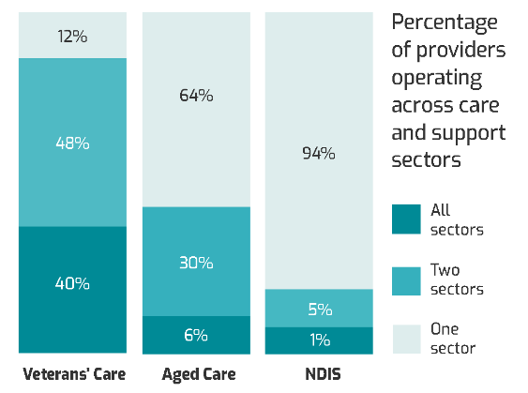

Aligning Provider Regulation across the Care and Support Sector Measure
$12.3m over two years, announced in the 2021-22 Budget, to improve alignment of regulation across the care and support sector.
Joint Regulatory Alignment cross-agency taskforce being led by the Department of Health. Input from:
- Department of Social Services
- Department of Veterans’ Affairs
- Aged Care Quality and Safeguards Commission
- NDIS Quality and Safeguards Commission
Key objective: Develop a roadmap for medium to long term regulatory alignment.

Sector Consultation
Consultation on the development of a Regulatory Alignment Roadmap for future reform has commenced:
- Stage 1: Consultation with providers and peak organisations was conducted in October 2021.
- Stage 2: Public consultation, including bespoke consultation designed for consumers and accessible engagement for people with disability, opened 15 November and will continue through to 17 December 2021.
- Findings of the consultations are expected to be released in early 2022.

Department of Social Services Led Projects
- NDIS Quality and Safeguards Framework Review
- Disability Service Grants and Procurement Review
- Consumer Information for the NDIS and Veterans’ Affairs project

NDIS Quality and Safeguards Framework Review
- Initial scope for Framework Review approved by the Minister for the National Disability Insurance Scheme on 2 September 2021.
- Following feedback from state and territory senior officials a revised scope has been prepared.
- Disability Ministers will be provided the revised scope once finalised.
- Successful consultant to conduct the Review from early 2022.
- Issues to be addressed:
  - Consultation and engagement with the sector to test the provisional scope.
  - Delays to timeframe of Review to input into Roadmap.

Disability Service Grants and Procurement Review
- Analysis of current quality and safety arrangements for disability grants and procurements to identify:
  - Good practice
  - Gaps
  - Possible improvements
- Internal and external consultation now complete.
- Currently developing a framework to assist grant areas to identify the level of protections required.
- Consideration of the broader alignment across the care and support sector will be led by the cross-agency taskforce.

Consumer Information Project
- Engagement with:
  - The NDIS Quality and Safeguards Commission
  - The National Disability Insurance Agency
  - The Department of Veterans’ Affairs
  - Other external stakeholders
- Purpose is to determine:
- What quality and safety performance information should be made available
- Produce a roadmap for the development and provision of this information
- Successful consultant to conduct the Project from early 2022.

Early Areas of Reform
The National Care and Support Worker Regulation measure was announced in the 2021-22 Budget.
- Addresses a key recommendation of the Royal Commission into Aged Care Quality and Safety.

Worker Screening
- NDIS worker screening checks recognised in residential aged care.
- Legislation drafted to establish worker screening arrangements for aged care consistent with NDIS worker screening from 1 July 2022.
- Most states and territories have provided in-principle support to align care sector worker screening arrangements.
- NDIS worker screening clearances now recognised across both the NDIS and Aged Care Sector.
- Allows NDIS workers to move across the sector.

Early Areas of Reform continued

Code of Conduct
- Working to create a Care and Support sector code of conduct based on the existing NDIS Code of Conduct.
- A single code of conduct will improve the quality and safety of care across the sector.
- Consultation has occurred on a Care and Support Sector Code of Conduct applicable to providers and workers across the sector.
- The single code of conduct will be supported by information sharing across the sector.
  - Provides consistent quality and safety protections.
  - Reduces the regulatory burden and red tape for cross-sector providers and workers.

Next Steps
- Consultant engaged to undertake the Consumer Information Project in early 2022.
  - Report due March 2022.
- Consultant engaged to progress the NDIS Quality and Safeguards Framework Review in early 2022.
  - Report due December 2022.
- DSS to continue to work with Regulatory Alignment Cross-Agency taskforce and stakeholders to inform the development of the Regulatory Roadmap in early 2022.
- DSS to continue to work with the Department of Health on Worker Screening and Code of Conduct reforms.

Thank you

