Families and Children Activity outcomes framework

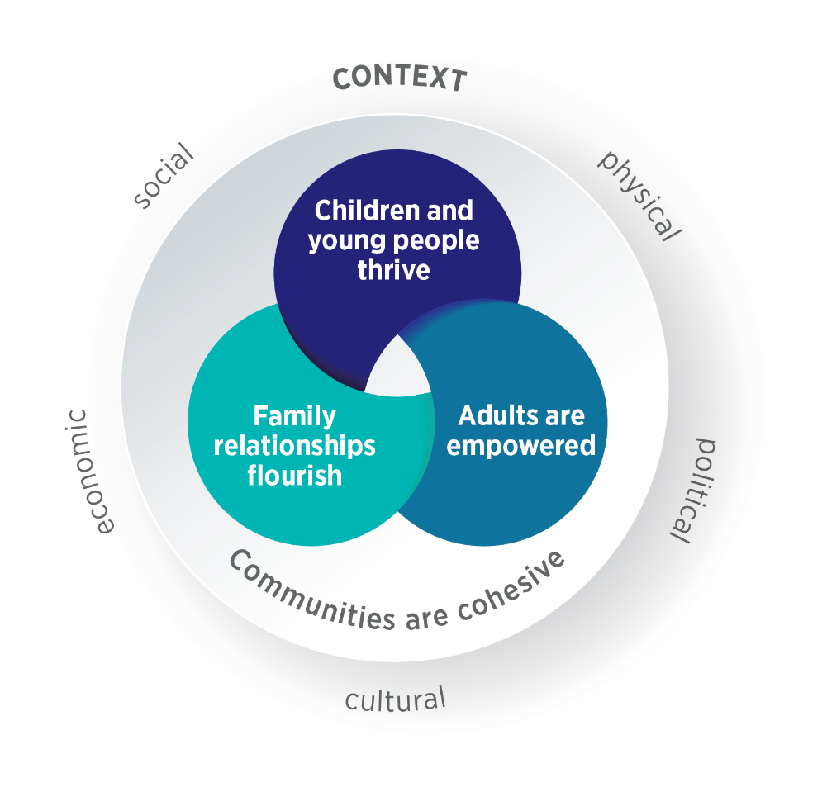

AIM: CHILDREN AND YOUNG PEOPLE THRIVE | AIM: ADULTS ARE EMPOWERED
OUTCOMES:  Positive mental health and wellbeing  Increased resilience  Positive relationships  Safe at home and in the community  Strong connections to social supports and community Strong connection to culture  Greater participation in decision making  Positive development  Positive engagement in education and training | OUTCOMES:  Positive mental health and wellbeing  Increased resilience  Positive relationships  Safe at home and in the community  Strong connections to social supports and community Strong connection to culture  Greater participation in decision making  Sense of self-efficacy and confidence
AIM: FAMILY RELATIONSHIPS FLOURISH | AIM: COMMUNITIES ARE COHESIVE
OUTCOMES:  Positive parenting/caregiver practice  Positive caregiver–child relationship  Respectful relationships  Family cohesion  Effective conflict management | OUTCOMES:  Communities are safe  Communities are inclusive  Communities understand issues facing children, young people and families  All community members are able to participate in decision making  Services are accessible and appropriate  Services are safe and inclusive  Services work together to support families

WHAT DO WE MEAN WHEN WE SAY FAMILY?
A family can be made up of anyone a person considers to be their family. Families can include children, but they may not. Family members contribute significantly to the wellbeing of each other and play essential roles in supporting each other through life’s transitions, stresses and celebrations.

WHAT DO WE MEAN WHEN WE SAY CONTEXT?
The context is the physical, social, cultural, economic and political environment that clients are located within. It can influence the extent to which clients’ basic needs, such as stable housing and food security, are met and, in turn, can affect their ability to engage consistently and effectively with services.

Suggested data exchange SCORE

Outcome: Positive mental health and wellbeing |  | Outcome: Strong connections to social supports and community
Circumstances SCORE  - Mental health, wellbeing and self-care  SCORE Translation Matrix  - Strengths and Difficulties Questionnaire |  | Circumstances SCORE  - Community participation and networks  SCORE Translation Matrix  - Personal Wellbeing Index

Outcome: Increased resilience |  | Outcome: Strong connection to culture
Circumstances SCORE  - Mental health, wellbeing and self-care |  | Circumstances SCORE  - Mental health, wellbeing and self-care  - Community participation and networks

Outcome: Positive relationships |  | Outcome: Greater participation in decision making
Circumstances SCORE  - Mental health, wellbeing and self-care  - Family functioning |  | Circumstances SCORE  - Community participation and networks

Outcome: Safe at home and in the community |  | Outcome: Positive development
Circumstances SCORE  - Personal and family safety  SCORE Translation Matrix  - Child neglect index  - Personal Wellbeing Index |  | Circumstances SCORE  - Age-appropriate development  SCORE Translation Matrix  - Strengths and Difficulties Questionnaire

Outcome: Positive engagement in education and training
Circumstances SCORE
- Education and skills training

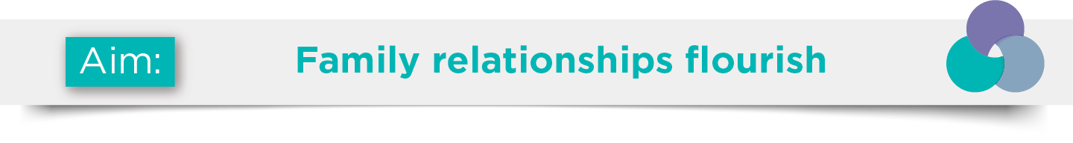
Outcome: Positive parenting/caregiver practices |  | Outcome: Family cohesion
Circumstances SCORE  - Family functioning  SCORE Translation Matrix  - Parental Empowerment and Efficacy Measure |  | Circumstances SCORE  - Family functioning

Outcome: Positive caregiver–child relationship |  | Outcome: Effective conflict management
Circumstances SCORE  - Family functioning |  | Circumstances SCORE  - Family functioning  - Personal and family safety

Outcome: Respectful relationships
Circumstances SCORE
- Family functioning
- Personal and family safety

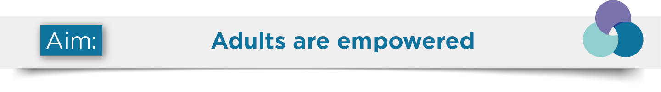
Outcome: Positive mental health and wellbeing |  | Outcome: Positive mental health and wellbeing
Circumstances SCORE  - Mental health, wellbeing and self-care  SCORE Translation Matrix  - Carers Star  - Edinburgh Postnatal Depression Scale  - Growth Empowerment Measure  - Kessler Psychological Distress Scale (K10)  - Outcome Rating Scale |  | Circumstances SCORE  - Community participation and networks  SCORE Translation Matrix  - Personal Wellbeing Index  - Parental Empowerment and Efficacy Measure

Outcome: Increased resilience |  | Outcome: Strong connection to culture
Circumstances SCORE  - Mental health, wellbeing and self-care  SCORE Translation Matrix  - Edinburgh Postnatal Depression Scale  - Growth Empowerment Measure  - Kessler Psychological Distress Scale (K10) |  | Circumstances SCORE  - Mental health, wellbeing and self-care  - Community participation and networks

Outcome: Positive relationships |  | Outcome: Greater participation in decision making
Circumstances SCORE  - Family functioning  - Mental health, wellbeing and self-care |  | Circumstances SCORE  - Community participation and networks

Outcome: Safe at home and in the community |  | Outcome: Sense of self-efficacy and confidence
Circumstances SCORE  - Personal and family safety  SCORE Translation Matrix  - Personal Wellbeing Index |  | Circumstances SCORE  - Mental health, wellbeing and self-care  SCORE Translation Matrix  - Personal Wellbeing Index  - Parental Empowerment and Efficacy Measure

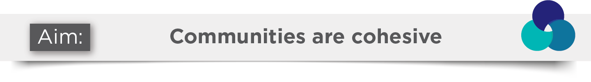
Outcome: Communities are safe |  | Outcome: All community members are able to participate in decision‑making
Community SCORE  - Social cohesion  - Group/community knowledge, skills, attitudes and behaviours  - Community infrastructure and networks to better respond to needs |  | Community SCORE  - Community infrastructure and networks  - Social cohesion

Outcome: Communities are inclusive |  | Outcome: Services are accessible and appropriate
Community SCORE  - Social cohesion  - Group/community knowledge, skills, attitudes and behaviours |  | Community SCORE  - Organisational knowledge, skills and practices  - Community infrastructure and networks to better respond to needs

Outcome: Communities understand issues facing children, young people and families |  | Outcome: Services are safe and inclusive
Community SCORE  - Group/community knowledge, skills, attitudes and behaviours |  | Community SCORE  - Organisational knowledge, skills and practices

Outcome: Services work together to support families
Community SCORE
- Group/community knowledge, skills, attitudes and behaviours

