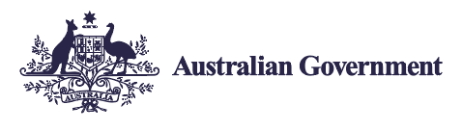
Employ My Ability
Your community is
your customer.

Did you know that building a team of staff that reflects the diversity of your community is likely to lead to greater customer satisfaction and loyalty?
- 4.4 million people in Australia live with disability. This is a big customer base.
- Your business, your clients and your community all benefit when you hire a person with disability.

See how easy it is to find the right person for the job by visiting the JobAccess website or by calling 1800 464 800.

