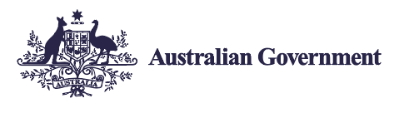
Employ My Ability
Interested in employing a person with disability?
Don’t know where to start?
People with disability have unique perspectives and abilities. Teams are stronger and workplaces are richer when they include members with different abilities.
- One in six Australians live with disability and over 110,000 are actively looking for work.
- It’s easy to make your recruitment processes more inclusive.
- The Australian Government provides free, expert support to help identify and remove barriers to employing people with disability.
This includes an advice service, employer engagement team, workplace modifications, support and training… and much more.
Find out more by visiting the JobAccess website or by calling 1800 464 800.

