Vanguard Laundry - An audience for change
Vanguard Laundry is a social enterprise that was launched in late 2016 to help people with a lived experience of mental health to access employment opportunities. The organisation operates a commercial laundry in Toowoomba, Queensland and works with other local community organisations supporting people with a lived experience of mental health to identify potential staff members (known as ‘target staff’).
Vanguard provides career development to target staff, many of whom have been out of the workforce for long periods of time, or have experienced difficulties in working due to mental ill health. The ultimate aim of Vanguard is to support target staff to transition to paid employment opportunities with other organisations.
In its three years of operation, Vanguard has provided employment to around 80 target staff with 33 of these employees transitioning to study or other employment.

Measuring outcomes and impact
As a new social enterprise, Vanguard raised over $7 million in funding to support the capital and operational costs of establishing a new laundry enterprise, including career development support to help achieve their social outcomes. The organisation needed a strong focus on outcome and impact measurement (OIM) to support access to this funding and to further validate the success and sustainability of its business model. Vanguard were successful in attracting philanthropic funding to engage an external evaluator (Centre for Social Impact Swinburne) to report on the organisation’s outcomes and impacts across its first three years.
The evaluation used both qualitative and quantitative data to report on outcomes in four areas:
- People – improved health and wellbeing and improved long-term economic participation
- Place – more socially inclusive communities and a stronger local economy
- Profits – surplus to reinvest and development of a model that can be expanded or replicated
- Policy – better policy for social and economic inclusion.

Audience for OIM
The three-year evaluation of Vanguard Laundry provided the organisation with a breadth and depth of information to be able to tell the story of their impact and outcomes. This ranged from the demographic profile of target staff through to changes to the income support payments target staff receive and their improved health and wellbeing.
The first three years of operation required a significant focus on attracting and sustaining funding to help support the financial sustainability of the business and to allow for a focus on social outcomes for target staff. Vanguard does however have ambition to scale its impact through growth of its existing Toowoomba business as well new sites in other areas. To raise further capital needed to expand, it is important that the evaluation’s OIM focus is on telling a detailed story of the organisation’s social impact and outcomes. This information is critical to demonstrate Vanguard’s ability to create and grow impact which could then be used to source further funding for business expansion.

While funders were a key audience for the OIM activity, one of the key strengths of the evaluation was the ability to provide high-level information on Vanguard’s outcomes and impact to a number of different audiences as detailed below:
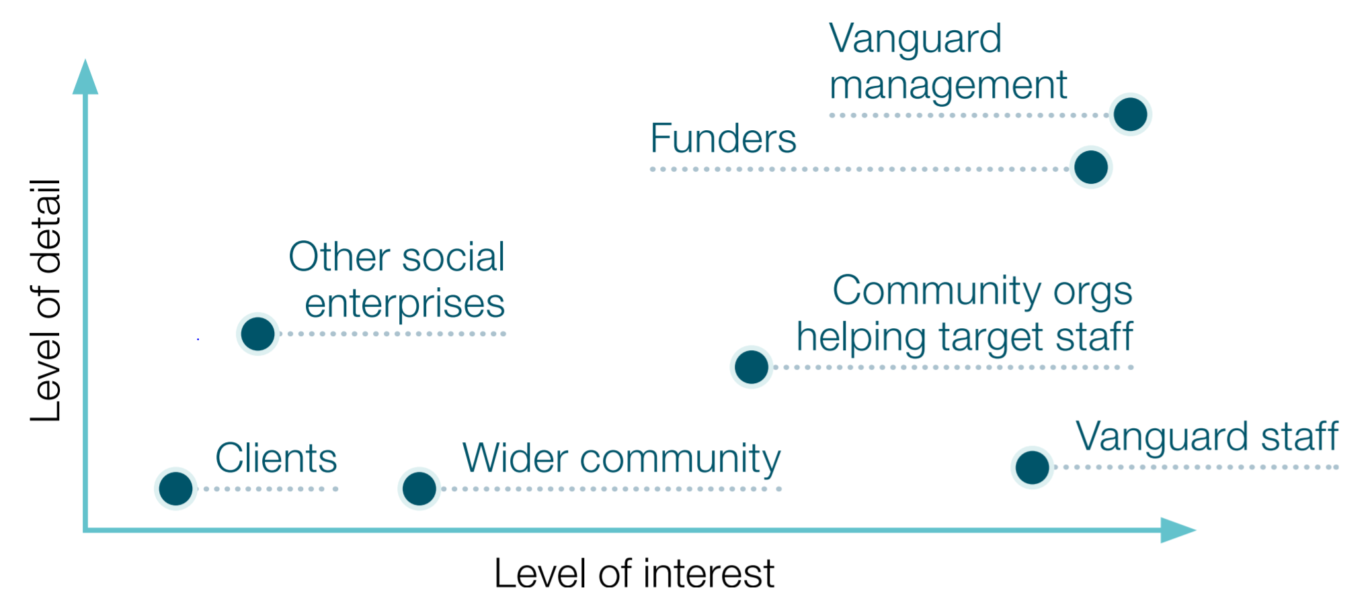
The evaluation was able to provide valuable information across these varied audiences due to rigorous methodology that provided differing levels of detail and identified relevant tangible outcomes for these different stakeholder groups.
For further insights and learnings visit dss.gov.au.
This case study was funded by the Department of Social Service (DSS) to provide information to the social impact investing sector to better understand, define, measure and communicate their non-financial social outcomes and impact.

