|  |
| --- |
| https://intra.aspac.kpmg.com/sites/AU/marketsandgrowth/pursuittoolkit/BrandRefreshPublicationCovers/block013-p.jpgDigital Work and Study Services Evaluation  For the Department of Social Services  2020 |
| KPMG.com.au |

Disclaimer

#### Inherent limitations

This report has been prepared as outlined in the Introduction section and with Department of Social Services in the contract dated 28 April 2020. The services provided in connection with this engagement comprise an advisory engagement, which is not subject to assurance or other standards issued by the Australian Auditing and Assurance Standards Board and, consequently no opinions or conclusions intended to convey assurance have been expressed.

No warranty of completeness, accuracy or reliability is given in relation to the statements and representations made by, and the information and documentation provided by, Department of Social Services management and personnel consulted as part of the process.

KPMG have indicated within this report the sources of the information provided. We have not sought to independently verify those sources unless otherwise noted within the report.

KPMG is under no obligation in any circumstance to update this report, in either oral or written form, for events occurring after the report has been issued in final form.

#### Third party release

This report is solely for the purpose set out in the Introduction Section and for Department of Social Services information and is not to be used for any purpose not contemplated in contract or to be distributed to any third party without KPMG’s prior written consent.

This report has been prepared at the request of Department of Social Services in accordance with the terms of KPMG’s contract dated 28 April 2020. Other than our responsibility to Department of Social Services, neither KPMG nor any member or employee of KPMG undertakes responsibility arising in any way from reliance placed by a third party on this report. Any reliance placed is that party’s sole responsibility.

#### Accessibility

To comply with the Commonwealth Government’s accessibility requirements, two versions of this Report are available: a KPMG-branded PDF version and a Microsoft Word version. The KPMG-branded PDF version of this Report remains the definitive version of this Report.

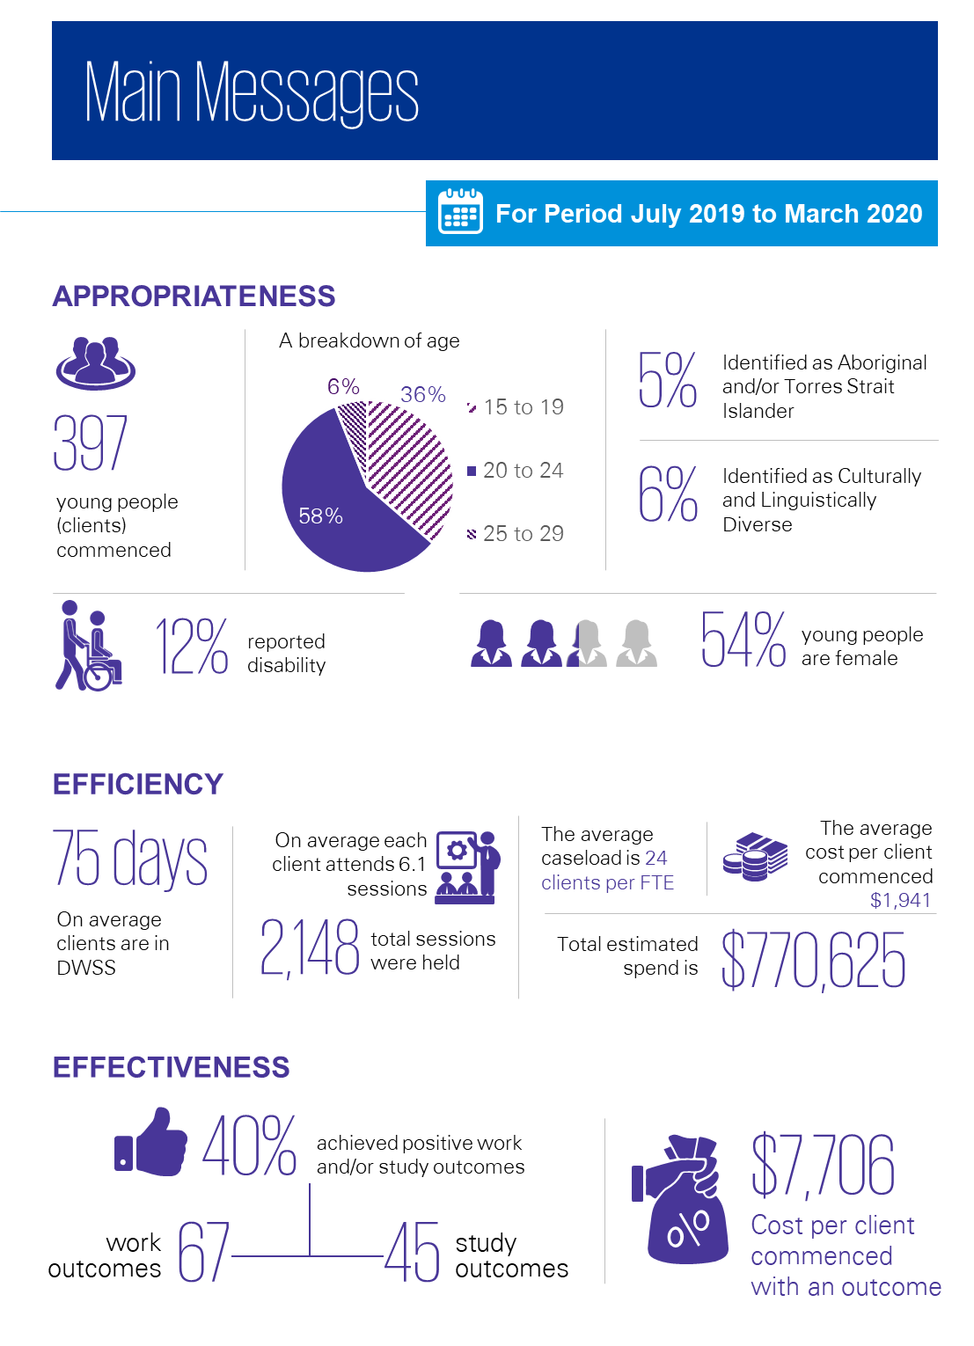

Executive summary

This evaluation report, commissioned by the Department of Social Services (DSS), looks to assess the appropriateness, efficiency and effectiveness of the Digital Work and Study Sessions (DWSS) program delivered by headspace between July 2019 and March 2020 inclusive.0F[1]

The DWSS provides multifaceted supports to young people living in Australia aged 15 to 24, by providing work and study support through a digital platform. The supports provided work to increase the extent to which young people seek, attain and maintain work and study outcomes. Priority access is offered to young people in targeted regional and remote locations, Indigenous young people and school leavers.

The headspace National Office has been contracted and funded by DSS from July 2019 to July 2021 to deliver the DWSS. headspace delivering agencies are responsible for the delivery of the Individual Placement and Support (IPS) Trial, which the DWSS is designed in line with. Both the IPS Trial and DWSS share common key principles centred on supporting young people in their vocational goals whilst also supporting their mental health needs, while providing collaborative care with relative clinical supports.

For this evaluation, the key information source is the analysis of the DWSS program data, with review of a number of documents documents to understand the delivery of the service. This data and documentation was then analysed against a series of questions designed to assess the appropriateness of the DWSS, the efficiency of service delivery and effectiveness of supports provided. Client-level data was analysed for the period July 2019 to March 2020, clients who were considered active in the program at 1 July 2019 were excluded from the data set. Discussion with DWSS staff was limited to discussions to further understand the data, and interviews with staff, clients and other stakeholders was out of scope for the evaluation.

The DWSS service model

The DWSS service model was designed in line with the eight core IPS practice principles that were adapted to best suit the target group and delivery method of DWSS. The DWSS aims to increase the extent young people who access the service:

* Understand their work and/or study goals
* Know how to reach their work and/or study goals
* Are equipped to reach and maintain their work and/or study goals
* Are equipped to understand and manage vocational and non-vocational barriers impacting on their capacity to achieve their work and study goals.

Delivered via a digital platform, the DWSS leverages already established eheadspace infrastructure with the capability to provide information and support through:

* Asynchoronous1F[2] email
* Content hosting
* Secure data transfer
* Synchronous chat
* Telephone assistance
* Video conferencing.

Access to the DWSS is either through referral from a headspace service or accessed directly through the headspace website without referral.

DWSS records a range of client work and study outcomes including:

* Gained work or study,
* Changed work or study,
* Increased work or study hours,
* Obtained placement, volunteer placement or job taster; and
* Resolved work or study at risk.

Key evaluation findings

From July 2019 to March 2020, there were 397 young people who commenced in the DWSS. The most common age group of clients were 15 to 24 years of age. The majority of clients were female, as is representative of headspace services as a whole. Some clients identified as Aboriginal and/or Torres Strait Islander, culturally and linguistically diverse (CALD) or living with disability; however, these groups did not represent a substantial proportion of clients.

Many clients agreed in the 2018 survey conducted by headspace that the DWSS provided services in line with their wants and needs, as well as accessing the appropriate amount of support. The few eligibility requirements and ability to remain anonymous was well accepted, and enabled access to the DWSS. Respondents further expressed that they were supported when pursuing their goals and that those supports increased their self-confidence in attaining their goals.

The time limited nature of the service was evident, with clients remaining engaged on average for 75 days (for clients who commenced and exited DWSS during the evaluation period). This was slightly less than described in the “service model/contract” in which it was expected clients would remain engaged for three months, equating to approximately 90 days. During the DWSS support episodes clients participated in an average of 6.1 sessions each.

Work sessions were the most commonly accessed services by clients, with the majority of clients accessing at least one work session, indicating young people in the DWSS have a greater interest in employment than education. Additional services provided to clients were more numerous than the work and study sessions. This was demonstrated through there being 3.6 instances of an additional service provided for every one work or study session, and this was consistent across the entire evaluation period. This suggests that, in order for clients to achieve their work and/or study goal, they need a number of additional supports and services provided to them.

The contract with DSS states that the target client number for the DWSS is 175 young people every six months across eight FTE (which equates to a target caseload of less than 15 clients per FTE). With 397 client commencements across the evaluation period, the DWSS exceeded the contracted target number of clients. This may be in part be attributed to clients being engaged for a shorter period than the expected average (75 days on average rather than around three months) and a reduced average service intensity than in the early implementation of the DWSS (6.1 sessions per client, down from 8.4 sessions per client).

For the evaluation period, there were approximately six FTE work/study specialists providing services to clients, with an expected caseload of 25 clients each. This expected caseload of 25 was achieved in the latter part of the evaluation period.

Considering the average sessions delivered by the work/study specialists on a daily/weekly basis and the average session duration, it indicates that there may be capacity for caseload to be increased. Currently, a DWSS work/study specialist delivers, on average, just over two work and study sessions per day that last 60 minutes or less. Therefore, it may be that, given the FTE number and with an increased client load, the capacity to increase the number of young people that access the DWSS exists.

During the evaluation period, 40 per cent of clients self-reported that they have been successful in achieving a positive work and/or study outcome. These outcomes were most prominent in work, with the most common outcome being clients attaining work, including those who gained an apprenticeship or traineeship. Study was not as prominent within the outcomes achieved.

The client survey further demonstrated that the DWSS helped young people achieve their goal, improve their optimism and confidence whilst also assisting to develop the skills to achieve their goals. This saw the majority of respondents’ state that their situation regarding work or study had improved along with their “mental health and wellbeing issues” and the impacts relating to their goals.

While underpinned by the same principles as the DWSS, the IPS Trial is delivered in a different manner, with differences including that it is delivered in person, is a time unlimited service that continues to offer support after a vocational outcome is achieved, and has an expectation that 65 per cent of staff time is spent in the community including networking with employers. To account for these differences in service delivery IPS has a lower caseload than the DWSS, with each IPS Trial Vocational Specialist having a caseload of 20 at any one time. These differences imply that the IPS Trial would have greater cost base than the DWSS.

In addition, it is worth noting that ‘outcomes’ are not the same in the DWSS and the IPS Trial, with the DWSS including a broader range of outcomes2F[3] compared to the IPS Trial, where for the IPS Trial only work or study commencement is considered an outcome, this means that it is more likely that DWSS will have a greater volume of outcomes compared to the IPS Trial. Vocational Specialists in the IPS Trial are expected to undertake considerable networking with local employers to directly link participants with jobs, therefore it is likely that the IPS Trial has a greater ability to be effective in achieving vocational outcomes. In addition, the client cohorts of each program may also be different (e.g. those accessing an online program compared to a face-to-face program may have different motivations and barriers to finding work or study) and analysis could not be undertaken on the basis of a matched cohort. As such, direct comparison of the two programs in terms of outcomes and costs should be undertaken in light of these factors.

For the same July 2019 to March 2020 period, 40 per cent of DWSS clients achieved a work and/or study outcome, in comparison to the IPS Trial that saw 39 per cent of participants achieve a work and/or study outcome.3F[4] When considering only work commencement outcomes for the two programs, 21 percent of DWSS clients achieved an outcome compared to 26 per cent of IPS Trial participants.

Considering the proportion who achieved outcomes, and that the notional spend for the DWSS and the IPS Trial was approximately $770,625 and $2,854,284, respectively for the period, the cost per client commencement and cost per client with an outcome for the DWSS is less in comparison to the IPS Trial. With the cost being:

* $1,941 per client commencing for DWSS compared to $4,887 per participant for the IPS Trial
* $7,706 per client with a work or study outcome for DWSS compared to $12,410 per participant with a work or study outcome for the IPS Trial
* $14,820 per client with a work only outcome for DWSS compared to $18,180 per participant with a work only outcome for IPS Trial.

Given that the analysis could not be undertaken on a matched cohorts basis, it cannot be determined whether the differences in cost is a ‘true’ difference or is due to a difference in the types of client that participates in each of the services.

Contents

Executive summary iv

Glossary of terms viii

1 Introduction 1

1.1 Purpose and scope 1

1.2 Structure of this report 1

2 The DWSS 3

2.1 Funding 3

2.2 Underpinning service model 3

2.3 The DWSS model 3

2.4 Previous evaluations 5

2.5 Program logic 5

2.6 The IPS Trial 7

3 Evaluation overview 10

3.1 Purpose and scope 10

3.2 Evaluation questions 10

3.3 Methods and data sources 11

3.4 Limitations 12

4 Appropriateness 14

4.1 Client characteristics 14

4.2 Clients’ perspectives on appropriateness 18

5 Efficiency 20

5.1 Client engagement with the DWSS 20

5.2 Caseload 24

5.3 Funding and costs 28

6 Effectiveness 29

6.1 Work and study outcomes 29

6.2 Other outcomes 33

7 Summary of findings 35

Appendix A : IPS Trial costing calculations 38

Appendix B : Reference list 41

Glossary of terms

|  |  |
| --- | --- |
| **Key Term** | **Definition** |
| CALD | Culturally and Linguistically Diverse |
| DES | Disability Employment Services |
| DEX | DSS Data Exchange |
| DSS | Department of Social Services |
| DWSS | Digital Work and Study Service |
| FTE | Full time equivalent |
| IPS | Individual Placement and Support |
| MDS | Minimum Data Set |
| PRT | Program Reporting Tool |
| DoH | Department of Health |

# Introduction

KPMG has been engaged by the Commonwealth Department of Social Services (DSS) to undertake a desktop evaluation of the Digital Work and Study Service (DWSS) delivered by headspace.

The DWSS works to provide multifaceted support to young people aged 15 to 24 across Australia through the provision of work and study support via a digital platform. These supports work to increase the extent to which young people seek, attain and maintain work and study.

Designed in line with the key principles of the Individual Placement Support (IPS) model, the DWSS seeks to support young people’s work and study needs, while undertaking collaborative care with clinical supports.

## Purpose and scope

The purpose scope of the evaluation is to determine if the digital medium is an appropriate, effective and efficient way to provide employment support services and for which cohorts in comparison of face-to-face supports, namely the Individual Placement and Support Trial. Centred on a quantitative desktop approach of pre-existing data, the evaluation seeks to inform the future policy for the delivery of appropriate and targeted vocational assistance for young people experiencing mental health issues. Out of scope for this evaluation is the collection of additional data, including qualitative data, and comparison to services such as jobactive or Disability Employment Services.

This report provides a summary of evaluation findings based on DWSS service delivery between July 2019 and March 2020 inclusive.

## Structure of this report

This Report is structured as outlined in Table 1 below.

Table 1: Overview of Evaluation Report structure

| Section | | Description |
| --- | --- | --- |
| **2** | **The DWSS** | Provides an overview of the DWSS. |
| **3** | **Evaluation overview** | Provides an overview of the evaluation approach, including the methods and information sources that have been used to inform this report. | |
| **4** | **Appropriateness** | Provides commentary on the appropriateness of the DWSS. Specifically, it details the number of young people engaging and participating in the DWSS and their characteristics, and the appropriateness of the DWSS to meet client needs. | |
| **5** | **Efficiency** | Details how efficiently vocational education and employment support is provided through the DWSS. | |
| **6** | **Effectiveness** | Explores the extent to which the DWSS has achieved work and study outcomes for participating young people. | |
| **7** | **Summary of findings** | Provides a summary of evaluation findings by evaluation question. | |
| **Appendices** | | A: IPS Trial costing calculations  B: Reference list | |

# The DWSS

This section provides an overview of the DWSS being delivered by headspace.

## Funding

The DWSS program is an aspect of the National Youth Mental Health Foundation, otherwise known as headspace, which provides vocational support services through a digital platform that incorporates chat, email, telephone and video functions.

The DWSS was initially funded by the Department of Jobs and Small Business (now the Department of Education, Skills and Employment) through the ‘Empowering YOUth Initiatives’ grant from 1 July 2016 to 30 June 2018. Thereafter, the Department of Health provided interim funding to 30 June 2019, before the current funder, DSS, agreed to provide funding for the 2019-20 and 2020-21 financial years. The total funding amount, provided by DSS, for the service is $2.4 million for the two years.

## Underpinning service model

The DWSS was designed based on the eight core practice principles that underpin the IPS model, however it was adapted to support young people through a digital platform. Therefore, it services young people experiencing high prevalence mental health issues, such as anxiety and depression, to access personalised work and study support. These eight principles are (Dartmouth Psychiatric Research Centre 2011):

1. Focus on competitive employment
2. Eligibility based on clients’ choices
3. Integration of rehabilitation and mental health services
4. Attention to clients’ preferences
5. Personalised benefits counselling
6. Rapid job search
7. Systematic job development
8. Time-unlimited and individualised support.

## The DWSS model

The DWSS aims to increase the extent to which young people aged 15-24 years across Australia:

* Understand their work and/or study goals
* Know how to reach their work and/or study goals
* Are equipped to reach and maintain their work and/or study goals
* Are equipped to understand and manage vocational and non-vocational barriers impacting on their capacity to achieve their work and study goals.

The program is accessible to all young people in the age cohort, however those identified in targeted regional locations, Indigenous young people and school leavers are given priority. The service is intended to predominantly support young people with high prevalence mental health issues (depression and anxiety).

The main point of access for young people is through referral by another headspace service, such as a headspace centre or eheadspace. Alternatively, the service can be accessed directly without a referral, such as through the headspace website.

The DWSS delivers work and study support via a digital platform that leverages pre-existing eheadspace infrastructure. The platform enables workers to provide information and work and study support/sessions through:

* Asynchronous email
* Content hosting
* Secure data transfer
* Synchronous chat
* Telephone assistance
* Video conferencing.

These capabilities are leveraged to provide a range of work and study support focused on:

Figure 1: Work and study supports available through DWSS

**WORK SUPPORT**

**STUDY SUPPORT**

* Benefits assistance
* Canvassing/job brokering discussion
* Career planning
* Interview skills
* Job application
* Job at risk counselling
* Job searching
* Mock interviews
* Resume building
* Volunteer work
* Work conditions/rights discussion
* Work experience/mentoring
* Accessing external study assistance
* Career planning
* Course option discussion
* Disability Liaison Unit discussion
* Enrolment discussion/assistance
* Exam stress reduction
* Organisational skills
* Study at risk counselling
* Study skills assistance

Source: KPMG adapted from headspace

In addition, the DWSS works collaboratively with young people’s clinical supports and provides and assists access to clinical support where required.

Support through DWSS is time-limited, with a focus on a distinct timeframe to achieve short-term and longer-term goals. Young people may receive up to two episodes of care, where an episode of care consists of intensive support over a three month period including, at a minimum, a regular fortnightly appointment.

## Previous evaluations

Evaluations of DWSS that have been conducted to date, including:

* External qualitative evaluation by the Department of Jobs and Small Business (now known as the Department of Education, Skills and Employment); and
* Internal evaluation by headspace.

The evaluation has reviewed the available evaluations and has used these to help inform findings where relevant.

## Program logic

Figure 2 overleaf provides the program logic, which was supplied by the DSS.

Figure 2: The DWSS program logic

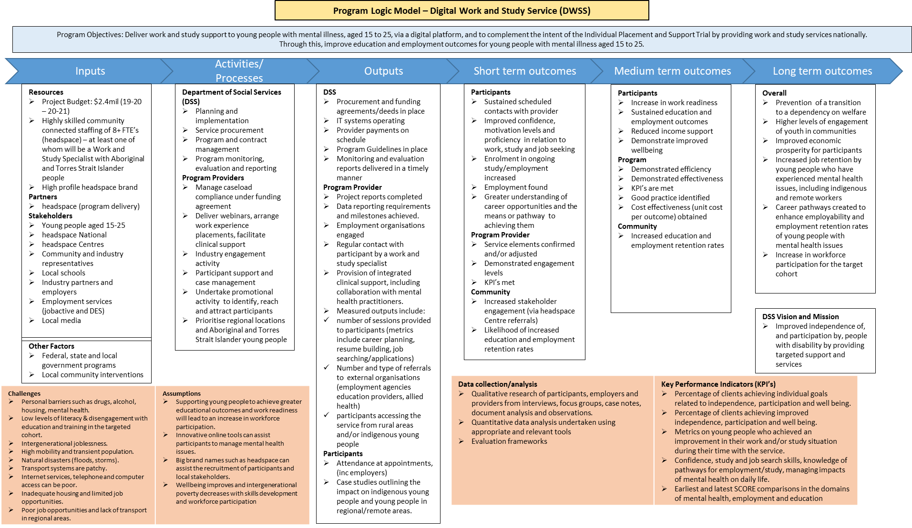

Source: DSS

## The IPS Trial

Delivered by 24 headspace sites across Australia, the primary aim of the IPS Trial (the Trial) is to improve the vocational education and employment outcomes of young people requiring mental health support up to the age of 25 years, who are at risk of disengaging from education or employment and who are at risk of long-term welfare dependency (Department of Social Services 2016). The Trial commenced in 2016 with 14 Trial sites, originally intending to conclude in June 2019. The Trial was subsequently extended until 2021 with an additional 10 sites (Figure 4).

The aim of the Trial is to provide time unlimited vocational education and employment support to participants, with funding for two FTE of Vocational Specialists per site. The Trial is not intended to:

* Replace existing programs or other vocational education assistance provided at each Trial site through other funding arrangements; and/or
* Replace or make participants ineligible to receive support from Disability Employment Services (DES) or jobactive providers.

Traditionally, the IPS model has been offered to people with moderate to severe mental illness, however at headspace, the primary focus is on young people experiencing mild to moderate mental health disorders. Meaning, the Trial target group is designed to reflect the young people accessing headspace services.

DSS is responsible for the management and policy area creation of the trial, including:

* Holding responsibility for the Trial
* Undertaking the initial design of the Trial
* Conducting ongoing management of the Trial.

Figure 3: headspace IPS Trial Sites

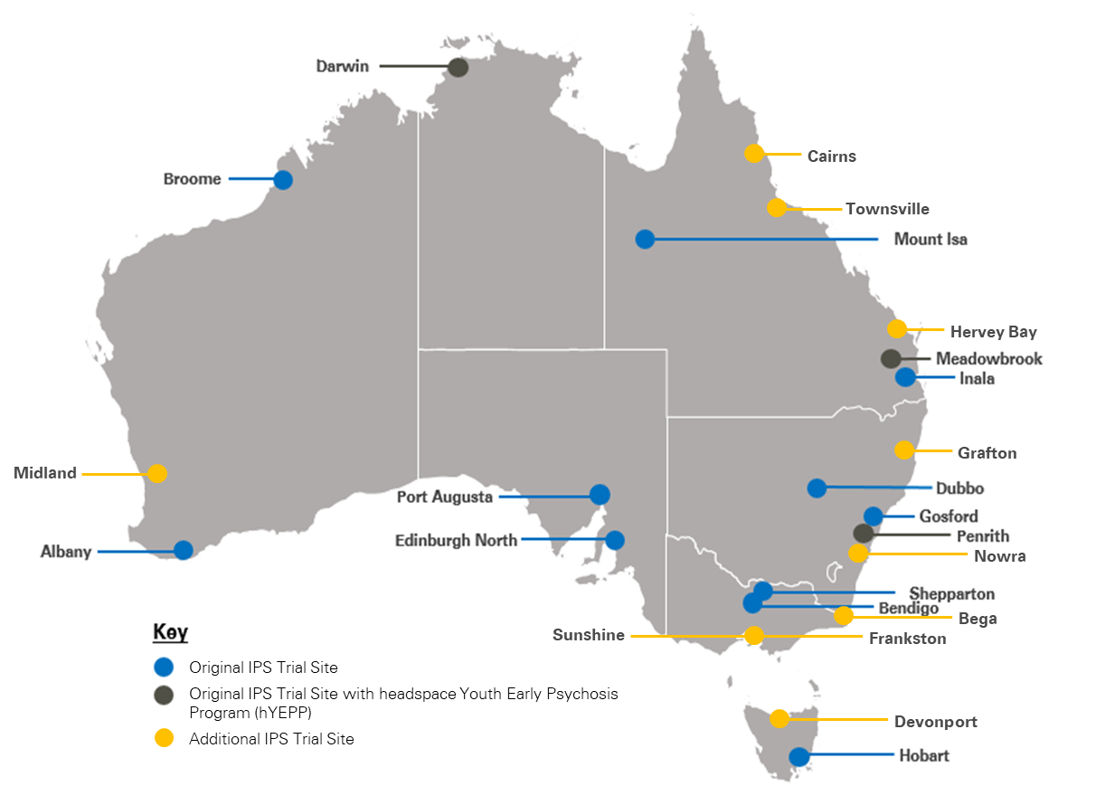

Source: KPMG

### High level comparison of the DWSS and IPS

The table below provides a high level summary of the core components of both the DWSS and the IPS Trial to understand the fundamental elements of each program, how they are similar and how they differ. These differences should be noted when undertaking a comparison of the costs and client outcomes of the two services as this has considerable implications for the costs of these services as well as their ability to influence outcomes for young people.

Table 2: Comparison of the DWSS and the IPS Trial

| Program element | DWSS | IPS Trial |
| --- | --- | --- |
| **Service delivery mode** | Digital | Face-to-face |
| **Access** | Referral through any headspace centre or direct access through website | Referral from host headspace centre |
| **Eligibility** | * Aged 15-24 years * Work and study needs * Priority given to target cohorts (e.g. Indigenous young people, early school leavers, specific locations) | * Aged 12-25 years * Client of host headspace site * Education and employment needs |
| **Coverage** | National | 24 selected headspace centres |
| **Proactive engagement with employers/ potential employers** | No | Yes, target 65 per cent of time in community networking, including at least six face-to-face employer contacts per week |
| **Caseload** | 25 (contracted caseload is approximately15) | 20 |
| **Post-employment support** | Not formally, may occur if young person starts working while still engaged in DWSS | Yes |
| **Length of participation** | Time-limited (around three months) | Unlimited |
| **Integrated with mental health services** | If required | Yes, co-located |
| **Outcomes recorded** | * Gained work or study * Changed work or study * Increased work or study hours * Obtained placement, volunteer placement or job taster * Resolved work or study at risk | Gained competitive education and/or employment. |

Source: KPMG

# Evaluation overview

This section details the purpose, scope, methods and limitations addressed to conduct the evaluation.

## Purpose and scope

The purpose of the evaluation is to determine if the digital medium is an appropriate, effective and efficient way to provide employment support services and to provide a comparison to a face-to-face service, namely the IPS Trial. The evaluation questions presented (see section 3.2) address these evaluation objectives.

The scope of the evaluation is centred on conducting a quantitative desktop review of pre-existing data to inform future policy for the DWSS delivery. Out of scope for this evaluation is the collection of additional data, including qualitative data, and comparison to services such as jobactive or Disability Employment Services.

The evaluation considers DWSS activity from 1 July 2019 to 31 March 2020.

## Evaluation questions

The evaluation will be guided by four over-arching questions and a series of sub-questions, as outlined below (Table 4):

Table 3. Evaluation questions and sub-questions

| Evaluation questions | Sub-questions |
| --- | --- |
| 1. To what extent is the DWSS appropriate for proving employment support services for young people? | How many young people participated in DWSS and what were their characteristics? |
| What are the clients’ perspectives on the appropriateness of DWSS to meet their needs? |
| Is the DWSS appropriate for different subgroups in the program (e.g. younger [under 18 years] vs older [18 to 25 years] clients, Aboriginal and Torres Strait Islander people, CALD)? |
| 1. To what extent is the DWSS efficient in providing employment support services for young people? | How long did young people remain engaged with DWSS? How many sessions, on average, were accessed by young people? |
| What is the average cost per client? |
| What proportion of funding is directed to salaries of the work/study specialists providing employment support? |
| What is the average caseload per work/study specialist? |
| 1. To what extent is the DWSS effective in helping young people achieve education and/or employment outcomes? | To what extent do young people report improved confidence, motivation levels and proficiency in relation to work, study and job seeking? |
| What work and study outcomes were achieved for young people who participated in DWSS? |
| How long did it take for young people participating in DWSS to achieve work and/or study outcomes? |
| 1. To what extent is the Digital Service effective and efficient in achieving education and employment outcomes for young people compared to face to face service? | What education and employment outcomes have been achieved compared to similar cohorts, such as those achieved by the IPS Trial? |
| What is the cost per client compared to the IPS Trial? |
| What is the cost per outcome achieved compared to the IPS Trial? |

Source: DWSS Evaluation Framework

## Methods and data sources

This section provides an overview of the methods and data sources utilised for this evaluation.

### Document review

Documents provided by DSS and headspace national reviewed were:

* The headspace Digital Work and Study Service: Final Evaluation Report (2018)
* headspace Work and Study: Service Update July – December 2019
* Empowering Youth Initiative Evaluation: headspace Digital Work and Study Service qualitative report (August 2018).

### Program data analysis

The evaluation analysed data from four key sources as described below.

#### Minimum Data Set

An Excel data file was examined which provided unit level information for clients’ commencement in the DWSS between 1 July 2019 and 31 March 2020. This dataset provided de-identified record data on:

* Client characteristics on entry to the DWSS
* DWSS session and additional service session data for clients engaged in the DWSS
* Education and employment outcomes achieved while engaged in the DWSS
* Client characteristics on exit of the DWSS.

Data from the Minimum Data Set (MDS) were analysed to understand the extent to which clients engaged with the DWSS during their participation with the program. This analysis also examined the extent to which clients obtained educational or employment outcomes.

It is important to note that this data includes only clients who commenced from 1 July 2019, and therefore does not include data on clients who were accessing the DWSS at this time but commenced prior to this date.4F[5]

#### DSS Data Exchange

DSS Data Exchange (DEX) program data was examined to provide aggregate client demographic data for those engaged with the DWSS. DEX program data provided de-identified aggregate data on:

* Client gender distribution
* Client age distribution
* Client Indigenous status distribution
* Client CALD status distribution
* Client disability status distribution.

#### Program Reporting Tool

A Program Reporting Tool (PRT) was used by Vocational Specialists at IPS Trial sites to capture data on the progress of Trial participants as part of case management practice. The measurement tool collected de-identified unit record data on:

* Education and employment characteristics at entry to the Trial
* Education and employment characteristics achieved while engaged in the Trial;
* Notification that the participant exited the Trial.

The Program Reporting Tool also captured participant demographics.

Data from the Program Reporting Tool was analysed to understand the extent to which Trial participants obtained vocational educational or employment outcomes.

#### Analysis of program financial data

DSS supplied funding information for the DWSS for the 2019-20 period.

DSS also supplied funding information for each of the IPS Trial sites for 2016‑17, 2017‑18, 2018‑19, and 2019‑20.

This financial data was analysed to provide insights into the use of the funding and the cost of each of the programs. The cost of the IPS Trial Fidelity Reviewer was excluded from the aggregate cost of the IPS Trial.

### Survey analysis

The headspace Evaluation Department designed a survey for the DWSS. It covers the following broad domains: work/study impacts; mental health assistance; overall wellbeing; satisfaction; appropriateness of the ‘digital platform’; and appropriateness of core components. The survey was disseminated by headspace at two points:

* Time one: Sent across November/December 2017 to all clients who used the service between August 9, 2016 and November 15, 2017.
* Time two: Sent across December 2018/January 2019 to all clients who used the service between November 16, 2017 and December 4, 2018.

Overall, the survey was sent to 711 clients and saw a response rate of 19 per cent, with 137 responses received.

The survey asked young people to respond to a broad range of questions and the extent to which they agreed or disagreed with the statements. The evaluation was provided with aggregate responses to each of the survey questions.

## Limitations

There are some limitations to the data available for the DWSS Evaluation. Limitations specific to each of the data sources is outlined below.

### Minimum Data Set and IPS Trial Program Reporting Tool

There were some instances of missing data points in the MDS supplied by headspace5F[6] and the IPS Trial Program Reporting Tool. In most cases, the missing data related to client outcomes.

* For the MDS, the clients’ end of service characteristics were considered the most appropriate and complete source of client outcomes data, and for this reason analysis around client outcomes was conducted using this data.
* For the IPS Trial PRT where a date was missing it meant that it difficult to identify the exact number of participants who achieved a positive outcome in the nine month period examined from July 2019 to March 2020.

However, this did not have substantial impact on the overall analysis that was able to be conducted.

The end of service characteristics captured the main change in a young person’s work status, and study status at the end of the client’s time in the DWSS program but did not include the date on which the outcome was achieved. For this reason, the evaluation was not able to calculate how long it took for clients participating in the DWSS to achieve work and/or study outcomes.

The MDS did not include demographic data for DWSS clients. Whilst DEX program data was able to provide demographic data, this could not be linked to the MDS file. For this reason, it was not possible, using the available data, to determine whether outcomes differed for different cohort groups e.g. for males or females. It also meant that demographic comparisons in terms of outcomes between the DWSS and IPS Trial could not be conducted. As a result, the evaluation has considered outcomes at the overall service level for each program only.

### DSS DEX data

There was a discrepancy in the number of DWSS clients based on the client’s age (n=420) compared to the number of clients identified as utilising the service in the MDS data (n=397). This discrepancy only occurred for the client age data sources from DEX.

### Survey data

With surveys, there is a possibility of bias for response rates given a range of factors, the most prominent bias may be non-response bias as 81 per cent of clients did not respond to the survey, and therefore the sample population may not be representative of the DWSS cohort as a whole.

In addition, there is the possibility that positive response bias was evident as a Likert scale was used often leading to overestimation of positive satisfaction (Roberts 2016; in Wolf et al), acquiescence bias as respondents have a tendency to choose positive responses more frequently and demand response bias as clients adopt particular traits as a result of engagement (Nichols & Maner 2010).

These factors should be considering when interpreting responses to the survey. As the evaluation did not administer the survey, we cannot comment on the extent to which these factors may be relevant to this survey.

# Appropriateness

This chapter will consider the appropriateness of the DWSS. Specifically, it considers:

* The number of young people engaging and participating in the DWSS and their characteristics
* The appropriateness of the DWSS to meet client needs.

The appropriateness of the DWSS in engaging specific sub‑groups will be explored to the extent of understanding if those accessing the DWSS are representative of the headspace client cohort and general Australian population.

## Client characteristics

To be eligible to participate in the DWSS, a young person must:

* Receive a referral through any headspace centre or directly access the service through the website
* Be aged between 15 to 24 years inclusive
* Have work or study needs
* Be located in Australia.

Priority access is provided to particular target cohorts, including Indigenous young people, early school leavers, young people with mental health issues and young people in regional and remote locations.

This section provides details on the characteristics of the clients accessing the DWSS.

### Number of clients

A total of 397 young people commenced in the DWSS for a nine month period, from July 2019 to March 2020. For this period, there were an average of 44 commencements per month, with intake numbers fluctuating between 33 and 63 (see Figure 5).6F[7] December saw the lowest number of commencements, however this could be due to limited service days as a result of an office shut down during the holiday period.

Figure 4: DWSS commencing clients and total client numbers by month (July 2019 – March 2020)



Source: KPMG analysis of DWSS MDS data (2020)

The number of young people who accessed the service for the nine month period is proportionally higher than the number of young people who accessed the service over the first two years of operation. A previous headspace evaluation of the DWSS, *The headspace Digital Work and Study Service: Final Evaluation Report* (previous evaluation), identified that in the first two years of operation, from August 2016 to June 2018, a total of 604 young people accessed the service (where FTE was higher with 9.2 FTE, consisting of work/study specialists and one FTE clinical role). This may be as a result of less clients than expected due to the infancy of the service at the time, and the limited relationship with headspace centres, who were a key referral source.7F[8]

The number of work and study specialists was six FTE for the 2019‑20 period  however the headspace representative stated that this number fluctuated over time  and one FTE intake worker. Therefore, variations in the number of client commencements and in client numbers over time may be partially attributed to turnover in staff.

#### Age of clients

The age of clients was recorded for 4208F[9] young people and, of these, the majority were aged from 20 to 24 years (n=240, 57 per cent), inclusive. Refer to Table 5 below.

Table 4: Age distribution of DWSS clients

| Client age (5 year intervals) | Number of clients | Percentage of clients |
| --- | --- | --- |
| 15 to 19 | 153 | 36% |
| 20 to 24 | 240 | 57% |
| 25 to 29 | 27 | 6% |
| **Total** | **420** | **100%** |

Source: KPMG analysis of DWSS DEX data (2020)

The data shows that the DWSS engaged with a greater percentage of clients who fell within the target 15 to 24 year age bracket (n=393, 94 per cent) compared to the previous evaluation of 86 per cent (ages 15 to 23 inclusive). This demonstrates that some young people who are serviced are older than the prescribed age range of 15 to 24. Based on this desktop review, the evaluation is unable to comment as to the reasons for the inclusion of young people outside of the target age group.

The majority of clients aged 15 to 24 aligns with school leaving and post-school education aged cohorts, and therefore it is not surprising that there is strong engagement from this age group. In addition, there is alignment to the age of young people accessing headspace, with 66 per cent of young people aged from 15 to 23 inclusive, while the same age cohort represented 76 per cent of young people accessing eheadspace services (headspace 2019).

#### Aboriginal and/or Torres Strait Islander clients

Overall, 5 per cent of young people who engaged with DWSS identified as Aboriginal and/or Torres Strait Islander (Table 6), which is greater than in the Australian population aged 15 to 24 according to 2018 ABS data, which is 4.1 per cent. This demonstrates that in comparison to the population, Aboriginal and/or Torres Strait Islander young people are well represented in DWSS.

Table 5: Indigenous status distribution of DWSS clients

| Indigenous status | Number of clients | Percentage of clients |
| --- | --- | --- |
| Aboriginal and/or Torres Strait Islander | 19 | 5% |
| Not Indigenous | 378 | 95% |
| **Total** | **397** | **100%** |

Source: KPMG analysis of DWSS DEX data (2020)

The proportion of Aboriginal and/or Torres Strait Islander young people accessing the DWSS is below the headspace national average of 9 per cent, but greater than the eheadspace average of 4 per cent.

This is only marginally higher than the 4 per cent of Aboriginal and/or Torres Strait Islander young people who accessed DWSS in the first two years.

#### Culturally and Linguistically Diverse clients

Six per cent of clients identified as CALD (refer to Table 7), which is lower than the Australian population, where 21 per cent of residents do not speak English at home and English is not the first language of 15 per cent of the population (Australian Institute of Health and Welfare 2018).

Table 6: CALD status distribution of DWSS clients

| CALD status | Number of clients | Percentage of clients |
| --- | --- | --- |
| CALD | 374 | 6% |
| Not CALD | 23 | 94% |
| **Total** | **397** | **100%** |

Source: KPMG analysis of DWSS DEX data (2020)

The percentage of CALD clients who accessed the DWSS is proportionally the same as the CALD cohort who accessed eheadspace (6 per cent) but is less than the percentage of headspace clients who were CALD (10 per cent).

This may be as a result of stigma towards mental health, services and providers in some CALD communities preventing a young person from engaging, as is often common with mental health services (Mental Health in Multicultural Australia 2014).

#### Gender of clients

Approximately half of DWSS clients were female (n=213, 54 per cent), and approximately one‑quarter identified as male (n=99, 25 per cent). The remainder identified as not stated/inadequately described or intersex/indeterminate. See Table 8 for details.

Table 7: Gender distribution of DWSS clients

| Gender | Number of clients | Percentage of clients |
| --- | --- | --- |
| Male | 99 | 25% |
| Female | 213 | 54% |
| Intersex / indeterminate | 16 | 4% |
| Not stated / inadequately described | 69 | 17% |
| **Total** | **397** | **100%** |

Source: KPMG analysis of DWSS DEX data (2020)

Both headspace and eheadspace had a greater proportion of females (60 per cent and 78 per cent respectively) than males (38 per cent and 18 per cent respectively) in FY2018/19 (headspace 2019). This suggests that the gender of clients who accessed the DWSS was proportionate to that of headspace for both males and females, when excluding non-responses. Meanwhile, the number of young people accessing the DWSS who identify as intersex/indeterminate is slightly greater than the broader cohort accessing headspace and eheadspace. This may be as a result of gender diverse individuals facing unique barriers to accessing in person services, with it being suggested that tailored digital mental health interventions may be appropriate in addressing these barriers (Strauss et. al. 2019).

A greater number of females accessing services compared to males may be as a result of women being more likely than males (22 per cent for females compared to 18 per cent for males) to have experienced mental and behavioural conditions (Australian Bureau of Statistics 2019). Additionally, research demonstrates that women are more likely to seek assistance from mental health professionals than men, possibly as a result of greater psychological openness (Mackenzie et. al. 2007). This means it is more likely that a greater number of females would access headspace than males to receive mental health services (Australian Bureau of Statistics 2019). This may also be as a result of females aged 20 to 24 being more likely than males (29.7 per cent compared to 21.1 per cent) to not be fully engaged with education and/or employment (Australian Bureau of Statistics 2019).

#### Disability status of clients

Almost one-eighth of clients identified as having a disability, compared to just over one‑quarter stating they did not have a disability. The remainder (n=245, 62 per cent) did not state their disability status. Table 9 below provides this data. Due to the large number of clients where their disability status was not stated, the evaluation cannot draw comparisons to other headspace services or the Australian population.

Table 8: Disability status distribution of DWSS clients

| Disability status | Number of clients | Percentage of clients |
| --- | --- | --- |
| Has a disability | 49 | 12% |
| Does not have a disability | 103 | 26% |
| Not stated | 245 | 62% |
| **Total** | **397** | **100%** |

Source: KPMG analysis of DWSS DEX data (2020)

In 2018, it was reported that 17.7 per cent (9.3 per cent aged 15 to 24) of the Australian population live with disability and, of those, 23.2 per cent have a mental or behavioural disorder as their primary condition (Australian Bureau of Statistics 2019). Of people with disability, it has been identified that:

* 59 per cent over the age of 15 receive income support as their main source of income
* 53 per cent aged 15 to 64 participate in the labour force
* 90 per cent of school-age children with disability attend school (Australian Institute of Health and Welfare 2019).

Therefore, it is appropriate that people with disability are supported to find education and/or employment. However, it is noted that there may be additional needs and challenges that need to be addressed compared to people who do not have disability. These include differing workplace arrangements, discrimination, employment and education restrictions and social difficulties (Australian Institute of Health and Welfare 2019).9F[10]

## Clients’ perspectives on appropriateness

This section explores the views and perspectives of young people who accessed the DWSS based on the findings from the *headspace Work and Study survey* conducted in 2017‑18.

### Access to the DWSS

Overall, clients held a positive view of their ability to access the DWSS, with positive sentiments reiterated with the number of responses that agreed or strongly agreed with a statement in this regard.

In line with the DWSS design and the fundamental concepts behind the model design, almost all respondents agreed or strongly agreed (96 per cent) that the DWSS is open to everyone with only a few eligibility requirements, in addition to being voluntary (86 per cent agreed or strongly agreed).

Respondents also expressed that it is appropriate for young people aged from 15 to 24 years to access the service (94 per cent agree or strongly agree). With the ability to access the service as much or as little as they want (90 per cent agree or strongly agree), with the option to also remain anonymous (80 per cent agree or strongly agree). These results also align with the findings reported in the headspace Digital Work and Study Service qualitative report.

This aligns to research that highlights that with advancements in technology there is the potential for young people to be more likely to engage and actively participate as a result of reduced barriers to access (Lord et al. 2014).

### Supports provided by the DWSS

Clients of the DWSS felt supported in pursuing their work and study goals (89 per cent) and 86 per cent received the support they wanted, including:

* Identification of goals (86 per cent)
* Increased confidence in completing interviews and applications (83 per cent)
* Felt confident in achieving their work and study goals (81 per cent)
* Felt confident in managing their work or study situation going forward (77 per cent).

One young person stated in their response that they “…liked how casual, yet professional, the staff [they] have spoken to have been. It allows some chatter, but also stays on topic and focuses the tasks at hand.” This feedback demonstrates that the service provided by the DWSS aligned with the expectations held by those who responded to the survey, and that their confidence increased in their journey to work or study.

### Intensity of contact with the DWSS

In general, clients believed the amount of contact they had with DWSS was appropriate for the program, with clients agreeing or strongly agreeing they had:

* the right amount of contact (82 per cent)
* Not enough contact (14 per cent)
* Too much contact (4 per cent).

This supports the principle that the service be driven by young people and is flexible in their support approach.

# Efficiency

This chapter considers the efficiency of the DWSS. Specifically, it considers:

* The length of time young people remained engaged with DWSS and the intensity of engagement
* The average caseload per specialist
* The average cost per client
* The proportion of funding dedicated to salaries of work/study specialists.

## Client engagement with the DWSS

This section will explore the services accessed by clients engaged with the DWSS, including the length of engagement and intensity of engagement. The service types available to young people accessing the DWSS include:

Table 9: Description of different service types offered by the DWSS

| Service category | Service Type/Subset | Description |
| --- | --- | --- |
| Additional services | Brief service provision | A short, direct interaction with young people, could be administrative, service access or service support related. Not a full work/study session. |
| Additional services | Indirect clinical service | An indirect session held on behalf of the young person. |
| Clinical services | Counselling support | Direct clinical support for young people, provided by a qualified mental health clinician.10F[11] |
| Work/study services | Career planning | Direct support for young people relating to career planning. This excludes commencement, end of service and post placement sessions. |
| Work/study services | Non-vocational support | Direct support for young people with general aspects of day-to-day life that impact on work/study situation but are not work/study focussed per se. |
| Work/study services | End of service form | Captures a young person’s change in circumstance from beginning to the end of the service period. |
| Work/study services | Post-placement follow-up | Direct support for young people to maintain a work/study placement conducted after achieving an outcome during their time in the service. |
| Work/study services | Study assistance | Direct support for young people relating to study directly. This excludes commencement, end of service and post placement sessions. |
| Work/study services | Work and study assistance | Direct support for young people relating to both work and study assistance concurrently. This excludes commencement, end of service and post placement sessions. |
| Work/study services | Work assistance | Direct support for young people relating to work directly. This excludes commencement, end of service and post placement sessions. |

Source: Adapted from headspace data notes

### Length of engagement

On average, clients remained engaged with the DWSS for a duration of 75 days in the period from July 2019 to March 2020. The minimum number of days a client remained with the DWSS was seven days, and the maximum was 242 days (refer to Table 11 below).

Based on the data, the average client will remain in the service for approximately two months. This aligns with the DWSS model which is a time limited service that allows for two episodes of care, with each episode consisting of intensive support over a three month period.11F[12]

Table 10: Length of engagement of clients with the DWSS

| Reporting period | Average number of days a client remained engaged with the DWSS12F*[13]* | Minimum number of days a client remained engaged with the DWSS | Maximum number of days a client remained engaged with the DWSS |
| --- | --- | --- | --- |
| July 2019 – March 2020 | 75 | 7 | 242 |

Source: KPMG analysis of DWSS MDS data (2020)

The table below (Table 11) shows the number of clients based on the length of their engagement in the DWSS. It shows that more than half of DWSS clients (58 per cent) stay connected to DWSS for between one and three months (31 to 90 days), including just over one quarter between two and three months (61to 90 days). Around 14 per cent of clients remain engaged with the DWSS for 121 days or more. Given that no consultation was undertaken for this evaluation, definitive conclusions as to the reasons for this long engagement cannot be established, however, it could be assumed that these young people may have had more complex needs that required a longer time to address.

Table 11: Number of days in DWSS

|  |  |  |
| --- | --- | --- |
| Time in program (days) | Number of clients | Percentage of clients |
| 1-30 | 33 | 13% |
| 31-60 | 78 | 32% |
| 61-90 | 64 | 26% |
| 91-120 | 37 | 15% |
| 121+ | 35 | 14% |
| **Total** | **247** | **100%** |

Source: KPMG analysis of DWSS MDS data (2020)

### Intensity of engagement

For the period July 2019 to March 2020, there were a total of 2,148 work and study sessions conducted, with an average of 6.1 sessions per client (refer to Table 12 below).

Table 12: Number of work and study sessions provided by the DWSS

| Reporting period | Total work and study support sessions13F*[14]* | Average number of sessions per client | Minimum number of sessions per client | Maximum number of sessions per client |
| --- | --- | --- | --- | --- |
| July 2016 – June 2018 | 5,086 | 8.4 | 1 | 91 |
| July 2019 – March 2020 | 2,148 | 6.1 | 1 | 31 |

Source: KPMG analysis of DWSS MDS data (2020)

The data also shows that clients attended, on average, less sessions than in 2016-18. This is shown in the average number of sessions decreasing from 8.4 to 6.1, while the maximum number of sessions per client decreased from 91 to 31.

Due to the evaluation being limited to a desktop data review, it cannot be concluded why 2016-18 saw greater engagement than the 2019-20 period.

#### Work and study sessions accessed

Work and study sessions are the main type of service offered through the DWSS. In these sessions, the work and study specialists work with young people on addressing their work and/or study goals.

The three most common session types clients attended were:

1. Work assistance (1,301 sessions)
2. Study assistance (200 sessions)
3. End of service (182 sessions).

Work assistance sessions had the greatest number of sessions delivered and greatest number of clients (Figure 6). This service includes delivering assistance such as capacity building sessions, job search sessions and resume reviews. Greater rates of work assistance over other sessions indicates that the majority of clients were interested in achieving a work outcome, rather than a study outcome.

The least common sessions conducted were:

1. Non-vocational support (85 sessions)
2. Career planning (88 sessions)
3. Work and study assistance (142 sessions).

This further emphasises that clients were focused on either work or study when accessing the DWSS, not receiving supports for both at the same time. However, it is interesting to note that career planning is the second least common service, which may indicate that clients have career goals in mind prior to accessing the DWSS, and therefore do not require those services.

Figure 5: Breakdown of work and study sessions held and the number of client who attended at least one session of a given type

*Source: KPMG analysis of DWSS MDS data (2020)*

#### Additional services accessed

In addition to work and study services, the DWSS provides other additional services including brief service provision, counselling support and indirect clinical services. These services focus on providing non-work and study related services for young people, with an emphasis on elements that may impact on a young person’s ability to find employment. These may be done directly with a client or indirectly.

Additional services were accessed by all clients but one, and there was a total of 7,672 sessions held. The most commonly accessed additional service was brief service provision, which accounted for 6,448 sessions, or 84 per cent of additional services provided (refer Table 13). Brief service provision includes a range of activities including appointment scheduling, follow-up for non-engagement or missed appointments, service closures and SMS contact with clients. Based on the data, it highlights that there is the possibility that are high levels of administrative or non-work and study related needs when providing services to clients.

Table 13: Number of additional service provisions provided by the DWSS

| Additional service type | Sessions held | Number of clients who received at least one session14F[15] |
| --- | --- | --- |
| Brief service provision | 6,448 | 396 |
| Counselling support | 25 | 14 |
| Indirect clinical service | 1,199 | 313 |
| **Total** | **7,672** | **397** |

Source: KPMG analysis of DWSS MDS data (2020)

In total, 313 DWSS clients received 1,199 indirect clinical service sessions, including activities such as case review and care planning, care collaboration, liaising with organisations, account reactivation, work and study preparation, referrals, and clinical reviews. Fourteen clients received direct clinical support through the DWSS, thus demonstrating the services were integrated with clinical services for at least 82 per cent of clients.

For every one work or study support session held, there are 3.6 instances of additional service provisions provided to clients, which has remained a relatively constant proportion across each month, as seen in Figure 6. This demonstrates that additional service provisions are far more common in volume than work or study sessions.

Figure 6: Number of work and study services provided, additional services provided, and number of clients commencing per month

Source: KPMG analysis of DWSS MDS data (2020)

## Caseload

This section explores what the average caseload looks like per work/study specialist and seeks to understand the activities completed by specialists in the average week and average day. Note that the data presented in this section are presented either as a collective across all work/study specialists or based on an average of six FTE work/study specialists, as the client data did not identify a particular work/study specialist providing the services to an individual client, which would have allowed for more detailed analysis.

In the contract with DSS there is a target of 175 clients every six months, equating to a caseload of less than 15 clients per specialist.15F[16] According to headspace, work/study specialists operate with a recommended caseload of 25 clients each. Based on an average of six FTE, there should be 150 clients in the DWSS at any one time, greater than the contracted amount. Given this, consideration could be given to increase the target number of clients in future contracts to ensure that the DWSS is operating efficiently.

On average, the client numbers increased from July 2019 to March 2020, with July 2019 to September 2019 experiencing higher growth than the other periods. This may be attributed to DWSS data not including pre-existing clients in these early month totals and subsequently filling these spots with new clients as pre-existing clients exited during this period.

While the DWSS service exceeded the number of target clients as per the contract, it did not quite achieve its desired client numbers based on a caseload of 25 clients, although it was very close to this between December 2019 and March 2020. It is important to note that number of clients and the average caseload figures presented below will not be an accurate representation of full DWSS activity given that clients who commenced before 1 July 2019 are not contained in this data. Given that the average time in the service is expected to be around three months, it should be expected that data from October onwards should present a more accurate picture of service activity.

Figure 7: Client numbers, average caseload and recommended client numbers over time



Source: KPMG analysis of DWSS MDS data (2020)

### Average number of sessions delivered by a specialist

To understand the workload of work/study specialists, the average weekly (Figure 8) and average daily (Figure 9) activity by service type was analysed.

From this analysis, it was found that in an average week the most sessions occur on a Tuesday, with the number of sessions decreasing as the week continues, with the least number of sessions occurring on a Friday (see Figure 8). This holds for both work/study sessions and additional services. Based on available information, it is unknown why this is the case, however, there are a range of factors that may be influencing this such as work/study specialist rostering, internal organisation factors (e.g. timing of team meetings, training etc.), and the preferences of the clients.

Figure 8: Average number of work and study services provided, additional services provided, and number of clients commencing per week

Source: KPMG analysis of DWSS MDS data (2020)

headspace reported that each specialist generally aims to schedule four to five work and study appointments in a day, with the telephone being the most common engagement method for these sessions. When looking at the services provided in an average day, there are two client commencements, 14 work and study sessions and 44 other services provided across the six FTE of work/study specialists. Based on six FTE work/study specialists, on an average day, they will each provide nine services. However, this equates to just over two work and study sessions (including commencements) for each work and study specialist on an average day, less than the four to five sessions reported by headspace.

Figure 9: Average number of work and study services provided, additional services provided, and number of clients commencing per day16F[17]



Source: KPMG analysis of DWSS MDS data (2020)

An analysis of session length shows that, on average, the majority of commencement sessions lasted between 31 and 60 minutes (77 per cent), with less than 7 per cent lasting less than 31 minutes. This means that over 90 per cent of those who completed a commencement session, the session was longer than 30 minutes. In contrast, 94 per cent of additional services provided lasted less than 15 minutes (refer to Table 14 below).

Work and study services demonstrated a greater volume of sessions lasting less than 61 minutes, with the most common session duration being between 31 and 60 minutes (41 per cent). Work and study service sessions lasting longer than 60 minutes were rare, accounting for less than 6 per cent of these session types.

Table 14: Distribution of the duration of commencement sessions, work and study sessions, and additional services provided

| Time bracket | Commencement Sessions17F*[18]* | Work and study services18F*[19]* | Additional services19F*[20]* |
| --- | --- | --- | --- |
| Less than 15 minutes | <1% | 30% | 94% |
| 15 to 30 minutes | 6% | 24% | 4% |
| 31 to 60 minutes | 77% | 41% | 2% |
| 61 to 89 minutes | 14% | 5% | <1% |
| 90 minutes or more | 3% | <1% | 0% |

Source: KPMG analysis of DWSS MDS data (2020)

## Funding and costs

This section details the average cost per client and funding directed to work/study specialists for the duration of the evaluation period.

### Average cost per client

The DWSS notional spend for the period July 2019 to March 2020 was approximately $770,625, with the cost per client commencement equating to $1,941.

It is difficult to directly compare costs related to DWSS and costs related to the IPS Trial as, while they may have similar principles and objectives, they are delivered in fundamentally different ways, as outlined in Table 3 (see page 8). This includes IPS being delivered in person, with vocational specialists needing to spend 65 per cent of their time in the community, IPS vocational specialists have a lower maximum caseload. Given these differences, as expected, the IPS Trial has a greater cost per client of $4,887.

Table 15: Comparison of the number of young people commencing in the DWSS and the IPS Trial between July 2019 and March 202020F[21]

| Statistic | DWSS | IPS Trial |
| --- | --- | --- |
| Notional cost21F[22] | $770,625 | $2,854,284 |
| Number of young people commenced in the program | 397 | 584 |
| Cost per young person commenced in the program | $1,941 | $4,887 |

Source: KPMG analysis of DWSS MDS data (2020)

### Proportion of funding to work/study specialists

According to the Activity Plan agreed between headspace and DSS for funding of the DWSS, 76 per cent of funding is allocated to the salaries and professional development for the employment of eight staff and management to deliver the DWSS.

# Effectiveness

This chapter will consider the effectiveness of the DWSS in helping young people to achieve education and/or employment outcomes. Specifically, it considers:

* The extent young people report improved confidence, motivation and proficiency in relation to work, study and job seeking
* The work and study outcomes achieved by young people who participated in the DWSS
* The length of time it took for a young person in the DWSS to achieve a work or study outcome.

## Work and study outcomes

This section describes the work and study outcomes achieved by the DWSS over the evaluation period.

### Total outcomes achieved

From July 2019 to March 2020, 100 DWSS clients achieved a positive work and/or study outcome, which accounted for 40 per cent of young people who both entered and exited the program during that period. This is less than the 55 per cent of clients who had a positive outcome between August 2016 and June 2018.22F[23] Given that the DWSS is time limited and behaviour of young people to potentially disengage once their goal is achieved, it is possible that clients achieved outcomes that the DWSS has not been able to record.

Work outcomes were the most common, with 67 positive work outcomes achieved, in comparison to 45 study outcomes. This aligns with the fact that DWSS clients were more inclined to pursue work over study, as is supported through the services clients received.

Table 16: Number of positive work/study outcomes achieved by DWSS clients

| Program time frame | Number of clients with a positive work/study outcome23F*[24]* | Percentage of clients who have achieved a positive work/study outcome24F*[25]* | Number of clients with a positive work outcome25F*[26]* | Number of clients with a positive study outcome5 |
| --- | --- | --- | --- | --- |
| July 2019 – March 2020 | 100 | 40% | 67 | 45 |

Source: KPMG analysis of DWSS MDS data (2020)

### Work outcomes

Work outcomes were measured as a main change in work status as according to End of Service Characteristics provided in the end of service form and the types of outcomes as provided in Figure 10.

According to the main change in work status for clients, the majority of the work outcomes (n=42, 63 per cent) were for clients who had gained work, an apprenticeship or traineeship. Meanwhile, almost one‑quarter (n=16, 24 per cent) either gained a better job than the one they had or increased their work hours.

Figure 10: Main change in work status for clients

Source: KPMG analysis of DWSS MDS data (2020)

### Study outcomes

Study outcomes (see Figure 11) were measured using End of Service Characteristics provided in the end of service form, in the same manner as work outcomes.

The main study status change that occurred throughout the evaluation period was the number of clients who began study (n=31, 69 per cent). This was followed by 18 per cent who resolved study at risk, whilst 11 per cent changed to a ‘better’ course/training program.

This demonstrates that for the majority of clients the aim was to enter study or maintain study through changing programs or resolving study at risk.

Figure 11: Main change in study status for clients

Source: KPMG analysis of DWSS MDS data (2020)

### Cost per client with an outcome

As previously mentioned, the notional spend for the DWSS was $770,625. Given that 100 young people achieved a positive work or study outcome, this indicates that the average cost per client achieving an outcome is $7,706.

When considering the cost per outcome of the DWSS compared to the IPS Trial it is important to consider that the nature of the programs are different, meaning that a range of considerations need to be taken into account when comparing the two services. These include:

* The type of young person likely to participate in the DWSS and the IPS Trial may be different given the different modes of access, a greater self-motivation in accessing a digital service.
* Further, given the data available, a direct detailed comparison of cohorts cannot be undertaken, therefore, the analysis is not undertaken on the basis of ‘matched cohorts’.
* The IPS Trial has a longer relationship with its participants, meaning that outcomes are able to be tracked over a longer time period than for DWSS, meaning DWSS is constrained in tracking outcomes once a client exits the service or the sustainment of outcomes compared to the IPS Trial.
* The IPS Trial has a greater ability to directly assist young people into jobs through the employer networking focus of the IPS model.
* Differences in outcomes data, such as the DWSS employment outcomes recording the date of employment and type of employment is recorded differently to the IPS Trial. As a result, direct comparison between outcomes achieved of each program is limited to the number of outcomes only. Further, outcomes in the IPS Trial are narrower in focus, with only new study or competitive employment considered to be an outcome.

The IPS Trial has a notional spend of $2,854,284 and has seen 230 young people achieve a positive work or study outcome (39 per cent). Based on this data, the IPS Trial has a greater cost per client achieving an outcome of $12,410, when any type of outcome in the context of the service is considered (noting that outcomes in the DWSS are broader than the IPS Trial).

Further analysis was conducted to compare similar work outcomes achieved for the DWSS and the IPS Trial. For these calculations, only young people who commenced work or started a better job in the DWSS were counted and only those with a work outcome in the IPS Trial were counted. This shows that 52 clients in the DWSS achieved a work outcome (21 per cent) and 157 clients in the IPS Trial (27 per cent). The cost per client achieving a work outcome for each program is $14,820 and $18,180 for the DWSS and the IPS Trial respectively.

Given the differences in the two programs (refer to section 2.6.1 for details), it is not unexpected that the cost per client with an outcome is greater for the IPS Trial and the DWSS. In considering the comparison of findings between the programs it should be noted that the current study design does not allow clarity in the relative contribution of the service and client characteristics to the outcome achieved.

Table 17: Comparison of the number of young people commencing in the DWSS and the IPS Trial between July 2019 and March 2020 and achieving a positive work or study outcome26F[27]

| Statistic | DWSS | IPS Trial |
| --- | --- | --- |
| Notional cost27F[28] | $770,625 | $2,854,284 |
| Number of young people commenced in the program who achieved a positive work or study outcome | 100 | 230 |
| Cost per client outcome (all outcomes) | $7,706 | $12,410 |
| Number of young people with a work outcome (gain work or gained a better job) | 52 | 157 |
| Cost per client with a work outcome | $14,820 | $18,180 |

Source: KPMG analysis of DWSS MDS data (2020)

### SCORE outcomes

Standard Client Outcomes Reporting (SCORE) is an Australian Government implemented method to allow service providers to measure current and community outcomes using a five-point rating scale to understand what has been achieved from the beginning and end of service delivery to best assess change.

The majority of DWSS clients did not experience a change (51 per cent; see Figure 12) in either their employment, education or skills training and half experienced no change in their mental health, wellbeing and self-care. However, employment saw the greatest positive change amongst the three categories, likely aligning to the number of young people seeking to gain employment, which also aligns with the percentage of positive work/study outcomes achieved (40 per cent).

Education experienced the least positive change (37 per cent) and greatest negative change (12 per cent) of the three areas.

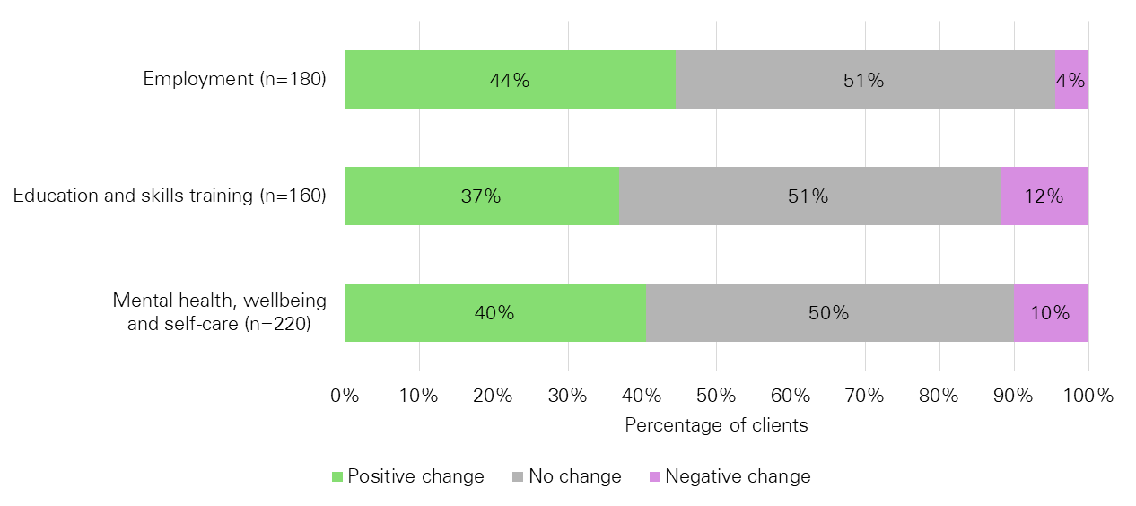Figure 12: Percentage of clients that achieved a positive, negative, or did not achieve a to their SCORE Circumstances ratings

Source: KPMG analysis of DWSS MDS data (2020)

Compared to the client circumstance SCOREs (Figure 12), the Goals ratings (Figure 13) saw more than 50 per cent of clients experience no change or negative change.

The greatest positive change (48 per cent) was observed when referring to changed knowledge and access to information, but also experienced the smallest amount of negative change (8 per cent).

Changed skills had the smallest positive change of the three (see Figure 13), however empowerment, choice and control to make own decision experienced the largest negative change.

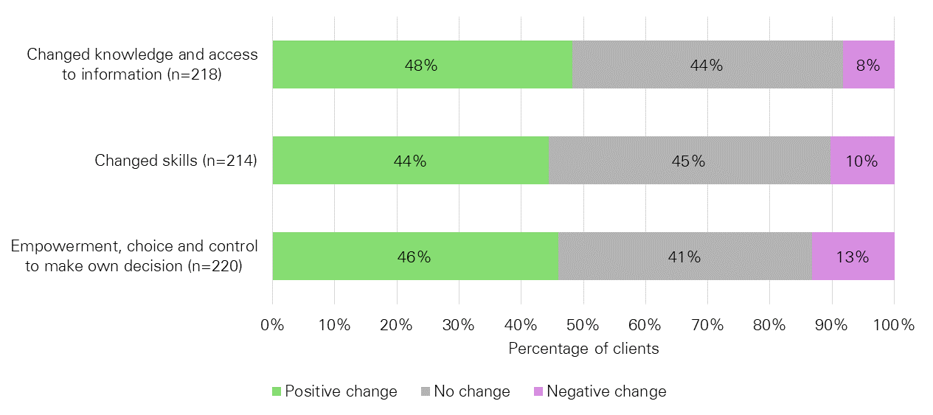Figure 13: Percentage of clients that achieved a positive, negative, or did not achieve a change to their SCORE Goals ratings

Source: KPMG analysis of DWSS MDS data (2020)

## Other outcomes

This section is informed by the client survey conducted by the DWSS.

### Client goal attainment

The DWSS survey asked respondents ‘To what extent did clients agree that working with the headspace Work and Study service provided the following outcomes?’:

* They took steps towards achieving their work/study goal28F[29] (84 per cent)
* They feel more optimistic about their work/study future than before accessing DWSS (82 per cent)
* They gained skills that would assist with their work/study goals (78 per cent).

This demonstrates that the DWSS has supported young people in developing skills and progressing towards their work and study goals.

Survey respondents saw an improvement in their confidence and optimism towards their work and/or study situations and goals, with 84 per cent agreeing or strongly agreeing that they made progress towards achieving their work or study goal through the DWSS. However, there were less respondents who believed the following as a result of working with the DWSS:

* 69 per cent stated their study situation has improved or will improve
* 66 per cent stated their work situation has improved or will improve
* 59 per cent stated they have achieved their work and/or study goals.

Thereby demonstrating that for some respondents while the DWSS support helped them to improve their confidence to find work/study, it did not necessarily result in them improving their work and/or study situation.

### Mental health and wellbeing

Respondents were asked about the extent mental health and wellbeing supports received from DWSS helped them. This revealed that the vast majority of respondents agreed or strongly agreed (85 per cent) that the DWSS helped to realise how their mental health and wellbeing issues was impacting on their work/study situation. In addition, over two‑thirds agreed that the DWSS helped them:

* Feel better equipped to manage their mental health and wellbeing issues (68 per cent)
* Reduce the impact of their mental health and wellbeing issues on their work/study goals (68 per cent)
* Reduce the impact of their mental health and wellbeing issues on their life more generally (67 per cent).

Furthermore, almost three‑quarters felt supported by the DWSS in managing their health and wellbeing issues.

In addition to respondents feeling supported and optimistic about achieving their work and study goals, a general positive attitude was received towards the overall experience with the DWSS as:

* 72 per cent agreed or strongly agreed that they are optimistic about their future
* 66 per cent agreed or strongly agreed that their general wellbeing improved
* 61 per cent agreed or strongly agreed that they are more confident in day to day life.

Regarding connection and social interactions, exactly half agreed or strongly agreed that they are more socially active, just over half agreed/strongly agreed (54 per cent agreed or strongly agreed) they are more connected into their social network, whilst less than half (49 per cent agreed or strongly agreed) believed that they are connected to the broader community.

# Summary of findings

This section provides an overview of findings based on each of the core evaluation questions.

**To what extent is the DWSS appropriate for providing employment support services for young people?**

*The DWSS appears to be appropriate for providing employment support services to young people. The DWSS engaged 397 young people, most aged 15 to 24. According to clients who accessed the service, they felt it was appropriate to their needs.*

The DWSS is intended to be delivered to young people in Australia aged 15 to 24 years inclusive, who have work and/or study needs. In addition, priority access is provided for those who identify as Aboriginal and/or Torres Strait Islander, early school leavers, those with mental health issues and those located in regional and remote locations.

To the extent of eligibility, for the nine month period from July 2019 to March 2020, 397 young people accessed DWSS, with 94 per cent falling within the 15 to 24 year age range, thus demonstrating that the program is appropriate to deliver to young people within the 15 to 24 year age bracket.

In addition, the DWSS saw engagement from young people who identified as Aboriginal and/or Torres Strait Islander and culturally and linguistically diverse, however they did not represent significant proportions of the client cohort. Meanwhile, the client data demonstrated that the DWSS may experience difficulty in recruiting male clients, as well as clients with disability, however, this is in line with headspace services more generally.

The client survey demonstrated that the majority of clients believe that the DWSS is appropriate in delivering services to suit their wants and needs, as well as providing appropriate access that has few eligibility requirements and enables individuals to remain anonymous if they choose. This was further demonstrated through respondents highlighting that they felt supported in pursuing their goals and felt confident in their ability to achieve them.

**To what extent is the DWSS efficient in providing employment support services for young people?**

*The DWSS is broadly efficient, with on average clients remaining in the DWSS for 75 consecutive days and the average cost per client being $1,941. There may be an opportunity to further increase throughput of young people to reduce the average cost per client.*

On average from July 2019 to March 2020, clients remained engaged with the DWSS for 75 consecutive days, aligning with the concept of a time limited service lasting around three months. During this time, it saw clients participate in an average of 6.1 sessions across their engagement.

Work assistance had the greatest number of both clients and sessions held, of the work and study session types. In addition, for every one work and study session type held, there were 3.6 instances of additional service provisions, and this remained constant across the entire period. Thereby demonstrating that it is more common for an additional service to be provided than a work or study session and that potentially there is a high volume of other supports required to be provided to clients in order to support their work and study goals.

headspace reported that across the period, there were on average six FTE work/study specialists with a recommended caseload of 25 clients, equating to a target of 150 clients in the DWSS at any one time. Towards the end of the evaluation period, the work/study specialists began to reach their targeted caseload. The DWSS, however, exceeded the contracted targeted number of clients. When considering the average number of sessions delivered and session duration, it appears that the caseload could be increased. This comes from the understanding that DWSS work/study specialists are only delivering, on average, just over two work and study services per day. Further, if it is considered that session duration is on average, for a work and study session 60 minutes or less, it would appear that there should be capacity to take on more clients.

The DWSS notional spend for the period July 2019 to March 2020 was approximately $770,625, with the cost per client commencement being $1,941.

**To what extent is the DWSS effective in helping young people achieve education and/or employment outcomes?**

*Forty per cent of clients achieved a positive work or study outcome, with 63 per cent and 69 per cent of work or study outcomes aligning to gaining employment or beginning study respectively.*

Respondents to the client survey reported that the DWSS assisted them to achieve their goal, improved their optimism, improved their confidence, and assisted them in gaining skills to assist with their goals. In addition, the majority of clients stated that their work or study situation had improved, as well as improved their capacity to manage their mental health and wellbeing issues and subsequent impacts.

Forty per cent of clients achieved a positive work and/or study outcome, with the majority of those being work outcomes, aligning to the notion that DWSS clients are more likely to want help to pursue work over study. Of these work outcomes, 63 per cent gained work (including apprenticeships and traineeships) and 24 per cent gained a better job than the one they had on entry to the DWSS. For those who sought to purse study, the most common attainment was to begin study (69 per cent of study outcomes), followed by resolving study at risk.

Based on SCORE data, the majority of clients accessing the DWSS did not experience a change in their employment, education or skills training, and exactly half saw no change in their mental health, wellbeing and self-care. However, where positive change did occur, it was most evident in employment, followed by mental health, wellbeing and self-care. A greater positive change was observed when looking at clients’ SCORE Goals ratings, where 48 per cent had experienced a positive change in their knowledge and access to information, and 46 per cent had experienced a positive change to their empowerment, choice and control to make their own decisions.

**To what extent is the DWSS effective and efficient in achieving education and employment outcomes for young people compared to face to face service?**

*Compared to the IPS Trial, when similar outcomes are compared (that is, job commencements), the DWSS is slightly less effective; 21 per cent of clients in DWSS compared to 27 per cent in the IPS Trial commenced work.*

*It is estimated that when compared to the IPS Trial, the DWSS has a lower cost per client commencement and cost per outcome.*

Within the DWSS, 40 per cent of clients achieved a work or study outcome, compared to the IPS Trial where 39 per cent achieved a work or study outcome. While these results are similar, it is worth noting that ‘outcomes’ are not the same in the DWSS and the IPS Trial (i.e. the DWSS includes a broader range of outcomes compared to the IPS Trial where only work or study commencement is considered an outcome), and the ability of each service to impact on young people achieving outcomes is different (i.e. the IPS Trial can go out and meet employers directly to find work, while the DWSS does not do this).

Both the cost per client commencing and cost per client outcome for the DWSS was less when compared with the IPS Trial, with cost being:

* $1,941 per client commencement for DWSS compared to $4,887 per participant commencement for the IPS Trial
* $7,706 per client with a work or study outcome for DWSS compared to $12,410 per participant with a work or study outcome for the IPS Trial
* $14,820 per client with a work only outcome for DWSS compared to $18,180 per participant with a work only outcome for IPS Trial.

Based on the differences in service delivery of the two programs, is not unexpected that the cost per client with an outcomes is greater for the IPS Trial and the DWSS given the differences in nature of the services (refer to section 2.6.1 for details). However, given that the analysis could not be undertaken on a matched cohorts basis, it cannot be determined whether the differences in cost is a ‘true’ difference or is due to a difference in the type of client that participates in each of the services.

1. : IPS Trial costing calculations

The following aggregate calculations were done for the IPS Trial:

* The aggregate number of participants commencing in the IPS Trial between July 2019 and March 2020
* The aggregate number of participants commencing in the IPS Trial between July 2019 and March 2020 who also achieved a positive work and/or study outcome
* The aggregate number of participants commencing in the IPS Trial between July 2019 and March 2020 who also achieved a positive work outcome;

The calculations considered 16 IPS Trial sites, with 8 IPS Trial sites excluded from the aggregate calculations due to too few participants and/or large underspends.

The table overleaf provides the cost calculations at the site level for those sites that have been included in the aggregate calculations. Phase one sites are shaded blue.

Table 18: Number of DWSS and IPS Trial commencements and outcomes between July 2019 and March 2020

| **Site name** | **Number of clients entering the program** | **Number of clients achieving a positive work/study outcome** | **Number of clients achieving a positive work outcome** | **Notional Cost**29F**[30]** | **Cost per client entering the program** | **Cost per client achieving at least one positive work/study outcome** | **Cost per client achieving at least one positive work outcome** |
| --- | --- | --- | --- | --- | --- | --- | --- |
| Albany | 21 | 11 | 6 | $182,598 | $8,695 | $16,600 | $30,433 |
| Dubbo | 35 | 8 | 4 | $192,348 | $5,496 | $24,044 | $48,087 |
| Meadowbrook | 34 | 8 | 3 | $182,598 | $5,371 | $22,825 | $60,866 |
| Mt Isa | 24 | 11 | 11 | $167,598 | $6,983 | $15,236 | $15,236 |
| Penrith | 41 | 14 | 7 | $197,598 | $4,819 | $14,114 | $28,228 |
| Port Augusta | 37 | 12 | 12 | $197,598 | $5,340 | $16,467 | $16,467 |
| Shepparton | 28 | 13 | 10 | $173,598 | $6,200 | $13,354 | $17,360 |
| Edinburgh North | 13 | 9 | 7 | $197,598 | $15,200 | $21,955 | $28,228 |
| Bega | 47 | 18 | 12 | $172,500 | $3,670 | $9,583 | $14,375 |
| Cairns | 71 | 21 | 17 | $195,000 | $2,746 | $9,286 | $11,471 |
| Grafton | 48 | 14 | 9 | $195,000 | $4,063 | $13,929 | $21,667 |
| Hervey Bay | 30 | 25 | 9 | $177,750 | $5,925 | $7,110 | $19,750 |
| Midland | 17 | 6 | 5 | $157,500 | $9,265 | $26,250 | $31,500 |
| Nowra | 44 | 20 | 14 | $172,500 | $3,920 | $8,625 | $12,321 |
| Sunshine | 41 | 13 | 9 | $105,000 | $2,561 | $8,077 | $11,667 |
| Townsville | 53 | 27 | 22 | $187,500 | $3,538 | $6,944 | $8,523 |
| DWSS | 397 | 100 | 52 | $770,625 | $1,941 | $7,706 | $14,820 |

Source: KPMG analysis of DWSS MDS data (2020) and IPS PRT

1. : Reference list

Australian Bureau of Statistics, 2015, ‘The ABS Data Quality Framework’, ABS, Canberra, available at <https://www.abs.gov.au/websitedbs/D3310114.nsf/home/Quality:+The+ABS+Data+Quality+Framework>.

Australian Bureau of Statistics, 2018, ‘2071.0 - Census of Population and Housing: Reflecting Australia - Stories from the Census, 2016’, Australia - ’, ABS, Canberra, available at <https://www.abs.gov.au/AUSSTATS/abs@.nsf/DetailsPage/2071.02016?OpenDocument>.

Australian Bureau of Statistics, 2019, ‘4125.0 - Gender Indicators, Australia, Nov 2019’, ABS, Canberra, available at <https://www.abs.gov.au/ausstats/abs@.nsf/Lookup/by%20Subject/4125.0~Nov%202019~Main%20Features~Key%20Findings~2>.

Australian Bureau of Statistics, 2019, ‘4364.0.55.001 - National Health Survey: First Results, 2017-18’, ABS, Canberra, available at https://www.abs.gov.au/ausstats/abs@.nsf/Lookup/by%20Subject/4364.0.55.001~2017-18~Main%20Features~Mental%20and%20behavioural%20conditions~70.

Australian Bureau of Statistics, 2019, ‘4430.0 - Disability, Ageing and Carers, Australia: Summary of Findings, 2018’, ABS, Canberra, available at <https://www.abs.gov.au/ausstats/abs@.nsf/Lookup/by%20Subject/4125.0~Nov%202019~Main%20Features~Key%20Findings~2>.

Australian Institute of Health and Welfare 2018, ‘Australia’s health 2018’. Australia’s health series no. 16. AUS 221., AIHW, Canberra, available at <https://www.aihw.gov.au/getmedia/f3ba8e92-afb3-46d6-b64c-ebfc9c1f945d/aihw-aus-221-chapter-5-3.pdf.aspx>.

Australian Institute of Health and Welfare, 2019. ‘People with disability in Australia’, AIHW, Canberra, available at <https://www.aihw.gov.au/reports/disability/people-with-disability-in-australia>.

Dartmouth Psychiatric Research Centre, 2011, ‘Practice Principles of IPS Supported Employment’, available at <https://www.dartmouth.edu/~ips/page48/page79/files/ips-practice-principles-002880029.pdf>.

headspace National Youth Health Foundation, 2019, ‘headspace Annual Report 2018-19’, available at <https://headspace.org.au/assets/Uploads/Documents/HSP029-Annual-Report-LR-FA03.pdf>.

Lord, S.E., McGurk, S.R., Nicholson, J. Carpenter-Song, E.A., Taushcer, J.S., Becker, D.R., Swanson, S.J., Drake, R.E. & Bond, G.R. 2014, ‘The Potential of Technology for Enhancing Individual Placement and Support Supported Employment’, *Psychiatric Rehabilitation Journal*, Vol. 37, no. 2, pp. 99-106.

Mackenzie, C. S., Gekoski,W. L. & Knox, V. J., 2007, ‘Age, gender, and the underutilization of mental health services: The influence of help-seeking attitudes’, Aging & Mental Health, Vol. 10, no. 6, pp. 574-582. doi: 10.1080/13607860600641200.

Mental Health in Multicultural Australia, 2014, ‘Framework for Mental Health in Multicultural Australia Towards culturally inclusive service delivery’, MHiMA, Macgregor, available at <https://www.mentalhealthcommission.gov.au/getmedia/59a020c5-ac1e-43d5-b46e-027c44b94654/Framework-for-Mental-Health-in-Multicultural-Australia>.

Nichols, A. L. & Maner, J. K., 2008, ‘The Good-Subject Effect: Investigating Participant Demand Characteristics’, The Journal of General Psychology, Vol. 135, no. 2, pp. 151–165. doi:10.3200/GENP.135.2.151-166. PMID 18507315.

Roberts, C., 2016, ‘Response styles in surveys: understanding their causes and mitigating their impact on data quality’. Referenced in Wolf, C., Joye, D., Smith, T. W., & Fu, Y. ‘The SAGE Handbook of survey Methodology’, SAGE Publications Ltd, pp. 579-596, London. doi: 10.4135/9781473957893.

Strauss, P., Morgan, H., Wright Toussaint, D., Lin, A., Winter, S. & Perry, Y., 2019, ‘Trans and gender diverse young people’s attitudes towards game-based digital mental health interventions: A qualitative investigation’, Internet Interventions, Vol. 18, pp. 1-11. doi:10.1016/j.invent.2019.100280.

Contact us

**Ben Wallace**

Project Partner

[bwallace@kpmg.com.au](mailto:bwallace@kpmg.com.au)

Mob: 0438 657 609

Tel: 08 8236 3432

**Kim Hawthorne**Project Manager and statistical lead

[khawthorne@kpmg.com.au](mailto:khawthorne@kpmg.com.au)

Mob: 0422 072 108

Tel: 08 9263 7224

**Stephanie Carter**

Project Manager and report lead

[scarter3@kpmg.com.au](mailto:khawthorne@kpmg.com.au)

Tel: 08 8236 3443

1. Data prior to this period also is also provided in this report to provide further context where appropriate.
2. Asynchoronous refers to tasks being conducted intermittently over time, rather than continuously at regular intervals.
3. Refer above to DWSS outcomes.
4. To align timeframes, only participants who commenced from 1 July 2019 have been included in the analysis; for IPS Trial participants recorded as commencing prior to1 July 2019 their outcomes have not been included. This should also be considered in interpreting IPS Trial outcomes presented in this report.
5. According to the Service Update Report, this constituted 95 clients who were engaged at 1 July 2019 and commenced before this date.
6. Examples include client referral source, client location
7. These totals do not include young people previously accessing the DWSS service when it was funded by Department of Health (DoH) (n=95). Therefore, the client numbers from October onwards are likely to be more representative of the active number of young people accessing and engaging with the DWSS at any one time.
8. *The headspace Digital Work and Study Service: Final Evaluation Report*, p. 36
9. The DEX data included the age for 420 young people, it is unclear based on the data provided why it is greater than the number of clients, which is recorded as 397.
10. Social difficulties refers to ability to fit in socially and communication difficulties.
11. Many young people access mental health assistance via an external clinical provider and, where possible, DWSS staff undertake collaborative care with their provider. Interactions DWSS staff have with these providers is logged via Indirect sessions.
12. From previous DWSS evaluation, p. 18.
13. Excludes individuals who have not been identified as having left the program by the end of service characteristics data in the DWSS MDS, or where the number of days was negative based on the available data. Given this, n=247 for July 2019 to March 2020.
14. Work and study support sessions consist of work assistance, study assistance, work and study assistance, end of service form, post placement follow-up, non-vocational support, and career planning sessions.
15. The categories are not mutually exclusive, so a client may be counted in one or additional service type
16. From the headspace Work and Study Service 2019-2021 Activity Work Plan.
17. This average looks at the time period from 1 October 2019 to 31 March 2020, excluding weekends, public holidays, and the Christmas closure period (23 December 2019 to 3 January 2020).
18. Percentages calculated using the number of commencement sessions conducted by the DWSS (n=409). Note that a number of clients attended more than one commencement session.
19. Percentages calculated using the number of work and study sessions conducted by the DWSS (n=2,148).
20. Percentages calculated using the number of additional services provided by the DWSS (n=7672).
21. A number of IPS Trial sites were excluded from the aggregate figures in Table 15 above. A complete table of calculations that was provided for each IPS Trial site and for the DWSS can be found in Appendix A.
22. The notional cost between July 2019 to March 2020 was calculated as 75 per cent of the total spend for FY20, including any indexing, less any underspend for that financial year.
23. *The headspace Digital Work and Study Service: Final Evaluation Report*, 2018.
24. Where a client has made both a positive work and study outcome, this has been counted once.
25. Only clients with a completed end of service form have been analysed (n=248).
26. Where a client has achieved more than one positive work or study outcome, this has been counted once.
27. A number of IPS Trial sites were excluded from the aggregate figures in Table 17 above. A complete table of calculations provided for each IPS Trial site and for the DWSS can be found in Appendix A.
28. Notional cost between July 2019 to March 2020 is 75 per cent of the total spend for FY20, including any indexing, less any underspend for that financial year.
29. For the purposes of this evaluation, due to a lack of distinction between outcomes and goals, they have been considered as two different achievement types.
30. Notional spend between July 2019 to March 2020 is 75 per cent of the total spend for FY20, including any indexing, less any underspend for that financial year.