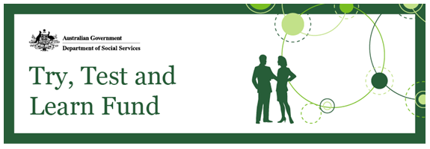
Slides from Sydney information session now available
The first information session on tranche two was held in Sydney on Friday,
8 December 2017. The session outlined the process for applying to tranche two, as well as the priority groups for the new tranche. The presentation notes, as well as a questions and answers document are now available on the Community Grants Hub website. The questions and answers will be updated following future information sessions.
These sessions will be rolled out to other capital cities and regional centres; we will let you know the dates and locations of these sessions through this newsletter and how to register your interest in attending.
Additional information sessions to be held in the new year
Information sessions are planned for Hobart on 31 January 2018 and for Launceston on 1 February 2018.
An information session will also be held in Adelaide on 8 February 2018. Other capital and regional areas to be advised.
If you would like to attend, please email TTLFund@dss.gov.au by COB 24 January 2018 with the information session you would like to attend, along with your name, organisation and contact details. Please note that while the venue is large, demand may exceed capacity, so make sure to register early.
Priority Investment Approach data now available to public users
Access to Priority Investment Approach data is now available for public users. Two datasets are available, which may be helpful in formulating applications for the Try, Test and Learn Fund.
Priority Investment Approach data on ABS TableBuilder
A subset of Priority Investment Approach data was released for public access through ABS TableBuilder. The aggregate data is a five per cent sample of Priority Investment Approach data, but is representative of the full dataset.
This data can be used by organisations looking for data to use in their grant applications for the Try, Test and Learn Fund, but may also be of interest to academics, teachers, students, and journalists. You can register for access to TableBuilder on the ABS website.
Synthetic dataset through Australian Institute of Health and Welfare (AIHW)
A subset of Priority Investment Approach data that has been converted to synthetic data was also recently released. Synthetic data is de-identified data that mimics the characteristics of the administrative data at the aggregate or group level, but no longer contains data that is reflective of any particular individual. The synthetic dataset is available here.
These datasets are in addition to the unit record data already available to approved researchers in the secure enclave.
Keep in touch
Until the next update, please feel free to distribute this newsletter to your networks, and encourage them to sign up for updates here. You can also contact us at: TTLFund@dss.gov.au.

