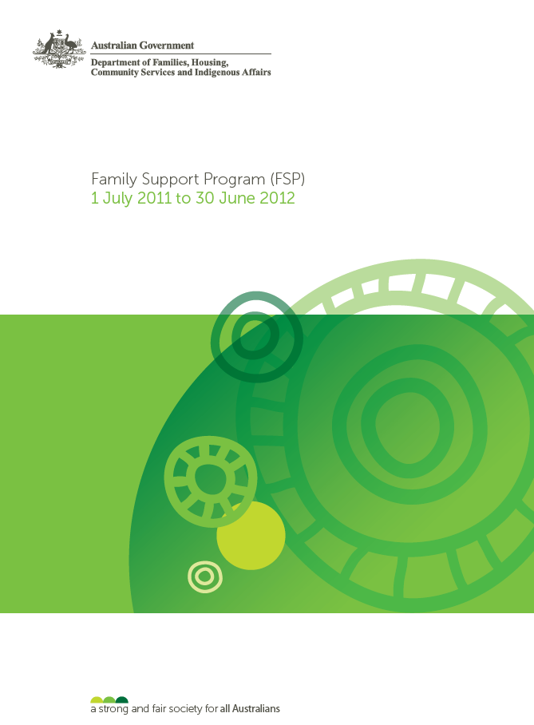

© Commonwealth of Australia 2012

With the exception of the Commonwealth Coat of Arms and where otherwise noted all material presented in this document is provided under a Creative Commons Attribution 3.0 Australia licence (<http://creativecommons.org/licenses/by/3.0/au/>). The details of the relevant licence conditions are available on the Creative Commons website (accessible using the links provided) as is the full legal code for the CC BY 3.0 AU licence (<http://creativecommons.org/licenses/by/3.0/au/legalcode>).

[Description: License](http://creativecommons.org/licenses/by/3.0/)

The document must be attributed as the Department of Families, Housing, Community Services and Indigenous Affairs Family Support Program (FSP) 1 July 2011 to 30 June 2012.

**Phone:** 1300 653 227

**Email:** [fahcsiafeedback@fahcsia.gov.au](mailto:fahcsiafeedback@fahcsia.gov.au)

**Post:** Department of Families, Housing, Community Services and Indigenous Affairs

Tuggeranong Office Park

PO Box 7576

Canberra Business Centre ACT 2610

ISBN Number: 978-1-921975-86-8 (PDF)

ISBN Number: 978-1-921975-85-1 (RTF)

FaHCSIA12271.1210

Family Support Program (FSP) 1 July 2011 to 30 June 2012

Contents

**Acronyms** 5

**List of Tables/Charts** 7

Section one: Introduction 8

Background 8

Achievements 9

FSP 9

Building Australia’s Future Workforce (BAFW) 9

Intensive Family Support Services 9

MyTime for Grandparents 10

Find and Connect 10

FSPDS 11

Vulnerable and Disadvantaged Client Access Strategy (VADCAS) 11

Complaints 12

Section Two: Client Data/Outputs 13

Family Support Program (All services combined) 14

FSP client numbers 14

FSP cients by demographic groups 15

FSP clients who identified as Aboriginal and/or Torres Strait Islander 16

FSP clients who identified as Culturally and Linguistically Diverse 16

FSP clients who identified as having a disability 17

Income from service fees 18

Referrals to External Services 19

Presenting needs 20

Building Australia’s Future Workforce (BAFW) 20

Family and Relationship Services, Specialist Services and Family Law Services 22

FaRS, SS & FLS client numbers 22

Communities for Children and Community Playgroups 23

CfC and CP client numbers 24

Section three: Activity Information 25

Ranking of eligible activities 25

Family Relationship Advice Line (the Advice Line) – 1800 050 321 26

MensLine Australia - 1300 78 99 78 27

Raising Children Network 28

Family Relationships Online (FRO) 28

Section FOUR: Performance Data 30

FaHCSIA 2011-12 Annual Report Data 30

FSP Performance Framework 31

Reporting Changes for 2011-12 - FaRS, SS and FLS services 31

Reporting changes for 2011-12 – CfC and CP 32

FSP data collection methods for client feedback/follow-up 32

Immediate outcomes 32

Intermediate outcomes 33

Service delivery quality 34

Service outputs 36

Vulnerable and Disadvantaged Client Access Strategy (VADCAS) results 36

Section Five: Future Directions – how to improve performance 37

FSP Evaluation 37

FSP Data System (FSPDS) 37

Communities for Children reporting 38

FSP Future Directions 38

What we know we could have done better 38

APPENDIX 40

FSP data 40

FaRS, SS and FLS data 45

CfC and CP Data 48

**Acronyms**

|  |  |  |
| --- | --- | --- |
| **ATSI** |  | Aboriginal and Torres Strait Islander |
| **BAFW** |  | Building Australia’s Future Workforce |
| **CaLD** |  | Culturally and Linguistically Diverse |
| **CCS** |  | Children’s Contact Service |
| **CfC** |  | Communities for Children |
| **CfC D** |  | Communities for Children Direct Services |
| **CfC FP** |  | Communities for Children Facilitating Partner Services |
| **CfC IPS** |  | Communities for Children Indigenous Parenting Services |
| **CGNT** |  | Closing the Gap in the Northern Territory |
| **CP** |  | Community Playgroups |
| **FaHCSIA** | | Department of Families, Housing, Community Services and Indigenous Affairs |
| **FaRS** |  | Family and Relationship Services |
| **FDR** |  | Family Dispute Resolution |
| **FLS** |  | Family Law Services |
| **FRAL** |  | Family Relationship Advice Line |
| **FRC** |  | Family Relationship Centre |
| **FRO** |  | Family Relationships Online |
| **FRS** |  | Family Relationship Services |
| **FRSA** |  | Family Relationship Services Australia |
| **FRSHE** |  | Family Relationship Services for Humanitarian Entrants |
| **FSP** |  | Family Support Program |
| **FSDRT** |  | Family Services Drought Response Teams |
| **FSPDS** |  | Family Support Program Data System |
| **KiF** |  | Kids in Focus |
| **KPIs** |  | Key performance indicators |
| **PI** |  | Performance indicators |
| **POP** |  | Parenting Orders Program |
| **PSCP** |  | Post Separation Co-operative Parenting |
| **RFDR** |  | Regional Family Dispute Resolution |
| **RRFSS** |  | Rural and Regional Family Support Services |
| **SCASP** |  | Supporting Children After Separation Program |
| **SFVS** |  | Specialised Family Violence Services |
| **SS** |  | Specialist Services |
| **TDRS** |  | Telephone Dispute Resolution Service |
| **VADCAS** |  | Vulnerable and Disadvantaged Client Access Strategy |

**List of Tables/Charts**

**Section 2 – CLIENT DATA/OUTPUTS**

2.1: Chart – Number of FSP clients by service type 2011-12

2.2 Chart – Percentage of FSP clients by service type 2011-12

2.3 Chart – Percentage of FSP clients from demographic groups 2011-12

2.4 Chart – Percentage of FSP clients identifying as Aboriginal and/or Torres Strait Islander by service type 2011-12

2.5 Chart – Percentage of FSP clients identifying as Culturally and Linguistically Diverse by service type 2011-12

2.6 Chart - Percentage of CfC and CP clients identifying as people with a disability by service type 2011-12

2.7 Chart – Percentage of sessions with fees charged – FaRS, SS-SFV and FLS 2009-12

2.8 Table - Total fees charged FaRS, SS-SFV and FLS 2009-2012

2.9 Table – Service type to which clients were most often referred in 2011-12

2.10 Table – Top 10 presenting needs identified by FSP FaRS, SS and FLS registered clients in 2008-09, 2009-10, 2010-11 and 2011-12

2.11 Table – BAFW CfC FP referral numbers for Helping Young Parents Measure

2.12 Chart – Number of FaRS, SS and FLS clients by service type 2011-12

2.13 Chart – Number of registered and unregistered clients by FaRS, SS and FLS service type from 2009-12

2.14 Chart – Number of CfC and CP clients by service type 2011-12

2.15 Table – Calls to the Family Relationship Advice Line 2011-12

2.16 Table – FRAL type of assistance provided 2011-12

2.17 Table – Mensline service statistics in 2011-12

2.18 Table – Types of assistance provided for Mensline telephone service in 2011-12

2.19 Table – Raising Children Network statistics in 2011-12

2.20 Table – Family Relationships Online statistics for 2011-12

2.21 Table – Services which collect information against each performance indicator

# Section one: Introduction

The Family Support Program (FSP) funds non-government organisations to deliver services that strengthen family well-being and community cohesion, protect the best interests of children, close the gap in Indigenous disadvantage, and build parents’ capacity to participate in work. More than $1 billion (2011‑14) is invested in over 350 organisations to deliver FSP across Australia.

This document is a summary of Program activity and performance over the period 1 July 2011 to 30 June 2012. It has been compiled to provide a national shapshot of data for service providers, give the Department visibility of the performance of the services it funds, and to help inform future policy and program design decisions. The Report is based on information drawn from data and performance information submitted to the Department by service providers.

It should be noted that the FSP client data and performance information for 2011-2012 reflects the new Program structure from 1 July 2011 and in most cases is not easily comparable to previous years’ data. This report contains caveats and notes against data items with comparative limitations.

## Background

FSP represents a significant investment by the Australian Government in improving the safety and well‑being of children and families, including during difficult periods in their lives such as separation. The ‘best interests of children’ is the fundamental principle that underpins all FSP services and reflects the Government’s commitment and responsibilities as a signatory to the United Nations Convention on the Rights of the Child. FSP services:

* target vulnerable and disadvantaged families, through a holistic understanding of the nature of disadvantage and its impacts
* support children’s social, emotional and cognitive development, as a pathway to lifelong learning and well-being
* deliver prevention, early intervention and secondary services, to support the safety and well-being of children
* provide support to parents, through counselling and parenting skills training
* promote the job readiness of families, stabilising the home environment and improving their engagement with school, training and work
* deliver family dispute resolution and other specialist services for separated families and/or families experiencing high conflict, to achieve the co-operative care of children

A number of additional initiatives were funded as part of the new FSP from 1 July 2011. These initiatives included:

* expanding Communities for Children-Facilitating Partner (CfC FP), CfC-Direct and   
  CfC-Indigenous Parenting services
* investing in Intensive Family Support Services (IFSS) in the Northern Territory and APY Lands
* establishing Find and Connect Support Services nationally for Forgotten Australians and Former Child Migrants
* increased funding in seven existing CfC FP sites and establishing three new CfC FP sites to support the Government’s Building Australia’s Future Workforce (BAFW) trials
* a ten year commitment through the Child, Youth, Family and Community Wellbeing package under Stronger Futures in the Northern Territory, with the planned establishment of 15 new CfCs, with a particular focus on remote communities

The Government also announced approximately $3 billion of supplementation funding for organisations, including the FSP organisations, to support the transition to the new modern award for social and community services workers.

FSP services are funded through Budget appropriations to FaHCSIA and the Attorney-General’s Department (AGD).

## Achievements

### FSP

FSP service providers are meeting the needs of many vulnerable and disadvantaged families with most providers reporting positive outcomes for their clients.

Overall, the FSP met its performance expectations during 2011-2012. All targets in the Portfolio Budget Statements and FaHCSIA’s Annual Report were met except for “Percentage of service sites in the most disadvantaged or targeted communities” which had a target of 75%. It should be noted, however, that the published 75% target should have read as 25%. For 2011-2012, 40.2% of service sites were located in the most disadvantaged or targeted communities. The correct figure will be used in the 2012-2013 FaHCSIA Annual Report.

The total number of clients assisted for 2011-2012 was 873,597[1], which exceeded the target of 750,000 clients set in the FaHCSIA Portfolio Budget Statement 2011-2012. This represents an increase of 4.2% from the total number of clients assisted for 2010-11 (838,071).[2]

### Building Australia’s Future Workforce (BAFW)

As part of the BAFW package, the Government provided additional funding over four years to enhance and expand CfC FP services in ten trial locations around Australia. This funding is to be invested in new or enhanced services to support people participating in the Helping Young Parents trial, implemented from 1 January 2012, and the Supporting Jobless Families trial, implemented from 1 July 2012. All 52 CfC FP sites were also provided with additional funding to support families affected by eligibility changes to the Parenting Payment (to come into effect from 1 January 2013)

### Intensive Family Support Services

Intensive Family Support Services provide home-based intensive, long-term support to families and are delivered under FSP Communities for Children - Indigenous Parenting Support. They engage families with children identified by the statutory child protection authority as experiencing or being at high risk of neglect.

Intensive Family Support Services were delivered by 14 family support workers and community liaison workers and five team leaders across nine locations in the Northern Territory during 2011-12. Forty-two per cent of these workers were Indigenous.

### MyTime for Grandparents

In 2011-12 23 MyTime for Grandparents peer support groups were delivered under FSP Communities for Children Direct, providing grandparents much-needed support in their role as full-time carers of their grandchildren. The responsibility of caring for their grandchildren is often as a result of tragedy or dysfunction in the child’s immediate family and grandparents in these circumstances frequently experience financial and health impacts and can become socially isolated.

### Find and Connect

As part of the National Apology to Forgotten Australians and Former Child Migrants on 16 November 2009, the Australian Government announced funding of $26.5 million over four years to help Forgotten Australians and Former Child Migrants trace their records and identities, search for family, access professional counselling services and peer and social support programs, and connect with other services that may improve their lives.

During 2011-12 the National Find and Connect Consultative Forum was established to provide the Australian Government with advice on implementation and evaluation. The Find and Connect Records Access Documentation Project provided grants of up to $15,000 to 29 not-for-profit organisations to document, index and release records relating to children in ‘care’ during 1920-1989. The Australian Government also entered into:

* high-level Memoranda of Understanding with each state and territory government to ensure parties work collaboratively to enhance existing service offers and build services nationally
* funding agreements with state and territory service providers (with a service provider in WA still to be finalised) to provide the following services:
  + records tracing and family restoration, specialist counselling and information and referral to mainstream services such as aged care, health, housing and dental services
* funding agreements with four advocacy organisations to strengthen the voice of Forgotten Australians and Former Child Migrants through advocacy, education, awareness-raising and mutual support
* a funding agreement with the University of Melbourne to develop a national Find and Connect web resource

An oral history project was recommended in two Senate Community Affairs References Committee reports *Lost Innocents: Righting the Record - Report on Child Migration (August 2001)* and *Forgotten Australians - A report on Australians who experienced institutional or out-of-home care as children (August 2004).* The National Library of Australia received funding to record the personal stories from more than 200 Forgotten Australians and Former Child Migrants. The stories will be preserved in the Library and publicly available, together with the commemorative booklet by November 2012 and more than 100 of these interviews can be accessed at ["You Can't Forget Things Like That" booklet and interviews](http://www.nla.gov.au/news/2012/11/16/forgotten-australians-remembered-1).

During 2011-12 the National Museum of Australia hosted an exhibition called *Inside: Life in Children’s Homes and Institutions*. The exhibition featured the words, voices and objects of the Forgotten Australians and Former Child Migrants who experienced institutional ‘care’ as children. A touring exhibition program is being developed by the Museum in conjunction with cultural institutions in states and territories.

### FSPDS

On 1 July 2012, enhancements were implemented into FRSP Online, including changing the system’s name to the *Family Support Program Data System* (FSPDS). The changes focused on better reflecting the current Program environment, strengthening data integrity, removing out-dated functions and improving how the application operates. Many of the changes were based on sector feedback.

The changes that were introduced into the system can be summarised as:

* format changes – In order to reflect the FSP reform FRSP Online was also renamed the FSP Data System (FSPDS)
* changes to data submission rules – as a condition of funding agreements, service providers must collect and record client data in FSPDS within 28 days of client service. The system now includes functionality that aligns with the funding agreements
* question changes – To improve the clarity of data and to improve system usability, three obsolete fields have been removed and two additional questions have been introduced

In May 2012, the Department initiated an FSP data working group, which consists of FSPDS users, a representative from Family Relationship Services Australia (FRSA) and departmental staff. The working group supports the FSPDS system changes made to date, and is working towards further streamlining/improving FSPDS between now and 30 June 2014.

### Vulnerable and Disadvantaged Client Access Strategy (VADCAS)

The Vulnerable and Disadvantaged Client Access Strategy (VADCAS) was introduced as part of the FSP reforms which took effect in July 2011.

An analysis of the VADCAS plans by the Australian Institute of Family Studies (AIFS) shows there has been strong and innovative practice by FSP providers to improve their servicing to vulnerable and disadvantaged families. The AIFS report “*Good and innovative practice in service delivery to vulnerable and disadvantaged families and children*” was made available on the AIFS Communities Families Clearinghouse Australia (CFCA) website ["Good and innovative practice in service delivery to vulnerable and disadvantaged families and children"](http://www.aifs.gov.au/cfca/pubs/papers/a142861/index.html).

### Complaints

A total of 202 client complaints were reported to 54 FSP service providers. As a result of receiving a complaint in 2011-12, 47 organisations made changes to policies or procedures. No complaints resulted in adverse media coverage or litigation.

# Section Two: Client Data/Outputs

FSP data is collected from service providers according to the type of service being delivered.

The following services input individual client data into the FSP Data System, the Program’s online data collection system, within 28 days of service delivery:

* Family and Relationship Services (FaRS)
* Specialist Services (SS)
  + Kids in Focus – Family Drug Support (KiF)
  + Family Relationship Services for Humanitarian Entrants (FRSHE)
  + Specialised Family Violence Services (SFVS)
* Family Law Services (FLS)
  + Children’s Contact Services (CCS)
  + Family Dispute Resolution/Regional Family Dispute Resolution (FDR/RFDR)
  + Family Relationship Centres (FRC)
  + Parenting Orders Program (POP)
  + Post Separation Co-operative Parenting (PSCP)
  + Supporting Children After Separation Program (SCASP)

The following services submit aggregated client data to the Department in February and July each year via a SmartForm:

* Communities for Children
  + Direct Services
  + Indigenous Parenting Services (including Indigenous Family Support Services)
  + Facilitating Partners (FP)
* Community Playgroups
* Find and Connect [3]

Communities for Children Facilitating Partner services participating in the 10 BAFW trial sites also submit client and activity data on a monthly basis to the Department.

This document reports on each service type, or group of service types individually. Although information is presented in a similar format wherever possible, it should be remembered that the different types of data collection methods make it impossible to draw conclusions when comparing different service types.

## Family Support Program (All services combined)

### FSP client numbers

For the 2011-12 financial year, CfC FP recorded the highest number of clients[4] assisted (226,816 or 25% of total FSP clients), followed by Community Playgroups with 189,439 clients (20.9%). This is most likely due to these service types providing predominantly universal services with the broadest reach rather than targeted services. FaRS, FLS, CfC Direct, and CfC IPS service providers assisted 175,822 (19.4%), 146,920 (16.2%), 112,416 (12.4%) and 38,189 clients (4.2%) respectively. These service types provide targeted and intensive services to clients, many of whom are in the high end of the vulnerability continuum.

As shown in Charts 2.1 and 2.2 below, the lowest numbers of clients assisted were through the Specialist Services. SS- SFV, SS-KiF and SS‑FRSHE assisted 10,573 (1.17%), 2,662 (0.29%) and 1,919 (0.21%) respectively in 2011-12. These services assist clients with complex needs such as mental health, drug and alcohol dependency and family violence or, in the case of FRSHE, provide family relationship services to individuals and families who have entered Australia under the Humanitarian Entrants Program.

#### 2.1: Chart – Number of FSP clients by service type 2011-12

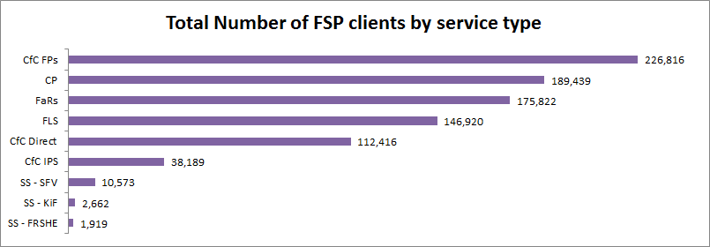

Note: Unregistered clients may be counted more than once where the individual attends a service on multiple occasions.

#### 2.2: CHART – percentage of fsp clients by service type 2011-12

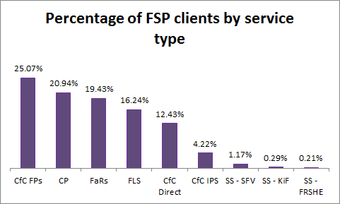

Note: Unregistered clients may be counted more than once where the individual attends a service on multiple occasions.

### FSP cients by demographic groups

FSP services support children and families with an emphasis on engaging vulnerable and disadvantaged families with their support and expertise. As a proxy for vulnerability, the FSP data identifies clients who are in the target groups of Aboriginal and/or Torres Strait Islander, Culturally and Linguistically Diverse and Disability. These target groups may be under represented in the data as clients may not wish to self‑identify.

#### 2.3: Chart - Percentage of FSP clients from demographic groups 2011-12

The highest percentage of FSP clients was recorded for ATSI 9.45%; the next highest percentage was for CaLD (8.84%) and the lowest percentage was recorded for people with a disability (1.48%).

The chart above shows the total percentage of FSP clients by demographic group. Overall for FSP the percentage of clients from target groups was 19.78%. Further details for each group are provided below.

### FSP clients who identified as Aboriginal and/or Torres Strait Islander

As at 30 June 2006, according to the Australian Bureau of Statistics, the Indigenous estimated resident population of Australia was 2.5%[5]. For FSP, indicators are that across the Program the following percentages were recorded for clients serviced by providers who identified as ATSI in 2011-12:

* 19.8% of CfC clients (excluding CP)
* 2.51% of FaRS, SS and FLS
* 4.72% of Registered FaRS, SS and FLS
* Overall 9.45% of FSP

Registered clients who identified as being Aboriginal and/or Torres Strait Islander people accounted for 5.19% of all registered clients seen under FaRS. The data may represent an underestimate of Aboriginal and/or Torres Strait Islander status among FaRS clients.

#### 2.4: Chart - Percentage of FSP clients identifying as ATSI by service type 2011-12

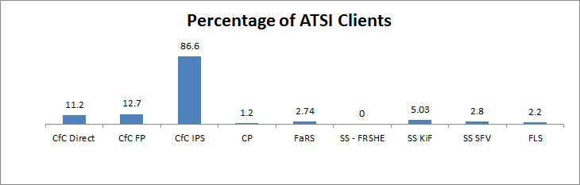

*CfC IPS includes Closing the Gap in the Northern Territory services.

The chart above shows the percentage of FSP clients identifying as ATSI by service type in 2011-12. As would be expected, the highest percentage of clients who identify as ATSI is in the Indigenous Parenting Services.

### FSP clients who identified as Culturally and Linguistically Diverse

Chart 2.5 shows the total number of clients by service type and age category who identified as CaLD in 2011-12.

* 17.3% of CfC clients (excluding CP) identified as CaLD in 2011-12
* 2.1% of FaRS, SS & FLS clients identified as CaLD in 2011-12
* 3.96% of Registered FaRS, SS and FLS clients identified as CaLD in 2011-12
* Overall 8.84% of FSP clients identified as CaLD in 2011-12

Across the Program, Specialist Services – FRSHE had the highest percentage of CaLD clients (36.53%). However, only 701 out of 750 registered clients identified as CaLD; the total number of FRSHE clients was 1,919 therefore, the majority were unregistered clients for which demographic details are not collected.

This low registration rate therefore underestimates the likely percentage of CaLD clients being supported through the FSP. A breakdown of the percentages of CaLD clients by service type is shown in the chart below.

#### 2.5: chart - Percentage of clients identifying as CaLD by service type 2011-12

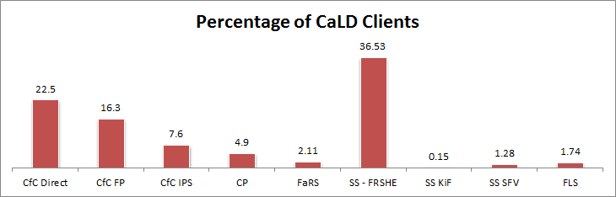

*CfC IPS includes Closing the Gap in the Northern Territory services.

### FSP clients who identified as having a disability

Four million people in Australia or just under one in five Australians (18.5%) reported having a disability in 2009, according to the results of the Survey of Disability, Ageing and Carers (SDAC).[6] The disability rate increases steadily with age, with younger people less likely to report a disability than older people. Of those aged four years and under, 3.4% were affected by disability, compared with 40% of those aged between 65 and 69 and 88% of those aged 90 years and over.

People with a disability is a priority target group for CfC services but is not a priority target group identified for FaRS, SS or FLS. The percentage of people identifying as having a disability accessing CfC services in 2011-12 was 3%. This may represent an underestimate as people may not choose to identify as having a disability or else the disability is not evident at the time of service.

#### 

#### 2.6: Chart - Percentage of CfC and CP clients identifying as people with a disability by service type 2011-12

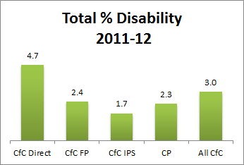

The chart above provides a breakdown of the percentages of clients identifying as people with a disability by service type.

### Income from service fees

The FSP funding agreement permits most service providers to collect fees from clients. Service types for which the collection of fees is expressly excluded are SS – KIF, SS – FRSHE and CfC (though an exemption may be granted for CfC Direct).

The FSP funding agreement specifies that fee income must be reinvested in activities related to FSP services.

#### 2.7: Chart - Percentage of sessions with fees charged – FaRS, SS-SFV and FLS 2009-10, 2010-11 and 2011-12

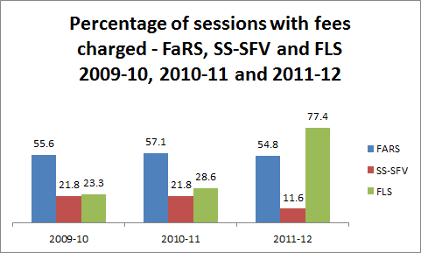

The chart above shows a comparison over 2009 to 2012 of the percentage of sessions where fees were charged for FaRS, SS-SFV and FLS. The percentages have remained relatively static over the three financial years for FaRS. There was an increase from 28.6 % to 77.4% of sessions where fees were charged for FLS for the 2010-11 and 2011-12 financial years respectively. It should be noted that from 1 July 2011, AGD introduced changes to its fees regime for family law services, which seems to be reflected in Chart 2.6 for the 2011-12 financial year. The table below however shows that in terms of total fees charged there was a modest percentage increase charged for FLS with the percentage change from 2009-10 to 2010-11 being 15.9% and the percentage change from 2010-11 to 2011-12 being 16.6%.

#### 2.8: Table – Total fees charged FaRS, SS-SFV and FLS 2009-2012

| Total fees charged | | | |
| --- | --- | --- | --- |
| Service Type | **2009-10** | **2010-11** | **2011-12** |
| FaRS | $7,338,496.91 | $7,686,128.09 | $7,124,556.87 |
| FRESHE | $0.00 | $0.00 | $30.00 |
| SS-KIF | $0.00 | $950 | $3.00 |
| SS-SFVS | $65,862.41 | $93,801.88 | $73,413.05 |
| FLS | $2,083,912.65 | $2,415,394.85 | $2,817,479.82 |
| TOTAL | **$9,488,271.97** | **$10,196,274.82** | **$10,015,482.74** |

### Referrals to External Services

FaRS, SS and FLS, providers are able to select a service from a drop down list to identify where they have referred clients. The following table shows those services most commonly selected.

#### 2.9: Table - Service types to which clients were most often referred in 2011-12

| **Service Type** | **Number of referrals** | **Percentage of**  **all referrals** |
| --- | --- | --- |
| Community Legal Centre | 3,333 | 16.7 |
| Professional at this service | 2,552 | 12.8 |
| Other funded family relationship service | 2,339 | 11.7 |
| Community organisation | 2,317 | 11.6 |
| Legal Aid Commission | 1,094 | 5.5 |
| Domestic Violence Service | 844 | 4.2 |
| Other family relationship service (not funded under the FSP) | 829 | 4.2 |
| Family Relationship Centre | 800 | 4.0 |
| Private Legal Practitioner | 775 | 3.9 |
| Health practitioner | 766 | 3.8 |

Table 2.7 shows the type of services that clients have been most often referred to in 2011-12 including the number of referrals and the percentage of all referrals. The referrals reflect that the complex needs of clients are being addressed in collaboration with a number of different types of organisations which provide specialist services or services needed to meet the multiple needs of clients.

### Presenting needs

#### 2.10: Table - Top 10 presenting needs identified by FSP FaRS, SS and FLS registered clients in 2008-09, 2009-10, 2010-11 and 2011-12

| **Presenting need** | **2008-09** | **2009-10** | **2010-11** | **2011-12** | **Percentage of all presenting needs in 2011-12** |
| --- | --- | --- | --- | --- | --- |
| Post-separation parenting | 66,058 | 70,185 | 68,790 | 72,235 | 10.1 |
| Dealing with relationship difficulties | 51,063 | 49,922 | 53,589 | 52,012 | 7.3 |
| Communication issues | 34,640 | 40,192 | 45,217 | 49,315 | 6.9 |
| Conflict | 36,463 | 39,616 | 45,372 | 47,520 | 6.7 |
| Parenting | 30,007 | 29,751 | 32,231 | 31,095 | 4.4 |
| Stress | 19,104 | 24,106 | 29,053 | 30,932 | 4.3 |
| Relationship breakdown | 30,720 | 30,437 | 28,994 | 26,035 | 3.6 |
| Separation of parents | 17,035 | 20,764 | 24,334 | 24,763 | 3.5 |
| Anxiety | N/A | N/A | N/A | 24,214 | 3.4 |
| Family separation | 19,731 | 22,699 | 25,100 | 23,806 | 3.3 |

The table above shows a comparison of the top ten presenting needs identified by registered clients from 2008-09 to 2011-12. The table also shows the percentage of all presenting needs in 2011-12. The type of services clients are being referred to in Table 2.7 is reflected in the top ten presenting needs identified in Table 2.8. Clients are presenting with relationship and parenting issues, where there may be issues requiring legal advice and/or ongoing counselling services.

What typically is not represented in these figures (except for the ‘anxiety’ presenting need) is the number of clients who have presented with mental health issues. A number of case studies provided by FSP service providers include clients who have complex mental health issues.

According to the *ABS 2007 National Survey of Mental Health and* *Wellbeing* one in five Australians aged 16‑85 years had a mental disorder in 2007 and almost one in two (or 7.3 million people) had experienced a mental disorder at some point in their lives. People with a mental illness may not be able to fully participate in the community due to difficulties faced with everyday functioning and often experience social isolation. FSP services provide services to help with information, counselling, social intervention or skills training.

FSP services are contributing to improving the life chances of children at greatest risk of long-term disadvantage (a social inclusion strategic change indicator). In 2011-12 84.8% of FSP clients reported improved child wellbeing and family functioning.

## Building Australia’s Future Workforce (BAFW)

The Building Australia’s Future Workforce (BAFW) participation agenda, announced in the 2011-12 Federal Budget, supports vulnerable parents on income to develop their attachment to work through training, job services and targeted parenting and family support services.

The BAFW package includes two measures where CfC FPs play an important role: the Helping Young Parents (HYP) measure and the Supporting Jobless Families (SJF) measure. These measures operate in the 10 Local Government Areas (LGAs) of Playford (SA), Hume and Greater Shepparton (VIC), Burnie (TAS), Bankstown, Wyong and Shellharbour (NSW), Rockhampton and Logan (QLD) and Kwinana (WA). The HYP measure was implemented on 1 January 2012, while the SJF measure began on 1 July 2012.

The Government provided funding over four years to enhance and expand Communities for Children Facilitating Partner (CfC FP) services in these locations to support people participating in the trials. Activities that CfC FPs may offer include home visits, early learning and literacy programs, social and communication skills, parenting and family support programs and child nutrition. CfC FPs also link parents to other support services as part of their role in supporting the objectives of BAFW.

All 52 CfC FP sites were also provided with additional funding to support families affected by eligibility changes to the Parenting Payment to become job ready (to come into effect from 1 January 2013).

#### 2.11: Table - BAFW CfC FP Referral Numbers For helping young parents measure

|  |  |  | **April 2012** | | **May 2012** | | **June 2012** | | **Total** |
| --- | --- | --- | --- | --- | --- | --- | --- | --- | --- |
| **State** | **CfC FP Site** | **Organisation Name** | **DHS Referred** | **Other** | **DHS Referred** | **Other** | **DHS Referred** | **Other** |
| **NSW** | Bankstown | The Smith Family | 1 | 0 | 0 | 0 | 0 | 0 | 1 |
| Shellharbour | Barnardos Australia | 1 | 0 | 1 | 0 | 1 | 0 | 3 |
| Wyong | The Benevolent Society | 0 | 0 | 3 | 2 | 3 | 1 | 9 |
| **QLD** | Logan | The Salvation Army (Qld) Property Trust | 0 | 0 | 0 | 0 | 0 | 0 | 0 |
| Rockhampton | The Smith Family | 4 | 3 | 3 | 0 | 0 | 0 | 10 |
| **SA** | Playford | Anglicare SA Inc | 0 | 0 | 0 | 1 | 0 | 0 | 1 |
| **TAS** | Burnie | Catholic Care Victoria Tasmania Ltd | 1 | 1 | 3 | 0 | 0 | 1 | 6 |
| **WA** | Kwinana | The Smith Family | 0 | 0 | 4 | 1 | 1 | 0 | 6 |
| **VIC** | Greater Shepparton | Catholic Care Victoria Tasmania Ltd | 0 | 0 | 1 | 1 | 0 | 0 | 2 |
| Hume/Broadmeadows | Broadmeadows Uniting Care | 0 | 1 | 1 | 0 | 1 | 0 | 3 |
|  | **Total** | | **7** | **5** | **16** | **5** | **6** | **2** | **41** |
|  | **Total referred per month** | | **12** | | **21** | | **8** | | **41** |
|  | **Total DHS Referred** | | **7** | | **16** | | **6** | | **29** |

The table above shows Helping Young Parents client referral numbers from 1 April to 30 June 2012. A detailed breakdown of referrals to CfC from 1 January to 30 March 2012 has not been included as CfC FPs recorded the attendance of all young parents not just trial participants, and the trial participant numbers could not be disaggregated.

CfC FPs report that young parents are primarily accessing playgroup, parenting skills and family relationship activities and that young parents are becoming more aware of the support available to them in their community.

## Family and Relationship Services, Specialist Services and Family Law Services

Family and Relationship Services provide relationship advice, counselling for young people and children, and broader parenting support while Specialist Services support vulnerable families affected by issues such as drugs, violence and trauma.

Family Law Services provide alternatives to formal court processes for families who are separated, separating or in dispute to improve their relationships and care arrangements in the best interests of their children. These services are funded through the Attorney-General’s Department.

### FaRS, SS & FLS client numbers

Client numbers were generally evenly distributed throughout the year. For the most part, across both financial years, services saw noticeably fewer clients in December and January which reflects the closedown of services over the Christmas and New Year period.

#### 2.12: Chart - Number of FarS, SS and FLS clients by service type 2011-12

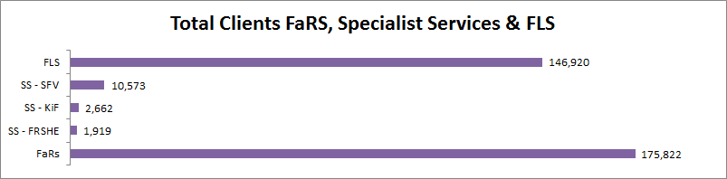  
Note: Unregistered clients may be counted more than once where the individual attends a service on multiple occasions.

Chart 2.10 above shows total client numbers for FaRS, Specialist Services and Family Law Services.

The relatively low client numbers for the Specialist Services reflect the fact that these services exclusively support complex clients with high needs requiring long term intervention.

FaRS and FLS have more registered than unregistered clients while SS services have more unregistered than registered clients. A registered client is a person who receives a service from a FSP funded organisation and has consented to provide his or her demographic details for capture through FSPDS. An unregistered client is a person who receives a service from a FSP funded organisation and has not consented to provide his or her demographic details for capture through FSPDS. Unregistered clients may be counted more than once where the individual attends a service, or a range of services on different occasions.

FSP clients may choose not to provide their demographic information to the Department for a number of reasons, such as cultural or privacy concerns or in some cases because the service setting does not readily allow for the collection of individual data (e.g. group work with a large number of participants).

In 2011-12 the number of registered vs unregistered clients were as follows:

* FaRS recorded the highest number of registered clients (92,757) and unregistered clients (83,065)
* FLS recorded the next highest number of clients (82,401) and unregistered clients (64,519)
* SS-SFV was next with 3,038 registered clients and 7,535 unregistered clients
* KiF followed with 756 registered clients and 1,906 unregistered clients
* The lowest number of registered clients was recorded for SS-FRSHE with 750 and 1,169 unregistered

Having clients registered with a service is important to the Department because it allows for the capture of client demographic data and identifies the characteristics of clients accessing services, i.e whether vulnerable and/or disadvantaged, and what type of services being accessed, which assists with Program planning. It also allows for follow up surveys with clients in order to measure performance against Program objectives.

#### 2.13: Chart - Number of registered and unregistered clients by FaRS, SS and FLS service type from 2009-2012

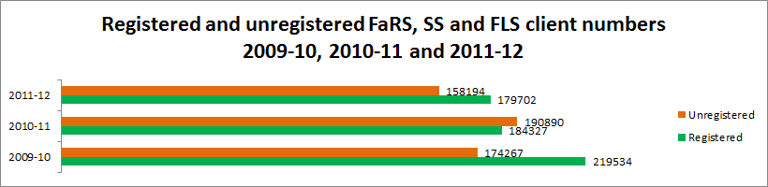

The chart above shows a comparison of the total registered and unregistered client numbers for FaRS, SS and FLS over the period 2009-10 to 2011-12.

In 2009-10 there was a higher percentage of registered (55.75%) than unregistered clients (44.25%). However, in 2010-11 the percentage of unregistered clients (50.87%) exceeded the percentage of registered clients (49.13%). But in 2011-12 the percentage of registered clients (53.18%) again exceeded the percentage of unregistered clients (46.82%).

Service providers across all three activity types reported difficulty in obtaining client consent to forward personal client data to the Department. The Department has been working with providers to try to reduce the incidence of unregistered clients, e.g. by improving the consent form and introducing functionality to allow organisations to generate client IDs without sending client details to the Department. As a result, the percentage of registered clients increased by 4.05%, from 49.13% in 2010-11 to 53.18% in 2011-12.

## Communities for Children and Community Playgroups

Communities for Children services provide prevention and early intervention services for families with children up to age 12 with the aim of strengthening family wellbeing and community capacity. Community Playgroup Associations enable self-managed and self-funded playgroups to operate in all communities around Australia to promote positive parent-child play, social support and community cohesion.

State Community Playgroup Associations’ statistics on people identifying as Aboriginal and/or Torres Strait Islander, Culturally and Linguistically Diverse or having a disability are underreported and should be considered as indicative only.

### CfC and CP client numbers

A total of 566,860 clients participated in CfC and Community Playgroup Activities during 2011-12. As shown in Chart 2.12, CfC FPs recorded the highest number of clients followed by Community Playgroups, CfC Direct and CfC IPS.

The highest percentage of clients for Community Playgroups was recorded in the children 0 to 4 years age cohort (55.21%), followed by adults 18 years plus (49.49%). This result is as expected as Community Playgroups target adults with preschool aged children.

The highest percentage of clients for CfC FP was recorded in the adults 18 years plus cohort, followed by children 0 to 4 years, children 5 to under 13 years and, finally, a small percentage of clients in the youth 13 to 18 years age cohort.

The highest percentage of clients for CfC IPS was recorded in the adults 18 years plus cohort, followed by children 0 to 4 years, children 5 to under 13 years and finally a small percentage of clients in the youth 13 to 18 years age cohort.

Over 50% of clients for CfC Direct were recorded in the adults 18 years plus cohort, followed by children 5 to under 13 years, children 0 to 4 years and, finally, a small percentage of clients in the youth 13 to 18 years age cohort.

#### 2.14: Chart - Number of CfC and CP clients by service type 2011-12

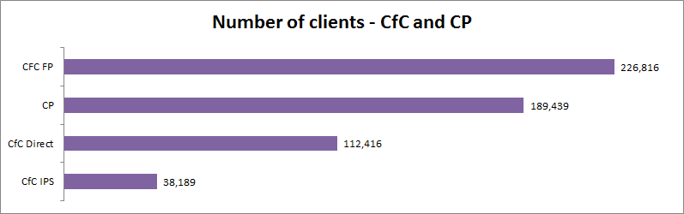

Note: Communities for Children – Indigenous Parenting Services include services delivered under Closing the Gap in the Northern Territory.

# Section three: Activity Information

## Ranking of eligible activities

Communities for Children service providers deliver a range of activities as part of service delivery. Services include:

Information and Referral

6% of CfC FP service providers ranked Information and Referral as the eligible activity that they spent most time delivering. Across all CfC services, 3.3% ranked this activity as first, 15.2% cent as second, 27% as third, 26.7 % as fourth, 14.6% as fifth, 8.8% as sixth. 4.4% of CfC services reported delivering no Information and Referral activities.

Resource Development

Development of information and advice to assist parents and families, child care workers, family and child professionals and community members. This may include resources such as brochures and posters, videos, DVD’s, booklets, training resources and websites.

4% of CfC FP service providers ranked Resource Development as the eligible activity that they spent most time delivering. Across all CfC services, 2.5% ranked this activity as first, 3.9% cent as second, 6.9% as third, 14.3% as fourth, 27.8% as fifth, 33.9% as sixth. 10.7% of CfC services reported delivering no Resource Development activities.

Support

45.2% of CfC IPS service providers ranked Support as the eligible activity that they spent most time delivering. Across all CfC services, 39.9% ranked this activity as first, 28.1% as second, 14.6% as third, 7.4% as fourth, 4.4% as fifth, 1.7% as sixth. 3.9% of CfC services reported delivering no Support activities.

Education

Examples include, but are not limited to, pre-marriage courses, conflict management and parenting programs. The term education is often used interchangeably with Skills Training.

27.8% of CfC Direct service providers ranked Education and Training as the eligible activity that they spent most time delivering. Across all CfC services, 23.1% ranked this activity as first, 22% as second, 16.5% as third, 15.2% as fourth, 11% as fifth, 7.4% as sixth. 4.7% of CfC services reported delivering no Education and Training activities.

Outreach and Home Visits

Outreach targets families who have difficulty accessing services or who are unlikely to proactively engage with a service. Outreach is a particularly important strategy to engaging highly vulnerable families.

15.4% of CfC IPS service providers ranked Outreach and Home Visits as the eligible activity that they spent most time delivering. Across all CfC services, 13.2% ranked this activity as first, 14% as second, 14.6% as third, 12.1% as fourth, 10.5% as fifth, 20.4% as sixth. 15.2% of CfC services reported delivering no Outreach or Home Visits services.

Community Capacity Building and Development.

32% of CfC FP service providers ranked Community Capacity Building and Development as the eligible activity that they spent most time delivering. Across all CfC services, 15.4% ranked this activity as first, 14.3% as second, 17.1% as third, 19.3 % as fourth, 21.2% as fifth, 7.4% as sixth. 5.2% of CfC services reported delivering no Community Capacity Building and Development activities.

## Family Relationship Advice Line (the Advice Line) – 1800 050 321

The Family Relationship Advice Line is a national telephone service that provides information and referral for callers to enable them to connect with services that help address relationship difficulties or deal with separation. During 2011-12 the Advice Line comprised:

* Information Officer Services
* Parenting Advice Services
* Telephone and Online Dispute Resolution Service
* Legal Advice Services

The Advice Line is available from 8am to 8pm Monday~~s~~ to Friday~~s~~ and 10am to 4pm on Saturdays (except on national public holidays).

The Advice Line complements the services offered by Family Relationship Centres.

The numbers of calls in 2011-12 has reduced by 3,639 over those recorded last year. In 2010-11 the advice line answered 65,959 calls and the total number of calls per month ranged between 4,223 and 6,625.

The number of calls that received Information Officer Services increased by 13,910 in 2011-12 from a total of 48,410 in 2010-11. The number of calls that received Parenting Advice Services reduced by 3,490 in 2011-12 from a total of 15,611 in 2010-11. The number of calls that received Telephone and Online Dispute Resolution Services also reduced by 2,970 in 2011-12 from a total of 19,758 in 2010-11 and the number of calls that received Legal Advice Services increased by 2,279 in 2011-12 from a total of 3,022 in 2010-11.

#### 2.15: Table - Calls to the Family Relationship Advice Line 2011-12

|  | **Number of calls** |
| --- | --- |
| Incoming Telephone Calls | 69,910 |
| Telephone calls answered | 62,320 |
| Total number of calls per month ranged between | 4,211 and 6,242 |

Source: Centrelink Telephony System.

#### 2.16: Table - Type of assistance provided 2011-12

|  | **Number of calls** |
| --- | --- |
| Family Relationship Advice Line – Information Officer Service | 62,320 |
| Family Relationship Advice Line – Parenting Advice Service | 12,121 |
| Family Relationship Advice Line – Telephone and Online Dispute Resolution Service | 16,788 |
| Family Relationship Advice Line – Legal advice service | 5,301 |

Note: Callers to the FRAL can receive more than one type of assistance.

Source:  
* Centrelink Telephony System  
** Provided by the Attorney-General’s Department  
*** RAQ Telephony System

## MensLine Australia - 1300 78 99 78

Mensline Australia is an Australia wide 24-hour-a-day, seven-day-a-week telephone and online service providing family relationship counselling, information and referral. MensLine also provide a Call Back Service and a website for men and professionals working with men.

The number of incoming calls increased by 5,833 in 2011-12 to the previous years. The number of calls answered decreased by 2,279. The number of outgoing calls has dropped slightly over the last year by 731. The number of calls recorded for the MensLine Australia Call Back Service has decreased by 2,416 over the total in 2010-11. 95,693 more page views were recorded in 2011-12 and 29,798 more visitors to the website were recorded in 2011-12 than in 2010-11.

The number of calls that received counselling services in 2011-12 has reduced slightly (by 1,585) over last year. The number of calls that received information and referral services in 2011-12 has also reduced by 1,127 from 2010-11.

#### 2.17: Table - MensLine service statistics in 2011-12

Notes for table below:

1. A page view is defined as the number of times the Mensline website has been viewed.
2. Mensline always report on outbound calls as they provide call back to some callers. This provides a full description of the service being provided.
3. By showing incoming and answered calls the table below shows the number of callers attempting to contact the service. The demand is higher than the number of calls being answered.
4. Inappropriate calls are calls made to the service which do not fit into Mensline’s service delivery model e.g. crank calls, abusive calls etc.

| **Type of calls/views/visits** | **Number of calls/views/visits** |
| --- | --- |
| Incoming telephone calls | 52,104 |
| Telephone calls answered | 33,890 |
| Telephone (outgoing) calls | 4,342 |
| MensLine Australia Call Back Service | 1,392 |
| Number of page views | 353,734 |
| Number of visitors to website | 114,075 |

Source: MensLine Australia Annual Statistical Report July 2011 – June 2012

#### 2.18: Table - Types of assistance provided for MensLine telephone service in 2011-12

|  |  |
| --- | --- |
| **Call Type** | **Number of Calls** |
| Counselling | 21,405 |
| Information and referral | 5,869 |
| Inappropriate calls | 1,008 |
| Non-engaged calls (for example hang –up, caller didn’t engage etc) | 5,224 |

Source: MensLine Australia Annual Statistical Report July 2011 – June 2012.

Note:  Includes calls answered and outgoing calls. The introduction of the new data base resulted in 1,470 call types not recorded. This error is being rectified.

## Raising Children Network

The Raising Children Network (RCN) provides Australian focussed, evidence based information and activities for parents with children aged 0 – 15 years, including children with special needs.  It also has information for other groups including grandparents, carers and professionals who work with families.

#### 2.19: Table - Raising Children Network statistics in 2011-12

| **Type** | **Number** |
| --- | --- |
| Page views | 10,278,548 |
| Visitors to website | 2,543,626 |

Source: Raising Children Network – Google Analytics

## Family Relationships Online (FRO)

[Family Relationships Online (FRO)](http://www.familyrelationships.gov.au/Pages/default.aspx) is an Australian Government website managed by FaHCSIA. Its URL is [www.familyrelationships.gov.au](http://www.familyrelationships.gov.au/)

FRO’s purpose is to provide the general public with access to information about family relationship issues, ranging from building better relationships to dispute resolution. People are able to locate a range of services available by either accessing individual FRO pages or by conducting a topic-based search with the choice of nominating locality details or not.

The total number of visits to FRO in 2010-11 was 257,009. The total number of visits to FRO in 2011-12 has increased by 21,221 to 278,230.

The top five pages visited on FRO were:

1. FRO Home Page
2. Brochures and Publications page
3. Services – Family Relationship Centres page
4. Search page KEYWORD=frc (Family Relationship Centre) NOT pop (Parenting Order Program) – this was used to locate a client’s local FRC
5. Search page

The average number of countries accessing FRO every month was 122. The top five foreign countries visiting FRO were:

1. United States of America
2. United Kingdom
3. Canada
4. Philippines
5. India

#### 2.20: Table - FRO statistics for 2011-12

|  |  |
| --- | --- |
| Number of visits to website | 278,230 |
| Average visits per month | 23,186 |
| Average visits per day | 760 |

# Section FOUR: Performance Data

## FaHCSIA 2011-12 Annual Report Data

The FaHCSIA Annual Report 2011-2012 which is tabled in Parliament provides a summary of performance against key performance indicators and actual results against set targets. For Program 1.1 Family Support the key performance indicators and targets for 2011-12 were:

* Percentage of clients reporting improved child wellbeing and development, safety and family functioning. Target: 70%
* Percentage of clients with increased knowledge and skills related to child wellbeing and development, safety or family functioning. Target: 80%
* Percentage of clients satisfied with the assistance received. Target: 80%
* Percentage of clients assisted from priority groups
  + Aboriginal and Torres Strait Islander. Target: 8%
  + Culturally and linguistically diverse. Target: 9%
  + Children. Target: Not applicable
* Percentage of service sites in the most disadvantaged or targeted communities. Target: 25%

The following results have been calculated based on 2,401 responses collected by a representative sample of 120 providers delivering 200 Activities. The sample includes all states and territories and all FSP service types. From 1 July 2011, all FSP funded services were required to report against the FSP Performance Framework:

* the percentage of FSP clients reporting improved child wellbeing and development, safety and family functioning of 84.8% exceeded the target of 70%
* the percentage of FSP clients reporting increased knowledge and skills related to child wellbeing and development, safety and family functioning of 86.8% exceeded the target of 80%. The information was extracted from the same sample of clients mentioned above
* the percentage of clients satisfied with the assistance received through FSP was 95.7% and exceeded the target of 80%
* the percentage of FSP clients assisted from priority groups - 9.7% from ATSI exceeded the target of 8%; 11.3% from CaLD exceeded the target of 9%; and 45% from the priority group of children for which there was no target set for 2011-12

In previous years, ATSI, CALD and child clients were reported separately for Family Relationship Services and Children and Parenting Services. From 2011-12, percentages are reported FSP wide, and therefore cannot be compared to past years.

Fifty-four per cent of FSP clients assisted were from the priority group, men. The percentage of men is recorded for Family and Relationship Services, Specialist Services registered clients and Mensline only. This data is not collected for Community Playgroups, Indigenous Parenting Services or Communities for Children.

The percentage of FSP service sites in the most disadvantaged or targeted communities was 40.2%. The target figure for this indicator was incorrectly published in FaHCSIA’s 2011 Annual Report as 75% and was corrected to read as 25% for the 2012 Annual Report.

## FSP Performance Framework

FaHCSIA needs data and information from service providers funded under the FSP to:

* assess service performance under the funding agreement between FaHCSIA and the service provider including benchmarking
* report on the overall performance of the FSP and its components
* contribute to program and policy development

FSP developed the FSP Performance Framework in partnership with service providers in 2010-11.

The Performance Framework covers all activities delivered under the FSP. Each service only contributes to those aspects of the framework that are relevant to its specific activities and their clients. The framework also links with funding agreement performance indicators and requirements.

FSP has received a number of calls from providers to improve the Performance Framework to better reflect the clients and services being delivered and strengthen the evidence base for the program. A working group will be established early in 2013 to redesign the Performance Framework.

### Reporting Changes for 2011-12 - FaRS, SS and FLS services

#### Annual service report

The Annual Service Report is used to submit immediate and intermediate client outcome data to FaHCSIA. The FSP Performance Framework contains two additional parts relating to Service Delivery Quality and Service Outputs. Information collected for these performance indicators is also part of the questions in the Annual Service Report.

The 2012 Annual Service Report under the current funding agreement (2011-14) was significantly changed from previous years. Consultation with the sector was undertaken to develop a template that reflected the reporting requirements that demonstrate the effectiveness of the FSP.

The Annual Service Report included sections for service providers to report their immediate and intermediate client outcome data for each service they are funded to deliver.

From 1 July 2011, the Annual Service Report is due on 31 July each year in order to meet timelines for reporting FSP outcomes in the FaHCSIA Annual Report. This new 31 July due date will mean consistent outcomes reporting due dates for all FSP services.

### 

### Reporting changes for 2011-12 – CfC and CP

The six monthly CfC and CP Performance Reports gathers the necessary information to enable FaHCSIA to:

1. Assess provider performance in meeting funding agreement deliverables and fulfilling the requirements of the FSP Performance Framework
2. Assess performance of the FSP:
   1. How well we are reaching vulnerable and disadvantaged families
   2. How well the FSP is achieving its objectives
   3. Identify trends, gaps etc to build the evidence base and inform future funding decisions and policy development
3. Fulfil departmental obligations:
   1. To promote the efficient, effective, economical and ethical use of Commonwealth resources as required by the Financial Management Act 1997, Section 44
   2. Report against KPIs in the Annual Report
   3. Inform the Minister

In addition to the immediate and intermediate client outcomes data, the FSP Performance Framework contains two additional parts relating to Service Delivery Quality and Service Outputs. Information collected for these performance indicators is part of the questions in the CfC Performance Reports.

CfC and Community Playgroup service providers report to FaHCSIA using a six monthly Performance Report. In previous years, Performance Reports were consistent for both halves of each financial year. From 2011-12, the July to December period Performance Report (due on 28 February each year) is a shorter version focusing on key basic information. The report for the January to June period (due on 31 July each year) includes additional sections to report annual data on items such as performance indicators, complaints, client access plans and approval requirements where applicable.

### FSP data collection methods for client feedback/follow-up

The Performance Framework should provide a consistent approach to monitoring and reporting performance across the FSP – drawing on a common set of high-level results and performance indicators. A key goal of the Framework is to help set clear performance expectations, assess whether levels of performance have been met, set benchmarks to monitor trends and offer feedback to services on their performance.

The 2011-14 funding agreements require service providers to collect data on immediate and intermediate outcomes under the FSP Performance Framework, as well as data to measure service delivery quality and service outputs.

### Immediate outcomes

**Immediate outcomes/impacts: Did we make an immediate difference?**

Immediate outcomes are client outcomes expected as a result of the FSP in the short term (at the time of service).  These in turn contribute to the intermediate outcomes.  Data shows outcomes at the service provider level and is used to assess service provider performance.

Immediate client outcomes (or client feedback) are collected at or near the time of service. As a minimum, providers are required to report client feedback collected from all clients accessing the service during a representative 20 working day period.  A minimum 50% response rate is expected.

For 2012 only, CfC services had the option of addressing only two of the four immediate performance indicators.  From 2013, all CfC providers will have to address all four immediate performance indicators.

#### 2.21: Table - Services which collect information against each performance indicator

| **Ref** | **Performance Indicator** | **FaRS, SS, FLs** | **CfC** | **CP** |
| --- | --- | --- | --- | --- |
| 2.1 | Proportion of clients with increased knowledge and skills | ✓ | ✓ | ✓ |
| 2.2 | Proportion of clients satisfied with the service they received | ✓ | ✓ | ✓ |
| 2.3 | Proportion of clients with improved access/engagement with services | ✓ | Optional 2011-12. Mandatory from 2012‑13 | N/A |
| 2.4 | Proportion of clients with improved family, community and economic engagement | ✓ | Optional 2011-12. Mandatory from 2012‑13 | N/A |
|  |  |  |  |  |

### Intermediate outcomes

**Intermediate outcomes/impacts: Did we make a lasting difference?**

Intermediate outcomes are client and community outcomes expected from the FSP in the medium term (3-6 months after service). Data shows outcomes at the Program level and are not used to assess the performance of individual service providers.

Under the FSP Performance Framework, providers report on two intermediate performance indicators by following up a small sample of clients who accessed their service in the previous 3 to 6 months, or in the case of continuing contact, 6 months after commencing the service.

Each service provider collects intermediate client outcome data on a small sample of their clients.

* The sample size is based on the number of clients attending the service in the June‑December period
* The number of clients to be sampled is provided by FaHCSIA in March/April for each service type
* Service providers report their results in the Annual Service Report or six‑monthly Performance Report due on 31 July each year

The sample number for each service is determined by the Department and based on the July - December client numbers.

Intermediate outcomes are only collected from clients who have accessed services over 2011-12 and who have provided consent to follow‑up. Clients are asked for consent to follow‑up at the time of commencing the service.

New performance indicator reporting tables included in both the July 2012 Annual Service Report and the CfC and CP Performance Report allowed consistent performance indicator data to be collected across the whole FSP.

Analysis of reports has shown overall high positive response rates for all performance indicators.  However, assessment of individual service data indicates that some providers need additional support to appreciate the differences between immediate and intermediate Performance Indicator data collection, as well as understand the contractual responsibilities for their organisation.

### Service delivery quality

**Service delivery quality**

Performance indicator 3.1 - Proportion of clients from priority groups

FSP services are required to collect and report data on vulnerable groups, which include but are not limited to:

* Aboriginal and Torres Strait Islander families (see data in Section Two)
* Culturally and Linguistically Diverse families (see data in Section Two)
* Low income families
  + In 2011-12 the total percentage of registered FaRS (including FSDRT and RRFSS) SS and FLS clients who indicated they received Centrelink income support payments was:
    - FaRS – 26.7%
    - SS-FRSHE – 41.3%
    - SS-SFV – 44%
    - SS-KiF – 57.7%
    - FLS – 34%
  + The figures were underreported for CfC services with 49 organisations (or 25%) not providing data. In 2011-12 the total percentage of clients whose main source of income was known to be from Centrelink or DVA payments for CfC and Community Playgroups was 6.7%. The breakdown by service type was:
    - CfC IPS – 32.9%
    - CfC Direct – 16.1%
    - CfC FP – 7.8%
    - CP – 0.6%

Note: The level of data supplied by CfC service providers is insufficient to draw any meaningful conclusions.

* Young parent families
  + Data that identifies young parent families is not available for FaRS, SS and FLS.
  + In 2011-12 the total percentage of CfC and Community Playgroup clients who identified as young parents was 1.9% for parents aged less than 20 years and 1.2% for parents aged 20 to 25 years. The breakdown by service type was:
    - CfC Direct – 3.5% <20 yrs and 2.4% 20-25 yrs
    - CfC FP – 2.5% <20 yrs and 1.2% 20-25 yrs
    - CfC IPS – 4.7% <20 yrs and 4.2% 20-25 yrs
    - CP – 0.7% <20 yrs and 0.6% 20-25 yrs

Performance indicator 3.2 - Proportion of partner agencies reporting satisfaction with the contribution of FSP service providers to integrated service delivery

FaHCSIA periodically undertakes or commissions program evaluations and reviews to ensure its programs are high quality, effective, efficient and appropriately targeted to the needs of families.

In 2012, service providers self-nominated three organisations as ‘partner agencies’ that they work with most frequently (excluding sub-contracted agencies, e.g. Community Partners and consortia). The nominated partner agencies were asked to complete a survey on how satisfied they were with their relationship with the FSP service provider.

The survey results indicate that a majority of the nominated partner agencies who took part in the survey had developed strong partnerships with FSP-funded organisations. Overall, the findings indicate that FSP-funded organisations appear to have successfully engaged in a range of collaborative activities with partner agencies.

Performance indicator 3.3 - Proportion of service providers that meet approval requirements

The FSP Administrative Approval Requirements are a set of 15 quality service standards, covering the five key risk areas of governance, financial management, viability, performance management and issues management. FaHCSIA assessed the number of service providers which met these requirements in 2011‑12 through information provided in the Performance Reports or Annual Services Report and by FaHCSIA Activity Managers.

* Family Relationship service providers have been required to comply with the existing set of 15 service standards for a number of years and in 2011-12 continued to comply universally.
* Some CfC and CP service providers that have not been required to comply with the standards in the past, were required to meet a minimum of 4 of the set of 15 approval requirements in 2011-12.
* Across the FSP the Department has been working with service providers through the Network to assist service providers to ensure ongoing compliance with the Approval Requirements.

In 2011-12 88 per cent of organisations reported they were fully compliant, 10.9 per cent reported partial compliance and less than one per cent was non-compliant. For those organisations identified as being partially or non-compliant, the FaHCSIA STO Network is working with these providers to address their issues.

### Service outputs

Performance indicator 4.1 - Number of:

* clients by demographic characteristics (see data in Section Two and Appendix)
* service events/activities
  + Data was not able to be extracted for this item however changes are being made to reporting processes which will allow this to happen in the future.
* service sites (and locations)
  + The percentage of FSP service sites in the most disadvantaged or targeted communities was 40.2% which exceeded the target of 25%.

FaHCSIA collated the information from all service providers to report program-wide data. This included details on the demographic characteristics of clients including vulnerable groups, total clients assisted, service type breakdown and locations/numbers of service sites.

## Vulnerable and Disadvantaged Client Access Strategy (VADCAS) results

The Indigenous Access Plans, in particular, appear to be gaining traction in the system. Between the first and second half of the 2011-12 financial year client data from FSP organisations has shown the proportion of Indigenous clients in FSP funded mainstream services (excluding Indigenous Parenting Services and Community Playgroups) has grown from nearly 10% of all clients to just over 11.5%. Indigenous participation in AGD funded Family Law Services has improved slightly over the same period, rising from just over 3.6% of all registered clients to 4.2%. This period coincides with the VADCAS development phase and a number of VADCAS actions were in place at this time.

# Section Five: Future Directions – how to improve performance

## FSP Evaluation

Many of the activities delivered through the FSP are independently evaluated, either by the Department and/or by organisations and their academic partners.

Research and analysis undertaken or underway includes the Stronger Families in Australia longitudinal study, the evaluation of the Protective Behaviours Pilot, the analysis of VADCAS best practice, the evaluation of MyTime for Grandparents, the evaluation of Find and Connect, and the evaluation of Intensive Family Support Services (IFSS – a CfC Indigenous Parenting Service).

AGD have also commissioned research on activities funded under the Family Law Services stream of the FSP.

A diverse range of activities, projects and consultation processes are planned or underway to address Program issues identified by the Department and the sector.

They span relatively small consultations with the sector to refine the type of data collected by the Program to wide consultations with the sector on the future directions of the Program.

## FSP Data System (FSPDS)

Family and Relationship, Specialist and Family Law Services use the FSP Data System to record service data within 28 days of delivery of a service.

Users have generally responded favourably to the changes introduced to the data collection system since 1 July 2011, particularly to the improved look and ‘user experience’ of the reports able to be generated.

In early 2012, FSP, in conjunction with FRSA and 12 representatives from the sector, formed a data working group.

The purpose of the working group was to gain a greater understanding of what service providers felt were barriers when collecting data, to review the current data elements in the FSPDS and to discuss what development changes could be implemented to increase usability of the system in 2013 and 2014.

The group met in June and August 2012 to discuss the changes to the FSPDS that were implemented on 1 July 2012 and to discuss potential changes that could be implemented from 1 July 2013.

The agreed changes will be circulated to the broader sector for comment before end December 2012.

Once broad agreement is reached on the changes, FSP will determine what can be implemented in the FSPDS by 1 July 2013.

## Communities for Children reporting

CfC service providers are required to submit a Performance Report to the Department in July and February of each financial year. The Report details aggregated client data for July to December and January to June.

To reduce the provider reporting burden for the Performance Report due to be completed in January 2013, the Performance Report template has been streamlined, providing a clearer line of sight between the FSP objectives and the outputs and achievements of service providers towards the FSP outcomes. The number of questions to be answered has been reduced, with problematic questions removed and remaining questions simplified.

The changes to the Performance Report included feedback from CfC providers on the Report’s content. Providers strongly indicated that the reporting burden, particularly on those providers receiving lower levels of funding, is too high. In the first quarter of 2013, the Department will be consulting with providers on more significant changes which could be made to the Performance Report for the reporting period July to December 2013. The data currently collected by FSP will be reviewed to ensure the Department collects only that information for which it has a specific use, including building evidence about program and activity effectiveness.

## FSP Future Directions

The Hon Julie Collins MP, Minister for Community Services and Minister for the Status of Women, released the Family Support Program Future Directions Discussions Paper on 15 October 2012 as a means to commence dialogue with the sector and other key stakeholders about how the FSP can be strengthened.

Written submissions on the Discussion Paper are due 30 November 2012 and key themes from these submissions will be posted to the website [Family Support Program Future Directions Discussion Paper October 2012](http://www.fahcsia.gov.au/our-responsibilities/families-and-children/programs-services/family-support-program/family-support-program-future-directions-discussion-paper).

Early in 2013, there will be a round of face-to-face consultations with the sector on the future directions of FSP.

## What we know we could have done better

Over the course of 2011-12, the FSP Branch has sought to make improvements wherever possible to its processes, particularly in the areas of data collection and reporting. It is acknowledged however that further work is required, particularly in consulting with the sector in a more timely and effective fashion.

One of the issues raised by service providers is the timely distribution of reporting templates. The FSP Branch is endeavouring to address this issue and is aiming to get reporting templates out earlier to give service providers enough time to incorporate considered and detailed responses. In October, the FSP Branch sent out a draft of the proposed amended CfC and Community Playgroups six monthly report template for the 1 July to 31 December 2012 period to allow service providers to start collecting data. It is expected that the final six monthly performance report template will be distributed to service providers through Activity Managers in December 2012. The FSP Branch will also be investigating further streamlining of reports and reporting requirements.

Service providers are required to provide client data and performance information through FSPDS, six monthly performance reports and the Annual Service Report. In gathering this information, the FSP Branch recognises that it needs to provide this information back to the sector in a more timely manner and in a form which better informs the sector. As part of this process, examples of best practice and innovation, case studies and any other informative qualitative data sourced from performance reports will be provided to all FSP service providers.

It should be recognised that collating and analysing information received from FSP service providers is a time consuming process. Some automated processes are being put in place which it is hoped will speed up the extraction and collation of information from performance reports. This will be reflected in the new structure of the CfC and Community Playgroups six monthly performance report template.

As highlighted earlier in this Report, the FSP Branch has been working with the sector to identify and implement improvements to data collection through the FSPDS. This will continue into the future and it is expected further work will be undertaken to consider how best to incorporate service activities not currently reported through FSPDS. All amendments to the FSPDS require a long lead time and typically there is a limited window of opportunity (four weeks per annum) to have system changes implemented. Should there be any reason/s why system changes suggested by service providers cannot be implemented, the FSP Branch will endeavour to provide this feedback to the sector.

We welcome your feedback on this report which provides a snapshot of the FSP data and performance reports, to ensure an annual report of this nature is useful to FSP providers.

# APPENDIX

This Appendix contains charts and tables with additional data collected from Annual Service Reports and six monthly Performance Reports which may be of interset to service providers.

### FSP data

#### Chart - Percentage of FSP clients by age 2011-12

The highest number of FSP clients was recorded against the Adults 18 years plus cohort followed by children 0 to <5 years, Children 5 to <13 years and finally a small proportion of clients from the Youth 13 to <18 years age group.

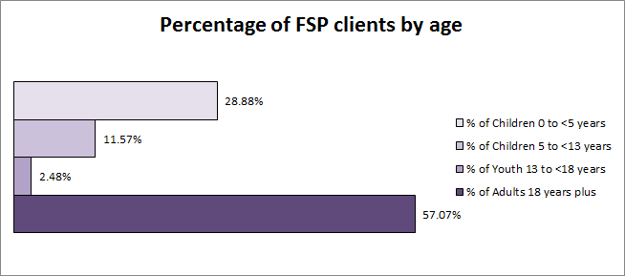

#### Chart - Percentage of clients from demographic groups by service type 2011-12

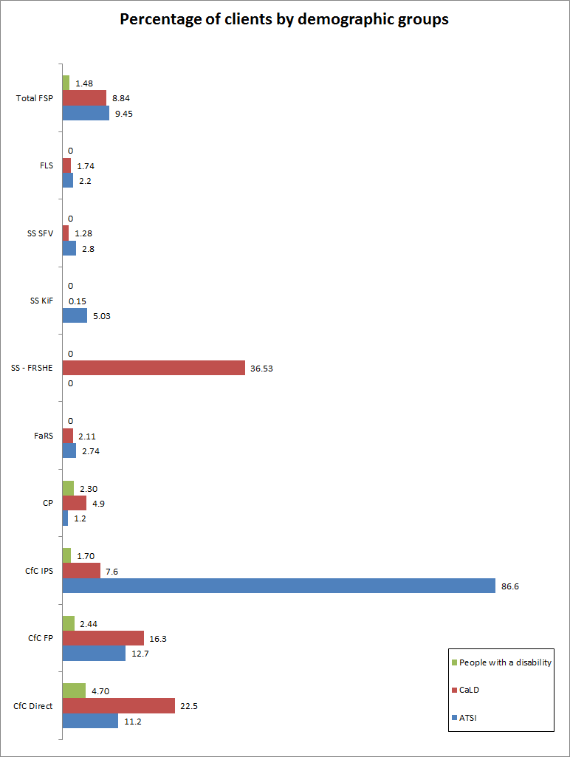

*CfC IPS includes Closing the Gap in the Northern Territory services.

#### Table - Income from service fees 2011-12

| **Service type** | **Number of sessions where no fee was charged** | **Number of sessions where a fee was charged** | **Total fees charged** | **% of sessions that charged a fee (to 1 decimal place)** |
| --- | --- | --- | --- | --- |
| FaRS | 104,596 | 126,873 | $7,124,556.87 | 54.8 |
| FRSHE | 2,248 | 1 | $30.00 | 0.0 |
| KiF | 6,493 | 3 | $3.00 | 0.0 |
| SFV | 13,100 | 1,713 | $73,413.05 | 11.6 |
| FLS | 207,814 | 711,019 | $2,817,479.82 | 77.4 |

The table above provides information on fees across the FSP as reported by providers. The data relates only to the 105 services delivering FRS, SS and FLS. Other services do not charge fees.

Family and Relationship Services are, at the service provider’s discretion, permitted to charge fees. While Family and Relationship Services providers may charge fees, clients must not be refused service or referred to other organisations on the basis of incapacity to pay fees.

Unless an exemption has been granted by the Department, CfC services must be provided free of charge. In exceptional circumstances where providers may charge limited fees, clients must not be refused service or referred to other organisations on the basis of incapacity to pay fees.

62 (59%) of the 105 FSP service providers reported having collected fees, collectively totalling $10.015m during the reporting period.

#### Chart - registered and unregistered clients by FaRS, SS and FLS service type 2011-12

• FLS recorded the highest percentage of registeredclients (56.09%)
• FaRS recorded the next highest percentage of registered clients (52.76%)
• SS-FRSHE was next with39.08% of registered clients. 
• SS-SFV followed with 28.73% of registered clients 
• The lowest percentage of registered clients was recorded for SS-KiF with 28.4% 

• SS-Kif recorded the highest percentage of unregistered clients (71.6%)
• SS-SFV recorded the next highest percentage of unregistered clients (71.27%)
• SS-FRSHE was next with 60.92% of unregistered clients
• FaRS followed with 47.24% of unregistered clients
• The lowest percentage of unregistered clients was recorded for FLS with 43.91%.


The chart above shows the percentage of registered and unregistered FaRS, SS and FLS client for 2011-12 by service type.

* FaRS and FLS have a higher percentage of registered than unregistered clients.
* SS services have a higher percentage unregistered than registered clients.

#### Chart - PI 2.1 Percentage of clients with improved knowledge and skills

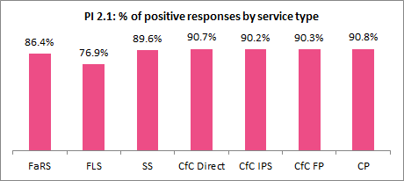

#### Chart - PI 2.2 Percentage of clients satisfied with the service they received or percentage of clients reporting that the service was responsive/respectful of their needs and/or cultural/language background

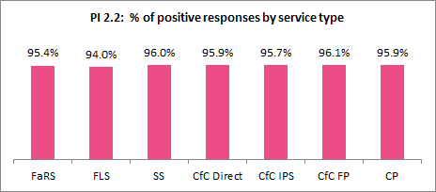

#### Chart - PI 2.3 Percentage of clients with improved access/engagement with services

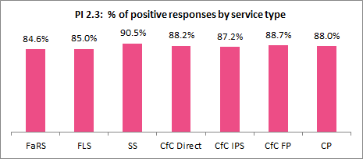

#### 

#### Chart - PI 2.4 Percentage of clients with improved family, community and economic engagement

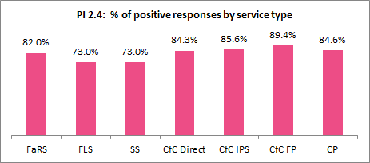

#### Chart - PI 1.1 Percentage of clients with improved family functioning, including child wellbeing

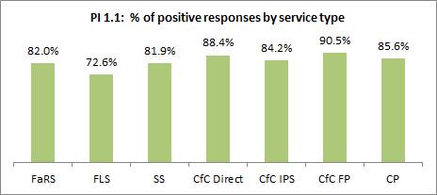

#### Chart - PI 1.2 Percentage of children with improved development

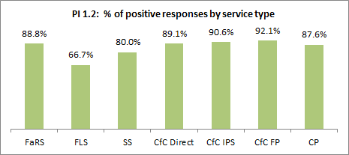

#### 

#### Chart - PI 1.3 Percentage of clients that live in safer family and community environments

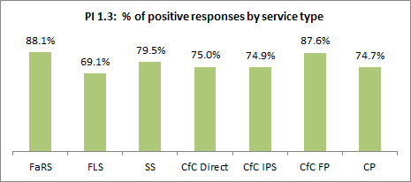

#### Chart - PI 1.4 Percentage of clients who are included in and socially connected to their community

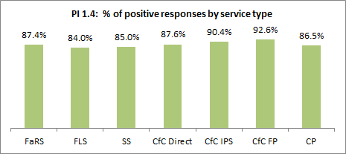

### FaRS, SS and FLS data

#### chart - Percentage of FaRS, SS and FLS clients by service type and age 2011-12

• The percentage of total clients for adults 18 years plus was: 
o FaRS 91.22%
o SS – SFV 89.53%
o FLS 89.02%
o SS – FRSHE 70.22%
o SS – KiF 54.10%
 • The percentage of total clients for youth 13 to under 18 years was:
o SS – FRSHE 9.36%
o SS – KiF 7.67%
o FaRS 4.11%
o SS – SFV 3.65%
o FLS 1.88%
 • The percentage of total clients for children 5 to under 13 years was:
o SS – KiF 21.96%
o SS – FRSHE 16.38%
o FLS 7.32%
o SS – SFV 6.14%
o FaRS 4.11%
 • The percentage of total clients for children 0 to under 4 years was:
o SS KiF 16.27%
o SS – FRSHE 4.03%
o FLS 1.78%
o SS – SFV 0.68%
o FaRS 0.55%


The charts above show percentage of FaRS, SS and FLS clients by the four age categories of adults 18 years plus; youth 13 to under 18 years; children 5 to under 13 years and children 0 to under 5 years for 2011-12.

#### Chart - Percentage of FaRS, SS and FLS clients from demographic groups by service type 2011-12

Overall for FaRS, SS and FLS the highest percentage of clients from demographic groups was recorded for SS-FRSHE, the next highest percentage was SS-KiF; followed by FaRS; then SS-SFV and the lowest percentage recorded was for FLS.

SS-FRSHE recorded the highest percetage of CaLD clients; the next highest percentage was FaRS; then FLS; followed by SS-SFV and the lowest percentage of CaLD clients was recorded for SS-KiF.

SS-KiF recorded the highest percentage of ATSI clients; the next highest percentage was SS-SFV; then FaRS and the lowest percentage of ATSI clients was recorded for FLS.  SS-FRSHE did not record any ATSI clients.


The chart above shows the total percentage of FaRS, SS and FLS clients from demographic groups and a breakdown by service type.

Note: People with a disability is not a priority target group for FaRS, SS and FLS and therefore clients are not recorded for this cohort.

#### Chart - Percentage of FaRS, SS and FLS clients identifying as ATSI by service type and age 2011-12

The total percentage of FaRS, SS and FLS clients identifying as ATSI for Youth 13 to 18 yrs was 10.23%; Children 0 to under 5 years was 9.71% ; Children 5 to under 13 years was 7.85%; and Adults 18 years plus was 4.08%.

The percentage of SS-KiF clients identifying as ATSI for Children 0 to under 5 was 26.02%, Youth 13 to under 18 years was 20.69%.Children 5 to under 13 years was 18.67%; and Adults 18 years plus was 14.43%. 

The percentage of SS-SFV clients identifying as ATSI for Children 0 to under 5 years was 61.9%. Youth 13 to under 18 years was 18.58%; Children 5 to under 13 years was 17.89%; and Adults 18 years plus was 8.23%.

The percentage of FaRS clients identifying as ATSI for Children 5 to under 13 years was 12.32%; Youth 13 to under 18 years was 12.31%; Children 0 to under 5 years was 8.37% and Adults 18 years plus was 4.37%.

The percentage of FLS clients identifying as ATSI for Children 0 to under 5 years was 8.37%, Youth 13 years to under 18 years was 04.83, Children 5 to under 13 years was 4.73%;  and Adults 18 years plus was 3.59%.

The percentage of ATSI for SS-FRSHE was 0.


The chart above shows the percentage of FaRS, SS and FLS clients identifying as ATSI by service type and age in 2011-12.

#### Chart - Percentage of FaRS, SS and FLS clients identifying as CaLD by service type and age 2011-12

The total percentage of FaRS, SS and FLS clients identifying as CaLDI for Children 0 to under 5 years was 4.59% ; Adults 18 years plus was 3.86%; Children 5 to under 13 years was 3.01%;. And Youth 13 to 18 yrs was 2.93%;.

The percentage of SS-FRSHE clients identifying as CaLD for Youth 13 to under 18 years was 97.22%. Children 0 to under 5 was 93.55%, Children 5 to under 13 years was 90.48%; and Adults 18 years plus was 90.37%.

The percentage of FaRS clients identifying as CaLD for Children 0 to under 5 years was 4.75%; Adults 18 years plus was 4.11%; Children 5 to under 13 years was 2%; and Youth 13 to under 18 years was 1.67%.

The percentage of FLS clients identifying as CaLD for Children 0 to under 5 years was 3.13%; Adults 18 years plus was 2.98%. Children 5 to under 13 years was 2.06%; and Youth 13 to under 18 years was 1.87%. 

The percentage of SS-SFV clients identifying as CaLD for Children 0 to under 5 years was 4.76%; Adults 18 years plus was 4.69%; Youth 13 years to under 18 years was 3.54 and Children 5 to under 13 years was 0.

The percentage of CaLD for SS-KiF was Adults 18 years plus was 0.73%; Children 5 to under 13 years was 0.6%.  The percentage of CaLD for Children 0 to under 5 years and Youth 13 years to under 18 years was 0.


The chart above shows the percentage of FaRS, SS and FLS clients identifying as CaLD by service type and age in 2011-12.

### CfC and CP Data

#### Chart - Percentage of CfC and CP clients by service type and age 2011-12

The percentage of total clients for adults 18 years plus was: 
o CfC Direct 51.55%
o CfC IPS 45.7%
o CfC FP 45.11%
o CP 44.49%
 The percentage of total clients for youth 13 to under 18 years was:
o CfC IPS 7.06%
o CfC Direct 3.52%
o CfC FP 2.75%
o CP 0%
 The percentage of total clients for children 5 to under 13 years was:
o CfC FP 23.48%
o CfC Direct 15.12%
o CfC IPS 14.73
o CP 0.3%%
 The percentage of total clients for children 0 to under 4 years was:
o CP 55.21%
o CfC IPS 32.51%
o CfC Direct 29.81%
o CfC FP 28.67%


The chart above shows percentage of CfC and CP clients by the four age categories of adults 18 years plus; youth 13 to under 18 years; children 5 to under 13 years and children 0 to under 5 years for 2011-12.

#### Chart - Percentage of CfC and CP clients from demographic groups by service type 2011-12

Overall for CfC and CP the highest percentage of clients from demographic groups was recorded for CfC IPS, the next highest percentage was CfC Direct; followed by CfC FP; and the lowest percentage recorded was for CP.

CfC Direct recorded the highest percetage of CaLD clients; the next highest percentage was CfC FP; followed by CfC IPS and the lowest percentage of CaLD clients was recorded for CP.

CfCIPS recorded the highest percentage of ATSI clients; the next highest percentage was CfC FP; followed by CfC Direct and the lowest percentage of ATSI clients was recorded for CP.  

CfC Direct recorded the highest percentage of people with a disability; the next highest percentage was CfC FP; followed by CfC IPS and the lowest percentage was recorded for CP.


The chart above shows the total percentage of CfC and CP clients from demographic groups and a breakdown by service type.

#### Chart - Percentage of CfC and CP clients identifying as ATSI by service type and age 2011-12

The total percentage of CfC and CP clients identifying as ATSI for Youth 13 to 18 yrs was 33.1%; Children 5 to under 13 years was 22.5%; Children 0 to under 5 years was 18.7% and Adults 18 years plus was 17.2%.
The percentage of CfC IPS clients identifying as ATSI for Children 0 to under 5 was 83.8%, Children 5 to under 13 years was 81.3%; Adults 18 years plus was 80.2% and Youth 13 to under 18 years was 71.6%.

The percentage of CfC FP clients identifying as ATSI for Youth 13 to under 18 years was 23.5%; Children 5 to under 13 years was 16.8%; Adults 18 years plus was 11.3% and Children 0 to under 5 years was 10.5%.

The percentage of CfC Direct clients identifying as ATSI for Youth 13 to under 18 years was 21.6%; Children 5 to under 13 years was 20.6%; Children 0 to under 5 years was 10.2% and Adults 18 years plus was 8.4%.

The percentage of CP clients identifying as ATSI for Children 5 to under 13 years was 3.3%; Adults 18 years plus was 1.4% and Children 0 to under 5 years was 1%.  The percentage of ATSI for Youth 13 years to under 18 years was 0.


*All CfC excludes CP. CfC IPS includes Closing the Gap in the Northern Territory services.

The chart above shows the percentage of CfC and CP clients identifying as ATSI by service type and age in 2011-12.

#### Chart - Percentage of CfC and CP clients identifying as CaLD by service type and age 2011-12

The total percentage of CfC and CP clients identifying as CaLD for Adults 18 years plus was 18.7%; Children 0 to under 5 years was 17.5%; Youth 13 to 18 yrs was 14.6 %; and Children 5 to under 13 years was 14.1%

The percentage of CfC Direct clients identifying as CaLD for Adults 18 years plus was 24.7%; Children 0 to under 5 years was 24%; Youth 13 to under 18 years was 16.8%; and Children 5 to under 13 years was 13.7%;

The percentage of CfC FP clients identifying as CaLD for Adults 18 years plus was 17.1%; Youth 13 to under 18 years was 16.3%; Children 0 to under 5 years was 16.1%; and Children 5 to under 13 years was 15%;

The percentage of CfC IPS clients identifying as CaLD for Adults 18 years plus was 8.1%; Children 0 to under 5 was 7.6%; Youth 13 to under 18 years was 7.1%; and. Children 5 to under 13 years was 6%.

The percentage of CP clients identifying as CaLD for Adults 18 years plus was 4.9% and Children 0 to under 5 years was 4.2%.  The percentage of CaLD for Youth 13 years to under 18 years and Children 5 to under 13 years was was 0.



*All CfC excludes CP. *CfC IPS includes Closing the Gap in the Northern Territory services.

The chart above shows the percentage of CfC and CP clients identifying as CaLD by service type and age in 2011-12.

#### Chart - Percentage of CfC and CP clients identifying as people with a disability by service type and age 2011-12

The total percentage of CfC and CP clients identifying as people with a disability for Children 5 to under 13 years was 4.6%; Children 0 to under 5 years was 3.1%; Adults 18 years plus was 2.4%; and Youth 13 to 18 yrs was 2.0% %

The percentage of CfC Direct clients identifying as people with a disability for Children 5 to under 13 years was 7.3%; Children 0 to under 5 years was 5.2%;  Adults 18 years plus was 3.9%; and Youth 13 to under 18 years was 1.9% 

The percentage of CP clients identifying as people with a disability for Children 0 to under 5 years was 1.6%. Adults 18 years plus was 0.7%.  The percentage of people with a disability for Youth 13 years to under 18 years and Children 5 to under 13 years was was 0.

The percentage of CfC FP clients identifying as people with a disability for Children 5 to under 13 years was 4%; Children 0 to under 5 years was 2.3%; Youth 13 to under 18 years was 2.2%; and Adults 18 years plus was 1.8%,

The percentage of CfC IPS clients identifying as people with a disability for Children 5 to under 13 years was 1.9%; Adults 18 years plus and Youth 13 to under 18 years was 1.7%; and Children 0 to under 5 was 1.4%.


*CfC IPS includes Closing the Gap in the Northern Territory services.

The chart above shows the percentage FSP of clients identifying as people with a disability by service type and age in 2011-12.

#### Chart - Ranking of eligible activities 2011-12 – CfC Direct

The chart above shows a consecutive ranking reported by service providers of the most time spent to the least time spent against eligible activities delivered under CfC Direct during 2011-12.

#### Chart - Ranking of eligible activities 2011-12 – CfC FP

The chart above shows a consecutive ranking reported by service providers of the most time spent to the least time spent against eligible activities delivered under CfC FP during 2011-12.

#### Chart - Ranking of eligible activities 2011-12 – CfC IPS

The chart above shows a consecutive ranking reported by service providers of the most time spent to the least time spent against eligible activities delivered under CfC IPSduring 2011-12.

#### Chart - Ranking of eligible activities 2011-12 – community capacity building and development

The chart above shows the percentage of CfC service providers who ranked *Community Capacity Building and Development* as the eligible activity that they spent most to the least time delivering during 2011-12.

#### Chart - Ranking of Eligible activities 2011-12– Information and Referral

The chart above shows the percentage of CfC service providers who ranked *Information and Referral* as the eligible activity that they spent most to the least time delivering during 2011-12.

#### Chart - Ranking of eligible activities 2011-12 – support

The chart above shows the percentage of CfC service providers who ranked *Support* as the eligible activity that they spent most to the least time delivering during 2011-12.

#### Chart - Ranking of eligible activities 2011-12 – resource development

The chart above shows the percentage of CfC service providers who ranked *Resource Development* as the eligible activity that they spent most to the least time delivering during 2011-12.

#### Chart - Ranking of eligible activities 2011-12 – outreach and home visits

The chart above shows the percentage of CfC service providers who ranked *Outreach and Home Visits* as the eligible activity that they spent most to the least time delivering during 2011-12.

#### Chart - Ranking of eligible activities 2011-12 – education and training

The chart above shows the percentage of CfC service providers who ranked *Education and Training* as the eligible activity that they spent most to the least time delivering during 2011-12.

1. The figure of 873,597 represents a unique count of registered FaRS clients plus CfC and CP client numbers as at 3 October 2012. A unique count is a single count of registered clients who received FaRS services. Although only counted once, clients may have attended multiple services or multiple activities within a single service.
2. It should be noted that the total number of clients reported in the 2011-12 Annual Report is 800,514. The Annual Report figure was based on an estimate of the number of clients as at August 2012, when not all data had yet been received from service providers and is therefore lower than the actual figure which was determined in October 2012 once all data had been received.
3. Find and Connect data is not included in this report due to these services not having commenced reporting until July 2012.
4. A client for FSP purposes is defined as an individual who receives or has received support or assistance from a FSP service.
5. It should be noted that the ABS uses a different method of counting/determining people in Australia identifying as ATSI. ABS Indigenous estimated resident population – method of calculation can be found at: [ABS Appendix 2 "Indigenous estimated resident population - method of calculation"](http://www.abs.gov.au/Ausstats/abs@.nsf/Latestproducts/4705.0Appendix22006?opendocument&tabname=Notes&prodno=4705.0&issue=2006&num=&view)=
6. For the purposes of SDAC, disability is defined as any limitation, restriction or impairment which restricts everyday activities and has lasted or is likely to last for at least six months. Examples range from loss of sight that is not corrected by glasses, to arthritis which causes difficulty dressing, to advanced dementia that requires constant help and supervision. Males and females were similarly affected by disability (18% and 19% respectively).