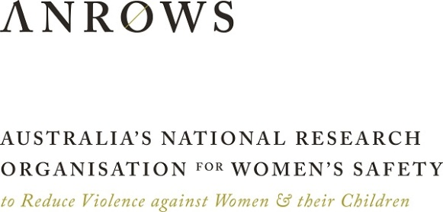

Evaluation of Monash University’s Accredited Training for Sexual Violence Responses

Final report

March 2023

Table of Contents
Acknowledgements 6
Acronyms 8
List of tables 9
List of figures 9
Executive summary 14
Background 14
Overview of the Recognising and Responding to Sexual Violence course 14
Evaluation Overview 15
Objectives, scope and ethics 15
Evaluation approach and sample size 16
Limitations 17
Key findings and conclusions 17
Key findings against Evaluation Question 1 17
Key findings against Evaluation Question 2 19
Key findings against Evaluation Question 3 20
Conclusion 20
Recommendations 20
Recommendations based on the evaluation findings 20
Recommendations based on the changing national context 21
Introduction 22
Background 22
Roles of partners delivering the units 22
Course overview 22
CPD stream 24
VET stream 25
Course and unit participation 25
Focus of the evaluation 26
Structure of this report 30
Methods 30
Overview 30
Ethics 30
Data collection 31
Unit feedback forms 31
Interviews 33
Impact survey 36
Secondary data 37
Data analysis 37
Feedback form analysis 37
Interview analysis 39
Impact survey analysis 40
Review by lived experience advocates 40
Final evaluation report review workshop 41
Evaluation limitations 42
Findings 44
Evaluation question 1: Achievement of specific learning outcomes 44
SLO 1 Understanding of the forms of sexual violence impacting adults 45
SLO 2 Understanding of the consequences of sexual violence on health, social, financial and community outcomes 49
SLO 3 Understanding of barriers to disclosure and stages of disclosure 53
SLO 4 Knowledge of resources and confidence to respond in a trauma-informed way 56
SLO 5 Knowledge of trauma-informed and culturally appropriate responses 59
SLO 6 Skills in trauma-informed and culturally appropriate responses 65
SLO 7 Understanding of practical techniques and knowledge and confidence to make referrals 72
SLO 8 Understanding the complexities of sexual violence for victim/ survivors from at-risk cohorts 79
SLO 9 Understanding and application of the Adult Sexual Violence Healthcare Response Tool 85
Overall self-reported achievement of learning outcomes 86
Discussion of and conclusions regarding self-reported achievement of learning outcomes 91
Evaluation question 2: Quality of the units and their delivery 94
Overall satisfaction with the units 95
Relevance 95
Efficiency 98
Effectiveness 102
Accessing and completing the units 110
Discussion of and conclusions regarding the quality of the units and their delivery 110
Evaluation question 3: Impact of the units on professional practice 111
Potential impact 112
Short-term impact 115
Medium-term impact 118
Discussion of and conclusions regarding impact of the course 123
Reflections and lessons learnt 124
Recommendations 127
Recommendations based on the evaluation findings 127
Recommendations based on the changing national context 127

Acknowledgements
We would like to acknowledge all the people who have contributed to this evaluation. First, we wish to extend our gratitude to Professor Richard Bassed, Dr Maaike Moller, Associate Professor David Wells, Dr Elizabeth Manning, Jennifer Ryan, Associate Professor Lyndal Bugeja, Bianca Lang, Anna Cartwright, Samuel Gillard, and Alexander Gillard from Monash University and the Victorian Institute of Forensic Medicine, and Kim Monaghan from RMIT University, who provided sound guidance and maintained a strong spirit of collaboration throughout the project. We also thank our co-evaluators Anne Redman, Dr Alice Knight, Dr Shiho Rose and Dr Sallie Newell from the Sax Institute, who provided valuable feedback on the evaluation plan, methodology, tools and reports. We are very grateful to the three lived experience advocates who provided highly valuable input for the evaluation.
We thank the course facilitators and participants who generously offered their time to provide feedback at various stages of this evaluation.
This evaluation was conducted with funding from the Australian Department of Social Services (DSS). ANROWS gratefully acknowledges the financial and other support it has received from the DSS, without which this evaluation would not have been possible.
This evaluation would not have been possible without the support of our colleagues at ANROWS. We would like to express our gratitude to ANROWS management: Padma Raman (Chief Executive Officer), Dr Dominiek Coates (former Director, Research Program), Susan Innes-Brown (former Director, Strategic Operations), Gary Sillett (Director, Corporate Operations), Michele Robinson (Director, Evidence to Action), Dr Jane Lloyd (Director, Research and Evaluation), and Lauren Hamilton (Manager, Evaluations and Partnerships). Finally, we are grateful to our ANROWS colleagues who have helped in numerous ways, particularly Nina Serova who conducted interviews, and Rebecca Pollard who coded participant interviews.
Acknowledgement of Country
ANROWS acknowledges the Traditional Owners of the land across Australia on which we live and work. We pay our respects to Aboriginal and Torres Strait Islander Elders past, present and emerging. We value Aboriginal and Torres Strait Islander histories, cultures and knowledge.

Acknowledgement of lived experiences of violence
We acknowledge the lives and experiences of the women and children affected by domestic, family, and sexual violence and neglect. We recognise the individual stories of courage, hope and resilience that form the basis of ANROWS’s research.
Authors
Prepared by Dr Peter Ninnes, Dr Tran Nguyen and Chloe Jacob.

Acronyms
DSS | Australian Department of Social Services
ANROWS | Australia’s National Research Organisation for Women’s Safety
SLO | Specific learning outcome
CPD | Continuing professional development
VET | Vocational education and training
DFM | Monash University Department of Forensic Medicine
VIFM | Victorian Institute of Forensic Medicine
DoHAC | Department of Health and Aged Care

List of tables
Table 1. Numbers of cohorts and participant enrolments and completions for each unit 26
Table 2. Feedback form response rates for each unit 33
Table 3. Number of participants completing each unit, and number and percentage of participants interviewed 35
Table 4. Impact survey distribution and response rate 37
Table 5. SLOs and SLO aspects by feedback form question and unit 37
Table 6. Mean achievement ratings for each SLO and SLO aspect for each unit in which the SLO was covered 86
Table 7. Number and percentage of interview respondents who mentioned the unit content was excessive 101
Table 8. Number and percentage of interviewees identifying issues with the learning platform in each unit 106

List of figures
Figure 1. Mean feedback form question ratings for SLO1.1, SLO1.2 and SLO1.3 46
Figure 2. Mean feedback form question ratings for SLO1.1, SLO1.2 and SLO1.3 for various sub-groups of CPD participants 47
Figure 3. Mean feedback form question ratings for SLO1.1 for various sub-groups of VET participants 48
Figure 4. Mean feedback form question ratings for SLO2 50
Figure 5. Mean feedback form question ratings for SLO2 for various sub-groups of CPD participants 51
Figure 6. Mean feedback form question ratings for SLO2 for various sub-groups of VET participants 52
Figure 7. Mean feedback form question ratings for SLO3 from questions L3a and L3b for CPD and VET respondents 53
Figure 8. Mean feedback form question ratings for SLO3 for various sub-groups of CPD participants 54
Figure 9. Mean feedback form question ratings for SLO3 for various sub-groups of VET participants 55
Figure 10. Mean feedback form question ratings for SLO4 from CPD and VET respondents 56
Figure 11. Mean feedback form question ratings for SLO4 for various sub-groups of CPD participants 57
Figure 12. Mean feedback form question ratings for SLO4 for various sub-groups of VET participants 58
Figure 13. Mean feedback form question ratings for SLO5.1 from CPD and VET respondents 60
Figure 14. Mean feedback form question ratings for SLO5.1 for various sub-groups of CPD participants in Units 1 and 2 61
Figure 15. Mean feedback form question ratings for SLO5.1 for various sub-groups of VET participants 62
Figure 16. Mean feedback form question ratings for SLO5.2 from CPD and VET respondents 63
Figure 17. Mean feedback form question ratings for SLO5.2 for various sub-groups of CPD Unit 3 participants 64
Figure 18. Mean feedback form question ratings for SLO5.2 for various sub-groups of VET participants 65
Figure 19. Mean feedback form question ratings for SLO6.1 from CPD and VET respondents 66
Figure 20 Mean feedback form question ratings for SLO6.1 for various sub-groups of CPD Unit 3 participants 67
Figure 21. Mean feedback form question ratings for SLO6.1 for various sub-groups of VET Units 1 and 2 participants 68
Figure 22. Mean feedback form question ratings for SLO6.2 from CPD and VET respondents 69
Figure 23. Mean feedback form question ratings for SLO6.2 for various sub-groups of CPD Unit 3 participants 70
Figure 24. Mean feedback form question ratings for SLO6.2 for various sub-groups of VET Unit 2 participants 71
Figure 25. Mean feedback form question ratings for SLO7.1 from question L7a in the CPD feedback form and questions 7c and 7d in the VET feedback forms 73
Figure 26. Mean feedback form question ratings for SLO7.1 for various sub-groups of CPD Unit 2 participants 74
Figure 27. Mean feedback form question ratings for SLO7.1 for various sub-groups of VET Unit 2 participants 75
Figure 28. Mean feedback form question ratings for SLO7.2 from CPD and VET respondents 76
Figure 29. Mean feedback form question ratings for SLO7.2 for various sub-groups of CPD Unit 2 participants 77
Figure 30. Mean feedback form question ratings for SLO7.2 for various sub-groups of VET Unit 2 participants 78
Figure 31. Mean feedback form question ratings for SLO8.1 and SLO 8.2 from questions L8a and L8c in the CPD and VET feedback forms 79
Figure 32. Mean feedback form question ratings for SLO8.1 and SLO8.2 for various sub-groups of CPD Unit 3 participants 80
Figure 33. Mean feedback form question ratings for SLO8.1 and SLO8.2 for various sub-groups of VET Unit 2 participants 81
Figure 34. Mean feedback form question ratings for SLO8.3 from the seven parts of question L8b in the CPD feedback form for CPD Unit 3 and the eight parts of question L8b in the VET feedback form for VET Unit 2 83
Figure 35. Mean feedback form question ratings for SLO8.3 for various sub-groups of CPD Unit 3 participants 83
Figure 36. Mean feedback form question ratings for SLO8.3 for various sub-groups of VET Unit 2 participants 84
Figure 37. Overall Mean feedback form ratings for SLO9 and the men ratings for various sub-groups of participants in CPD Unit 2 86
Figure 38. Mean responses to the question asking respondents to “indicate how satisfied you were with this unit", on a scale of 1 (very unsatisfied) to 5 (very satisfied) 95
Figure 39. Participants’ mean agreement ratings with the statement “The activities enhanced my knowledge and learning” (1 = strongly disagree; 5 = strongly agree) 96
Figure 40. Percentage of participant interview respondents who provided particular responses to open-ended questions about unit relevance 97
Figure 41. Mean levels of agreement with each statement about ease of online navigation and manageability of workload from respondents in each unit 99
Figure 42. Level of agreement with statements about facilitator quality and instructional mix 102
Figure 43. Percentage of interviewees who made positive comments about aspects of the unit delivery 104
Figure 44. Proportion of interview respondents who identified issues with the online platform 109
Figure 45. Levels of application of learning reported by impact survey respondents 118
Figure 46. Level of impact at policy, organisation or system level 121

Executive summary

Background
Monash University was funded by the Australian Department of Social Services (DSS) as an initiative, under the National Plan to Reduce Violence against Women and their Children 2010-2022, to increase the capacity and skills of healthcare professionals and frontline workers to recognise, respond and refer adult victim/survivors of sexual violence to appropriate services to support recovery through the delivery of online Course on Recognising and Responding to Sexual Violence.
In September 2021, ANROWS, in partnership with the Sax Institute, was contracted to conduct an evaluation of this course. ANROWS led, designed and conducted the evaluation and the Sax Institute provided technical advice on designing and conducting health sector evaluations and reviewed all the key evaluation deliverables and tools.

Overview of the Recognising and Responding to Sexual Violence course
Monash University (specifically the Department of Forensic Medicine) led the development and delivery of Recognising and Responding to Sexual Violence courses including the adaptation and accreditation of the course content to create two course streams - one for health professionals and the other for a broad range of frontline workers:
- The CPD (medical) stream, which comprised three units (CPD Unit 1, 2 and 3), was accredited by Australian medical colleges and delivered online by Monash University to healthcare professionals, including general practitioners, emergency department doctors, other doctors, nurse practitioners and other nurses and midwives.
- The VET (frontline worker) stream, which comprised two units (VET Unit 1 and 2), was accredited by the Australian Skills Quality Authority and delivered online by RMIT University to frontline workers in sectors such as community support, non-government organisations, government departments and agencies, aged care, legal services, and education.

Evaluation Overview

Objectives, scope and ethics
The purpose of this evaluation was to measure how well the training program met the course learning objectives, how the participants perceived the mode of delivery and impact on professional practice. ANROWS developed an evaluation protocol in collaboration with Monash to describe how the evaluation approach and methods are being used to address the evaluation objectives. The evaluation protocol was reviewed by a panel of lived experience advocates and the Sax Institute to ensure the evaluation is informed by diverse lived experience perspectives and sector expertise, and underpinned by a trauma-informed approach.
The evaluation was guided by an evaluation plan developed in collaboration with and approved by Monash University and included three key questions:

This question arose from the requirement that the evaluation determines “the extent to which the participants in both the medical CPD and frontline VET cohorts believe that their knowledge of those elements of the course has been improved”. It aimed to assess course participants’ achievements against the nine Specific Learning Outcomes (SLOs) listed in the tender specifications.
Evaluation question 1: To what extent do participants perceive they have achieved the course learning outcomes?

This question examined the participants and trainers’ perceptions of the relevance, efficiency and effectiveness of the various delivery modes for the training.
Evaluation question 2: How relevant, efficient and effective were the course modes of delivery?

This question focused on the extent to which participants who completed all the units in a stream expected to and were actually able to apply their learning to their professional practice and to influence the policies and procedures in their workplace.
Evaluation question 3: What were the short- and medium-term impacts of the course on participants’ professional practice?
Ethics approval was provided by the ANROWS Internal Research Ethics Review Panel in November 2022. The ethics review determined that the evaluation was of negligible risk.

Evaluation approach and sample size
The evaluation used a mixed methods approach comprising of the collection of quantitative data through feedback forms, closed-ended interview questions and an impact survey, and qualitative data using open-ended questions in feedback forms, interviews, and the impact survey. The data collected by the evaluation team was synthesised with the output data on unit/course completions collected by the course providers (Monash University and RMIT University).

Below are key details of the collected data:

Unit feedback forms: N=681
Interviews: N=90
(82 course participants and 8 facilitators)
Impact surveys: N=138
The unit feedback form data were analysed using the mean rating score calculation. The interview qualitative data were thoroughly analysed using a thematic analysis and coding system. The impact survey qualitative data were subject to a brief thematic analysis.

Limitations
The evaluation had several methodological and analytical boundaries:
- Participation in the evaluation was limited to course participants who attended the final online learning session for each unit and thus had access to the feedback form links provided in this session.
- Completing the feedback form was voluntary, which limited the number of respondents.
- The absence of baseline data on learning outcomes requires caution when interpreting the self-reported learning outcome data.
- The quantitative data analyses were limited to descriptive statistics.

Key findings and conclusions
This section presents key findings against the three evaluation questions, and the evaluation report’s main conclusion.

Key findings against Evaluation Question 1
This evaluation assessed how the participants rated their knowledge, understanding, skills or confidence for each SLO-related question compared to before they did the unit, on a scale of 1 (about same as before doing the unit) to 5 (much greater than before doing the unit). Below are the main findings based on data collected from the unit feedback forms:

- Most of the unit participants perceived that units they undertook made a substantive contribution to increasing their knowledge, understanding, confidence or skills.
- CPD participants tended to provide higher ratings of perceived SLO achievement than VET participants.
- Participants perceived that their skills increased more in trauma-informed responses than in culturally appropriate responses.

Key findings within the CPD stream:

Nurses rated their advances in learning noticeably higher than doctors in 10 of the 16 SLOs/SLO aspects
Participants working in metropolitan locations rated their learning higher than their counterparts in other locations for six SLO/SLO aspects

Participants working in rural or remote locations rated their learning higher than their counterparts in other locations for ten of the SLOs
Participants in Queensland tended to give higher ratings than their counterparts in other jurisdictions to the SLOS related to diversity

Key findings within the VET stream:

Participants working in government departments and agencies gave the highest mean ratings for all the SLOs
Participants in regional locations gave the highest mean ratings to six of the 13 VET SLOs, while those in rural and remote locations gave the highest mean ratings to another five SLOs

Participants from NSW provided the highest mean rating on eight of the 13 VET SLOs, suggesting that these participants perceived they learned more from the unit than their counterparts in other jurisdictions

Key findings against Evaluation Question 2
This evaluation focused on participants’ overall satisfaction with the unit, their views on the relevance, efficiency and effectiveness of the units and their delivery. Below are the main findings based on data collected from the unit feedback forms and interviews.

- Overall, the participants considered the units to be of high quality. The contents were considered highly relevant, logical in their scope, and appropriately sequenced. The units were perceived to be efficiently and effectively delivered. Provision of the units online enhanced efficiency, especially in making good use of participants’ resources. However, for some of participants, the online platform presented issues which impacted effectiveness and efficiency, such as difficulty navigating the platform.
- Some evaluation respondents had concerns about the workload of or amount of content in some units, especially in relation to the advertised time required versus the actual time required.
- The CPD Unit with the highest completion rate (CPD Unit 3) also had the highest ratings for manageability of the workload and ease of navigability of the online format, but not for the other course delivery feedback form questions. Otherwise, there appears to be little correspondence between unit delivery and unit completions when comparing between units.

Key findings against Evaluation Question 3
This evaluation assessed participants’ views on the potential and actual impact of the unit on their professional practice. Below are the main findings based on data collected from the unit feedback forms, interviews and impact surveys.

- The course has meaningful impacts on individuals’ work and, to a lesser extent, at the policy, organisation and system level, based on the perceived impact reported by participants at the six to eight-week post course stage.
- Four-fifths of respondents reported at least some medium-term impact on individual work practices, compared to a little under half of the respondents who reported at least some impact at the policy, organisation or system level.
- The lower rates of impact at the latter levels are expected, given that not all participants in the course held positions where they are responsible for policy, organisation or system level changes, and that six to eight weeks is a short timeframe for implementing changes at those levels.

Conclusion
Findings from the evaluation based on feedback from the course participants and facilitators indicate that Monash University’s Course in Recognising and Responding to Sexual Violence has successfully increased the knowledge, understanding, skills and confidence of a wide range of participants in both streams of the program. It is an important, valuable and much-needed offering for healthcare professionals and other frontline workers who may encounter victim-survivors of sexual violence in their work.

Recommendations

Recommendations based on the evaluation findings
- Continue to offer the courses to healthcare and other frontline professionals, preferably free of charge to allow a high level of access, wider dissemination of knowledge and skills, and hence better recognition of and responses to sexual violence.
- Consider if there are particular professions or categories of participants to which the course offerings should be targeted or marketed, such as workers in rural and remote areas and specific government agencies such as police and frontline legal services.
- Identify other groups of frontline workers who would benefit from the course and explore ways to offer the course to them e.g., paramedics, community legal service professionals, and hospital and primary care administration and support staff.
- Review the scope of the units against their advertised time allocation and revise or signpost the content to indicate essential and optional material.
- Consider ways in which the course providers can economically support implementation of learning after the course, such as encouraging or facilitating participation in existing communities of practice, such as those facilitated by professional colleges.
- Undertake research on the long-term impact of the course on individual work and organisational change.
- Undertake further analysis of the feedback form data sets to identify statistically significant relationships and participants’ detailed perceptions of areas for unit improvement, in order to guide future offerings and iterations of the course.

Recommendations based on the changing national context
- Review the course to ensure it aligns with the National Plan to End Violence against Women and Children (2022-2032).
- Continue to liaise with the training providers of the Improving Health System Responses to Domestic and Family Violence Primary Health Network pilots to ensure that training in both programs is appropriately aligned and consistent.

Introduction

Background
In September 2021, ANROWS was contracted to conduct an evaluation of Monash University’s Course in Recognising and Responding to Sexual Violence. This training was funded by the Australian Department of Social Services (DSS) as an initiative under the National Plan to Reduce Violence against Women and their Children 2010-2022. ANROWS partnered with the Sax Institute whose role was to provide technical advice on conducting and reporting on evaluations in the health sector. ANROWS led and managed the evaluation including liaison with Monash University, development of the evaluation protocol, data collection instruments, data analysis and reporting. Sax Institute personnel reviewed the evaluation protocol, data collection instruments, and draft final report.

Roles of partners delivering the units
The partners in the consortium delivering the training were:
- Monash University’s Department of Forensic Medicine (DFM; developing the curriculum for both streams and delivering the CPD units)
- The Victorian Institute of Forensic Medicine (VIFM; providing content expertise, curriculum development, supporting consultation with industry and at-risk communities, informing the development of victim assessment and response tools and facilitating CPD training delivery)
- RMIT University (delivering the VET units).

Course overview
Monash University (specifically the Department of Forensic Medicine) led the development and delivery of Recognising and Responding to Sexual Violence courses including the adaptation and accreditation of the course content to create two course stream; one for health professionals and the other for a broad range of frontline workers. The objective of the project was to increase the capacity and skills of healthcare professionals and frontline workers to recognise, respond and refer adult victim/survivors of sexual violence to appropriate services to support recovery.
The training learning outcomes expected to be achieved were:
- Increased understanding of all forms of sexual violence impacting adults (children under the age of 15 were not covered in this training course).
- Understanding of the short and long-term consequences of sexual violence and related health, social, financial and community impacts.
- Barriers to disclosure and stages of disclosure.
- Increased capacity, capability, and skills to respond to, and support those affected by sexual violence in culturally appropriate ways without re-traumatising the individual.
- Practical techniques and skills to support response and referrals.
- Ability to understand and respond to the complexities of sexual violence for people from at-risk cohorts – in particular Aboriginal and Torres Strait Islander people, culturally and linguistically diverse communities, regional and rural populations, people with disabilities, people with diverse sex, gender and sexuality, sex workers, older adults and youth (15 years and older).
- Competent understanding and application of the Adult Sexual Violence Healthcare Response Tool (CPD participants only).

Funded by the Australian Department of Social Services (DSS), the courses were provided nationwide in two training streams: a continuing professional development (CPD) stream and a vocational education and training (VET) stream. The use of two streams recognised the differing practice contexts of medical and non-medical frontline workers and the different response pathways.
The diverse array of participants in the course resulted from a deliberate strategy by the course administration to encourage engagement from a wide range of jurisdictions, locations and professions. Applicants were required to submit an expression of interest and a statement regarding their motivation for undertaking one or more units in their stream. This allowed this evaluation to examine the learning outcomes and course delivery for various sub-groups. VET participants also engaged in a formal enrolment process with RMIT University.

CPD stream
The CPD stream was accredited by Australian medical colleges and delivered online by Monash University to health care professionals, including general practitioners, emergency department doctors, other doctors, nurse practitioners and other nurses and midwives. It included the use of a practical Sexual Violence Healthcare Response Tool developed by specialist forensic medical practitioners. This tool assisted health care professionals to operationalise their course learning in the workplace.
The CPD stream comprised three, six-hour units, each of which delivered interactive on-line content and two Zoom sessions over a period of approximately six weeks. These units accrued CPD points/hours and are accredited by a range of relevant professional bodies. Participants could complete one, two or three of the units. The CPD units were:
- Unit 1: Sexual Violence Drivers and Impacts
- Unit 2: Responding to Adult Disclosures of Sexual Violence
- Unit 3: Responding to At-Risk Patients

VET stream
The VET stream was accredited by the Australian Skills Quality Authority and delivered online by RMIT University to frontline workers in sectors such as community support, non-government organisations, government departments and agencies, aged care, legal services, and education. It was primarily delivered through interactive on-line training using Collaborate Ultra as part of Canvas, RMIT's learning management system. As with the CPD stream, the units employed a flipped approach, with students engaging in interactive digital material prior to workshops. Students also engaged with facilitators, each other, and optional material throughout the course.
- Develop and apply knowledge of the impacts of sexual violence NAT10994001(Unit 1). This unit was delivered over seven weeks, which included four, three-hour online workshops.
- Respond to individuals who disclose sexual violence NAT10994002 (Unit 2). This unit was delivered over nine weeks which included six, three-hour online workshops.
VET participants were enrolled in both units. Unit 1 was a pre-requisite for Unit 2. If students deferred or did not successfully complete Unit 2, then they did not successfully complete the course and did not receive a statement of attainment. They could decide to drop Unit 2 and just do Unit 1

Course and unit participation
During the evaluation period, 45 cohorts were trained. A cohort comprised one group of participants undertaking one unit. Twenty-one cohorts undertook the CPD stream units while 24 cohorts undertook the VET stream units (See Table 1).

Table 1. Numbers of cohorts and participant enrolments and completions for each unit
Unit | Number of cohorts/groups | Participants enrolled | Participant completions  n(%)
CPD Unit 1 | 7 | 190 | 128 (67.4)
CPD Unit 2 | 7 | 198 | 128 (64.6)
CPD Unit 3 | 7 | 176 | 142 (80.7)
VET Unit 1 | 12 | 388 | 272 (70.1)
VET Unit 2 | 12 | 261 | 197 (75.4)

Focus of the evaluation
The purpose of the independent evaluation was to measure how well the training program met the course learning objectives, how the participants rated the mode of delivery and impact on professional practice. The evaluation was guided by an evaluation plan developed in collaboration with and approved by Monash University and included three key questions.

Evaluation question 1: To what extent do participants perceive they have achieved the course learning outcomes?
This question arose from the requirement that the evaluation determine “the extent to which the participants in both the medical CPD and frontline VET cohorts believe that their knowledge of those elements of the course has been improved”. The evaluation collected self-reported data on how training participants assess the following specific learning outcomes (SLOs) listed in the tender specifications. It is important to note that in CPD steam some of the SLOs listed below are presented in particular units. For instance, SLOs 4-6 which are the focus of Unit 3 and participants may have only undertaken one unit. Also the SVHRT is used in CPD Units 2 and 3 but not in Unit 1.
SLO 1. | Understanding of the forms of sexual violence impacting adults.
SLO 2. | Understanding of the consequences of sexual violence on health, social, financial and community outcomes.
SLO 3. | Understanding of barriers to disclosure and stages of disclosure.
SLO 4. | Capacity to respond and support victim/survivors of sexual violence in a culturally appropriate and trauma informed way.
SLO 5. | Capability to respond and support victim/survivors of sexual violence in a culturally appropriate and trauma informed way.
SLO 6. | Skills to respond to and support victim/survivors of sexual violence in a culturally appropriate and trauma informed way.
SLO 7. | Practical techniques and skills to support disclosures and referrals.
SLO 8. | Understanding the complexities of sexual violence for victim/survivors from at-risk cohorts.
SLO 9. | Understanding and application of the Adult Sexual Violence Healthcare Response Tool.
In operationalising the evaluation of the SLOs, the evaluation team sought to distinguish between capacity, capability, skills and practical techniques (as per SLOs 4-7 above), since their definitions and the SLOs have some overlap.
Capacity (SLO 4) was conceptualised as time, resources, support, and energy to make a change or perform a function. Since it was not expected that the course would increase the amount of time or support participants would have in their workplace, the evaluation focused on knowledge of resources in general (since SLO 9 above asks about a specific resource) and energy (as measured by the proxy concept of “confidence”) to make a change or perform a function.
Capability (SLO 5) was conceptualised as the knowledge and skills to make a change or perform a function. Since SLOs 6 and 7 focus on skills and techniques, evaluation of ‘capability’ in SLO 5 was limited to knowledge to make a change or perform a function.
In sum, SLOs 4 – 7 focused on:
- SLO 4: Knowledge of resources and confidence to respond in a trauma-informed way
- SLO 5: Knowledge of trauma-informed and culturally appropriate responses
- SLO 6: Skills in trauma-informed and culturally appropriate responses
- SLO 7: Understanding of practical techniques and knowledge and confidence to make referrals
Evaluation question 2: How relevant, efficient and effective were the course modes of delivery?
In addition, the evaluation examined the participants and trainers’ perceptions of the relevance, efficiency and effectiveness of the various delivery modes for the training, including:
- The three, six-hour online CPD units delivered over a six-week period per unit
- The online VET units delivered over a 17-week period for both units
In this evaluation, “Relevance” refers to whether the unit is providing appropriate information in a suitable format. “Efficiency” refers to whether the unit can be completed in a timely and cost-efficient manner. “Effectiveness” refers to whether the unit is achieving its objectives in terms of delivering the content that it intends to cover.
Evaluation question 3: What were the short- and medium-term impacts of the course on participants’ professional practice?
This question focused on how the participants who completed all the units in a stream expected to and actually applied their learning to their professional practice and to policy and procedures in their workplace. Short-term impacts were defined as occurring within two weeks of completing a unit. Medium-term impacts were defined as occurring eight to twelve weeks after completing a course.

Structure of this report
The next section of this report provides an overview and description of the methods selected to perform the evaluation, including ethics approvals, data collection, data analysis, and data management. This is followed by the presentation of the findings against the three evaluation questions. Each set of findings includes its own discussion and conclusions. The report concludes with reflections, lessons learned and recommendations.

Methods

Overview
The evaluation used a mixed methods approach. Quantitative data were collected via unit feedback forms, closed-ended interview questions and an impact survey. Qualitative data were collected using open-ended questions in feedback forms, interviews, and the impact survey. Secondary data on unit completions was collected from the course providers (Monash University and RMIT University). The evaluation protocol, including methods, was reviewed by a panel of lived experience advocates to ensure the evaluation used a trauma-informed approach.

Ethics
Ethics approval was provided by the ANROWS Internal Research Ethics Review Panel in November, 2022. The ethics review determined that the evaluation was of negligible risk. The methodology was designed to conform with relevant National Health and Medical Research guidelines and the Australian Evaluation Society guidelines.

Data collection

Unit feedback forms
The unit feedback forms were developed in collaboration with Monash University DFM and on the basis of advice received from Sax Institute partners. The unit materials were reviewed by the research team to identify the SLOs covered in the content. Feedback forms were then drafted, and the questions were reviewed by Monash University DFM, RMIT University and Sax Institute counterparts.
Google Forms were used for the participants to provide confidential feedback. Five Google forms were used – one for each unit. A link to the form was provided to participants in the final online sessions for each unit. The form took about ten minutes to complete, and contained the following sections:
Demographic questions - the participants’ gender identity, Aboriginal or Torres Strait Islander identification, home language, their state or territory, work locations, primary area of practice, and groups that the participants or their organisation routinely see. The demographic questions can be found in Annex A.
Specific learning outcomes – closed-ended questions asking the participants to rate their level of knowledge, understanding, skills or confidence about different aspects of sexual violence recognition and response after completing the course. Each question started with the stem “Compared to before you did this unit, how do you rate your…” The rating scale ranged from 1 (“About the same as before I did this unit) to 5 (“Much greater than before I did this unit”). A list of learning outcomes questions for each Unit, mapped against the SLOs, can be found in Annex B.
Professional learning questions asking participants about their most valuable learning acquired from the unit that they could immediately apply to their practice and the reasons why. Modification of these questions occurred for CPD Units after the delivery of the first three pilot Units in order to accommodate RACGP reporting requirements (see Annex C). These modified questions focused on how respondents might review and/or modify workplace systems and/or processes and their own professional practice as a result of doing the unit.
Course delivery questions asking the participants to provide feedback on different aspects of course delivery to guide future course improvements (see Annex D).
Course participants were also asked if they were interested in joining an interview as part of the evaluation.
The participant feedback forms were completed at the end of each unit. The form and the linked response spreadsheet were maintained within a password-protected section of Google Drive set up specifically for this evaluation. The response spreadsheet was used to display aggregated, de-identified data in two Google Data Studio dashboards, one for the CPD stream and one for the VET stream. This allowed project staff and evaluation team members to monitor project implementation. In addition, the Monash University DFM staff were able to independently analyse unit feedback data in order to make improvements during course implementation.
Table 2 shows the feedback form response rates for each unit. The demographic characteristics of the respondents for each unit are shown in Annex E.
Table 2. Feedback form response rates for each unit
Unit | No. of participants who completed the unit | Number of feedback forms submitted | Response rate (%)
CPD Unit 1 | 128 | 121 | 94.5
CPD Unit 2 | 128 | 100 | 78.1
CPD Unit 3 | 142 | 84 | 59.2
VET Unit 1 | 272 | 164 | 60.2
VET Unit 2 | 197 | 84 | 42.6

Lower response rates in CPD Unit 3 and VET Unit 2 may be due to feedback fatigue. In addition, CPD Unit 3 was delivered towards the end of the calendar year, when some participants may have already accrued enough CPD points/hours for the year thus and did not need to formally complete the unit, including the feedback form.

Interviews
Participant interviews
Participant interviews were conducted to gather in-depth information on their experience of undertaking the unit. Participants were provided with a participant information and consent form (PICF)(Annex G). Participants were asked about:
- the suitability of the learning approach used in the unit to their circumstances and preferred mode of learning (online vs face-to-face)
- the strengths and weaknesses of the functionality of the delivery mode (online training was provided; face-to-face training was not an option during this period as the training delivery due to COVID related lockdowns and related limitations).
- the strengths and weaknesses of the course content and structure
- barriers and enablers to accessing and completing units, and means to address these barriers
- the influence of the learning on their professional practice
- suggestions for how the content could be made more relevant to their work.

Unit participants who expressed an interest via Google unit feedback forms were formally invited to participate in a telephone or online interview via email. Participants were initially approached who could contribute to ensuring the interviewees came from a wide range of demographic groups. The final demographic characteristics of the interviewees for each unit are provided in Annex F.
Unit participants selected for the interview were provided via email with the PICF outlining the purpose of the evaluation, what participation would involve and any needs the participant had for accessing the interview (Annex G). The invitation email also included a request to complete the PICF and return it within one week if they would like to participate. If there was no response from participants, one SMS text was sent one week following the initial contact. Once consent was provided, a member of the evaluation team scheduled and conducted the interview.
The participant interview protocol can be found in Annex H.
Facilitator interviews
Facilitator interviews were conducted to hear the views of facilitators concerning the suitability of the online delivery, the scope and sequencing of the unit content, and the issues students had accessing and completing the unit. The facilitator information sheet and consent form and interview protocol can be found in Annexes I and J respectively.
The interview protocols were drafted by the ANROWS evaluation team and then reviewed by and discussed with Monash University DFM project counterparts before finalisation.
The course co-ordinators provided the evaluation team with contact details of all course facilitators. Facilitators selected for the interview were provided a Participant Information and Consent Form (PICF) via email outlining the purpose of the evaluation, what participation would involve and any needs they had for accessing the interview (see Annex I). The invitation email also included a request to complete the PICF and return it within one week if they would like to participate. If there was no response from the facilitators, another email was sent one week following the initial contact. Once consent was provided, a member of the evaluation team scheduled and conducted the interview.
Conduct of participant and facilitator interviews
Interviewers reviewed the distress protocol (Annex K) with the evaluation manager prior to commencing their interview work.
The interview commenced with a self-introduction from the interviewer, followed by a brief explanation of the purpose of the evaluation and the interview, and identification of the interviewee’s specific course unit.
The interviewer also reminded the interviewee that the interview was not a space for individual therapeutic treatment or disclosures and pointed out the contact details of support services in the unlikely event that any topics covered in the interview resulted in emotional upset.
The interviewer then acknowledged receipt of the signed consent form, or asked the interviewee if they wanted to provide verbal consent. The interviewer then started asking the interview questions. At the end of the interview, the interviewer reminded the interviewee that they had the option to review the interview transcript.
A total of 82 participants were interviewed. The number interviewed in each unit is shown in Table 3.
Table 3. Number of participants completing each unit, and number and percentage of participants interviewed
Unit | Number of completions | Number of interviewees | Percent interviewed
CPD Unit 1 | 128 | 15 | 11.7%
CPD Unit 2 | 128 | 11 | 8.5%
CPD Unit 3 | 142 | 15 | 10.6%
VET Unit 1 | 272 | 22 | 8.0%
VET Unit 2 | 197 | 19 | 9.6%
Eight facilitators were interviewed (four for the CPD stream and four for the VET stream). For the CPD stream, one facilitator taught Unit 1, one facilitator taught Unit 2 and two facilitators taught Unit 3. For the VET stream, three facilitators taught Unit 1 and one facilitator taught Unit 2.

Impact survey
The impact survey (see Annex L) was developed in consultation with counterparts at Monash University DFM. Its purpose was to find out if and how participants had changed their work practices in the two months since completing the course. Specifically, the survey collected data on if and how the participants have been able to apply their learnings in their work, and, where applicable, the factors that have supported or inhibited this application.
There were two main parts in the impact survey. The first part included demographic questions related to the participants’ gender identity, Aboriginal or Torres Strait Islander identity, their home-speaking language, their state or territory, work locations, primary area of practice, and groups that the participants or their organisation routinely see. The second part included two sets of impact questions asking the participants:
- how they applied the knowledge/skills from the course in their everyday work such as work practices and procedures;
- how the course had impacted their work overall such as at the policy, organisational or system level.
The impact survey was sent electronically to 188 participants who completed all units, 8-12 weeks after the delivery of the final unit in each suite (CPD and VET). Table 4 shows the response rate for the impact survey for each stream. The demographic characteristics of the respondents for each stream are shown in Annex M.
Table 4. Impact survey distribution and response rate
Stream | Surveys distributed (no.) | Surveys completed (no.) | Response rate (%)
CPD | 38 | 19 | 50.0
VET | 150 | 50 | 33.3
Total | 188 | 69 | 36.7

Secondary data
The evaluation originally planned to compare participants’ self-reported SLO data against their formal assessment achievements. This was not possible for two reasons.
- The CPD units did not include formal assessment tasks
- VET Unit assessment data were based on satisfactory or non-satisfactory achievement of competency, and did not record achievement against the SLOs.
For the sake of completeness, completion rates for the CPD and VET streams are included in Annex N. They are mentioned in the results and discussion where relevant, but are not otherwise analysed in this report.

Data analysis

Feedback form analysis
For each unit, mean rating scores were calculated for each SLO question. Where there was more than one question for an SLO, ratings for each question were totalled and the mean of those totals calculated for the unit. Since some SLOs or different aspects of an SLO were sometimes presented in different units, mean ratings were calculated for each SLO aspect and/or for each unit, as per Table 5.
Table 5. SLOs and SLO aspects by feedback form question and unit
SLO | SLO aspect | Feedback form questions | Unit
- Understanding of the forms of sexual violence impacting adults | - Understanding of forms and drivers of sexual violence | L1a, L1b | CPD1  VET1
 | - Understanding of reinforcing factors, impact of social disruption | L1c, L1d | CPD1
 | - Understanding of consent | L1e | CPD1
- Understanding of the consequences of sexual violence on health, social, financial and community outcomes |  | L2 | CPD1  VET1
- Understanding of barriers to disclosure and stages of disclosure |  | L3a, L3b | CPD2  VET2
- Knowledge of resources and confidence to respond in a trauma-informed way |  | L4a, L4b | CPD2  VET1, 2
- Knowledge of trauma-informed and culturally appropriate responses | - Knowledge of trauma-informed responses | L5a | CPD 1, 2  VET 1, 2
 | - Knowledge of culturally-appropriate responses | L5b, L5c | CPD3  VET2
- Skills in trauma-informed and culturally appropriate responses | - Skills in trauma-informed responses | L6a | CPD2  VET1, 2
 | - Skills in culturally-appropriate responses | L6b, L6c | CPD3  VET2
- Understanding of practical techniques and knowledge and confidence to make referrals | - Understanding of supporting disclosures | L7a (CPD)  L7c, L7d (VET) | CPD2  VET2
 | - Knowledge and confidence in making referrals | L7b | CPD2  VET2
- Understanding the complexities of sexual violence for victim/survivors from at-risk cohorts | - General understanding of complexities | L8a | CPD3  VET2
 | - Understanding of complexities for specific cohorts | L8b | CPD3  VET2
 | - Confidence to respond to and support diverse groups | L8c | CPD3  VET2
- Understanding and application of the Adult Sexual Violence Response Tool |  | L9a | CPD2
Mean scores were calculated for the course delivery questions and compared between streams and sub-groups of participants to identify trends and patterns in the data. The qualitative data generated by the professional learning questions were coded using the SLOs as themes (See Annex C). Percentages of respondents mentioning a particular theme in their response were calculated.

Interview analysis
Qualitative data in a sample of four participant interview transcripts was coded separately by two members of the interview team in order to generate a preliminary list of thematic codes and their definitions, based on the evaluation criteria of relevance, efficiency and effectiveness. Differences in the use of the codes were discussed and resolved, then the code list finalised through coding four more transcripts. A third team member coded the remainder of the interview transcripts using the final code list (see Annex O), with the team leader checking the coding for accuracy and consistency. The closed-ended question responses and qualitative data codes for each transcript were entered in a Google Form and analysed using Google Sheets.
The eight facilitator interview transcripts were coded by the team leader, using the codes generated for the participant interview transcripts.

Impact survey analysis
Means for the closed-ended questions in the impact survey were calculated using Google Sheets. Thematic analysis was used to identify the key themes in the open ended responses.

Review by lived experience advocates
The evaluation protocol, including the data collection and analysis methods, were reviewed by a panel of three lived experience advocates. The advocates were asked to comment on the following aspects of the protocol.
- Is the procedure for informing participants of the purpose of the evaluation appropriate, safe and trauma-informed?
- Is the procedure for obtaining consent appropriate, safe and trauma-informed?
- Is the interview procedure suitable, safe and trauma-informed?
- Is the overall trauma-informed approach suitable?
- Are the interview questions appropriate, safe and trauma-informed?
- Is the interview distress protocol suitable?
- Are there any risks we have not considered but that we should consider?
- What improvements, if any, do you suggest for the evaluation plan and data collection tools to make them safer and more trauma-informed?
As a result of the feedback from the panel, the following modifications were made:
- The question concerning confidence to respond was added to the feedback forms
- More details about the question topics were added to the information sheet
- The paragraph in the information sheet concerning disclosures was expanded to say “The interview is not a space for individual treatment or disclosures. As such it will not be necessary to discuss in the interview details of the participants’ personal experiences of violence, if any. If the participant feels some level of disclosure is necessary to explain their experience of the unit, then the participant will first check that the interviewer is comfortable with that. Any such information disclosed will not be included in the data for analysis.”
- The wording of the interview distress protocol regarding disclosures was expanded in a similar way to the information sheet.

Final evaluation report review workshop
Monash University DFM facilitated a workshop to review the draft final evaluation report. Participants included project and evaluation personnel from Monash University DFM, Victorian Institute of Forensic Medicine, RMIT University, ANROWS, Sax Institute and a lived experience advocate. The draft report was circulated to participants prior to the workshop. Key discussions were recorded in workshop notes produced by ANROWS and distributed to participants after the workshop. Some points were incorporated into the body or footnotes of this final report. These points included clarifications around enrolment data, refinement of terminology, possible explanations for certain results, and the feasibility or necessity of particular recommendations.

Evaluation limitations
The evaluation had several methodological and analytical boundaries. First, links to feedback forms were provided at the end of the final online learning session for each unit. This meant that participants who did not attend this session were unlikely to complete the feedback form. In some VET cohorts, facilitators provided the link by email after the final session, which may have resulted in variations in response rates.
Completing the feedback form was voluntary, which limited the number of respondents.
The absence of baseline data on learning outcomes requires caution when interpreting the self-reported learning outcome data. Reported increases in knowledge, skills or understanding are based on perceptions of pre-participation levels, which differ between individuals, professions and sectors. Participants with high initial knowledge, skills or understanding potentially report smaller increases resulting from undertaking the unit.
The CPD units were not formally assessed, so it is not possible to know whether participants’ perceptions of learning match their actual learning. While the VET units did have formal assessment requirements, the manner in which they were reported did not allow comparison with participants self-reported learning. For completeness, the VET Unit competency achievement rates are provided in Annex Q.
Unit participant interviewees were recruited through completion of the feedback form in the final online session. Participants who did not attend that session may not have completed the feedback form and therefore were not part of the pool of participants from which interviewees were selected. Thus, most participant interviewees were participants who completed the attendance requirements of the course, although some may not have completed the other requirements (i.e. working through the online materials or completing assignments). This suggests there was probably less feedback from participants who did not complete the course and likely faced barriers to achieving the learning outcomes or who were too time poor to fill out the feedback form. It is reasonable to suspect that learners who didn’t complete the course would answer differently the questions on how manageable was the online format or the workload. In addition, it was beyond the scope of this evaluation to explore reasons people expressed interest in the course but did not complete the enrolment process.
There may also be plausible associations between completing the feedback survey and volunteering for the interview and how a learner experienced the course whose analysis is beyond the scope of this evaluation.
The quantitative data analyses were limited to descriptive statistics. This approach identified a number of key trends and patterns in the data, particularly with respect to perceived learning outcomes for various sub-groups. However, it did not identify the statistical significance of variations between sub-groups. In addition, some sub-groups were too small to allow meaningful comparison.

Findings
The findings below are presented to address the three key evaluation questions. Specifically, findings are presented in three major sections: participants’ (who attended the final online session) perceptions of their achievement of the specific learning outcomes; the quality of the units and their delivery; and the impact of the units of professional practice. Each section first presents results and comparisons between demographic groups. Where appropriate, data from the participant and facilitator interviews is interspersed with the feedback form data. Each major section includes a discussion of the results and conclusions pertinent to that section.

Evaluation question 1: Achievement of specific learning outcomes
Key evaluation question 1 aimed to assess course participants’ achievements against the nine SLOs. For each SLO-related question, participants were asked to rate their knowledge, understanding, skills or confidence compared to before they did the unit, on a scale of 1 (about same as before doing the unit) to 5 (much greater than before doing the unit).
Mean rating scores for questions pertaining to each SLO are presented below, organised around the topic of the learning outcomes questions asked in the unit feedback form.
Results are presented overall for each unit in which the learning outcome was included. Since the SLO questions in the feedback forms were mandatory, number of responses (n) for each question is equal to the number of respondents to the form in the unit in which the question was asked (see Table 2 above). In addition, the results have been disaggregated for particular demographic variables. A demographic variable was chosen for disaggregation if data for that variable came from sub-groups or categories (e.g. respondents based in Victoria), or meaningful aggregations of sub-groups or categories (e.g. respondents based in the less populated jurisdictions of WA, SA, Tasmania and NT), that submitted at least ten percent of feedback forms for all the units in the stream. Using this criterion, occupation group or sector, jurisdiction, and work location data were disaggregated, but gender and First Nations status were not (see Annex E for sub-group sizes).
- Occupation group for the CPD participants and sector for the VET participants.
Nurses, nurse practitioners and midwives were grouped together as the “Nurses”. General practitioners, emergency medical doctors and other medical doctors were grouped together as “Doctors”.
The VET sectors included in the analysis were “Education including higher education”, “Government departments and agencies”, and “Social and community services”. The other responses were combined into an “Other sectors” category.
- Jurisdiction
Jurisdictions included were those in which ten percent or more of the feedback forms for each unit were submitted by participants located in that state or territory. The three jurisdictions included in this analysis were Victoria, New South Wales and Queensland. The other responses were combined into an “Other jurisdiction” category.
- Work location
Participants whose work location included “remote” comprised less than ten percent of the respondents for each of the five feedback forms. Therefore, “remote” and “rural” were combined for the analysis of SLO achievement.

SLO 1 Understanding of the forms of sexual violence impacting adults
This SLO had three aspects:
- SLO 1.1 Understanding of the forms and drivers of sexual violence (covered in CPD Unit 1 and VET Unit 1)
- SLO 1.2 Understanding of the reinforcing factors and impact of social disruption on sexual violence (covered in CPD Unit 1)
- SLO 1.3 Understanding of consent (covered in CPD Unit 1).
Figure 1 shows the mean ratings for SLO1.1, SLO1.2 and SLO1.3 from the questions in the feedback form.
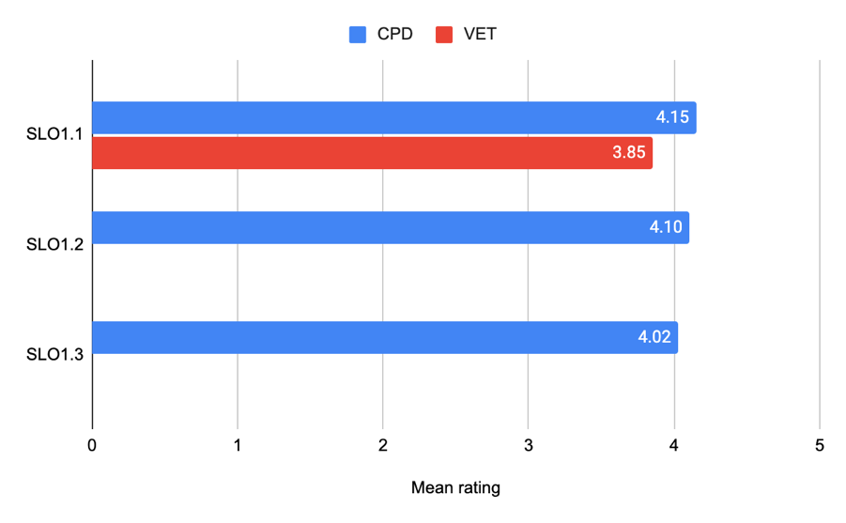
Figure 1. Mean feedback form question ratings for SLO1.1, SLO1.2 and SLO1.3
The data in Figure 1 shows that:
- Most participants reported a marked improvement in their understanding of aspects of violence covered in this SLO.
- CPD participants reported slightly greater increases in their understanding of the forms and drivers of sexual violence among adults than did VET participants.

Figure 2 shows the mean ratings for SLO1.1, SLO1.2 and SLO1.3 for various sub-groups of CPD participants.
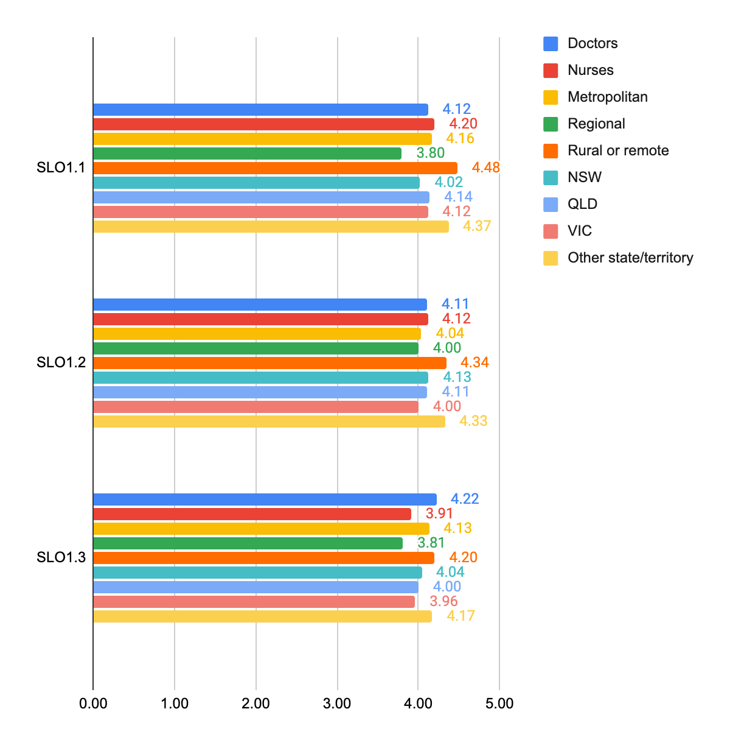Figure 2. Mean feedback form question ratings for SLO1.1, SLO1.2 and SLO1.3 for various sub-groups of CPD participants

Overall, for understanding the forms of sexual violence impacting adults:
- Doctors reported greater increased understanding of consent than did nurses
- Participants in rural and remote locations reported greater increases in all three SLOs than participants in other locations
- Participants in NSW, Victoria and QLD reported lesser increases in all three SLOs than participants overall in other states and territories.
Figure 3 shows the mean ratings for SLO1.1 for various sub-groups of VET participants.
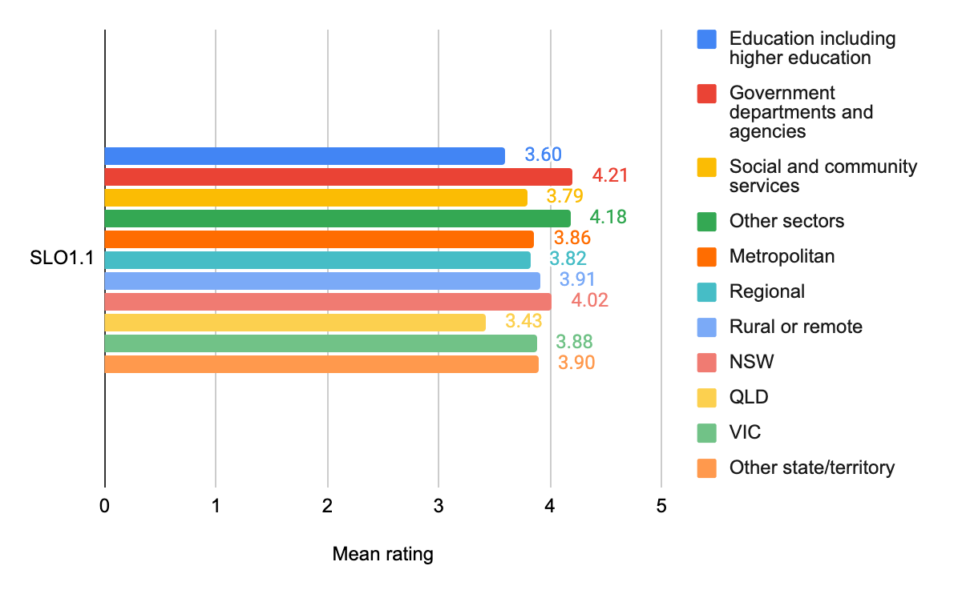Figure 3. Mean feedback form question ratings for SLO1.1 for various sub-groups of VET participants

Overall, for understanding of the forms and drivers of sexual violence (SLO1.1):
- Participants in education including higher education and in social and community services reported lesser increases in learning than participants in government departments and agencies and other sectors (in aggregate).
- Participants in rural and remote locations reported greater increases in learning than participants in other locations.
- Participants from Queensland reported lesser increases in learning than participants from NSW, Victoria and the other jurisdictions (in aggregate).

SLO 2 Understanding of the consequences of sexual violence on health, social, financial and community outcomes
This SLO was covered in question L2 in both the CPD Unit 1 and VET Unit 1 feedback forms. Figure 4 shows the mean ratings for SLO2 from the questions in the feedback form.
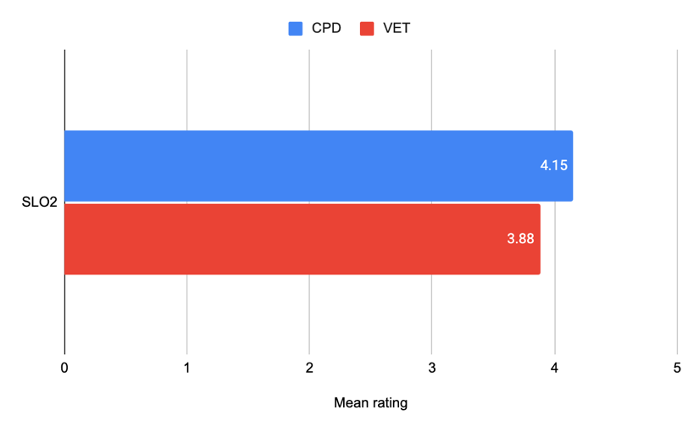
Figure 4. Mean feedback form question ratings for SLO2
- Most participants reported a marked improvement in their understanding of the consequences of sexual violence on health, social, financial and community outcomes covered in this SLO.
- CPD participants reported slightly greater increases in their understanding than did VET participants.
Figure 5 shows the mean ratings for SLO2 for various sub-groups of CPD participants.
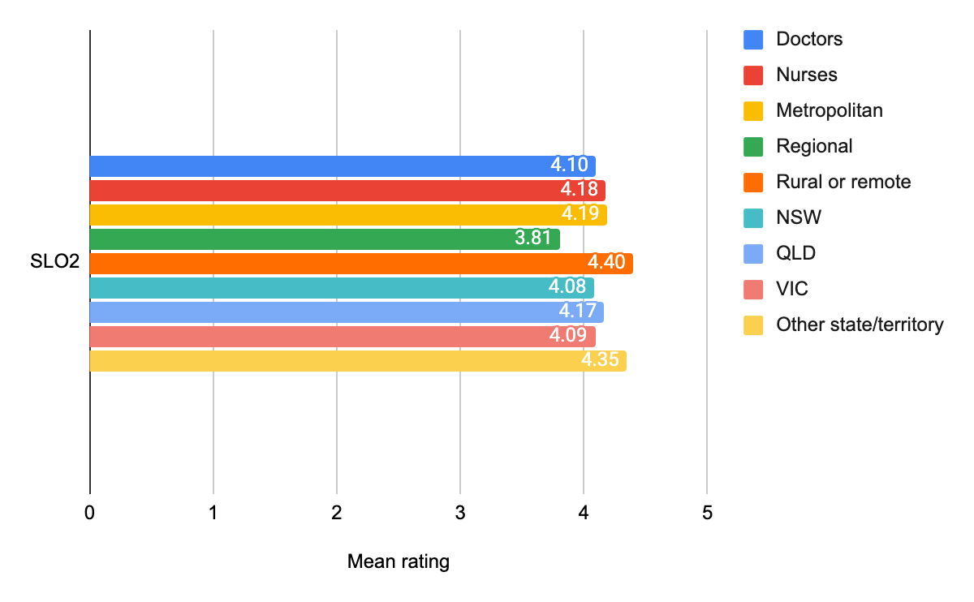Figure 5. Mean feedback form question ratings for SLO2 for various sub-groups of CPD participants

Overall, for reported increases in understanding of the consequences of sexual violence on health, social, financial and community outcomes:
- There was little difference between doctors and nurses
- Participants in regional locations reported lesser increases in understanding than participants in remote and rural locations
- The greatest reported increases in understanding occurred for participants outside NSW, Queensland and Victoria.
Figure 6 shows the mean ratings for SLO2 for various sub-groups of VET participants.
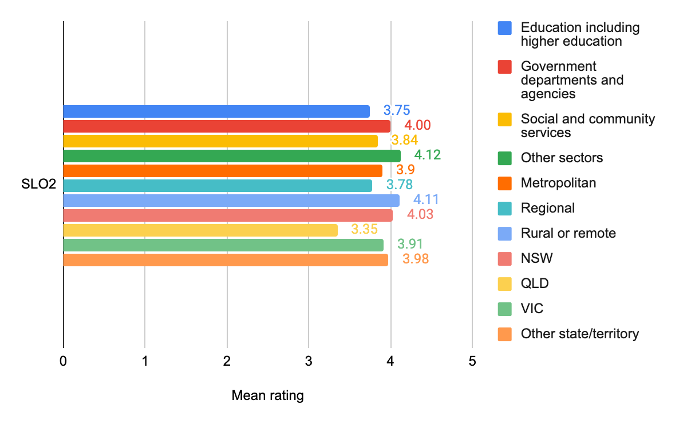Figure 6. Mean feedback form question ratings for SLO2 for various sub-groups of VET participants

Overall, for reported increases in understanding of the consequences of sexual violence on health, social, financial and community outcomes:
- Participants in education including higher education and in social and community services reported lesser increases in learning than participants in government departments and agencies and other sectors (in aggregate).
- Participants in rural and remote locations reported greater increases in learning than participants in other locations.
- Participants from Queensland reported lesser increases in learning than participants from NSW, Victoria and the other jurisdictions (in aggregate).

SLO 3 Understanding of barriers to disclosure and stages of disclosure
This SLO was covered in CPD Unit 2 and VET Unit 2. Figure 7 shows the mean ratings for SLO3 from questions L3a and L3b in the CPD and VET feedback forms.
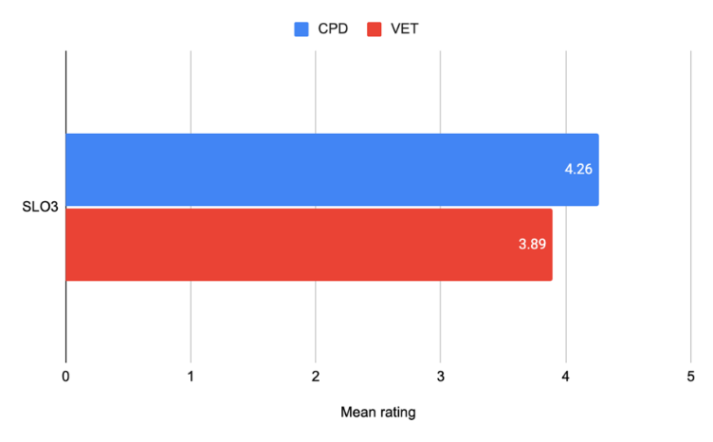
Figure 7. Mean feedback form question ratings for SLO3 from questions L3a and L3b for CPD and VET respondents
Overall, in terms of understanding of barriers to disclosure and stages of disclosures:

- Most participants reported a marked improvement in their understanding of the barriers to disclosure and the stages of disclosure covered in this SLO.
- CPD participants reported slight greater increases in their understanding than did VET participants.

Figure 8 shows the mean ratings for SLO3 for various sub-groups of CPD participants.
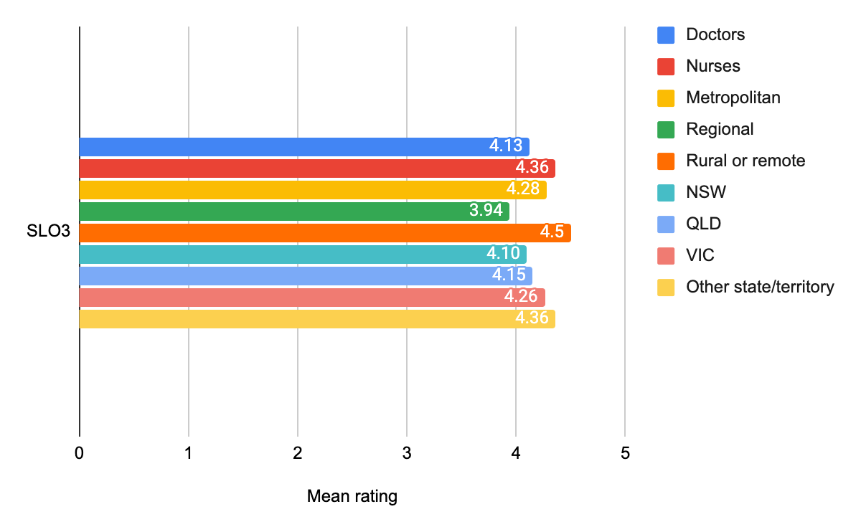Figure 8. Mean feedback form question ratings for SLO3 for various sub-groups of CPD participants
Overall, for reported increases in understanding of the barriers to disclosure and the stages of disclosure:
- Nurses reported greater increases in learning than doctors
- Participants in regional locations reported lesser increases in understanding than participants in metropolitan, remote and rural locations
- The greatest reported increases in understanding occurred for participants outside NSW, Queensland and Victoria.

Figure 9 shows the mean ratings for SLO3 for various sub-groups of VET participants.
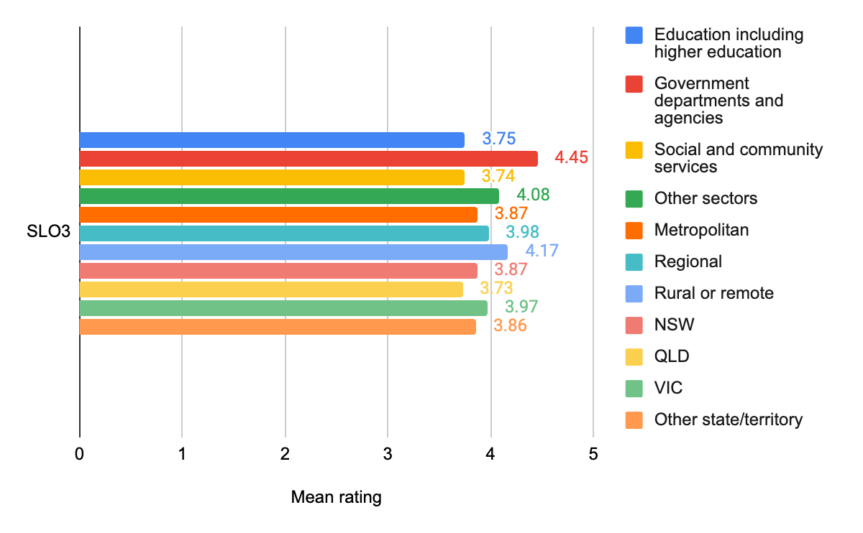Figure 9. Mean feedback form question ratings for SLO3 for various sub-groups of VET participants
Overall, for reported increases in understanding of the barriers to disclosure and the stages of disclosure:
- Participants in education including higher education and in social and community services reported lesser increases in learning than participants in government departments and agencies and other sectors (in aggregate).
- Participants in rural and remote locations reported greater increases in learning than participants in other locations.
- Participants from Queensland reported lesser increases in learning than participants from NSW, Victoria and the other jurisdictions (in aggregate).

SLO 4 Knowledge of resources and confidence to respond in a trauma-informed way
This SLO was covered in CPD Unit 2 and VET Units 1 and 2. Figure 10 shows the mean ratings for SLO4 from questions L4a and L4b in the CPD and VET feedback forms.
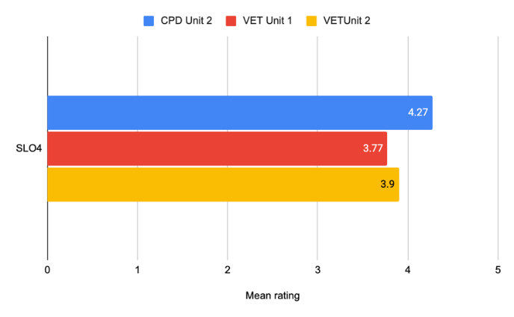
Figure 10. Mean feedback form question ratings for SLO4 from CPD and VET respondents
- Most participants reported a marked improvement in their knowledge of resources and confidence to respond in a trauma-informed way covered in this SLO.
- CPD participants reported slightly greater increases in their understanding than did VET participants.
- VET Unit 2 participants reported greater increases in learning than VET Unit 1 participants.

Figure 11 shows the mean ratings for SLO4 for various sub-groups of CPD participants.
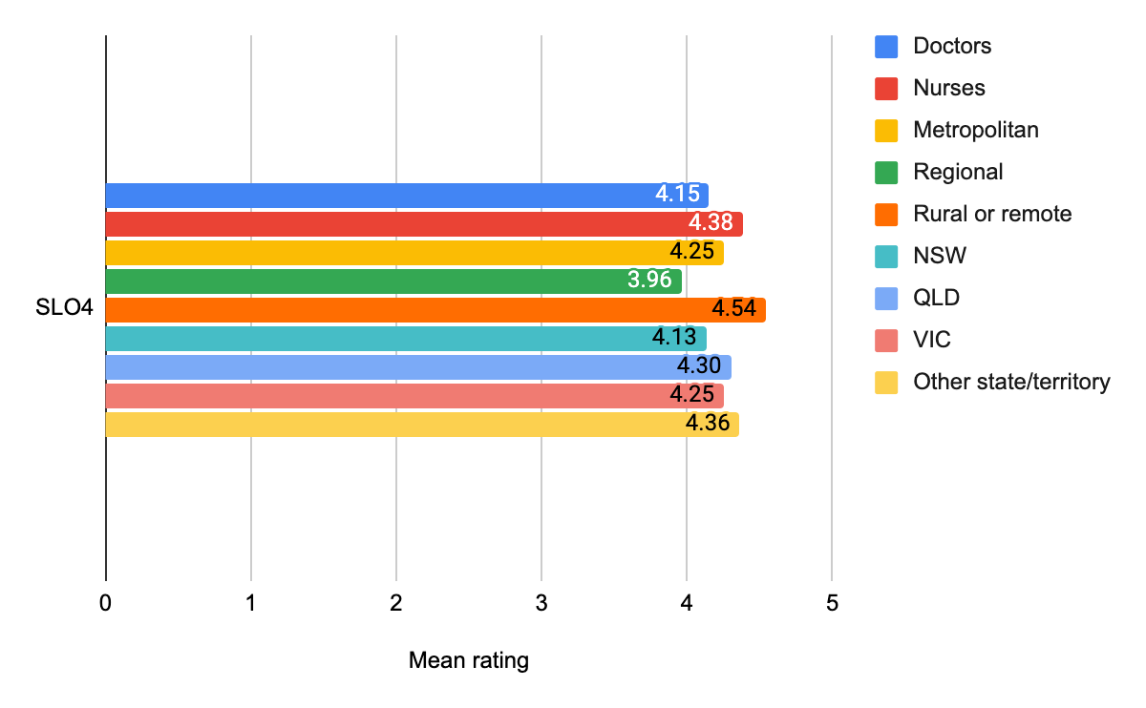Figure 11. Mean feedback form question ratings for SLO4 for various sub-groups of CPD participants
Overall, in terms of increases in knowledge of resources and confidence to respond in a trauma-informed way:
- Nurses reported greater increases in learning than did doctors
- Rural and remote participants reported greater learning than did their counterparts in other locations
- There were only minor differences in participants’ learning between jurisdictions.

Figure 12 shows the mean ratings for SLO4 for various sub-groups of VET participants.
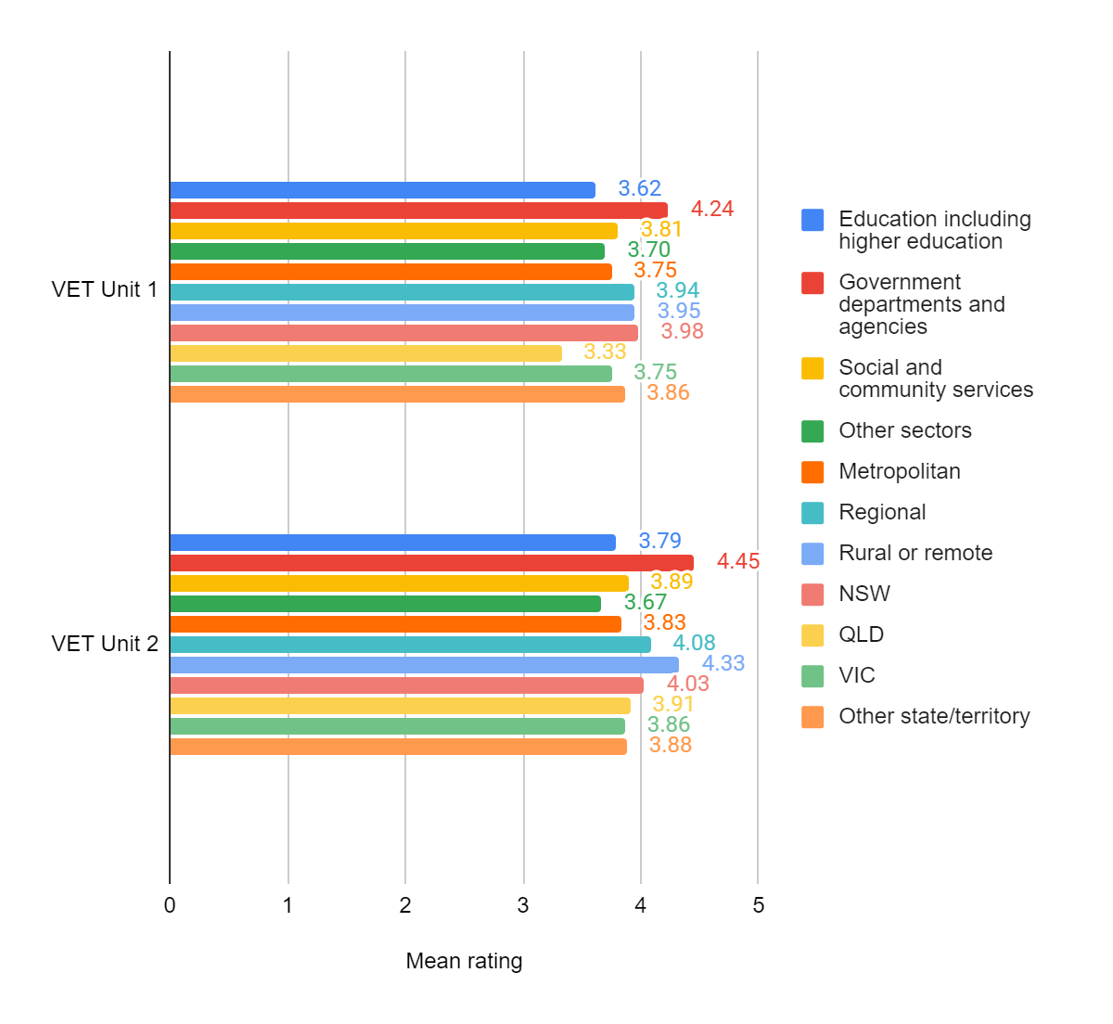Figure 12. Mean feedback form question ratings for SLO4 for various sub-groups of VET participants

Overall, in terms of increases in knowledge of resources and confidence to respond in a trauma-informed way:
- In both VET Units, participants from government departments and agencies reported greater increases in learning than did participants from other sectors
- In VET Unit 2, participants from rural and remote locations reported greater increases in learning than their counterparts in other locations
- In VET Unit 1, participants from Queensland reported lesser increases in learning than their counterparts from other jurisdictions.

SLO 5 Knowledge of trauma-informed and culturally appropriate responses
This SLO had two aspects:
- SLO 5.1 Knowledge of trauma-informed responses, covered in CPD Units 1 and 2 and VET Units 1 and 2.
- SLO5.2 Knowledge of culturally appropriate responses, covered in CPD Unit 3 and VET Unit 2.

SLO5.1 Knowledge of trauma-informed responses
Figure 13 shows the mean ratings for SLO5.1 from question L5a in the CPD and VET feedback forms.
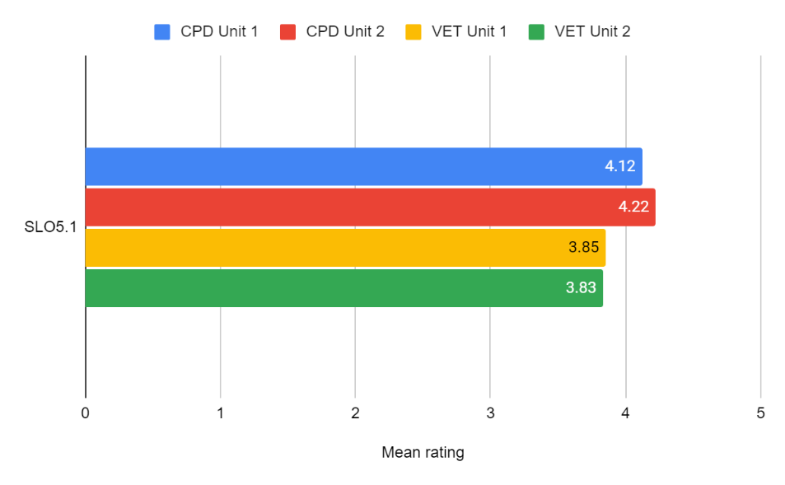
Figure 13. Mean feedback form question ratings for SLO5.1 from CPD and VET respondents
Overall, CPD participants in both units reported higher increases in knowledge of trauma-informed responses than did VET participants.
Figure 14 shows the mean ratings for SLO5.1 for various sub-groups of CPD participants in Units 1 and 2.
Overall, regarding knowledge of trauma-informed responses:
- The various sub-groups reported similar levels of increases in learning in CPD Unit 1, with rural and remote participants and participants in states other than NSW, Queensland and Victoria showing slightly higher increases
- For CPD Unit 2, rural and remote participants and participants in states other than NSW, Queensland and Victoria reported slightly higher increases, while participants from regional locations reported somewhat lower increases in learning than other sub-groups.
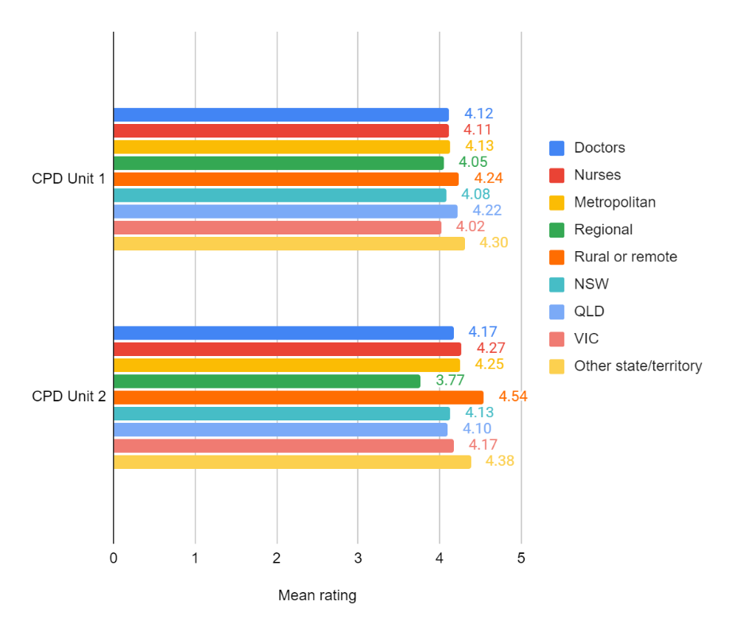
Figure 14. Mean feedback form question ratings for SLO5.1 for various sub-groups of CPD participants in Units 1 and 2

Figure 15 shows the mean ratings for SLO5.1 for various sub-groups of VET participants.
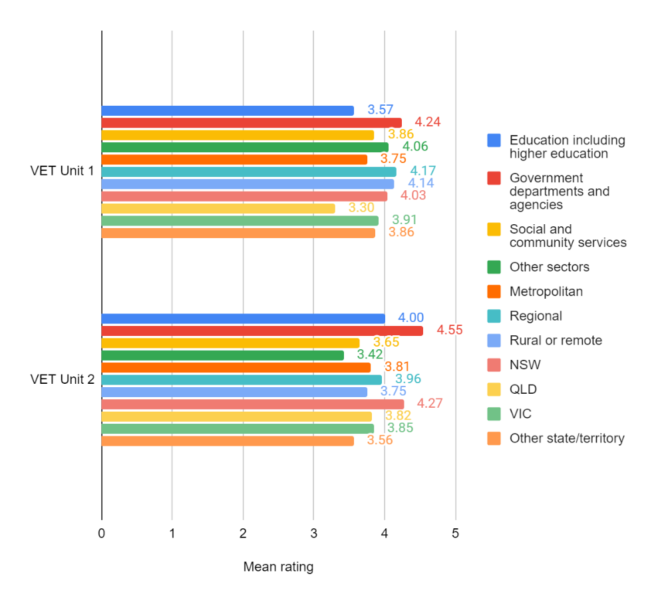
Figure 15. Mean feedback form question ratings for SLO5.1 for various sub-groups of VET participants
In terms of increases in knowledge of trauma-informed responses:
- In both VET Units, participants from government departments and agencies reported the greatest increases in knowledge
- VET Unit 1 participants based in metropolitan areas reported the lowest levels of knowledge increase, but there was little difference between VET Unit 2 participants in terms of location
- VET Unit 2 participants from NSW reported noticeably higher increases in knowledge than participants from other jurisdictions.

SLO 5.2 Knowledge of culturally appropriate responses
Figure 16 shows the mean ratings for SLO5.2 from questions L5b and L5C in the CPD and VET feedback forms.
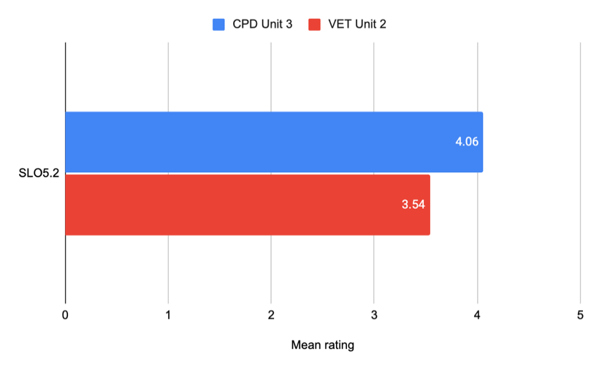
Figure 16. Mean feedback form question ratings for SLO5.2 from CPD and VET respondents
Overall, CPD participants reported greater increases in knowledge of culturally appropriate responses than did VET participants.
Figure 17 shows the mean ratings for SLO5.2 for various sub-groups of CPD Unit 3 participants.
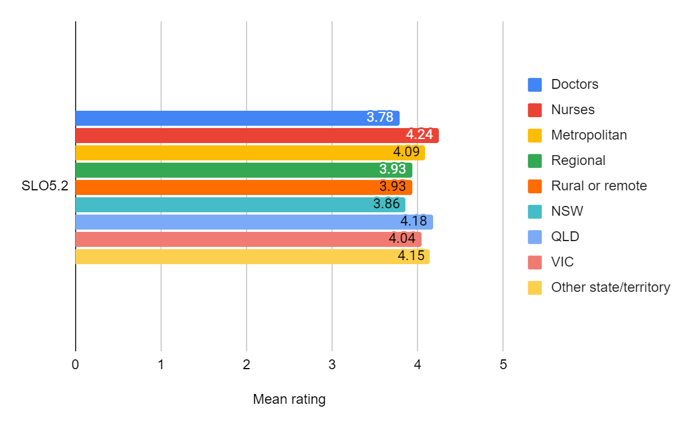Figure 17. Mean feedback form question ratings for SLO5.2 for various sub-groups of CPD Unit 3 participants
- Nurses reported greater increases in knowledge of culturally-appropriate responses than did doctors.
- There was little difference between participants in various locations or jurisdictions, although participants in NSW reported the least increase in knowledge of culturally-appropriate responses.

Figure 18 shows the mean ratings for SLO5.2 for various sub-groups of VET participants.
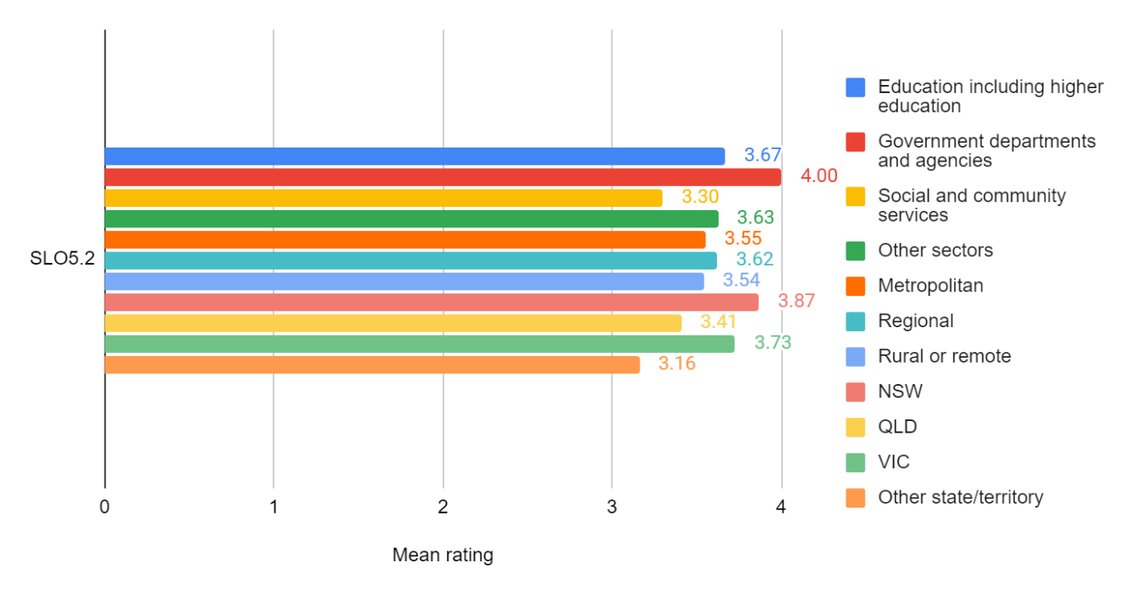Figure 18. Mean feedback form question ratings for SLO5.2 for various sub-groups of VET participants
- Participants from government departments and agencies reported greater increases in knowledge than participants from other sectors.
- There was little difference in increase in knowledge for participants from different locations
- Participants from NSW and Victoria reported greater increases in learning than participants from Queensland or the other jurisdictions (in aggregate).

SLO 6 Skills in trauma-informed and culturally appropriate responses
SLO6 had two aspects:
- SLO6.1 Skills in trauma-informed responses, covered in CPD Unit 2 and VET Units 1 and 2
- SLO6.2 Skills in culturally-appropriate responses, covered in CPD Unit 3 and VET Unit 2.

SLO6.1 Skills in trauma-informed responses
Figure 19 shows the mean ratings for SLO6.1 from question L6a in the CPD and VET feedback forms.
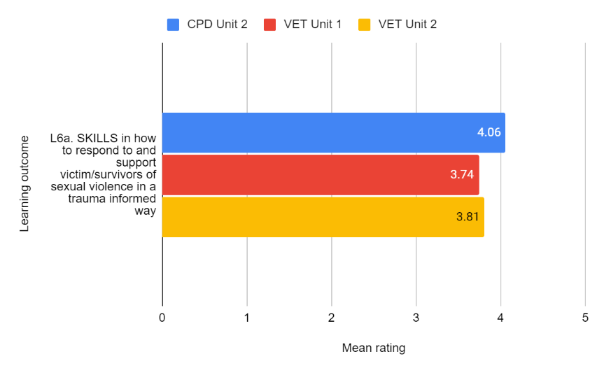
Figure 19. Mean feedback form question ratings for SLO6.1 from CPD and VET respondents
CPD Unit 3 participants reported greater increases in skills in trauma-informed approaches than did participants in either of the VET Units.

Figure 20 shows the mean ratings for SLO6.1 for various sub-groups of CPD Unit 3 participants.
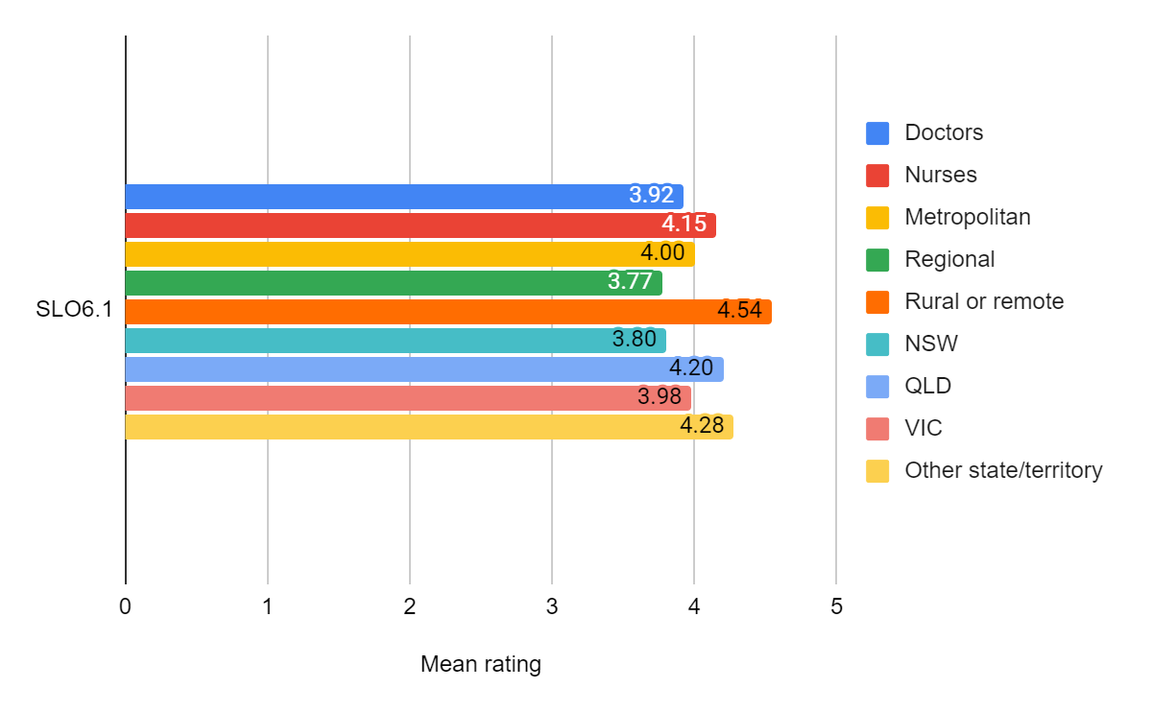Figure 20 Mean feedback form question ratings for SLO6.1 for various sub-groups of CPD Unit 3 participants
Overall, regarding skills in trauma-informed responses:
- Nurses reported somewhat greater increases in skills than did doctors
- Participants in rural and remote areas reported noticeably greater increases in skills than did participants in other locations
- Participants working NSW and Victoria reported lesser increases in skills than did participants in Queensland and the other jurisdictions (in aggregate).

Figure 21 shows the mean ratings for SLO6.1 for various sub-groups of VET Units 1 and 2 participants.
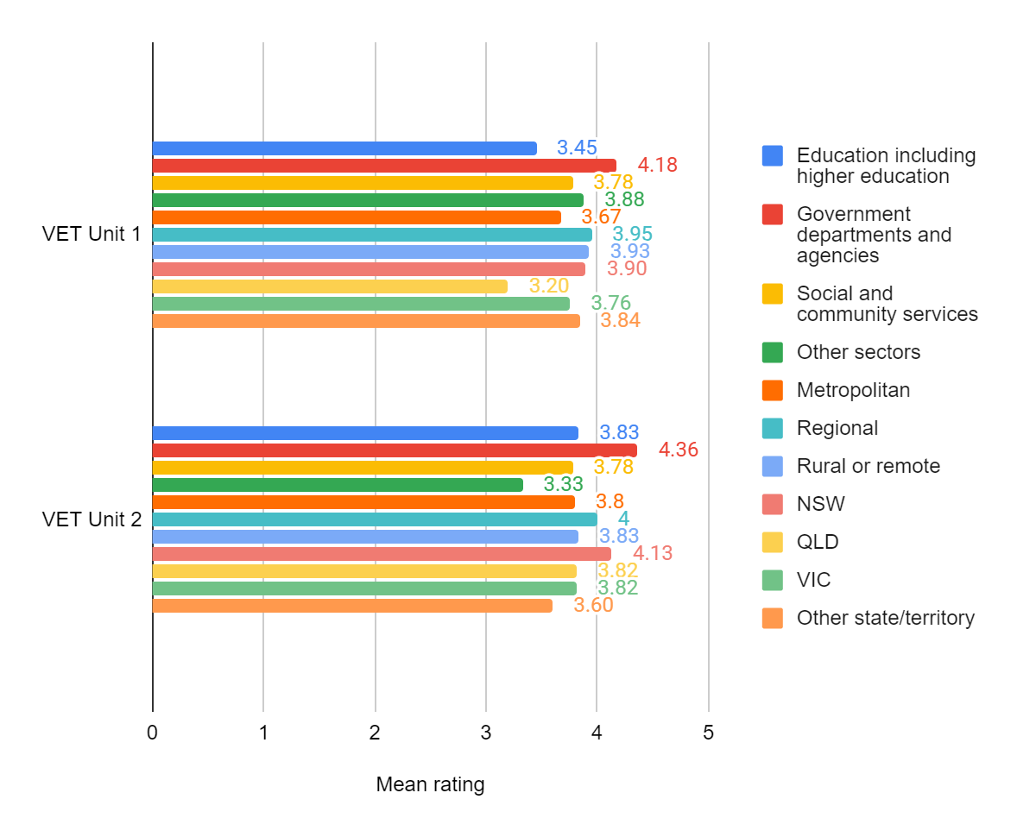Figure 21. Mean feedback form question ratings for SLO6.1 for various sub-groups of VET Units 1 and 2 participants

Overall, in terms of skills in trauma-informed responses:
- Participants working in government departments and agencies reported greater increases in skills in trauma-informed responses than participants working in other sectors.
- VET Unit 1 participants in metropolitan locations reported lesser increases in skills than participants in other locations, but variations based on location were less noticeable among VET Unit 2 participants.
- In VET Unit 1, reported increases in skills were noticeably lower for participants from Queensland than for participants from other jurisdictions.
- In VET Unit 2, reported increases in skills were noticeably higher for participants from NSW than for participants from other jurisdictions.

SLO6.2 Skills in culturally-appropriate responses
Figure 22 shows the mean ratings for SLO6.2 from questions L6b and L6c in the CPD and VET feedback forms.
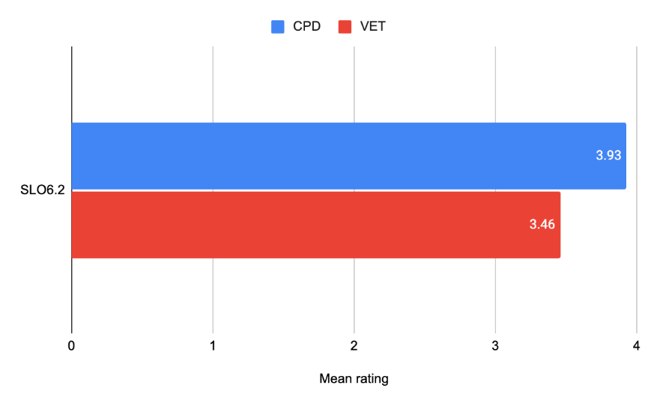
Figure 22. Mean feedback form question ratings for SLO6.2 from CPD and VET respondents
Overall, data from Figure 22 shows that regarding skills in culturally-appropriate responses:
- The mean ratings for skills in culturally-appropriate responses were noticeably lower for participants in both streams than for SLO 6.1 (skills in using a trauma-informed approach).
- CPD participants reported greater increases in skill development than did VET participants.

Figure 23 shows the mean ratings for SLO6.2 for various sub-groups of CPD Unit 3 participants.
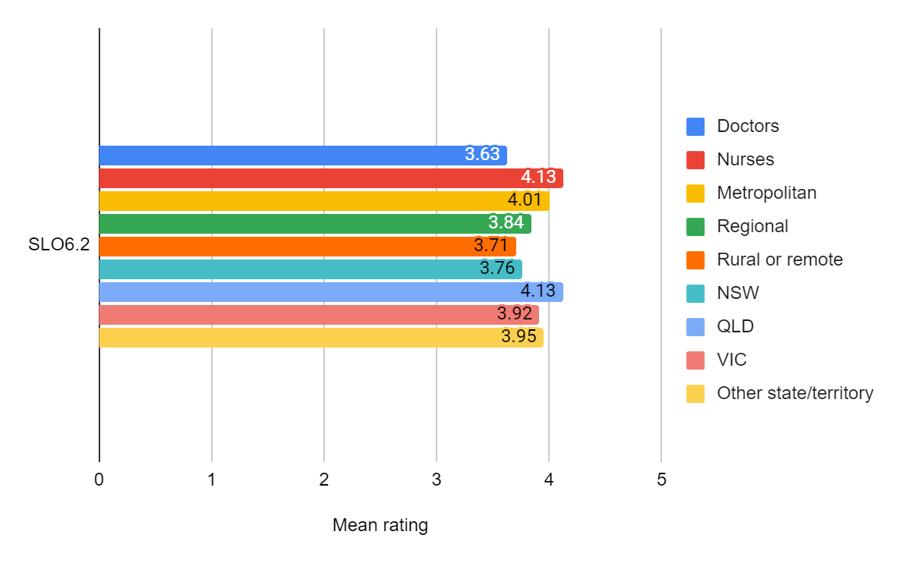Figure 23. Mean feedback form question ratings for SLO6.2 for various sub-groups of CPD Unit 3 participants
- Nurses reported greater increases in skills in culturally-appropriate responses than did doctors
- Participants in metropolitan areas reported greater increases in skills than did participants in rural and remote areas
- Participants in Queensland reported greater increases in skills than did participants from other jurisdictions.

Figure 24 shows the mean ratings for SLO6.2 for various sub-groups of VET Unit 2 participants.
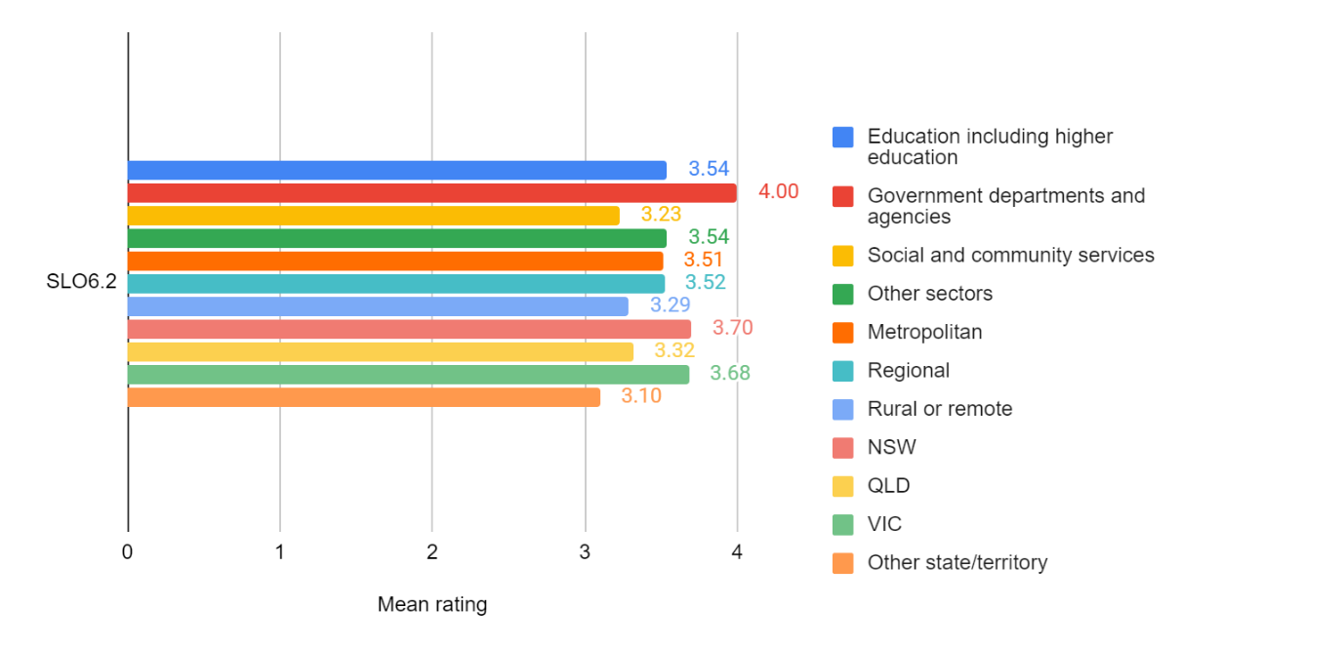Figure 24. Mean feedback form question ratings for SLO6.2 for various sub-groups of VET Unit 2 participants
- Participants working in government departments and agencies reported greater increases in skills in culturally-appropriate responses than did participants working in other sectors.
- Participants located in rural and remote areas reported lower increases in skills than participants in other locations.
- Participants in NSW and Victoria reported greater increases in skills than participants from other jurisdictions.

SLO 7 Understanding of practical techniques and knowledge and confidence to make referrals
This SLO had two aspects:
- SLO7.1 Understanding of supporting disclosures, covered in CPD Unit 2 and VET Unit 2
- SLO7.2 Knowledge and confidence in making referrals, covered in CPD Unit 2 and VET Unit 2.

SLO7.1 Understanding of supporting disclosures
Figure 25 shows the mean ratings for SLO7.1 from question L7a in the CPD feedback form and questions 7c and 7d in the VET feedback forms.
Due to the different nature of the kind of support that health care professionals need to provide compared to non-health care professionals, the feedback forms asked about different kinds of support. For example, non-health care professionals would not be involved in undertaking a forensic examination upon disclosure of a sexual assault.
Question 7a asked CPD participants to rate their “understanding of practical techniques and skills to support disclosures of sexual assault (e.g. history taking, documentation, examination process)”.
Question 7c asked VET participants to rate their “understanding of risk assessment as part of supporting disclosures of sexual assault”, while question 7d asked VET participants to rate their “understanding of safety planning as part of supporting disclosures of sexual assault.”

Figure 25 reveals that CPD participants reported greater increases in understanding of how to support disclosure than did VET participants.
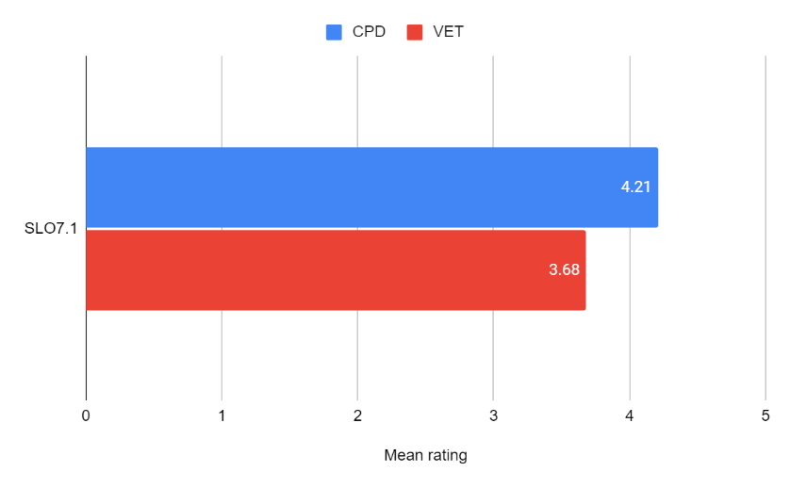
Figure 25. Mean feedback form question ratings for SLO7.1 from question L7a in the CPD feedback form and questions 7c and 7d in the VET feedback forms

Figure 26 shows the mean ratings for SLO7.1 for various sub-groups of CPD Unit 2 participants.
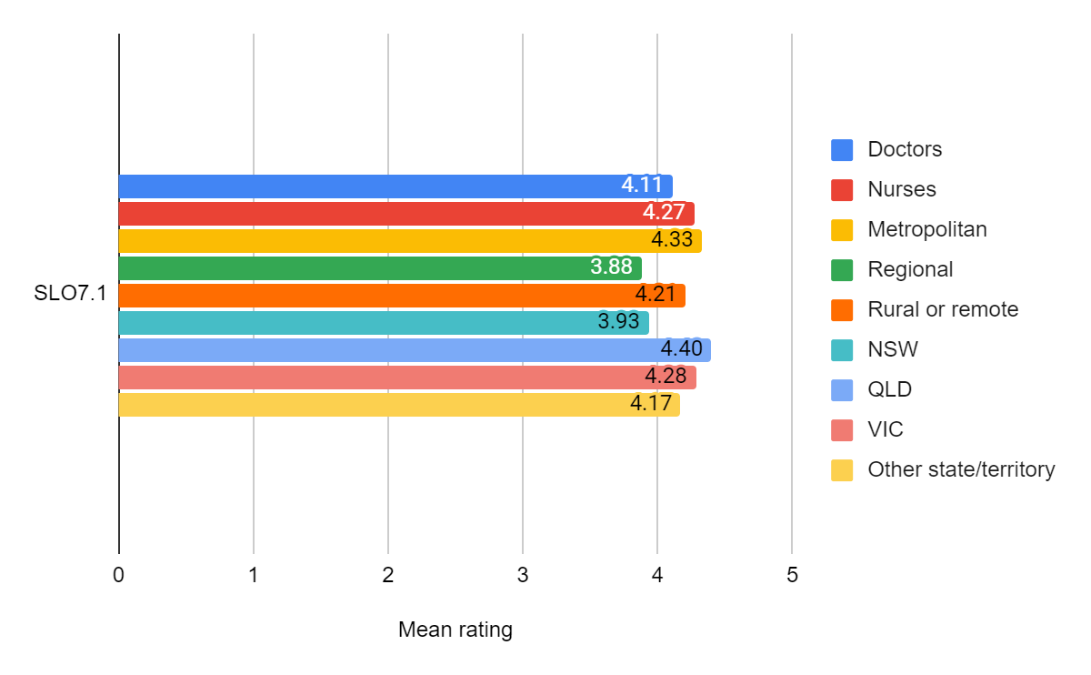Figure 26. Mean feedback form question ratings for SLO7.1 for various sub-groups of CPD Unit 2 participants
According to the data in Figure 26:
- Nurses reported greater increases in understanding of how to support disclosures than did doctors
- Metropolitan and rural and remote participants reported greater increases in understanding than did participants in regional areas
- Participant based in NSW reported lesser increases in understanding than did participants from other jurisdictions.

Figure 27 shows the mean ratings for SLO7.1 for various sub-groups of VET Unit 2 participants.
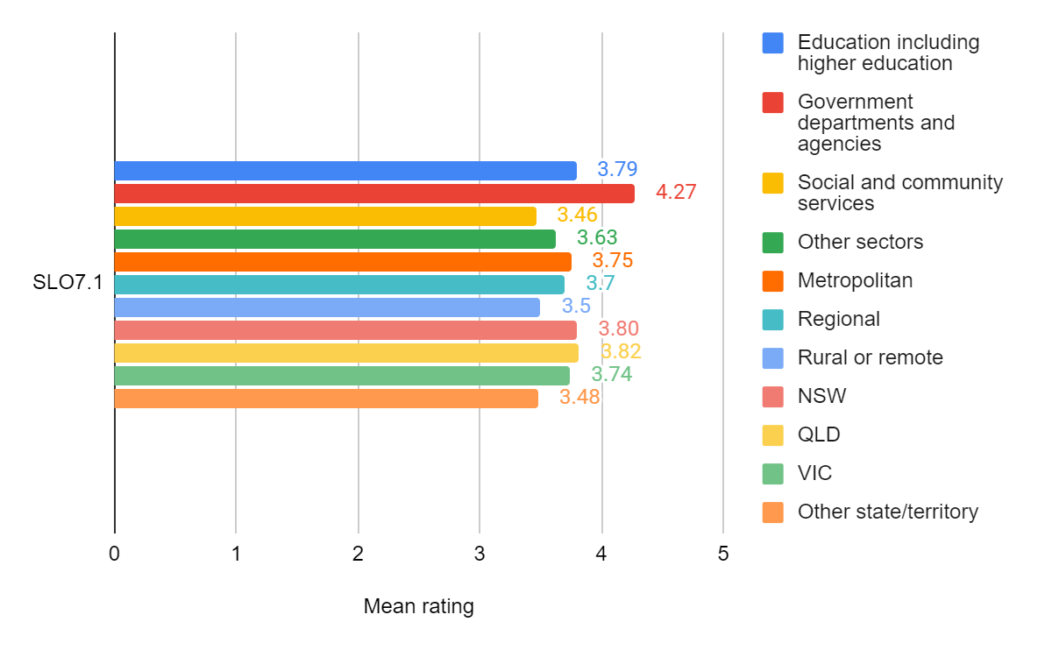Figure 27. Mean feedback form question ratings for SLO7.1 for various sub-groups of VET Unit 2 participants
Based on the data in Figure 27:
- Participants from government departments and agencies reported greater increases in understanding of how to support disclosures than did participants from other sectors
- Metropolitan and rural and remote participants reported greater increases in understanding than did participants in regional areas
- Participants in NSW, Queensland and Victoria reported greater increases in understanding than did participants from other jurisdictions.

SLO7.2 Knowledge and confidence in making referrals
Figure 28 shows the mean ratings for SLO7.2 from question L7b in the CPD and VET feedback forms.
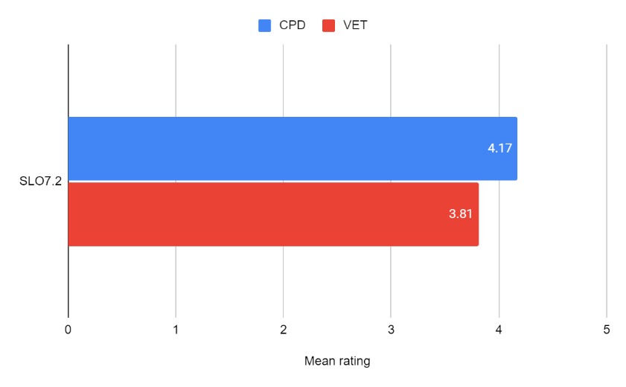
Figure 28. Mean feedback form question ratings for SLO7.2 from CPD and VET respondents
The data reveals that CPD participants reported greater increases in knowledge and confidence in making referrals than did VET participants.

Figure 29 shows the mean ratings for SLO7.2 for various sub-groups of CPD Unit 2 participants.
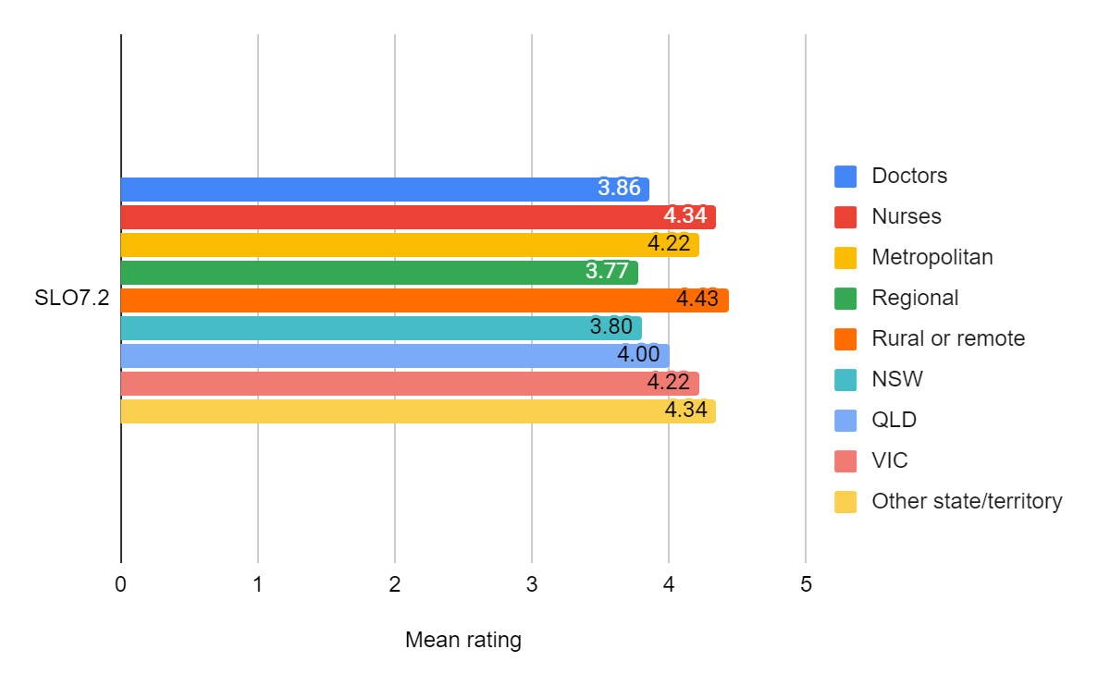Figure 29. Mean feedback form question ratings for SLO7.2 for various sub-groups of CPD Unit 2 participants
The data in Figure 29 reveals that:
- Nurses reported greater increases in knowledge and confidence in making referrals than did doctors
- Metropolitan and rural and remote participants reported greater increases in knowledge and confidence than did participants in regional areas
- Participant based in NSW reported lesser increases in knowledge and confidence than did participants from other jurisdictions.

Figure 30 shows the mean ratings for SLO7.2 for various sub-groups of VET Unit 2 participants.
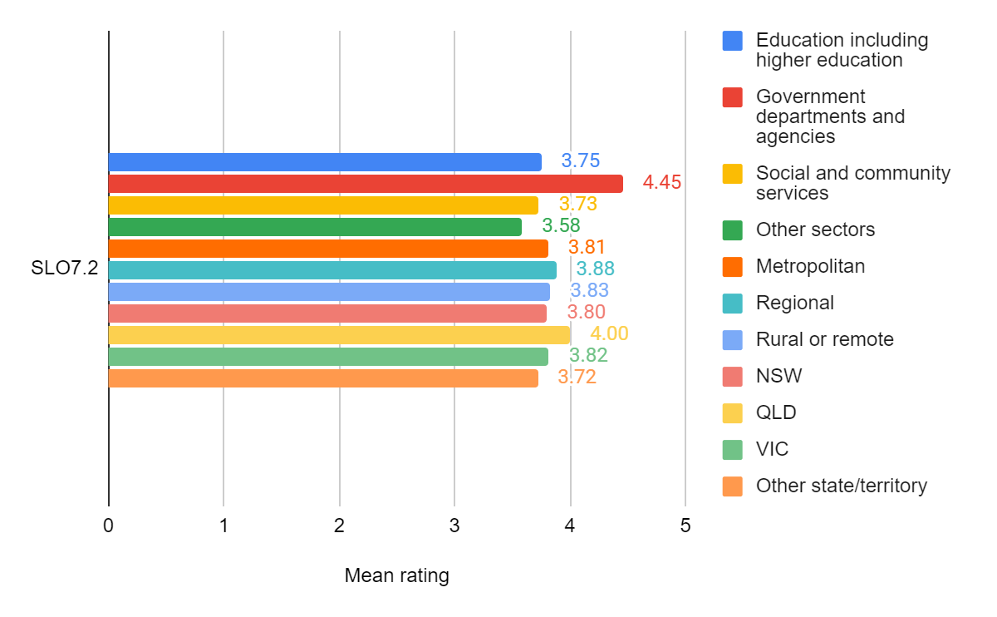Figure 30. Mean feedback form question ratings for SLO7.2 for various sub-groups of VET Unit 2 participants
Based on the data in Figure 30:
- Participants from government departments and agencies reported greater increases in knowledge and confidence for making referrals than did participants from other sectors
- There was little difference in increases in knowledge and confidence to make referrals between participants from metropolitan, regional, rural or remote locations
- Participants in Queensland reported greater increases in knowledge and confidence than did participants from other jurisdictions.

SLO 8 Understanding the complexities of sexual violence for victim/ survivors from at-risk cohorts
This SLO had three aspects, all covered in CPD Unit 3 and VET Unit 2:
- SLO8.1 General understanding of the complexities of sexual violence for victim/survivors from at-risk cohorts
- SLO8.2 Confidence to respond to and support diverse groups.
- SLO8.3 Understanding of complexities for specific cohorts.

SLO8.1 General understanding of the complexities of sexual violence for victim/survivors from at-risk cohorts and SLO8.2 Confidence to respond to and support diverse groups
Figure 31 shows the mean ratings for SLO8.1 and SLO 8.2 from questions L8a and L8c in the CPD and VET feedback forms.
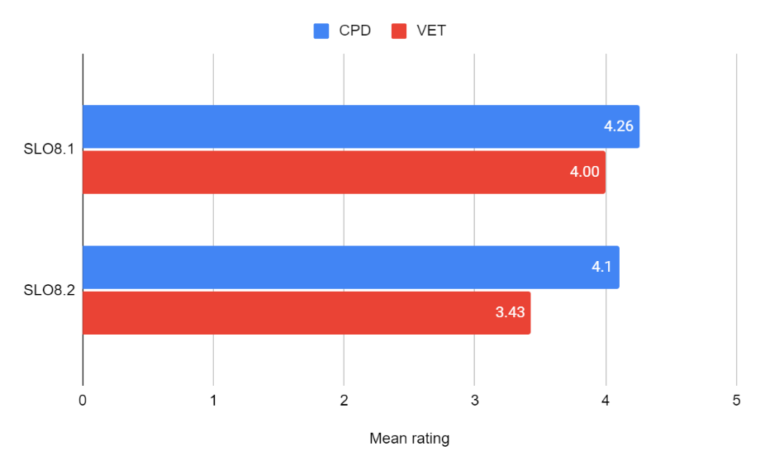
Figure 31. Mean feedback form question ratings for SLO8.1 and SLO 8.2 from questions L8a and L8c in the CPD and VET feedback forms

Overall, Figure 31 reveals that CPD participants reported greater increases in learning than VET participants for both their general understanding of the complexities of sexual violence for victim/survivors from at-risk cohorts and their confidence to respond to and support diverse groups.
Figure 32 shows the mean ratings for SLO8.1 and SLO8.2 for various sub-groups of CPD Unit 3 participants.
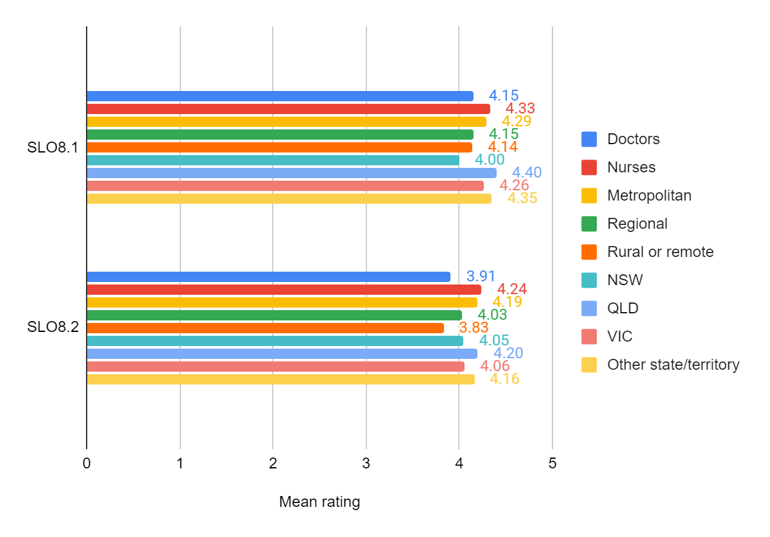Figure 32. Mean feedback form question ratings for SLO8.1 and SLO8.2 for various sub-groups of CPD Unit 3 participants

The data in Figure 32 reveals that:
- Nurses reported greater increases in learning than doctors for both SLOs
- Participants working in metropolitan locations reported greater increases in both understanding (SLO8.1) and confidence (SLO8.3) than did their counterparts in other locations.
- Participants in Queensland reported greater increases in understanding and confidence than did their colleagues in other jurisdictions.

Figure 33 shows the mean ratings for SLO8.1 and SLO8.2 for various sub-groups of VET Unit 2 participants.
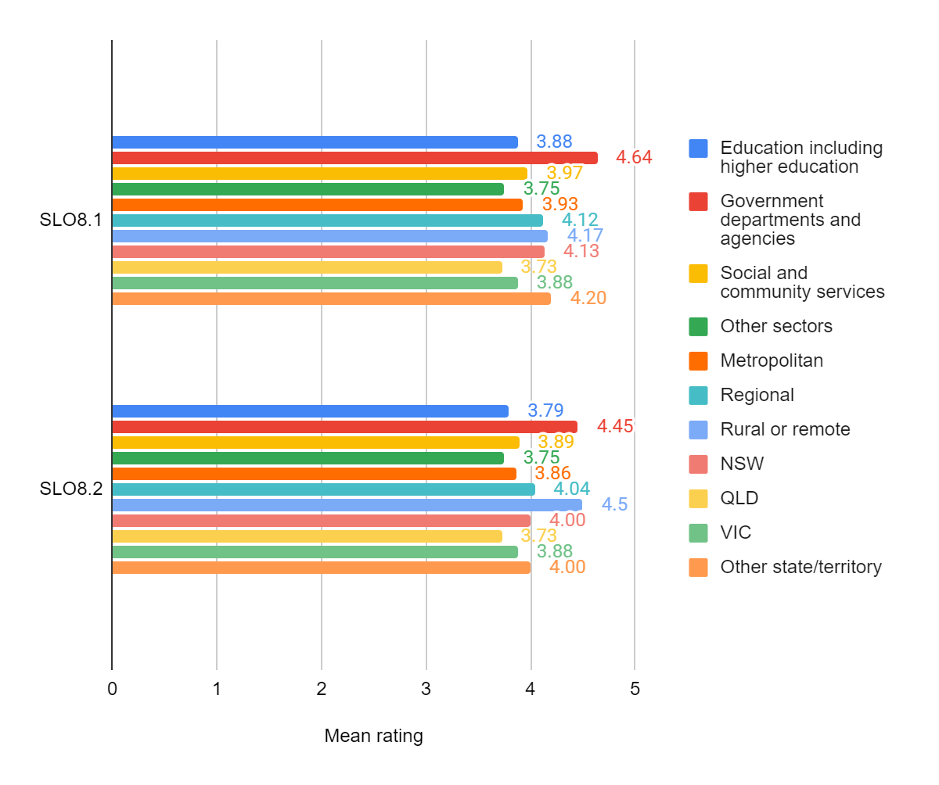Figure 33. Mean feedback form question ratings for SLO8.1 and SLO8.2 for various sub-groups of VET Unit 2 participants

The data in Figure 33 reveals that:
- Participants from government departments and agencies reported greater increases in learning for both SLOs than did participants from other sectors
- Participants in rural and remote locations reported greater increases in their learning for both SLOs, and particularly in their confidence to support diverse groups (SLO8.2)
- Participants in Queensland reported lesser increases in learning for both SLOs than did participants from other jurisdictions.

SLO8.3 Understanding of complexities for specific cohorts
The data presented in this section comprises the mean scores for participants ratings of their “understanding of responding to the complexities of sexual violence for victim/survivors” from particular cohorts (question 8b in the feedback forms). The question had seven (CPD) or eight (VET) parts, one for each cohort, namely, Aboriginal and Torres Strait Islander peoples, members of culturally and linguistically diverse communities, people with disability, older adults, LGBTQI+ people, youth aged 15-24, sex workers, and (for VET participants) people in rural and remote locations. The mean scores for each part of the question can be found in Annex P.

Figure 34 shows the mean ratings for SLO8.3 from the seven parts of question L8b in the CPD feedback form for CPD Unit 3 and the eight parts of question L8b in the VET feedback form for VET Unit 2.

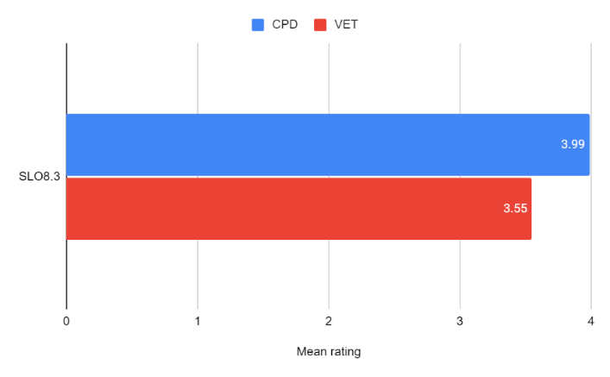
Figure 34. Mean feedback form question ratings for SLO8.3 from the seven parts of question L8b in the CPD feedback form for CPD Unit 3 and the eight parts of question L8b in the VET feedback form for VET Unit 2
Figure 34 reveals that CPD participants overall reported greater understanding of responding to the complexities of specific cohorts than did VET participants.

Figure 35 shows the mean ratings for SLO8.3 for various sub-groups of CPD Unit 3 participants.

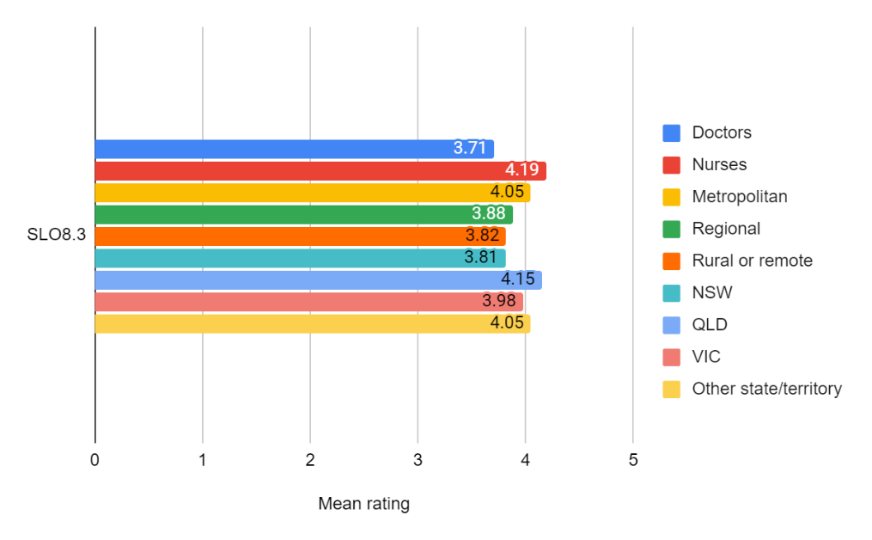
Figure 35. Mean feedback form question ratings for SLO8.3 for various sub-groups of CPD Unit 3 participants
The data in Figure 35 reveals that for SLO8.3:
- Nurses reported greater increases in learning than doctors
- Participants working in metropolitan locations reported greater increases in learning than did their counterparts in other locations.
- Participants in Queensland reported greater increases in learning than did their colleagues in other jurisdictions.

Figure 36 shows the mean ratings for SLO8.3 for various sub-groups of VET Unit 2 participants.

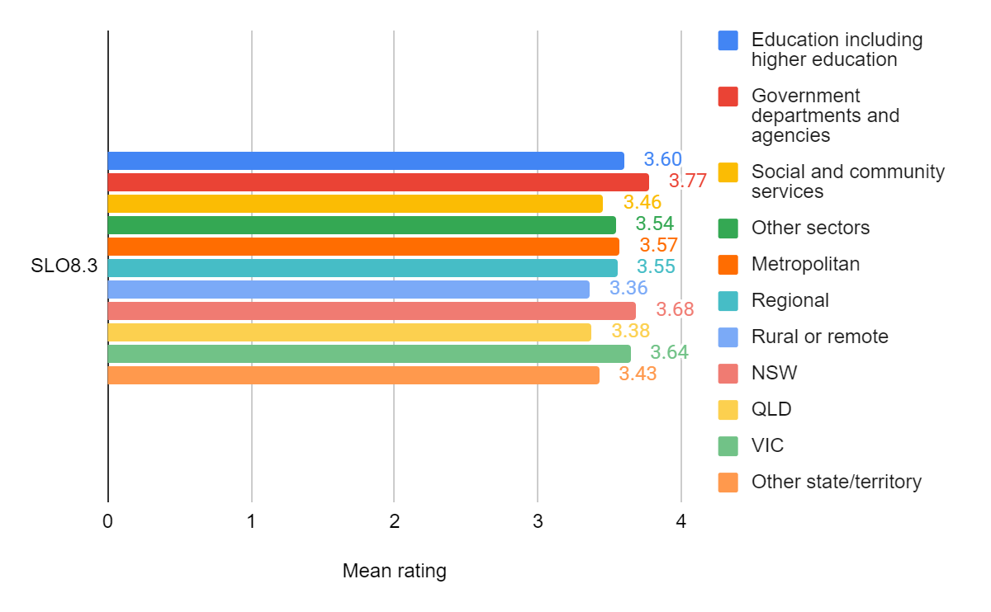Figure 36. Mean feedback form question ratings for SLO8.3 for various sub-groups of VET Unit 2 participants
From Figure 36, it can be seen that:
- Participants from government departments and agencies reported greater increases in learning for SLO8.3 than did participants from other sectors
- Participants in rural and remote locations reported lesser increases in their learning than did their metropolitan and regional counterparts
- Participants in NSW and Victoria reported greater increases in learning than did participants from other jurisdictions.

SLO 9 Understanding and application of the Adult Sexual Violence Healthcare Response Tool
This SLO was covered in CPD Unit 2. The question asked how participants rated their “understanding of how to use the Adult Sexual Violence Healthcare Response Tool (SVHRT)”. Figure 37 shows the overall results for SLO9 and the results for various sub-groups of participants in CPD Unit 2.
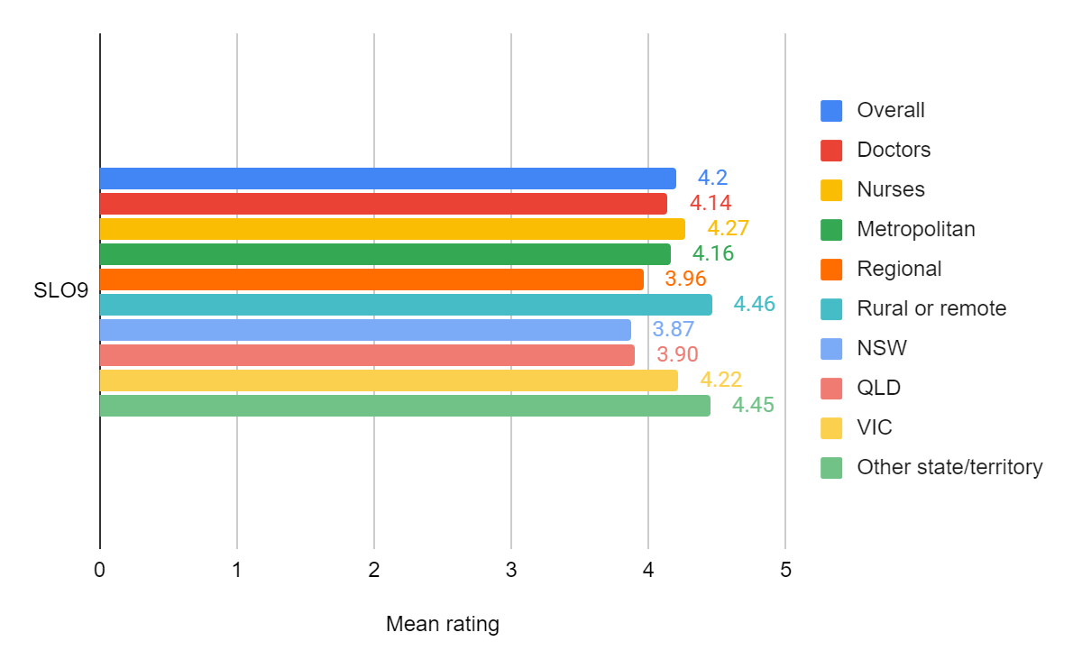Figure 37. Overall Mean feedback form ratings for SLO9 and the men ratings for various sub-groups of participants in CPD Unit 2
The data in Figure 37 show that:
- Nurses reported greater increases in understanding of how to use the SVHRT than did doctors
- Participants who work in rural and remote locations reported greater increases in understanding of how to use the SVHRT than did participants in other locations
- Participants in NSW and Queensland reported lesser increases in understanding of how to use the SVHRT than did participants in other jurisdictions.

Overall self-reported achievement of learning outcomes
Table 6 shows the mean achievement ratings for each SLO and SLO aspect for each unit in which that learning outcome was covered. The means and standard deviations for each SLO feedback form question in each unit can be found in Annex P.
Table 6. Mean achievement ratings for each SLO and SLO aspect for each unit in which the SLO was covered
SLO | SLO definition | Mean rating
SLO4 CPD Unit 2 | Knowledge of resources and confidence to respond in a trauma-informed way | 4.27
SLO3 CPD Unit 2 | Understanding of barriers to disclosure and stages of disclosure | 4.26
SLO8.1 CPD Unit 3 | General understanding of complexities | 4.26
SLO5.1 CPD Unit 2 | Knowledge of trauma-informed responses | 4.22
SLO7.1 CPD Unit 2 | Understanding of supporting disclosures | 4.21
SLO9 CPD Unit 2 | Understanding and application of the Adult Sexual Violence Response Tool | 4.20
SLO7.2 CPD Unit 2 | Knowledge and confidence in making referrals | 4.17
SLO2 CPD Unit 1 | Understanding of the consequences of sexual violence on health, social, financial and community outcomes | 4.15
SLO1.1 CPD Unit 1 | Understanding of forms and drivers of sexual violence | 4.15
SLO5.1 CPD Unit 1 | Knowledge of trauma-informed responses | 4.12
SLO1.2 CPD Unit 1 | Understanding of reinforcing factors, impact of social disruption | 4.10
SLO8.2 CPD Unit 3 | Confidence to respond to and support diverse groups | 4.10
SLO5.2 CPD Unit 3 | Knowledge of culturally-appropriate responses | 4.06
SLO6.1 CPD Unit 2 | Skills in trauma-informed responses | 4.06
SLO1.3 CPD Unit 1 | Understanding of consent | 4.02
SLO8.1 VET Unit 2 | General understanding of complexities | 4.00
SLO8.3 CPD Unit 3 | Understanding of complexities for specific cohorts | 3.99
SLO6.2 CPD Unit 3 | Skills in culturally-appropriate responses | 3.93
SLO4 VET Unit 2 | Knowledge of resources and confidence to respond in a trauma-informed way | 3.90
SLO3 VET Unit 2 | Understanding of barriers to disclosure and stages of disclosure | 3.89
SLO2 VET Unit 1 | Understanding of the consequences of sexual violence on health, social, financial and community outcomes | 3.88
SLO1.1 VET Unit 1 | Understanding of forms and drivers of sexual violence | 3.85
SLO5.1 VET Unit 1 | Knowledge of trauma-informed responses | 3.85
SLO5.1 VET Unit 2 | Knowledge of trauma-informed responses | 3.83
SLO6.1 VET Unit 2 | Skills in trauma-informed responses | 3.81
SLO7.2 VET Unit 2 | Knowledge and confidence in making referrals | 3.81
SLO4 VET Unit 1 | Knowledge of resources and confidence to respond in a trauma-informed way | 3.77
SLO6.1 VET Unit 1 | Skills in trauma-informed responses | 3.74
SLO7.1 VET Unit 2 | Understanding of supporting disclosures | 3.68
SLO8.3 VET Unit 2 | Understanding of complexities for specific cohorts | 3.55
SLO5.2 VET Unit 2 | Knowledge of culturally-appropriate responses | 3.54
SLO6.2 VET Unit 2 | Skills in culturally-appropriate responses | 3.46
SLO8.2 VET Unit 2 | Confidence to respond to and support diverse groups | 3.43

The rating scale invited participants to rate their learning outcome achievement from 1 (“About the same as before I did this unit) to 5 (“Much greater than before I did this unit”). All the mean ratings are above the midpoint of the scale. This indicates a substantive amount of learning compared to the participants perceived level prior to undertaking the unit. In general, CPD participants perceived that they attained greater achievement on the SLOS than the VET participants.

Discussion of and conclusions regarding self-reported achievement of learning outcomes
Most of the unit participants perceived that units they undertook made a substantive contribution to increasing their knowledge, understanding, confidence or skills.
As noted in the previous section, CPD participants tended to provide higher ratings of perceived SLO achievement than did VET participants. A probable reason for this difference is that the VET cohorts tended to include participants working in a range of sectors and occupations potentially related to recognising and responding to sexual assault. More than two thirds of the participants in each of VET Unit 1 and 2 worked in social and community services and education. Many of these participants may have already been familiar with some of the concepts covered in the courses. Therefore, their perception of increases in their learning resulting from a unit was not as great as the perception of participants who had not already been exposed to the concepts and knowledge. These results suggest that the VET units were less relevant and effective than the CPD units, at least for some groups of professionals. This means that the VET unit content could be made more advanced or some of the content could be reduced if it is already somewhat familiar. This in turn would address issues pertaining to workload and efficiency.
Participants perceived that their skills increased more in trauma-informed responses (SLO6.1) than in culturally-appropriate responses (SLO6.2). This could be because the training methods or content was not as effective at teaching culturally appropriate responses skills, baseline skill levels were higher for culturally-appropriate responses, culturally-appropriate skills are harder to teach than trauma-informed response skills using an online approach, or, in the case of CPD units, the limited time available to cover a wide range of social and cultural groups.
The analysis above provided some noteworthy variations in self-rated perceptions of learning among CPD sub-groups undertaking the units:
- Nurses rated their advances in learning noticeably more highly than doctors in 10 of the 16 SLOs/SLO aspects. The only SLO aspect in which doctors had noticeably greater perceptions of learning than nurses was in SLO1.3 “Knowledge of consent”.
- Among CPD participants, participants working in metropolitan locations rated their learning higher than their counterparts in other locations for six SLO/SLO aspects. Five of these SLOs/SLO aspects related to addressing diversity (SLOs 5.2, 6,2, 8.1, 8.2 and 8.3).
- Among CPD participants, those working in rural or remote locations rated their learning higher than their counterparts in other locations for ten of the SLOs.
- Among CPD participants, those in Queensland tended to give higher ratings than their counterparts in other jurisdictions to the SLOS related to diversity (including SLO5.2, 8.1, 8.2 and 8.3). Participants in jurisdictions other than NSW, QLD and Victoria provided the highest mean ratings for ten of the SLOs, which probably correlates with the extent to which these jurisdictions have remote and rural locations.
For VET participants, the analysis above provided some noteworthy variations in self-rated perceptions of learning among sub-groups undertaking the units:
- Participants working in government departments and agencies gave the highest mean ratings for all the SLOs compared to their counterparts in education, social and community work and the “other sectors” aggregation. A probable explanation for this is that workers in government departments and agencies may be less likely to be working directly in frontline services, although this depends on jurisdiction.
- VET participants in regional locations gave the highest mean ratings to six of the 13 VET SLOs, while those in rural and remote locations gave the highest mean ratings to another five SLOs.
- Participants from NSW provided the highest mean rating on eight of the 13 VET SLOs, suggesting that these participants perceived they learned more from the unit than their counterparts in other jurisdictions.
Overall, the CPD units were reported to be of most learning value to nurses and to participants in the smaller jurisdictions. Topics related to social and cultural diversity were of most value to metropolitan participants, while the other topics were considered of most value to rural and remote participants.
The VET units were considered of greatest value by participants from government departments and agencies, those in regional, rural, and remote locations, and those working in NSW.

Evaluation question 2: Quality of the units and their delivery
Information on the quality of the units and their delivery was obtained from unit feedback forms and interviews. One question in the feedback forms focused on participants’ overall satisfaction with the unit. Other feedback form and participant and facilitator interview questions probed for respondents’ views on the relevance, efficiency and effectiveness and of the units and their delivery.

Overall satisfaction with the units
Figure 38 shows the mean responses to the question asking respondents to “indicate how satisfied you were with this unit", on a scale of 1 (very unsatisfied) to 5 (very satisfied).
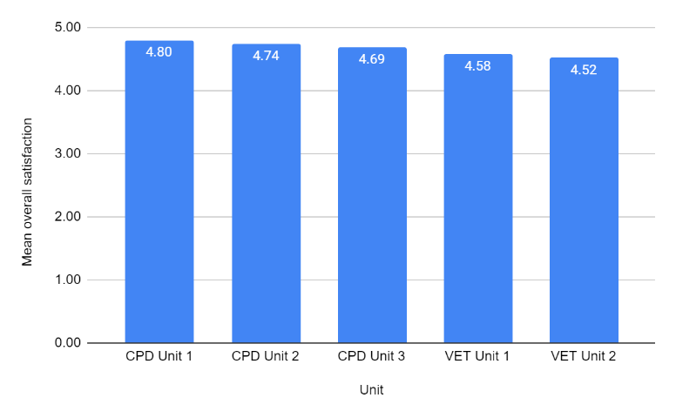
Figure 38. Mean responses to the question asking respondents to “indicate how satisfied you were with this unit", on a scale of 1 (very unsatisfied) to 5 (very satisfied)
On average, respondents in each unit were more than satisfied with the unit, with the mean responses closer to 5 (very satisfied) than 4 (satisfied). CPD respondents showed slightly higher levels of satisfaction than VET respondents.

Relevance
Relevance in this evaluation refers to whether the units’ content and format were appropriate to the participants’ professional development needs and personal and professional circumstances.

Feedback form data
The feedback forms also asked respondents to rate their agreement on a scale of 1 (strongly disagree) to 5 (strongly agree) on several statements about the unit. The statement pertaining to relevance was: “The activities enhanced my learning and knowledge”. Figure 39 shows participant agreement ratings for that statement.
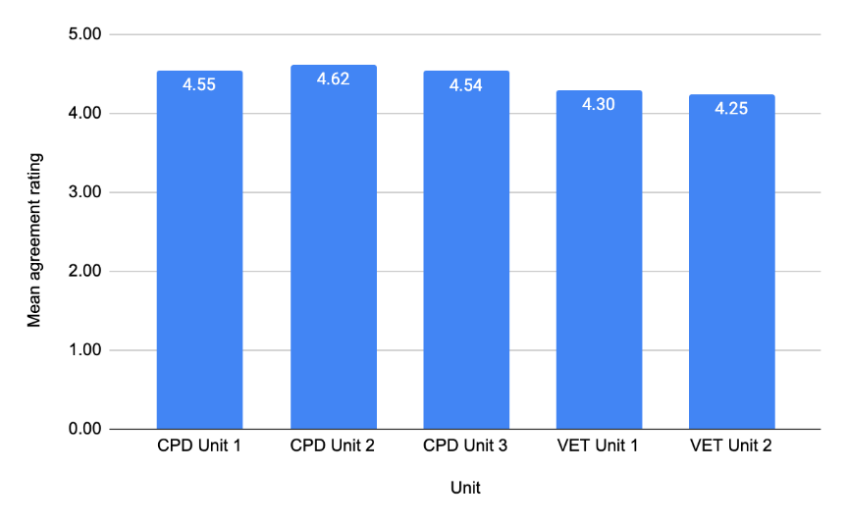
Figure 39. Participants’ mean agreement ratings with the statement “The activities enhanced my knowledge and learning” (1 = strongly disagree; 5 = strongly agree)
On average, the participants had high levels of agreement with the statement. CPD Unit 2 showed the highest level of agreement, while VET Unit 2 had the lowest.

Interview responses
Relevance of the course was also gauged through several of the interview questions. In particular, unit participants were asked how well doing the unit online suited their circumstances, what they thought of the scope and sequence of the unit content, what aspects they found particularly useful, and whether the learning platform was appropriate for the content.
Figure 40 shows the percentage of participant interview respondents who provided particular kinds of answers to these questions.
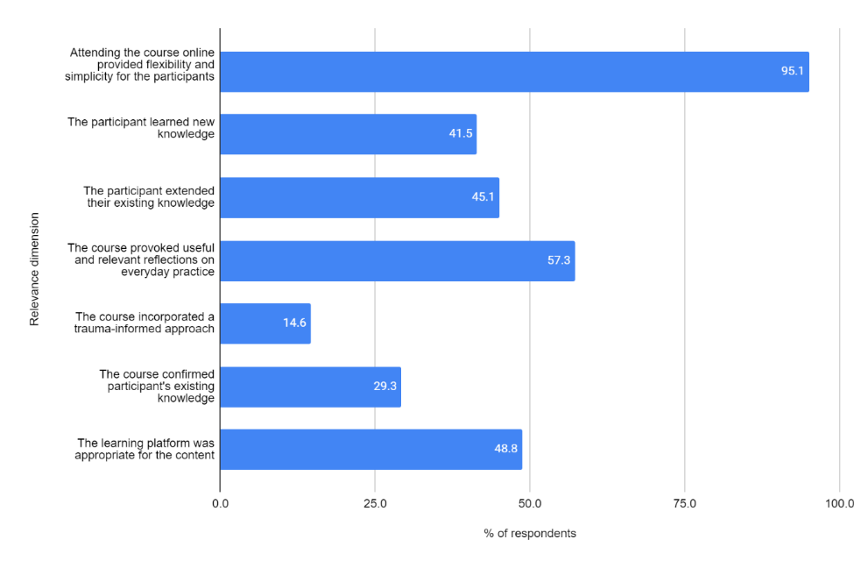Figure 40. Percentage of participant interview respondents who provided particular responses to open-ended questions about unit relevance
Overall, the delivery of the unit online was very relevant to respondents’ circumstances. Over 95 percent said that the online delivery provided flexibility or allowed easy access to the unit.

In providing responses to open-ended questions about the content of the units:
- More than 41 percent of respondents highlighted that they learned new knowledge from the unit
- More than 45 percent emphasised that the unit extended their existing knowledge
- A little under 30 percent pointed out that the course confirmed their existing knowledge
- Nearly three out of five respondents (57.3%) mentioned that the course provided useful and relevant reflections on their professional practice
- About one in seven respondents (14.6%) specifically mentioned the relevance of the trauma-informed approach of the unit
- Nearly half of the respondents specifically mentioned that the learning platform was appropriate for the content.
It should be noted that the above reports of prevalence in open-ended responses should be qualified with the caveat that a respondent not mentioning a theme or element does not mean they perceived the theme or element as unimportant.
Six of the eight interviewed facilitators (3 CPD, 3 VET) specifically mentioned the value of the flexibility and convenience created by the course being offered online. Three of the CPD facilitators noted how the diversity within the participant groups created opportunities for relevant and useful professional reflections, especially in terms of difference between jurisdictions and locations. Six of the facilitators (3 CPD and 3 VET) commented on the value and drawbacks of the online approach for the learning content, which at times was potentially traumatic. On the one hand, the online format allowed people to participate and interact to the extent they felt safe or comfortable to do so. On the other hand, facilitators reported more difficulty gauging the mood and comfort levels of the participants compared to in-person settings.

Efficiency
Efficiency in this evaluation refers to the extent to which the units made good use of resources, such as the participants’ time, energy and money.
Feedback form data
The unit feedback form asked for agreement on two statements pertaining to the efficiency of the course.
- The format of the online content and resources for this unit were easy to navigate
- The workload in this unit was manageable.
Figure 41 shows the mean levels of agreement with each of these statements from respondents in each unit.
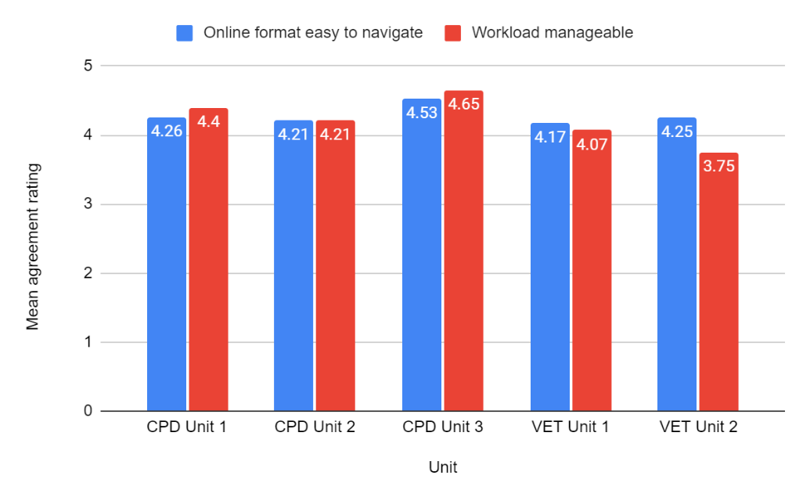
Figure 41. Mean levels of agreement with each statement about ease of online navigation and manageability of workload from respondents in each unit
- On average, respondents tended to “agree” rather than “strongly agree” with the statements about ease of navigation of the online format and the workload.
- CPD Unit 3 participants had the highest level of agreement with the two statements, reflecting the improvements made to the unit delivery in response to feedback from previous units.
- VET Unit 2 respondents had the least favourable view of the unit workload.
Interview responses
When asked for reasons why the online delivery of the unit was suitable, many respondents mentioned aspects related to efficiency. Undertaking the unit online was specifically mentioned as being time efficient by 32.9 percent of interview respondents, and as being cost-efficient by 17.1 percent of interview respondents. Interviewees not only referred to the fact that the units were free, but that there was no cost involved in travel to an educational institution of face-to-face class.
I think having the option of having it free made it accessible for a lot of other people who may not have already done the course or wanted to do the course. And I've encouraged a lot of my colleagues if it comes around again next year to do it (Worker, ‘Other’ sector, VET Unit 2)
Because I live in regional Victoria, I don't have to worry about taking study leave because it's outside of my work hours and I don't have to worry about travel costs or time for travel either. (Worker, Government department and agencies sector, VET Unit 1)
Several interviewees felt that the Unit content was excessive (Table 7).

Table 7. Number and percentage of interview respondents who mentioned the unit content was excessive
Unit | Number of interviewee comments  about units’ excessive content | Number of interviewees | Percent
CPD Unit 1 | 3 | 15 | 20.0
CPD Unit 2 | 1 | 11 | 9.1
CPD Unit 3 | 4 | 15 | 26.7
VET Unit 1 | 2 | 22 | 9.1
VET Unit 2 | 5 | 19 | 26.3
None of the CPD facilitators but three of the VET facilitators (two who taught VET Unit 1 and one who taught VET Unit 2) felt that the time required to complete the unit was too great. VET facilitators noted the effort required to attend a three-hour online session after a full day of work. Only one facilitator (who taught CPD Unit 3) mentioned that the online format was good because it saved participants money.

Effectiveness
Effectiveness in this evaluation refers to whether the project, in this case the pilot course, achieved what it intended to do in terms of activities and outputs (regardless of the outcomes or impacts), that is, providing a course on recognising and referring sexual violence.
Feedback form data
Two questions in the feedback form related to this criterion:
- Course facilitators in this unit were knowledgeable and clear in their explanations
- This unit contained a good mix of instruction and interactive content
Figure 42 shows the level of agreement with these statement from respondents for each unit.
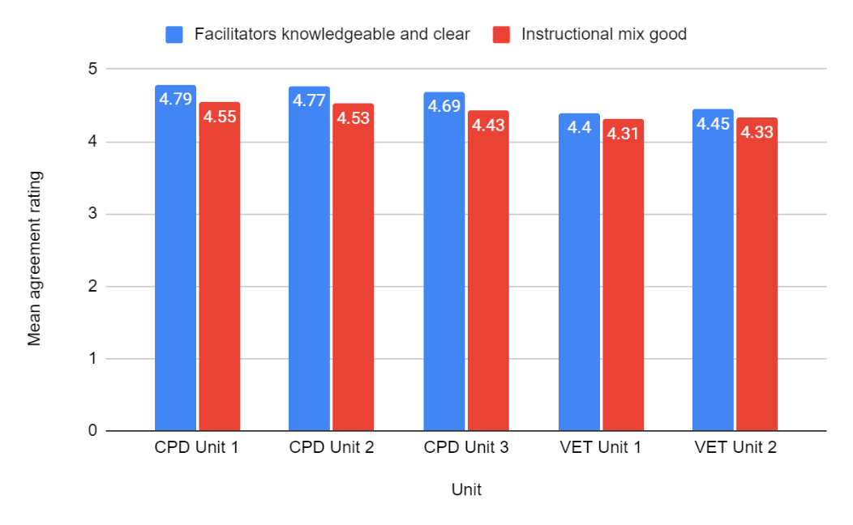
Figure 42. Level of agreement with statements about facilitator quality and instructional mix

- CPD respondents on average tended to “strongly agree” that the facilitators were knowledgeable and clear (all means >4.5), while VET respondents’ responses were slightly lower, although still indicating agreement.
- On average, respondents agreed that the mix of direct instruction from the facilitators and interactive content was appropriate.
Interview responses
Unit participants interviewees were asked questions related to:
- The extent to which the learning approach was active and engaging
- The scope of the unit and its topics
- The sequence of topics in the unit
- The quality of the resources and assessments
- The overall functionality of the online learning platform
- The specific issues (if any) they encountered with the online learning platform
- Any other issues with the unit

Figure 43 shows the percentage of respondents who answered in the affirmative or provided comments that indicated a positive perspective on the effectiveness of the unit.
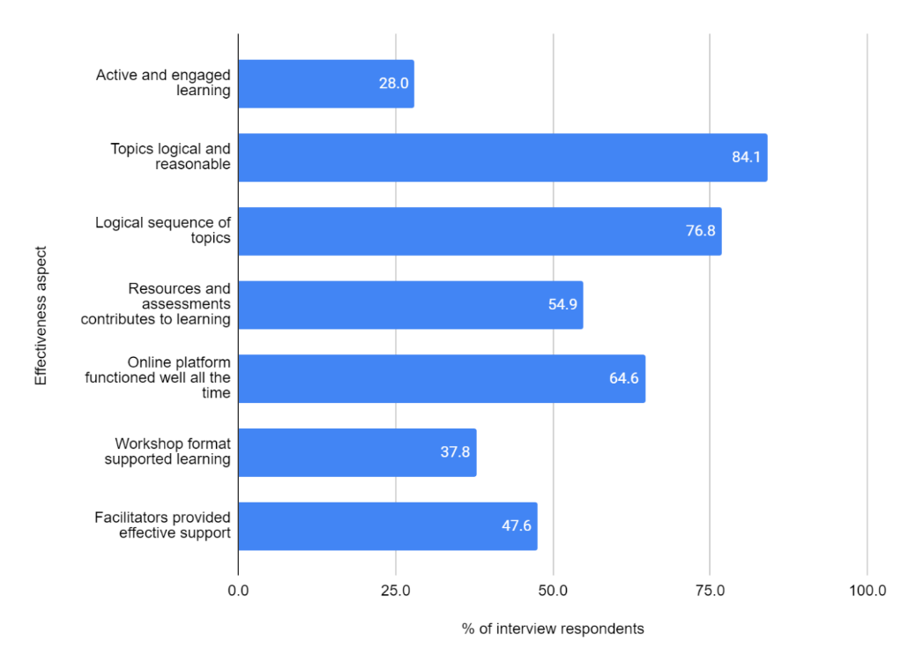
Figure 43. Percentage of interviewees who made positive comments about aspects of the unit delivery
Figure 43 reveals that:
- More than a quarter of the respondents (28.0%) made comments that indicated that the learning approach was effective in that it encouraged active and engaged learning.
- Most respondents felt that the scope and sequence of the topics was logical and reasonable
- More than half of the respondents mentioned that they felt the resources and assessments contributed to their learning
- Nearly two-thirds of the respondents reported that the online platform functioned well all of the time.
With regard to other comments about the units:
- Nearly two in five respondents (37.8%) mentioned that the workshop format supported their learning
- Nearly half of the respondents (47.6%) mentioned that the facilitators provided effective support.
There were some differences between Units in the proportions of interviewees who identified issues with the learning platform (Table 8). These results show that issues identified in CPD Units 1 and 2 were resolved to some extent by the time interviewees undertook CPD Unit 3. In addition, since all the interviewees from VET Unit 2 had already completed VET Unit 1, they were familiar with the platform.
Table 8. Number and percentage of interviewees identifying issues with the learning platform in each unit
Unit | Number of interviewee comments about online platform issues | Number of interviewees | Percent
CPD Unit 1 | 7 | 15 | 46.7
CPD Unit 2 | 5 | 11 | 45.5
CPD Unit 3 | 4 | 15 | 26.7
VET Unit 1 | 4 | 22 | 18.2
VET Unit 2 | 0 | 19 | 0.0
Many interviewees recognised the necessity and value of online learning during the COVID-19 pandemic, but also valued to face-to-face learning.
With face to face, I think…I mean I'm someone who get easily distracted. With face to face I think there is constant encouragement and motivation from, you know, our teacher or tutor, whoever is presenting and also in face to face, we get to meet a lot of people in the class. They get to share their experiences, which would be equally enlightening. People might contribute their own idea which can help you know further, extend the discussion. So there's only some material that can be posted online but with face to face it's like an open ended questionnaire. So people can put a lot of input from their own side, which might, you know, give insights to other topics we might get to hear about the experience, which is not possible with online. (Nurse, CPD Unit 1)
I think you miss a lot of communication when it's online. You do miss a lot of things and I think you sort of in some ways connect with your fellow students but not in the same way as if you're in the same room, you'd naturally gravitate to some people and in the online thing, like it's sort of randomly get ascribed to a group and often those people are poles apart from what you're doing, and sometimes that can be a valuable thing. But other times it's been like, really like I found in some of the group activities, it's not a big deal, but sometimes the contexts are so far apart (Worker, Social and community services sector, VET Unit 1)
Facilitators, including those who were not involved in unit development, were very positive about the effectiveness of the unit delivery. All interviewed facilitators felt that the format promoted active learning and that the scope of the units was logical and reasonable. Six of the facilitators considered the sequence of the learning materials was logical, and none of them had any criticisms of the sequence. Four facilitators (one CPD and three VET) commented particularly on the value of the learning resources (e.g. linked documents).
Most facilitators also noted that online learning had both strengths and weaknesses. In terms of strengths, some facilitators found that online learning delivered in this course has created a flexible, safe and diverse environment for participants across different professions and locations to learn together and hear about other people’s work experience:
I think the flexibility is great. I mean there are people from all states and territories in one training and that actually also gives some variety in the group which I think was really great, so I really did love that. And yeah, it offers flexibility and I think that's really important. And yeah, it makes it accessible. You know, sometimes you see people kind of just hand the baby over to their partner for this hour, they wouldn't have been able to come somewhere and, like, attend that session. So it's really flexible, so I think that is the pros. (Facilitator, CPD Unit 3)
It is a very sensitive unit and there were also students who haven't studied for [a] very long time. So when the course is online, sometimes you can get more contributions. People are probably more likely to contribute because it's not in the classroom, it's not in front of everybody. Yes, it's online, but you can't see everybody. And when you don't feel confident to speak as you may think there’s going to be something wrong or anything like that, so again you can use the chat function, you can use the whiteboard. The whiteboard is good because everybody else will be putting their comments and that can encourage people to contribute a little bit more as well. (Facilitator, VET Unit 1)
I mean I suppose related to the fact that you get a breadth of people from different places is that diversity as well, you get a group of people who can share a whole lot of perspectives, and then the city people are hearing about the challenges of a rural setting, which might, again, might not happen if you had it in hubs, because then only the city people would be learning with the city people and they wouldn't appreciate the challenges for the people in rural and regional and remote settings. So I think that another strength is that you then bring people together and there's a lot of learning from each other. (Facilitator, CPD Unit 3)
Regarding weaknesses in course delivery, some facilitators commented on the online format making it more difficult to capture the classroom’s environment, or the reduced connections between the facilitator and course participants, as well as among the participants:
Face to face is always preferred, as you can read the room a bit more in terms of how students are, how the questions are. And it's difficult to do that online, and with the platform that we use – Canvas - if everybody has their cameras on, it distorts it (Facilitator, VET Unit 1)
I suppose connection. You know, working with adult learners is interesting, and of course we're all professionals and you work, you do this for yourself, however, people still want to be seen and they want to hear from someone that their answer was good, or that they’re working on an assignment well, I don't think that goes away for adult learners. And they might be able to do stuff without it, but the connection is less there and I think what you really miss with online learning is the fact that everyone in the group has heaps of experience and you can't really benefit from that if you're all doing, you're working individually online and I think if you ever do a face to face training, a big thing is kind of the joint learning. It's difficult to facilitate or it costs a lot of time, and it becomes like a real process, like you have to put something on the forum, you'll have to respond, and it becomes a bit artificial whereas in a group that's very easy. (Facilitator, CPD Unit 3)
Figure 44 shows the proportion of interview respondents who had issues with aspects of the online platform. Note that a respondent not mentioning an issue does not mean they did not have the issue, but that they did not mention it in the interview.
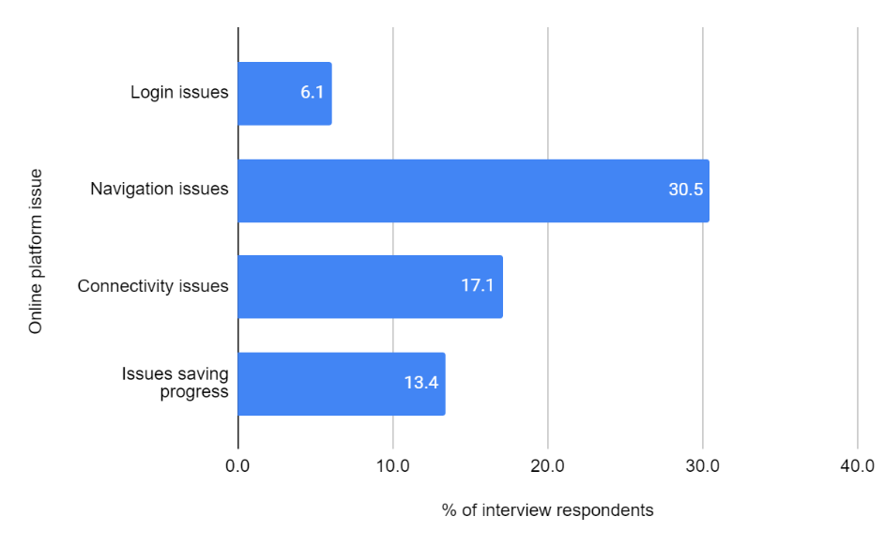
Figure 44. Proportion of interview respondents who identified issues with the online platform
The most common issue for participants concerned navigating the online platform, followed by connectivity issues. Several participants commended the responsiveness of IT support staff. Apart from connectivity issues or initial login and navigation issues, most facilitators felt the learning platforms used in the units functioned well. One VET facilitator suggested that more detailed instructions could be given before the first online session so that the facilitator would not need to spend too much time showing people how to access the platform. Facilitators reported that some participants had difficulty accessing the platform because of workplace IT blocks or when trying to access the platform on a mobile phone or a non-Windows device.
Overall, the facilitators felt that course administrators and IT support staff did a good job of supporting students with learning platform issues.

Accessing and completing the units
Facilitators had little hard data on reasons people enrolled in a unit but did not finish it. In some cases, they had heard from participants that illness, work pressures, and family matters had come up and prevented completion. In other cases, there was no information on why enrolees did not commence, or participants did not complete. One VET facilitator suggested that the enrolment process was complicated and this put some people off completing their enrolment. One unit participant interviewee also shared that their colleagues did not complete their enrolment because they found it too complicated. (Worker, Social and community services sector, VET Unit 1)
I know that some students mentioned that they found the enrolment process a bit confusing and a bit time consuming, and I imagine there might have been people that started the process that didn't finish. (Facilitator, VET Unit 1)
I will tell you a little story about when trying to enrol, I can't remember how I first got the e-mail about the opportunity to participate in the course, but initially the enrolment was really difficult and eventually, I found a window of time and rang the university and after multiple phone calls getting transferred to this person and that person, I was advised I had the wrong code and I was given the right code. And from then on it just went very smoothly, but I know there were other people in my organisation so like it sort of went around our organization and we also understand the University would like, you know, really wants people from regional and remote areas to get a broad spectrum. And we had quite a lot of staff at our work that wanted to do it, but because they had an issue with the code and they're busy, they just went ‘too hard, forget it’. (Worker, Social and community services sector, VET Unit 1)

Discussion of and conclusions regarding the quality of the units and their delivery
Overall, the respondents considered the units to be of high quality. The contents were considered highly relevant, logical in their scope, and appropriately sequenced. The units were generally efficiently and effectively delivered. Provision of the units online enhanced efficiency, especially in making good use of participants’ resources. However, for some of participants, the online platform presented issues which impacted effectiveness and efficiency, such as difficulty navigating the platform.
The main issue that interview respondents encountered with the online learning platform that could be addressed at the server side concerned navigating around the various parts of the site and providing clearer or earlier instructions regarding logging in and saving users’ progress. Connectivity may be more related to the user side and the quality of their internet connection.
Some evaluation respondents had concerns about the workload of or amount of content in some units, especially in relation to the advertised time required versus the actual time required. This concern was more prevalent in CPD Units 1 and 2, but was less of a concern for participants in CPD Unit 3. Workload remained a concern for participants in VET Unit 2. Concern about the amount of content was least in CPD Unit 2 and VET Unit 1. In the former case, this may have been because this Unit focused on medical examination, a process which, in general healthcare workers are already familiar, albeit not necessarily in the context of a forensic examination. In the latter case, the reason may have been that the Unit focused on the drivers and impacts of sexual violence, topics with which workers in social and community services may have already been familiar.
The CPD Unit with the highest completion rate (CPD Unit 3 – see Annex N) also had the highest ratings for manageability of the workload and ease of navigability of the online format, but not for the other course delivery feedback form questions. Otherwise, there appears to be little correspondence between unit delivery and unit completions when comparing between units.

Evaluation question 3: Impact of the units on professional practice
The evaluation assessed participants’ views on the potential and actual impact of the unit on their professional practice.
Potential impact was assessed through questions P1 and P2 in the VET feedback form and questions P3 and P4 in the CPD feedback form.
- P1. What was the most valuable learning from this unit that you can immediately apply to your job role?
- P2. Give reasons why the learning described in the previous question is valuable to your job role.
- P3. Please outline how you might review and/or modify practice-based systems and/or processes relevant to this activity? Comment if relevant.
- P4. Will this course change how you practice? If so, how?
The evaluation team used two methods to garner respondents’ views on whether and how they had applied their learning from the unit. First, short-term impact data were collected using relevant questions in the participant interviews conducted within about two weeks of the completion of the unit. Second, medium-term impact was assessed by an online impact survey sent to participants who had completed all the units in the course (that is, all three CPD units or both VET units) approximately six to eight weeks after the completion of the unit. It should be noted that this sample is less representative of the overall participant pool and even less representative of the overall target population for the courses.

Potential impact
Potential impact was analysed in terms of the SLOs where feedback form respondents believed they would be able to apply to systems and processes or their own practice.
CPD respondents
In reference to application to systems and processes:
- Among CPD Unit 1 respondents
  - 31percent mentioned how they could apply knowledge of trauma-informed responses (SLO5.1)
  - 22 percent mentioned how they could apply their understanding of the forms and drivers of sexual violence (SLO1.1)
  - 11 percent mentioned how they could apply their knowledge of resources (SLO4)
- Among CPD Unit 2 respondents
  - 14 percent mentioned how they could apply their knowledge of resources (SLO4)
  - 12 percent mentioned they would apply their knowledge of and confidence in making referrals (SLO7.2)
  - Nine percent mentioned they would apply their understanding of supporting disclosures (SLO7.1) and their knowledge of trauma-informed responses (SLO5.1)
- Among CPD Unit 3 respondents
  - 15 percent mentioned they would be able to apply their general understanding of the complexities of sexual violence for victim/survivors from at-risk groups, especially in terms of appropriate use of language and intersectional approaches (SLO8.1)
  - Eight percent mentioned they would apply their understanding of the complexities pertaining to specific at-risk cohorts (SLO8.3).
In regards to their own practice:
- Among CPD Unit 1 respondents
  - 47 percent mentioned they would apply their knowledge of trauma-informed approaches (SLO5.1)
  - 17 percent mentioned they would apply their knowledge of trauma-informed resources or be more confident to use a trauma-informed approach (SLO4)
  - 16 percent mentioned they would apply their knowledge of the forms and drivers of sexual assault (SLO1.1)
  - Among CPD Unit 2 respondents
  - 29 percent mentioned they would apply their knowledge of trauma-informed resources or be more confident to use a trauma-informed approach (SLO4)
  - 18 percent mentioned they would apply their knowledge of trauma-informed approaches (SLO5.1)
  - 12 percent mentioned they would apply the Adult Sexual Violence Healthcare Response Tool (SLO9)
  - Among CPD Unit 3 respondents
  - 31 percent mentioned they would be able to apply their general understanding of the complexities of sexual violence for victim/survivors from at-risk groups, especially in terms of appropriate use of language and intersectional approaches (SLO8.1)
  - 11 percent mentioned they would have increased confidence to respond to and support diverse groups (SLO8.2),
VET respondents
In reference to the most valuable learning that participants could apply to their job role:
- Among VET Unit 1 respondents
  - 42 percent cited knowledge or skills in trauma-informed care (SLO5.1 and/or SLO6.1) as a key learning
  - 23 percent cited knowledge of the types and/or drivers of sexual violence (SLO1.1) as a key learning
- Among VET Unit 2 respondents
  - 25 percent cited their increased understanding of how to support disclosure (risk assessment and/or safety planning) as the key learning (SLO7.1)
  - 19 percent mentioned knowledge of and/or confidence in making referrals as a key learning (SLO7.2)
  - 19 percent mentioned knowledge or skills in trauma-informed approaches (SL05.1 and SLO6.1)
  - 17 percent mentioned knowledge of resources or confidence to respond in a trauma-informed way were key learnings (SLO4).

Short-term impact
Exactly half of the 82 interviewees provided examples of how they had applied their new knowledge, understanding, skills or tools in their work.
A number of respondents referred to increased awareness about potential sexual violence that may have occurred to victims/survivors that they serve in their daily practice:
It helped me to have more of an awareness and it is a potential issue in my patient population and to have the confidence to deal with that in a more holistic and/or supportive manner. It’s more of an awareness of, I suppose, the structure and that's what I was talking about, learning about the roles of different people, who does what, where, when and how. And probably I wouldn't have had as good of understanding of that part prior to the course and I feel that that will really enhance my clinical acumen with help regard to supporting patients who are at risk, and particularly from a local perspective, awareness of the services that are available locally and then in more broad terms as well. (General Practitioner, CPD Unit 3)
[W]hen I'm doing an assessment on a patient, I mean, I used to do it with pregnant women all the time anyway, but now I've just made it more organic where it rolls off my tongue, where if I'm seeing a new trans patient and LGBTQI patient and age care patient who, you know, lives with relatives or is dependent on someone for care, I now check for violence. I ask if they'll say there's anything they want to discuss. It's a lot more empowering because it opens up that door for the patient to know that they can discuss anything. Sometimes they come in, you know, wanting to just discuss their blood pressure. But if they know that they can discuss anything they might, not on the day, but later down the track, they still know that that's a safe place for them to discuss an issue. (General Practitioner, CPD Unit 3)
Some respondents mentioned being more aware of bias when treating victims/survivors of sexual violence:
Addressing implicit bias is something that I've taken back into my practice and being mindful of how I am around certain cohorts of community members so that I'm able better to break down those barriers that I put up around myself to improve the support that I provide. (Worker in the education sector, VET Unit 1)
Numerous respondents reported having higher confidence when providing support to victims/survivors of sexual violence as a result of undertaking the course:
So in terms of the work that I do, it's a sexual health clinic. It’s not a sexual assault clinic. So I don't work forensically, but we work with people presenting just for sexual health issues… When I'm working in the clinic, if I have someone that has a background of sexual assault or it has just been sexually assaulted and might just be presenting to us for screening or testing, I think it just gives me more confidence to just talk about it and spend some time on it. You know, just making sure they've got the support, understanding that impact and just having that kind of space for them to be able to talk about certain things if they wanted to. (Nurse, CPD Unit 1)
Some particular areas of knowledge that respondents have applied in their daily practice include better knowledge about available local services to refer victims/survivors of sexual violence, or legislations regarding domestic and family violence and sexual violence:
So I have done that in my community work environment where I've had a school student do a disclosure, so following along making sure that they've got the Gillick competency because they're under 18 years of age and that was touched on in the course. And then just that we did a particular task where we had to try and access and list all of the local resources, services and supports from our local area and make like a directory of them. And I've actually found that to be very, very useful tool that I actually have already utilised, being able to go ‘Oh well, I think we need this service’, and I already know who that is locally and refer them on or phone up for assistance or advice. (Nurse, CPD Unit 2)
It made me more aware of legislations around domestic and family violence and sexual violence. And being in the Northern Territory, being mandated to report that and stuff like that, so then that legislative aspect of what I was taught in the course, I've definitely been able to apply that in terms of if kids have disclosed witnessing sexual or domestic and family violence. Also, when looking at the child as well, you know, like for example, here it's an Indigenous population, so you look at the intersectionality of being Indigenous, you look at the intersectionality of being a young person, they have been vulnerable, looking at, you know, the fact that they're from a low socio-economic background, all that kind of stuff. (Worker in the social and community services sector, VET Unit 2)
Being able to apply trauma-informed practice is also an important factor that some respondents have learnt from the course:
Just being more mindful when speaking or communicating with some of the complainants when we call them or the reporting people that are experiencing some sort of trauma, even though I already know that and I'm aware of that, but just having it more fresh in my mind and being mindful of that. And changing my communication to express some of those trauma informed practices… I can't think of a specific example, but that's the general gist of it. And then also I'm developing procedures, like guidelines for how we deal with things and just putting some of that wording, some of that trauma informed wording into our guides that we're going to be giving to complainants. Changing our processes, trying to change our processes so that they are more trauma informed. And so explain everything, every step to a complainant so that they're well informed so just to ease their anxiety, so things like that. (Worker in the education sector, VET Unit 2)
I work with people who are affected by domestic and family violence on a routine basis, so nothing specific other than when I am talking to new clients that come in who disclosed domestic and family violence, I understand the trauma a little bit better. I mean, I think it reinforced, you know, some of my approaches in terms of open listening and normalising and active feedback. So it helped make me more confident in some of the things that I'm doing with victim/survivors and it certainly made me feel more comfortable and confident in my knowledge of what they may be experiencing and not telling me. (Worker in the social and community services sector, VET Unit 1)

Medium-term impact
The impact survey administered six to eight weeks after respondents finished all the units in a stream/course asked respondents two questions concerning the professional impact of the course. The first questions asked respondents to indicate the extent to which they had been able to apply the knowledge or skills learned in the course to their everyday work (practices and procedures). Figure 45 shows the percentage of respondents who reported on each level of application of their learning.
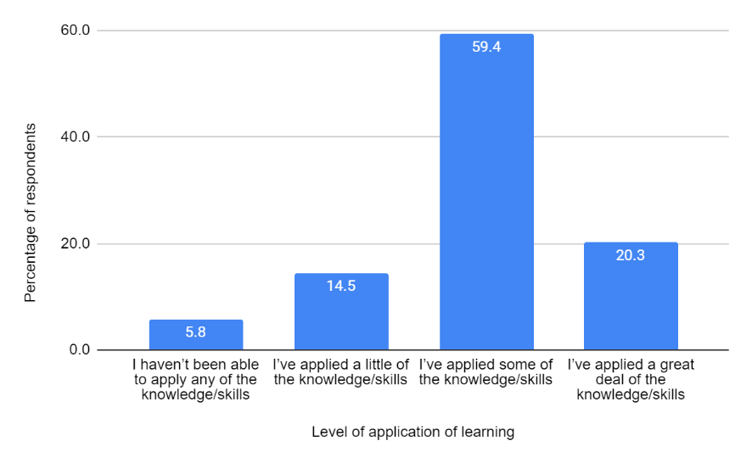
Figure 45. Levels of application of learning reported by impact survey respondents
The data in Figure 45 indicates that six to eight weeks after completing the course, about one in five participants (20.3%) have been able to apply a great deal of their learnings to their work, while another three-fifths (59.4%) have applied some of their learnings. Selected illustrative responses for each degree of application are presented below.

Haven’t been able to apply any of the knowledge or skills to everyday work
Since doing the course, I haven’t had any patients/clients with whom the knowledge or skills could be applied (Worker, Social and community services sector)
The knowledge and skills weren’t relevant to my work (Worker, Education including higher education sector)
Have applied a little of the knowledge and skills to everyday work
I am not in direct practice currently, but I have been able to look at the company policies regarding sexual abuse and harassment and ask for clarification on a number of points based on the learning from the course (Worker, Social and community services sector)
I work in the education field but I have been able to use the knowledge in supporting my peers and my direct reports through disclosure and support (Worker, Education including higher education sector)
Have applied some of the knowledge of skills to everyday work
I have become much more trauma informed when a woman discloses a previous sexual assault in pregnancy screening, ensuring to not re-traumatise and more empathetic if needed a forensic exam (Midwife)
As I work for a support service for individuals who have experienced a crime, there are multiple occasions where clients have disclosed sexual violence. The course was a helpful reminder in providing the best practice on how to support clients in these instances. (Worker, Government departments and agencies sector)
Have applied a great deal of the knowledge and skills to everyday work
Ability to recognise a young person with a mild intellectual disability experiencing sexual violence and subsequently assist stakeholders in assisting her and her caregivers. (Medical doctor)
Alongside providing legal advice to someone experiencing family violence, I now incorporate a ‘safety planning’ section into my appointments where I can work with the client to keep them safe in the meantime while I am doing legal work for them. (Worker, Legal services)
The second impact survey question asked respondents to indicate the extent to which the course learning had impacted their work at the policy, organisation or system level. Figure 46 shows the percentage of respondents who reported on each degree of application of their learning at those levels.
Figure 46 shows that six to eight weeks after completing the course, at the policy, organisation or system level:
- The course had a substantial or very substantial impact on about one in five respondents’ work.
- The course had some impact on a further three in ten respondents’ work
- The course had only a small amount of impact on about a quarter of respondents’ work
- The course had no impact on a little over a quarter of the respondents’ work.
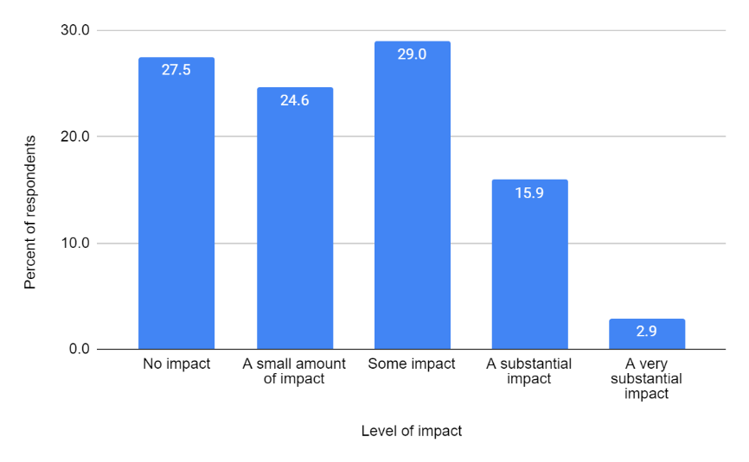
Figure 46. Level of impact at policy, organisation or system level

Selected responses that illustrate the kinds of and reasons for each of the perceived degrees of impact are presented below.
No impact at the policy, organisation or system level
Not currently in a role where I can apply the knowledge or impact the organisation. (Worker, Education including higher education sector)
I don't have the power or influence to impact in this area. (Nurse)
The knowledge and qualification I hold plus my organisational role does not place me in a position to enact policy/organisational/system level change. (Worker, Social and community services sector)
A small amount of impact at the policy, organisation or system level
We have shared and used some of the resources in creating education programs for the community and in talking to others about the issues our clients may be facing. (Worker, Legal services sector)
Ensuring we tightened work practices around sexual violence/harassment. (Worker, Social and community services sector)
Some impact at the policy, organisation or system level
MARAM and SAFER risk assessment have been enhanced by incorporating the knowledge and skills learnt from this course. (Worker, Government departments and agencies sector)
Sharing the knowledge at work so that our clinic environment can be more culturally sensitive with appropriate safe space. (Medical doctor)
Substantial or very substantial impact at the policy, organisation or system level
I've told my peers about the course and they are keen to do it. I have discussed the concepts and screening aids with our practice registrars, as we didn't receive this teaching while we were registrars. (General Practitioner)
I made it a point to highlight my training. I requested that I and only colleagues I had briefed work with clients presenting with sex violence experience. (Worker, Government departments and agencies)
I have taken the knowledge I have learnt from the course to my Domestic Violence team and has helped my colleagues with educating their clients. (Worker, Social and community services sector)

Discussion of and conclusions regarding impact of the course
Many participants anticipated that they would be able to apply their learning to their own professional practice or to their workplace systems and processes. Two learning outcomes that were particularly prevalent in terms of participants’ expectations involved employing a trauma-informed approach and using the resources they had obtained during the unit.
The evaluation findings suggest that the course has meaningful impacts on individuals’ work and, to a lesser extent, at the policy, organisation and system level, based on the perceived impact reported by participants at the six to eight-week post course stage. Four-fifths of respondents reported at least some medium-term impact on individual work practices, compared to a little under half of the respondents who reported at least some impact at the policy, organisation or system level. The lower rates of impact at the latter levels are expected, given that not all participants in the course held positions where they are responsible for policy, organisation or system level changes, and that six to eight weeks is a short timeframe for implementing changes at those levels.
It could be argued that the latter set of quotes do not suggest “substantial or very substantial” impact at the policy, organisation or system level. However, they are promising instances of impact and point to knowledge sharing with colleagues and peers and attempts to improve ways of working.

Reflections and lessons learnt
Findings from the evaluation based on feedback from the course participants and facilitators indicate that Monash University’s Course in Recognising and Responding to Sexual Violence has successfully increased the knowledge, understanding, skills and confidence of a wide range of participants in both streams of the program. It is an important, valuable and much-needed offering for health care professionals and other frontline workers who may encounter victim-survivors of sexual violence in their work.
While course participants generally perceived that units provided them with a great deal of valuable learning, some categories of participants reported higher levels of learning than other categories. These variations raise important issues for future offerings of the course.
- Should the course providers continue to offer the course broadly and equally across jurisdictions, locations and professions/sectors? Or, should the focus turn to those groups who were shown in this evaluation to derive the most benefit from the program e.g. participants in rural and remote areas or working in frontline sectors other than social and community services such as government departments and agencies (which included the police)?
- Alternatively, should the course develop a more advanced stream for participants already working in a relevant sector, such as social and community services, while focusing the current streams on workers with less background in recognising, responding and referring victim/survivors of sexual violence?
- Another option for developing the course would be to accredit and/or offer it to other frontline medical workers who were not represented in the units but who may encounter victim/survivors of sexual violence, such as paramedics through the Australasian College of Paramedicine or administrative and other support staff in hospitals and primary care settings.
The variations between sub-groups or categories of participants in this study were explored using descriptive statistics. The data could be explored further using inferential statistics to identify which of these relationships were statistically significant.
This evaluation collected a large amount of qualitative data in the feedback forms, interviews and impact survey. The interview qualitative data were thoroughly analysed using a thematic analysis and coding system. The impact survey qualitative data were subject to a brief thematic analysis. Since Monash University DFM staff had access to the dashboards displaying feedback form qualitative data pertaining to areas for unit improvement, they were able to undertake a partial analysis of the CPD data. However, further qualitative analysis could be undertaken of the full CPD and VET qualitative data sets concerning unit improvement.
The participants in this evaluation generally considered the units to be of high quality, both in terms of content and the teaching and learning process and platform. The scope and sequence of the content and the relevance of the tools provided were appreciated by most participants.
Offering the units online, necessitated by the COVID-19 pandemic, turned out to be a blessing in disguise. The online mode facilitated access to a very geographically dispersed range of participants. This evaluation shows that many participants from rural and remote regions benefitted most from the courses. Thus, offering the units online, although resulting from necessity, resulted in a much greater impact for the units than if they had only been offered face to face in a metropolitan centre.
In some units, participants noted that the content appeared to be excessive, or it was unclear which content was essential and which was optional. Although participants’ experience of the units can vary due to their own study, time management and information technology skills and personal circumstances, there remains some reputational risk to Monash University and RMIT University in offering units whose time-commitment requirement substantially exceeds the advertised amount.
The course was conducted as a pilot funded by DSS and offered free to participants. This evaluation did not explore the potential effect on future uptake of the course if the participants are required to pay for the experience. Charging a fee for the course or units could present a barrier to participation by key frontline workers and their attainment of vital knowledge, understanding and skills, and hence decrease the impact of the program on improving support for victim/survivors of sexual violence. However, DSS has extended funding support for VET and CPD delivery to mid-2027, which should minimise the cost barrier to course participation.
The interviews and impact survey showed that the units are having some important early impacts. These impacts have been stronger for participants’ work as individual practitioners, and less visible for changes at the organisational level. It would be useful to follow up with course participants concerning the ongoing impact of the course after a longer period of time e.g. six or twelve months. Such follow up could seek to discover not only the impacts of the course but the factors that could enhance impact. For example, the course providers could encourage or support the formation of communities of practice or other forums for participants to share their efforts to implement their learning following conclusion of the course.
During the conduct of this pilot program, the Australian Government released a new National Plan to End Violence Against Women and Children 2022-2032. In addition, the Australian Department of Health and Aged Care (DoHAC) in conjunction with DSS funded the Improving Health System Responses to Domestic and Family Violence Primary Health Network pilots (the PHN pilots) that provided training and systems development on recognising, responding and referring to domestic and family violence for primary care practitioners, that is, general practitioners and GP clinic staff. The most recent Australian Government budget allocated funds to extend these pilots. It will be important for DSS and Monash University DFM to coordinate or continue to coordinate future offerings of the Course in Recognising and Responding to Sexual Violence with both the National Plan and the PHN pilots to ensure consistent messaging and approaches to supporting victim/survivors of violence. The former DFM curriculum lead for this project was on the Melbourne University Advisory Board for the DoHAC Primary Health Network project and DSS is now facilitating a meeting for DFM with DoHAC to discuss synergies between the two programs, such as promoting the sexual violence response training for general practice medical and non-medical staff.

Recommendations

Recommendations based on the evaluation findings
- Continue to offer the courses to healthcare and other frontline professionals, preferably free of charge to allow a high level of access, wider dissemination of knowledge and skills, and hence better recognition of and responses to sexual violence.
- Consider if there are particular professions or categories of participants to which the course offerings should be targeted or marketed, such as workers in rural and remote areas and specific government agencies such as police and frontline legal services.
- Identify other groups of frontline workers who would benefit from the course and explore ways to offer the course to them e.g., paramedics, community legal service professionals, and hospital and primary care administration and support staff.
- Review the scope of the units against their advertised time allocation and revise or signpost the content to indicate essential and optional material.
- Consider ways in which the course providers can economically support implementation of learning after the course, such as encouraging or facilitating participation in existing communities of practice, such as those facilitated by professional colleges.
- Undertake research on the long-term impact of the course on individual work and organisational change.
- Undertake further analysis of the feedback form data sets to identify statistically significant relationships and participants’ detailed perceptions of areas for unit improvement, in order to guide future offerings and iterations of the course.

Recommendations based on the changing national context
- Review the course to ensure it aligns with the National Plan to End Violence against Women and Children (2022-2032).
- Continue to liaise with the training providers of the Improving Health System Responses to Domestic and Family Violence Primary Health Network pilots to ensure that training in both programs is appropriately aligned and consistent.

Independent Evaluation Tender document, 21 June, 2021, version 1.0, p. 9.
See this Report’s Focus of Evaluation section for more details regarding the SLOs.
Independent Evaluation Tender Application, p. 8.
Independent Evaluation Tender document, 21 June, 2021, version 1.0, p. 9.
Independent Evaluation Tender Application, p. 9. (List numbering adapted)
National Health and Medical Research Council (2007, updated 2018), National Statement on Ethical Conduct in Human Research; NHMRC (2014), Ethical Considerations in Quality Assurance and Evaluation Activities; Australian Evaluation Society (2013), Guidelines for the Ethical Conduct of Evaluations.
Work locations categories in the feedback forms were: metropolitan (capital city areas); regional (non-capital cities and surrounding areas); rural (country towns and surrounding areas); and remote (places relatively far from a town and/or with minimal access to services).
For example, Monash staff analysed the CPD Unit 1, 2 and 3 feedback form responses for question C7. “What changes could be made to the content, delivery format and / or your learning experience to improve this unit?” and wrote up the results for review by the implementation team. See Lyndal Bugeja and Anna Cartwright (2022), “Accredited Training For Sexual Violence Responses: CPD Participant Feedback.” Unpublished manuscript, Monash University.
Participants in the final evaluation report review workshop noted that in future a brief baseline assessment could be undertaken in the CPD units as an engagement activity, while the longer time frame of the VET units might lend themselves to a more detailed baseline assessment.
Due to space considerations, only mean scores are presented in the body of the report. Standard deviations indicating the spread of responses are in Annex P. Readers interested in further data details are referred to the Google Data Studio (Looker) dashboard for the CPD Units https://lookerstudio.google.com/s/tbIj7_ZCfj8 and VET Units https://lookerstudio.google.com/s/rT3ylo3wj9E
“noticeably higher ratings” here means a mean rating difference of greater than or equal to 0.1.
One participant in the final evaluation report review workshop noted that most doctors have good knowledge of medical consent, and may have interpreted this question to mean consent in general. The results may have been different if the question had specified “sexual consent”.
Participants at the draft evaluation final report review workshop noted the greater prevalence of violence in rural and remote regions. The VET course coordinator provided several sources to substantiate this observation: NTCOSS 2020, NTCOSS Submission to the Inquiry into domestic, family and sexual violence – August 2020; ABS 2021, Sexual Violence - Victimisation; Personal Safety Survey 2016 data by state/territory; ABS 2022, Crime Victimisation, Australia and Recorded Crime- Victims. The VET course coordinator also noted variations in the quality and knowledge of tools for responding to victim-survivors, such as risk assessment frameworks, across Australia jurisdictions e.g. reviews of the NSW risk assessment framework by the NSW Bureau of Crime, Statistics and Research and Richardson and Norris’s 2021.
While the analysis here uses the question to analyse relevance, the question could also be an indicator of perceived impact.
DFM is developing one-day face-to-face workshops based on each of the three units which will be delivered in addition to on-line training options. However, this form of delivery is much more expensive.
Questions P1 and P2 were used in the original versions of the CPD Unit 1 and Unit 2 feedback forms used in the first delivery of each unit in 2021. These questions were replaced by questions P3 and P4 in the 2022 delivery of these units and in Unit 3 to align with the questions asked in the RACGP evaluation form. Only the analyses of CPD questions P3 and P4 are presented here, since they were completed by the large majority of unit participants.
The timeframes for the interviews and completion of the impact survey were somewhat variable due to participants’ availability and interruptions caused by end-of-year holidays.
MARAM – Multi-Agency Risk Assessment and Management framework used in Victoria; SAFER -- Children Risk Assessment Framework used in Victoria
https://www.dss.gov.au/women-programs-services-reducing-violence/the-national-plan-to-end-violence-against-women-and-children-2022-2032
https://plan4womenssafety.dss.gov.au/initiative/expansion-of-the-recognise-respond-and-refer-pilot-and-national-training-for-the-primary-care-workforce/

