Gambling Tagline Research Phase 2: Implementation and Market Testing
Department of Social Services
Hall & Partners
MEL: +61 (0)3 9868 6200
SYD: +61 (0)2 9925 7450
info@hallandpartners.net.au
hallandpartners.com/au

Disclaimer
The author of this report is Hall & Partners Australia.
The research was commissioned by the Department of Social Services and was conducted between February and April 2022.
The analysis presented in this report reflects data from a two-phased program of work across the country, with a range of audiences conducted as in-depth discussions and an online survey. Hundreds of unique inputs and comments were made during the course of the consultations and survey, and these are collected, de-identified and maintained as a rich data source for providing direction on the placement, format and selection of taglines to address wagering behaviours in line with the National Consumer Protection Framework (NCPF).
The Commonwealth of Australia accepts no responsibility for the accuracy or completeness of any material contained in this report. Additionally, the Commonwealth disclaims all liability to any person in respect of anything, and the consequences of anything, done or omitted to be done by any such person in reliance, whether wholly or partially, upon any information contained in this report.
Any views and recommendations of third parties contained in this report do not necessarily reflect the views of the Commonwealth or indicate a commitment to a particular course of action.
All direct quotes in this report are excerpts from the survey and what people said during the consultation process. This report should not be read as being representative of all Australians.
For matters relating to this report contact:
Frances Chapman  Partner  frances@hallandpartners.net.au | Kathryn Priestly  Partner  kathryn@hallandpartners.net.au

Table of contents

Disclaimer 2

Table of contents 3

Executive Summary 4

Introduction 13

Research design 23

Research insights 33

Selection of the final suite of taglines 61

Conclusions & recommendations 102

Executive Summary
The Department of Social Services (DSS) commissioned Hall & Partners to conduct research to test ten proposed taglines across a range of platforms. This report comprises the final deliverable of the research and recommends a suite of seven taglines be implemented nationally to reduce gambling harm.
The objectives of this research were:
- To determine the most effective messaging and tagline executions on their ability to intercept behaviour and encourage behaviour change, direct consumers to help-seeking measures, and other key metrics;
- To establish any differences by target audience (online wagerers and the general public) in terms of message preference, memorability and likely action as a result;
- To establish the best locations and advertising medium for different taglines or messages, including testing the hypothesis that certain messages are best placed for broadcast media and others are better placed for online and in-app interception of behaviour; and
- To determine the best placement and positioning of messages within each advertising medium, including radio, television, online and in-app placement.
The multi-methodological research programme was designed to give breadth and depth to the recommendation of specific taglines. It comprised three components:
- Listen and learn session with a Delphi group comprising expert government representatives from all Australian states and territories, the same group which devised five of the taglines that were tested;
- Quantitative research comprising a 10-minute online survey of a total n=2,000 (comprised of n=1000 online wagerers and n=1000 general population, including n=500 gambling non-rejecters and n=500 gambling rejecters); and
- Qualitative research comprising n=30 qualitative sessions with online wagerers of a range of PGSI profiles, with all states and territories represented. Interviews with First Nations (n=4) and Culturally and Linguistically Diverse (n=4) participants were included.
A comprehensive base of insights was built over the course of the research which was analysed holistically in the development of the final recommendations.

Ten taglines were tested
Ten taglines were identified for testing, including five which were developed from behavioural research conducted by Hall & Partners in 2021, and five which were developed through the Delphi group’s expertise. Each was supported by a call to action developed by the Delphi group, directing the consumer to help through the existing telephone helpline and website.
- Betting too much? For free and confidential support call 1800 858 858 or visit gamblinghelponline.org.au
- What’s gambling really costing you? For free and confidential support call 1800 858 858 or visit gamblinghelponline.org.au
- To quit/stop gambling call Gambling Help on 1800 858 858 or visit gamblinghelponline.org.au
- Worried about your gambling? We can help. Call 1800 858 858 or visit gamblinghelponline.org.au
- What are you really gambling with? For free and confidential support call 1800 858 858 or visit gamblinghelponline.org.au
- Chances are you’re about to lose. For free and confidential support call 1800 858 858 or visit gamblinghelponline.org.au
- Think. Is this a bet you really want to place? For free and confidential support call 1800 858 858 or visit gamblinghelponline.org.au
- You win some. You lose more. For free and confidential support call 1800 858 858 or visit gamblinghelponline.org.au
- What are you prepared to lose today? Set a deposit limit. For free and confidential support call 1800 858 858 or visit gamblinghelponline.org.au
- Imagine what you could be buying instead. For free and confidential support call 1800 858 858 or visit gamblinghelponline.org.au

Seven taglines as a suite of messages are recommended
Seven taglines were identified as being effective at engaging consumers and intercepting rational decision making for online wagerers, while also enjoying the support and interest of the general population.
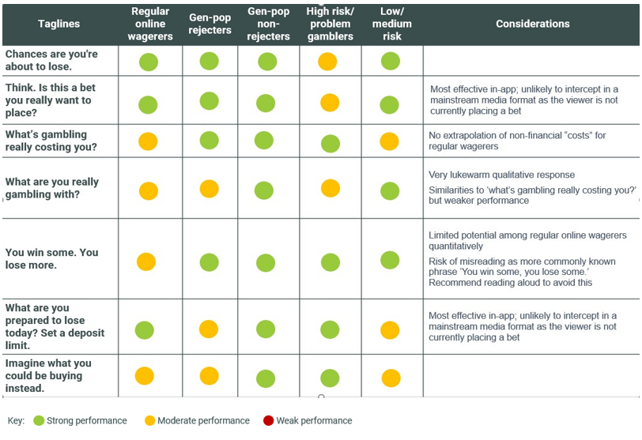
Implemented as a suite, the taglines maximise the opportunity to resonate with all consumer audiences, including all risk levels of the Problem Gambling Severity Index, across a range of platforms, including mainstream (TVC, radio, online) and in-app. It is recommended that these are rolled out evenly across the various platforms to expose viewers to a range of taglines, and reduce the likelihood of message fatigue. There is also scope for these messages to be expanded into land-based environments in the future.

The seven taglines (in no particular order):
- Chances are you’re about to lose.
- Think. Is this a bet you really want to place?
- What’s gambling really costing you?
- What are you prepared to lose today? Set a deposit limit
- Imagine what you could be buying instead.
- You win some. You lose more.
- What are you really gambling with?
It is recommended that all taglines be accompanied by the call to action ‘for free and confidential support call 1800 858 858 or visit gamblinghelponline.org.au’ for TVC, radio and in-app formats. There is seen to be value in raising awareness of these help-seeking resources. Indeed, the Delphi group reports that campaigns with a clear call to action have resulted in an uplift in traffic to both phone and website service. This potential for interest also exists among the general population beyond their intended audience of problem gamblers which creates a wider community understanding that help is always available for those negatively impacted by gambling.

As a suite, the taglines maximise the opportunity to reduce gambling harm
The taglines were found to be effective in different ways. Collectively, they worked on both rational and emotional levels to cut through and encourage consumers to take positive, harm minimising actions without stigmatising gamblers.
Measuring the efficacy of messages is complex and can be best understood through a series of metrics: ability to cut through and capture attention (salience), prompting consumers to stop and rationally process the message (rational response), engage consumers on a personal level so that they internalise the message (emotional response), and motivating positive changes to behaviour (action). The recommended taglines performed strongly across multiple measures of efficacy and as a suite ensure a desired response is elicited from consumers.
The research confirmed that for each audience, at least two taglines within the recommended suite have strong efficacy, indicating that all audiences can be engaged through the suite of messages in market. Furthermore, none of the recommended taglines performed poorly or jarred with any audience: the suite of taglines has low risk of stigmatisation or inducing other negative consequences (for example, encouraging harmful behaviours).
No significant differences in tagline efficacy were found between states and territories, suggesting that a consistent suite of taglines can be implemented nationwide.
Consumers claim that seeing rotating different messages in market reduces the likelihood of them ‘tuning out’ to the message in a short space of time, as was an often-reported response to the ‘gamble responsibly’ tagline.
However, participants also commented that the more they read and thought about a particular tagline, the deeper they connected with and rationally processed the message. There is therefore a strong case for ensuring consumers are given the opportunity to be exposed to each tagline on multiple occasions to aid the digestion of the message and its subsequent behavioural response. There is also scope to present more than one tagline in market at the same time in different environments. This is because the messages speak to different truths and thus do not detract from or conflict with other taglines.

Full recommendations for the taglines in each format
Prior research conducted by Hall & Partners in 2021 found that current gambling warning messages were ineffective, easily missed, and discouraging of consumer engagement. Guidelines for the most effective presentation of the taglines were informed by consumers’ reflection on and evaluation of the presentation of the current ‘Gamble responsibly’ tagline in different settings, and the quantitative testing of presentation formats.
The suite of taglines has the potential to be effective if presented in a range of settings and environments, including advertising or as stand-alone messages. It is recommended that all seven taglines are rotated evenly over a period of time.
There is strong consumer appetite for any of the seven taglines to accompany industry advertising, such as television, radio, and print advertising. Consumers claim that the taglines presented to replace ‘Gamble responsibly’ in advertising would be effective: catching their attention and engaging them with the message if presented in the recommended presentation format.
Of the seven taglines, ‘Chances are you’re about to lose’ showed the broadest promise with application to a range of formats and media, and potential for its own campaign.
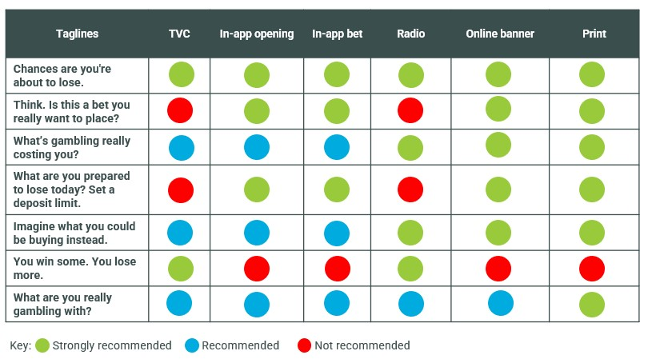

Recommendations for TVC advertising
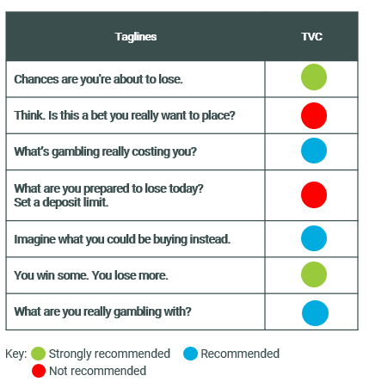
The above table shows the recommendations for taglines for TVC advertising.
The TVC tagline should be placed at the end of the commercial, with a slow, evenly-paced voiceover to allow for greatest digestion of the message and tagline. The voice can be either gender, but it is recommended that attention is paid to the pace of the tagline, ensuring cut-through as a faster-paced tagline is easily dismissed. A shorter call to action will achieve this, with the call to action ‘call the number on screen or visit the website’ recommended over ‘for free and confidential support call 1800 858 858 or visit gamblinghelponline.com.au’.
The tagline should be presented in large font, taking up as much of the screen as possible, and a black background with white text to allow the viewer to easily read it.

Recommendations for radio advertising
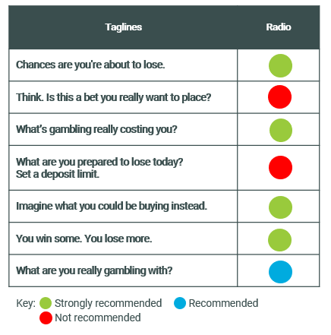
The above table shows the recommendations for taglines for radio advertising.
The radio tagline should have an evenly-paced voiceover and a pause between the tagline and other messages such as ‘terms and conditions apply’. It is recommended that the full website not be read aloud, with a shorter call to action such as ‘visit Gambling Help Online’ to allow for time to absorb the message.

Recommendations for in-app placement
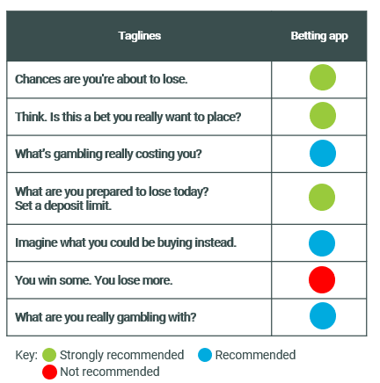
The above table shows the recommendations for taglines for betting applications.
The in-app tagline should occur at two locations: both on opening the app and at the point of placing a bet. The tagline should appear as a pop-up box, which viewers must engage with to minimise. This will ensure the message catches both those consumers who log in casually, and those who leave the app continuously logged in for ease of use.
The font should be clear, legible, and easy to read with the largest possible font consistent across the whole message. The message should be presented as black text on a white background.
It is not recommended that ‘You win some. You lose more’ be included in in-app settings due to the possibility for confusion.

Recommendations for online banner advertising
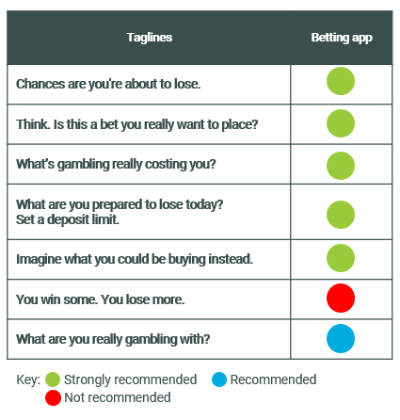
The above table shows the recommendations for taglines for online banner advertising.
The tagline should occur at the end of the banner ad in clear, easy to read text with the largest possible font consistent across the whole message. The message should be presented as black text on a white background.
It is recommended that the call to action ‘For free and confidential support call 1800 858 858 or visit gamblinghelponline.org.au’ be removed for online banner advertising so as to avoid the risk of a gambler seeking help, clicking on the banner in the hope of being taken to the Gambling Help Online website, and instead finding themselves on an online betting site. Instead, the call to action to ‘Set a deposit limit’ should be considered, or the tagline can be left to stand alone without a call to action.

Recommendations for print advertising
Print executions were not tested in the research, but a recommendation can be made based on other advertising formats which utilise print and visual mediums.
Taglines in print advertising should stand alone from the advert so as not to be confused with the message contained within the advertisement. The tagline should be in large, legible font and presented in black text on a white background.
All taglines will be appropriate for this format apart from ‘You win some. You lose more’ which should only be used in channels where it is read aloud.

Introduction

A guide to this report
This report documents the findings of the research program. It first outlines the context of the research, then details the research findings, and lastly summarises the opportunities and recommendations.
Where verbatim quotations from qualitative participants are used, they are referenced with the participant’s risk level (as identified in line with the Problem Gambling Severity Index), audience segment (e.g. gender, age), and location. Verbatim quotations are intended to give the reader an insight into the tone and dialogue heard from participants during qualitative discussions and provide examples of the sentiment heard across sessions.
Individuals in the qualitative research are referred to as ‘participants’, while those who responded to the quantitative surveys are referred to as ‘respondents.’ People who engage in online wagering behaviour and the intended message recipients of the taglines are sometimes referred to as ‘consumers’ for ease.
For purposes of brevity, acronyms are used throughout the report.
Table of acronyms
Acronym | Definition
CALD | Culturally and Linguistically Diverse
DSS | Department of Social Services
EGM | Electronic gaming machine
H&P | Hall & Partners Pty Ltd
NCPF  NCPF IGC | National Consumer Protection Framework for online wagering  National Consumer Protection Framework Implementation Governance Committee
PGSI | Problem Gambling Severity Index
The research was carried out in accordance with ISO 20252 requirements which includes data collection, analysis and reporting processes.
Australians are some of the most prolific gamblers in the world. Gambling losses in Australia represent some of the largest losses per capita of any country in the world and present a significant public health issue that needs addressing. There are around 150 licensed online wagering providers in Australia (ACMA, August 2022) and there are approximately 3.3 million active online wagering accounts held by consumers in Australia. On an adult per capita basis, Australians had higher gambling losses than any other country at $1,276 per year in 2018-19. Problem gambling in the Australian adult population doubled from 0.6 per cent in 2011 to 1.23 per cent in 2019 and the rate of problem gambling among online wagerers (3.9 percent) was three times the rate among land-based only gamblers (1.4 per cent).
Gambling behaviours tend to exist on a continuum from very occasional gambling to frequent betting. Wagerers can very quickly move along this continuum from infrequent to frequent and problematic use. According to Latvala, Lintonene and Konu (2019), harms associated with gambling tend to increase along the continuum with more frequent wagerers experiencing greater financial, social and familial hardship. For these reasons, it is important to provide mechanisms for providing effective, evidence based tools for gamblers to prevent themselves from sliding too far up spectrum of gambling frequency and assist them in avoiding experiencing these negative consequences that are linked with frequent betting. In this context, tools for behaviour change are going to be crucial to minimise the personal and societal cost of problematic gambling by promoting safer wagering habits amongst Australians.

The place for tagline messaging in social marketing and behaviour change
While messaging is an essential component of influencing behaviour, we must also acknowledge that it is just one component of a comprehensive behaviour change program.
It is clear from the expanding body of social psychology literature that people do not change their behaviour simply because they have the correct information: all classic behaviour change models demonstrate that an individual’s beliefs and attitudes (as seen overleaf) are the critical intervening factors between knowledge/awareness and behavioural intentions. In addition, even after desirable behavioural intentions have been formed, intervening heuristics (mental short-cuts), habits, unconscious biases and environmental influences can still get in the way of desirable behaviour.
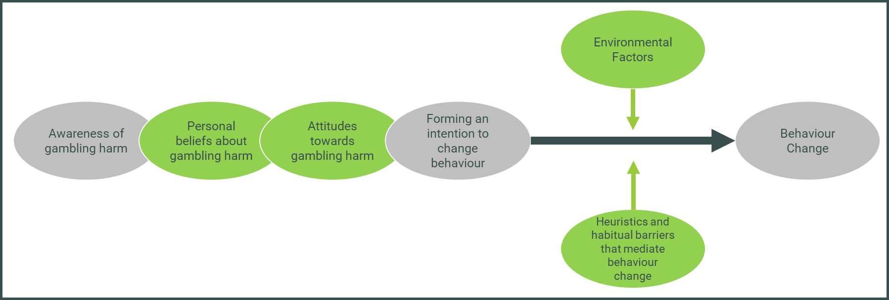
The behaviour change journey with regard to gambling behaviour, adapted from Ajzen and Fishbein’s Theory of Reasoned Action (1980)
A well-designed tagline can go some way towards intercepting these heuristics, biases and habits, and engaging conscious decision-making processes at a point when they might otherwise be disengaged. However, decisions are never made free of context, and an individual is always subject to a wide range of influences.
While marketing and communications target the individual, they work most effectively when operating in conjunction with changes on the macro level (shown below), such as legislation, as well as influence from peer and social groups, and the wider community (the middle rectangles in the model).
Social & Structural
- Resources & Services
- Policies & Legislation
- Guidance & protocols
- Political leadership
- Gender norms
- Religious & cultural norms.
- Media & technology
- Socio economic factors

Community
Leadership, access to information, social
capital, collective efficacy
Family & Peer Networks
Peer influence, spousal communications,
partner & family influence, social support
Individual
Knowledge, skills, benefits & values,
self-efficacy, perceived norms, perceived risk,
emotion
Influences on an individual, adapted from Bronfenbrenner’s Ecological Model of Influences (1979)
We have seen this with other legal but addictive behaviours such as smoking, where a combination of legislative changes (for example, plain packaging or increased taxes), environmental controls (such as reducing smoking in public places), changing social norms, hard-hitting social marketing campaigns and taglines on packaging have reduced rates of smoking in adults in Australia from 25% in 1991 to 11.6% in 2019. While gambling does not impact physical health in the way that smoking does, significant ongoing research into the public health implications of gambling for individuals and society more broadly (see Latvala, Lintonen & Konu, 2019). To minimise the ill effects of gambling on individuals, families and society as a whole, campaigns for safe wagering are going to play a crucial role.
When it comes to reducing gambling harm, messaging is an essential piece of a complex puzzle. This puzzle also includes environmental changes, peer norms and social pressure, and possible structural or legislative changes all of which play a substantial role in encouraging behaviour change. As we can see from the Ajzen and Fishbein model, in order to make a behaviour change, people must first be aware of the issue and then hold sufficiently motivating beliefs and attitudes. Messaging is an opportunity to change some of these beliefs and attitudes, to challenge misconceptions and influence social norms, and to target individuals at a moment of decision-making.

The National Consumer Protection Framework for online
wagering
The NCPF has acknowledged the various influences on behaviour change by introducing a suite of measures, of which consistent gambling messaging is but one. The measure includes the use of consistent messaging about the risks and potential harm of gambling in the advertising of online wagering providers, and includes their direct marketing, websites, and other direct communications to their customers. This will help to avoid inconsistent or ineffective messages about responsible gambling, and make sure messages reach people as they are making gambling decisions.
A 2017 meta-analysis by the Victorian Responsible Gambling Foundation concluded that action into gambling harm should closely consider the stigmatising tone of some gambling messages. The analysis concluded by calling for change in regulation and messaging, with its first recommendation being the introduction of a national framework which assists in the national regulation of gambling advertising.
The NCPF Baseline Report, released in 2019, states that messaging needs to facilitate conscious decision-making at the point where consumers engage in online wagering, and correct misperceptions about individuals’ own gambling behaviour. Messaging must also inform consumers about harmful gambling behaviours and remove stigma associated with consumer protection tools and gambling help services in order to encourage their uptake.
These are all appropriate areas for messaging to target, as they are within the realm of control of the individual. Importantly, messaging has the advantage (over some other measures) of targeting the individual at the point of their decision-making and offering an opportunity to intercept the behaviour.
Other measures among the ten included in the NCPF include those in legislative and regulatory spaces, such as restricting payday lenders and inducements, prohibitions on lines of credit, and streamlining the verification of customers’ identity. In this way, we can see that the NCPF acknowledges that regulatory, legislative, and social and environmental changes all have a role to play in targeting gambling harm, with messaging working alongside these to improve outcomes.

Targeting conscious decision-making: The Hall & Partners Approach
Existing behavioural theory can help to dissect and make sense of these various factors that influence gambling behaviour. Behavioural theory can also assist in understanding how these influences might be utilised to inform interventions. However, there are numerous models and theories – indeed, Darnton (2008) identified over sixty such models. Selecting the most appropriate model, and then applying these highly academic constructs in a practical and pragmatic way can often pose a challenge.
To simplify the process, Hall & Partners has developed a clear, simple, real-world approach that draws on the latest thinking in behavioural theory and behavioural economics. The Hall & Partners Behaviour Change Framework was developed by. The framework applies the principles of dual process theory to examine both rational systems (‘conscious’ attitudes, beliefs and behaviours) as well as unconscious systems (attitudes, biases, impulses, emotional and non-deliberative behaviours of which the person may not be aware).
Like all addictive behaviours, online wagering works on the unconscious mind of the consumer to disconnect conscious decision-making and encourage compulsive behaviour. The behaviour of online wagering in particular is highly influenced by context, environment and unconscious influences which cannot be easily explained or articulated. A study in 2018 by the Australian Gambling Research Centre found that sports betting behaviour was normalised among young men, suggesting that social norms feature heavily for this behaviour.

Research to replace ‘gamble responsibly’ tagline
Hall & Partners was commissioned by DSS in 2021 to work with a copywriter to devise taglines which would target both rational thinking and intercept behaviour. Extensive behavioural research was conducted, informing the development of thirty taglines which were tested qualitatively and quantitatively with regular gamblers. Of these, five were found to be effective at both engaging consumers and intercepting rational decision-making. It was recommended that the existing tagline ‘gamble responsibly’ be replaced by this suite of five taglines which would operate together to target different PGSI levels, heuristics, behaviours and attitudes.
These taglines were (in no particular order):
- Chances are you’re about to lose.
- Think. Is this a bet you really want to place?
- You win some. You lose more.
- What are you prepared to lose today? Set a deposit limit.
- Imagine what you could be buying instead.
The recommended taglines were underpinned by human insights from the behavioural research that were informed by different mindsets, behaviours, biases, and heuristics held by consumers. Each human insight led to the development of a unique message theme (territory). The suite of taglines spoke to three different themes, all of which had high personal relevance across consumer audiences:

Tagline | Theme (territory) | Human insight | Intention of the territory
Chances are you're about to lose. | Confidence | Consumers ignore negative feelings experienced when wagering which leads to a sense of confidence they will win. | Reduce consumers’ overconfidence when placing a bet.
Think. Is this a bet you really want to place? | Confidence | Consumers ignore negative feelings experienced when wagering which leads to a sense of confidence they will win. | Reduce consumers’ overconfidence when placing a bet.
You win some. You lose more. | Loss | Dreaming about the prospect of winning makes consumers forget they might lose. | Remind consumers of the rational truth that losing is a likely outcome of wagering.
What are you prepared to lose today? Set a deposit limit. | Loss | Dreaming about the prospect of winning makes consumers forget they might lose. | Remind consumers of the rational truth that losing is a likely outcome of wagering.
Imagine what you could be buying instead. | Positive | Consumers do not consider what else they could spend their gambling money on. | Reframe the conversation away from gambling harm to the positive outcome of not betting.
Consumer testing confirmed that for each audience, at least two taglines within the recommended suite have strong efficacy, indicating that all audiences can be engaged through the suite of messages in market. Furthermore, none of the recommended taglines performed poorly or jarred with any audience: the suite of taglines has low risk of stigmatisation or inducing other negative consequences (for example, encouraging harmful behaviours).
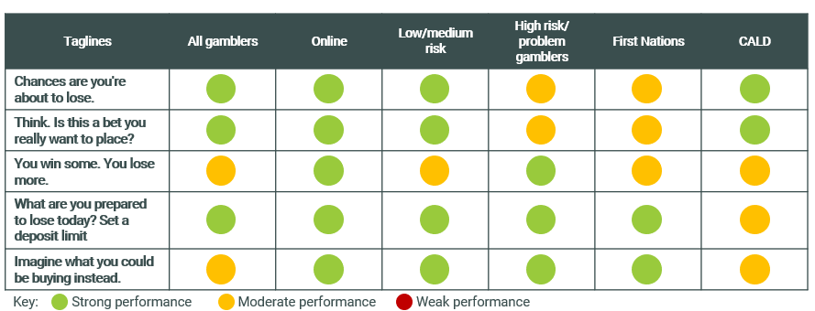
No significant differences in tagline efficacy were found between states and territories, suggesting that a consistent suite of taglines can be implemented nationwide.
In addition, a group of experts in gambling behaviour, including representatives from each state and territory government, known as the Delphi group, was also convened in July 2021. This included the following representatives:

State | Position | Organisation
NSW | Director | Office of Responsible Gambling, Better Regulation Division, Department of Customer Service
NSW | Manager | Strategy and Development ORG NSW
VIC | Branch Head | Strategic Communication and Marketing, Victorian Responsible Gambling Foundation
QLD | Director | Office of Regulatory Policy Liquor and Gaming, Department of Justice & Attorney General
ACT | A/G Senior Director | Policy and Coordination, Access Canberra
SA | Senior Policy Officer | Office for Problem Gambling
WA | Regulatory Officer | Local Government Liquor and Gaming, Department of Local Government, Sport and Cultural Industries
TAS | Senior Program Officer | Gambling Support Program, Housing, Disability and Community Services, Department of Communities Tasmania
NT | No representative: written submission provided | No representative: written submission provided
Drawing on research and experience from state and territory jurisdictions, five additional messages were developed by the group, each with a call to action to direct consumers to support:
- Betting too much? For free and confidential support call 1800 858 858 or visit gamblinghelponline.org.au
- What’s gambling really costing you? For free and confidential support call 1800 858 858 or visit gamblinghelponline.org.au
- To quit/stop gambling call Gambling Help on 1800 858 858 or visit gamblinghelponline.org.au
- Worried about your gambling? We can help. Call 1800 858 858 or visit gamblinghelponline.org.au
- What are you really gambling with? For free and confidential support call 1800 858 858 or visit gamblinghelponline.org.au
An evidence base was then required to test the ten taglines and messages and to establish which taglines work best in which format, which medium, and for which target audience.

Research objectives of this research program
The research aims and objectives tie in with the eighth measure of the NCPF, which provides for evidence-based, consistent gambling messaging.
The NCPF National Policy Statement says: “The same approved gambling message(s) must be used in connection with any interactive wagering service, including as it relates to the following:
- within their customers’ ‘My Account’ window
- on their websites and internet applications
- on direct marketing materials
- on print and broadcast advertising
- on any sponsorships and promotional activities.
The research program aimed to determine the most effective approach to gambling messaging and dynamic warning messaging, and this report comprises our recommended messages, taglines, and presentation formats to target online wagering behaviours and promote safe gambling and help for those worried about their betting across multiple media channels.
The objectives of this research were:
- To determine the most effective messaging and tagline executions on their ability to intercept behaviour and encourage behaviour change, direct consumers to help-seeking measures, and other key metrics;
- To establish any differences by target audience (online wagerers and the general public) in terms of message preference, memorability and likely action as a result;
- To establish the best locations and advertising medium for different taglines or messages, including testing the hypothesis that certain messages are best placed for broadcast media and others are better placed for online and in-app interception of behaviour; and
- To determine the best placement and positioning of messages within each advertising medium, including radio, television, online and in-app placement.

Research design

Listen and learn session with the Delphi group
At the beginning of the research process, a short summary of the recommendations of the Delphi meeting was provided to the Hall & Partners research team. The group was also consulted early in the research process to ensure that understandings, priorities, and clarity of information was all in alignment.
As such, a ‘listen and learn’ session was held with the Delphi group to allow them to ask key questions of the research team to ensure that the objectives of this program of research aligned with the group’s key considerations. As there was no representative from the Northern Territory in the Delphi Group, an additional NT representative was invited to ensure all Australian state and territory governments were represented.
The group comprised a number of experts in gambling harm, some of whom had tested messaging and other communications around gambling harm in different state jurisdictions. This knowledge was invaluable at this early point, as it ensured we did not simply cover previous ground with this research program, but garnered new insights from a wide range of sources. In addition, this session helped to engage key stakeholders with the research at an early point and allowed the representatives to share insights from previous research conducted by different jurisdictions with Hall & Partners to inform the current research program. The ability to formulate the program of work as a collaborative journey ensured that expertise and experience from the sector was leveraged.
This session allowed the identification of shared goals and outcomes to ensure the findings were appropriate, relevant and applicable to the various states. It was agreed by the group that one desired objective was that the messages being tested would assist those engaging in gambling to consider their actions and seek assistance or support if needed. Additionally, the group agreed that the messages should go some way to supporting the idea that gambling has the potential to be a detrimental or harmful behaviour. At a more granular level, the testing would explore different semantic options (for example the use of ‘stop’ as opposed to ‘quit’ and ‘change’) and the aesthetic aspects of the message also be explored (font size, voiceover preferences, tone, placement of message etc).
The outcome of this session was to create a clear project plan, a written agreement of the objectives and key research questions, all of which greatly informed the design of the research instruments, in particular the metrics that were tested in the quantitative questionnaire. The Delphi group were kept updated with the project progression and were given the opportunity to review the creative stimulus being tested in the qualitative and quantitative phases. This collaboration and communication allowed a joint effort in ensuring that all elements were considered, all expertise and experience was leveraged and therefore that the outcomes are insightful, usable and relevant.

Testing taglines, layout applications & identifying the recommended taglines
Ten taglines were taken forward and tested quantitatively and qualitatively, comprising five recommended by the Delphi group and five from the first round of Hall & Partners research.
The ten taglines in no particular order were:

- Betting too much? For free and confidential support call 1800 858 858 or visit gamblinghelponline.org.au
(‘Betting too much’)
- What’s gambling really costing you? For free and confidential support call 1800 858 858 or visit gamblinghelponline.org.au (‘What’s gambling really costing’)
- Worried about your gambling? We can help. Call 1800 858 858 or visit gamblinghelponline.org.au (‘Worried about your gambling’)
- What are you really gambling with? For free and confidential support call 1800 858 858 or visit gamblinghelponline.org.au (‘What are you really gambling with?’)
- To stop gambling call Gambling Help on 1800 858 858 or visit gamblinghelponline.org.au (‘to stop gambling’)
- Chances are you’re about to lose. For free and confidential support call 1800 858 858 or visit gamblinghelponline.org.au (‘Chances are’)
- Think. Is this a bet you really want to place? For free and confidential support call 1800 858 858 or visit gamblinghelponline.org.au (‘Think.’)
- You win some. You lose more. For free and confidential support call 1800 858 858 or visit gamblinghelponline.org.au (‘You win some’)
- What are you prepared to lose today? Set a deposit limit. For free and confidential support call 1800 858 858 or visit gamblinghelponline.org.au (‘What are you prepared to lose’)
- Imagine what you could be buying instead. For free and confidential support call 1800 858 858 or visit gamblinghelponline.org.au (‘Imagine’)

Qualitative exploration
Qualitative and quantitative research was conducted. The purpose of the qualitative component was to gain in-depth responses to the stimulus, which displayed the taglines and messages in a range of advertising and broadcast mediums and online formats. This was done to understand which messages resonated most strongly with online wagerers and why.

30 interviews with online wagerers, including 8 with CALD and First Nations audiences
In-depth interviews were conducted with online wagerers of a range of risk profiles. Unlike the first round of Hall & Partners research, which had a target audience of low-moderate gamblers and included a more limited sample of high risk or ‘problem’ gamblers, this research program saw those two risk profiles more evenly distributed.
In addition, a range of male and female respondents were consulted, as per the below table. As online wagering is more common among males, the matrix was developed to reflect this. A range of locations across Australia was included, with input from all eight States and Territories.
Risk level / demographic | Male | Female | Total
Low-Moderate Risk 18-50 | 8 | 4 | 12
High Risk 18-50 | 7 | 3 | 10
CALD 18-50 | 3 | 1 | 4
First Nations 18-50 | 2 | 2 | 4
Total | 20 | 10 | 30
Each interview was up to 60 minutes long and was conducted by an experienced qualitative moderator from Hall & Partners. Participants were shown stimulus depicting up to 10 taglines or messages per participant in a range of advertising mediums including television, a radio script, two versions of an in-app wireframe and online banner advertising.
Hall & Partners’ creative partner, Clemenger BBDO, developed the stimulus which included:
- TV commercials for betting companies that featured six taglines (selected by DSS, H&P and the Delphi group as best suited to this medium), with two different placements or positioning (totalling 12 that were rotated across interviews).
- In-app prototypes featuring eight taglines (selected by DSS, Hall & Partners and the Delphi group as best suited to this medium), with two different placements or positioning (totalling 12 that were rotated across interviews).
- Radio script featuring all ten taglines, that were read aloud by the moderator and rotated across interviews.
- Online banner advertising featuring all ten taglines, that were rotated across interviews.
The positioning of taglines and messages, which was agreed on at the inception meeting, included TVC presentations that were adapted from an actual ad for a wagering service provider. They demonstrated:
- All available taglines rotated through the different interviews
- At least one tagline delivered by a female voiceover and a male voiceover per interview
- At least one tagline that appeared at the beginning and at the end of the TVC per interview
- At least one tagline that was shorter and longer form per interview

The purpose of a qualitative methodology
Qualitative research allowed us to ask key questions of participants and gain an insight into the reasons behind their responses. In-depth interviews allowed us to understand participants’ responses away from the influence of a group dynamic and allowed a degree of flexibility concerning the schedule of the participant. This ensured the inclusion of participants who might not otherwise be able to attend a centralised focus group.
This project lent itself to an online methodology due to the target audience engaging primarily with the topic online (through online wagering). In addition, online interviews prevented the research from being impacted by any existing or emergent COVID-19 restrictions, allowing the research team to complete the project within its allocated timeframe.
Prior to the research, the Delphi group hypothesised that the Hall & Partners taglines would be most effective in an online or in-app format, whereas the messages developed by the Delphi group might hold more relevance in a broadcast medium. The research methodology employed allowed this hypothesis to be tested by comparing different taglines and messages and understanding participants’ responses in depth.
By using actual industry advertising and an in-app prototype which was developed to appear to the user as the familiar interface for an actual betting app, we overcame potential scepticism around an unknown provider, allowing for an authentic response to stimulus. Several major brand platforms were used so as not to target any particular betting service, while exposing participants to familiar brands to create a more realistic research environment to test the taglines.

CALD and First Nations consumers
A small cohort of CALD and First Nations gamblers was included qualitatively to check for linguistic challenges, cultural nuance, and potential intersection of disadvantage. We know that potentially addictive behaviours such as gambling can be compounded by marginalisation factors such as education, health, poverty, social norms and other markers of vulnerability, which disproportionately affect people of Aboriginal or Torres Strait Islander background. Because of this, we felt it was essential to include these key groups to check for potential harms or cultural factors which might influence the reception of these messages. The qualitative phase of the research therefore interviewed a total of four people of CALD and four people of First Nations background in order to test the effectiveness and impact of the messaging for these diverse groups.

Recruitment and reimbursements
All in-depth interviews were moderated by Hall & Partners’ consultants and took up to 60 minutes. The discussion guide for the interviews was prepared by Hall & Partners with approval from DSS prior to the commencement of the in-depth interviews. Each interview was recorded via Teams with the permission of participants to ensure accuracy of quotations.
Participants were sourced by our recruitment partners in each state (QandA Research in Queensland, McGregor Tan in NT and South Australia, Painted Dog Research in Western Australia, Myriad Research in Tasmania, and Cooper Symons and Research Connections in all other states). Each participant was provided with a reimbursement of $100 (as an e-gift card) as compensation for their time in line with The Research Society’s recommendations.

Quantitative validation
Concurrent with the qualitative interviewing, we conducted a quantitative survey to determine the effectiveness of the top taglines and evaluate their performance across the various advertising media. Through this component we have been able to:
- Provide statistically robust findings on the priority ranking of messages
- Clarify preference and performance of the leading taglines, particularly if there was any division or mixed preference coming out of the qualitative discussions
- Evaluate performance of the taglines in-situ across TVC, in-app and online banner advertising formats.

Audience & Approach
We conducted a 10-minute online survey among the following audiences:
- Regular online wagerers (at least once a month) of n=1000 (margin of error +/- 2.53% at 95% confidence level), and
- General 18+ public of n=1000, split into:
  - Gambling rejecters (i.e. people who do not partake in any gambling activity) of n=500, and
  - Gambling non-rejecters (i.e. people who gamble at least occasionally, but are not regular online wagerers) of n=500

Survey design
The survey length of 10 minutes struck the balance between enough survey real estate to adequately validate the leading taglines and maintain respondent engagement.
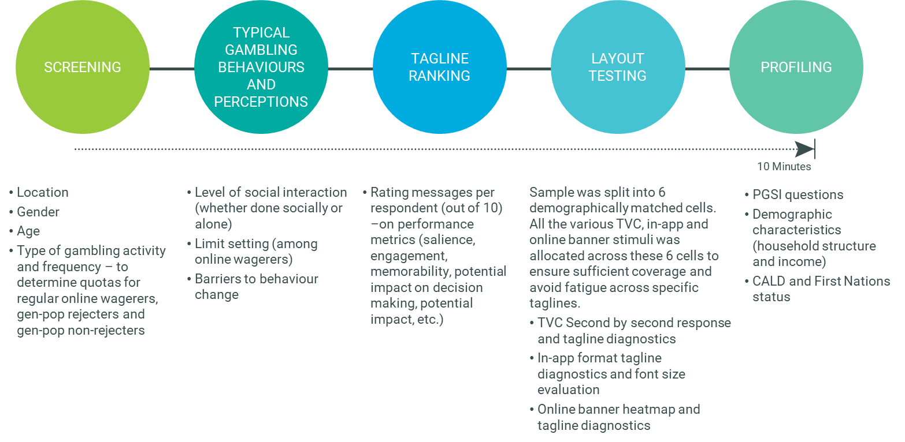
The tagline ranking in this survey focused on metrics to measure the leading taglines against the key objectives: increasing awareness of gambling harm, encouraging positive behaviour change (through conscious decision making), and promoting the use of consumer protection tools without stigma.

Layout and message presentation testing
To provide evaluation of performance of the taglines in various advertising media formats, the n=2,000 sample was split into six equal groups of similar respondents (c. 333 per group). All the various TVC, in-app and online banner stimuli were allocated across these six groups to ensure sufficient coverage for each stimulus, while ensuring that respondents would not be over-exposed to certain taglines. The order of the stimulus shown (including the order in which the TVCs, in-app and online banner questions were asked) was rotated across the sample to ensure minimisation of order effects.
Respondents were asked to rate each of the stimuli against a range of diagnostics, covering attributes such as message salience, font size and encouragement to take various actions.
For the TVCs, we also used second by second response where, on a scale of -50 to +50, online survey respondents used an interactive slider whilst each video and radio ad was played. Respondents indicated how engaged they were with the material by moving the slider upwards and downwards as they saw different images and heard different messages, to indicate their level of positivity with the content.
For the online banners, we also used a heatmapping exercise. Respondents were presented with the stimulus and asked to, as quickly as possible, click the areas that stood out to them the most, focusing less on the messaging and more on the visual features. The output was a visually digestible heatmap, allowing us to compare the different areas of attention across the various online banners.

A summary of previous research and Delphi group advice which informed this research program
This current research was informed by the findings of Hall & Partners’ 2021 research into behaviours and attitudes towards online wagering, and the Delphi group’s extensive research in their respective states. As has been stated, Australia has some of the highest rates of gambling in the world and messaging has a crucial part to play in minimising the social and financial losses of Australian gamblers in the future.

Targeting the message to the recipient
Messages aimed at reducing gambling harm were often most effective when targeted to individuals of different demographic groups, risk profiles, or behavioural profiles. As a result of this, the development of a number of taglines was felt to best target different groups, as different messages, tones and techniques were found to resonate with different groups. For example, Hall & Partners identified six different messaging territories which worked on different behavioural levers to target different groups and risk profiles. The Delphi group identified that high-risk gamblers were receptive to help-seeking messages, whereas low- and moderate-risk gamblers are less accepting of such messages, as they do not see themselves as requiring support.Messaging which appeals to personal responsibility and leaves the feeling of control with the individual has been traditionally used to target gamblers, with the current ‘gamble responsibly’ tagline taking this approach. While there is scope to move beyond this traditional tone and explore new ways to encourage behaviour change, the Delphi group identified the importance of reducing stigmatising language, as this could reduce the likelihood for problem gamblers to seek help. The group also recommended positive and non-judgemental language be used, to further reduce stigma and ensure gamblers do not feel attacked by messaging, as this is seen as counterproductive to assisting them assess their own betting behaviours.

Placement and design of the message
The Hall & Partners 2021 research found that presentation of current gambling warning messages was ineffective, easily missed, and discouraging of consumer engagement. In order to ensure attention of the viewer is captured and cut through of messages is achieved, it was recommended that the presentation of the taglines follow six guidelines:
- The tagline should stand alone, without distraction;
- The tagline should be capitalised and in a large, uniform and legible font;
- The tagline is most ideally black writing on a white background;
- The tagline should cover at least a third of the space if shown on its own screen;
- The tagline should be removed or delineated from any gambling advertising content, for example:
  - In television advertising the tagline would appear in a frame on its own, centred text, without any other text relating to the gambling advertisement present;
  - In print advertising the tagline would be in a legible sized font (at least the same size font as the advertisement’s key message), with white space around the tagline. It would not be positioned in the terms and conditions section of the advertisement (bottom of the ad);
  - In radio advertising the tagline would be orated at the same tempo as the advertisement, not quickened; and
- Engagement with the tagline through a click-box (where a viewer must minimise the tagline to continue with the gambling session) is recommended within betting apps, betting websites, or online advertising (e.g. banner ads) to create an environmental interruption which could cause reflection on behaviour. In-situ or longitudinal studies, which are outside the scope of this program of research could be used to validate this at a later stage.
Emphasising specific words with bold text has merit in directing consumers’ attention and proved efficacious through the quantitative study. Utilisation of emphasis is not recommended as the default presentation for the seven recommended taglines, but this could be revisited by the DSS in time to help re-engage consumers with the message.
The Delphi group identified that placement and design of any help-seeking call to action was crucial to avoid confusion. It was considered important, for example, that the helpline does not receive calls from consumers wanting advice on optimal betting odds.

Terminology
Further research would be needed to determine the extent to which the use of the words ‘gamble’ and ‘responsibly’ themselves influenced the low efficacy of the ‘gamble responsibly’ tagline (as opposed to issues within the overall message, such as a lack of specificity or a focus on individual control in the face of systemic factors). However, both the Delphi group and Hall & Partners identified the word ‘gamble’ as contributing to lack of efficacy in messaging.
An important finding of the initial Hall & Partners research was that the word ‘gambling’ led to self-exclusion from the message for participants at all risk levels. The term was seen to refer to those with a problem and some participants in the research expressed discomfort with the word to describe their own behaviour, leading to a protective belief that this term did not apply to them. This suggested there would be a broader self-exclusion from any messaging which uses the term ‘gambling’ or ‘gamble’.
In addition, the word ‘gambling’ proved more likely to be associated with land-based gambling than online wagering, which further led to self-exclusionary beliefs among those participants for whom online wagering was their main gambling behaviour.
Instead, participants preferred terms such as ‘betting,’ ‘tipping,’ or ‘taking a punt,’ which were seen to have less ‘serious’ negative connotations than the term ‘gambling’ and thus differentiated their own behaviour from that of consumers with a perceived ‘problem’. These terms were also felt to apply to online wagering, as ‘sports betting’ was a particular focus of online wagering behaviours among the participants of the study. In addition, other terms were used which further distanced the participant from the potential negative consequences of the behaviour, such as ‘a cheeky bet’, or ‘having a flutter’, which incorporated a casual, ‘fun’ element to participation. This played into beliefs that the participants had control over their behaviour.
“I never say ‘gambling’ I call it betting…I don’t like the word gambling and it doesn’t resonate with me” (Male, 43, NSW, High Risk)
This was true across all risk levels, with high-risk or ‘problem gambler’ consumers also stating a discomfort with the term ‘gambling’ to describe their own behaviour. When pressed, participants were aware that they were distancing themselves from the behaviour denoted by the term ‘gambling’ by using less technical language, but they did not see this as a problem, and this reflection was rarely spontaneous.
These insights on the influence of terminology have important implications for messaging: messaging aimed at online wagering in particular should avoid using the term ‘gambling’ or ‘gamble,’ in order to ensure viewers do not self-exclude from the message. This was illuminated in this research, which found that messaging which used the words ‘gamble’ or ‘gambling’ were less effective than those which did not.

Self-exclusion from messaging
While the PGSI defines gambling behaviours along a continuum or scale from no-risk to high-risk (or from non-problem gambler to problem-gambler), participants appeared to see gambling behaviours as falling into two binary categories that could broadly be defined as ‘problem gamblers’ and ‘everyone else.’ There was a stated belief from consumers that they would never slide along the continuum into a higher-risk category, and that ‘problem-gamblers’ possessed some personality characteristics which differentiated them from non-problem gamblers.
This led to self-exclusion from messaging around gambling harm. (Please note that the term ‘self-exclusion’ when used in this report refers to likelihood of a person to find messaging personally relevant and is not to be confused with the gambling self-exclusion register.) It was felt that such messages were directed at people with a serious problem, rather than ‘ordinary’ consumers – a category to which all participants believed they belonged, regardless of risk level. As a result, consumers of all risk levels stated that they ignored messaging around gambling harm, as it lacked perceived personal relevance.
Of particular note was the fact that this belief proved true across all risk levels, with high-risk participants also feeling that they should not have been included among problem-gamblers. As a result, it was likely that consumers would ignore any messaging which implied that behaviours they deemed under control at this stage may become more harmful over time. Participants spoke freely of hypothetical ‘problem-gamblers’, clear in their belief that this group did not include themselves, even when their PGSI indicated otherwise.

The role of Government in communications to reduce gambling harm
Participants in the 2021 Hall & Partners research felt that it was appropriate for Government to fund communications to reduce gambling harm, and that the Government also had an important role in assisting people who needed support for their gambling. This was borne out in this research study, with broad support for the role of messaging in this area. It was anticipated by consumers that the taglines would have greater efficacy in this context and would help to delineate the message from industry and thus enhance the sincerity of the tagline.
However, there was some scepticism around the role of Government among those participants who believed that the Government derived income from gambling activities, and therefore stood to benefit financially from increased gambling behaviour. There was little stated understanding between the different roles of State and Federal Government in this area.

Research insights
The Department of Social Services (DSS) commissioned Hall & Partners to conduct qualitative and quantitative research into beliefs, behaviours, and attitudes among regular online wagerers of a range of risk profiles, in order to develop new messaging aimed at reducing gambling harm.

Overarching insights from this research program
A number of key insights emerged from the research program, with researchers drawing some overarching conclusions.
Taglines were broadly divided into two groups: those which spoke directly to consumers and those which were easily ignored. Broadly, qualitative participants divided the ten taglines into two groups, with the quantitative research supporting this.
Seven taglines were received broadly positively, with five in particular receiving particularly high levels of support. These were said to be engaging or thought-provoking, intercepting the participant’s decision-making and encouraging rational reflection on their decisions. It was said that the top five taglines, in particular, spoke to participants directly and without judgement, and were therefore more likely to elicit a behavioural response than others.
The top five taglines, which performed the best in both qualitative and quantitative research, were (in no particular order):
- Chances are you’re about to lose. For free and confidential support call 1800 858 858 or visit gamblinghelponline.org.au
- Think. Is this a bet you really want to place? For free and confidential support call 1800 858 858 or visit gamblinghelponline.org.au
- What’s gambling really costing you? For free and confidential support call 1800 858 858 or visit gamblinghelponline.org.au
- You win some. You lose more. For free and confidential support call 1800 858 858 or visit gamblinghelponline.org.au
- What are you prepared to lose today? Set a deposit limit. For free and confidential support call 1800 858 858 or visit gamblinghelponline.org.au
The additional two taglines, which performed slightly less strongly and rounded out the top seven, were:
- Imagine what you could be buying instead. For free and confidential support call 1800 858 858 or visit gamblinghelponline.org.au
- What are you really gambling with? For free and confidential support call 1800 858 858 or visit gamblinghelponline.org.au
Of note, the more successful taglines often contained a direct question which was said to intercept the participant’s thought process and invite reflection.
The remaining three taglines were seen as speaking to participants from an authoritative position, which was said to make participants feel judged and to add to feelings of shame and stigmatisation which made them less likely to internalise the message. These were also said to be less creative and consequently seen as weaker. Some participants dismissed these as “lazy” or as contributing the “bare minimum” which was said to feel like a tokenistic approach to reducing harm and was therefore unlikely to achieve cut-through. These qualitative findings were supported by the quantitative study.
These taglines were:
- Betting too much? For free and confidential support call 1800 858 858 or visit gamblinghelponline.org.au
- To stop gambling call Gambling Help on 1800 858 858 or visit gamblinghelponline.org.au
- Worried about your gambling? We can help. Call 1800 858 858 or visit gamblinghelponline.org.au

The term ‘gamble’ was easily ignored
Consistent with the findings of the Delphi group and the 2021 H& P research which informed this study, the word ‘gamble’ was off-putting for respondents, as it was seen to apply only to those who were losing substantial amounts. This was true even for those with a high-risk PGSI profile, who self-excluded from the idea that they might be the target for this message.

Participants did not express intention to seek help
Indeed, participants in this study expressed aversion to the website name Gambling Help Online as they did not associate their activities with ‘gambling’. There was also scepticism over the effectiveness of a helpline in reaching gamblers and a stated reluctance to interact with the website or helpline, even for those of a high-risk PGSI. This poses a challenge for the function of the website and helpline.
While there was broad support for a website and helpline to assist the government in reducing gambling harm, participants and respondents self-excluded from this call to action at the end of each tagline.
Based on this research, it seems the call to action inviting consumers to call the helpline or visit the website will be limited in its ability to reach those who might need this support. However, it does serve a broader purpose of raising awareness of this service, as a majority of participants reported that they had not heard of the website or helpline before the research.
More broadly, the Delphi group identified that the helpline and website had important roles to play for the general population who might be supporting a loved one experiencing gambling harm.

The context of gambling advertising poses a challenge for message cut-through
Participants noted that gambling advertising was often bright, loud, and employed humour to engage consumers. The use of music in a TVC in particular was said to uplift and entice viewers to encourage them to engage in gambling behaviour. Consumers said that in this context, it was difficult for messaging to intercept the positive feelings one was left with at the conclusion of gambling advertising, regardless of how effective an individual tagline was seen to be.
It is therefore important to note that while messaging has a key role to play in harm reduction, it should not be expected to overcome gambling harm single-handedly: participants felt that advertising could be restricted in other ways, such as restrictions on the hours that TVCs and radio advertising could be broadcast, or on the content of the advertisements themselves.

Selection of the final suite of taglines
As detailed earlier in this report, ten taglines were taken forward into this round of research. These included five recommended by the Delphi Group and five from the findings from the previous Hall & Partners research.

- Betting too much? For free and confidential support call 1800 858 858 or visit gamblinghelponline.org.au
- What’s gambling really costing you? For free and confidential support call 1800 858 858 or visit gamblinghelponline.org.au
- Worried about your gambling? We can help. Call 1800 858 858 or visit gamblinghelponline.org.au
- What are you really gambling with? For free and confidential support call 1800 858 858 or visit gamblinghelponline.org.au
- To stop gambling call Gambling Help on 1800 858 858 or visit gamblinghelponline.org.au
- Chances are you’re about to lose. For free and confidential support call 1800 858 858 or visit gamblinghelponline.org.au
- Think. Is this a bet you really want to place? For free and confidential support call 1800 858 858 or visit gamblinghelponline.org.au
- You win some. You lose more. For free and confidential support call 1800 858 858 or visit gamblinghelponline.org.au
- What are you prepared to lose today? Set a deposit limit. For free and confidential support call 1800 858 858 or visit gamblinghelponline.org.au
- Imagine what you could be buying instead. For free and confidential support call 1800 858 858 or visit gamblinghelponline.org.au
Each tagline was evaluated on a range of 20 different performance diagnostics, several of which were not asked of gambling rejecters due to the lack of context for this audience. These were grouped into the following themes to allow the research team to a) identify a refined set of top performing messages, and b) assess their relative strengths and weaknesses across various different areas of the tagline experience.

Salience and potential cut through | Rational response | Potential impact on taking action | Emotional reaction (Positive) | Emotional reaction (Negative)
It grabs my attention | It changes how I think about gambling in general | It makes me want to talk to others about gambling | It speaks to me on a personal level | I don't like this message
It is memorable | I believe what is being said in this message | It makes me reconsider my spend or time limits while I'm playing [GAMBLERS ONLY] | It makes me feel empowered [GAMBLERS ONLY] | This message goes too far
 | It reminds me that I can seek help if I need it [GAMBLERS ONLY] | It makes me reconsider whether I really want to place this bet or play this game [GAMBLERS ONLY] | It gives me reassurance that there is help for people who need it [GAMBLING REJECTERS ONLY] | It makes me feel uncomfortable
 | It makes me think about what I could lose [GAMBLERS ONLY] | It suggests to me that I should stop betting or playing altogether [GAMBLERS ONLY]
 | It reminds me that I don't control the odds [GAMBLERS ONLY] | It suggests that I should cut back my gambling activity  [GAMBLERS ONLY]
While analysis was conducted across all key sub-groups of interest where possible across the taglines, for the purposes of strategic guidance the analysis detailed in this report focuses on performance of all consumers, regular online wagerers, gen-pop non-rejecters and gen-pop rejecters. These findings were then sense-checked against other cohorts of importance including the various PGSI categories and by jurisdiction (where sample size was sufficient.
Each theme speaks to multiple ‘winning’ taglines to ensure that performance across all key audiences was taken into consideration. For the purposes of selecting the final suite of taglines, researchers analysed differences which at times may only be marginal.

Salience and potential cut through
Firstly, the research team considered how well these taglines caught the attention of the viewer and how memorable they were. Ratings among gen-pop non-rejecters were generally high across most taglines, however, only a couple performed consistently strongly across all cohorts including regular online wagerers and gen-pop rejecters.
This analysis as shown in Figure 1 revealed three standout performers on salience and potential cut through – ‘Chances are you’re about to lose’, ‘Think. Is this a bet you really want to place?’ and ‘You win some, you lose more’.
Figure 1 - Tagline ratings (9-10 agreement) - SALIENCE AND POTENTIAL CUT-THROUGH AVERAGES
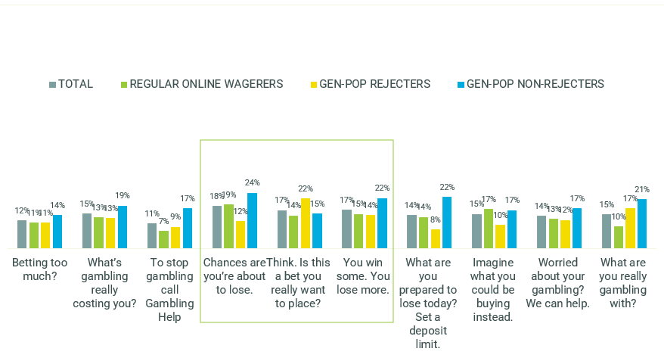
E2. We'd now like you to think about how well each of the below applies to this message. For each, please indicate on a scale from 0 to 10, where 0 means you feel that it doesn't apply at all to this message and 10 means you feel that it applies extremely well.
Total n=382-417 per tagline, Regular online wagerers n=181-217 per tagline, Gen-pop rejecters n=86-109 per tagline, Gen-pop non-rejecters n=91-108 per tagline
Salience and memorability were considered individually among the aforementioned top three performers. The following findings illustrated in

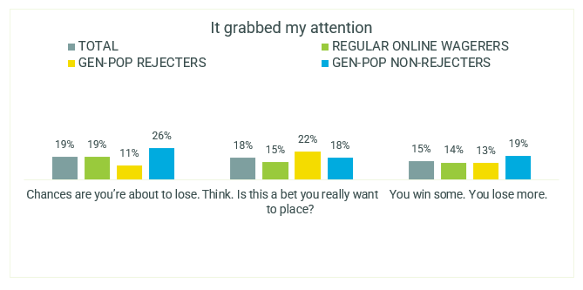
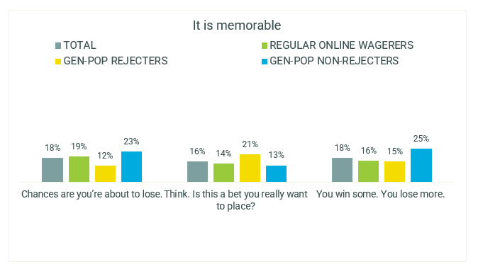
Figure 2 highlight how different taglines were stronger at being salient across the various cohorts, while something that was deemed ‘attention-grabbing’ may not necessarily have been considered ‘memorable’:
- ‘Chances are you’re about to lose’ was the most attention-grabbing tagline among both regular online wagerers and gen-pop non-rejecters;
- ‘Think. Is this a bet you really want to place?’ was the most attention grabbing among gen-pop rejecters;
- ‘Think. Is this a bet you really want to place?’ was also the most memorable among gen-pop rejecters;
- ‘Chances are you’re about to lose’ was the most memorable among regular online wagerers; and
- ‘You win some. You lose more’ was the most memorable among gen-pop non-rejecters.

Figure 2 - Tagline ratings (9-10 agreement) - SALIENCE AND POTENTIAL CUT-THROUGH -Individual diagnostics on key performers
E2. We'd now like you to think about how well each of the below applies to this message. For each, please indicate on a scale from 0 to 10, where 0 means you feel that it doesn't apply at all to this message and 10 means you feel that it applies extremely well.
Total n=382-417 per tagline, Regular online wagerers n=181-217 per tagline, Gen-pop rejecters n=86-109 per tagline, Gen-pop non-rejecters n=91-108 per tagline

Rational response
Secondly, the research team considered these taglines’ ability to elicit a more rational response: that is, to change how consumers think about gambling, cause them to think about how much they could lose, remind them that they can seek help if they need it, and remind them that they do not control the odds. The taglines were also tested for their general believability.
The analysis in
Figure 3 shows that, similar to salience and potential cut through, rational response among gen-pop non-rejecters was consistently strong across most messages. However, when we also take into account performance among the other cohorts, there were three stand outs - ‘Chances are you’re about to lose’ which achieved the strongest response among regular online wagerers, ‘You win some, you lose more’ achieved the strongest response among rejecters, and ‘What are you prepared to lose today’ achieved a generally strong response at an overall level.
Figure 3 - Tagline ratings (9-10 agreement) - RATIONAL RESPONSE AVERAGES
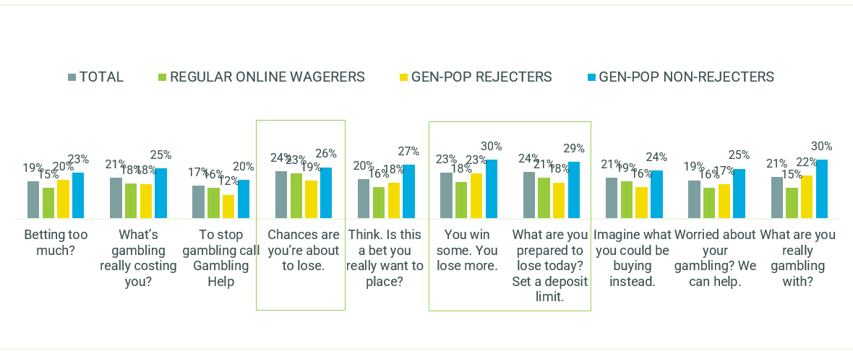
E2. We'd now like you to think about how well each of the below applies to this message. For each, please indicate on a scale from 0 to 10, where 0 means you feel that it doesn't apply at all to this message and 10 means you feel that it applies extremely well.
Total n=382-417 per tagline, Regular online wagerers n=181-217 per tagline, Gen-pop rejecters n=86-109 per tagline, Gen-pop non-rejecters n=91-108 per tagline

Again, the research team considered the individual elements of rational response for top performers at Figure 4. The following highlighted how these various taglines triggered different rational responses.
- In terms of changing how consumers think of gambling more generally, ‘Chances are you’re about to lose’ performed the strongest among regular online wagerers, ‘You win some. You lose more’ performed the best among gen-pop rejecters, and ‘What are you prepared to lose today?’ achieved the strongest performance among gen-pop non-rejecters;
- On believability, ‘You win some. You lose more’ performed particularly strongly among both gen-pop rejecters and non-rejecters, while ‘What are you prepared to lose today?’ performed the best among regular online wagerers;
- ‘Chances are you’re about to lose’ achieved the strongest result on reminding regular online wagerers that they don’t control the odds, while ‘You win some. You lose more’ did so for the gen-pop non-rejecters;
- ‘Chances are you’re about to lose’ also performed the best among regular online wagerers on making them think about what they could lose, while ‘What are you prepared to lose today?’ did so for the gen-pop non-rejecters;
- In terms of these taglines’ ability to be help seeking reminders, ‘Chances are you’re about to lose’ and ‘You win some. You lose more’ both performed well among gen-pop non-rejecters, while ‘What are you prepared to lose today?’ performed well among the regular online wagerers.
Figure 4 - Tagline ratings (9-10 agreement) – RATIONAL RESPONSE - Individual diagnostics on key performers
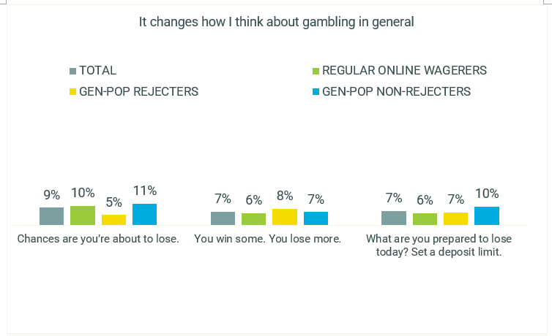
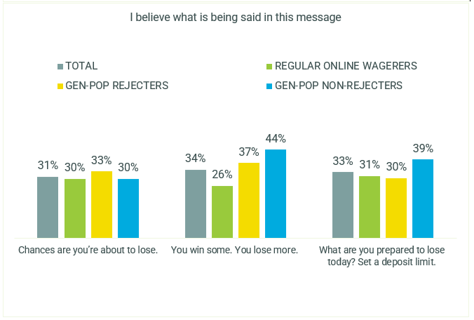
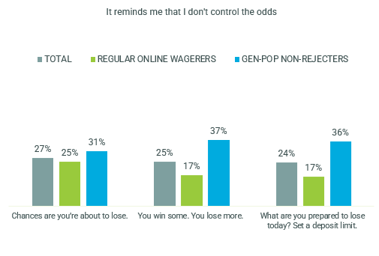
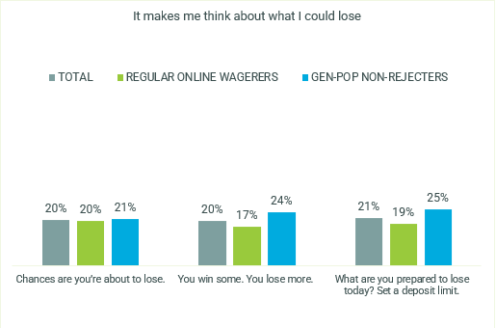

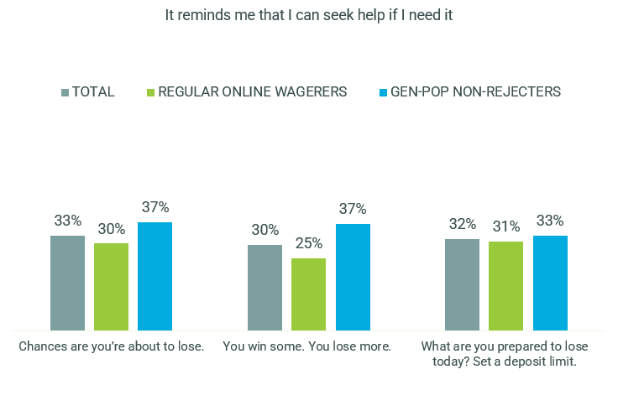
E2. We'd now like you to think about how well each of the below applies to this message. For each, please indicate on a scale from 0 to 10, where 0 means you feel that it doesn't apply at all to this message and 10 means you feel that it applies extremely well.
Total n=382-417 per tagline, Regular online wagerers n=181-217 per tagline, Gen-pop rejecters n=86-109 per tagline, Gen-pop non-rejecters n=91-108 per tagline

Potential impact on taking action
It was essential to understand the potential impact each tagline might have on action among consumers. In particular, in terms of wanting to talk to others about gambling, reconsidering their spend or time limits, reconsidering whether this was a bet they really wanted to place, thinking about whether they should stop altogether and likely influence on reducing their gambling activity. Figure 5 shows how likelihood to take action differed across the different cohorts. Scores among gen-pop rejecters were generally lower due to lower relevance of context of various actions among non-gamblers.
‘What are you really gambling with?’ performed strongly among both gen-pop rejecters and non-rejecters, ‘What’s gambling really costing you?’ performed the best among the regular online wagerers, and both ‘Chances are you’re about to lose’ and ‘Think. Is this a bet you really want to place?’ performed well among both regular online wagerers and gen-pop non-rejecters.
Figure 5 - Tagline ratings (9-10 agreement) - POTENTIAL IMPACT ON
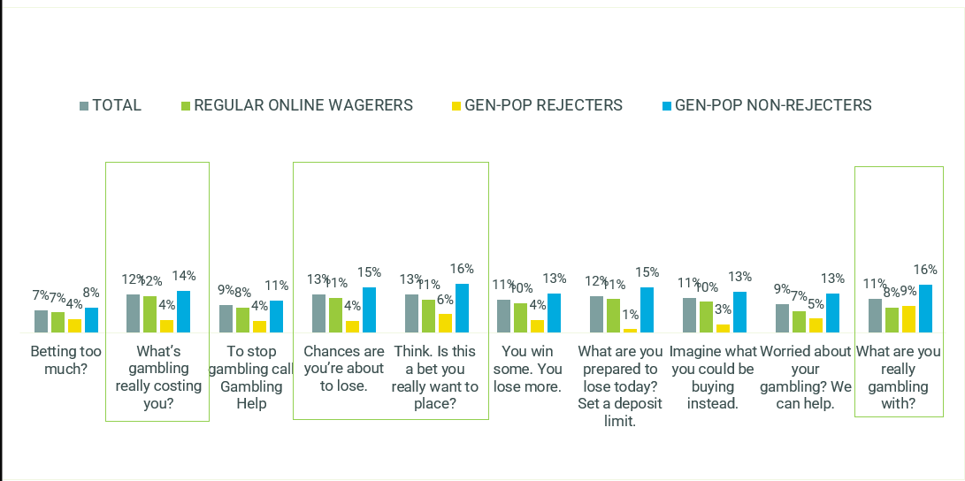
ACTION AVERAGES
E2. We'd now like you to think about how well each of the below applies to this message. For each, please indicate on a scale from 0 to 10, where 0 means you feel that it doesn't apply at all to this message and 10 means you feel that it applies extremely well.
Total n=382-417 per tagline, Regular online wagerers n=181-217 per tagline, Gen-pop rejecters n=86-109 per tagline, Gen-pop non-rejecters n=91-108 per tagline
The research again considered the individual elements of potential impact on action among these top performers, as shown in Figure 6:
- ‘What’s gambling really costing you?’ performed the best among regular online wagerers on making them reconsider their limits, while the other three taglines performed better than ‘Think. Is this a bet you really want to place?’ among gen-pop non-rejecters;
- On making respondents reconsider whether they really want to place a bet or play a game, ‘What are you really gambling with?’ performed the strongest among gen-pop non-rejecters, and ‘Think. Is this a bet you really want to place?’ did so among the regular online wagerers;
- ‘What’s gambling really costing you?’ and ‘Chances are you’re about to lose’ performed the best among regular online wagerers at suggesting a stop to betting altogether, while ‘Think. Is this a bet you really want to place?’ did so among gen-pop non-rejecters;
- ‘Chances are you’re about to lose’ performed well among both regular online wagerers and gen-pop non-rejecters on suggesting they should cut back on their gambling;
- In terms of encouraging discussion with others, ‘What’s gambling really costing you?’ performed strongly among regular online wagerers, ‘Think. Is this a bet you really want to place?’ performed the best among gen-pop non-rejecters and ‘What are you really gambling with?’ performed the best among gen-pop rejecters.

Figure 6 - POTENTIAL IMPACT ON ACTION - Individual diagnostics on key performers
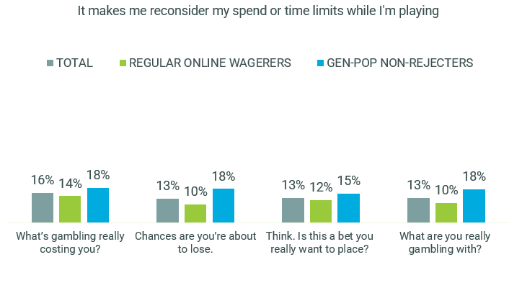
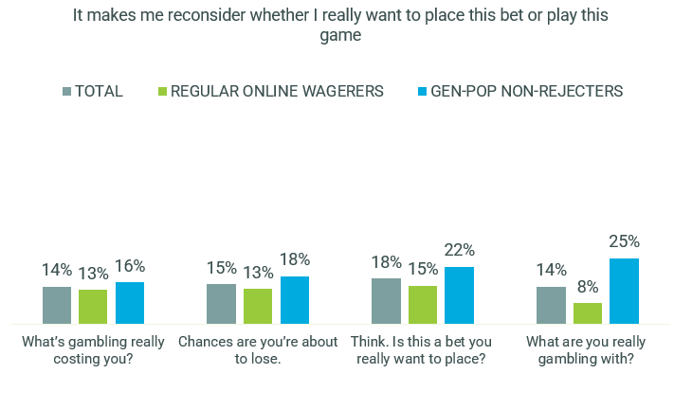
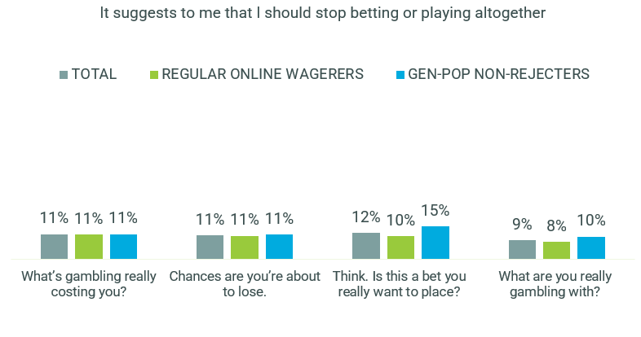
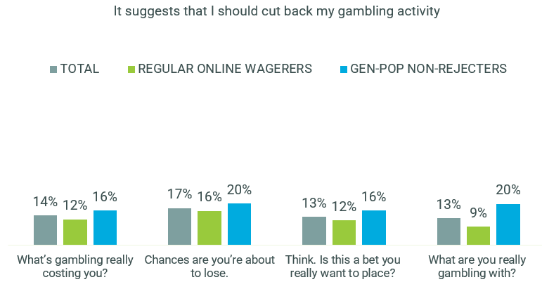
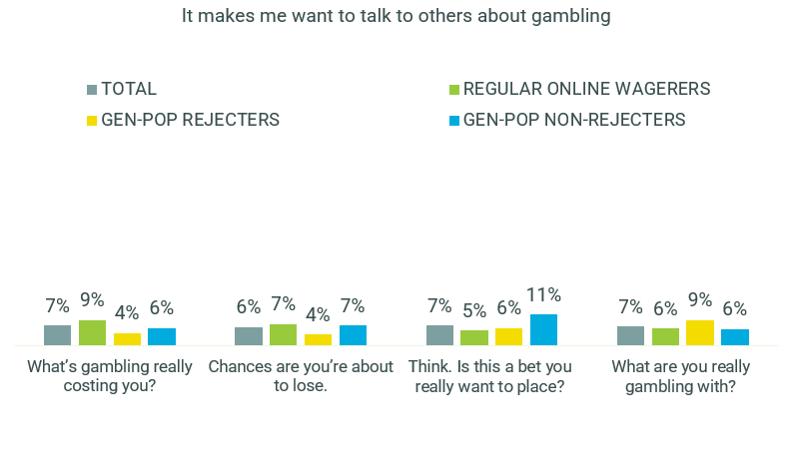
E2. We'd now like you to think about how well each of the below applies to this message. For each, please indicate on a scale from 0 to 10, where 0 means you feel that it doesn't apply at all to this message and 10 means you feel that it applies extremely well.
Total n=382-417 per tagline, Regular online wagerers n=181-217 per tagline, Gen-pop rejecters n=86-109 per tagline, Gen-pop non-rejecters n=91-108 per tagline

Emotional reaction (Positive)
Positive emotional response was measured in terms of whether a tagline resonated on a personal level, left consumers feeling empowered, and reassured rejecters that help is available for people who need it. Positive emotional response across all taglines was relatively limited among regular online wagerers, particularly relative to gen-pop rejecters as seen in Figure 7.
The top performing taglines were ‘What’s gambling really costing you?’ which resonated well among gen-pop non-rejecters. ‘Think. Is this a bet you really want to place?’ performed the strongest among gen-pop rejecters, and ‘Worried about your gambling?’ achieved the best results among regular online wagerers.
Figure 7 - Tagline ratings (9-10 agreement) - EMOTIONAL REACTION
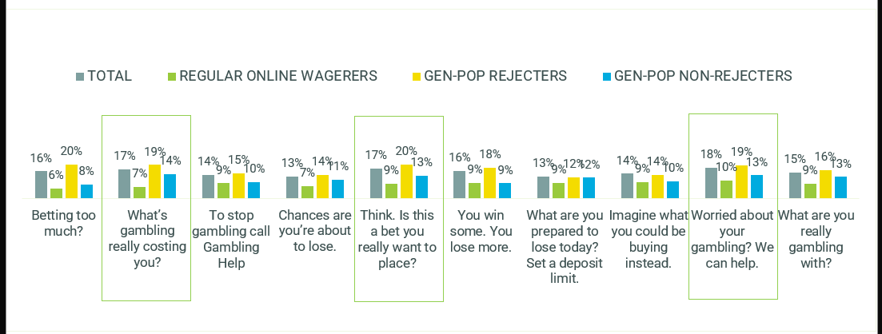
(POSITIVE) AVERAGES
E2. We'd now like you to think about how well each of the below applies to this message. For each, please indicate on a scale from 0 to 10, where 0 means you feel that it doesn't apply at all to this message and 10 means you feel that it applies extremely well.
Total n=382-417 per tagline, Regular online wagerers n=181-217 per tagline, Gen-pop rejecters n=86-109 per tagline, Gen-pop non-rejecters n=91-108 per tagline

Figure 8 shows that ‘What’s gambling really costing you?’ performed the best at personal relevance among both gen-pop rejecters and non-rejecters, while ‘Worried about your gambling?’ was the strongest performer among regular online wagerers. All three taglines performed equally on empowering regular online wagerers, while ‘Think. Is this a bet you really want to place?’ and ‘Worried about your gambling?’ both resonated well among gen-pop non-rejecters
Figure 8 - Tagline ratings (9-10 agreement) - EMOTIONAL REACTION (POSITIVE) AVERAGES - Individual diagnostics on key performers
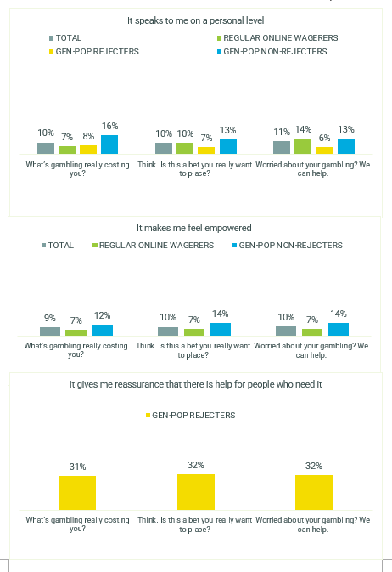
E2. We'd now like you to think about how well each of the below applies to this message. For each, please indicate on a scale from 0 to 10, where 0 means you feel that it doesn't apply at all to this message and 10 means you feel that it applies extremely well.
Total n=382-417 per tagline, Regular online wagerers n=181-217 per tagline, Gen-pop rejecters n=86-109 per tagline, Gen-pop non-rejecters n=91-108 per tagline

Emotional reaction (Negative)
When considering negative emotional reactions such as not liking the tagline, feeling that the message goes too far and feeling uncomfortable, a few of the top performing taglines elicited a stronger negative reaction among regular online wagerers and gen-pop non-rejecters, as shown in Figure 9.
Figure 9 - Tagline ratings (9-10 agreement) - EMOTIONAL REACTION (NEGATIVE) AVERAGES
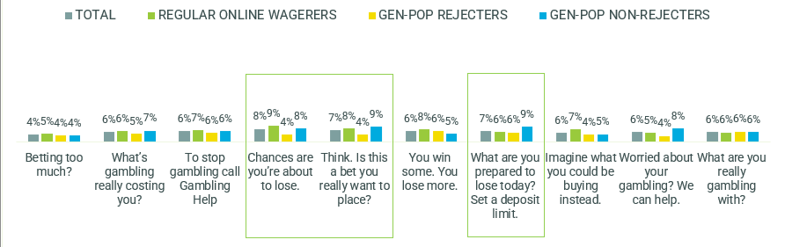
E2. We'd now like you to think about how well each of the below applies to this message. For each, please indicate on a scale from 0 to 10, where 0 means you feel that it doesn't apply at all to this message and 10 means you feel that it applies extremely well.
Total n=382-417 per tagline, Regular online wagerers n=181-217 per tagline, Gen-pop rejecters n=86-109 per tagline, Gen-pop non-rejecters n=91-108 per tagline
However, a negative reaction is not necessarily an undesirable response among online wagerers in this context.
Figure 10 shows that, among regular online wagerers, there was a positive correlation between salience and potential cut-through and the negative reaction of a tagline, suggesting that a jarring reaction to a tagline may indeed help it stand out. This correlation was weaker among gen-pop non-rejecters and non-existent among gen-pop rejecters.

Figure 10 - Tagline ratings (9-10 agreement) – Correlations between salience/cut-through and negative emotional reaction
REGULAR ONLINE WAGERERS
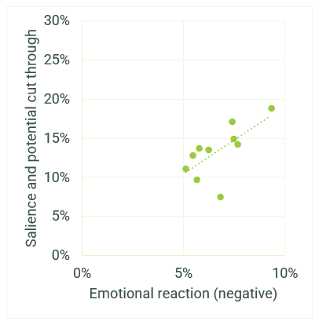
GEN-POP REJECTERS
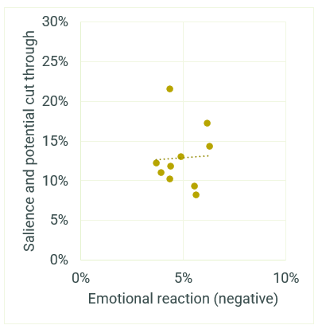

GEN-POP NON-REJECTERS
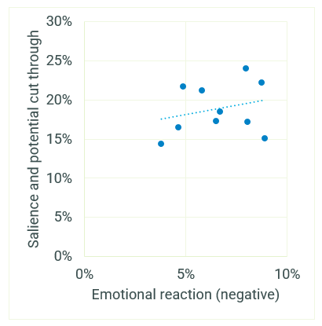
E2. We'd now like you to think about how well each of the below applies to this message. For each, please indicate on a scale from 0 to 10, where 0 means you feel that it doesn't apply at all to this message and 10 means you feel that it applies extremely well.
Regular online wagerers n=181-217 per tagline, Gen-pop rejecters n=86-109 per tagline, Gen-pop non-rejecters n=91-108 per tagline

Performance of taglines by PGSI and jurisdiction
Although the seven top performers were consistently effective across a range of audiences, there were some differences in the performance of the taglines by PGSI profile and by state jurisdiction.
Performance of the taglines varied by PGSI classification as illustrated by 11. However, the six top taglines formed a suite which encompassed all cohorts.
‘Chances are you’re about to lose’ performed well among the non and low-risk gamblers, ‘Think. Is this a bet you really want to place?’ performed highest among non-gamblers, ‘What are you really gambling with?’ performed best for low-risk, ‘You win some. You lose more’ and ‘Imagine what you could be buying instead’ performed well among moderate-risk, and ‘What are you prepared to lose today?’ performed well among problem gamblers.
Figure 11 - Tagline ratings (9-10 agreement) – Performance summary by PGSI classification
 | Betting too much? | What’s gambling really costing you? | To stop gambling call Gambling Help | Chances are you’re about to lose. | Think. Is this a bet you really want to place? | You win some. You lose more. | What are you prepared to lose today? Set a deposit limit. | Imagine what you could be buying instead. | Worried about your gambling? We can help. | What are you really gambling with?
NON GAMBLER
SALIENCE AVERAGE | 10% | 14% | 12% | 18% | 19% | 15% | 12% | 12% | 14% | 13%
RATIONAL AVERAGE | 18% | 22% | 17% | 26% | 24% | 25% | 24% | 21% | 21% | 22%
POTENTIAL IMPACT AVERAGE | 5% | 11% | 6% | 11% | 11% | 8% | 10% | 9% | 8% | 10%
EMOTIONAL POSITIVE AVERAGE | 14% | 16% | 12% | 14% | 20% | 15% | 12% | 12% | 21% | 12%
EMOTIONAL NEGATIVE AVERAGE | 2% | 5% | 7% | 10% | 8% | 4% | 7% | 4% | 4% | 4%
LOW RISK
SALIENCE AVERAGE | 18% | 14% | 8% | 23% | 15% | 22% | 8% | 10% | 16% | 20%
RATIONAL AVERAGE | 24% | 20% | 18% | 24% | 23% | 25% | 20% | 18% | 26% | 26%
POTENTIAL IMPACT AVERAGE | 9% | 11% | 11% | 14% | 14% | 11% | 5% | 9% | 12% | 12%
EMOTIONAL POSITIVE AVERAGE | 9% | 7% | 7% | 9% | 11% | 7% | 8% | 6% | 14% | 10%
EMOTIONAL NEGATIVE AVERAGE | 6% | 5% | 7% | 4% | 5% | 10% | 6% | 7% | 7% | 4%
MODERATE RISK
SALIENCE AVERAGE | 12% | 14% | 11% | 19% | 10% | 16% | 14% | 22% | 10% | 14%
RATIONAL AVERAGE | 20% | 20% | 17% | 25% | 16% | 23% | 24% | 27% | 13% | 18%
POTENTIAL IMPACT AVERAGE | 8% | 11% | 10% | 12% | 12% | 17% | 14% | 18% | 4% | 10%
EMOTIONAL POSITIVE AVERAGE | 7% | 9% | 10% | 6% | 5% | 13% | 8% | 15% | 7% | 9%
EMOTIONAL NEGATIVE AVERAGE | 5% | 5% | 3% | 7% | 4% | 8% | 1% | 6% | 4% | 6%
PROBLEM GAMBLER
SALIENCE AVERAGE | 13% | 18% | 10% | 16% | 18% | 17% | 23% | 19% | 16% | 15%
RATIONAL AVERAGE | 16% | 20% | 14% | 20% | 15% | 19% | 25% | 17% | 18% | 18%
POTENTIAL IMPACT AVERAGE | 9% | 17% | 13% | 15% | 14% | 9% | 18% | 11% | 13% | 13%
EMOTIONAL POSITIVE AVERAGE | 10% | 16% | 13% | 10% | 11% | 11% | 17% | 13% | 10% | 19%
EMOTIONAL NEGATIVE AVERAGE | 7% | 10% | 9% | 8% | 9% | 8% | 11% | 8% | 10% | 11%
E2. We'd now like you to think about how well each of the below applies to this message. For each, please indicate on a scale from 0 to 10, where 0 means you feel that it doesn't apply at all to this message and 10 means you feel that it applies extremely well.
Non-gamblers n=143-171, Low risk n=45-63, Moderate risk n=77-95, Problem gamblers n=89-105

Selection of the final suite of taglines

Selection of the final suite of taglines
The results across these various rating themes, in particular the difference in performance across the key audiences, indicates that a single ‘cover-all’ tagline could not be identified.
Instead, a set of seven taglines that perform well on various attributes among the various audiences were identified (listed here in no particular order). Qualitative analysis of the individual taglines follows.
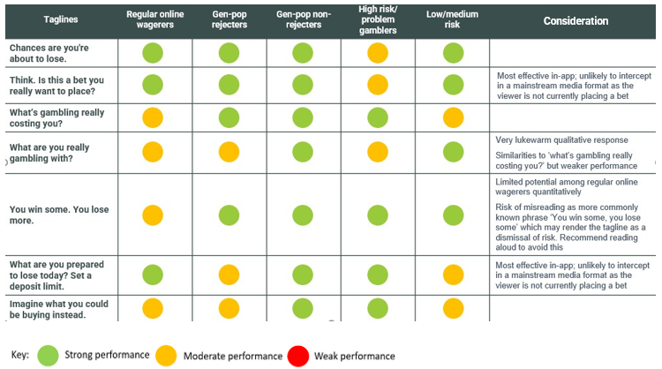

Our selected suite of seven taglines
Chances are you’re about to lose. For free and confidential support call 1800 858 858 or visit gamblinghelponline.org.au
The strongest tagline, this message was said to be compatible with all formats, including TVC, radio, online banners and in-app formats.
Participants felt that this message was a stated truth, describing the tagline as ‘genuine’ and ‘truthful’. By reminding participants of the likelihood of loss, the message intercepted their rational decision-making and caused them to reflect. Indeed, participants reacted strongly to the word ‘lose’, stating that this message was direct and unexpected.
“The chances are you’re about to lose, it’s just being real and honest…that’s a good warning.” (Male, CALD, NSW, 27, High Risk).
“Do I want to do it? It would make me think, chances are I’m going to lose, so I’m probably not going to win, so do I really want to do this? Do I want to do this? Look, no I’ll put it to something else. Of all the ones that have come up so far this has the most impact.”
(Male, VIC, 50, Moderate Risk).
The meaning of this tagline was perceived as two-fold: a reminder that participants are more likely to lose a bet than win, and a reiteration of the perceived truth that ‘the house always wins.’ The direct, non-judgemental tone was said to be relatable and did not cause participants to reflexively dismiss the message; rather, they stated an inclination to reflect on their behaviour.
The salience of this tagline was especially felt in the in-app betting screen format, with participants noting the confronting nature of the message before placing a bet would be likely to cause them to stop.
“That’s definitely going to be a turn off when you’re making a bet and you see that (Male, WA, 35, Moderate Risk).
It is the recommendation of the research that this tagline be included in the final suite of seven, as it was seen to be very effective in intercepting potentially problematic gambling before it escalates.
Think. Is this a bet you really want to place? For free and confidential support call 1800 858 858 or visit gamblinghelponline.org.au
This tagline was particularly salient for participants due to its ‘attention-grabbing’ qualities, making it able to intercept decision-making specifically when using online betting apps.
The tagline seemed to be most effective when appearing before placing a bet, as the word ‘think’ grabbed their attention and intercepted decision-making. This part was generally seen as the most engaging part of the message, with the follow up question causing participants to engage with their decision and reflect on the question.
“It’s not absolute. It’s just saying do you really want to place this bet, are you happy with that amount of money on it? This is great, it’s really aimed at all gamblers, particularly those who aren’t gambling in an unhealthy way but those who might be sliding towards it.”
(Male, VIC, 22, Moderate Risk).
However, some participants noted that the question ‘is this a bet you really want to place?’ felt disjointed in the context of the mainstream broadcast formats (TVC and radio) as betting usually was not taking place at the moment of engaging with this media.
It is the recommendation of the research that this tagline be included in the final suite of seven, utilised particularly in online betting platforms.

What’s gambling really costing you? For free and confidential support call 1800 858 858 or visit gamblinghelponline.org.au
This tagline was a high performer for gamblers of all risk profiles, with a number of participants claiming they had quickly understood the message. Though many participants considered this tagline purely in financial terms, the broader meaning of the message was clear to some, with the related ‘costs’ of time, family, and employment raised.
The tagline was said to be non-judgmental – instead of lecturing participants on controlling their gambling, the message puts the onus on the individual to reflect on their choices rather than directly telling them what to do.
“it’s telling gamblers to have a think about what they’re doing. It’s not telling people they’ve got a gambling problem it’s just asking them a question. It doesn’t seem to insinuate that you have a problem.” (Male, CALD, VIC, 44, Moderate Risk).
A few participants said that the tagline felt like a standard government message, and it consequently did not resonate strongly with them. For others, the term ‘gambling’ was believed to be unrelated to online wagering. However, the term ‘gambling’ was said to be less off-putting for this tagline than for some others which used it.
It is the recommendation of the research that this tagline be included in the final suite of seven.
What are you prepared to lose today? Set a deposit limit. For free and confidential support call 1800 858 858 or visit gamblinghelponline.org.au
This tagline was considered most effective in-app, where its message was felt to be impactful and directly relevant for participants. The message was especially thought-provoking when shown upon opening the betting app and was said to effectively set the context for the betting experience, making participants slightly uncomfortable but not confronted or stigmatised.
The call to action of ‘Set a deposit limit’ resonated well with higher PGSI participants who reported that they had often gambled more than they could afford to lose. In particular, it was said that this call to action was a more helpful call to action than that of calling the helpline or visiting the website, which participants reported they were unlikely to do.
“That’s a good message, that’s how I got help [with gambling] I learned to set limits…this reminds me to set deposit limits” (Male, SA, 46, High Risk). However, for participants who didn’t have experience with setting deposit limits or who self-excluded from problematic gambling, this call to action was not something they reported they would undertake.
This was reinforced by the quantitative research, which showed (Figure 12) that this tagline tended to see stronger performance among online wagerers who already set a limit every time they play. At the other end of the spectrum, performance was relatively weaker among online wagerers who never set a limit.
Figure 12 - Tagline ratings (9-10 agreement) – What are you prepared to lose today? Set a deposit limit - among Regular online wagerers by limit setting status
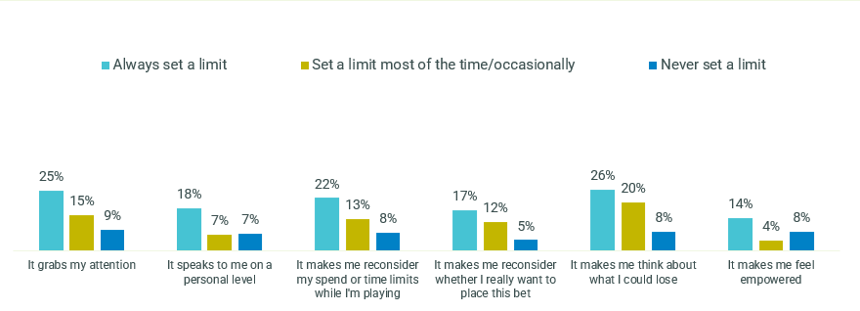
E2. We'd now like you to think about how well each of the below applies to this message. For each, please indicate on a scale from 0 to 10, where 0 means you feel that it doesn't apply at all to this message and 10 means you feel that it applies extremely well.
Regular online wagerers, always set a limit n=63, set a limit most of the time/occasionally n=84, never set a limit n=36
It is the recommendation of the research that this tagline be included in the final suite of seven, with its application in in-app settings.
Imagine what you could be buying instead. For free and confidential support call 1800 858 858 or visit gamblinghelponline.org.au
Some participants reported that this tagline was direct and non-judgemental, inviting them to pause and reflect on their decision.
However, for one or two participants, the word ‘buying’ was not seen as relevant in the context of gambling. Unlike the word ‘cost’ in other taglines, some participants remarked that gambling was not seen as a purchase. Some participants reported that this rendered the tagline less impactful, but others said that it caused them to pause and reflect on the other uses for the money, reconsidering the frame of reference for their gambling activities.
“It’s probably more aimed at people who either are just about to or already have a gambling problem and gambling effects their income or their ability to buy the necessities. The message does resonate, but I feel like the wording is just a bit off.” (Male, QLD, 27, Low-Moderate Risk)

Although not one of the top five taglines overall, ‘Imagine what you could be buying instead’ performed highly among moderate-risk gamblers compared to the other PGSI categories, as shown in Figure 13.
Figure 13 - Tagline ratings (9-10 agreement) - Imagine what you could be buying instead – by PGSI classification
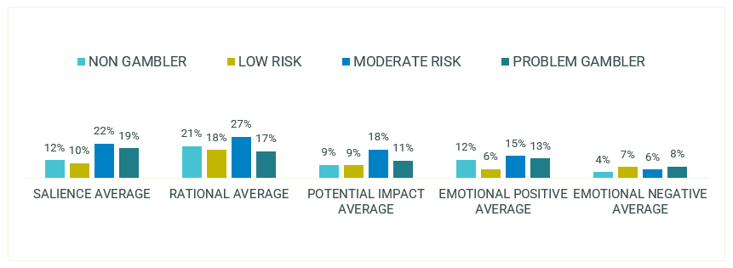
E2. We'd now like you to think about how well each of the below applies to this message. For each, please indicate on a scale from 0 to 10, where 0 means you feel that it doesn't apply at all to this message and 10 means you feel that it applies extremely well.
Non-gamblers n=143-171, Low risk n=45-63, Moderate risk n=77-95, Problem gamblers n=89-105
Despite these few lukewarm responses to the tagline, overall it was said to be a useful way to ask gamblers to think about their money in different terms, assisting in preventing people compulsively gambling without thought to the wider ramifications of their actions. It is the recommendation of the research that this tagline be included in the final suite of seven.
You win some. You lose more. For free and confidential support call 1800 858 858 or visit gamblinghelponline.org.au
Multiple participants across all PGSI profiles felt this was a salient tagline, and its strong quantitative performance supports this, with the tagline coming across as one of the top five quantitative performers. A number of participants commented on the likely resonance across different levels of gambling engagement, with a belief this would resonate regardless of the regularity of gambling. Like ‘chances are’ it was said to reinforce a perceived truth and intercept rational decision-making.
“I completely agree with it… I don’t want to hear it but it’s so true! The amount of times you win is so scarce compared to the amount of times you lose.” (Male, QLD, 29, Low-Moderate Risk).

Though many participants were impressed by the tagline and enjoyed its word play, some confused it with the common expression ‘You win some. You lose some.’ This was exclusively a problem in formats where it was not read aloud (that is, in-app and online banner) rather than in those formats where it was read aloud (TVC, radio).
However, while this was a minority response and occurred only in formats in which the tagline was not read aloud, this potential for misinterpretation is a significant concern. The meaning of ‘you win some. You lose some’ is to shrug off losses and if consumers misread the tagline there is a risk it would cause them to adopt a nonchalant approach to loss or potentially even increase their gambling behaviour. In particular, if this tagline were to be rolled out on a betting app, some participants reported that they would only read ‘You win some’ before dismissing the message and continuing with their bet.
“I think people will associate that phrase with ‘you win some, you lose some’…there’s still the positive component of the win there which I think people will hold onto”. (Male, ACT, 42, Moderate Risk)
To further illustrate the risk of this tagline potentially being ‘shrugged off,’ particularly during a social situation, the data indicated that ‘You win some. You lose more.’ was stronger on salience and relatability among sole online wagerers compared to those who wager socially.
Figure 14 - Tagline ratings (9-10 agreement) – You win some. You lose more. – by sole vs social online wagerers
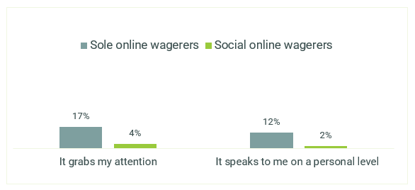
E2. We'd now like you to think about how well each of the below applies to this message. For each, please indicate on a scale from 0 to 10, where 0 means you feel that it doesn't apply at all to this message and 10 means you feel that it applies extremely well.
Sole online wagerers n=175, Social online wagerers n=38
Overall, when this tagline is well-understood, as occurred in the majority of cases, it had high salience and substantial impact, but the risks associated with its misinterpretation suggest that if it is to be included in the final suite, it must be used exclusively in settings where the tagline is read aloud: radio and television.

What are you really gambling with? For free and confidential support call 1800 858 858 or visit gamblinghelponline.org.au
This tagline was generally considered a less impactful version of ‘What’s gambling really costing you?’ and when compared to the latter, was said to be more abstract and less specific.
The absence of the word ‘cost,’ a term with which gamblers are very familiar, rendered the question too abstract for some consumers, who were not inclined to consider the tagline on a deeper level and therefore easily dismissed it.
“I just don’t really understand what it’s trying to say. Are you gambling with left over money, extra money, your family’s money? Can you really afford to make those bets? But those questions have never really stopped me in the past.” (Male, CALD, NSW, 27, High risk).
As with ‘worried about your gambling?’, participants claimed that this tagline was something one might expect to hear from the government, and this further reduced its impact.
Despite these perceptions, the tagline still performed well at engaging audiences in a non-judgemental way. As with other similar taglines, the question format was seen as creating agency and asking wagerers to consider their actions rather than judging them. This was said to be crucial in intercepting potentially harmful behaviour without increasing the likelihood of self-exclusion or stigmatisation. For this reason, it is the recommendation of the research that this tagline be included in the suite.

Taglines excluded from the suite
Betting too much? For free and confidential support call 1800 858 858 or visit gamblinghelponline.org.au
This tagline received a generally favourable qualitative response, especially when placed in the context of a betting app, where it was felt it was directly relevant.
“Are you betting too much? I’ll listen to that. I could probably go down a bit and make it a more healthy gambling session. That would resonate with me more rather than an absolute statement” (Male, 22, VIC, Low-Moderate Risk).
The use of the word ‘betting’ was seen as a non-judgmental and relatable term. It was reported that this language was a common way for consumers to refer to their gambling, and it was said to be directly relevant to them. The direct, supportive tone was also praised and was said to encourage gambling in a healthy way, rather than stigmatising gambling behaviour and directing the consumer to cease altogether.
“It’s short and it’s to the point, and it’s a question, you have to reflect on what you’re doing.” (Male, NSW, 19, Moderate Risk).
However, despite the generally favourable response, self-exclusion was high. Participants felt the descriptor of ‘too much’ lacked specificity and was entirely subjective to each consumer, making it easy to rationalise gambling habits. Additionally, when compared to ‘What’s gambling really costing you?’ the tagline was said to be limited to the financial outcomes of betting, rather than the more expansive ‘costs’ implied by the latter.
It was also felt that this tagline was easy to ignore and was unlikely to intercept behaviour for this reason. The binary nature of the tagline (that is, the expected answer of ‘yes’ or ‘no’) was said to be less likely to trigger deep thought. As a result, though the tagline was seen as impactful in a betting app context, in other formats it was much less effective. This finding was supported by the quantitative research, in which this tagline performed weakly.
It is the recommendation of the research that this tagline be excluded from the suite due to its weak quantitative performance and lack of specificity.
To stop gambling call Gambling Help on 1800 858 858 or visit gamblinghelponline.org.au
‘To stop gambling’ was widely regarded as the weakest tagline. An overwhelming majority of participants responded negatively to the tagline, labelling it as ‘lazy’ and ‘judgemental’.
“It just feels like a disclaimer. To have this kind of message at the end of such a positive video of gambling, it just doesn’t weigh up. It’s just a closed question. It’s a dead end. It’s not asking people a question to make them think.” (Female, NSW, 48, High Risk).
It was said that the tagline inherently implied that all gambling behaviour is problematic, leading to high levels of self-exclusion. Participants stated that because gambling was a legal activity, the message was unreasonable. A number of participants said they felt defensive and were moved to rationalise their behaviour, switching off from the message.
Participants were asked if other words – such as ‘quit’ or ‘cease’ – might replace ‘stop’, and while some said this might slightly improve the message, the belief remained that the message was inherently lacking in creativity, especially when compared to some of the other available taglines.
In addition, this tagline triggered anti-government sentiment, as participants reported feeling that they were being lectured at.
Worried about your gambling? We can help. Call 1800 858 858 or visit gamblinghelponline.org.au
This tagline was not considered impactful or provocative to participants. The binary nature of the question meant that gamblers who heard or saw the tagline automatically responded “no” without reflecting on their behaviour. As with the direct question ‘Betting too much?’, participants stated it was easy to dismiss.
Problem gamblers in particular reported a tendency to self-exclude from this message and claimed that they did not need to ‘worry.’ In addition, this was said to sound like government communications and to therefore be easy to dismiss.
“Most people with a gambling issue don’t admit to it so they might not act upon this message even though it’s put out there.” (Female, QLD, 42, High Risk).

Performance of taglines among First Nations and CALD
audiences
There were no significant differences between the results of First Nations and CALD audiences from those of the general population, with the same suite of taglines receiving favourable results.
Unfortunately, there was not sufficient sample in the quantitative study to extract data on First Nations response to the taglines. Qualitatively, 4 First Nations participants were consulted and 4 CALD participants. While this was a small sample, this provided an important opportunity to ensure that mainstream communications were taking specific cultural sensitivities into account, and that language used was clear for audiences with diverse linguistic and cultural backgrounds. Amongst First Nations and CALD participants, no clear differences in comprehension of semantics, language or intended messaging was reported.
Among CALD audiences (Figure 15), ‘What are you prepared to lose today?’ was one of the stronger performing taglines, rating particularly well on rational and emotional response and influencing potential action. ‘You win some. You lose more’ performed the best on salience.

Figure 15 - Summary of tagline performance – CALD audiences - Tagline ratings (9-10 agreement) – THEME AVERAGES
 | Betting too much? | What’s gambling really costing you? | To stop gambling call Gambling Help | Chances are you’re about to lose. | Think. Is this a bet you really want to place? | You win some. You lose more. | What are you prepared to lose today? Set a deposit limit. | Imagine what you could be buying instead. | Worried about your gambling? We can help. | What are you really gambling with?
SALIENCE AVERAGE | 12% | 15% | 13% | 13% | 13% | 18% | 13% | 12% | 16% | 9%
RATIONAL AVERAGE | 18% | 20% | 20% | 14% | 15% | 22% | 27% | 16% | 22% | 14%
POTENTIAL IMPACT AVERAGE | 11% | 16% | 16% | 9% | 14% | 10% | 22% | 5% | 16% | 7%
EMOTIONAL POSITIVE AVERAGE | 10% | 13% | 13% | 5% | 12% | 9% | 15% | 6% | 14% | 11%
EMOTIONAL NEGATIVE AVERAGE | 8% | 8% | 7% | 7% | 8% | 9% | 10% | 5% | 9% | 7%
E2. We'd now like you to think about how well each of the below applies to this message. For each, please indicate on a scale from 0 to 10, where 0 means you feel that it doesn't apply at all to this message and 10 means you feel that it applies extremely well.
CALD audiences n=48-75

Testing of taglines across particular formats
Following the evaluation of the taglines in isolation, each tagline was then tested across various TVC, gambling app, radio ad and online banner formats to help identify which taglines performed the best across these media, as well as identifying the ideal placement and positioning of these taglines within each medium.

TVC Format
A total of 16 TVC executions were tested encompassing six taglines. Across 12 of the TVCs the six taglines were each placed at the start of the TVC and at the end, all with a male voiceover and the call to action “For free and confidential support call 1800 858 858 or visit gamlbinghelponline.org.au” being read out after the tagline. Four additional executions were created in which two taglines were coupled with varying voiceovers and a shorter call to action being read out. One variation of the TVC with the tagline “What’s gambling really costing you?” was created – with a female voiceover with a shorter call to action (“For free and confidential support call the number on screen or visit gambling help online”). Two variations of the TVC with the tagline “To stop gambling” were created – one with a male voiceover and a shorter call to action being read out, and a second with a female voiceover reading the full call to action.
In order to give participants and respondents the most authentic experience of viewing the tagline, each execution accompanied a recent advert from a prominent gambling company. Each tagline execution featured as white text on a black background, with the tagline capitalised, a format recommended by the previous Hall & Partners research.
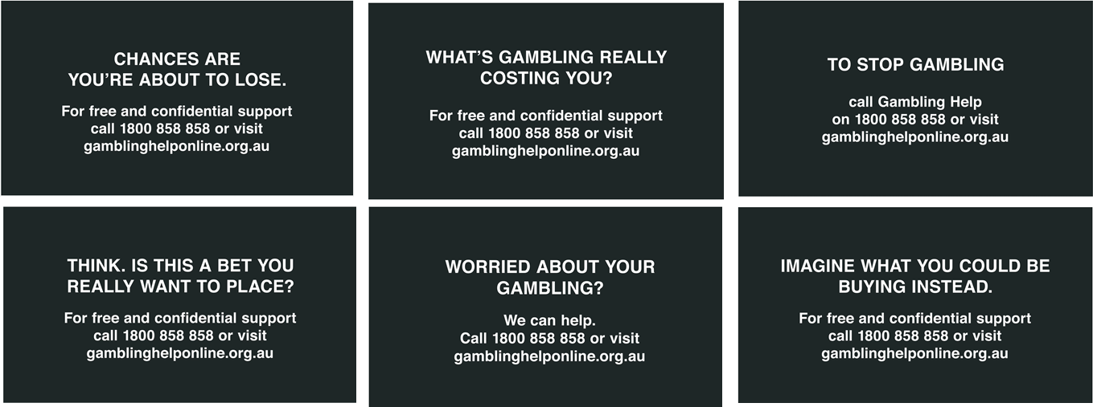
In the quantitative survey, in order to understand the various levels of engagement with the taglines in situ, we used a second-by-second response analysis. On a scale of -50 to +50, online survey respondents used an interactive slider whilst each video and radio ad was played. Respondents could indicate how engaged they were with the material by moving the slider upwards and downwards as they saw different images and heard different messages, to indicate their level of positivity with the content.

Best Positioning of Taglines
It was clear that the chosen taglines were more effective at the end of the TVC than at the beginning. This finding was also supported by the qualitative research. Taglines shown after a stimulating pro-gambling advertisement resulted in higher levels of reported engagement and cut-through than pre-TVC taglines due to a recency effect. When the tagline was shown at the beginning of the commercial, participants reported quickly forgetting the message of the tagline as they got caught up in the TVC.
“If you’re pumped up from the ad, you’re not thinking about the tagline [at the beginning].” (Male, VIC, 23, Low-Moderate Risk)

Taglines shown at the end

Figure 16 shows a summary of the engagement of the various taglines when placed at the end of the TVC among regular online wagerers. Among regular online wagerers, placing the taglines at the end of a positively performing TVC saw a drop off in engagement.
Figure 16 - TVC Second by second response – summary of all taglines at end – regular online wagerers
Seconds | What’s gambling really costing you? End | To stop gambling call Gambling Help End long form | To stop gambling call Gambling Help End short form female | To stop gambling call Gambling Help End short form male | Worried about your gambling? End | Chances are you’re about to lose End | Think. Is this a bet you really want to place? End | Imagine what you could be buying instead. End
0 | 0.0 | 0.0 | 0.0 | 0.0 | 0.0 | 0.0 | 0.0 | 0.0
1 | 5.7 | 5.7 | 5.7 | 5.7 | 5.7 | 5.7 | 5.7 | 5.7
2 | 7.6 | 7.6 | 7.6 | 7.6 | 7.6 | 7.6 | 7.6 | 7.6
3 | 9.3 | 9.3 | 9.3 | 9.3 | 9.3 | 9.3 | 9.3 | 9.3
4 | 12.4 | 12.4 | 12.4 | 12.4 | 12.4 | 12.4 | 12.4 | 12.4
5 | 13.9 | 13.9 | 13.9 | 13.9 | 13.9 | 13.9 | 13.9 | 13.9
6 | 13.2 | 13.2 | 13.2 | 13.2 | 13.2 | 13.2 | 13.2 | 13.2
7 | 12.1 | 12.1 | 12.1 | 12.1 | 12.1 | 12.1 | 12.1 | 12.1
8 | 11.7 | 11.7 | 11.7 | 11.7 | 11.7 | 11.7 | 11.7 | 11.7
9 | 12.6 | 12.6 | 12.6 | 12.6 | 12.6 | 12.6 | 12.6 | 12.6
10 | 12.8 | 12.8 | 12.8 | 12.8 | 12.8 | 12.8 | 12.8 | 12.8
11 | 12.6 | 12.6 | 12.6 | 12.6 | 12.6 | 12.6 | 12.6 | 12.6
12 | 13.3 | 13.3 | 13.3 | 13.3 | 13.3 | 13.3 | 13.3 | 13.3
13 | 14.2 | 14.2 | 14.2 | 14.2 | 14.2 | 14.2 | 14.2 | 14.2
14 | 14.9 | 14.9 | 14.9 | 14.9 | 14.9 | 14.9 | 14.9 | 14.9
15 | 14.8 | 14.8 | 14.8 | 14.8 | 14.8 | 14.8 | 14.8 | 14.8
16 | 15.0 | 15.0 | 15.0 | 15.0 | 15.0 | 15.0 | 15.0 | 15.0
17 | 15.1 | 15.1 | 15.1 | 15.1 | 15.1 | 15.1 | 15.1 | 15.1
18 | 14.6 | 14.6 | 14.6 | 14.6 | 14.6 | 14.6 | 14.6 | 14.6
19 | 14.8 | 14.8 | 14.8 | 14.8 | 14.8 | 14.8 | 14.8 | 14.8
20 | 15.0 | 15.0 | 15.0 | 15.0 | 15.0 | 15.0 | 15.0 | 15.0
21 | 15.3 | 15.3 | 15.3 | 15.3 | 15.3 | 15.3 | 15.3 | 15.3
22 | 15.2 | 15.2 | 15.2 | 15.2 | 15.2 | 15.2 | 15.2 | 15.2
23 | 15.4 | 15.4 | 15.4 | 15.4 | 15.4 | 15.4 | 15.4 | 15.4
24 | 15.2 | 15.2 | 15.2 | 15.2 | 15.2 | 15.2 | 15.2 | 15.2
25 | 15.0 | 15.0 | 15.0 | 15.0 | 15.0 | 15.0 | 15.0 | 15.0
26 | 15.2 | 15.2 | 15.2 | 15.2 | 15.2 | 15.2 | 15.2 | 15.2
27 | 16.4 | 16.4 | 16.4 | 16.4 | 16.4 | 16.4 | 16.4 | 16.4
28 | 16.9 | 16.9 | 16.9 | 16.9 | 16.9 | 16.9 | 16.9 | 16.9
29 | 17.3 | 17.3 | 17.3 | 17.3 | 17.3 | 17.3 | 17.3 | 17.3
TAGLINE STARTS HERE
30 | 17.1 | 17.0 | 17.2 | 16.6 | 16.1 | 16.4 | 16.6 | 16.0
31 | 14.2 | 14.0 | 13.9 | 12.5 | 14.3 | 15.5 | 14.1 | 14.2
32 | 12.1 | 11.3 | 13.4 | 10.6 | 12.7 | 14.4 | 11.4 | 12.9
33 | 11.0 | 11.7 | 13.4 | 10.5 | 12.5 | 13.4 | 11.3 | 12.1
34 | 10.5 | 12.3 |  |  | 12.1 | 11.7 | 10.6 | 12.1
35 | 10.6 |  |  |  |  | 11.7 | 10.3 | 11.6
36 |  |  |  |  |  |  | 10.3 | 11.5
F1. Now we'd like to play you this ad that you may see on TV. As the ad plays, use the slider on the side of the screen to indicate how you feel as you see different images and hear different messages. The MORE positive you feel, move the slider towards the top. The LESS positive you feel, move the slider towards the bottom. Please continue to move the slider as you see different images and hear different messages.
Base: Regular online wagerers, n=159-338 per TVC
When determining the maximum drop off for each of the taglines in this format as shown in
Figure 17, the short form female version of ‘To stop gambling’ as well as ‘Worried about your gambling?’ and ‘Chances are you’re about to lose’ resulted in the lowest level of drop off in engagement at the end of the TVC among regular online wagerers.

Figure 17 - TVC Second by second response – summary of all taglines at end - Maximum drop off from baseline - Regular online wagerers
What’s gambling really costing you? End | To stop gambling call Gambling Help End long form | To stop gambling call Gambling Help End short form female | To stop gambling call Gambling Help End short form male | Worried about your gambling? End | Chances are you’re about to lose End | Think. Is this a bet you really want to place? End | Imagine what you could be buying instead. End
-6.8 | -6.1 | -4.0 | -6.8 | -5.3 | -5.7 | -7.0 | -5.8
F1. Now we'd like to play you this ad that you may see on TV. As the ad plays, use the slider on the side of the screen to indicate how you feel as you see different images and hear different messages. The MORE positive you feel, move the slider towards the top. The LESS positive you feel, move the slider towards the bottom. Please continue to move the slider as you see different images and hear different messages.
Base: Regular online wagerers, n=159-338 per TVC
Respondents then rated the TVCs across a range of diagnostics. Figure 18 shows that while all TVC ‘end form’ taglines performed close together, ‘Chances are you’re about to lose’ achieved the best overall performance among regular online wagerers.
Figure 18 - TVC Tagline Diagnostics – summary of all taglines at end - Regular online wagerers
 | What’s gambling really costing you? End | To stop gambling call Gambling Help End long form | To stop gambling call Gambling Help End short form female | To stop gambling call Gambling Help End short form male | Worried about your gambling? End | Chances are you’re about to lose End | Think. Is this a bet you really want to place? End | Imagine what you could be buying instead. End
The message grabbed my attention | 47% | 41% | 46% | 34% | 42% | 52% | 40% | 44%
I don't remember seeing this message at all | 4% | 9% | 5% | 11% | 7% | 8% | 8% | 9%
The text was too small | 3% | 2% | 3% | 2% | 2% | 1% | 2% | 3%
It makes me want to search online for more information about gambling help | 13% | 12% | 15% | 12% | 13% | 16% | 13% | 14%
It makes me want to call the phoneline (1800 858 858) | 10% | 12% | 13% | 8% | 11% | 12% | 6% | 13%
It makes me want to visit the website (gamblinghelponline.org.au) | 14% | 17% | 17% | 10% | 16% | 15% | 13% | 14%
It makes me want to be more mindful about how much I gamble | 31% | 29% | 30% | 36% | 28% | 39% | 32% | 37%
F2. We'd now like you to focus on this message that appeared in the advert you just watched. Which of the following do you feel best applies to this message?.
Base: Regular online wagerers, n=159-338
In contrast to the regular online wagerers, the selected commercial did not engage gen-pop rejecters well, as this audience is disengaged from gambling advertising. Figure 19 shows that the taglines at the end tended to serve as a relief at the end of the ad among this cohort, resulting in an increase in engagement.
Figure 19 - TVC Second by second response – summary of all taglines at end - Gen-pop rejecters
F1. Now we'd like to play you this ad that you may see on TV. As
Seconds | What’s gambling really costing you? End | To stop gambling call Gambling Help End long form | To stop gambling call Gambling Help End short form female | To stop gambling call Gambling Help End short form male | Worried about your gambling? End | Chances are you’re about to lose End | Think. Is this a bet you really want to place? End | Imagine what you could be buying instead. End
0 | 0.0 | 0.0 | 0.0 | 0.0 | 0.0 | 0.0 | 0.0 | 0.0
1 | 0.1 | 0.1 | 0.1 | 0.1 | 0.1 | 0.1 | 0.1 | 0.1
2 | -0.4 | -0.4 | -0.4 | -0.4 | -0.4 | -0.4 | -0.4 | -0.4
3 | -1.4 | -1.4 | -1.4 | -1.4 | -1.4 | -1.4 | -1.4 | -1.4
4 | -1.8 | -1.8 | -1.8 | -1.8 | -1.8 | -1.8 | -1.8 | -1.8
5 | -1.8 | -1.8 | -1.8 | -1.8 | -1.8 | -1.8 | -1.8 | -1.8
6 | -2.8 | -2.8 | -2.8 | -2.8 | -2.8 | -2.8 | -2.8 | -2.8
7 | -3.4 | -3.4 | -3.4 | -3.4 | -3.4 | -3.4 | -3.4 | -3.4
8 | -4.2 | -4.2 | -4.2 | -4.2 | -4.2 | -4.2 | -4.2 | -4.2
9 | -4.4 | -4.4 | -4.4 | -4.4 | -4.4 | -4.4 | -4.4 | -4.4
10 | -4.9 | -4.9 | -4.9 | -4.9 | -4.9 | -4.9 | -4.9 | -4.9
11 | -5.5 | -5.5 | -5.5 | -5.5 | -5.5 | -5.5 | -5.5 | -5.5
12 | -5.1 | -5.1 | -5.1 | -5.1 | -5.1 | -5.1 | -5.1 | -5.1
13 | -4.9 | -4.9 | -4.9 | -4.9 | -4.9 | -4.9 | -4.9 | -4.9
14 | -5.1 | -5.1 | -5.1 | -5.1 | -5.1 | -5.1 | -5.1 | -5.1
15 | -5.4 | -5.4 | -5.4 | -5.4 | -5.4 | -5.4 | -5.4 | -5.4
16 | -5.7 | -5.7 | -5.7 | -5.7 | -5.7 | -5.7 | -5.7 | -5.7
17 | -6.1 | -6.1 | -6.1 | -6.1 | -6.1 | -6.1 | -6.1 | -6.1
18 | -6.1 | -6.1 | -6.1 | -6.1 | -6.1 | -6.1 | -6.1 | -6.1
19 | -6.3 | -6.3 | -6.3 | -6.3 | -6.3 | -6.3 | -6.3 | -6.3
20 | -6.3 | -6.3 | -6.3 | -6.3 | -6.3 | -6.3 | -6.3 | -6.3
21 | -6.7 | -6.7 | -6.7 | -6.7 | -6.7 | -6.7 | -6.7 | -6.7
22 | -6.9 | -6.9 | -6.9 | -6.9 | -6.9 | -6.9 | -6.9 | -6.9
23 | -7.0 | -7.0 | -7.0 | -7.0 | -7.0 | -7.0 | -7.0 | -7.0
24 | -7.6 | -7.6 | -7.6 | -7.6 | -7.6 | -7.6 | -7.6 | -7.6
25 | -7.7 | -7.7 | -7.7 | -7.7 | -7.7 | -7.7 | -7.7 | -7.7
26 | -7.7 | -7.7 | -7.7 | -7.7 | -7.7 | -7.7 | -7.7 | -7.7
27 | -7.8 | -7.8 | -7.8 | -7.8 | -7.8 | -7.8 | -7.8 | -7.8
28 | -7.5 | -7.5 | -7.5 | -7.5 | -7.5 | -7.5 | -7.5 | -7.5
29 | -7.6 | -7.6 | -7.6 | -7.6 | -7.6 | -7.6 | -7.6 | -7.6
TAGLINE STARTS HERE
30 | -8.5 | -8.1 | -6.7 | -7.9 | -8.4 | -5.1 | -8.1 | -4.5
31 | -6.4 | -6.7 | -5.0 | -4.4 | -4.1 | -2.2 | -8.0 | -2.5
32 | -4.2 | -3.6 | 1.7 | -1.5 | -3.4 | -0.4 | -6.1 | -0.9
33 | -2.7 | -5.3 | 2.5 | -1.9 | -4.0 | 2.2 | -5.2 | 0.2
34 | -2.6 | -5.7 |  |  | -3.4 | 2.8 | -4.7 | 2.8
35 | -2.4 |  |  |  |  | 2.9 | -3.1 | 3.5
36 |  |  |  |  |  |  | -3.3 | 4.2
the ad plays, use the slider on the side of the screen to indicate how you feel as you see different images and hear different messages. The MORE positive you feel, move the slider towards the top. The LESS positive you feel, move the slider towards the bottom. Please continue to move the slider as you see different images and hear different messages.
Base: Gen-pop rejecters, n=74-167
When considering the maximum rise in engagement of the taglines from the baseline as shown in Figure 20, similar to the regular online wagerers, the short form female version of ‘To stop gambling’ and ‘Chances are you’re about to lose’ as well as ‘Imagine what you could be buying instead’ managed to achieve the highest maximum engagement levels from the TVC baseline among the gen-pop rejecters.
Figure 20 - TVC Second by second response – summary of all taglines at end - Maximum rise from baseline - Gen-pop rejecters
What’s gambling really costing you? End | To stop gambling call Gambling Help End long form | To stop gambling call Gambling Help End short form female | To stop gambling call Gambling Help End short form male | Worried about your gambling? End | Chances are you’re about to lose End | Think. Is this a bet you really want to place? End | Imagine what you could be buying instead. End
-2.4 | -3.6 | 2.5 | -1.5 | -3.4 | 2.9 | -3.1 | 3.5
F1. Now we'd like to play you this ad that you may see on TV. As the ad plays, use the slider on the side of the screen to indicate how you feel as you see different images and hear different messages. The MORE positive you feel, move the slider towards the top. The LESS positive you feel, move the slider towards the bottom. Please continue to move the slider as you see different images and hear different messages.
Base: Gen-pop rejecters, n=74-167
While the TVC did not perform as poorly among the gen-pop non-rejecters, the taglines again served as some form of relief, as shown in
Figure 21

Figure 21 - TVC Second by second response – summary of all taglines at end – gen-pop non-rejecters
Seconds | What’s gambling really costing you? End | To stop gambling call Gambling Help End long form | To stop gambling call Gambling Help End short form female | To stop gambling call Gambling Help End short form male | Worried about your gambling? End | Chances are you’re about to lose End | Think. Is this a bet you really want to place? End | Imagine what you could be buying instead. End
0 | 0.0 | 0.0 | 0.0 | 0.0 | 0.0 | 0.0 | 0.0 | 0.0
1 | 2.1 | 2.1 | 2.1 | 2.1 | 2.1 | 2.1 | 2.1 | 2.1
2 | 2.0 | 2.0 | 2.0 | 2.0 | 2.0 | 2.0 | 2.0 | 2.0
3 | 2.4 | 2.4 | 2.4 | 2.4 | 2.4 | 2.4 | 2.4 | 2.4
4 | 2.2 | 2.2 | 2.2 | 2.2 | 2.2 | 2.2 | 2.2 | 2.2
5 | 2.7 | 2.7 | 2.7 | 2.7 | 2.7 | 2.7 | 2.7 | 2.7
6 | 2.6 | 2.6 | 2.6 | 2.6 | 2.6 | 2.6 | 2.6 | 2.6
7 | 1.5 | 1.5 | 1.5 | 1.5 | 1.5 | 1.5 | 1.5 | 1.5
8 | 0.7 | 0.7 | 0.7 | 0.7 | 0.7 | 0.7 | 0.7 | 0.7
9 | 0.1 | 0.1 | 0.1 | 0.1 | 0.1 | 0.1 | 0.1 | 0.1
10 | -0.1 | -0.1 | -0.1 | -0.1 | -0.1 | -0.1 | -0.1 | -0.1
11 | -0.1 | -0.1 | -0.1 | -0.1 | -0.1 | -0.1 | -0.1 | -0.1
12 | 0.2 | 0.2 | 0.2 | 0.2 | 0.2 | 0.2 | 0.2 | 0.2
13 | 0.5 | 0.5 | 0.5 | 0.5 | 0.5 | 0.5 | 0.5 | 0.5
14 | 0.6 | 0.6 | 0.6 | 0.6 | 0.6 | 0.6 | 0.6 | 0.6
15 | 0.7 | 0.7 | 0.7 | 0.7 | 0.7 | 0.7 | 0.7 | 0.7
16 | 0.1 | 0.1 | 0.1 | 0.1 | 0.1 | 0.1 | 0.1 | 0.1
17 | -0.2 | -0.2 | -0.2 | -0.2 | -0.2 | -0.2 | -0.2 | -0.2
18 | -0.4 | -0.4 | -0.4 | -0.4 | -0.4 | -0.4 | -0.4 | -0.4
19 | -0.7 | -0.7 | -0.7 | -0.7 | -0.7 | -0.7 | -0.7 | -0.7
20 | -0.5 | -0.5 | -0.5 | -0.5 | -0.5 | -0.5 | -0.5 | -0.5
21 | -0.6 | -0.6 | -0.6 | -0.6 | -0.6 | -0.6 | -0.6 | -0.6
22 | -0.9 | -0.9 | -0.9 | -0.9 | -0.9 | -0.9 | -0.9 | -0.9
23 | -1.0 | -1.0 | -1.0 | -1.0 | -1.0 | -1.0 | -1.0 | -1.0
24 | -1.4 | -1.4 | -1.4 | -1.4 | -1.4 | -1.4 | -1.4 | -1.4
25 | -1.2 | -1.2 | -1.2 | -1.2 | -1.2 | -1.2 | -1.2 | -1.2
26 | -1.5 | -1.5 | -1.5 | -1.5 | -1.5 | -1.5 | -1.5 | -1.5
27 | -1.6 | -1.6 | -1.6 | -1.6 | -1.6 | -1.6 | -1.6 | -1.6
28 | -1.4 | -1.4 | -1.4 | -1.4 | -1.4 | -1.4 | -1.4 | -1.4
29 | -1.2 | -1.2 | -1.2 | -1.2 | -1.2 | -1.2 | -1.2 | -1.2
TAGLINE STARTS HERE
30 | -1.1 | -1.4 | -0.2 | 0.8 | -1.6 | 0.1 | -1.4 | 0.8
31 | 0.7 | -1.7 | 1.5 | 2.5 | -1.7 | 3.2 | 0.1 | 4.2
32 | 1.3 | -0.9 | 2.9 | 3.0 | -0.8 | 5.4 | 0.5 | 3.7
33 | 2.5 | 1.4 | 2.2 | 2.8 | 0.5 | 4.9 | 1.5 | 3.4
34 | 1.9 | 2.9 |  |  | 1.3 | 5.9 | 2.8 | 3.8
35 | 1.9 |  |  |  |  | 6.7 | 4.0 | 4.2
36 |  |  |  |  |  |  | 4.3 | 4.3
F1. Now we'd like to play you this ad that you may see on TV. As the ad plays, use the slider on the side of the screen to indicate how you feel as you see different images and hear different messages. The MORE positive you feel, move the slider towards the top. The LESS positive you feel, move the slider towards the bottom. Please continue to move the slider as you see different images and hear different messages.
Base: Gen-pop non-rejecters =n=74-168
Among the gen-pop non-rejecters, ‘Chances are you’re about to lose’ managed to reach the highest peak from the TVC baseline, well above the other taglines, as seen in Figure 22

Figure 22 - TVC Second by second response – summary of all taglines at end - Maximum rise from baseline - Gen-pop non-rejecters
What’s gambling really costing you? End | To stop gambling call Gambling Help End long form | To stop gambling call Gambling Help End short form female | To stop gambling call Gambling Help End short form male | Worried about your gambling? End | Chances are you’re about to lose End | Think. Is this a bet you really want to place? End | Imagine what you could be buying instead. End
2.5 | 2.9 | 2.9 | 3.0 | 1.3 | 6.7 | 4.0 | 4.2
F1. Now we'd like to play you this ad that you may see on TV. As the ad plays, use the slider on the side of the screen to indicate how you feel as you see different images and hear different messages. The MORE positive you feel, move the slider towards the top. The LESS positive you feel, move the slider towards the bottom. Please continue to move the slider as you see different images and hear different messages.
Base: Gen-pop non-rejecters, n=74-168
Gender of Voiceover
Participants stated that it was necessary to read the tagline aloud to ensure it was clearly understood and internalised quickly by the consumer, particularly in contexts where they were paying little attention (such as during a commercial break).
However, between the female and male voiceover options when reciting taglines, the qualitative research indicated that participants were split over whether a male or female voice was preferred, with the research inconclusive on this point.
Those who preferred the male voiceover overstated a perceived authoritative and neutral presence, while those who preferred the female voiceover described it as softer and less domineering.
There is therefore no recommendation on the gender of the voiceover made as a result of this research.

Length of Tagline
A clear preference for the short version of the tagline (that is, one which stated ‘call this number or visit the website’ rather than reading the full text aloud) was articulated by qualitative participants. It was said that the shorter version humanised the message by providing a more personal and measured tone while the longer version’s rushed delivery reminded participants of a standard and forgettable government advertisement.
“Felt a bit more personal … more speaking to me than just reading the message.” (Male, QLD, 33, High Risk).
The quantitative results suggest that when comparing the two gender formats of the short ‘To stop gambling’ tagline at the end of the TVC, the short form female version saw the best engagement among regular online wagerers and gen-pop rejecters, and equal with the long form male version among gen-pop non-rejecters, as shown in Figure 23.
Figure 23 - TVC Second by second response – summary of ‘To stop gambling call’ taglines at end
Maximum drop off from baseline
To stop gambling call Gambling Help End long form | To stop gambling call Gambling Help End short form female | To stop gambling call Gambling Help End short form male
-6.1 | -4.0 | -6.8
Maximum rise from baseline
Gen-pop rejecters
To stop gambling call Gambling Help End long form | To stop gambling call Gambling Help End short form female | To stop gambling call Gambling Help End short form male
-3.6 | 2.5 | -1.5
Maximum rise from baseline
Gen-pop non-rejecters
To stop gambling call Gambling Help End long form | To stop gambling call Gambling Help End short form female | To stop gambling call Gambling Help End short form male
2.9 | 2.9 | 3.0
F1. Now we'd like to play you this ad that you may see on TV. As the ad plays, use the slider on the side of the screen to indicate how you feel as you see different images and hear different messages. The MORE positive you feel, move the slider towards the top. The LESS positive you feel, move the slider towards the bottom. Please continue to move the slider as you see different images and hear different messages.
Base: Regular online wagerers, n=159-338, Gen-pop rejecters, n=74-167, Gen-pop non-rejecters =n=74-168

Taglines shown at the beginning
When placed at the front of the TVC,

Figure 24 - TVC Second by second response – summary of all taglines at front - Regular online wagerers illustrates that the taglines caused engagement to stall before the beginning of the actual TVC among regular online wagerers. Of particular note, ‘Chances are you’re about to lose’ saw a dip to the negative, while ‘Think. Is this a bet you really want to place?’ saw the strongest engagement of all taglines prior to the onset of the TVC.

Figure 24 - TVC Second by second response – summary of all taglines at front - Regular online wagerers
Seconds | What’s gambling really costing you? Front | To stop gambling call Gambling Help Front long form | To stop gambling call Gambling Help Front short form female | To stop gambling call Gambling Help Front short form male | Worried about your gambling? Front | Chances are you’re about to lose Front | Think. Is this a bet you really want to place? Front | Imagine what you could be buying instead. Front
0 | 0.0 | 0.0 | 0.0 | 0.0 | 0.0 | 0.0 | 0.0 | 0.0
1 | 4.8 | 2.2 | 1.5 | 2.1 | 3.4 | 1.2 | 5.9 | 1.2
2 | 4.2 | 3.2 | 2.6 | 1.3 | 2.6 | -0.9 | 7.0 | 1.2
3 | 5.0 | 2.6 | 3.7 | 1.4 | 2.1 | -1.8 | 8.1 | 1.3
4 | 4.9 | 1.4 | 4.8 | 2.1 | 3.1 | -2.5 | 8.3 | 0.8
5 | 4.4 | 4.5 | 6.4 | 2.9 | 5.0 | -3.0 | 8.9 | 0.7
6 | 5.3 | 5.9 | 9.0 | 4.4 | 7.0 | -1.9 | 8.2 | 1.1
7 | 9.1 | 7.3 | 11.8 | 7.0 | 8.7 | 0.4 | 10.1 | 2.5
8 | 8.7 | 10.6 | 12.0 | 7.7 | 12.8 | 1.9 | 12.3 | 3.7
9 | 11.7 | 12.9 | 11.5 | 8.0 | 15.1 | 5.7 | 13.4 | 5.7
10 | 12.7 | 12.4 | 10.7 | 7.1 | 13.7 | 8.0 | 15.8 | 9.0
11 | 13.3 | 12.2 | 10.7 | 6.5 | 13.3 | 9.6 | 17.0 | 9.4
12 | 12.8 | 11.3 | 9.7 | 6.5 | 12.8 | 9.3 | 15.7 | 9.2
13 | 13.3 | 11.7 | 11.2 | 6.8 | 13.1 | 9.1 | 15.1 | 8.8
14 | 13.7 | 11.2 | 10.5 | 7.3 | 13.3 | 9.1 | 16.4 | 8.7
15 | 13.6 | 11.6 | 11.8 | 8.6 | 12.9 | 9.8 | 16.1 | 9.1
16 | 13.8 | 11.0 | 12.7 | 10.0 | 13.1 | 9.3 | 16.7 | 9.2
17 | 14.0 | 12.1 | 13.7 | 10.7 | 14.0 | 10.3 | 16.6 | 9.3
18 | 14.0 | 13.6 | 14.3 | 10.1 | 14.5 | 10.5 | 15.5 | 10.2
19 | 14.9 | 14.4 | 13.8 | 9.8 | 15.3 | 11.7 | 15.7 | 11.3
20 | 15.0 | 14.4 | 14.5 | 9.8 | 13.9 | 11.5 | 15.3 | 10.7
21 | 14.7 | 15.4 | 14.0 | 9.4 | 13.3 | 11.2 | 16.9 | 11.2
22 | 14.5 | 15.5 | 14.2 | 9.2 | 13.8 | 11.4 | 17.5 | 11.7
23 | 13.6 | 15.0 | 14.1 | 9.9 | 13.2 | 10.6 | 16.9 | 12.0
24 | 14.6 | 15.4 | 14.8 | 10.9 | 13.6 | 10.9 | 16.1 | 11.6
25 | 14.9 | 15.4 | 14.7 | 10.8 | 14.0 | 11.8 | 16.7 | 11.5
26 | 15.6 | 14.7 | 13.8 | 11.2 | 13.7 | 12.2 | 17.1 | 12.5
27 | 15.1 | 14.3 | 13.9 | 11.0 | 14.1 | 12.5 | 16.3 | 13.3
28 | 15.5 | 14.0 | 12.9 | 9.9 | 13.6 | 12.7 | 16.1 | 13.6
29 | 14.5 | 13.0 | 13.2 | 9.9 | 13.6 | 12.6 | 16.3 | 13.6
30 | 14.1 | 13.0 | 13.8 | 11.1 | 15.4 | 12.0 | 16.2 | 13.5
31 | 13.9 | 14.0 | 15.5 | 11.3 | 16.3 | 11.6 | 16.1 | 12.6
32 | 14.3 | 15.3 | 15.8 | 11.8 | 16.7 | 12.4 | 17.0 | 13.0
33 | 16.7 | 15.7 | 15.6 | 11.8 | 16.6 | 13.2 | 17.2 | 13.7
34 | 17.1 | 16.5 |  |  | 16.0 | 13.6 | 17.9 | 14.7
35 | 16.9 |  |  |  |  | 13.3 | 18.0 | 14.7
36 |  |  |  |  |  |  | 18.5 | 14.6
F2. We'd now like you to focus on this message that appeared in the advert you just watched. Which of the following do you feel best applies to this message?.
Base: Regular online wagerers, n=159-338
The diagnostic ratings suggest that of all the TVC ‘front form’ taglines, ‘Think. Is this a bet you really want to place?’ achieved the best overall performance among regular online wagerers.

Figure 25 - TVC Tagline Diagnostics – summary of all taglines at front - Regular online wagerers
 | What’s gambling really costing you? End | To stop gambling call Gambling Help End long form | To stop gambling call Gambling Help End short form female | To stop gambling call Gambling Help End short form male | Worried about your gambling? End | Chances are you’re about to lose End | Think. Is this a bet you really want to place? End | Imagine what you could be buying instead. End
The message grabbed my attention | 35% | 34% | 39% | 30% | 37% | 41% | 40% | 40%
I don't remember seeing this message at all | 10% | 14% | 10% | 13% | 10% | 11% | 13% | 12%
The text was too small | 2% | 6% | 1% | 5% | 3% | 3% | 1% | 2%
It makes me want to search online for more information about gambling help | 17% | 12% | 8% | 13% | 18% | 12% | 20% | 10%
It makes me want to call the phoneline (1800 858 858) | 10% | 8% | 7% | 9% | 11% | 7% | 16% | 6%
It makes me want to visit the website (gamblinghelponline.org.au) | 18% | 11% | 10% | 10% | 14% | 12% | 14% | 11%
It makes me want to be more mindful about how much I gamble | 33% | 24% | 23% | 26% | 26% | 28% | 35% | 31%
F2. We'd now like you to focus on this message that appeared in the advert you just watched. Which of the following do you feel best applies to this message?.
Base: Regular online wagerers, n=159-338
In contrast,
Figure 26 - TVC Second by second response – summary of all taglines at front - Gen-pop rejecters illustrates how placing the taglines up front helped build engagement among gen-pop rejecters, before seeing engagement decline again at the onset of the actual TVC. ‘Think. Is this a bet you really want to place?’ built the strongest engagement levels among this cohort.

Figure 26 - TVC Second by second response – summary of all taglines at front - Gen-pop rejecters
Seconds | What’s gambling really costing you? Front | To stop gambling call Gambling Help Front long form | To stop gambling call Gambling Help Front short form female | To stop gambling call Gambling Help Front short form male | Worried about your gambling? Front | Chances are you’re about to lose Front | Think. Is this a bet you really want to place? Front | Imagine what you could be buying instead. Front
0 | 0.0 | 0.0 | 0.0 | 0.0 | 0.0 | 0.0 | 0.0 | 0.0
1 | 2.9 | 0.5 | 1.3 | 2.1 | 0.8 | 2.3 | 1.6 | 1.5
2 | 1.3 | 3.1 | 3.6 | 4.4 | 2.5 | 3.3 | 2.4 | 0.7
3 | 2.7 | 5.9 | 2.5 | 2.7 | 3.9 | 3.9 | 4.4 | 1.9
4 | 2.7 | 5.5 | 0.2 | 2.6 | 3.1 | 4.4 | 5.6 | 3.7
5 | 3.3 | 4.3 | -1.0 | 0.1 | 2.5 | 2.1 | 7.6 | 4.5
6 | 3.9 | 2.1 | -1.5 | 0.3 | 2.0 | 1.5 | 8.1 | 4.9
7 | 3.5 | 2.3 | -1.5 | -1.5 | 1.3 | 0.3 | 6.4 | 4.6
8 | 2.1 | -0.1 | -1.9 | -1.9 | 0.8 | -0.9 | 5.4 | 2.9
9 | 1.0 | 0.0 | -1.5 | -2.0 | 2.1 | -1.3 | 3.3 | 1.4
10 | 1.6 | -1.4 | -2.1 | -3.4 | 1.6 | -1.1 | 2.0 | 0.3
11 | 1.4 | -1.6 | -2.8 | -2.6 | 0.8 | -3.3 | 1.1 | -0.5
12 | 1.7 | -1.6 | -4.4 | -3.9 | 0.1 | -3.6 | 0.7 | -2.0
13 | 1.5 | -0.9 | -3.9 | -4.0 | 0.7 | -4.2 | -0.6 | -1.9
14 | 0.6 | -1.5 | -4.3 | -4.7 | 0.7 | -3.6 | -0.4 | -2.4
15 | 0.3 | -1.2 | -4.2 | -3.4 | 0.7 | -3.3 | -1.8 | -3.3
16 | -0.8 | -1.5 | -3.5 | -4.4 | 0.6 | -4.8 | -0.9 | -1.9
17 | -0.4 | -0.7 | -3.7 | -3.9 | -0.4 | -4.7 | -3.6 | -2.3
18 | -0.5 | -1.3 | -4.5 | -5.5 | -0.4 | -3.8 | -6.2 | -2.1
19 | -0.7 | -2.9 | -3.9 | -5.7 | -2.1 | -3.6 | -7.1 | -2.0
20 | -2.0 | -3.7 | -4.6 | -5.8 | -3.3 | -4.5 | -6.3 | -2.3
21 | -2.7 | -3.6 | -5.2 | -7.1 | -3.5 | -5.4 | -8.5 | -3.1
22 | -3.1 | -3.9 | -5.4 | -7.4 | -4.3 | -4.5 | -7.2 | -3.3
23 | -2.8 | -4.0 | -5.6 | -7.8 | -4.5 | -4.8 | -7.4 | -4.0
24 | -2.5 | -3.2 | -6.0 | -7.9 | -4.6 | -5.8 | -8.0 | -4.5
25 | -2.2 | -1.4 | -4.8 | -8.0 | -4.1 | -4.6 | -8.2 | -4.4
26 | -2.8 | -2.9 | -5.2 | -8.5 | -4.1 | -5.2 | -9.4 | -4.6
27 | -2.8 | -3.9 | -6.6 | -6.6 | -4.1 | -6.1 | -8.7 | -5.0
28 | -3.8 | -3.1 | -7.7 | -8.2 | -4.2 | -6.3 | -11.0 | -4.4
29 | -4.9 | -3.5 | -6.3 | -8.2 | -4.0 | -6.1 | -11.9 | -5.0
30 | -5.2 | -3.1 | -6.5 | -8.5 | -3.2 | -6.3 | -11.8 | -5.0
31 | -5.4 | -3.4 | -7.0 | -8.6 | -3.3 | -6.5 | -11.1 | -5.2
32 | -4.8 | -2.4 | -6.6 | -7.3 | -3.5 | -6.2 | -11.1 | -5.8
33 | -5.2 | -3.1 | -6.4 | -7.2 | -3.3 | -5.0 | -10.5 | -6.2
34 | -5.4 | -2.8 |  |  | -4.1 | -6.2 | -10.8 | -5.8
35 | -5.9 |  |  |  |  | -6.4 | -9.3 | -5.2
36 |  |  |  |  |  |  | -10.0 | -5.5
F1. Now we'd like to play you this ad that you may see on TV. As the ad plays, use the slider on the side of the screen to indicate how you feel as you see different images and hear different messages. The MORE positive you feel, move the slider towards the top. The LESS positive you feel, move the slider towards the bottom. Please continue to move the slider as you see different images and hear different messages.
Base: Gen-pop rejecters, n=74-167
Similar to the rejecters, Figure 27 shows how engagement of the taglines built among gen-pop non-rejecters prior to the onset of the TVC. Again, ‘Think. Is this a bet you really want to place?’ appears to have generated the strongest engagement of all the taglines among this cohort.
Figure 27 - TVC Second by second response – summary of all taglines at front - Gen-pop non-rejecters
F1. Now we'd like to play you this ad that you may see on TV. As
Seconds | What’s gambling really costing you? Front | To stop gambling call Gambling Help Front long form | To stop gambling call Gambling Help Front short form female | To stop gambling call Gambling Help Front short form male | Worried about your gambling? Front | Chances are you’re about to lose Front | Think. Is this a bet you really want to place? Front | Imagine what you could be buying instead. Front
0 | 0.0 | 0.0 | 0.0 | 0.0 | 0.0 | 0.0 | 0.0 | 0.0
1 | 4.4 | 3.4 | 1.7 | 2.8 | 3.1 | 4.4 | 0.9 | 3.8
2 | 6.3 | 4.7 | 3.2 | 5.2 | 4.2 | 4.4 | 2.5 | 5.1
3 | 7.0 | 6.4 | 4.4 | 7.2 | 5.9 | 4.8 | 4.6 | 6.9
4 | 8.6 | 6.1 | 4.2 | 5.8 | 7.1 | 5.1 | 7.5 | 7.4
5 | 10.8 | 6.1 | 3.7 | 4.8 | 8.4 | 6.4 | 9.2 | 9.6
6 | 8.7 | 5.8 | 2.8 | 2.6 | 8.3 | 5.3 | 11.4 | 9.6
7 | 9.4 | 4.0 | 3.3 | 2.8 | 7.4 | 3.3 | 11.7 | 8.5
8 | 7.3 | 3.9 | 1.2 | 2.5 | 5.7 | 2.1 | 10.3 | 7.5
9 | 6.5 | 3.1 | -0.3 | 1.3 | 7.2 | 2.1 | 8.4 | 5.7
10 | 7.0 | 1.8 | -2.2 | -0.4 | 7.4 | 2.7 | 7.8 | 4.7
11 | 7.4 | 1.6 | -3.3 | -1.4 | 7.8 | 2.3 | 7.9 | 4.2
12 | 7.3 | 0.7 | -3.9 | -0.9 | 6.7 | 0.9 | 6.3 | 3.7
13 | 8.3 | 0.9 | -4.1 | -0.5 | 5.7 | -0.1 | 4.7 | 3.8
14 | 8.1 | 1.3 | -3.9 | -0.5 | 4.2 | -0.6 | 4.2 | 2.8
15 | 7.9 | 1.2 | -3.1 | -0.1 | 3.5 | -0.3 | 4.3 | 2.7
16 | 7.7 | 0.6 | 0.0 | -1.2 | 4.1 | -0.1 | 3.7 | 2.5
17 | 6.8 | 1.4 | -1.1 | 0.0 | 4.0 | -1.0 | 2.8 | 1.6
18 | 5.7 | 0.8 | -2.3 | 0.3 | 3.6 | -0.6 | 2.7 | 2.0
19 | 4.0 | -0.1 | -2.3 | -0.4 | 2.3 | -1.3 | 2.5 | 1.7
20 | 4.5 | -1.9 | -2.0 | -1.1 | 2.4 | -1.4 | 1.7 | 1.5
21 | 4.9 | -1.6 | -1.9 | -0.8 | 1.8 | -1.9 | 0.9 | 1.5
22 | 4.5 | -2.1 | -1.8 | -0.9 | 1.6 | -3.1 | 0.9 | 0.8
23 | 4.8 | -2.8 | -3.9 | -0.7 | 3.2 | -3.2 | 0.5 | 0.7
24 | 4.2 | -3.0 | -3.9 | -2.1 | 0.7 | -3.5 | 0.5 | 0.1
25 | 3.2 | -2.3 | -4.2 | -2.1 | 1.6 | -3.4 | 1.4 | 0.5
26 | 2.1 | -2.0 | -3.4 | -1.4 | 1.0 | -2.7 | 1.6 | 0.5
27 | 1.6 | -2.9 | -4.9 | -1.9 | 1.6 | -2.9 | 0.9 | 0.3
28 | 1.8 | -3.2 | -4.4 | -3.1 | 1.0 | -3.1 | -0.2 | -0.4
29 | 2.5 | -3.3 | -5.8 | -3.1 | 2.2 | -3.3 | -1.2 | -0.5
30 | 2.1 | -3.4 | -4.7 | -3.9 | 0.0 | -4.1 | 0.1 | -0.5
31 | 1.9 | -3.6 | -4.3 | -4.0 | 0.4 | -3.6 | -0.1 | -0.1
32 | 2.7 | -3.3 | -4.3 | -4.0 | -0.9 | -3.7 | 0.1 | -0.6
33 | 2.4 | -3.4 | -4.5 | -4.0 | 0.0 | -3.7 | 0.0 | -0.1
34 | 2.3 | -4.7 |  |  | -0.4 | -3.3 | 0.3 | 0.4
35 | 2.1 |  |  |  |  | -3.7 | 0.1 | -0.1
36 |  |  |  |  |  |  | 0.2 | 0.0
the ad plays, use the slider on the side of the screen to indicate how you feel as you see different images and hear different messages. The MORE positive you feel, move the slider towards the top. The LESS positive you feel, move the slider towards the bottom. Please continue to move the slider as you see different images and hear different messages.
Base: Gen-pop non-rejecters =n=74-168

Most Popular Taglines
The confronting nature of ‘Chances are you’re about to lose’ at the TVC’s end was unexpected by participants and instilled discomfort, causing them to consider the commercial realistically. Participants found that they could not argue with the tagline which reinforced its ability to cause reflection, particularly in the context of an upbeat ad which was focused on winnings. This tagline was substantially more effective in this context than others.
‘Think. Is this a bet you really want to place?’ was considered an especially strong tagline at the beginning of a TVC. However, some participants saw it as out of context as a bet was not occurring. While the research demonstrates that it can work in a TVC format, it is likely to be more effective in an app setting.

Gambling App Format
A total of 16 in-app layouts were tested encompassing eight taglines – with each tagline featured as two iterations: a pop-up when placing a bet, and a pop up when opening the app. These prototypes were modelled on an existing betting app with the pop-ups appearing as white boxes with the taglines in black text. An existing app from a prominent betting provider was used so as to mitigate the negative effects of unfamiliarity on participants. Eight taglines were chosen as depicted below. The examples were shown to respondents as a gif, an animation of short moving frames to provide a sense of the real in-app experience.
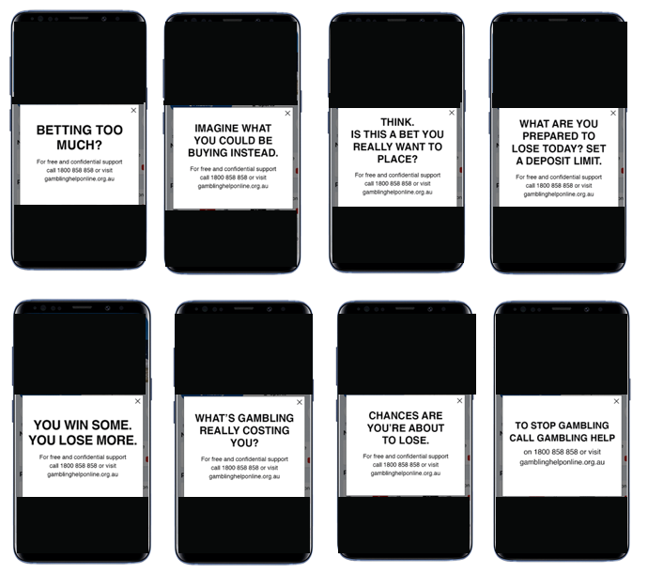

Best Positioning of Taglines
The tagline was shown in two positions: upon logging into the app, and before placing the bet. Participant responses suggest that both should be included to appeal to gamblers on either side of the spectrum and maximise the opportunity for consumers to be exposed to the message.
High-risk gamblers stated that they would benefit more from seeing the tagline before placing a bet and reported that being taken out of ‘the zone’ was likely to provoke deeper thought. Lower-risk and more casual gamblers stated that they would respond to being shown the tagline upon logging in to the app as they aren’t committed to the bet.
In particular, it must be noted that many gamblers do not log out of the gambling app between sessions, and therefore would not often be exposed to a tagline which was only seen at login. It is therefore recommended that a tagline from the suite be shown both upon opening the app and upon logging in.
“The way my [betting app] works, I never see the login page…it just goes right in and I can get started. A lot of people would miss that pop up if they aren’t logging in” (Female, 41, SA, Moderate Risk).
On the whole, performance of the various taglines as a pop-up window on a betting app among regular online wagerers was similar, as seen in
Figure 28. Performance of a tagline placed before a bet as opposed to after login was not consistently better or worse – response to this appears to have been dependent on the tagline in place rather than the position in the app.

Figure 28 - In-app Tagline Diagnostics - Regular online wagerers
 | What’s gambling really costing you? After login | What’s gambling really costing you? Before bet | To stop gambling call Gambling Help After login | To stop gambling call Gambling Help Before bet | Chances are you’re about to lose. After login | Chances are you’re about to lose. Before bet | Think. Is this a bet you really want to place? After login | Think. Is this a bet you really want to place? Before bet | Imagine what you could be buying instead. After login | Imagine what you could be buying instead. Before bet | What are you prepared to lose today? After login | What are you prepared to lose today? Before bet | Betting too much? After login | Betting too much? Before bet | You win some. You lose more. After login | You win some. You lose more. Before bet
The message grabbed my attention | 44% | 44% | 41% | 45% | 40% | 47% | 40% | 49% | 43% | 43% | 45% | 45% | 42% | 43% | 43% | 42%
I don't remember seeing this message at all | 7% | 12% | 12% | 4% | 13% | 9% | 6% | 8% | 9% | 7% | 7% | 10% | 10% | 9% | 6% | 12%
The text was too small | 2% | 5% | 2% | 3% | 3% | 3% | 4% | 8% | 5% | 5% | 1% | 5% | 4% | 6% | 2% | 4%
It makes me want to search online for more information about gambling help | 11% | 14% | 11% | 10% | 12% | 11% | 14% | 12% | 13% | 13% | 14% | 7% | 6% | 12% | 12% | 12%
It makes me want to call the phoneline (1800 858 858) | 4% | 8% | 11% | 7% | 8% | 11% | 8% | 4% | 9% | 8% | 10% | 4% | 4% | 11% | 6% | 5%
It makes me want to visit the website (gamblinghelponline.org.au) | 12% | 10% | 11% | 7% | 12% | 12% | 13% | 12% | 10% | 7% | 14% | 5% | 7% | 16% | 9% | 10%
It makes me want to be more mindful about how much I gamble | 32% | 31% | 27% | 26% | 39% | 44% | 37% | 34% | 42% | 40% | 34% | 37% | 31% | 34% | 36% | 32%
It makes me want to click on a link on this pop up to take me through to the website | 8% | 10% | 7% | 6% | 12% | 13% | 14% | 11% | 12% | 15% | 19% | 7% | 7% | 13% | 12% | 11%
F3. We'd now like you to focus on this message that appeared in the advert you just saw. Which of the following do you feel best applies to this message?
Base: Regular online wagerers n=159-176

Most Popular Taglines
The likely impact of a tagline upon opening the app was said to be dependent on their existing level of dedication to placing a bet. Participants said that a tagline would be more effective at dissuading them if they were not already dedicated to placing a bet, but if they were committed to gambling, the tagline might only be considered after the bet was lost.
Medium-to-high-risk gamblers reported falling into “the zone” when gambling, whereby gambling becomes their sole focus. In this state, it was reported that any distractions were considered a nuisance. The presence of a tagline immediately before placing a bet was therefore said to be especially aggravating for a time-sensitive bet.
“If I miss out on a last-minute bet, I would be p**** off” (Male, QLD, 38, High Risk).
For less time-sensitive bets (e.g., upcoming sports games), participants reported that taglines would be more thought-provoking and might even cause the gambler to reconsider the bet.
When narrowed down to the top performers,
Figure 29 overleaf shows that ‘What are you prepared to lose today?’ and ‘Chances are you’re about to lose’ achieved the most consistent performance for online wagerers.

Figure 29 - In-app Tagline Diagnostics - Regular online wagerers – reduced to top taglines
 | What’s gambling really costing you? After login | What’s gambling really costing you? Before bet | Chances are you’re about to lose. After login | Chances are you’re about to lose. Before bet | Think. Is this a bet you really want to place? After login | Think. Is this a bet you really want to place? Before bet | What are you prepared to lose today? After login | What are you prepared to lose today? Before bet | You win some. You lose more. After login | You win some. You lose more. Before bet
The message grabbed my attention | 44% | 44% | 40% | 47% | 40% | 49% | 45% | 45% | 43% | 42%
I don't remember seeing this message at all | 7% | 12% | 13% | 9% | 6% | 8% | 7% | 10% | 6% | 12%
The text was too small | 2% | 5% | 3% | 3% | 4% | 8% | 1% | 5% | 2% | 4%
It makes me want to search online for more information about gambling help | 11% | 14% | 12% | 11% | 14% | 12% | 14% | 7% | 12% | 12%
It makes me want to call the phoneline (1800 858 858) | 4% | 8% | 8% | 11% | 8% | 4% | 10% | 4% | 6% | 5%
It makes me want to visit the website (gamblinghelponline.org.au) | 12% | 10% | 12% | 12% | 13% | 12% | 14% | 5% | 9% | 10%
It makes me want to be more mindful about how much I gamble | 32% | 31% | 39% | 44% | 37% | 34% | 34% | 37% | 36% | 32%
It makes me want to click on a link on this pop up to take me through to the website | 8% | 10% | 12% | 13% | 14% | 11% | 19% | 7% | 12% | 11%
F3. We'd now like you to focus on this message that appeared in the advert you just saw. Which of the following do you feel best applies to this message?
Base: Regular online wagerers n=159-176

Text Size and Colour
Five text size and colour options were tested. Participants were largely unanimous in preferring the largest text. Figure 30 shows that overwhelmingly among all cohorts, the pop up with the largest font on all fronts was perceived as the most salient.
Figure 30 - In-app font size – most salient
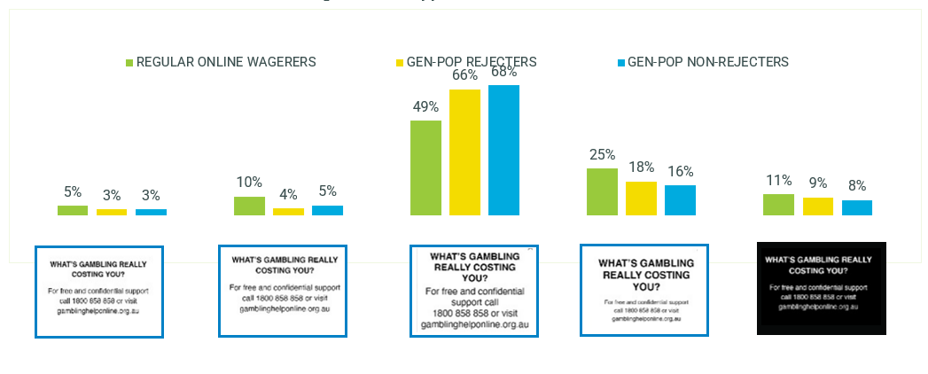

Radio Format
The radio formats were not tested in the quantitative survey. Qualitatively, all ten taglines were tested at the end of a radio script which was read aloud by the moderator. The script was taken from a radio advertisement for a popular betting company.
Overall, it is recommended that the reader leave a pause between the phrase “conditions apply” and the tagline, as this allows for the listener to understand the message without feeling it is merely a rushed formality.
The best taglines in this context were ‘chances are you’re about to lose’ and ‘you win some. You lose more’ which were said to have substantial cut-through for consumers. In particular, ‘you win some. You lose more’ performed strongly, with participants claiming that the confusion caused by this tagline in some other formats was removed when read aloud.
The tagline ‘what’s gambling really costing you?’ also performed well in this context, with participants stating that it reminded them of their family when read aloud.The taglines which seemed best suited to in-app formats demonstrated reduced potential cut-through in a radio context: ‘what are you prepared to lose today?’ and ‘Think. Is this a bet you really want to place?’ were said to feel “tagged on” and to lack relevance in this format.

Format Issues
Feedback surrounding the words ‘free and confidential support’ at the end of radio advertisements was mixed. Some participants admitted that they were ‘glad’ to know that support was available while others argued the relevance of this line.
“It’s a nice to know but is it going to make me seek help based on a radio ad? Probably not. I don’t really think I need help and don’t pay much attention to the radio to begin with” (Male, NSW, 28, Moderate Risk)
At an overall level, radio advertising is not felt to be the most engaging medium for this kind of messaging. However, there is some benefit in audiences being exposed to the repetition of the messaging via this channel. Similarly to the TVC messaging preferences, taglines requiring the listener to consider a question or the future outcomes of their gambling behaviour had the most traction.

Online Banner Format
A total of ten online banner layouts were tested, showing all ten taglines. An existing popular betting company execution was chosen as the vehicle, with the taglines presented as a final frame in black text on a white background. In the quantitative survey, respondents were asked to click on the areas of these layouts which stood out the most to them. The resulting heatmaps demonstrated that placing the taglines in the final frame garnered considerable attention for the tagline, regardless of the tagline in question.
In the previous Hall & Partners research, online banner layouts were also tested with the current positioning of the ‘gamble responsibly’ tagline. These heat maps demonstrated the failure of this tagline execution to attract attention.
Figure 31 - Layout diagnostics - ONLINE WAGERERS
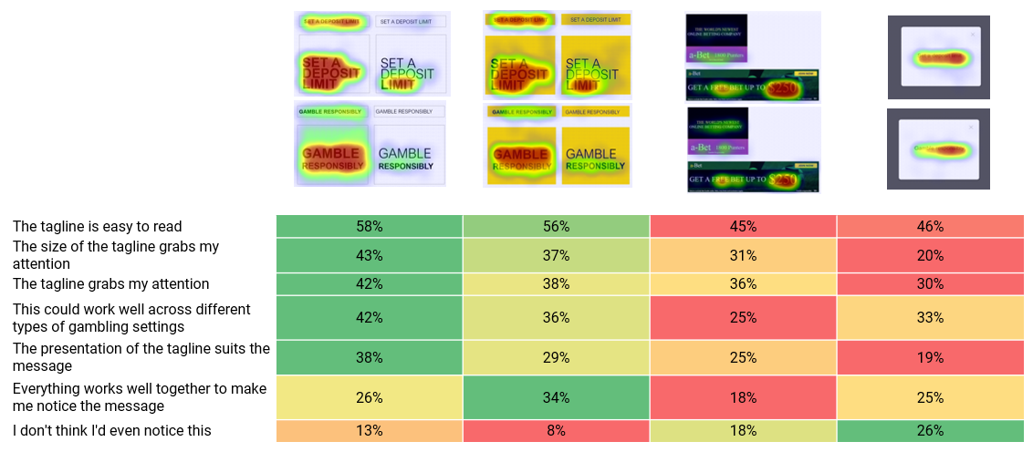
F2. Which of the following do you think applies to this image? *Colour coding is conditional formatting only and not indicative of significant differences.
MESSAGE TESTING SURVEY: Online wagerers n=104-130 per layout

Figure 32 shows that across the diagnostics, there was similar performance across the taglines in the online banner format among regular online wagerers. The taglines with the most consistent performance across these diagnostics were ‘What are you prepared to lose today’ and ‘You win some’.
Figure 32 - Online Tagline Diagnostics - Regular online wagerers
 | What’s gambling really costing you? | To stop gambling call Gambling Help | Worried about your gambling? We can help. | Chances are you’re about to lose. | Think. Is this a bet you really want to place? | Imagine what you could be buying instead. | What are you prepared to lose today? Set a deposit limit. | Betting too much? | You win some. You lose more. | What are you really gambling with?
The message grabbed my attention | 36% | 32% | 34% | 37% | 33% | 38% | 40% | 33% | 40% | 35%
I don't remember seeing this message at all | 9% | 11% | 13% | 9% | 10% | 9% | 7% | 9% | 9% | 8%
The text was too small | 6% | 7% | 5% | 9% | 6% | 8% | 8% | 9% | 7% | 8%
It makes me want to search online for more information about gambling help | 12% | 12% | 11% | 16% | 10% | 12% | 13% | 13% | 15% | 12%
It makes me want to call the phoneline (1800 858 858) | 10% | 8% | 11% | 9% | 9% | 7% | 9% | 9% | 11% | 10%
It makes me want to visit the website (gamblinghelponline.org.au) | 11% | 13% | 13% | 9% | 10% | 11% | 14% | 14% | 11% | 11%
It makes me want to be more mindful about how much I gamble | 28% | 26% | 27% | 31% | 31% | 31% | 36% | 30% | 32% | 29%
F5. We'd now like you to focus on this message that appeared in the advert you just saw. Which of the following do you feel best applies to this message?
Base: Regular online wagerers n=323-349

Figure 33 shows that among gen-pop rejecters, the tagline with the most consistent performance was ‘Chances are you’re about to lose’.
Figure 33 - Online Tagline Diagnostics - Gen-pop rejecters
 | What’s gambling really costing you? | To stop gambling call Gambling Help | Worried about your gambling? We can help. | Chances are you’re about to lose. | Think. Is this a bet you really want to place? | Imagine what you could be buying instead. | What are you prepared to lose today? Set a deposit limit. | Betting too much? | You win some. You lose more. | What are you really gambling with?
The message grabbed my attention | 33% | 27% | 26% | 30% | 26% | 27% | 32% | 27% | 30% | 23%
I don't remember seeing this message at all | 14% | 10% | 12% | 14% | 14% | 18% | 12% | 15% | 11% | 12%
The text was too small | 12% | 10% | 8% | 9% | 7% | 8% | 8% | 8% | 7% | 9%
It makes me want to search online for more information about gambling help | 5% | 5% | 5% | 3% | 7% | 3% | 6% | 5% | 5% | 4%
It makes me want to call the phoneline (1800 858 858) | 3% | 5% | 6% | 4% | 3% | 2% | 2% | 2% | 6% | 6%
It makes me want to visit the website (gamblinghelponline.org.au) | 4% | 4% | 4% | 5% | 4% | 3% | 2% | 2% | 2% | 5%
It makes me want to be more mindful about how much I gamble | 13% | 8% | 15% | 13% | 13% | 12% | 10% | 12% | 10% | 8%
F5. We'd now like you to focus on this message that appeared in the advert you just saw. Which of the following do you feel best applies to this message?
Base: Gen-pop rejecters n=157-172
Taglines that performed consistently across the diagnostics were harder to identify among the gen-pop non-rejecters, as seen in Figure 34.
Figure 34 - Online Tagline Diagnostics - Gen-pop non-rejecters
 | What’s gambling really costing you? | To stop gambling call Gambling Help | Worried about your gambling? We can help. | Chances are you’re about to lose. | Think. Is this a bet you really want to place? | Imagine what you could be buying instead. | What are you prepared to lose today? Set a deposit limit. | Betting too much? | You win some. You lose more. | What are you really gambling with?
The message grabbed my attention | 33% | 26% | 27% | 41% | 34% | 38% | 33% | 36% | 39% | 26%
I don't remember seeing this message at all | 18% | 18% | 13% | 11% | 15% | 16% | 15% | 17% | 17% | 17%
The text was too small | 6% | 5% | 6% | 10% | 10% | 5% | 10% | 11% | 8% | 10%
It makes me want to search online for more information about gambling help | 6% | 6% | 9% | 6% | 8% | 7% | 7% | 8% | 5% | 6%
It makes me want to call the phoneline (1800 858 858) | 7% | 6% | 6% | 4% | 5% | 7% | 5% | 6% | 6% | 3%
It makes me want to visit the website (gamblinghelponline.org.au) | 8% | 9% | 8% | 10% | 3% | 5% | 6% | 7% | 5% | 3%
It makes me want to be more mindful about how much I gamble | 25% | 17% | 21% | 25% | 23% | 22% | 31% | 26% | 25% | 24%
F5. We'd now like you to focus on this message that appeared in the advert you just saw. Which of the following do you feel best applies to this message?
Base: Gen-pop non-rejecters n=157-172

Format Issues
One substantial issue emerged with having the tagline in the final frame, rather than imbedded in the text of the ad. It was said by a few participants in the qualitative research that they expected that clicking on the tagline would result in being taken to the Gambling Help Online website, particularly as that call to action was present on every tagline.
It is therefore the recommendation of the research team that the call to action “For free and confidential support call 1800 858 858 or visit gamblinghelponline.org.au” be removed and instead one of the following calls to action be considered:
- “For free and confidential support call 1800 858 858”
- “Set a deposit limit.”
- No call to action, tagline alone

Conclusions & recommendations
The research gives a strong evidence base for several recommendations, which are detailed here.
There are seven taglines with greatest potential to engage consumers. It is recommended that the DSS proceed with all seven, presented in rotation to reduce message fatigue.
The ‘gamble responsibly’ tagline should be replaced nationally with a suite of seven taglines which work in conjunction to address different levers and gamblers of different risk levels, presented in rotation to reduce message fatigue.

A suite of taglines is recommended
Seven taglines were identified as performing strongly in both qualitative and quantitative modalities, and have been recommended to be implemented. These are:
- Chances are you’re about to lose
- Think. Is this a bet you really want to place?
- What’s gambling really costing you?
- What are you prepared to lose today? Set a deposit limit.
- Imagine what you could be buying instead.
- You win some. You lose more.
- What are you really gambling with?
As shown in the table below, these operate in conjunction to cover a broad range of PGSI profiles, online wagerers and the general population, including those who participate in gambling activities occasionally and those who reject all gambling.
The taglines should be rolled out evenly to allow consumers exposure to all messages, as they operate on different emotional and rational levers and speak to audiences of a range of PGSIs and gambling behaviours. Although some resonated more strongly in certain states, there were no significant differences between states, indicating that they can be rolled out nationally.
All seven have strong quantitative performance across the various metrics, with some performing especially high in particular states (as shown in the table below).
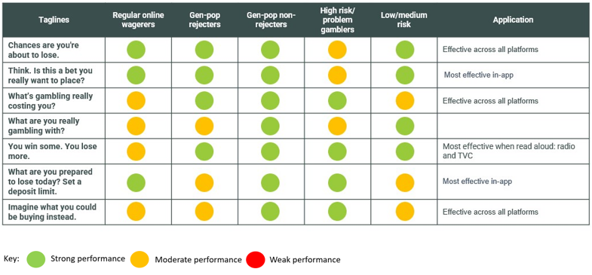

The call to action of seeking help
The call to action ‘for free and confidential support call 1800 858 858 or visit gamblinghelponline.com.au’ was not compelling for online wagerers, who reported that they were not likely to access the helpline or website. This is due to the disinclination of gamblers to see themselves as requiring support, regardless of risk profile.
A more compelling call to action was ‘set a deposit limit’ which offered gamblers a concrete action for which they could see the value. However, it is not recommended that this call to action replace the call to action of help-seeking due to the former’s association with the gambling industry: a number of betting companies use this call to action in their own campaigns.
The Delphi group stated that there is value in both gamblers and the general public being more aware of the helpline and website as resources to support those at risk of gambling harm, and this was supported by consumers in the qualitative interviews. It is therefore recommended that the taglines are implemented with the help-seeking call to action, as long as the call to action does not detract from the main message of the tagline.

The seven taglines should be implemented across various
platforms, allowing for maximum exposure of consumers to the messages
The taglines should be rolled out as shown in the below table:

Recommendations for ideal TVC tagline
The TVC tagline should be placed at the end of the commercial, with a slow, evenly-paced voiceover to allow for greater digestion of the message and tagline. The voice can be either gender, but it is recommended that attention is paid to the pace of the tagline, ensuring cut-through as a faster-paced tagline is easily dismissed as a “tick-box”. A shorter call to action will achieve this, with the call to action ‘call the number on screen or visit the website’ preferred to ‘for free and confidential support call 1800 858 858 or visit gamblinghelponline.com.au’.
The tagline should be presented in large font, taking up as much of the screen as possible, and a black background with white text to allow the viewer to easily read it.
The taglines ‘Chances are you’re about to lose’ and ‘You win some. You lose more.’ are particularly recommended for the TVC format, with ‘Imagine what you could be buying instead’ and ‘What is gambling really costing you?’ rounding out a suite of five.
The taglines ‘Think. Is this a bet you really want to place?’ and ‘What are you prepared to lose today?’ should not be used in TVC formats due to the reduced context.

Recommendations for radio advertising
The radio tagline should have an evenly-paced voiceover and a pause between the tagline and other messages such as ‘terms and conditions apply’. It is recommended that the full website not be read aloud, with a shorter call to action to allow for time to hear the message and absorb it.
‘Chances are you’re about to lose’ and ‘You win some. You lose more’ are strongly recommended for radio advertising. ‘What’s gambling really costing you?’ ‘What are you really gambling with?’ and ‘Imagine what you could be buying instead’ are also recommended for this format, with ‘Think. Is this a bet you really want to place?’ and ‘What are you prepared to lose today? Set a deposit limit’ not recommended for radio advertising.

Recommendations for in-app placement
The in-app tagline should occur at two locations: both on login to the app and at the point of placing a bet. The tagline should appear as a pop-up box, which viewers must click on to minimise. This will ensure the message catches both those consumers who log in casually, and those who leave the app logged in for ease of use.
The font should be clear, legible, and easy to read, with the largest possible font, consistent across the whole message. The message should be presented as black text on a white background.
‘Think. Is this a bet you really want to place?’ and ‘What are you prepared to lose today? Set a deposit limit’ are particularly strong in the in-app setting, while ‘Chances are you’re about to lose’, ‘What’s gambling really costing you?’, ‘Imagine what you could be buying instead’ and ‘What are you really gambling with?’ round out the suite of six to be rotated across betting sessions.
It is not recommended that ‘You win some. You lose more’ be included in in-app settings due to the possibility for confusion.

Recommendations for online banner advertising
The tagline should occur at the end of the banner ad, in clear, easy to read text, with the largest possible font consistent across the whole message. The message should be presented as black text on a white background.
Six taglines are recommended for online banner advertising, with ‘You win some. You lose more’ not recommended in this format due to a possibility of confusion. These six should be evenly rotated.
It recommended that the call to action ‘For free and confidential support call 1800 858 858 or visit gamblinghelponline.org.au’ be removed for online banner advertising so as to avoid the risk of a gambler seeking help, clicking on the banner in the hope of being taken to the Gambling Help Online website, and instead finding themselves on an online betting site. Instead, the call to action to ‘Set a deposit limit’ should be considered, or the tagline can be left to stand alone without a call to action.

Recommendations for print advertising
Print executions were not tested in the research, but a recommendation can be made based on other advertising formats which utilise print and visual mediums.
Taglines in print advertising should stand alone from the advert so as not to be confused with the message contained within the advertisement. The tagline should be in large, legible font and presented in black text on a white background. The taglines should be evenly rotated.
All taglines will be appropriate for this format apart from ‘You win some. You lose more’ which should only be used in channels where it is read aloud.

Gambling Tagline Research Phase 2: Implementation and Market Testing
Department of Social Services
Hall & Partners
MEL: +61 (0)3 9868 6200
SYD: +61 (0)2 9925 7450
info@hallandpartners.net.au
hallandpartners.com/au

QGSO 2021in Gambling snapshot, AIHW, 2021
Global Betting and Gaming Consultants Interactive Gambling Dataset, 2021
QGSO 2021in Gambling snapshot, AIHW, 2021
Gambling Research Australia, The 2nd National Study of Interactive Gambling, 2020
Latvala, Lintonen & Konu, Public Health Effect of Gambling – Debate on a Conceptual Model, BMC Public Health, 2019.
Ibid.
National Drug Strategy Household Survey, 2019.
Johns, R., et al. Impact of gambling warning messages on advertising perceptions, Victorian Responsible Gambling Foundation, 2017, p. 4.
National Consumer Protection Framework Baseline Report, 2019a, p. 100.
Darnton, A. (2008). Practical Guide: An overview of behaviour change models and their uses: Government Social Research (GSR) Behaviour Change Knowledge review. UK Government
Weighing Up The Odds: Sports Betting and Young Men: Research Summary, Australian Institute of Family Studies: Australian Gambling Research Centre, 2018, p. 3.

