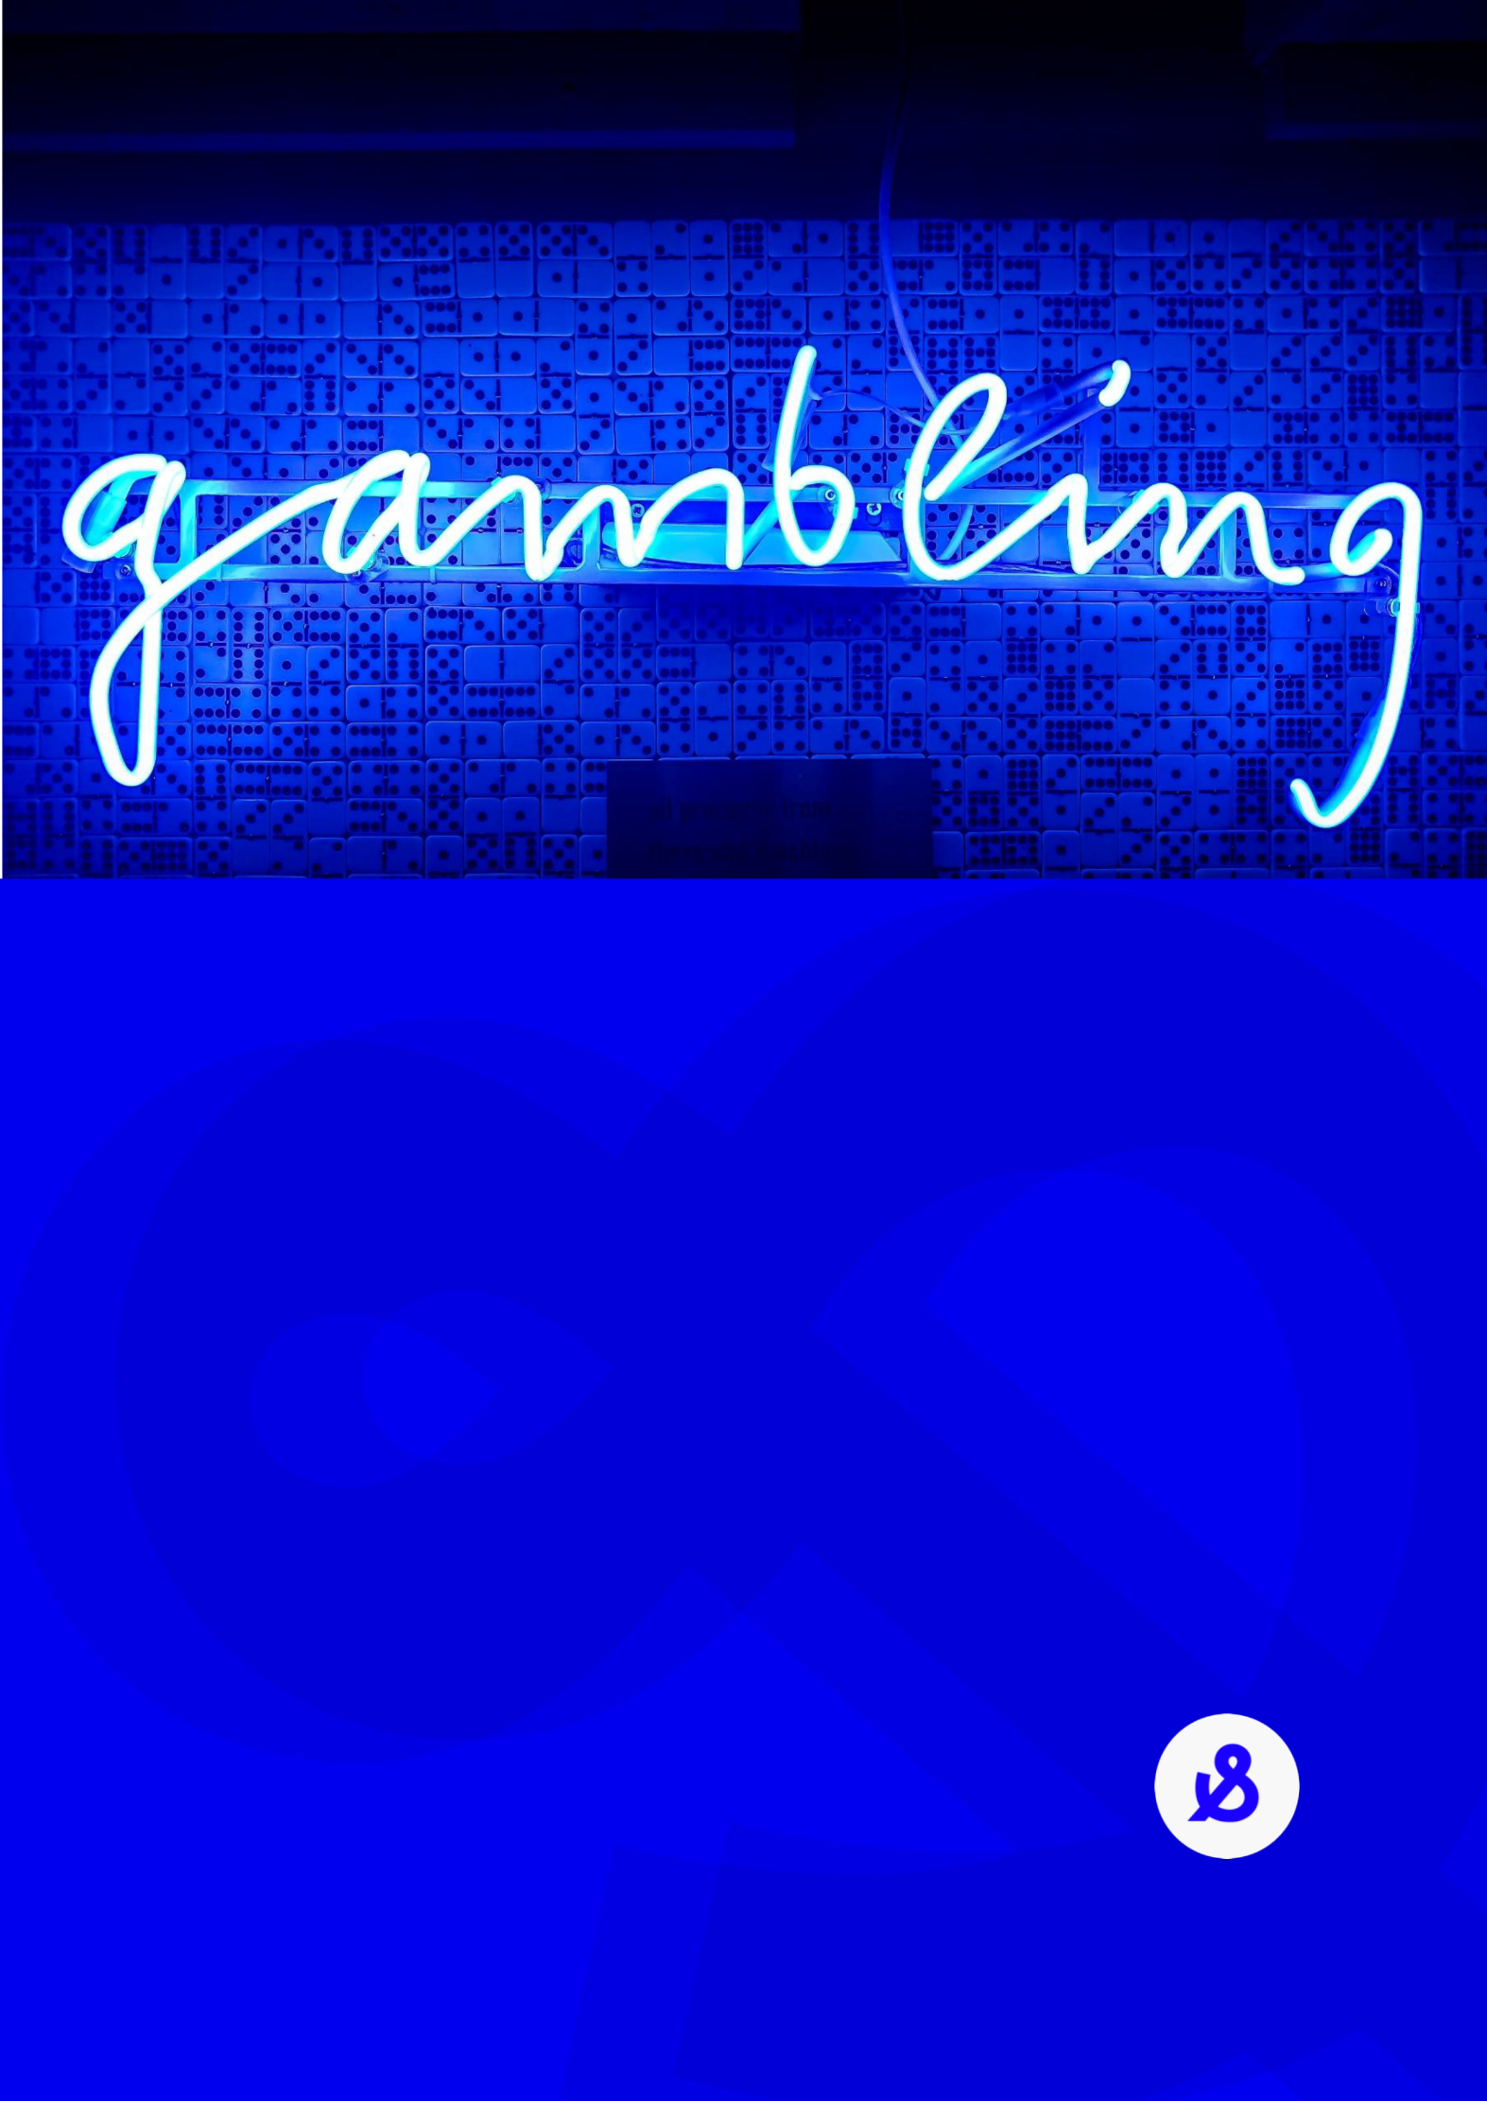

Consistent Gambling Messaging
Phase 1: Development and Refinement
Department of Social Services
Hall & Partners
MEL: +61 (0)3 9868 6200
SYD: +61 (0)2 9925 7450
info@hallandpartners.net.au
hallandpartners.com/au

Disclaimer
The author of this report is Hall & Partners Australia.
The research was commissioned by the Department of Social Services and was conducted between March and May 2021.
The analysis presented in this report reflects data from a two-phased program of work across the country, with a range of audiences conducted as affinity focus groups, general public focus groups, individual in-depth interviews and online surveys. Hundreds of unique inputs and comments were made during the course of the consultations and survey, and these are collected, de-identified and maintained as a rich data source for providing direction on the placement, format and selection of taglines to address wagering behaviours in line with the National Consumer Protection Framework (NCPF).
The Commonwealth of Australia accepts no responsibility for the accuracy or completeness of any material contained in this report. Additionally, the Commonwealth disclaims all liability to any person in respect of anything, and the consequences of anything, done or omitted to be done by any such person in reliance, whether wholly or partially, upon any information contained in this report.
Any views and recommendations of third parties contained in this report do not necessarily reflect the views of the Commonwealth or indicate a commitment to a particular course of action.
All direct quotes in this report are excerpts from the survey and qualitative research and were said by interviewees and participants during the consultation process. This report should not be read as being representative of all Australians.
For matters relating to this report contact:
Frances Chapman  Partner  frances@hallandpartners.net.au | Kathryn Priestly  Partner  kathryn@hallandpartners.net.au

Table of contents
Executive Summary 4
Introduction 9
Research Design 16
Research Insights 26
Conclusions and Recommendations 159
Appendix: Literature Review 167

Executive Summary
The Department of Social Services (DSS) commissioned Hall & Partners to conduct research to determine the most effective approach to gambling messaging and dynamic warning messaging. This report comprises the final deliverable of the research and recommends a suite of taglines to reduce gambling harm.
This research will contribute to the eighth objective of the National Consumer Protection Framework for online wagering (NCPF) which outlines that online wagering providers will use the same messaging about the risks and potential harm of gambling in their advertising, direct marketing, websites, and other direct communications to consumers, and that this messaging will be supported by an evidence base. This research comprises a portion of the evidence base for such messaging.
The multi-methodological research programme was designed to take an iterative approach to the development and recommendation of message taglines. It comprised four components:
- Literature review: review of existing research from Australia and other jurisdictions
- Phase I: exploratory research into the beliefs, attitudes, behaviours, drivers and barriers to behaviour change in relation to online wagering. This phase was conducted with current online wagerers and other secondary audiences across n=23 qualitative sessions and a 15-minute quantitative survey with n=2,500 respondents
- Activation: development of taglines designed to reduce gambling harm. Insights from the Literature review and Phase I research informed the development of these taglines
- Phase II: testing the taglines and associated messaging territories to inform the final recommendations. This phase was conducted with current online wagerers and other secondary audiences across n=15 qualitative sessions and a 10-minute quantitative survey with n=1,500 respondents
A comprehensive base of insights was built over the course of the research and each component of the program was informed by insights derived from earlier phases. The insights were analysed holistically in the development of the final recommendations.

Five taglines as a suite of messages are recommended to the NCPF IGC
Five taglines were identified as being effective at both engaging consumers and intercepting rational decision making. Implemented as a suite of messages, the taglines maximise the opportunity to resonate with all consumer audiences and across a range of online platforms. There is also scope for these to be expanded into land-based environments in the future.

The five taglines (in no particular order):
- Chances are you’re about to lose.
- Think. Is this a bet you really want to place?
- You win some. You lose more.
- What are you prepared to lose today? Set a deposit limit
- Imagine what you could be buying instead.

As a suite, the taglines maximise the opportunity to reduce gambling harm
The taglines are effective in different ways. Collectively, they work on both rational and emotional levels to cut through and encourage consumers to take positive, harm minimising actions
Measuring the efficacy of messages is complex and can be best understood through a series of metrics: ability to cut through and capture attention (salience), prompting consumers to stop and rationally process the message (rational response), engage consumers on a personal level so that they internalise the message (emotional response), and motivating positive changes to behaviour (action). The recommended taglines performed strongly across multiple measures of efficacy and as a suite ensure a desired response is always elicited from consumers.
The suite of taglines engage wagerers of a range of mindsets, behaviours and risk levels
The recommended taglines are underpinned by human insights that were informed by different mindsets, behaviours, biases, and heuristics held by consumers. Each human insight led to the development of a unique message theme (territory). The suite of taglines speaks to three different themes, all of which had high personal relevance across consumer audiences:
Tagline | Theme (territory) | Human insight | Intention of the territory
Chances are you're about to lose. | Confidence | Consumers ignore negative feelings experienced when wagering which leads to a sense of confidence they will win | Reduce consumers’ overconfidence when placing a bet
Think. Is this a bet you really want to place? | Confidence | Consumers ignore negative feelings experienced when wagering which leads to a sense of confidence they will win | Reduce consumers’ overconfidence when placing a bet
You win some. You lose more. | Loss | Dreaming about the prospect of winning makes consumers forget they might lose | Remind consumers of the rational truth that losing is a likely outcome of wagering.
What are you prepared to lose today? Set a deposit limit | Loss | Dreaming about the prospect of winning makes consumers forget they might lose | Remind consumers of the rational truth that losing is a likely outcome of wagering.
Imagine what you could be buying instead. | Positive | Consumers do not consider what else they could spend their gambling money on | Reframe the conversation away from the harm of online wagering
Consumer testing confirmed that for each audience, at least two taglines within the recommended suite have strong efficacy, indicating that all audiences can be engaged through the suite of messages in market. Furthermore, none of the recommended taglines performed poorly or jarred with any audience: the suite of taglines has low risk of stigmatisation or inducing other negative consequences (for example, encouraging harmful behaviours).
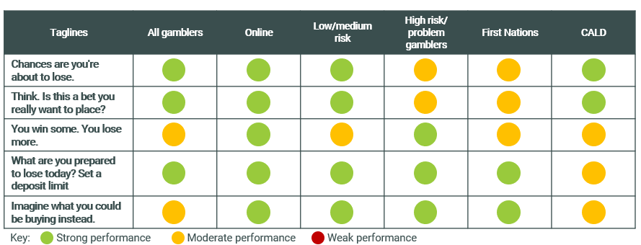
No significant differences in tagline efficacy were found between states and territories suggesting that a consistent suite of taglines can be implemented nationwide.
The suite of taglines has broad application: they are suitable for online and land-based environments
The taglines have a wide scope: consumers reported readily imagining each tagline in an online or land-based environment. This suggests that the taglines have utility beyond the online environment and the potential to engage a broader range of consumers if needed (for example, land-based consumers). To strengthen the applicability of the taglines in the land-based environment the call to action of ‘set a deposit limit’ could be substituted for a land-based harm minimisation tool.
Five taglines is the right number to strike a balance between mitigating message fatigue and ensuring consumers have sufficient opportunity to be re-exposed to each tagline
Consumers claim that seeing rotating different messages in market reduces the likelihood of them ‘tuning out’ the message in a short space of time, as was reportedly a response to the ‘Gamble responsibly’ tagline.
However, participants also commented that the more they read and thought about a particular tagline, the deeper they connected with and rationally processed the message. There is therefore a strong case for ensuring consumers are given the opportunity to be exposed to each tagline on multiple occasions to aid the digestion of message and subsequent behavioural response. There is also scope to present more than one tagline in market at the same time in different environments. This is because the messages speak to different truths and thus do not detract from or conflict with other taglines.

Presentation of the taglines
The presentation of current gambling warning messages was found to be ineffective, easily missed, and discouraging of consumer engagement. Guidelines for the most effective presentation of the taglines were informed by consumers’ reflection on and evaluation of the presentation of the current ‘Gamble responsibly’ tagline in different settings, and the quantitative testing of presentation formats.
In order to ensure attention of the viewer is captured and cut-through of message it is recommended that presentation of the tagline follows six guidelines:
- The tagline should stand alone, without distraction
- The tagline should be capitalised and in a large, uniform and legible font
- The tagline is most ideally black writing on a white background
- The tagline should cover at least a third of the space if shown on its own screen
- The tagline should be removed or delineated from any gambling advertising content, for example:
  - In television advertising the tagline would appear in a frame on its own, centred text, without any other text relating to the gambling advertisement present
  - In print advertising the tagline would be in legible sized font (at least the same size font as the advertisements key message), with white space around the tagline. It would not be positioned in the terms and conditions section of the advertisement (bottom of the ad)
  - In radio advertising the tagline would be orated at the same tempo as the advertisement, not quickened
- Engagement with the tagline through a click-box (where a viewer must minimise the tagline to continue with the gambling session) is recommended within betting apps, betting websites, or online advertising (e.g. banner ads) to create an environmental interruption which could cause reflection on behaviour; in-situ or longitudinal studies (outside the scope of this program of research) could validate this.
Emphasising specific words with bold text has merit to direct consumers’ attention and has proven efficacy through the quantitative study. Utilisation of emphasis is not recommended as the default presentation for the five recommended taglines, but this could be revisited by the DSS in time to help re-engage consumers with the message.

Application and presence of the taglines
The leading taglines all have the potential to be effective if presented in a range of settings and environments, including advertising or as stand-alone messages. It is recommended that all five taglines are rotated over a period of time.
Four of the five taglines were considered suitable and anticipated to have impact if presented across any application or setting, online or land-based: ‘Chances are you’re about to lose’, ‘You win some. You lose more.’, ‘What are you prepared to lose today? Set a deposit limit.’ and ‘Imagine what you could be buying instead’. It is recommended these options are utilised across all applications, settings, or environments.
There is strong consumer appetite for any of the five of the taglines to accompany industry advertising, such as television, radio, and print advertising. Consumers anticipate that inclusion of any of these taglines would be unwelcomed by industry, however they do not regard this as a deterrent and claim that these taglines replacing ‘Gamble responsibly’ in advertising would be effective: catching attention and engaging them with the message if presented in the recommended presentation format.
The timing of messages and relevance of the tagline to specific moments in the online gambling session was considered across audiences as critical for maximum cut-through and impact. It was felt that the online environment would facilitate even greater tailoring to individuals so that taglines presented could be most relevant to each person. For example, this could be based on the events within a session or selected in advance by the individual in relation to time or budget thresholds they have set for themselves when in a rational state of mind.
It is recommended that the specific locations and moments for the taglines to be presented within the betting app are:
- At the start of a session (e.g. when the app is opened)
- When going to confirm or place a bet
- When confirming how much money to deposit into their betting account
- As randomised or periodic popup windows during a session
- When a specific series of events is ‘triggered’ (e.g. after the fifth loss within a session or a certain amount of money bet)
Three of the five taglines are likely to have strongest traction at intercepting consumers at different stages of the playing experience, including within the online betting platform. Presenting the taglines ‘Think. Is this a bet you really want to place?’, ‘What are you prepared to lose today? Set a deposit limit.’ and ‘Imagine what you could be buying instead’ on rotation within the app during the online betting experience, or in land-based venues (for example on the playing floor, or elsewhere in the venue such as the lavatory stalls) has potential to maximise the impact these taglines have by prompting conscious decision making at crucial decision points during a session.

Introduction

A guide to this report
This report documents the findings of the research program. It first outlines the context of the research, then details the research findings by phase, and lastly summarises the opportunities and recommendations.
Where verbatim quotations from participants are used, they are referenced with the participant’s risk level (as identified in line with the Problem Gambling Severity Index, audience segment (e.g. gender, age), and location. Where the gambling activity is not stated in the quotation reference the mode of gambling is online wagering. Verbatim quotations are intended to give the reader an insight into the tone and dialogue heard from participants during qualitative discussions and provide examples of the sentiment heard across sessions.
Individuals in the qualitative research are referred to as ‘participants’, while those who responded to the quantitative surveys are referred to as ‘respondents.’ People who engage in online wagering behaviour and the intended message recipients of the taglines are referred to as ‘consumers’ for ease; these are not to be confused with ‘consumers’ in any other sense.
For purposes of brevity, acronyms are used throughout the report.
Table of acronyms
Acronym | Definition
CALD | Culturally and Linguistically Diverse
DSS | Department of Social Services
EGM | Electronic gaming machine
H&P | Hall & Partners Pty Ltd
NCPF  NCPF IGC | National Consumer Protection Framework for online wagering  National Consumer Protection Framework Implementation Governance Committee
PGSI | Problem Gambling Severity Index
The research was carried out in accordance with ISO 20252 requirements which includes data collection, analysis and reporting processes.

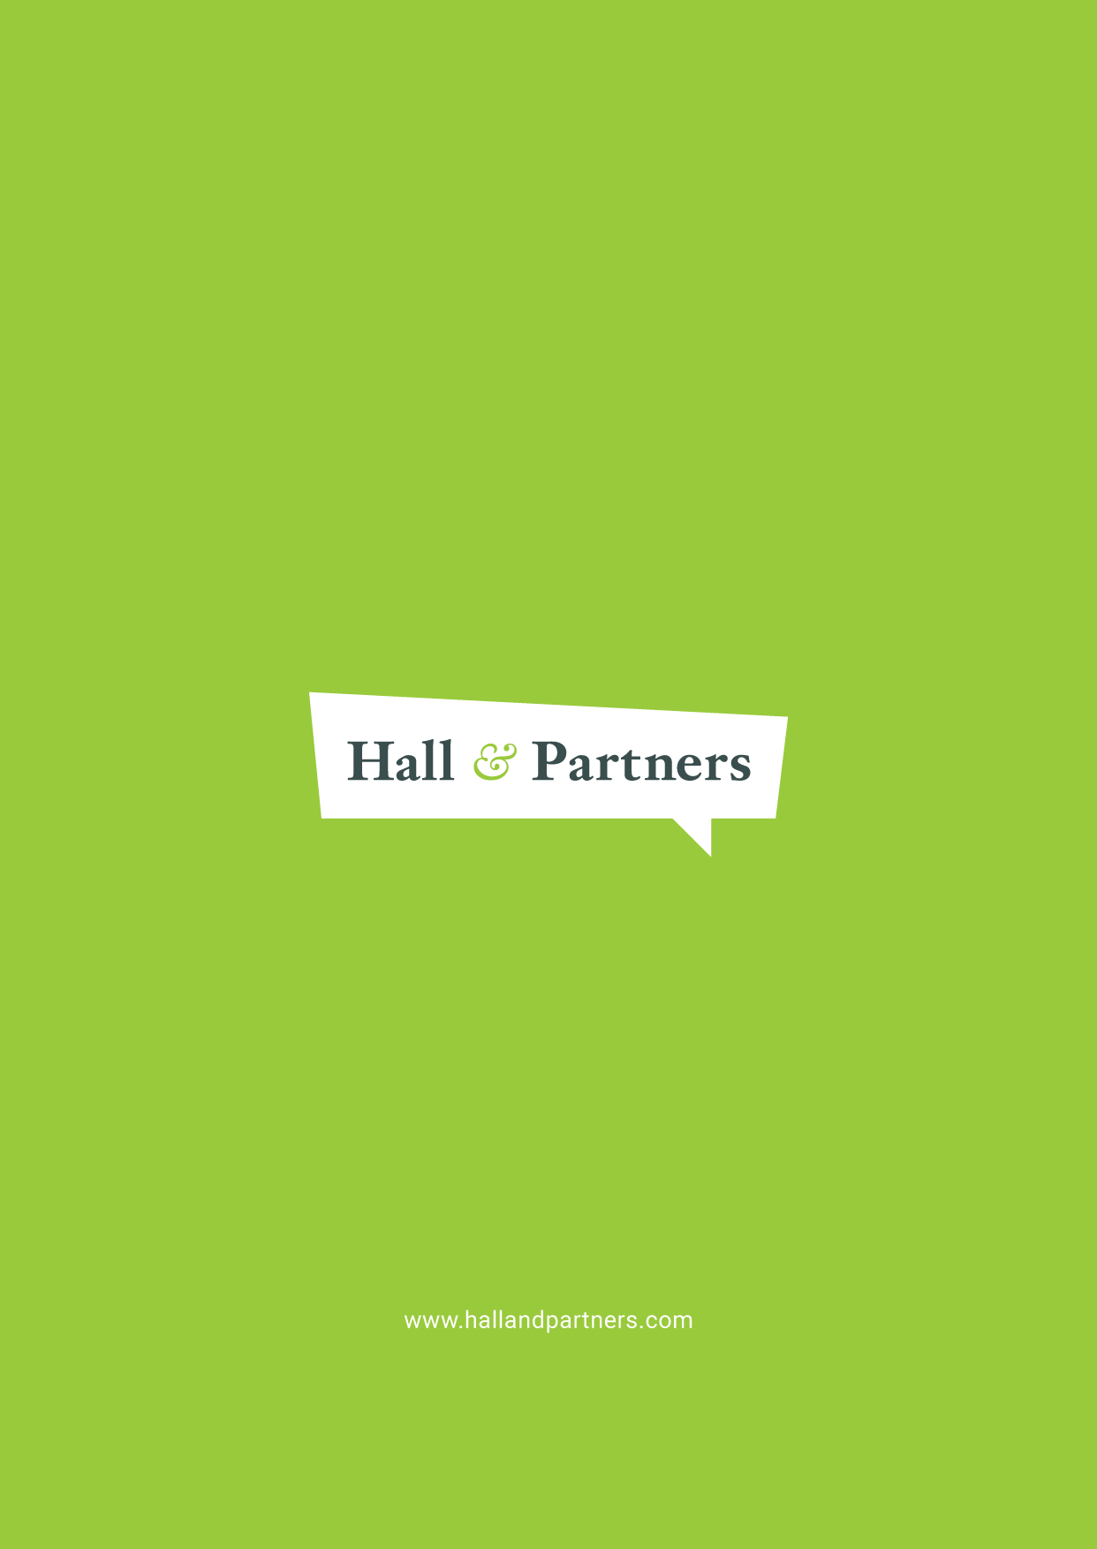
The place for messaging in social marketing and behaviour change
While messaging is an essential component of influencing behaviour, we must also acknowledge that it is just one component of a comprehensive behaviour change program.
It is clear from the social psychology literature that people do not change their behaviour simply because they have the correct information: all classic behaviour change models demonstrate that an individual’s beliefs and attitudes (seen below) are the critical intervening factors between knowledge/awareness and behavioural intentions. In addition, even after desirable behavioural intentions have been formed, intervening heuristics (mental short-cuts), habits, unconscious biases and environmental influences can still get in the way of desirable behaviour.
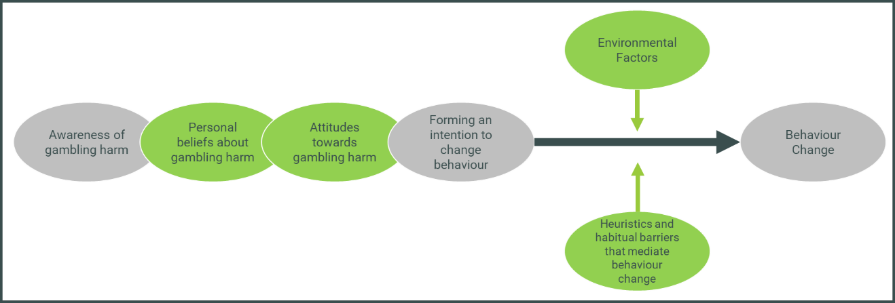
The behaviour change journey with regard to gambling behaviour, adapted from Ajzen and Fishbein’s Theory of Reasoned Action (1980)
A well-designed tagline can go some way towards intercepting these heuristics, biases and habits, and engaging conscious decision-making processes at a point when they might otherwise be disengaged. However, decisions are never made free of context, and an individual is always subject to a wide range of influences. While marketing and communications target the individual, they work most effectively when operating in conjunction with changes on the macro level (shown overleaf), such as legislation, and influence from peer and social groups and the wider community (the inner rectangles in the model).
Social & Structural
- Resources & Services
- Policies & Legislation
- Guidance & protocols
- Political leadership
- Gender norms
- Religious & cultural norms.
- Media & technology
- Socio economic factors

Community
Leadership, access to information, social
capital, collective efficacy
Family & Peer Networks
Peer influence, spousal communications,
partner & family influence, social support
Individual
Knowledge, skills, benefits & values,
self-efficacy, perceived norms, perceived risk,
emotion

Influences on an individual, adapted from Bronfenbrenner’s model Ecological Model of Influences (1979)
We have seen this with other legal but addictive behaviours such as smoking, where a combination of legislative changes (for example, plain packaging), taxes, environmental controls (such as reducing smoking in public places), changing social norms, and hard-hitting social marketing campaigns have reduced rates of smoking in adults in Australia from 25% in 1991 to 11.6% in 2019.
Gambling differs from many other addictive behaviours due to the incentive of possibly increasing wealth, a powerful disincentive to behaviour change for many consumers at risk of gambling harm. But it is not simply the promise of making money which encourages gambling behaviour. In the case of online wagering in particular, the peer group was found to play a substantial part, and much has been written about the influence of the environment on consumers who play Electronic Gaming Machines (EGMs).
We can therefore see that when it comes to gambling, messaging is just one piece of a complex puzzle, with environmental changes, peer norms and social pressure, and possible structural or legislative changes also playing a substantial role in encouraging behaviour change. Public policymakers hoping to reduce gambling harm must view messaging as an essential weapon in their arsenal, but not the ‘silver bullet’ which will single-handedly reduce gambling harm. However, we also see from the Ajzen and Fishbein model that in order to make a behaviour change, people must first be aware of the issue and then hold sufficiently motivating beliefs and attitudes. Messaging is an opportunity to change some of these beliefs and attitudes, to challenge misconceptions and norms, and to target individuals at the moment of decision-making.

The National Consumer Protection Framework for online wagering
The NCPF has acknowledged the various influences on behaviour change by introducing a suite of measures, of which consistent gambling messaging is but one. The measure provides for online wagering providers to use the same messaging about the risks and potential harm of gambling in their advertising, direct marketing, websites, and other direct communications to their customers. This will help to avoid inconsistent or ineffective messages about responsible gambling, and make sure messages reach people as they are making gambling decisions.
A 2017 meta-analysis by the Victorian Responsible Gambling Foundation concluded that action into gambling harm should take into account the stigmatising tone of some gambling messages, and called for change in regulation and messaging, with its first recommendation being to introduce a national framework which assists in the national regulation of gambling advertising.
The NCPF Baseline Report, released in 2019, states that messaging needs to facilitate conscious decision-making at the point where consumers engage in online wagering, and correct misperceptions about individuals’ own gambling behaviour. Messaging must also inform consumers about harmful gambling behaviours and remove stigma associated with consumer protection tools and gambling help services in order to encourage their uptake.
These are all appropriate areas for messaging to target, as they are within the realm of control of the individual. Importantly, messaging has the advantage (over some other measures) of targeting the individual at the point of their decision-making and offering an opportunity to intercept the behaviour.
Other measures among the ten included in the NCPF include those in legislative and regulatory spaces, such as restricting payday lenders and inducements, prohibitions on lines of credit, and streamlining the verification of customers’ identity. In this way, we can see that the NCPF acknowledges that regulatory, legislative, social and environmental changes all have a role to play in targeting gambling harm, with messaging working alongside these to improve outcomes.
Previous research has found that online wagerers comprise a different demographic to land-based gamblers, skewing towards high-income, highly-educated males aged 18-35. The influence of the peer group has been found to be key for this audience, and this segment was of greatest interest to the NCPF IGC for this research program.

Targeting conscious decision-making: The Hall & Partners Approach
Existing behavioural theory can help to dissect and make sense of these various different factors and understand how they might be applied to inform interventions. However, there are numerous models and theories – indeed, Darnton (2008) identified over sixty such models. Selecting the most appropriate model, and then applying these highly academic constructs in a practical and pragmatic way, can often pose a challenge.
To simplify the process, Hall & Partners has developed a clear, simple real-world approach that draws on the latest thinking in behavioural theory and behavioural economics. The Hall & Partners Behaviour Change Framework was developed by behaviour change specialists at Hall & Partners, including those in the team for this research program, applying the principles of dual process theory to examine both rational systems (‘conscious’ attitudes, beliefs and behaviours) as well as unconscious systems (attitudes, biases, impulses, emotional and non-deliberative behaviours of which the person may not be aware), as depicted.
Like all addictive behaviours, online wagering works on the unconscious mind of the consumer to disconnect conscious decision-making and encourage compulsive behaviour.
The behaviour of online wagering in particular is highly influenced by context, environment and unconscious influences which cannot be easily explained or articulated. A study in 2018 by the Australian Government found that sports betting behaviour was normalised among young men, suggesting that social norms feature heavily for this behaviour. Alcohol was also found to feature prominently while betting, indicating that rational decision-making might often be inhibited.
Using this Behaviour Change Framework and our extensive knowledge about behaviour change, Hall & Partners devised a methodology to target both rational thinking – the details which consumers can readily explain – and more unconscious influences, which might be acting on the consumer without their knowledge.

Research objectives
Hall & Partners are experts in branding and communications development, and regularly transferring our knowledge about behaviour change into workable strategy for messaging. This research program neatly tied together our two areas of expertise – exploratory behaviour change research and message development and testing.
The research aims and objectives tie in with the eighth measure of the NCPF: that online wagering providers must provide a set of gambling messaging for use in its advertising and the same approved gambling message(s) must be used in connection with any interactive wagering services.
The research program aimed to determine the most effective approach to gambling messaging and dynamic warning messaging, and this report comprises our recommended message territories, taglines and presentation formats to target online wagering behaviours.
The objectives included:
- Identify common attitudes and behaviours across interactive gambling populations that minimise gambling-related harm, and are common drivers, motivators and barriers to gambling behaviour change
- Confirm whether messaging should involve one new tagline or a set of taglines that can be used in different instances, including how they should be used and when
- Develop a set of messaging (ranked in order of priority) that is effective across different advertising mediums used by the interactive gambling industry, including web, television, print and radio
- Determine what messaging resonates most with the community and contributes to minimising gambling harm in the Australian population
- Be in collaboration with experts (harnessing new and existing research) with consideration of the jurisdictions in which they will be displayed
- Test the efficacy of messaging across and within audience segments of consumers who engage in interactive wagering and land-based venues in Australia, including the current tagline
- Test and develop an understanding of the most effective features of messaging across a range of media, including digital, radio, television and print, and in land-based venues, including message size, positioning, prominence, format style, colour, typeface, repetition and duration for digital and television
- Identify the differences in knowledge, understanding, perceptions and attitudes among First Nations people, CALD audiences and people from regional and remote Australia compared to the general population, and the best approaches for targeting them
- Identify any cultural sensitivities the proposed messaging should take into consideration

Research design

Literature review
Gambling behaviour and messaging is an area which has already been subject to much research, including research to inform messaging and communications, as well as to understand motivations and barriers to the behaviour itself. Hall & Partners conducted a systematic literature review of research pertaining to harm reduction messaging and communications in the gambling category. This included literature from Australia and other international jurisdictions.
The findings were developed into a document which has been included at Appendix 1. The review contributed to the design of the research protocols including qualitative discussion guide and quantitative survey and ensured that existing insights were leveraged so that the current research project could effectively progress and contribute to the collective understanding and knowledge in this area.

Phase I: Understanding Behaviours and Attitudes
In order to design a tagline to effectively intercept behaviour or change attitudes, there was a need to understand existing behaviours and attitudes which contribute to gambling harm. A dual qualitative and quantitative methodology was designed.
Two key primary audiences were identified: males aged 18-35 of low-moderate-risk according to the Problem Gambling Severity Index (PGSI), and males aged 18-35 of high-risk.

Phase I: Qualitative exploration
Principles underpinning the qualitative research design
On a topic such as gambling, which can sometimes carry feelings of shame and stigma, the sensitivity of the group is likely to be heightened. As researchers committed to the principles of ethical research, Hall & Partners designed a research methodology to minimise the impact of this potentially emotive topic on participants. For the first phase of the research, which focused on beliefs and attitudes and had potential to raise emotional responses, we chose affinity groups and online discussion boards.
We conducted six affinity groups with participants of a low-moderate risk profile and four online focus groups with participants of a high-risk profile, as well as three in-depth interviews with participants of CALD background of a range of risk profiles, and two in-depth interviews with First Nations people of a range of risk profiles.

Primary audience: 6 affinity groups, 4 online focus groups, 5 in-depth interviews
Risk Level (PGSI) | Format | Demographic | Location | Number
Low/moderate | Face to face affinity group | 18-35 year old males | 1 x Perth  2 x Sydney/Melbourne  2 x regional (QLD, VIC)  1 x Brisbane | 6
High | Online focus group | 18-35 year old males | All over Australia, mix of metro and regional | 4
Mix of risk levels, at least one high risk | In-depth interview | 18-35 year old males  First Nations | 1 x Sydney/Melbourne  1 x regional (QLD) | 2
Mix of risk levels, at least one high risk | In-depth interview | 18-35 year old males  CALD | 1 x Brisbane  1 x Sydney/Melbourne  1 x regional (VIC) | 3
TOTAL |  |  |  | 15
Affinity groups: understanding the influence of social norms on behaviour
Affinity groups/triads (groups where participants already know each other) produce higher quality, more accurate data, and with greater depth. Moreover, affinity groups reveal a great deal about the influence of the peer group – with an awareness that social factors play a significant role in gambling behaviours, particularly for online wagering behaviour in the 18-35 year-old male audience.
Understanding the dynamics, values, and codes of behaviours of the peer group provided insight into this important influence on behaviour. This was important for understanding how to support responsible gambling habits, as well as discourage harmful habits, and the extent to which the influences are grounded in peer norms. In addition, because the group structure in an affinity group represents a genuine group (rather than an artificial group of strangers), responses tend to be both more honest and more forthcoming because participants feel less judged, less guilty and have no need to exaggerate, defend, talk up or support concerns that they do not actually share.
The affinity groups included a range of metro and regional locations across Australia to ensure a spread of geographic representation, with locations including Perth, Sydney, Melbourne, Brisbane and regional locations (of Geelong in regional Victoria and Toowoomba in regional Queensland). Groups were held in participants’ homes to further allow for a natural social dynamic to develop.
Online focus groups: ideal for a high-risk audience
We split the primary audience for the research (males aged 18-35) into two key risk profiles: low- to moderate-risk and high-risk. While affinity groups were best for the low- to moderate-risk audience, an online methodology was selected for the high-risk audience to best preserve a feeling of anonymity. High-risk online wagerers are those who are already encountering high levels of gambling harm, and it was expected that feelings of shame and stigma might increase for these participants, to the point where they may prefer not to discuss these matters openly or with their peer group. An online environment allowed for more confidential discussion and a feeling of anonymity, as only first names were used.
In-depth interviews: ideal for hard-to-reach and vulnerable groups
An important component of this research was also the inclusion of people of First Nations and CALD background. While gambling behaviour can place people in vulnerable situations, we know from other studies that this can be greatly compounded by other marginalisation factors such as socio-economic status, First Nations or CALD status. Furthermore, linguistic requirements for people of First Nations and CALD background can sometimes mean that mainstream communications do not hit the mark for these audiences, so there was an important need to include the views of these groups in the research.
We chose to conduct this research in an intimate, one-on-one setting, allowing for the researcher to ensure a duty of care towards the participant in the event that they became distressed. Five in-depth interviews with First Nations and CALD male participants aged 18-35 of a range of risk profiles were held in the first phase in Brisbane, Sydney, Melbourne, regional Victoria and regional Queensland.
Secondary audiences: 3 online focus groups, 5 face-to-face groups
Risk Level (PGSI) | Format | Demographic | Location | Number
Low/moderate risk  (not male 18-35) | Online focus group | Females (18-50) | All over Australia, mix of metro and regional | 3
Friends and family members of people at risk of gambling harm from online wagering | Face to face focus group | Males and females 18-50 | 1 x Perth  1 x Sydney/Melbourne  1 x Brisbane | 3
Low/moderate risk  (land-based gamblers) | Face to face focus group | Males and females 18-50 | 1 x Sydney/Melbourne  1 x regional (QLD/VIC) | 2
TOTAL |  |  |  | 8

Three secondary audiences were identified in this study, and we spent a portion of the initial qualitative research on these groups. These include friends and family members of those at risk of gambling harm from online wagering, low- and moderate-risk land-based gamblers who do not currently engage in online wagering (but are not rejecters of it), and low- and moderate-risk online wagerers who do not fall into the males aged 18-35 audience. Input from these secondary audiences helped to inform the design of the messaging territories, which may be rolled out across a number of gambling platforms, not just in online wagering environments.
Eight focus groups with these secondary audiences were held, with the friends/family members and land-based gamblers groups held in a face-to-face context, and the low and moderate-risk online wagering group held in an online focus group setting to allow for anonymity. There is little current research to suggest that the peer group is important in the non-18-35 male audiences, and therefore it was not recommended that these groups are affinity groups. Instead, a larger sample can be sought through traditional focus groups.
Recruitment and incentives
Recruitment for the focus groups, in-depth interviews, affinity groups and online focus groups was completed through external recruitment providers with a proven record of recruiting on short timeframes. These included QandA Research, McGregor Tan Research, Myriad Research, and Cooper Symons.
Participants were incentivised for their time in line with The Research Society recommendations for participation in social and market research.

Phase I: Quantitative validation
Following the first few days of qualitative fieldwork the project team workshopped the emerging key qualitative findings and made final decisions on attitudes, perceptions, behaviours that needed to be validated in the quantitative validation survey, thus ensuring that learnings were maximised across methodologies.
The quantitative component of the phase demonstrated how demographic characteristics, gambling behaviours, knowledge, understanding, attitudes, and other related actions worked together to define the key levers in terms of barriers and drivers to behaviour change across various gambling activities. It validated the extent of these defining elements of awareness, attitudes and behaviour, and size and profiled any key segments that may have been critical to how the NCPF IGC’s development processes proceed.
Audience
We conducted the quantitative validation phase with a large robust and representative sample of Australians, consisting of consumers with a wide cross section of different types gambling activity – from a variety of platforms, to a range of levels of frequency of such gambling activity. We surveyed occasional and regular consumers aged 18+ across the nation – i.e. those who have taken part in gambling activity ‘at least twice in the past year’. Interviewing a broader audience has allowed us to achieve greater understanding of the effectiveness of certain levers and barriers. Also, less frequent consumers are also still likely to interact with the messaging across the various platforms, therefore gaining their viewpoint was also beneficial.
Approach
The validation survey was conducted via an online survey a 15 minute online survey, with a total sample size of n=2,500 (margin of error +/- 1.96% at 95% confidence level) of Australian consumers who have gambled at least occasionally in the past year. We were able to include sub-samples of most key audiences of particular interest such as age, gender, location, First Nations backgrounds, CALD backgrounds and other demographic identifiers. Throughout this report, these sub-groups were only reported by exception – if a particular sub-group has not been specifically mentioned, this implies that figures were broadly in line with the broader gambling group.
Data panel and processing partners
An online sample was achieved by utilising a dedicated research panel and respondents were incentivised to take part in the survey. All qualitative fieldwork employed the services of i-Link to program and manage the online surveys. i-Link fully complies with AMSRO Quality Standards, Australian Privacy Regulations and the Australian SPAM Act.
Survey design
Within the survey length of 15-minutes we addressed the different areas of priority and the complexities of attitudes, behaviours, and motivations to behaviour change. The line of questioning was determined collaboratively with the DSS and informed by the literature review and qualitative research:
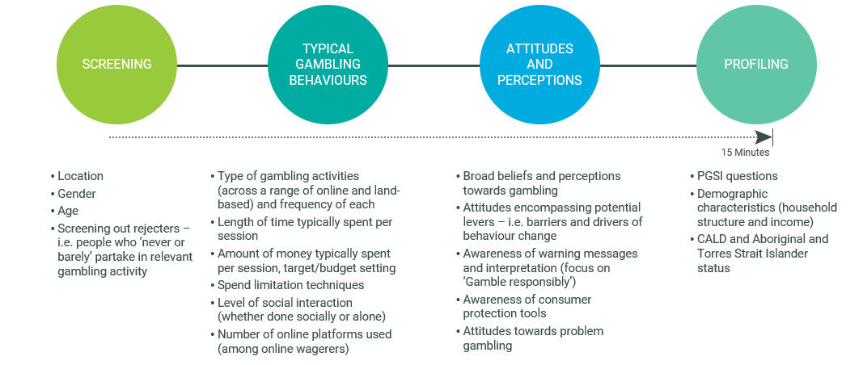
While the content in this survey was not of very sensitive nature, we were mindful that questions about their own gambling behaviour may create an element of social desirability bias among respondents – although this was minimised by virtue of the survey being self-administered online (i.e. respondents were less likely to respond in a socially desirable manner in self-administered than interviewer-administered surveys). We adopted the following techniques in our lines of questioning to minimise this bias as much as possible:
- Set a wider context during the screener by including other kinds of activities before narrowing down on gambling activity in the other sections
- Reassurance throughout the survey that responses will not be personally attributable and will be analysed in combination with thousands of other cases
- Provided ‘prefer not to answer’ and ‘don’t know’ options in behavioural questions
- Asked PGSI-relevant questions towards the back end of the survey
Activation Phase: Development of tagline messages
Following the first phase of research, insights were synthesised and used to develop seven messaging territories (a messaging territory is a paragraph which has been developed for testing, adhering to a certain set of principles which developed out of the research).
To ensure the highest level of quality in transforming the message territories into useful messaging, Hall & Partners engaged a Creative Director at the advertising agency Clemenger BBDO to develop up to six taglines for each territory (a tagline is a concise one-sentence “slogan” which is born from the messaging territory itself).
The message territories and taglines were tested in the second phase of qualitative research, with the top ten taglines overall selected to be validated quantitatively.

Phase II: Testing messaging territories and taglines & identifying the recommended taglines

Phase II: Qualitative exploration
Principles underpinning the qualitative research design
For the second phase of research, taglines and territories were tested with similar audiences to those selected for Phase I. As indicated in the table below, among the primary audience (males aged 18-35) five face-to-face focus groups were conducted with those who ranked low-moderate risk in the PGSI, two online groups with those categorised as high-risk, and in-depth interviews with three participants of First Nations background and two participants of CALD background (with varying risk levels represented).
Additionally, there were two other focus groups conducted face to face, one consisting of land-based gamblers aged 18-50 of a low-moderate risk, and one with friends and family of people at risk of gambling harm from online wagering. In addition, an online focus group was conducted with female participants aged 18-35 of low-moderate-risk profile.
Audiences for Phase II: 7 focus groups, 3 online focus groups, 5 in-depth interviews
Risk Level (PGSI) | Format | Demographic | Location | Number
Low/moderate risk  (male 18-35) | Face to face focus group | Males 18-35 | 2 x Sydney/Melbourne  2 x regional (NSW/TAS)  1 x Adelaide | 5
High risk | Online focus group | Males 18-35 | All over Australia, mix of metro and regional | 2
Mix of risk levels, at least one high risk | In-depth interview | 18-35 year old males  First Nations | 1 x regional (QLD)  1 x Sydney  1 x Brisbane | 3
Mix of risk levels, at least one high risk | In-depth interview | 18-35 year old males  CALD | 1 x Sydney/Melbourne  1 x Hobart | 2
Low/moderate risk  (land-based gamblers) | Face to face focus group | Females 18-50 | 1 x Hobart | 1
Low/moderate risk  (not male 18-35) | Online focus group | Females 18-35 | All over Australia, mix of metro and regional | 1
Friends and family members of people at risk of gambling harm from online wagering | Face to face focus group | Males and females 18-50 | 1 x Adelaide | 1
TOTAL |  |  |  | 15
For the primary audience (males aged 18-35 of a low-moderate-risk profile), discussions focused less directly on problem gambling behaviour, thus lessening the need for an affinity methodology. Accordingly, traditional focus groups – in a neutral setting with participants who were strangers to one another – were selected to gain insight into the most effective messaging. This allowed us to broaden our qualitative sample for this phase. Those who were high-risk participated in focus groups online to preserve participant feelings of anonymity and the ability of participants to effectively protect themselves from vulnerabilities, thus reducing the likelihood of shame and stigma for this vulnerable audience.
First Nations and CALD sample was again included, with three in-depth interviews with First Nations and two with people of CALD background conducted. This provided an important opportunity to ensure that mainstream communications were taking specific cultural sensitivities into account, and that language used was clear for audiences with linguistic challenges.
For secondary audiences, we proceeded with the three segments identified in the first phase of the research, using the same modalities as outlined in Phase I as a “sense-check” to understand whether messaging might be effective for non-gamblers or land-based gamblers.
The locations chosen ensured a geographic spread, with research conducted in Tasmania and South Australia during this phase of research, which allowed for a broad range of geographic locations across the study.
Recruitment and incentives
Similar to Phase 1, recruitment for the focus groups, in-depth interviews, and online focus groups was completed through external recruitment providers with a proven record of recruiting on short timeframes. These included McGregor Tan Research, Myriad Research, and Cooper Symons. Participants were incentivised for their time.

Phase II: Informing a final decision on taglines through quantitative validation
We conducted a second quantitative survey to determine the effectiveness of the top taglines as identified in the qualitative research; in order to inform the recommendation of a tagline(s) to replace the current ‘gamble responsibly’ tagline. Through this component we have been able to:
- Provide statistically robust findings on the priority ranking of messages
- Clarify preference and performance of the leading taglines, particularly if there was any division or mixed preference coming out of the qualitative discussions
- Provide digestible output on message layout (i.e. usage of font size, colour, placement etc) by way of ‘heatmapping’ to provide initial guidance on presentation
Audience & Approach
Speaking to the same audience in the Phase I quantitative validation, we conducted a 10 minute online survey with n=1,500 Australians who gamble at least occasionally (margin of error +/- 2.53% at 95% confidence level).
Survey design
The survey length of 10 minutes struck the balance between enough survey real estate to adequately validate the leading taglines and maintain respondent engagement.
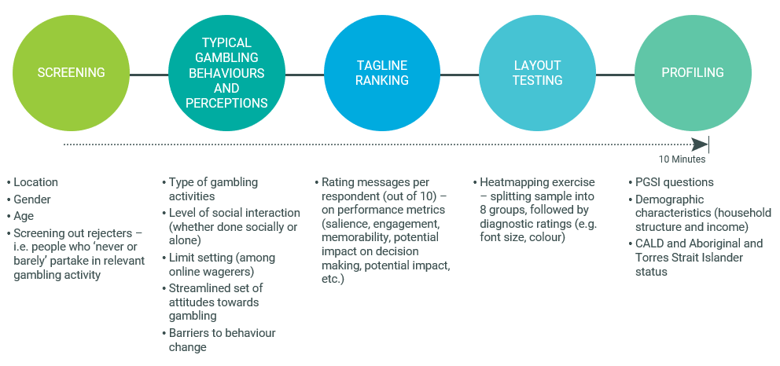
The tagline ranking focused on metrics to measure the leading taglines against the key objectives: increasing awareness of gambling harm, encouraging positive behaviour change (through conscious decision making), and promoting the use of consumer protection tools without stigma. Other tagline research evaluated based on measures such as importance/appeal, however, as this research sought to understand the tagline’s impact on behaviour, it was our view that effectiveness rather than importance should be assessed.
Layout and message presentation testing
To provide quantitative measurement with respect to messaging layout and presentation, we used a heatmapping exercise within the survey. The various presentations shown to respondents were determined and crafted in consultation with the DSS and informed by the qualitative phase. We then split the n=1,500 sample into four equal groups of similar respondents (c. 300-375 per group), where each group focussed on testing one layout (i.e. monadic testing) – each group was split in half with one half testing a version of the layout with the tagline ‘gamble responsibly’ and the other half testing the same layout but with the tagline ‘Set a deposit limit’. Respondents were presented with the layout and asked to, as quickly as possible, click the areas that stood out to them the most, focusing less on the messaging and more on the visual features. The output was a visually digestible heatmap, allowing us to compare the different areas of attention across the tested layouts.

Research insights
The Department of Social Services (DSS) commissioned Hall & Partners to conduct qualitative and quantitative research into beliefs, behaviours and attitudes among regular online wagerers of a range of risk profiles, in order to develop new messaging aimed at reducing gambling harm.

Findings of the literature review
This literature review, shared in Appendix 1, identified several key findings with important implications for the upcoming research. These findings were incorporated into the design of the research protocols and were used throughout the program to inform the development of new messaging territories and taglines for testing with consumers.
In summary, the major findings included:
- Messages aimed at reducing gambling harm were often most effective when targeted to individuals of different demographic groups, risk profiles, or behavioural profiles.
- As a result of this, the development of a number of taglines may be necessary in order to best target different groups, as different messages, tones and techniques will likely resonate with different groups.
- Messaging which appeals to personal responsibility and leaves the feeling of control with the individual has been traditionally used to target gamblers, but limited success has been seen in this area – and this is borne out by the evidence that the current ‘gamble responsibly’ tagline has been unsuccessful.
- Further research is needed in some areas, particularly in understanding the impact of positive or encouraging messaging, and in understanding the effectiveness of shock tactics or warning messaging in gambling behaviour specifically.
- Another area with limited research is in understanding the best positioning, text type, colour, size, repetition and other visual elements that work to intercept at-risk consumers with messages at the time of decision-making. While this is a small focus of the research scope for the Hall & Partners project, it is also a rigorous one, so academic modelling is needed.

Phase I Qualitative and Quantitative Insights: exploring attitudes and behaviours
Terminology
It was essential to consider terminology in informing public policy messaging and social marketing; indeed, getting the terminology of the message right can mean the difference between influencing behaviour change on a population level and seeing little efficacy.
The current ‘gamble responsibly’ tagline was found to be ineffective; further research would be needed to determine the extent to which the use of the words ‘gamble’ and ‘responsibly’ themselves influence this (as opposed to issues within the overall message, such as a lack of specificity or a focus on individual control in the face of systemic factors), however, preliminary qualitative discussions in this research suggested that the inclusion of the word ‘gamble’ may be a contributing factor to the lack of efficacy in this message.
An important finding of the qualitative research was that the word ‘gambling’ led to self-exclusion from the message for participants at all risk levels. The term was seen to refer to those with a problem and some participants in the research expressed discomfort with the word to describe their own behaviour, leading to a protective belief that this term did not apply to them. This suggested there would be a broader self-exclusion from any messaging which uses the term ‘gambling’ or ‘gamble’.
In addition, the word ‘gambling’ proved more likely to be associated with land-based gambling than online wagering, which further led to self-exclusionary beliefs among those participants for whom online wagering was their main gambling behaviour.
“I find that ‘gambling’ sounds negative”
“Yeah, it sounds like a problem even if it's a small bet”
“A cheeky bet”
“Go around to the pub for a punt, no problem with that”
“But if you're going down to the pub for a gamble …”
“Oh Jesus … probably have to talk about that”
(Low/moderate risk male, 18-35, Perth)
Instead, participants preferred terms such as ‘betting,’ ‘tipping,’ or ‘taking a punt,’ which were seen to have less ‘serious’ negative connotations than the term ‘gambling’ and thus differentiated their own behaviour from that of consumers with a perceived ‘problem’. These terms were also felt to apply to online wagering, as ‘sports betting’ was a particular focus of online wagering behaviours among the participants of the study. In addition, other terms were used which further distanced the participant from the potential negative consequences of the behaviour, such as ‘a cheeky bet’, or ‘having a flutter’, which incorporated a casual, ‘fun’ element to participation. This played into beliefs that the participants had control over the behaviour.
This was true across all risk levels, with high-risk consumers also stating a discomfort with the term ‘gambling’ to describe their own behaviour. When pressed, participants were aware that they were distancing themselves from the behaviour denoted by the term ‘gambling’ by using less technical language, but they did not see this as a problem, and this reflection was rarely spontaneous.
“I’m pretty casual though about it, I don’t bet regularly like every week or something like that so ... Would you call that gambling if someone did it like a few games a week?” (Low-med risk males, 18-35, Perth)
These insights on the influence of terminology have important implications for messaging: messaging aimed at online wagering in particular should avoid using the term ‘gambling’ or ‘gamble,’ in order to ensure viewers do not self-exclude from the message as they perceive it to be aimed at ‘problem’ gamblers.

A summary of typical gambling behaviours among consumers
The quantitative validation survey provided a picture of how occasional to regular consumers across Australia typically spend their time and resources on gambling activities.
In summary, profiling Australian consumers has shown how the typical online wagerer (a skew to younger males with higher incomes and dependent children) closely matched the skews seen for problem gamblers. This validated how online wagering has presented a new challenge for problem gambling in the last few years particularly as uptake of betting app products has grown. While online wagering is not the most common form of gambling in Australia, accessibility of this form of gambling (i.e. via a phone app, likely sending wagerers daily notifications) made it more of a ‘daily task’ than other forms of gambling where access required a bit more effort. And while incidence was lower than lottery, scratch tickets and the pokies, and average time and spend levels were relatively modest compared to the likes of casino gambling, this higher frequency and minimal effort put online wagerers at arguably higher levels of risk than other forms of gambling. Detailed quantitative findings are outlined below:

Comparing online wagering to other forms of gambling activity
In the quantitative surveying (both in Phases 1 and 2), EGM was referred to as ‘pokies’ to aid comprehension and familiarity among everyday Australian consumers.
Figure 1 shows that among Australians who claimed to take part in some kind of gambling activity on occasion, the most common form of gambling was the lottery at just under three quarters (72%), followed by scratch tickets at just under half (49%). Under a third (28%) claimed to place bets online or on an app.
Figure 1 - Incidence of different forms of gambling activity among occasional to regular gamblers
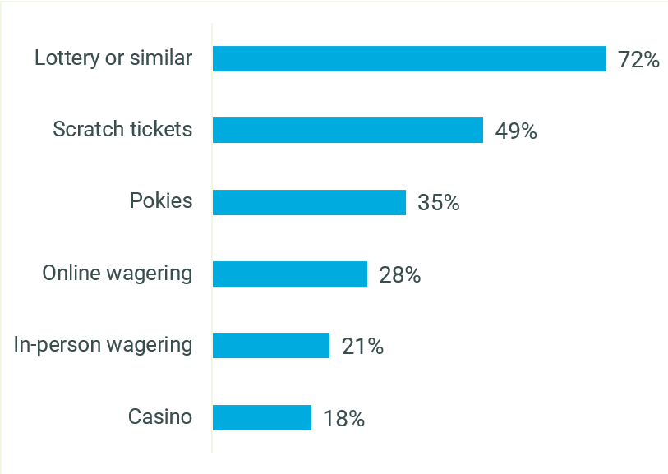
S5. Which of the following leisure activities do you take part in from time to time?
VALIDATION SURVEY: Occasional to regular gamblers n=2,500
Similar to casino players and in-person wagerers, online wagering skewed to males aged 18-49, full time workers, personal incomes of over $55,000, those in a couple with dependent children, those with a undergraduate or post-graduate degree and those in metro areas – as shown by Figure 2, Figure 3, Figure 4, Figure 5, Figure 6 and Figure 7. Other demographic details of online wagerers such as state, CALD and First Nations backgrounds were consistent with other gambling activity.
Figure 2 - Distribution of age and gender across gambling activity
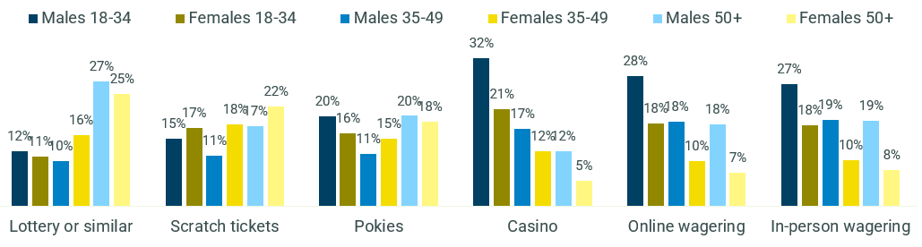
S1. What is your age? S2. Are you… S5. Which of the following leisure activities do you take part in from time to time?
VALIDATION SURVEY: Occasional to regular gamblers, Lottery players n=1,807, Scratch ticket players n=1,234, Pokies players n=876, Online wagerers n=698, In-person wagering n=534, Casino gamblers n=445
Figure 3 - Distribution of regionality across gambling activity
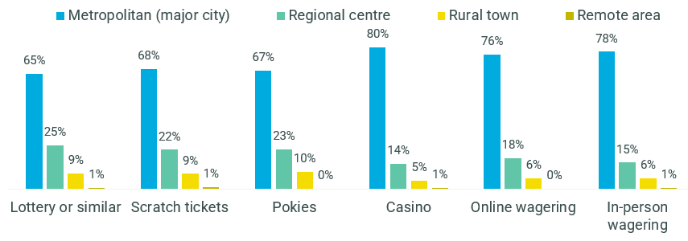
S4. Please enter your 4-digit postcode in the boxes provided. S5. Which of the following leisure activities do you take part in from time to time?
VALIDATION SURVEY: Occasional to regular gamblers, Lottery players n=1,807, Scratch ticket players n=1,234, Pokies players n=876, Online wagerers n=698, In-person wagering n=534, Casino gamblers n=445
Figure 4 - Distribution of employment status across gambling activity
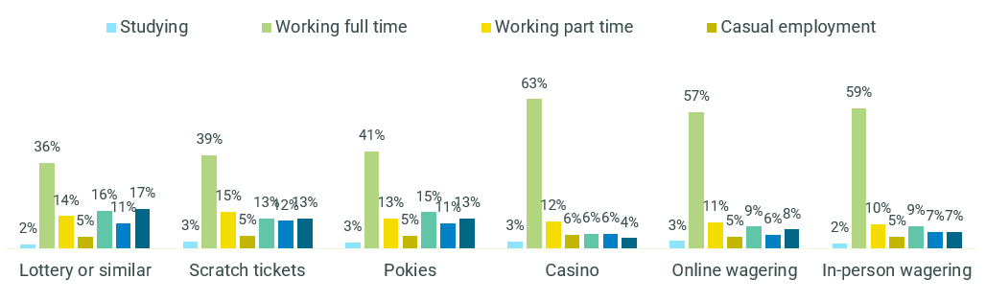
D3. Which of the following best describes your current situation – are you...? S5. Which of the following leisure activities do you take part in from time to time?
VALIDATION SURVEY: Occasional to regular gamblers, Lottery players n=1,807, Scratch ticket players n=1,234, Pokies players n=876, Online wagerers n=698, In-person wagering n=534, Casino gamblers n=445
Figure 5 - Distribution of annual personal income ($) across gambling activity
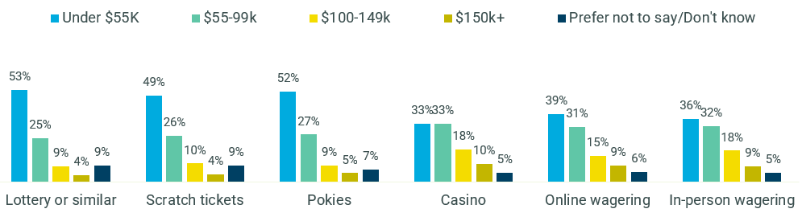
D4. What is your personal income before tax? S5. Which of the following leisure activities do you take part in from time to time?
VALIDATION SURVEY: Occasional to regular gamblers, Lottery players n=1,807, Scratch ticket players n=1,234, Pokies players n=876, Online wagerers n=698, In-person wagering n=534, Casino gamblers n=445
Figure 6 - Distribution of education level across gambling activity
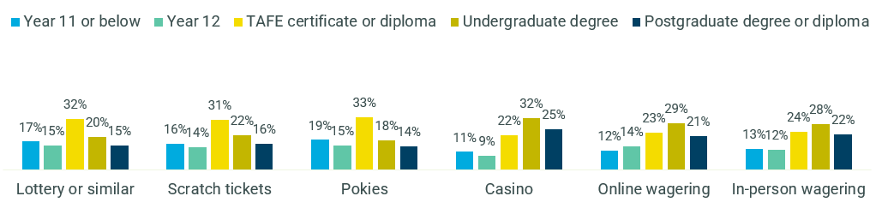
D7. Which of the following statements best describes the highest level of education that you have completed? S5. Which of the following leisure activities do you take part in from time to time?
VALIDATION SURVEY: Occasional to regular gamblers, Lottery players n=1,807, Scratch ticket players n=1,234, Pokies players n=876, Online wagerers n=698, In-person wagering n=534, Casino gamblers n=445
Figure 7 - Distribution of household structure across gambling activity
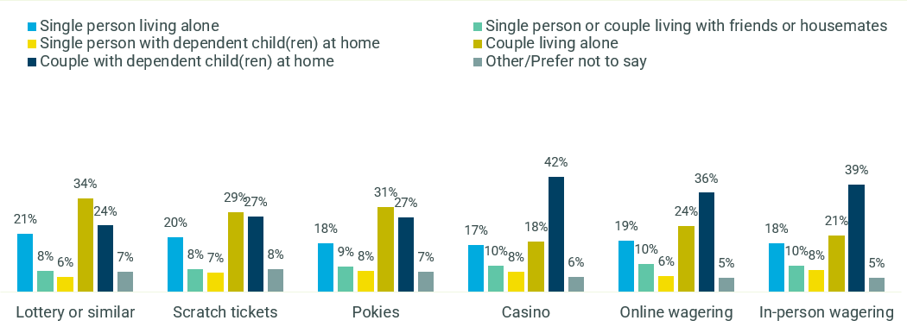
D6. Which of the following best describes your household? S5. Which of the following leisure activities do you take part in from time to time?
VALIDATION SURVEY: Occasional to regular gamblers, Lottery players n=1,807, Scratch ticket players n=1,234, Pokies players n=876, Online wagerers n=698, In-person wagering n=534, Casino gamblers n=445

Figure 8 shows that relative to most other forms of gambling, online wagering appeared to be played on a higher frequency with 11% of online wagerers claiming to play at least daily. The higher incidence activities such as lottery, scratch tickets and the pokies were being played on a less frequent basis mainly being weekly or less, while frequency of in-person wagering was similar to online wagering.

Figure 8 - Frequency of gambling activities
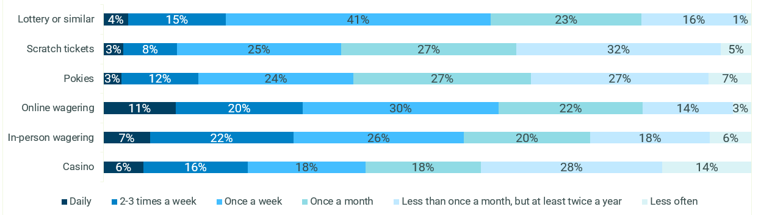
S6. And how often do you take part in each of these activities?
VALIDATION SURVEY: Occasional to regular gamblers, Lottery players n=1,807, Scratch ticket players n=1,234, Pokies players n=876, Online wagerers n=698, In-person wagering n=534, Casino gamblers n=445
The longest time per session claimed was for the ‘venue’ activities, with casino and pokies players claiming to spend over an hour per session on average, as seen in
Figure 9. Online and in-person wagering was relatively moderate ranging from around 40-45 minutes per session. Playing the lottery and scratch tickets typically involved considerably less time at just over 11 minutes per session, as expected given the ‘instant’ nature of these activities.

Figure 9 - Average time spent per session (min)
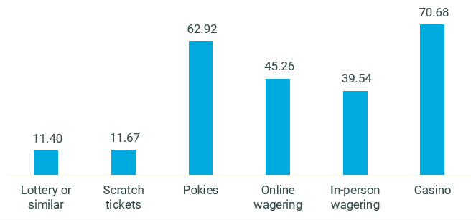
B1. How much time do you typically spend playing these activities in each session?
VALIDATION SURVEY: Occasional to regular gamblers, Lottery players n=1,807, Scratch ticket players n=1,234, Pokies players n=876, Online wagerers n=698, In-person wagering n=534, Casino gamblers n=445
Figure 10 shows that online and in-person wagerers and pokies players tended to spend similar amounts per session, averaging at around $73 to $80 per session. Casino players tended to spend the most at an average of around $132 per session, while lottery and scratch ticket players tended to spend much less at around $28 to $31 per session.
Figure 10 - Average amount ($) spent per session
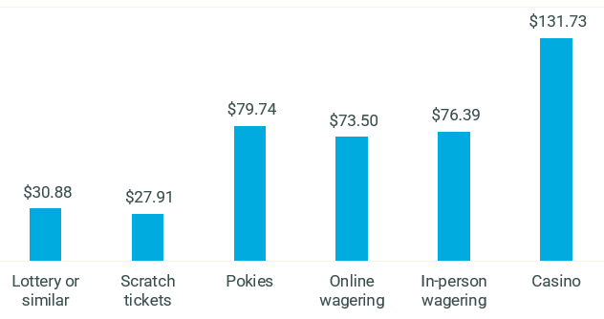
B3. And how much money do you typically spend playing these activities in each session?
VALIDATION SURVEY: Occasional to regular gamblers, Lottery players n=1,807, Scratch ticket players n=1,234, Pokies players n=876, Online wagerers n=698, In-person wagering n=534, Casino gamblers n=445

In line with the typical profile of online wagerers, frequency of playing, time and money spent per session was typically higher among males when compared to female online wagerers – as shown by Figure 11, Figure 12 and Figure 13. Over two thirds of males (68%) claimed to place online wagers at least weekly, while average time was over 20% higher and spend levels nearly 40% higher than their female online wagering counterparts.
Figure 11 - Frequency of gambling activity – online wagering by gender
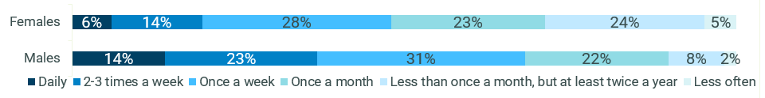
S6. And how often do you take part in each of these activities?
VALIDATION SURVEY: Online wagerers, Males n=453, Females n=244
Figure 12 - Average time spent per session (min) - online wagering by gender
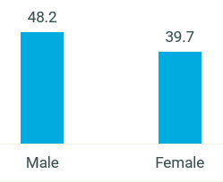
B1. How much time do you typically spend playing these activities in each session?
VALIDATION SURVEY: Online wagerers, Males n=453, Females n=244
Figure 13 - Average amount ($) spent per session – online wagering by gender
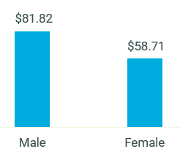
B3. And how much money do you typically spend playing these activities in each session?
VALIDATION SURVEY: Online wagerers, Males n=453, Females n=244
Figure 14 shows that for the most part, online and in-person wagerers, casino and pokies players claimed to place a firm budget on their activities, however there was a stronger tendency to claim looser targets when compared to lottery and scratch ticket players.
Figure 14 - Budget setting status by gambling activity
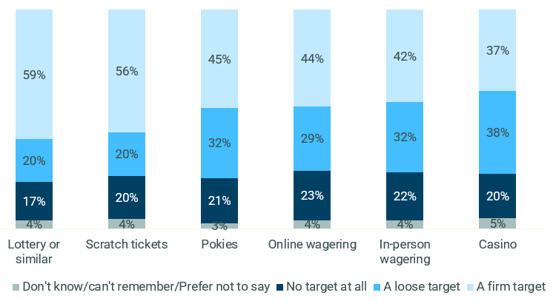
B4. For each session, would you say that you usually set yourself a firm target for the amount that you will spend on these activities, a loose target, or no target at all?
VALIDATION SURVEY: Occasional to regular gamblers, Lottery players n=1,807, Scratch ticket players n=1,234, Pokies players n=876, Online wagerers n=698, In-person wagering n=534, Casino gamblers n=445
In general, consumers were most likely to set specific dollar limits, only play with a clear mind and used only physical cash to hand, as seen in
Figure 15. However, there was a fair amount of variance across gambling activity. Lottery and scratch ticket players were more likely than others to set a specific dollar limit, while setting a time limit, withdrawing during a session, using separate accounts and credits and only playing at a certain time of day tended to skew to online and in-person wagerers and casino players.

Figure 15 - Spend limitation techniques by gambling activity
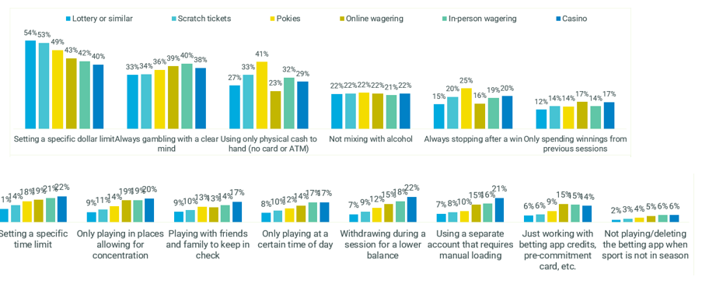

B5. Which of the following approaches do you usually take to limiting how much you spend on gambling activities?
VALIDATION SURVEY: Occasional to regular gamblers, Lottery players n=1,807, Scratch ticket players n=1,234, Pokies players n=876, Online wagerers n=698, In-person wagering n=534, Casino gamblers n=445

Figure 16 shows that EGM and casino players were most likely to play socially compared to other types of gambling. Online wagering for the most part appeared to be a solo activity with over two thirds (68%) of online wagerers claiming to play by themselves.
Figure 16 - Social interaction while playing by gambling activity
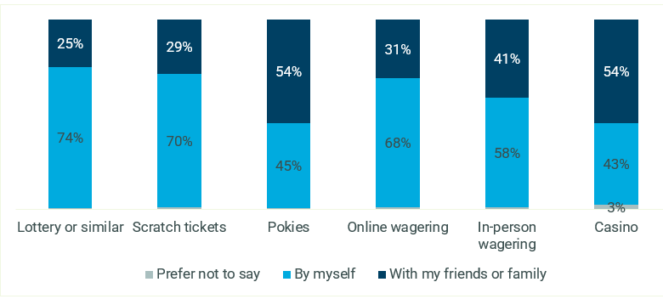
B6. And do you typically take part in these activities by yourself, or socially with friends or family? *Labels not shown for figures under 2%
VALIDATION SURVEY: Occasional to regular gamblers, Lottery players n=1,807, Scratch ticket players n=1,234, Pokies players n=876, Online wagerers n=698, In-person wagering n=534, Casino gamblers n=445
While online wagering was for the most part revealed to be a solo activity, there were sub-sets of online wagers who skewed more towards doing this as a social activity with friends or family, namely younger people (18-34s) and females as seen in Figure 17.
Figure 17 - Distribution of social interaction during online wagering across age and gender
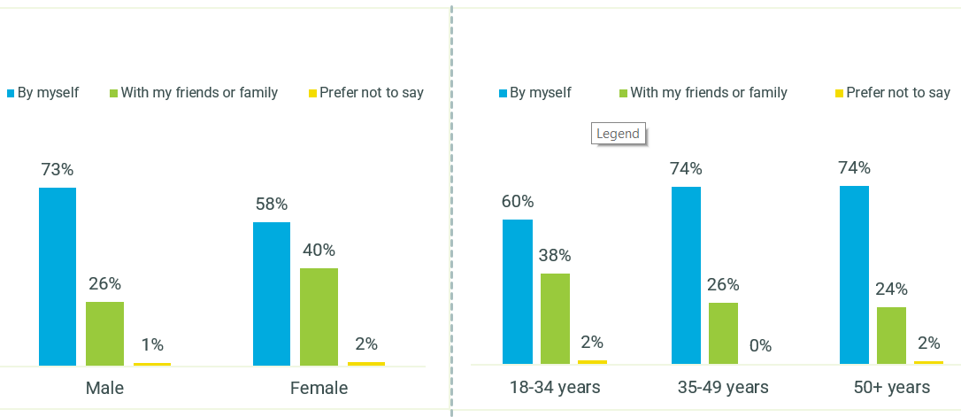
S1. What is your age? S2. Are you… B6. And do you typically take part in these activities by yourself, or socially with friends or family?
VALIDATION SURVEY: Online wagerers; 18-34 years n=316, 35-49 years n=198, 50+ year n=184, Males n=184, Females n=244
Most online wagerers tended to stick to one platform. However multiple app usage skewed to males and young age groups as seen in Figure 18.
Figure 18 - Distribution of multiple app usage across age and gender – online wagerers
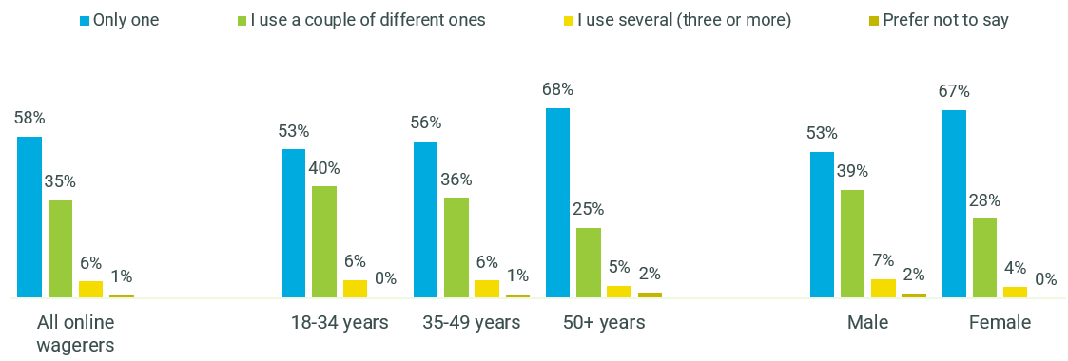
S1. What is your age? S2. Are you… B7. How many different online betting platforms, websites or apps do you use to place a bet?
VALIDATION SURVEY: Online wagerers; Total n=698, 18-34 years n=316, 35-49 years n=198, 50+ year n=184, Males n=184, Females n=244
Figure 19 shows that while most consumers claimed that their level of gambling activity had remained unchanged in the past year, online and in-person wagerers and casino players were more likely than other types of gamblers to claim they had been playing more often in the past year.
Figure 19 - Change in gambling activity over the past year
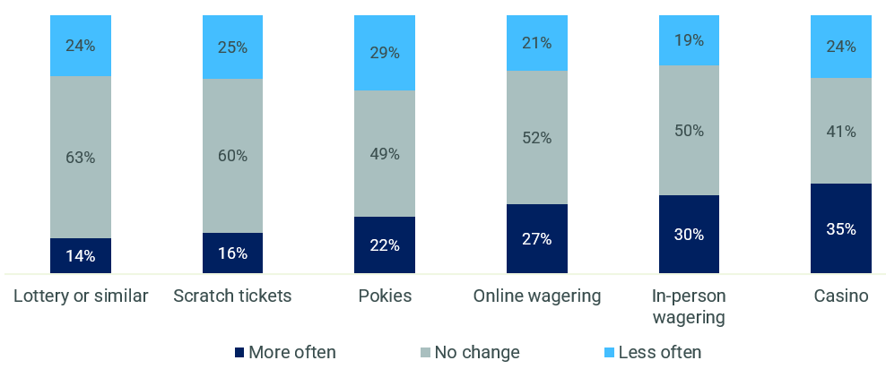
B2. Overall, would you say that how often you typically gamble or place a bet has changed in the past year?
Occasional to regular gamblers, Lottery players n=1,807, Scratch ticket players n=1,234, Pokies players n=876, Online wagerers n=698, In-person wagering n=534, Casino gamblers n=445

Typical behaviour and profiling across the different risk levels
Consistent with the components of this research programme, level of gambling risk in the validation survey was determined using the Problem Gambling Severity Index (PGSI). This was a key component in our analysis of typical gambling behaviours to help understand potential reception and impact of a new tagline.
Figure 20 shows that while the incidence of lottery and scratch ticket activity was high across the board, moderate risk and problem gambling tended to skew to pokies and casino players and those who bet either online or in person.
Figure 20 - Distribution of risk level across gambling activity
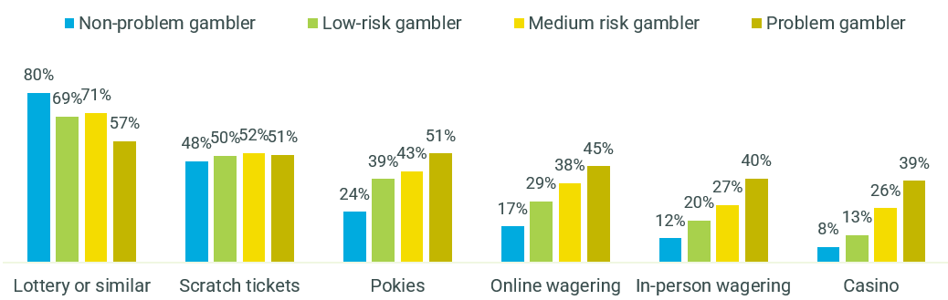
S5. Which of the following leisure activities do you take part in from time to time?
VALIDATION SURVEY: Non-problem gamblers n=1,200, Low-risk gamblers n=371, Moderate-risk gamblers n=398, Problem gamblers n=531
Frequency and the amount of money and time spent per session increased with the level of risk. Figure 21, Figure 22 and Figure 23 show this specifically for online wagering, though for the most part this was a consistent trend across the other forms of gambling.
Figure 21 - Frequency of gambling activity – online wagerers by risk level
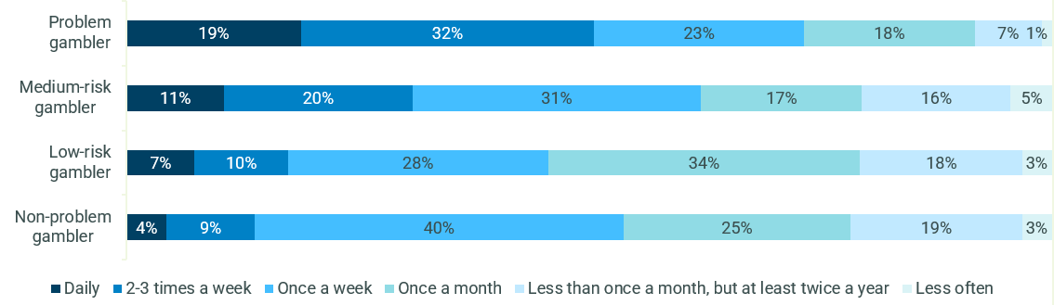
S6. And how often do you take part in each of these activities?
VALIDATION SURVEY: Online wagerers, Non-problem gamblers n=204, Low risk n=106, moderate risk n=148, Problem gamblers n=240
Figure 22 - Average time spent per session (min) – online wagerers by risk level
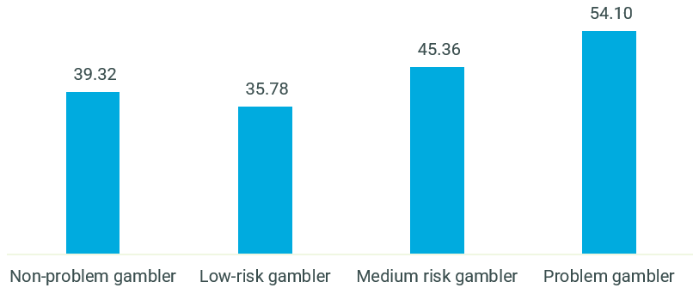
B1. How much time do you typically spend playing these activities in each session?
VALIDATION SURVEY: Online wagerers, Non-problem gamblers n=204, Low risk n=106, moderate risk n=148, Problem gamblers n=240
Figure 23 - Average amount ($) spent per session – online wagerers by risk level
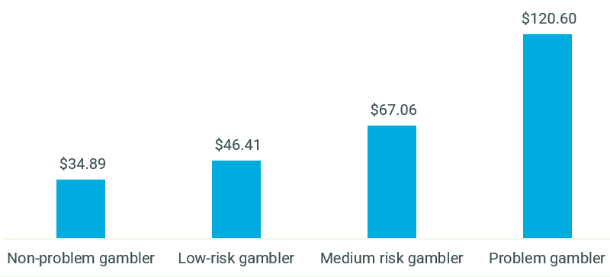
B3. And how much money do you typically spend playing these activities in each session?
VALIDATION SURVEY: Online wagerers, Non-problem gamblers n=204, Low risk n=106, moderate risk n=148, Problem gamblers n=240
From a profiling perspective, Figure 24 shows that problem gambling tended to skew to younger Australians (particularly males), with over half of problem gamblers (56%) aged between 18 and 34. Moderate and low risk gamblers were relatively more spread out across the age spectrum while non-problem gamblers skewed more towards older Australians.
Figure 24 - Distribution of age and gender across PGSI risk categories
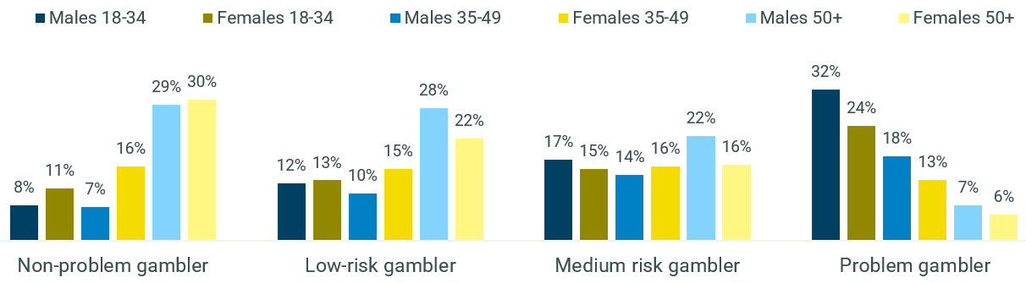
S1. What is your age? S2. Are you…
VALIDATION SURVEY: All gamblers, Non-problem gamblers n=1,200, Low risk n=371, moderate risk n=398, Problem gamblers n=531
Figure 25 shows that while the majority of problem gamblers earned under $100,000 per annum, there was a skew towards higher incomes relative to the other PGSI categories.
Figure 25 - Distribution of annual personal income ($) across PGSI risk categories
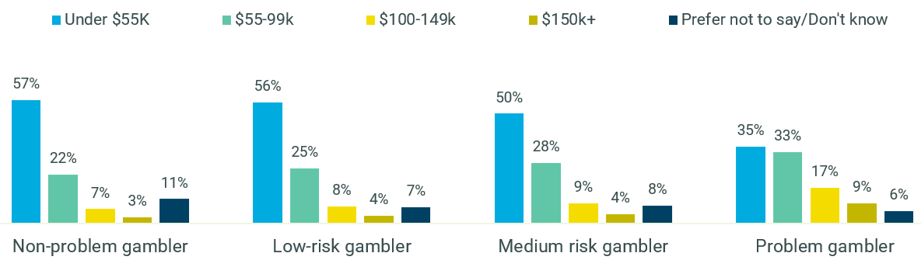
D4. What is your personal income before tax?
VALIDATION SURVEY: All gamblers, Non-problem gamblers n=1,200, Low risk n=371, moderate risk n=398, Problem gamblers n=531
Problem gamblers were also more likely to be in a couple with dependent children at home, while the other categories skewed more towards couples living by themselves, as seen in Figure 26.
Figure 26 - Distribution of household structure across PGSI risk categories
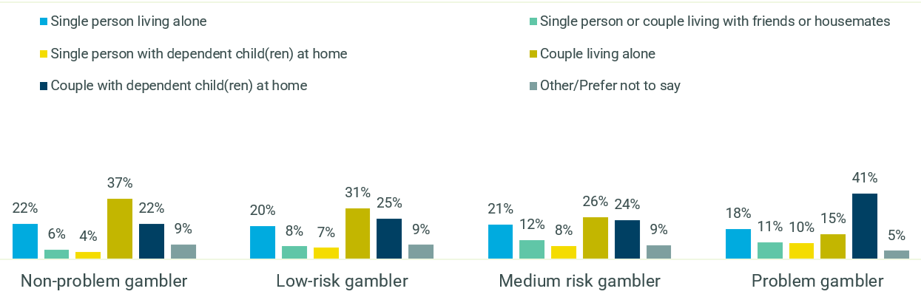
D6. Which of the following best describes your household?
VALIDATION SURVEY: All gamblers, Non-problem gamblers n=1,200, Low risk n=371, moderate risk n=398, Problem gamblers n=531

Messaging around gambling harm was seen to lack personal relevance for consumers, regardless of risk level
While the PGSI defines gambling behaviours along a continuum or scale from no-risk to high-risk (or from non-problem gambler to problem-gambler), participants appeared to see gambling behaviours as falling into two binary categories that could broadly be defined as ‘problem gamblers’ and ‘everyone else.’ There was a stated belief from consumers that they would never slide along the continuum into a higher-risk category, and that ‘problem-gamblers’ possessed some personality characteristics which differentiated them from non-problem gamblers.
This led to self-exclusion from messaging around gambling harm. It was felt that such messages were directed at people with a serious problem, rather than ‘ordinary’ consumers – a category to which all participants believed they belonged, regarded of risk level. As a result, consumers of all risk levels stated that they ignored messaging around gambling harm, as it lacked perceived personal relevance.
This stated self-exclusion to messaging represented a disconnect from the findings of research conducted by Central Queensland University which had found that when evaluating the behaviour of regular consumers they often tipped from one risk category into another, often in a short space of time. Thus, consumer perception and behaviour did not align. Of particular note was the fact that this belief proved true across all risk levels, with high-risk participants also feeling that they should not have been included among problem-gamblers.
“I don’t feel like I’m chasing my losses and where for me it’s purely entertainment. My mate with a problem definitely had a bit more of an addictive personality. He’s definitely trying to chase those losses as well.” (Low/moderate risk male, 18-35, Sydney)
As a result, it was likely that consumers would ignore any messaging which implied that behaviours they deemed under control at this stage may become more harmful over time. Participants spoke freely of hypothetical ‘problem-gamblers’, clear in their belief that this group did not include themselves, with stated problem behaviours seen as those with extreme negative consequences such as the breakdown of a marriage, theft from loved ones, or the loss of one’s house.
Other examples given included people who lacked self-control, such as someone who played all the time, was dependent on the thrill of playing, or someone who made poor decisions such as betting on poor odds. This tied into beliefs from participants that their own habits were securely under their control.
“You’ve got a problem if you’re using money that should be going to things like your rent or food, the basics. It’s hectic how bad it gets for people. It’s like they just can’t help themselves… it’s definitely an addiction at that point.” (Low/moderate risk female, 18-35)
In addition, problem-gambling behaviours were often especially associated with land-based gambling (in particular EGMs), which further fed a lack of personal relevance for consumers who felt that online wagering was a less dangerous behaviour, or one less likely to result in gambling harm. This contributed to ideas of control and strategy which were found to be pervasive in online wagerers (as outlined later in this section).
It was not believed that less severe negative consequences of gambling, such as arguing with loved ones, hiding one’s gambling behaviour from family and friends, or compulsive behaviours such as betting late into the night, might also be indicators of gambling harm. In particular, negative emotions associated with gambling (guilt, shame, anxiety, loss of self-esteem) were not seen as being indicators of gambling harm, as discussions of harm focused on the financial consequences of problem gambling behaviours. Figure 27 shows that when asked how gambling behaviour becomes ‘problem gambling’, the majority of consumers were unable to articulate what they believed to be the tipping point. Following this, most consumers tended to mention more behavioural aspects of problem gambling such as spending beyond means, chasing losses, addiction and being unable to stop, while negative consequences such as impact on family and mental health were mentioned by less than 5% of respondents.
Figure 27 - Perceptions of the problem gambling ‘tipping point’ (all gamblers)
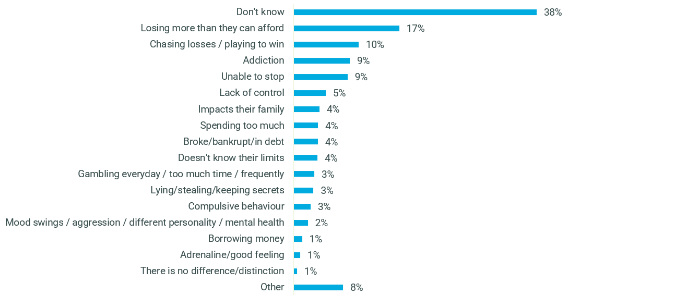
C8. Firstly, how do you think gambling behaviour becomes 'problem gambling'? How do you think someone with a gambling problem is different from someone who gambles but doesn't have a problem?
VALIDATION SURVEY: occasional to regular gamblers n=2,500
There was a sense that perhaps these negative emotions are only really experienced by those at the high-risk end of the spectrum. Figure 28 and Figure 29 show that unlike problem gamblers, moderate and low risk gamblers were more likely to claim that they do not often feel guilty, stressed or anxious about the way they gamble.
Figure 28 - Problem Gambling Severity Index (PGSI) - I have felt guilty about the way I gamble or what happens when I gamble
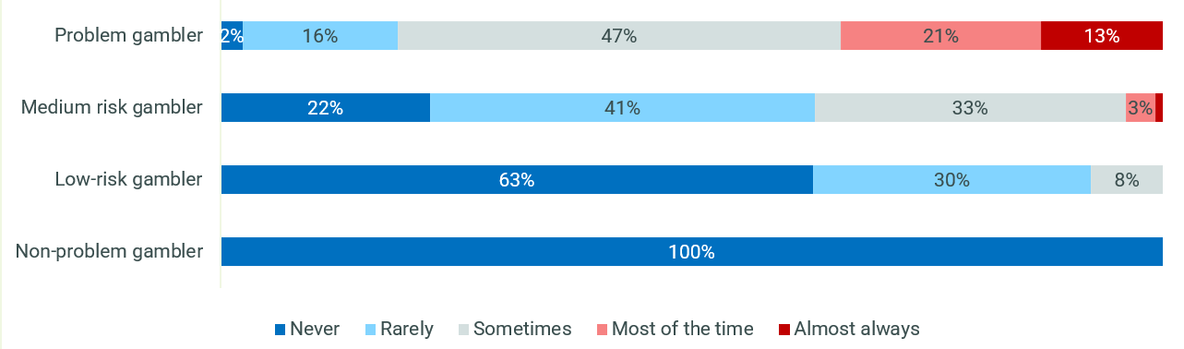

Figure 29 - Problem Gambling Severity Index (PGSI) - I have felt stressed or anxious about the way I gamble or what happens when I gamble
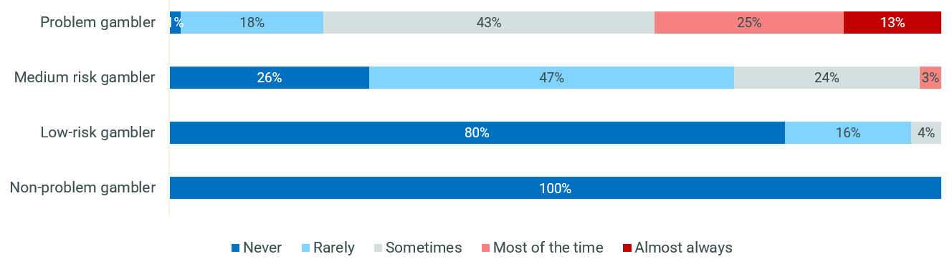
D1. Just thinking about the last 12 months, please indicate for each item on the list below how often you have been in these situations.
VALIDATION SURVEY: All gamblers, Non-problem gamblers n=1,200, Low risk n=371, moderate risk n=398, Problem gamblers n=531
This focus on external indicators of gambling harm also sometimes included a broader belief that gambling harm was a problem for government as problem-gamblers might be a “drain” on society as they required government support. It was rarely categorised as an addiction and indeed, the ‘disease model’ approach (which is often referred to by laypeople when discussing addictive substances) did not feature here. There was a pervasive belief that gambling should be an easy behaviour to control because technically the brain was not affected by an addictive substance. This was validated by the fact that around two thirds of consumers (63%) believed that problem gamblers should take responsibility for their own actions, as seen in Figure 30. The onus was believed to be less on help from family and friends with only around a third (38%) in agreement, while just over half (51%) believed that intervention from the Government is needed. This inflamed perceptions that those who did suffer gambling harm might be ‘weak’ or somehow lacking in character or personality traits, rather than building feelings of empathy for someone living with an addiction.

Figure 30 - Attitudes towards problem gambling (all gamblers)
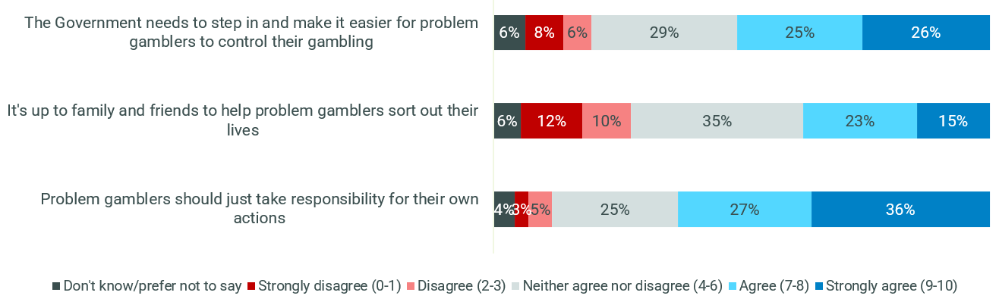
C9. In the list below are a number of things that people have said about problem gambling, and we’d like to know how much you agree or disagree with each statement. Please indicate on a scale from 0 to 10, where 0 means you disagree completely and 10 means you agree completely.
VALIDATION SURVEY: occasional to regular gamblers n=2,500
The belief that problem gamblers needed external help, for example from the government, appeared to be mainly driven by problem gamblers themselves while other risk groups were relatively distanced from the issue. Figure 31 shows that problem gamblers were most likely to believe that the government needs to step in and help. Low- and moderate-risk gamblers were more on the fence while non-problem gamblers were the most likely of the categories to disagree with the need for government support.
Figure 31 - Attitudes towards problem gambling by risk level - The Government needs to step in and make it easier for problem gamblers to control their gambling
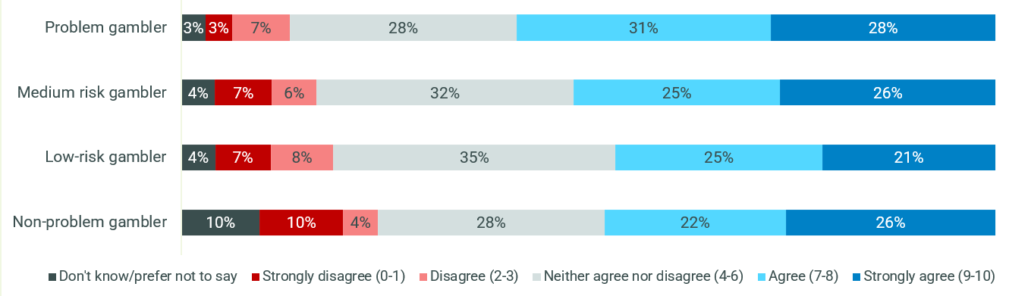
C9. In the list below are a number of things that people have said about problem gambling, and we’d like to know how much you agree or disagree with each statement. Please indicate on a scale from 0 to 10, where 0 means you disagree completely and 10 means you agree completely.
VALIDATION SURVEY: All gamblers, Non-problem gamblers n=1,200, Low risk n=371, moderate risk n=398, Problem gamblers n=531
However, when participants spoke of friends who they believed had “tipped” into the category of problem-gamblers (rather than participants who spoke about hypothetical problem-gamblers), their empathy was keenly developed, and many spoke of attempts to help friends who had struggled with gambling behaviours. Some of these friends were not exhibiting the devastatingly negative behaviours of perceived problem gamblers: this revealed a disconnect between the hypothetical ‘problem-gambler’ and the friend who was seen to be at high-risk, but who had not lost their home or relationship over their gambling behaviour.
“My mate with a problem is always trying to recuperate his losses. When he was betting quite a bit, he would bet a couple of hundred or a thousand, he was getting addicted to the really big wins.” (Low/moderate risk male, 18-35, Sydney)
Some differences were observed among CALD participants, for whom references to religion and ideas of morality featured more highly than among mainstream groups. CALD participants conveyed a belief that if one lost in gambling, this might impact another area of their lives. Fears around the attitude and judgement of friends and family also featured highly for this audience. One CALD participant stated that gambling was a sin in his holy texts, and the fact that it was taboo did not stop him from engaging but played into feelings of shame which were driven by his ideas of morality. When asked how he would cope in a world where gambling vanished overnight, he stated that he would be relieved as he wouldn’t feel a compulsion to gamble anymore. This is in direct contrast to mainstream groups where the idea of gambling being suddenly unavailable was met with a stated belief that it would not matter: they would find another way to meet the need for excitement which gambling provided them.
“I feel guilty, not from a religious point of view, but more from a moral point of view. As a human being I don’t want to be associated with gambling. I don’t think it is good for your ethics and principles.” (CALD high risk male, 18-35, Regional VIC)
Closely tied with these ideas of morality, some CALD participants felt gambling should be illegal, again in contrast to the mainstream groups which universally felt people should be allowed to gamble and advocated for personal choice in the matter.
As might be expected, family and friends of people at risk of gambling harm were particularly clear-eyed about identifying cases of gambling harm in others, and noted that their loved ones at risk of gambling harm would not have identified as having a problem themselves, despite the concerns of family and friends. Unlike consumer participants they stated that negative emotional consequences played a role in their awareness that their friend or family member’s gambling habits had become problematic. For example, some friends and family members observed that their loved one had developed a more competitive nature as their gambling problem proceeded, alongside a bad losing mentality or a desperation for winning, a new tendency to react badly to being incorrect, or a need to prove themselves.
Another observed indicator that a friend or family member’s gambling was no longer under control was a compulsion to talk about gambling at all times, to the point where it impacted the social circle. In addition, family and friends noted that when their loved one was confronted about their behaviour, they shifted to hiding it rather than engaging with the concerns of their family and friends. This tied in with the beliefs of participants that they did not have a problem, regardless of risk profile: consumers were reticent to engage with their family and friends’ concerns as they believed they were unfounded.
“It comes up in every conversation now, it’s like he doesn’t think about anything else other than the odds. I don’t even think he knows he’s doing it… talking about it constantly. It’s pretty boring for the rest of us, but also sad to see it get to this.” (Friends and family, Perth)
This has important implications for messaging and poses a particular challenge for the uptake of available tools to mitigate gambling harm. As participants did not see themselves as having a problem, regardless of risk level, they had a stated reluctance to engage in discussions or with tools and resources. Identifying that one has a problem was believed to be the first requirement before engaging in discussions or harm reduction tools would have genuine impact.
The reluctance of gamblers of all risk levels to self-identify as having a problem was unsurprising and was likely influenced by feelings of shame and stigma. Among high-risk gamblers in particular, there were signs of shame in their behaviours, even if they did not self-identify the driving emotion as shame. For example, there was an often-stated tendency to hide gambling behaviours from friends and family, with the reason given that family and friends did not ‘understand’ the behaviour, or would assume that the participant had a problem if they knew the extent of their behaviours - conclusions which were seen as inaccurate. This mirrored the unspoken assumption that to be seen to have a problem would be bring about great stigma.
“I normally try to find time by myself because you want to concentrate on what you’re putting on and what you’re doing and don’t want to be judged for the bets you are putting on. Like I find that I’ll put a bet on away from my partner because she doesn’t have the same view I do of having fun. I’ll understand the intangible of what I do and [she’ll] just see the stake that I’ve put down.” (High risk male, 18-35)
For low and moderate-risk gamblers, their strong belief in the aforementioned ‘binary’ categorisation of ‘problem gamblers’ and ‘everyone else’ meant that they put problem gambling behaviours in a completely different category to their own, so the prospect of their own behaviour ever becoming a problem did not even feature into their thinking.
The disconnect between one’s own behaviour and their perception of the behaviours that would constitute gambling harm has substantial implications for the development of messaging. Current associations of problem-gambling behaviours with extreme consequences such as inability to make mortgage repayments or the dissolution of a marriage, as well as the belief that problem gamblers mainly engage in land-based activities such as EGMs, gave consumers a comforting benchmark against which they measured themselves: as long as they were not experiencing consequences such as these, they did not perceive that they had a problem.
In addition, the risk of driving stigmatisation with messaging is high, which would likely further feed into a reluctance to seek support resources or tools. This therefore poses a substantial challenge when it comes to the development of messaging: how to cut through the perception that one does not have a problem without perpetuating feelings of shame?

The entry point for gambling behaviours
Many participants were unable to recall their first time placing a bet, indicating that the entry point for gambling was less focussed on a single event or rite of passage. Instead, it appeared that gambling behaviours have been normalised to the extent that participants saw the beginnings of their gambling habits in a casual light and thus did not see their behaviours as particularly dangerous or unusual.
A number of participants stated that their online wagering behaviour had its beginnings in social events, either through friends or colleagues, which was sometimes related to a specific “entry-level” event such as a tipping competition in football season or an office sweep during the Melbourne Cup. A number of participants believed their gambling behaviour had its roots in land-based activities, especially casinos or sports betting in a shop, sometimes with an older family member. It was common for participants to remember that their first bet was in their teens.
“For me [first few times betting] was the Melbourne Cup, Grand Final, like the big ones yeah. And then when online gambling became easier you’d be sitting on the couch about to watch something and you go oh I’ll throw 10 dollars on this 20 dollars on this so it just sort of happens as you get into it more.”(Low/moderate risk male, 18-35, Regional VIC)
While recall of their initial bet was hazy, participants had strong and emotive memories of some other bets they had placed in the past; those where a great win or loss was experienced. These moments had almost become mythologised in the minds of participants. It is likely that the low recall of first and early bets was linked to the small amounts placed and a lack of great wins or losses.
“My most memorable bet was later on, a 90-cent horse racing multi and I won about 2000 dollars. God it felt good.” (Low/moderate risk male, 18-35, Brisbane)
Given that participants were not winning big in their first bet it did not appear that having an early substantial win necessarily led to an increase in gambling behaviour.

Risk profile dictates differing attitudes and beliefs
A major finding of the qualitative research was the emergence of two key groups, linked to risk profile. Low and moderate-risk participants expressed different attitudes and beliefs to those of a high-risk profile, particularly as related to the illusion of control and the role of chance in winning.

The role of strategy and skill
While participants acknowledged that all gambling behaviours contained an element of risk and were heavily influenced by chance, there was a perception that online wagering was a behaviour that could be influenced by the consumer’s skill. This was related to the view that, with the help of research and a strategic mindset, one could become an expert in a sport or activity, allowing them to increase the odds in their favour. Participants who espoused this view had a perception that one could become more informed and that this would increase their skill and achieve some
mastery in the activity. Figure 32 and Figure 33 show that among problem and moderate risk gamblers, this ‘strategic mindset’ was particularly strong among online wagerers as well as casino and in-person wagerers.
Figure 32 - Attitudes towards gambling (total agree 7-10) - Problem gamblers by activity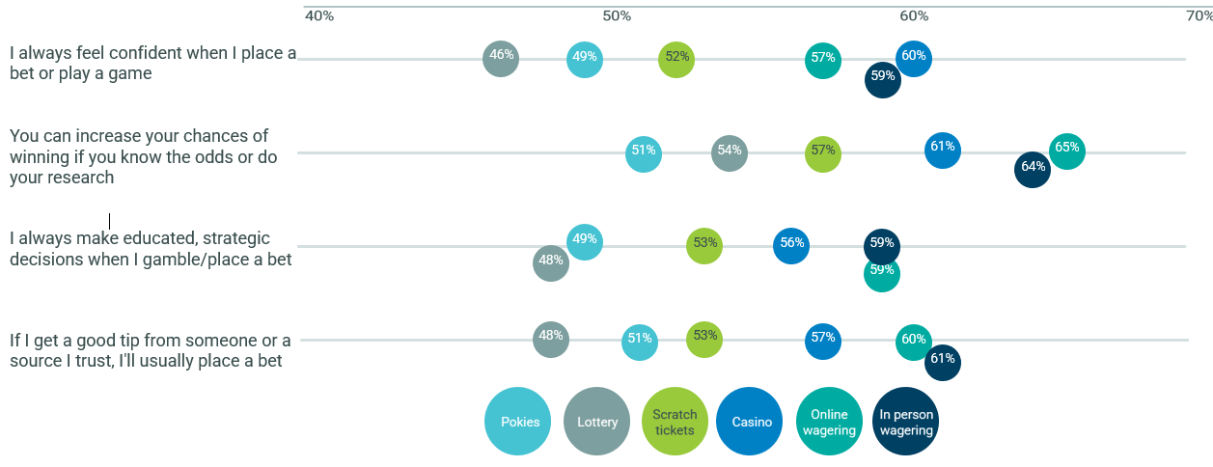
C1. In the list below are a number of things that people have said about gambling, and we’d like to know how much you agree or disagree with each statement. Please indicate on a scale from 0 to 10, where 0 means you disagree completely and 10 means you agree completely.
Base: Problem gamblers – Pokies n=273, Lottery n=307, Scratch tickets n=274, Casino n=209, Online wagerers n=240, In person wagerers n=209
Figure 33 - Attitudes towards gambling (total agree 7-10) – Moderate risk gamblers by activity
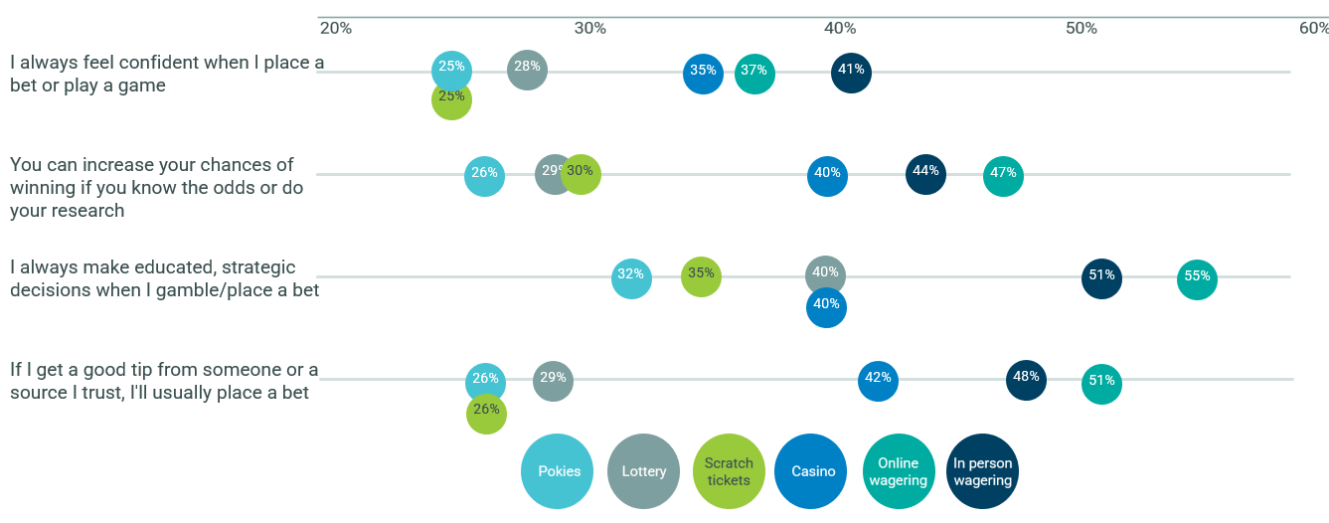
C1. In the list below are a number of things that people have said about gambling, and we’d like to know how much you agree or disagree with each statement. Please indicate on a scale from 0 to 10, where 0 means you disagree completely and 10 means you agree completely.
Base: Moderate risk gamblers – Pokies n=171, Lottery n=284, Scratch tickets n=206, Casino n=102, Online betters n=148, Betting in person n=109

Participants of all risk profiles subscribed to this view, but low- and moderate-risk participants were likely to self-identify as lacking the skills and knowledge to change the odds to their favour, whereas high-risk participants expressed the view that the time they had invested in gambling had given them a competitive edge when it came to making decisions. This gave these participants a feeling of confidence in their ability to estimate the outcome of a game or event.
“I feel like I’d put more on the horses if I knew more about them. I don’t want to escalate my gambling and for it to become more of a problem so I’m not going to learn too much” (Low/moderate risk male, 18-35, Sydney)
For example, some high-risk participants reported having knowledge of the horse racing form guide, which informed their betting decisions: if they knew the track was wet, and were aware of a horse which ran well in wet conditions, they saw this as a strategic bet. Others were keen followers of Australian football, with a good knowledge of individual players for each team and made decisions based on whether certain players were out with injury or historical knowledge of their success against specific teams.
“Like if it’s for rugby, football or anything like that you can learn a bit more about it and so I feel like you can kind of take more things into account, whereas the casino is very much just chance and there is less calculation in the risk. I take into account player performance and form, things that the bookies aren’t really taking into consideration, value betting and stuff” (High risk male, 18-35)
A paradox emerged: the more time spent gambling, the less likely the participant seemed to view it as a problem, as they believed they were in control and had sufficient skills to make strategic decisions. This was in direct contrast to the losses which emerged as a result of this behaviour, which were often substantial: high-risk participants reported spending larger amounts in a session than those of a lower risk-profile.
Participants often acknowledged that there was always much which could go wrong between placing a bet and the outcome, and that every gamble was a game of chance. This rational reflection appeared to be in opposition to the belief that one could control the outcome with skill or knowledge, but participants did not see these views as opposed.
“It’s always a game of chance, you’re not guaranteed to win, you’re not guaranteed to lose. It could go either way and that’s how I always look at it, but you try to win.” (Low/moderate risk male, 18-35, Regional VIC)
This carries an important implication for messaging: if the gambling outcome is perceived to be a result of gamblers’ own skill and strategy, the activity is seen as one of ‘ability’ not chance exacerbating feelings of control over the activity and outcome. There is an opportunity to develop messaging which reminds viewers that despite the skill or strategy they believe they possess, there is always a good chance of a losing outcome.

Socialisation is a key motivator for low- and moderate-risk groups
As noted in Figure 16, online wagering for the most part was conducted as a solo activity, more so than most other types of gambling. However online wagering as a social activity appeared to skew to young wagerers (18-34 years) and females, as seen in Figure 34.
Figure 34 - Social interaction while playing – online wagerers by age and gender
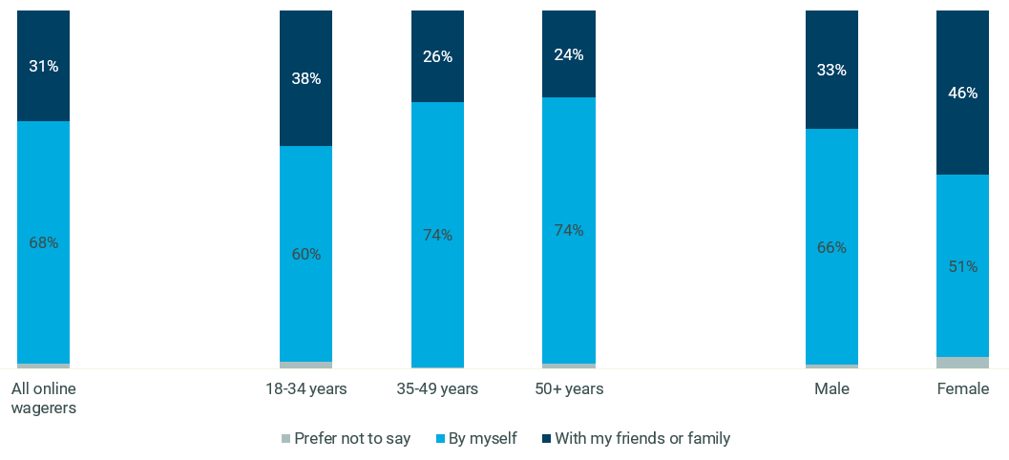
B6. And do you typically take part in these activities by yourself, or socially with friends or family? *Labels not shown for figures under 2%
VALIDATION SURVEY: Online wagerers, Total n=698, 18-34 years n=316, 35-49 years n=198, 50+ years n=184
Likely due to its ‘instant accessibility’ nature, social interaction during online wagering appeared to be more like playing the lottery and scratch tickets, in that the risk profile had little correlation to the level of social interaction as seen in Figure 35. On the other hand there was a clearer linkage between risk level and social interaction with forms of gambling that required more effort to access - non-problem, low- and moderate-risk gamblers were more likely to play the EGM, go to the casino and bet in person as a social activity while problem gamblers were more likely to do these things by themselves.

Figure 35 - Social interaction by gambling activity across PGSI risk categories
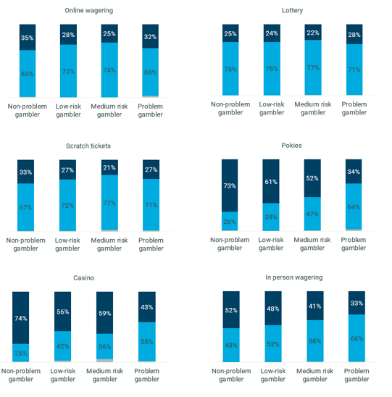
B6. And do you typically take part in these activities by yourself, or socially with friends or family? *Labels not shown for figures under 2%
VALIDATION SURVEY: Online wagerers, Non-problem gamblers n=204, Low risk n=106, moderate risk n=148, Problem gamblers n=240, Lottery, Non-problem gamblers n=962, Low risk n=255, moderate risk n=284, Problem gamblers n=306, Scratch tickets, Non-problem gamblers n=567, Low risk n=187, moderate risk n=206, Problem gamblers n=274, Pokies, Non-problem gamblers n=286, Low risk n=146, moderate risk n=171, Problem gamblers n=273, Casino, Non-problem gamblers n=91, Low risk n=48, moderate risk n=102, Problem gamblers n=204, In person wagering Non-problem gamblers n=141, Low risk n=75, moderate risk n=109, Problem gamblers n=209
That said, while online wagering was mostly done as a solo activity, non-problem, low- and moderate-risk online wagerers were more likely to deem social interaction as a key motivator for why they gambled (relative to problem gamblers as seen in Figure 36).
Figure 36 - Motivators of gambling behaviour – ‘It’s something I enjoy doing with my friends/family’ - online wagerers by PGSI category
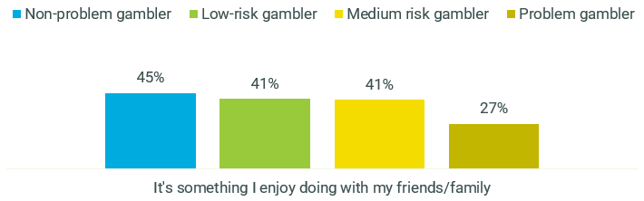
C2. Which of the following reasons best describes why you play or place bets?
VALIDATION SURVEY: Online wagerers, Non-problem gamblers n=204, Low risk n=106, moderate risk n=148, Problem gamblers n=240
For low- and moderate-risk participants, gambling was more likely to take place in a social context, such as placing bets on a weekly football game with friends, a workplace syndicate, or a tipping competition among colleagues. The amounts bet in each instance were reported as being lower than those reported by high-risk gamblers, with $10 to $20 per bet most regularly cited.
“I normally wouldn’t bet on my own. I like the social aspect, betting against my friends or betting together” (Low/moderate risk male, 18-35, Sydney)
These groups were highly motivated by the social aspect of gambling, with a belief that they would miss out on being part of the group if they did not participate. It is important to note that this was distinct from feeling pressure to participate from their peers - rather, this took the form of a more internalised fear. While participants were adamant that they could continue to be part of group gatherings without gambling, they believed their emotional investment in the sport or activity in question would be lowered if they did not have money invested.
While problem gamblers generally had more concerns about stopping their gambling behaviour than the other risk categories, Figure 37 shows that moderate-risk online wagerers were more likely than non-problem and low-risk to worry about missing out on the social interaction, by way of missing out on being part of the group, missing out on winnings and the social group thinking less of them for not chipping in.
Figure 37 - Barriers to behaviour change – social reasons - online wagerers by PGSI category
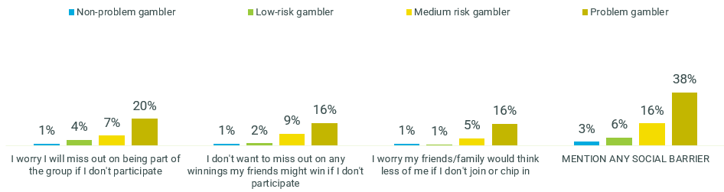
C3. Which of the following reasons best describes why you wouldn't want to stop playing or placing bets?
VALIDATION SURVEY: Online wagerers, Non-problem gamblers n=204, Low risk n=106, moderate risk n=148, Problem gamblers n=240
Importantly, concerns were not linked to missing out on possible financial gains, but rather focused on the emotional and social links between the group: that is, participants reported a fear that they would miss out on celebrating with friends in the event of a big win, or commiserating together in a shared loss.
“I have to go with work to the races all the time, so I feel a bit of pressure because my boss bids horses and I have to gamble… It’s not that he nudges me to do it, I would just feel a bit weird or on the outside if I didn’t, you know what I mean? Same for really big events like the Grand Final, you’ve got to be part of that. I feel like for those specific instances I have to do it, otherwise I don't think there's a huge amount of pressure.” (Low/moderate risk male, 18-35, Perth)
When it comes to messaging into this environment, two challenges exist: overriding the powerful influence of social norms, and intercepting a behaviour which is closely linked with environmental influencers (for example, congregating at the pub to watch the game, consumption of alcohol, distractions including social interactions, etc). In addition, there is possible scope to decouple the idea of participation and socialisation with the need to place a bet in a social setting (especially if the social setting involves watching an event such as sport in a group), particularly for lower-risk gamblers.
The social environment contributed to how low-moderate risk consumers made decisions about their bets. Participants reported engaging in little research before placing their bet, coupled with the finding that this audience held low beliefs in their knowledge levels and ability to influence the outcome of the bet, and as such most would readily take advice from friends, family or others who they believed had higher levels of knowledge than themselves that in turn influenced their betting decisions.
The element of socialisation played a more secondary role, or no role at all, for high-risk consumers. While some reported that they had begun online wagering in social settings, many now reported regularly engaging in the activity as a solitary activity. The solitary nature of the behaviour appeared to influence the risk profile of this group: participants in this audience reported hiding their behaviour from friends and family, engaging in compulsive behaviours (particularly in land-based settings) even after companions had opted out of the session, and participating in gambling activities in unusual settings (for example, on the bus.)
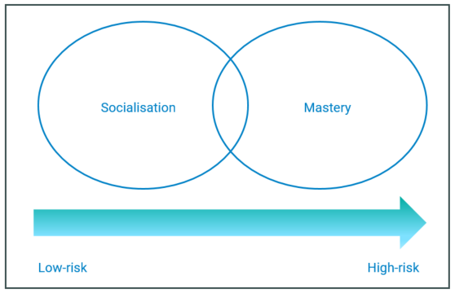
Risk profile influences motivations to participate in online wagering
Even in face of the denial that they have a gambling problem, online wagerers who are problem gamblers (as classified by the PGSI) were more likely than other risk categories to have concerns about what their friends and family think of their activity relative to the other risk categories, as seen in Figure 38. While this belief was not as strong as that seen among problem gamblers, moderate-risk gamblers were more likely to have this concern compared to the lower risk groups.
Figure 38 - Perceptions of gambling behaviour – ‘I'm worried my friends and family think I have a problem even though I don’t’ - Online wagerers by PGSI category
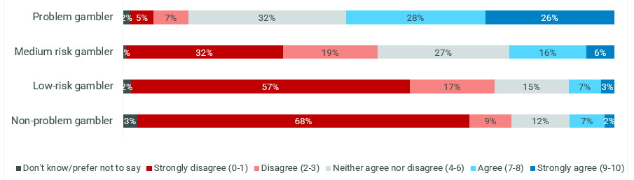
C1. In the list below are a number of things that people have said about gambling, and we’d like to know how much you agree or disagree with each statement. Please indicate on a scale from 0 to 10, where 0 means you disagree completely and 10 means you agree completely.
VALIDATION SURVEY: Online wagerers, Non-problem gamblers n=204, Low risk n=106, moderate risk n=148, Problem gamblers n=240
Despite the solitary nature of this behaviour, problem gamblers were less likely to believe that they have no-one to blame but themselves, particularly when compared to moderate and low risk online wagerers.
Figure 39 - Perceptions of gambling behaviour - ‘I have no one to blame but myself for my gambling choices’ - Online wagerers by PGSI category
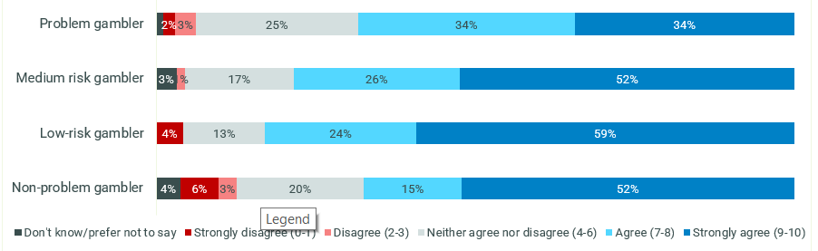
C1. In the list below are a number of things that people have said about gambling, and we’d like to know how much you agree or disagree with each statement. Please indicate on a scale from 0 to 10, where 0 means you disagree completely and 10 means you agree completely.
VALIDATION SURVEY: Online wagerers, Non-problem gamblers n=204, Low risk n=106, moderate risk n=148, Problem gamblers n=240

The ease of the online gambling environment
The online wagering environment was viewed as offering an easy and very available means of placing a bet, which was seen to feed into the opportunity for participants to make impulsive purchase decisions and reduce the time for rational reflection. The online environment limited participants’ ability to stay on top of their wins and losses or gain a clear view of the amounts they were spending and facilitated a sense of distance between participants and their financial investment in the activity.
Discussion of the online wagering environment was invested with less emotion than land-based gambling, as participants reported feeling less tangible connection to the money they spent. In a land-based situation, they reported handing over chips or cash, and being conscious of their spending in a more tangible way than when transferring online money. Experiences were akin to online shopping and other online spending, with participants mentioning the convenience of the purchase and the reduced connection with the money they spent.
“In the casino you literally hand over your chips and you see the money leave your hands. Half the time I forget I transfer money to my betting account. It’s like all online transactions or shopping, your sort of forget you did it.” (Low/moderate risk female, 18-35)
Participants reported a tendency to spend the full amount of money in the account linked to their betting app or website, which meant the idea that one could win “free” money to be spent on purchases outside the gambling environment held little power in practice. Once money was in the bank account, it was typically placed on another bet, sometimes over a session or a few sessions. Participants seldom reported occasions where there was an intention to withdraw their winnings and spend it on other things.
This was an important finding as it suggested that messaging around the other items which could be purchased with money spent on gambling might prove ineffective: behaviour around this money indicated that it was not the primary motivator for people.
Figure 40 shows that among online wagerers, only around a third of problem gamblers (32%) and just over a quarter of moderate risk gamblers (22%) felt that seeing what else they could do with the money they’ve just spent in a session may make them review their gambling behaviour.
Figure 40 - Motivators to behaviour change – seeing cumulative spend - online wagerers by PGSI category
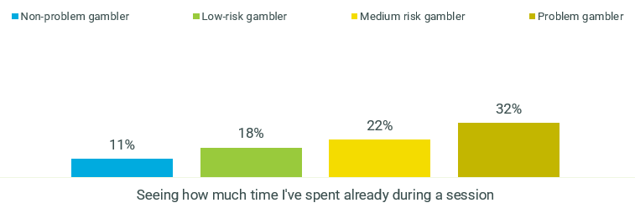
C5. And which of the following reasons might make you want to reduce the extent to which you play or place bets, or stop altogether?
VALIDATION SURVEY: Online wagerers, Non-problem gamblers n=204, Low risk n=106, moderate risk n=148, Problem gamblers n=240
In particular, participants stated that online apps were designed to be intuitive and easy to use, but to make access to online activity statements difficult. Some participants said that their apps have recently become more streamlined and easy to use which meant that they could now consolidate their gambling activity into just one online app, including common events such as sports betting alongside more obscure things activities such as sports from oversees, real-world events, and the outcomes of reality television shows.
“I used to have two or three apps, but now I just use [one]. I can bet on pretty much everything in that… sport, even really random sports like Eastern European Badminton. My fiancée actually made me put on a bet recently for MAFs or was it The Bachelor?” (Low/moderate risk male, 18-35, Perth)
Another major implication of the ease of online wagering is that there appear to be many opportunities to intercept gamblers with online messaging but cutting through will be difficult. It is expected that viewers would be distracted and already engaged in their purchase decision for much of their time online. In addition to this, a number of pro-gambling marketing messages were reported as being presented by the app and surrounding media (for example, during the commercial break of a sports game), and it appeared likely that any messaging in this environment would have to contend with this clutter of content.

The concept of loss encompasses more than money
Rational discussions focused on the financial costs of losses rather than taking into account more internal or emotional implications of loss. For example, participants could easily call to mind substantial losses they had encountered, even when these were several years ago.
However, that is not to say that participants did not feel their losses in an emotional way. A sense of regret was linked to losses, even those from some time ago, which appeared to be linked to feelings of shame or stigma arising from the belief that the individual should have expected such a loss, that they made a misjudged decision, or that they could have mitigated the risks. In this way, losses appeared to play into the self-esteem and self-efficacy of the individual. However, these emotional implications of loss were rarely reflected on in a self-aware way; participants often post-rationalised their loss by admitting that they always knew it was a game of chance, or acceptance of the belief that “the house always wins”.
For consumers who believed that skill and mastery played a role in a successful bet, particularly those of a high-risk profile, losses hit particularly hard; their ability to predict the outcome of a bet was a point of pride to them and gave them feelings of self-esteem and self-confidence. When they were wrong about the outcome, especially if they had put time and effort into researching and strategy behind their decision to bet, it undermined their sense of confidence and self-belief.
A dichotomy emerged: while participants sometimes reported a casual approach to losing money (expressed that they were prepared to lose the money as soon as they placed it on the bet), they did not feel as prepared to lose the bet itself. Being unable to predict the outcome of the event or game and therefore losing the bet threatened their core sense of identity and confidence.
For those who were engaging in the behaviour in a social setting, losing was seen as part of the experience. Participants reported a degree of banter between friends and seemed less likely to feel a loss of confidence or self-worth because they were less emotionally invested in the outcome. In addition, they had invested less time into research or strategy than those who felt losses more keenly.
“It’s part of it. I don’t know many people, or at least none of us, think that we’re actually going to win. It’s a bonus if you do.” (Low/moderate risk male, 18-35, Sydney)

Figure 41 shows that when consumers were asked about their main concerns about losing money when they gamble, problem gamblers were for the most part unlikely to articulate their emotions around this. Problem gamblers who did articulate their feelings were most likely to feel disappointment and more likely than other gamblers to express anxiety around loss. As well as being most likely to feel disappointment, moderate-risk online wagerers were more likely than others to feel anger and frustration, which may be reflective of their expectations from a ‘strategic mindset’. Non-problem or low-risk online gamblers displayed indifference about their gambling losses, likely due to the fact that they claimed they only tended to bet what they could afford to lose and expected loss as an outcome.
Figure 41 - Main concerns surrounding loss - Online wagerers by PGSI category
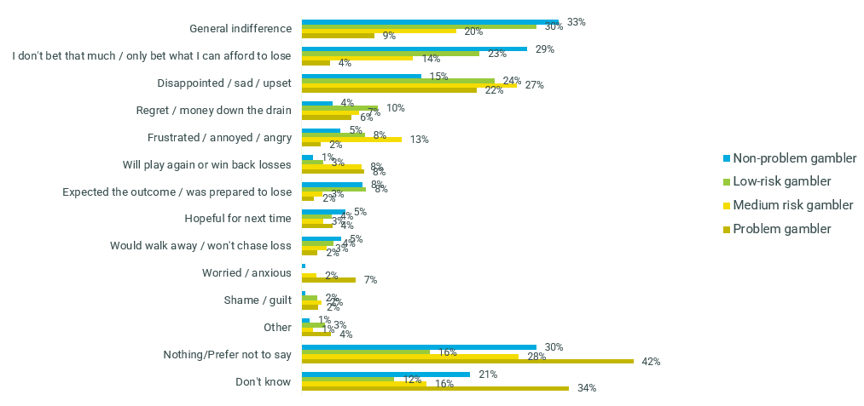
C4. We'd now like you to think about times when you've lost a game or bet. How do you tend to feel in these situations? What are your main worries or concerns when you lose money when you gamble?
VALIDATION SURVEY: Online wagerers, Non-problem gamblers n=204, Low risk n=106, moderate risk n=148, Problem gamblers n=240
The concept of loss therefore seemed to carry a lot of weight, particularly for high-risk participants, but a focus on the possible loss of money in messaging would likely be ineffective. While participants rationalised financial loss as the likely outcome of a lost bet, the emotional implications went much deeper. This might prove fertile ground for messaging development.

“Free” money and the effort heuristic
Most low- and moderate-risk participants reported setting aside money for their gambling, in the same way one might budget for any other entertainment expense or discretionary spending: tickets to a movie, for example, or a round of drinks for friends in the pub. To these participants, it was the cost of participating in the social activity, and whether they won or lost money was secondary to the social participation. Around 2 in 5 low- and moderate-risk online wagerers feel that their gambling is “just another entertainment expense” as seen in Figure 42.
Figure 42 - Barriers to behaviour change – Just an entertainment expense - online wagerers by PGSI category
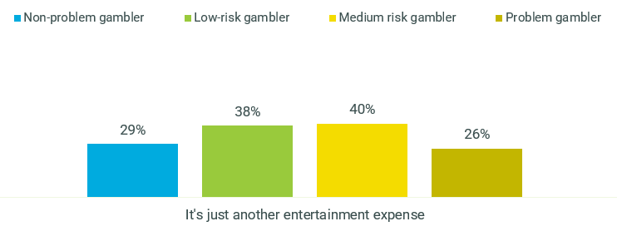
C3. Which of the following reasons best describes why you wouldn't want to stop playing or placing bets?
VALIDATION SURVEY: Online wagerers, Non-problem gamblers n=204, Low risk n=106, moderate risk n=148, Problem gamblers n=240
The preference of gambling over other leisure activities increased with risk level, as seen in Figure 43.
Figure 43 - Motivators of gambling behaviour – ‘I prefer spending money playing or betting rather than on other leisure activities’ - online wagerers by PGSI category
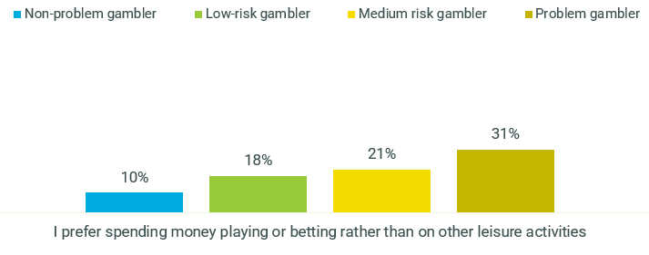
C2. Which of the following reasons best describes why you play or place bets?
VALIDATION SURVEY: Online wagerers, Non-problem gamblers n=204, Low risk n=106, moderate risk n=148, Problem gamblers n=240
This appeared to provide a rationalisation and a sense of comfort when the money was lost: once the bet was placed, the money was already gone.
“I treat gambling a bit like entertainment, going to the cinema or something like that. I think of it more as a cost I’m consciously taking. You don’t go to the cinema pay for you ticket, watch the movie and then expect your money back afterwards. It’s gone, you’ve spent it to do that thing, have that experience.” (Low/moderate risk male, 18-35, Sydney)
It also meant that when money was won, it did not feel tangible in the same way that money which had been earned was tangible. Participants reported that money which had been won did not feel “real” to them or saw it as “free money.” In this way, an effort heuristic was at play: participants felt that the money won was less valuable because it had required less effort to obtain it. Figure 44 shows how the likelihood to take more risks if it is with money won previously increased with the level of risk.
Figure 44 - Perceptions of gambling behaviour – ‘I am more likely to take a risk if I'm betting money I’ve won previously’ - Online wagerers by PGSI category
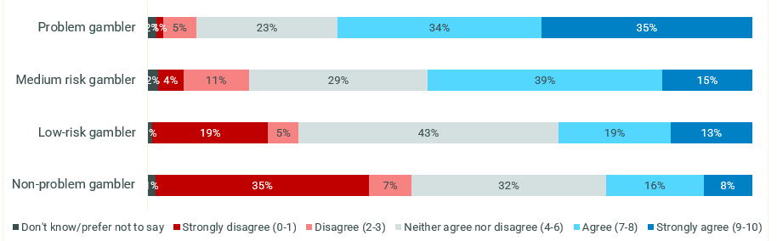
C1. In the list below are a number of things that people have said about gambling, and we’d like to know how much you agree or disagree with each statement. Please indicate on a scale from 0 to 10, where 0 means you disagree completely and 10 means you agree completely.
VALIDATION SURVEY: Online wagerers, Non-problem gamblers n=204, Low risk n=106, moderate risk n=148, Problem gamblers n=240
This was reflected by the behaviour surrounding a win: participants reported a tendency to leave winnings in their online betting account, rather than an intention to withdraw the money and spend it on necessities or save it. Thus, reported financial incentives to gamble were shown to be less influential than other effects of winning, such as feelings of self-worth and an increased sense of confidence: if winning money were seen as the main objective, one might expect the cumulative winnings to be removed from the account and spent by the individual.
Similarly, while participants reported dreaming of their financial winnings during the period between placing the bet and learning the outcome, this dreaming did not translate into behaviour: they reported an intention to withdraw the money from their online betting account, but if they did win, they left it in the account to be used for future bets.
“I guess that is the problem with me. There are so many times when I am on a massive profit and I keep on playing and use that money to re-bet and by the end of the night I am bust… no, I’ve never taken the money out, now I’m thinking why have I never done that? That is what I struggle with, when to back down.” (High risk male, 18-35)
Similarly, loss was not seen as cumulative: if a consumer had bet an initial amount (for example, $50) and subsequently won $700 over the course of the night, then lost $750 cumulatively, they saw their overall loss as $50 (that is, the initial bet) rather than totalling the overall cumulative amount.
One challenge for messaging will be in making these losses seem “real” and tangible, in order to translate them into behaviour change. In some ways, it seems that general messaging can be only one component of this: perhaps a more effective means of demonstrating the cost of gambling would be in environmental changes such as cumulative activity statements (showing the amount an individual had lost over a period of thirty days, for example) flashing up whenever they logged into their online betting account.
Another important messaging implication is that consumers are not actively or mindfully considering other items on which they could better spend their money: to their mind, it is being spent exactly how they planned. This suggests that messaging which focuses on the other ways one might spend their money, if not on gambling, would be ineffective: consumers already know that they could spend their money in other ways, but they report feeling comfortable with the idea that they have spent money on gambling activity. Alternatively, should messages want to speak to this idea they will need to purposefully nudge consumers to this mindset by reframing the value of the money for people who are not doing this inherently.

A disconnect between chance and probability
Participants reported a rational understanding that gambling, betting, and wagering were all behaviours which were heavily influenced by chance and understood that this might mean that the odds did not fall in their favour. In particular, participants stated an awareness that the chances of winning were much lower than the chance of losing. However, participants were quick to dismiss this and distinguish the concept of chance from that of ‘probability’.
“It’s always a game of chance, but you can also always improve your probability. It’s like three-door theory”
“With the goats”
“If you’ve got three doors and you pick one and then decide to change which door you pick with more information.”
(Low/moderate risk male, 18-35, Regional QLD)
Probability was deemed to be more under their control than chance, with a view that it could be manipulated in order to bet on an event with greater probability. This further contributed to notions of an internal locus of control which was linked to ideas of skill and mastery (as previously discussed). The belief among online wagerers that knowing the odds and doing research could increase their chances was particularly strong among problem gamblers as seen in Figure 45.
Figure 45 - Perceptions of gambling behaviour – ‘You can increase your chances of winning if you know the odds or do your research’ - Online wagerers by PGSI category
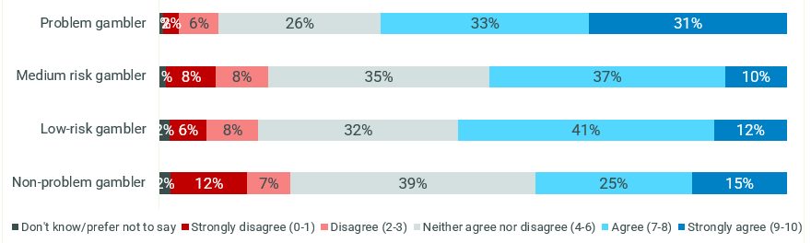
C1. In the list below are a number of things that people have said about gambling, and we’d like to know how much you agree or disagree with each statement. Please indicate on a scale from 0 to 10, where 0 means you disagree completely and 10 means you agree completely.
VALIDATION SURVEY: Online wagerers, Non-problem gamblers n=204, Low risk n=106, moderate risk n=148, Problem gamblers n=240
In addition to this, knowing the sport really well appeared to be a key motivator for online wagering, particularly among low and moderate risk gamblers as seen in Figure 46.
Figure 46 - Motivators of gambling behaviour – ‘I prefer spending money playing or betting rather than on other leisure activities’ - online wagerers by PGSI category
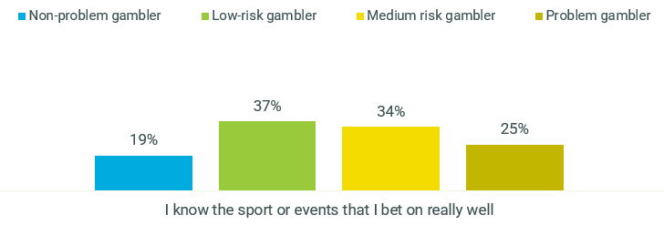
C2. Which of the following reasons best describes why you play or place bets?
VALIDATION SURVEY: Online wagerers, Non-problem gamblers n=204, Low risk n=106, moderate risk n=148, Problem gamblers n=240
Post-rationalisation occurred in this case: while participants would reflect that gambling was a game of chance, they often held a view that they could “change the likelihood” of losing and regain a sense of control and power. The language used was paramount here: participants spoke of becoming “better” at “predicting” the odds and spoke of “getting good at it”. In particular, discussions focused on the ability to diminish the chances of losing – but participants did not reflect that they might also diminish their chances of winning.
Professional gamblers were often brought up as examples of individuals who had “beat the system” – this ranged from high-profile gamblers such as David Walsh, who had reportedly made millions through online gambling, to participants’ family members such as a grandfather or uncle who was a “bookie” and who had “studied” the horses and form guide to be able to develop their skill.
“I think my uncle placed a bet for me at the Grand National and that was really exciting. It won 150 pounds and my uncle gave me half. That was really exciting even though I was really young. He made some serious income, it was pretty much his job. It made me think if you know what you’re doing you can come off pretty good.” (Low/moderate risk male, 18-35, Sydney)
As much of the pre-gambling forecasting seems to focus on winning, there may be an opportunity to reframe the conversation to focus on the chance of losing. This is also lent weight by the finding that participants did not withdraw their winnings to spend it on other purchases, but rather were likely to put it towards future bets. In this way, we see an optimism bias at play as gamblers fixate on the win and diminish the likelihood of the potential loss. Messaging which focuses on the likelihood of loss might therefore cut through the dreaming process to remind gamblers of the rational truth of which they are already aware: that the chance of winning is much lower than the chance of losing.
Another key implication for messaging is that while participants demonstrated rational awareness that chance was a key feature of betting and that the chance of winning was low, they were quick to circumvent this awareness by focusing on probability which was seen to be within their control. The co-existence of these beliefs was validated: the majority of problem gamblers and moderate-risk online wagerers felt that success could be determined by research and knowing the odds while still acknowledging that there was always an element of chance involved, as seen in
Figure 47.

Figure 47 - Perceptions of gambling behaviour – ‘You can increase your chances of winning if you know the odds or do your research’ and ‘It's always a game of chance’ - Online wagerers by PGSI category
 |  | You can increase your chances of winning if you know the odds or do your research | You can increase your chances of winning if you know the odds or do your research | You can increase your chances of winning if you know the odds or do your research
 |  | Total disagree (0-3) | Neither agree nor disagree (4-6) | Total agree (7-10)
It's always a game of chance | Total disagree (0-3) | 1% | 2% | 2%
It's always a game of chance | Neither agree nor disagree (4-6) | 3% | 15% | 12%
It's always a game of chance | Total agree (7-10) | 5% | 10% | 50%

 |  | You can increase your chances of winning if you know the odds or do your research | You can increase your chances of winning if you know the odds or do your research | You can increase your chances of winning if you know the odds or do your research
 |  | Total disagree (0-3) | Neither agree nor disagree (4-6) | Total agree (7-10)
It's always a game of chance | Total disagree (0-3) | 1% | 1% | 1%
It's always a game of chance | Neither agree nor disagree (4-6) | 2% | 11% | 8%
It's always a game of chance | Total agree (7-10) | 13% | 23% | 38%

C1. In the list below are a number of things that people have said about gambling, and we’d like to know how much you agree or disagree with each statement. Please indicate on a scale from 0 to 10, where 0 means you disagree completely and 10 means you agree completely.
All VALIDATION SURVEY: Online wagerers, moderate risk n=148, Problem gamblers n=240

Messaging which intercepts this dreaming process and reminds people that no amount of confidence or strategy can overcome the fact that it is a game of chance might therefore be effective.

The role of ritual, habit and superstition
Ritual and superstition were substantial influencers on gambling behaviour, with participants reporting a range of regular habits which nurtured their ritual and superstitious beliefs. This poses a substantial barrier to change, as ritual allows the habit to become imbedded in the everyday lives of consumers.
A number of low- and moderate-risk participants explained that they had developed a ritual around the behaviour. In particular, it was stated that individuals did not hold the same level of engagement with sports games if there was no wager on it, particularly in instances where their favourite team was not playing. This was claimed as a key motivator for gambling by around a third of problem gamblers (31%) and just under a quarter of low and moderate risk online wagerers as seen in Figure 48.
Figure 48 - Motivators of gambling behaviour – ‘I’m more invested in a game/match/event when I combine betting with it’ - online wagerers by PGSI category
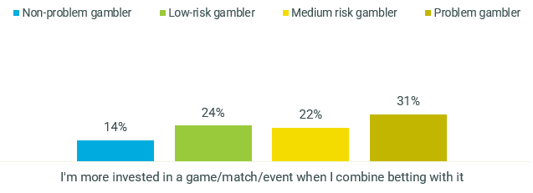
C2. Which of the following reasons best describes why you play or place bets?
VALIDATION SURVEY: Online wagerers, Non-problem gamblers n=204, Low risk n=106, moderate risk n=148, Problem gamblers n=240
For some, wagering was seen as a method through which to keep up to date with the sport – that is, participants felt that if they did not place a regular wager, they would lose interest in the league table. This contributed to anxieties around missing out on being part of the social occasion as participants felt they would be more likely to engage with friends on the topic of sports if they were connected to the sport through regular wagering activity.
“I only bet during footy season. It helps to get me interested at the start when it’s the less interesting rounds so I can stay up to date and talk about it with mates and at work.” (Low/moderate risk male, 18-35, Sydney)
In addition to this, some participants expressed that they had developed a superstitious heuristic whereby they believed that if they chose not to participate for one week, that would be the week they would have won. More than one in five problem gamblers (22%) claimed that ‘lost opportunities’ was a key reason they did not want to change their gambling behaviour highlighting the sunk cost fallacy was in effect, as seen in Figure 49. Although slightly lower, this was also mentioned by around one in six low and moderate risk online wagerers.
Figure 49 - Barriers to behaviour change – Concerns about lost opportunities - online wagerers by PGSI category
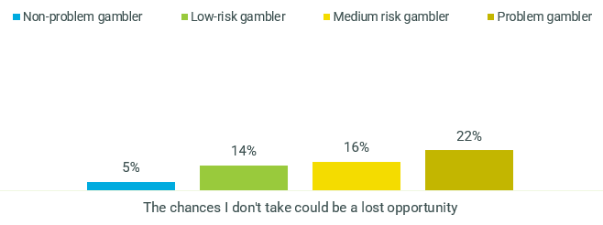
C3. Which of the following reasons best describes why you wouldn't want to stop playing or placing bets?
VALIDATION SURVEY: Online wagerers, Non-problem gamblers n=204, Low risk n=106, moderate risk n=148, Problem gamblers n=240
There was also a concerning tendency to believe the superstition that one is more likely to win when one has had a series of losses, leading to a heuristic whereby participants believe it is their “turn” to win. This indicated that the further someone proceeds in a gambling session, the more compelled they may be to continue, rather than their subsequent losses leading to a compulsion to walk away.
“If you want to describe the sunk cost fallacy to anyone, many examples from my life would be good and like I've got thirty dollars a week that comes out of my account for lotto because I'm convinced that as soon as that stops that's when those numbers are going to come up.” (Low/moderate risk male, 18-35, Perth)
While not the most commonly mentioned motivator for gambling among online wagerers, ‘being lucky’ was mentioned by around a quarter of problem gamblers (24%) and around one in 10 moderate risk wagerers (11%) as seen in Figure 50.

Figure 50 - Motivators of gambling behaviour – ‘I place bets/play because I’m generally a very lucky person’ - online wagerers by PGSI category
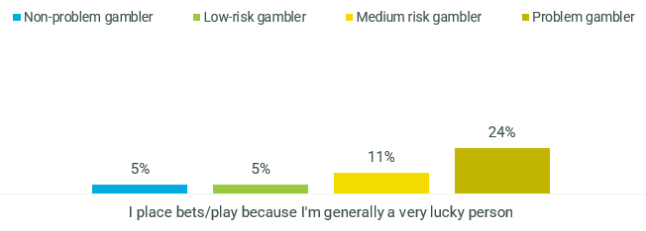
C2. Which of the following reasons best describes why you play or place bets?
VALIDATION SURVEY: Online wagerers, Non-problem gamblers n=204, Low risk n=106, moderate risk n=148, Problem gamblers n=240
Ritual and tradition were particularly strong in instances of land-based gambling, especially in the purchase of lottery tickets and the preference for particular EGMs which were seen as “lucky”. For example, one participant expressed that they played the lottery every week using their deceased grandparent’s favourite numbers, and that this behaviour was a way of remembering their grandparent. Another spoke of a superstitious tendency to watch the EGMs before selecting their preferred machine, based on a “feeling” and belief that this machine had not recently paid out.
Superstition was also present with a stated reluctance to bet against one’s favourite team, even if the participant knew they were unlikely to win the particular game. When participants’ favourite teams were playing, they claimed that they were less likely to “need” a bet to raise their engagement with the game, indicating a reliance on ritual to ensure engagement in instances where other teams were playing.
Ritual, tradition, and superstition pose a substantial barrier to altering behaviour as the repetition and related heuristics have imbedded the behaviour in participants’ lives. The ritual becomes combined with the social aspect of online wagering, which leads low- and moderate-risk participants to feel they need to place a bet to feel part of the group. This is linked to the earlier finding that people may feel unable to participate in these types of social occasions without putting on a bet.

Playing triggers emotions at both ends of the spectrum
At each point of play (before placing bet, during the bet, and while waiting for the outcome) players expressed emotions which were both positive and negative, indicating a tendency to be at an emotional crossroads through their betting session. This mirrored the reported feeling of wagering as “thrilling”: feelings of nervousness, anticipation and anxiety were intertwined to more positive feelings such as excitement. Figure 51 shows that both ‘lifting of mood’ and ‘adrenaline rush’ were mentioned by around a third of problem gamblers and just under a third of moderate risk wagerers.
Figure 51 - Motivators of gambling behaviour – Adrenaline rush and mood lift - online wagerers by PGSI category
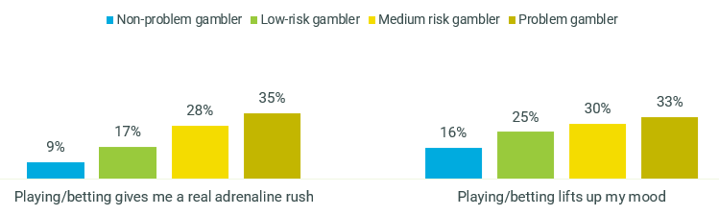
C2. Which of the following reasons best describes why you play or place bets?
VALIDATION SURVEY: Online wagerers, Non-problem gamblers n=204, Low risk n=106, moderate risk n=148, Problem gamblers n=240
Holding a degree of certainty about one’s bet does not appear to change this; indeed, participants expressed these dual emotions regardless of their level of certainty regarding the outcome. For higher-risk participants, the need to experience this “thrill” rose with subsequent occasions, and this need was met by raising the financial stake on each bet.
While these feelings occurred on every betting occasion, the negative feelings were usually ignored, with participants focusing instead on their projected winnings. Despite experiencing polar emotions, participants explained that they dreamed about the win, pictured the way they would spend their money, and imagined the feeling of winning. Conversely, they downplayed the possibility of losing, and moved forward with the bet.
This posed a challenge for messaging: once a consumer made a decision to place a bet, they stated that they were committed, which meant there were few opportunities to intercept the behaviour, particularly in messaging which was intended to be seen in a betting app.
Figure 52 shows that problem gamblers were more likely than other risk categories to find it hard to stop when on a winning streak, and while not as strong as problem gamblers, moderate-risk online wagerers were more likely than the lower risk groups to experience this difficulty in stopping.
Figure 52 - Perceptions of gambling behaviour – ‘I find it hard to stop when I'm on a winning streak’ - Online wagerers by PGSI category
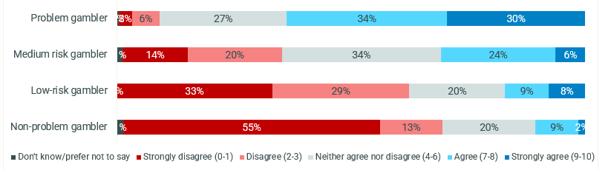
C1. In the list below are a number of things that people have said about gambling, and we’d like to know how much you agree or disagree with each statement. Please indicate on a scale from 0 to 10, where 0 means you disagree completely and 10 means you agree completely.
VALIDATION SURVEY: Online wagerers, Non-problem gamblers n=204, Low risk n=106, moderate risk n=148, Problem gamblers n=240
This indicated that a potential opportunity exists to intercept the consumer immediately after opening the app before they have typed in their bet.
There is also an opportunity for messaging to leverage the natural feelings of uncertainty in the beginnings of the session and encourage consumers to heed these feelings of caution.

The impact of cumulative losses was substantially felt
Participants stated that seeing how much they had cumulatively spent was likely to shock them into behaviour change, and that the incremental losses were easier to bear because they were unaware of the cumulative total. This was especially true for consumers of a high-risk profile.

Figure 53 shows that among problem gamblers and moderate risk online wagerers, reminders on cumulative spend was the most commonly deemed potential catalyst for behaviour. Among problem gamblers more specifically, this was closely followed by the idea of cumulative time, as well as knowing what else could have done with that money spent. Seeing warning or reminder messages was considered as potentially effective by just over a quarter of moderate-risk and problem gamblers, similar to levels of remembering a previous occasion when they went too far.

Figure 53 - Motivators to changing gambling behaviour - Online wagerers by PGSI category
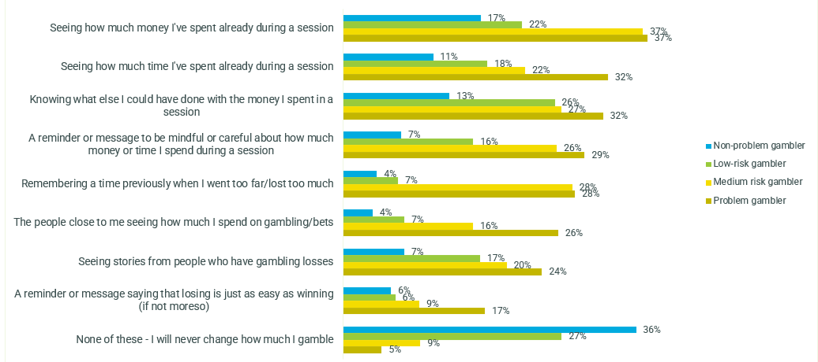
C5. And which of the following reasons might make you want to reduce the extent to which you play or place bets, or stop altogether?
VALIDATION SURVEY: Online wagerers, Non-problem gamblers n=204, Low risk n=106, moderate risk n=148, Problem gamblers n=240

Role of tools and resources
The idea of tools and resources was closely linked with problem gambling. As few gamblers identify as having a problem themselves, there was a tendency to self-exclude from the idea that these might be personally useful to them.
There was widespread support for the idea of tools and resources to support someone with a ‘gambling problem’, as participants acknowledged that gambling could be a substantial negative influence in people’s lives. However, when discussion turned away from the general idea of gambling tools and resources, and participants were asked whether the tools might be relevant to themselves, it was common for them to dismiss this idea. There was little traction to the idea that gambling tools or resources might hold interest for people who were not suffering extreme negative financial consequences, or that early intervention might be useful in cases of gambling harm.
This was supported by the experiences of family and friends, who stated that their loved ones were defensive when they tried to raise the possibility of gambling harm, and reported that they would be uncomfortable recommending tools or resources to their loved ones.
“I try make a joke out of it now or don’t bring it up at all. You can’t go in too hard or they just put their guard up and get all defensive… I definitely wouldn’t be suggesting any tools to him when he won’t even talk about it. I feel like they have to acknowledge they have a problem before they’d be open to using a tool.” (Friends and family, Brisbane)
However, further discussion revealed that tools and resources were perceived to sit on a scale that aligned to their binary mindset of ‘problem gambler’ versus ‘me’. Among the tools and resources which were discussed in the groups, there was a stated preference and palatability among participants for tools which allowed people to come to their own assessment as to how to manage their behaviour, rather than tools which were felt to assume that users automatically had a gambling problem. The most accepted and personally relevant tools included limit setting and activity statements. Some participants claimed they often set limits in a more informal way, so the idea that this might be done in ahead of a session appealed to them. Figure 54 shows that among both moderate-risk online wagerers and problem gamblers, the most commonly used tools were the activity statements and deposit limits. There was a sense that these groups may be avoiding tools that involve assistance from other parties, with majorities of both these groups aware of counselling services, self-exclusion registries and the gambling support app but not having used them. Lower awareness levels of filtering software and assessment tools may have been hindering consideration and uptake among these online wagerers.

Figure 54 - Awareness and usage of consumer protection tools - online wagerers by PGSI category
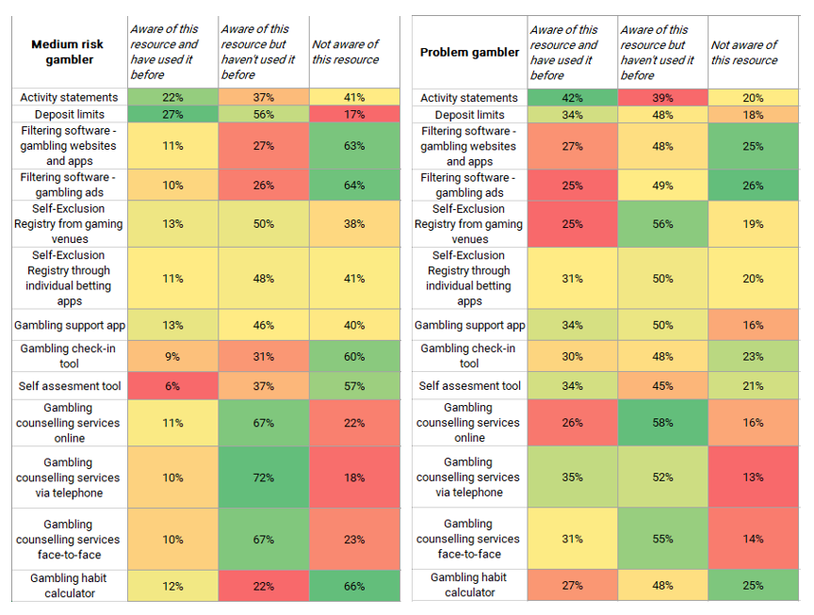
C7. Below are some tools and resources that are available to help people feel more confident and in control when placing a bet or gambling online. For each of these resources, please indicate whether you are aware and have used them before.
VALIDATION SURVEY: Online wagerers, moderate risk n=148, Problem gamblers n=240
In line with the above, Figure 55 shows that across the various forms of spend limitation, techniques that involved setting limits were commonly used across all online wagerers regardless of risk profile. Non-problem, low risk and moderate risk wagerers were most likely to set a general dollar limit, while problem gamblers used a variety of methods including time limits, spending only what was won in previous sessions, working only with credits and making lower balances during a session.
Figure 55 - Spend/time limitation techniques - Online wagerers by PGSI category
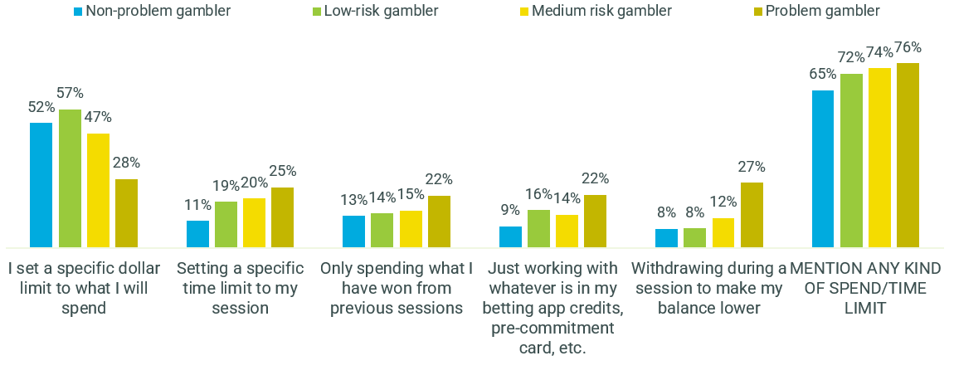
B5. Which of the following approaches do you usually take to limiting how much you spend on gambling activities?
VALIDATION SURVEY: Online wagerers, Non-problem gamblers n=204, Low risk n=106, moderate risk n=148, Problem gamblers n=240
In particular, there was a stated reluctance to use the National Gambling Helpline among participants, with a view that this would only be relevant to those who had a severe gambling problem. The idea that the helpline might assist gamblers to manage their habits was not widely believed.
If messaging is to direct viewers to tools or resources, those which help gamblers come to their own realisation that they might be betting too much will be more likely to be sought out than tools which give them behaviour advice such as the helpline or an information sheet. The exception here may be in messaging which raises awareness of what constitutes a gambling problem, which might reframe the definition of problem behaviour to include those behaviours not currently considered extreme. In these cases, tools or resources might provide a form of support for people who have recently learned (through messaging) the confronting truth that behaviours they had previously seen as acceptable actually constituted gambling harm.

Current perceptions of the ‘gamble responsibly’ tagline
Participants in the qualitative research had high recognition of the ‘gamble responsibly’ tagline when it was presented to them, however, were relatively dismissive of it. The tagline was said to have low cut-through and an unclear call to action, with participants stating that it was easy to ignore.
In addition to this, those who recalled seeing the tagline claimed that there was an inherent barrier to message receptivity in the current environment in which it is seen. Its attachment to gambling advertising meant that it was seen as having no legitimacy, especially among those who perceived that it was an industry initiative rather than mandated by government. There was a stated understanding that the gambling industry was unlikely to support the idea of consumers reducing their gambling spend, as the industry directly benefited from increased gambling behaviour.
“I find it hypocritical because you can’t advertise gambling and then say gamble responsibly, it doesn’t work. You just can’t have gambling advertisement if you really believe that people should be more responsible, there should be more regulation in terms of what you can advertise.” (Low/moderate risk male, 18-35, Regional VIC)
Figure 56 shows that two thirds of online wagerers (65%) were not able to spontaneously remember any warning messages from playing on online formats. ‘Gamble responsibly’ was the most remembered unprompted message however only remembered by 11% of online wagerers and even lower recall among problem gamblers. Other warning messages were mentioned at lower levels.
Figure 56 - Spontaneous memories of warning messaging on online formats - Online wagerers
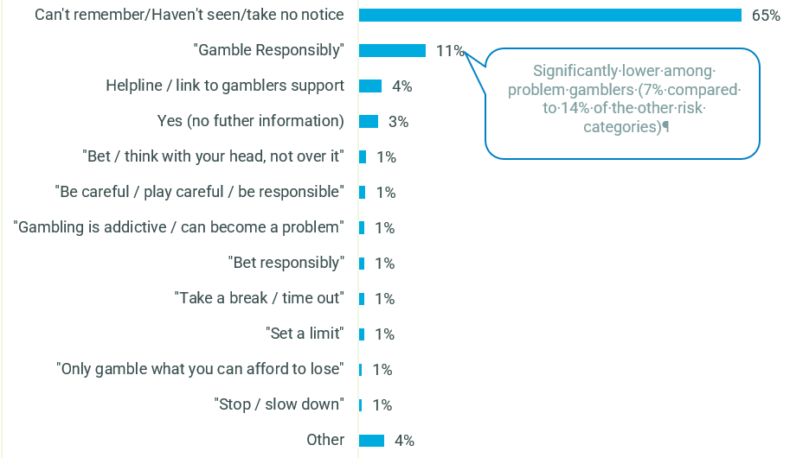
C6. We'd now like you to think more specifically about times when you've gambled online - i.e. using a mobile app or on a website. Do you remember seeing any messages on these platforms that might ask people to slow down, stop or think about their actions? If so, what did these messages say? Base: Online wagerers n=698
Only when prompted did online wagerers remember the ‘Gamble Responsibly’ tagline, as seen in Figure 57, suggesting how the tagline has been struggling to be top of mind and has weak recognition as a warning message. This was consistent across the risk profiles.
Figure 57 - Prompted awareness of ‘Gamble Responsibly’ message - Online wagerers
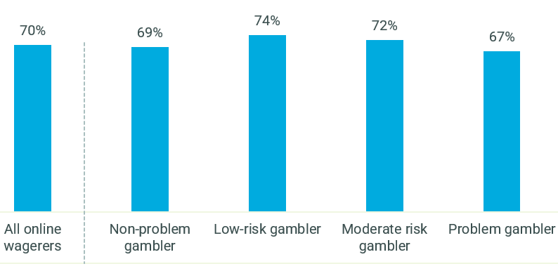
C6a. While playing online or on an app, do you recall seeing a message that said 'Gamble responsibly'?
Base: Online wagerers n=698
When asked what the tagline means to them, ‘not gambling more than what you can afford to lose’ was the most common language used by over a quarter of online wagerers, as seen in Figure 58. Other associations were more varied, however 12% of online wagerers expressed particular levels of cynicism towards this tagline in terms of its impact. These results were consistent across the risk categories.
Figure 58 - Interpretation of 'gamble responsibly' message - Online wagerers
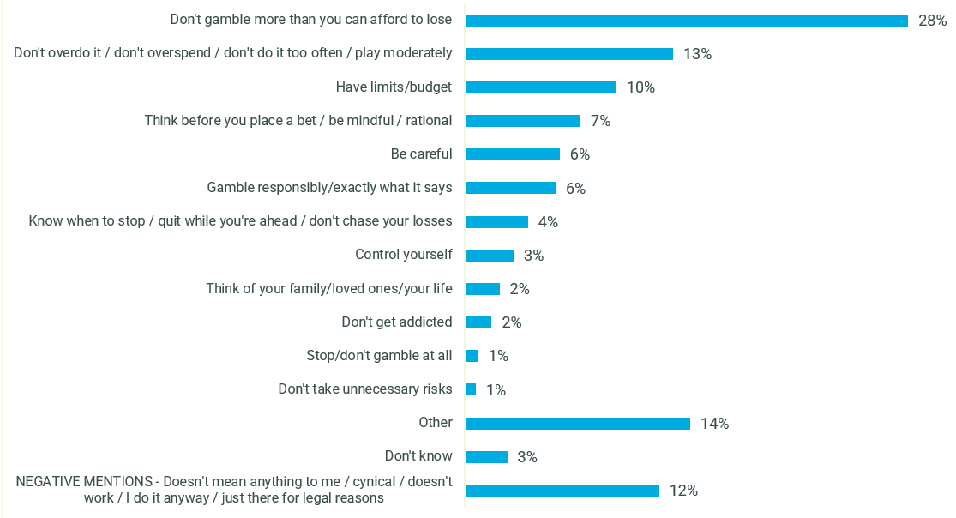
C6b. And when you think of the message 'Gamble responsibly', what comes to mind? What does it mean to you?
Base: Online wagerers n=698
Consumers were open to a new warning message to address gambling related harm and felt that there was ample opportunity to improve on the message’s impact, given the perceived shortcomings of the current ‘gamble responsibility’ tagline. However, there was repeated and unanimous concern over the true influence such tagline might have if it is to continue to be shown in conjunction with industry advertising.
“’Gamble responsibly’, yeah it's not meant to be effective. It’s such a tickbox. A new tagline is needed if it’s actually supposed to do something other than to let gambling companies get rid of their liability.” (High risk male, 18-35)

The role of Government in communications to reduce gambling harm
Participants in the qualitative research felt that it was appropriate for Government to fund communications to reduce gambling harm, and that the Government also had an important role in assisting people who needed support for their gambling. However, there was some scepticism around the role of Government among those participants who believed that the Government derived income from gambling activities, and therefore stood to benefit financially from increased gambling behaviour. There was little stated understanding between the different roles of State and Federal Government in this area.

Figure 59 shows that most online wagerers felt that the Government had a role to play in assisting problem gamblers, particularly seen among problem gamblers themselves (in line with findings noted across all gambling types at Figure 31).
Figure 59 - Attitudes towards problem gambling – ‘The Government needs to step in and make it easier for problem gamblers to control their gambling’ - Online wagerers by PGSI category
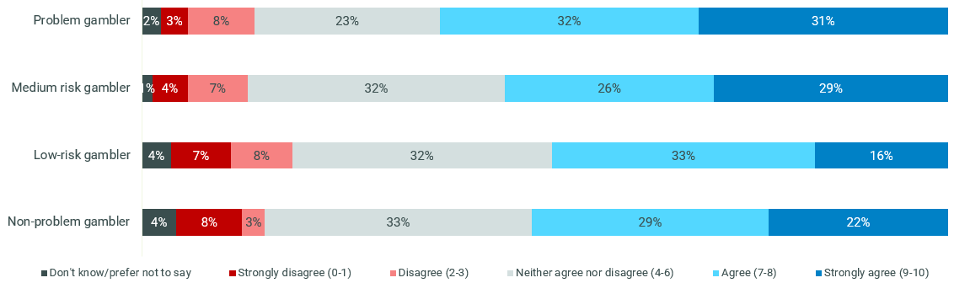
C9. In the list below are a number of things that people have said about problem gambling, and we’d like to know how much you agree or disagree with each statement. Please indicate on a scale from 0 to 10, where 0 means you disagree completely and 10 means you agree completely.
VALIDATION SURVEY: Online wagerers, Non-problem gamblers n=204, Low risk n=106, moderate risk n=148, Problem gamblers n=240

In line with this idea of the power of external influence, Figure 60 shows that problem gamblers and moderate-risk wagerers were more likely than the other risk categories to feel that the industry was too powerful.
Figure 60 - Attitudes towards problem gambling – ‘The gambling industry is too powerful for us to effectively reduce problem gambling in Australia’ - Online wagerers by PGSI category
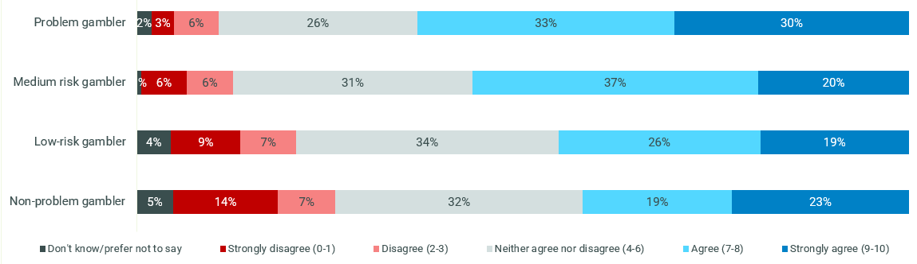
C9. In the list below are a number of things that people have said about problem gambling, and we’d like to know how much you agree or disagree with each statement. Please indicate on a scale from 0 to 10, where 0 means you disagree completely and 10 means you agree completely.
Online wagerers, Non-problem gamblers n=204, Low risk n=106, moderate risk n=148, Problem gamblers n=2
There is strong appetite among consumers for a dedicated campaign from government that communicates messages on the reduction of gambling harm. It is anticipated by consumers that the taglines would have greater efficacy in this context and would help to delineate the message from industry and thus enhance the sincerity of the tagline.

Activation: message territory development
The literature on gambling messaging suggests that messaging which gives people too much sense of control and responsibility (for example, “Gamble responsibly,” “When the fun stops, stop”, etc.) is ineffective because those who exhibit behaviours associated with gambling harm do not identify as having a gambling problem. In addition, research by Central Queensland University shows that normative and personalised messages may be a new direction for message territories.
From the first phase of qualitative research into behaviours and attitudes, Hall & Partners identified seven possible messaging ‘territories’ from which to develop taglines to target problem gambling behaviours. Each one was linked to a “human truth” or theme which we have uncovered from the research. The creative partner, a Creative Director at Clemenger BBDO, was briefed on the territories and instructed to develop taglines to fit each one, with a total of 30 developed for testing in the second round of qualitative research.
We know from the research surrounding gambling behaviours that conscious decision-making is often suppressed at the point of gambling. Our recommendation was for taglines to be developed appear at the beginning of the consumer’s journey, as soon as they log into the app or website, prior to becoming “invested” in putting in money. The principle was to intercept them before they commit to a bet.
Clemenger BBDO developed up to six taglines for each territory, resulting in a total of 30 taglines. For each territory, at least one of the following was included:
- A direct question designed to personalise the message and challenge the viewer to pause and consider
- A tagline framed around normative influences or designed to tap into social norms
- A tagline including a direct call-to-action, directing the individual to a tool or resource such as the gambling helpline or an activity statement.
It was also recommended that terminology avoid use of the word “gambling” as consumers did not self-identify as such, instead use “betting” for all subgroups and risk profiles. An exception was suggested for the Risk territory to emphasis the idea that their behaviour is indeed gambling.

Overview of messaging territories
 | NAME | TARGET | TERMINOLOGY | INSIGHT
1 | Limits | All | Avoid gambling | Setting a limit/budget at the start makes it easier to stick to
2 | Confidence | All | Avoid gambling | Gamblers feel a mixture of positive and negative emotions before placing a bet; if we can tap into the negative we may dissuade them before betting
3 | Loss | All | Avoid gambling | Gamblers report a focus on winning/projection of winnings before placing a bet; reframing the focus onto the chance of losing could dissuade them from betting
4 | Strategy | Online wagerers | Betting | Strategy plays a big role in feelings of control/power when betting; reminding gamblers that it's a game of chance could dissuade them
5 | Missing Out | Low-moderate risk, online wagerers | Betting | Low-moderate risk gamblers feel social pressure to gamble because they fear being left out of group celebrations; this message targets people who don't want to bet but feel pressured to do so
6 | Risk | High-risk (possibly all), online wagerers | Gambling | Most high-risk gamblers don't think they have a problem. This message is about rerouting their perception of themselves as being not at-risk and encouraging an immediate call to action.
7 | Positive | All |  | Research by CQU shows that positive messaging is well-received and supported by gambling support providers. Instead of focusing on the downsides, positive messaging should emphasise the positive outcomes of cutting back.

Territory 1: LIMITS
Human insight: People who set a limit/budget before starting a gambling session find it easier to stick to their budget.
Guiding principles: Limits/budgets are personal for everyone (one person might be able to afford $20, another person can afford $200.) Therefore, it’s essential that each individual makes their own choice about how much of a budget to set before commencement. (Note on terminology: the word “limit” describes the idea, rather than a word which was felt to test well – experiment with other terminology).
Taglines developed:
- Winners set limits
- People who set limits always win
- 92% of people set limits. Do you?
- Betting’s better with boundaries. (Set a deposit limit.)
- Give yourself an edge. Set a limit.
- Think straight. Take a break.

Territory 2: CONFIDENCE
Human insight: Consumers commonly report feeling a mixture of positive and negative emotions before placing a bet (anxiety and excitement); if we can tap into the negative, we may dissuade them before betting.
Guiding principles: While consumers report feeling worry before they bet (alongside excitement), they focus on the positive emotions: forecasting of their win, and confidence in their decision – in the moment, the positive feelings win out. This strategy should undermine the sense of confidence, sow doubt in the decision and give viewers the tools to manage these feelings.
Rationally, consumers report feeling most worried about “losing the money”, but what this really appears to tap into is fears of being wrong which feeds into a sense of failure and loss of self-esteem.
Taglines developed:
- Chances are you’re about to lose
- The odds are stacked against you
- You really think you can beat the house?
- If in doubt opt out. (Think. Is this a bet you really want to place?)
- Tired of that losing feeling?

Territory 3: LOSS
Human insight: Consumers report a focus on winning/projection of winnings before placing a bet; reframing the focus onto the chance of losing could dissuade them from betting.
Guiding principles: The dreaming process/forecasting of the expected win is a big part of the thrill of gambling; indeed, participants are thinking about their winnings in the moment they place a bet. However, the majority of participants reported that the salience of their losses was higher than their wins. If we can intercept the “forecasting of winnings” dreaming process and cause consumers to think about the chance of losses, we might dissuade them from betting. Suggestion on terminology: avoid the word “win” and include the word “lose/loss”.
Note: Low-moderate risk gamblers already think they don’t bet more than they can afford, so the messaging should not just focus on financial losses, but also on broader implications of a loss – self-esteem, possibility of being wrong, sense of failure etc.
Taglines developed:
- Don’t lose it all for a bet. (Hiding betting from your family? Call the helpline.)
- You win some. You lose more.
- Lose a bet. Lose self respect. (Call the helpline for support today)
- What are you prepared to lose today? (Set a deposit limit)

Territory 4: STRATEGY
Human insight: Strategy plays a big role in feelings of control/power when betting; reminding consumers that it's a game of chance could dissuade them
Guiding principles: Consumers’ sense of confidence increases with the amount they believe they “know” about a game/match, etc. They speak of making strategic decisions, feeling confident in their decision, being “calculated”, etc. As such, consumers believe they can influence the probability/likelihood of winning. This is in direct contrast to their agreement with the fact that it’s a game of chance and “the house always wins.” This territory is a reminder that it could not go in their favour – that no amount of strategy/research can overcome the game of chance. Perhaps there is also room here to reframe gambling as a less disciplined practice.
Taglines developed:
- The best gambling strategy? Knowing when to quit.
- There’s no such thing as a sure thing
- The smart money’s on the house
- In a game of chance there’s no second chance

Territory 5: MISSING OUT
Human insight: Low-moderate risk online wagerers feel social pressure to gamble because they fear being left out of group celebrations; this message targets people who don't want to bet but feel pressured to do so
Guiding principles: Online wagering is an activity which is often enjoyed socially, with participants heavily influenced by the social dynamic. While they did not report feeling peer pressure to participate, they feared being left out of the group if they did not, particularly in commiserating in losses or celebrating wins. (Note: this is a low-moderate risk specific message targeted to sports betting, which is unlikely to have resonance for high-risk audiences who generally participate in the behaviour alone).
Taglines developed:
- Tap out, don’t lose out. (You don’t need to place a bet with mates to have fun)
- Join in without losing out (You don’t need to place a bet with mates to have fun)
- Social gambling is still gambling

Territory 6: RISK
Human insight: Most high-risk gamblers don't think they have a problem. This message is about rerouting their perception of themselves as being not at-risk and encouraging an immediate call to action.
Guiding principles: No one self-identified as having a problem with gambling, no matter their risk profile. High-risk audiences reported hiding their behaviour and fearing the judgement of their friends/family and stigmatisation of society. Very little research has been done into challenging, direct messaging around gambling behaviour, either in Australia or overseas. While it is important not to feed into stigmatisation, there is room to target problem gamblers in a more direct way than has been previously done.
However, when people are challenged or triggered, they can become defensive, so it is necessary to follow a challenging message with a call to action which gives viewers tools to tackle the feeling they have.
Taglines developed:
- You can’t win back your reputation (Set a deposit limit)
- Problem gamblers hide it from their families (Got a problem? Call the gambling hotline)
- Know more about odds than you do your kids? (Call the gambling hotline)
- If your family knew you gambled they’d want you to stop (Call the gambling hotline)
- Gambling wrecks lives

Territory 7: POSITIVE
Human insight: Research by Central Queensland University suggests that messages which trigger positive responses were well received by support providers, especially those who previously had a gambling problem.
Guiding principles: Instead of focusing on the downsides of gambling, positive messaging should emphasise the positive outcomes of cutting back on gambling, reframing a potentially stigmatising and negative conversation about the downsides to focus on the positives of choosing to quit.
Taglines developed:
- Gamble less. Save more money. Simple.
- Spend less on bets. Spend more time with mates
- Imagine what you could be buying instead

Additional tagline
An additional tagline was also developed, with the intention for it to run at the end of a long gambling session and target gamblers who might be feeling despondent. This was evaluated separately to the main 30 taglines as it was designed to play a different role reducing harmful behaviours.
Tagline developed:
When you feel you’ve lost everything, don’t lose hope. (Call the helpline for support today)

Phase II Qualitative Insights: testing and refining message territories
30 taglines across seven message territories were qualitatively tested with all audiences. The additional tagline was evaluated separately to the main taglines in all sessions as it was designed to play a different role reducing harmful behaviours.
During the sessions, participants discussed their opinions on presentation, format and location of current gambling harm warning messages they have seen in market. This discussion informed a series of visual formats that were created into presentation mock-ups for quantitative testing.

Overarching Key Insights from the Phase II qualitative sessions
The human insight underpinning each message territory rang true; however, not all truths resonated when communicated as tagline messages.
Where the insight tapped into a more subtle and less self-reflective truth about people’s motivations and behaviours regarding online gambling, the associated taglines seldom elicited the desired response or reframing. As a result, the messages either came across as self-evident and obvious, leading consumers to disregard the tagline, or they did not break down people’s perceptions of the own behaviour, leading them to self-exclude from the messaging.
Therefore, whilst we can understand more about the mindset and behaviours of people who participate in online gambling from these insights, activating these truths to prompt positive behaviour change is unlikely to be effective at connecting with people who gamble online.

Message territories and associated taglines were seen as a new and different way of talking about gambling harm.
Overall, the taglines presented a firmer and more direct message than Australians were used to seeing in communications aimed to reduce gambling harm. Tonally, they were said to have similarities to other addictive behaviour categories, such as warning against the harms of smoking and alcohol consumption. This new way of talking about gambling harm was welcomed by participants at all risk levels.
However, there was some scepticism about whether these messages would gain the necessary traction within the gambling industry – given that some messages appeared overtly designed to dissuade participation in online gambling, it was difficult for some participants to believe that there would be willingness to adopting these taglines in industry advertising and other branded collateral (where the current ‘Gamble Responsibly’ tagline is presented).

Territories designed for the broader audience (across at-risk categories) have strongest resonance: in particular, the Confidence, Limits, and Loss message territories.
The foundational truths underpinning the message territories designed for all online gambling risk profiles were highly salient and relevant.
Consumers across all risk profiles could clearly and intuitively see how the message related to them personally and as a result were less likely to deflect or self-exclude from the message. Furthermore, the messages cut through on a rational level to elicit a conscious decision-making process.
Overall, the Confidence message territory was found to be most resonant, and most taglines taken forward to quantitative testing stemmed from this group.

Preferred individual tagline messages had depth but were still simple to comprehend.
Taglines that had depth worked on multiple fronts by tapping into several truths. For example, participants felt that ‘Chances are you’re about to lose’ in the Confidence territory spoke to both the doubt felt when a player was about to place bet (Confidence) and also reminded them that losing was a likely outcome of the bet (Loss).
As a result, audiences across different risk profiles were taking different messages out of the tagline, driving up the broad relevance to them and their behaviour.
In addition, depth of meaning within a tagline did not diminish the clarity of its message. As such, there is a developing case in support for taglines that are broad-based, rather than targeting different messages to specific target audiences, an initial hypothesis of the research.

There were indications that a suite of messages would be more effective to cut through in the dynamic and varied online gambling environment and protect against message wear-out.
Participants felt some taglines were better suited to different environments, based on the call to action. For example, some taglines would be expected to be seen in situ within the online betting platform, while other taglines felt appropriate at different stages of the playing experience. Others were considered messages you would see as part of a betting advertisement.
The alignment of the message to the behaviour and frame of mind across environments or moments has the potential to secure engagement of the viewer with the message, thus driving comprehension and uptake of the message.
Where taglines were seen to be similar in tone, intention and perceived efficacy, there was a desire to proceed with a suite of taglines in rotation to keep the message fresh over time, rather than filtering down to a hero message that tries to do all of the heavy lifting. Tagline alignment to different environments is detailed later in this section and was tested in the subsequent quantitative phase.

Message territories that spoke to a specific insight targeted at a particular risk group lacked resonance and were not recommended to take forward.
There was no indication that taglines within the three audience-specific message territories (Risk and Strategy territories for high-risk, Missing Out territory for low-moderate-risk) would change the behaviour or reframe the mindset of the intended target audience, even if some individual taglines were seen to have merit.
As such, going too niche with ideas that were only relevant for one particular audience and investing in highly targeted message strategies is not advised at this stage.
It is important to note that this does not mean that some taglines will hold stronger or weaker resonance with some risk groups over others; rather, it further supports the recommendation to prioritise broad-based messages.

High-risk participants self-excluded from taglines that were perceived to elicit feelings of shame, stigmatisation, or that questioned their behaviour, regardless of the message territory.
These types of messages were deemed confronting to some of the high-risk audience, leading to rejection of these taglines. This was not because the message struck a nerve about an aspect of their own online gambling behaviour or drew attention to a mindset that they typically downplayed or hid. Rather, it was because they outright did not identify those beliefs or behaviours in themselves – earnestly believing the messages to be for ‘other people’ with ‘severe gambling problems’.
As a result, these types of taglines appear to have low efficacy with the high-risk audience. Consistent with the NCPF Baseline Report and other existing literature, it is recommended to avoid messages that lead to shaming or stigmatisation of people who gamble. Ultimately, these messages did not circumnavigate or disrupt the schemas these players hold regarding their online gambling behaviours.

Low-moderate risk audiences disliked taglines where the message implied gambling is harmful and gamblers should stop, as opposed to messages that implied gambling is fine if done safely.
The low-moderate risk audience exhibited clear self-alignment to the messages that implied the latter, and actively distanced themselves from taglines that spoke to the negative impacts of gambling behaviours as these were seen as messages for “people with a problem”.
In delineating the taglines that were seen to speak to consumers like them, they were responsive to messages that appeared to serve as reminders in moments where they acknowledged there were factors interfering with their rational decision making (e.g. alcohol, social environment, hype or excitement of the game play). Aligning to ‘reminder’ messages reinforced their belief that they were rationally reflective of their behaviour and therefore still in control of how they conducted themselves when participating in online gambling.

Current gambling warning taglines were seen in a breadth of settings which made it hard to discern what catches attention and further engages players with the message.
Little was memorable about the presentation of current taglines such as ‘Gamble Responsibly’ in the minds of consumers. The different context in which the tagline was seen was top of mind, notably the tagline’s presence within or at the end of gambling promotion ads. However, the presentation, format and visualisation of gambling warning taglines was barely an afterthought, with many commenting on the tagline being ‘small’, ‘in fine print’, ‘miss-able’, essentially blending into the other content. As a result, the message is currently easy to ignore.
It was the strong view of participants that in the online gambling environment, timing and point of interception are key to engaging consumers, and the presentation itself slightly less important so long as the tagline was clear and easy to read. Overall, there was appetite for a stand-alone campaign from government which would drive the message home the best.

Ten taglines were identified to take into quantitative testing
Following qualitative testing, rigorous analysis was conducted to distil the tagline messages and identify those with the greatest potential to encourage safer online gambling behaviour. Ten taglines were identified as having greatest potential to intercept conscious decision making and were carried through to quantitative validation. These represented four of the territories.

Ten leading taglines identified in the qualitative phase (in no specific order):
- Chances are you’re about to lose (CONFIDENCE territory)
- The odds are stacked against you (CONFIDENCE territory)
- Think. Is this a bet you really want to place? (CONFIDENCE territory)
- If in doubt opt out. (CONFIDENCE territory)
- Tired of that losing feeling? (CONFIDENCE territory)
- Betting’s better with boundaries. (Set a deposit limit.) (LIMITS territory)
- 92% of people set limits. Do you? (LIMITS territory)
- You win some. You lose more. (LOSS territory)
- What are you prepared to lose today? (Set a deposit limit) (LOSS territory)
- Imagine what you could be buying instead (POSITIVE territory)

All of the taglines developed (30 in total) were evaluated based on the following overarching guiding principles to identify the respective merits and shortcomings of each tagline and ultimately led to the identification of the ten leading taglines:
- Does the idea hold true in the mind of the viewer? And does that human truth come through in the tagline’s articulation?
- Is the tagline personally relevant? Does it speak to the viewer as an individual, not to ‘other people’?
- Is the tagline clear and easy to understand? What is the risk of misinterpretation?
- How well does the tagline catch attention and engage the viewer?
- Does the viewer stop and think about what the message is saying to them? How well does it work to intercept their conscious decision making?
- Does the tagline change how viewers think about gambling? Does it work to break down any misconceptions about gambling?
- Is there any risk of stigmatisation or shaming?
- How does the tagline perform with our primary audience (versus secondary audiences)?
- How well does the tagline translates across different types of online gambling activities?
- Does it motivate consumers to use a gambling harm minimisation tool/ resource?
A description and rationale for each of the seven messaging territories and 30 taglines follows.

Detailed messaging territory & tagline insights

CONFIDENCE territory
Overall, the Confidence territory was the most successful message territory, with strong resonance across all risk profiles. Consumers readily identified with the feeling of getting swept up in the moment and the mounting optimism, which often transformed to confidence, which was said to accompany the lead-up to placing a bet. The familiarity of this experience across most online players meant there was high believability in the insight – it spoke to people on a personal level and was also recognised as a wider-known truth for consumers.
“It is a handy reminder versus getting pumped up…bring us back to reality probably a little bit.” (High risk male, 18-35)
This territory was found to effectively sow the seed of doubt in the minds of consumers, making them question whether it was a bet they should place – there was no ambiguity in the idea’s intention. This was achieved through its direct style of address and matter-of-fact focus on the negative emotions that are experienced during the online gambling journey. The idea struck the balance between prompting consumers to engage in an internal dialogue that questioned their behaviour (a gentle but firm reminder) but did well not to come across as external judgement which could be confronting. It was the reality check many welcomed and felt comfortable receiving.
“It’s a good suite to spark that second-guessing of whatever you’re about to do.” (Low/moderate risk male, 18-35, Sydney)
Collectively, the Confidence taglines were viewed as a move towards a stronger way of warning about the potential harms of gambling as they explicitly addressed to the odds or probability of negative outcomes. The lack of perceived judgement and factual, non-emotional tone were said to contribute to the success of the taglines appealing to consumers’ rational thoughts to interrupt the thought process.
There was simplicity in the structure of the taglines that ensured no distraction from the message and little room for misinterpretation. Contrasting the Confidence messages to taglines deemed similar in other territories (for example, Strategy), participants credited the use of simple language: there was a belief that the taglines were not trying too hard to be clever yet were still engaging.
Many could envisage these taglines cutting through and being most effective at intercepting behaviour during a session, for example before a bet was confirmed, to undermine consumers’ certainty and cause them to rationally consider their decision. Participants struggled to imagine how these taglines might play a role in other environments, such as in an industry-led betting ad, solely because it was perceived that industry would not be supportive of this kind of messaging. However, there was openness to see this type of message in different contexts within online wagering.
“I think gambling companies would hate these the most … They’d be the most effective as they’re quite potent. They dismantle the whole luck perception belief.” (Low/moderate risk male, 18-35, Sydney)

Taglines carried through to the quantitative research
- Chances are you’re about to lose
The tagline was clear and straight to the point. Its meaning was non-disputable, lending the tagline believability even among those who played ‘skilled’ games and generally felt strategy and research could increase their likelihood of winning. It was acknowledged as an accepted truth and through this tagline, these consumers understood that losing was a likely reality. The relevance of this tagline held in all situations, no matter the amount bet or type of betting activity.
“It’s reminding you that you are more than likely not going to win it, so is it worth what you are throwing down on it.” (High risk male, 18-35)
The phrasing of the tagline did not stigmatise the behaviour or cause shaming because it was grounded in a matter-of-fact tone rather than viewed as stating an opinion. As such, all participants could internalise this question and ask it of themselves, therefore interrupting their conscious thought process without rejection responses such as ‘gambling is legal and you can’t tell me not to do it.’
As well as working to undermine confidence, this tagline also brought to the fore loss as a possibility: it effectively spoke to two human insights. The tagline actively raised the potential consequences of placing an online bet, bringing consumers down from the highly emotive (and less rational) illusion of opportunity, where positivity and optimism typically overrode their rational mindset. As a result, the tagline successfully reframed the prospective outcomes of wagering and helped consumers to change how they think about their playing behaviours and the preconceptions they typically hold when playing.
‘Chances are you’re about to lose’ was consistently considered one of the most effective and resonant taglines across different audiences.
“If I heard something like that it would make me think twice.” (Low/moderate risk male, 18-35, Adelaide)
- The odds are stacked against you
The tagline was seen as straight to-the-point and factual, a close relative of ‘chances are you’re about to lose.’ Many considered the tagline to be effective as a measured and reasonable reminder of an accepted truth of gambling. The rational honesty of the phrasing meant the message was difficult to ignore or dispute.
There was no strong dislike voiced in relation to this tagline. Overall, it was considered catchy but lacking any emotional pull. Lack of emotionality was a strength of the tagline: it had the ability to intercept and prompt thought but did not stray into provocation which, as seen with other emotive taglines, had the risk of leaving the consumer feeling judged and dismissing the message.
“I picked the odds are stacked against you, I find it very straight, not like a challenge.” (Low/moderate risk male, 18-35, Regional NSW)
‘The odds are stacked against you’ was highly engaging in a rational sense and one of the more powerful messages overall across audiences. It was seen as a message that could work alongside ‘Chances are you’re about to lose’ to convey the same message in a new and varied way.
- If in doubt opt out
The tagline explicitly prompted doubt and questioning of the decision to place a bet.
“You’ve always got a bit of doubt in your mind…I’m always going to have a doubt so I might opt out.” (Low/moderate risk male, 18-35, Sydney)
There were indications that the tagline may have greater traction with higher-risk profile players; this audience viewed the tagline as solid and neutral advice. Given a lot of their behaviour centred on self-crafted strategy and research, this tagline offered a reminder that even with a strategy in place, one could still experience seeds of doubt in relation to the bet.
In particular, a few felt this tagline to be more relevant to particular types of betting such as sports betting, where consumers were more likely to implement strategy and knowledge to increase their chances of winning.
For some low-moderate risk participants the word ‘if’ caused them to self-exclude from the message of the tagline. This group were less likely to have a strategy and claimed that they already held significant doubt when gambling – for them, this was part of the activity and they accepted it. As such, the tagline did not cause them to question their behaviour as they were already often ‘in doubt.’
“It just doesn’t really turn me off gambling because I know there’s always a bit of doubt I suppose.” (Low/moderate risk male, 18-35, Hobart)
The word ‘doubt’ had different interpretations, which extended the tagline’s relevance to a wide audience. For some, doubt related to the overall behaviour of online gambling, whereas for others doubt related to a specific bet. Regardless of the interpretation, the call to action to cease behaviour was strong. The word ‘opt’ diluted the message for some who felt this terminology did not accurately describe the behaviour of not placing a bet. Suggestions of ‘bow’ or ‘tap’ out were put forward unprompted by several participant groups.
The original tagline ‘If in doubt opt out’ was supported by the line ‘Think. Is this a bet you really want to place?” This line stood out to all audiences as a meaningful, relevant, and engaging message, strong enough to stand on its own. Across several qualitative sessions, it was recommended that the statements be switched as the supporting line was seen as more of a general question to frame the decision to ‘opt out.’ Alternately, some consumers suggested the supporting line be tested alone. As a result, the research team recommended further testing of this supporting line as a standalone tagline in the quantitative research.
“Opt out is a bit random to me, I’m like opt out of what? But the sub-message is quite effective on its own.” (Low/moderate risk male, 18-35, Sydney)
- Think. Is this a bet you really want to place?
Originally part of the ‘If in doubt opt out’ tagline, the ‘Think. Is this a bet you really want to place?’ tagline captured attention across all audiences. ‘Think’ was considered a successful way to intercept people – short, commanding, and priming the reader to act (in response to the proceeding question). The question itself was felt to be a sensible, neutral point on which to reflect without feeling threatened. This was in keeping with the intention of the message territory which sought to plant a seed of doubt in consumers’ decision to place a bet.
“It’s making you have that second guess of oh actually do I really want to put this, it’s easy enough to just put a quick bet on but it’s that second thought of do I really want to put this one on.” (High risk male, 18-35)
The simplicity of the tagline mirrored a common internal dialogue for consumers. As such, it was anticipated that this familiarity in language and tone might be a successful intercept of dis-inhibitors such as alcohol: consumers felt they were hearing their rational selves speaking to them. Projecting this tagline into their own voice meant that the question felt to be supporting them to make the right decision and did not come across as overbearing or berating.
It is envisaged that this tagline would be presented in situ during a session and that to have most impact consumers would engage with the tagline directly: that is, they would agree that this was a bet they wanted to place before proceeding. By stopping during a state of high emotion, this would activate their rational brain, providing the opportunity for doubt to come to surface.
“I think if the subtext was the actual thing it would be a lot better. ‘Is this a bet you really want to place’ speaks to me a lot more than ‘if in doubt opt out’’. Sometimes I will actually think that to myself and then having a reminder constantly being fed to me like that would actually make me think harder about something like that.” (Low/moderate risk male, 18-35, Sydney)
- Tired of that losing feeling?
Reception to this tagline was more mixed. Those in favour of the message could see it gaining cut-through if placed in specific context: for example, timing the tagline to pop up in an online wagering session after a series of losses. Participants stated that the tagline would mirror ‘losing’ feelings in the moment, and thus deter consumers from further chasing losses, effectively providing them with a circuit-breaker to end participation in that session. The majority could not see this tagline following a gambling advertisement.
This tagline was also considered suitable beyond the online environment: in land-based venues either on the back of stall doors or next to the EGMs.
“It’s definitely more targeted. When I was thinking about this I envisioned it in those big poker rooms… someone who’s been sitting at the same machine for ages, if they see that it might prompt them to get fed up and walk away.” (Low/moderate risk male, 18-35, Sydney)
Not only did the message feel specific in the location or context it could be shown in, it was also believed that the message felt more personalised than other messages in the territory as the question addressed consumers directly. The ‘losing feeling’ was a relatable concept and had been experienced by all.
“I like this one because I think everyone’s had one point where they lose and they’re really over it, and I think if you saw that after you lost a gamble you wouldn’t want to gamble again for a long time.” (Low/moderate risk CALD male, 18-35, Regional NSW)
This tagline was a leading message among secondary audiences. Friends and family resonated with the message: exasperated and fatigued by the support they offer their friends and family, they felt this tagline reflected the exact question they wanted to ask their loved one. Those who participated in land-based gambling activities also found this a highly relatable scenario and could readily recall occasions where they felt the cumulative negative emotions of losing take over and erode their feelings of enjoyment or optimism.
“The connotation for me isn’t just tired of that losing feeling as in I’ve just lost a bet, it’s are you tired of feeling like you’ve lost all your money and that your losing your friends and that your losing your livelihood and your sense of self. I think that it really encapsulates a lot into that one phrase.” (Low/moderate risk Land-based, 18-50, Hobart)
For those who did not engage with the tagline, it was simply not considered as strong as some of the other messages, rather than being negatively perceived or rejected.

Taglines rejected through the qualitative research
- You really think you can beat the house?
This message was overwhelmingly perceived by consumers to pose an exciting challenge, and it was therefore felt that this tagline would encourage further participation in online gambling activities as consumers attempted to prove the message wrong. Rather than correct misconceptions about gambling, this tagline reinforced the idea that the player could win more often than they could lose. These reasons caused it to be excluded from the quantitative validation as it was believed the tagline might promote, rather than discourage, potentially harmful participation in online wagering activities.
“I’d gamble almost more because I’d be like I’ll show you – after a couple of beers.” (Low/moderate risk male, 18-35, Sydney)
“It is kind of baiting you to beat the house a little bit.” (Low/moderate risk male, 18-35, Adelaide)

LIMITS territory
The Limits territory was viewed as an enhanced take on the ‘gamble responsibly’ tagline. Similar to ‘gamble responsibly’, the territory was believed to acknowledge the truth that gambling was a legal behavior and that consumers would continue to gamble but suggested that it could be done safely. The taglines within the territory positively built on this idea with a clear call to action, directing viewers to resources to help them participate in online gambling in a safer way by limiting the amount they intended to spend.
Accordingly, the Limits territory appeared to alleviate ambiguity in the message - it was seen as ‘gamble responsibly’ with a direct call to action.
“Gamble responsibly is very vague and this is specifically saying here’s a way you can gamble responsibly and I think that’s good.” (Low/moderate risk male, 18-35, Sydney)
Generally, this type of messaging acted as a ‘voice of reason’ or a ‘wise friend’ to provide perspective and prompt consideration of checks and balances which might minimise negative consequences. Tonally, this positioned the territory as one of the less hard-hitting message ideas.
“It’s a nice way of giving advice not like badgering it which I really like, I like the tone of it.” (Low/moderate risk male, 18-35, Regional NSW)
The territory was particularly resonant among the high-risk audience who were familiar with the tool and understood its purpose. It acknowledged that the activity was legal and therefore did not shame the behaviour. This was very appealing as it fuelled this audience’s belief that their online wagering behaviour was not problematic. However, there was uncertainty among the research team at the efficacy of these taglines when it came to intercepting behaviour. Validation of some of these taglines in the quantitative phase provided answers to these questions.
Additionally, the territory delivered a sense of control. As identified in the first phase of research, this was of importance to the high-risk audience – the Limits territory gave them the feeling that decisions over their gambling choices rested in their own hands.
Setting a limit intuitively lent itself to the online environment, with the ‘deposit limit’ being a familiar concept and limit setting technique to participants of online gambling. The call to action of ‘set a deposit limit’ creates a tangible barrier that supports consumers in not spending more than they feel comfortable doing so in a given session. Choice of this specific tool as the call to action was welcomed as it acknowledged that players could easily get carried away with emotions in a session, and thus a ‘set and forget’ approach to establishing their limits at the start of the session, when they are more likely to be in rational state of mind, is a sensible way to help them gamble within their threshold. The inclusion of the ‘set a deposit limit’ motivated consumers to want to use the tool the next time they go to place a bet.
“Need to see it when you are still in a relatively stable state of mind…maybe I should set some reminders…once you see the excitement that is when you forget about all these rational things I suppose.” (High risk male, 18-35)
Outside of the Limits territory, several other taglines tapped into this idea of establishing boundaries before gambling to support safer online gambling behaviours. Typically, this was achieved through the inclusion of limit-setting tools as a call to action or communicating the idea of tolerable boundaries, for example ‘What are you prepared to lose today?’ in the Loss territory.

Taglines carried through to the quantitative research
- 92% of people set limits. Do you?
The statistic ‘92%’ divided opinion towards the tagline. Large city metro audiences found the statistic compelling and generally believable, even for those who did not currently set a limit, as they rationalised that there were a lot of consumers outside of themselves and their circle who might set a limit. For this group, the tagline served as a reminder to set a deposit limit before playing.
The direct question of ‘Do you?’ was viewed as a gentle prompt and engaged them on a personal level. This worked positively with the normative element of the tagline which was noticed and considered effective at encouraging them to take part in a harm reduction behaviour that was seen as common and familiar in online wagering.
“If you’re setting a limit while you’re gambling, hopefully you’re betting within your means and you’re doing something that’s somewhat responsible. And then I think to myself, if I’m only one of 8% of people who aren’t doing that, do I need to be doing that?” (Low/moderate risk male, 18-35, Adelaide)
However, the statistic was found to have less resonance for some consumers from regional areas (Wollongong) and smaller capital cities (Hobart) due to lack of believability. These groups tended to look to their immediate peers in evaluating credibility of the statistic. Discussions within the groups identified a proportion of consumers who never set limits themselves and did not know anyone else who set deposit limits, and thus the believability of the statistic unravelled – the percentage was deemed by some as much too high to be true.
“I wasn’t really sure about the number to be honest it seems quite high. And I’m not quite sure what kind of limit it’s targeting, it’s kind of ambiguous.” (Low/moderate risk male, 18-35, Hobart)
There were even some indications that the tagline might be ineffective for the high-risk audience and encourage further online gambling behaviour as the audience thought themselves separate to the majority of online wagerers: they had a hand up on the game and strategies in place that allowed them an edge on other consumers. As such, they did not want to be categorised in with the vast majority and instead rejected normative ideas and saw the tagline as a challenge not to set a deposit limit and still win.
“Do you want to be in the minority/majority basically.” (High risk male, 18-35)
Despite these risks, the tagline had merit and was assessed as warranting understanding regarding its quantitative performance: it was the most successful normative message of all taglines. The statistic, when compelling, showed potential to drive action, tonally it did not shame or stigmatise, and it was seen as having broad application across online gambling activities.
- Betting’s better with boundaries. (Set a deposit limit.)
The word ‘boundaries’ was the main strength of this tagline. Framing boundaries as an alternative to ‘limits’ felt less challenging of consumers’ behaviour, and encouraged proactive parameters. Relative to ‘limits’ it better communicated a sense of self-control as a boundary is something they can see themselves actively implementing and tailored to their own circumstance (e.g. financial, emotional, risk appetite, confidence, etc). A few suggested that ‘boundaries’ felt more flexible (working within the boundaries they set for themselves) and did not quash the behaviour, whereas ‘limits’ felt more restrictive.
“You are setting those self-imposed boundaries and you are in control. So it’s not like someone’s telling you, no you cant bet, you have told yourself this is my limit.” (Low/moderate risk male, 18-35, Sydney)
‘Set a deposit limit’ was considered an intuitive call to action to proceed the main tagline and most consumers felt this would remind them to use the deposit limit tool if they saw that message prior to a session.
State differences arose in the qualitative research in response to the term ‘boundaries.’ South Australian participants did not resonate with the word, preferring ‘limits.’ However, the idea of having a limit to enable safer behaviours was clearly understood with many drawing parallels to drink-driving, the idea of having limits on other addictive behaviours.
The alliteration of the tagline was polarising. Some appreciated that taglines (in contrast to messages) needed to be catchy, with a belief that this aided memorability. Some consumers welcomed the technique and felt it would be more likely to stand out if shown at the end of a gambling advertisement (compared to the current ‘gamble responsibly’ tagline). Others did not find the alliteration appealing and considered it to be cliché and ‘typical of marketing.’ However, these consumers did not disagree that the tagline would be memorable.
“It’s a bit cheesy, like it’s trying to be too clever with all the ‘B’s… I suppose you might remember it.” (High risk First Nations male, 18-35, Brisbane)
The decision to quantitatively validate this tagline was founded on the potential strength of ‘boundaries’ as an alternate framing for the idea of ‘limits,’ as well as sound indication that the territory was clearly conveyed through the tagline and held true across all audiences, high personal relevance of the idea as many already set parameters (either formally as a deposit limit or informally in the mind), potential to work across all types of online gambling activities, and low risk of misinterpretation.

Taglines rejected through the qualitative research
- Winners set limits
The word ‘Winners’ was seen to conflict with the overarching intention of a message to promote safer online gambling. This language was what consumers would expect to see in advertising from gambling companies, which further contributed to the disconnect. Some found themselves immediately drawn to the word ‘winners’, to the point where it distracted them from the rest of the message.
“It’s like saying by gambling you’re winning if you set a limit, even if you lost your money.” (Low/moderate risk male, 18-35, Adelaide)
- People who set limits always win
This tagline lacked believability. ‘Win’ in this context was interpreted as winning a bet, and therefore the implied correlation between setting limits and winning a bet did not hold true to people. Relative to other taglines, ‘People who set limits always win’ was viewed as prosaic and lacking cut-through or anticipated memorability.
“’People who set limits always win’ I’m just like hmm… snooze.” (Low/moderate risk male, 18-35, Sydney)
- Give yourself an edge. Set a limit.
There was a perceived risk that the tagline would encourage online gambling behaviour by framing it as permissible by setting a limit. It appeared to take the Limits territory one step further, suggesting that setting a limit would reduce exposure to potential negative consequences of online gambling, but also increase positive playing outcomes (as inferred from giving oneself an ‘edge’). This premise lacked believability as setting a limit was not seen as a credible way to gain an edge; instead, research, having a strategy, and taking a break were believed to give consumers an edge on the bet.
“You’re convoluting what the meaning of give yourself an edge is. A lot of people might take it the wrong way.” (Low/moderate risk Land-based, 18-50, Hobart)
- Think straight. Take a break.
This tagline cut through and was felt to be a compelling message to encourage action. However, it was revealed through discussion that the intended action of taking a break did not mean taking a break altogether, rather it was viewed as taking a temporary or momentary break from gambling within a given session. Similar to ‘Give yourself an edge’, this tagline came across as permitting gambling behaviour by helping people gamble with a clear and rational mind. The tagline was also not viewed as different or unique, with many commenting that the phrase ‘take a break’ was already owned by other activities, such as driving or study habits.
“To me it was a driving thing… to me it doesn’t resonate gambling.” (Low/moderate risk female, 18-35)

LOSS Territory
Framing gambling harm reduction messages around the idea of loss was noticed and felt to be effective. It summoned to attention the thought that losing was a real outcome, which was a universal truth accepted by consumers and seen as applicable to both online and land-based gambling activities. Even those that typically researched or implemented strategies to increase their probability of winning acknowledged that they could lose in any given bet. Thus, the territory was credible across all audiences and worked to remind them that they could lose. It was anticipated by viewers that a message like this would intercept projections of winning, effectively breaking down optimism bias.
“It definitely brings the idea of losing into the picture and makes you think about it and think about what would happen to you if you’re going to lose.” (Low/moderate risk male, 18-35, Regional NSW)
Additionally, the lack of specificity of the term ‘loss’ meant that viewers interpreted the idea to have an implicit dual meaning: losses were seen to incorporate more than the obvious financial loss.
While the idea behind this territory was felt to be sound, the individual taglines themselves were not believed to be the best iteration of this idea. With the exception of ‘What are you prepared to lose today?’ and ‘You win some. You lose more’, the taglines were all felt to individually have ambiguities or qualities which led to self-exclusion from the message among consumers.
However, ideas of ‘loss’ featured prominently in taglines from other territories, for example in the Confidence territory tagline ‘Chances are you’re about to lose.’ As such, the powerful idea of loss was not limited to the taglines within this territory and could be successfully leveraged through other taglines outside of the Loss territory.

Taglines carried through to the quantitative research
- You win some. You lose more.
The tagline triggered viewers to think rationally: upon reading the message they mentally tallied their winnings and losses and came to the truth that net for net they had lost more than they had won. In this sense, consumers were prompted to think differently about gambling. This was consistent across all participants spoken to. With the rationality deemed sound, the tagline was highly believable.
“You are going to lose more…it is factual…you are not going to win every single one …it’s punchy and to the point, I liked it.” (Low/moderate risk female, 18-35)
Many participants felt the idea communicated that loss does not have to be financial. Losing could be interpreted as losing time, optimism, confidence, or in more extreme scenarios, losing friends, family, or even the family house. The tagline left it open to interpretation to individuals.
“It hits you a little bit harder because it is a saying that has been so ingrained in everybody…I thought it was pretty effective because you do lose... and for some people not just money.” (High risk male, 18-35)
The term ‘win’ did not jar in this context, nor did it distract from the message of losing. This was because the word ‘lose’ created a juxtaposition that caused viewers to anchor the meaning in losing, not winning. However, the tagline was initially misread by many as ‘You win some, you lose some’ due to the presentation of the tested message: ‘You win some’ was stacked on top of ‘You lose more’ potentially reducing the distinction between ‘some’ and ‘more’. The casual tone of the misread tagline confused as this was not seen as the right message to minimise gambling harms. Given the merits of the tagline, it was taken forward to the quantitative testing with a presentation change: a single line of text with a full stop between the two parts of the sentence to promote clarity.
- What are you prepared to lose today? (Set a deposit limit)
The leading strength of the tagline was that it spoke to viewers on two levels: reminding them of the reality of loss as a likely outcome and encouraging them to set limits to support safe online gambling behaviours. These messages were derived from the main tagline ‘What are you prepared to lose today?’ and did not require the additional ‘Set a deposit limit’ to communicate the idea of limits.
“Get straight to the point and makes you think what would I be content with losing, what’s my limit.” (High risk male, 18-35)
Framed as a question, the tagline drew consumers in and prompted them to reflect on their decision. Additionally, the question conveyed a neutral yet firm tone which left the viewers to contemplate without feeling judged.
The supporting line ‘Set a deposit limit’ was a clear call to action, and it made sense for it to come after the question posed by the tagline. This was felt to support viewers in their self-assessment of the question by providing them with a tool to mitigate negative thoughts or feelings raised by the tagline. In particular, the low-moderate risk audience were highly engaged by the tagline and appreciated that the message did not cast assumptions around what people can ‘afford’ or ‘not afford’ to lose. This translated to a tagline that was felt to be tonally supportive and not stigmatising. The word ‘afford’ was familiar to people in the context of gambling harm reduction messages, but it was not felt the inclusion of this term would add to the message as it was seen as confronting consumers to ask them what they might be able to ‘afford.’

Taglines rejected through the qualitative research
- Don’t lose it all for a bet (Hiding betting from your family? Call the helpline.)
The tagline had low resonance among the target audience as consumers did not see themselves as betting enough that if they lost they would be losing it all. As such, there was high self-exclusion from the tagline. The by-line further supported a view that the tagline was for ‘other’ gamblers as hiding betting from one’s family or calling the helpline were actions of those with a serious gambling problem. There was some resonance among low-moderate risk female online wagers who took a less literal interpretation to the word ‘all’.
“As someone who doesn’t bet more than they can afford to lose – the messages don’t do much for me, they don’t make me think at all.” (Low/moderate risk male, 18-35, Regional NSW)
- Lose a bet. Lose self-respect. (Call the helpline for support today)
The connection between self-respect and betting was not recognised on a conscious level by consumers, which led to rejection of the message when it was presented directly in the tagline. As a result, the message had low believability and limited personal relevance.
“I don’t think there’s any respect to be lost for losing a bet, [losing] is just part of gambling.” (Low/moderate risk male, 18-35, Hobart)

POSITIVE territory
The Positive territory was mainly rejected by participants, as the message that money could be spent in other ways was said to be self-evident. This mirrored the finding from the first phase of the qualitative research that participants were comfortable spending their money on gambling and had allocated it as an entertainment expense. Pointing out that they could spend their money on other things was therefore unlikely to sway them as they had already decided to spend it on this activity.
“I don’t like them just because of the fact that they’re targeting such a small problem. It feels like these are aimed at people who just occasionally place a small bet here and there and I don’t consider that such a personal trouble or trouble upon society in their messaging being targeted to that. It’s very weak and I don’t feel like it needs to be addressed for me personally or other people.” (Low/moderate risk male, 18-35, Sydney)
As well as being seen to have limited truth, the territory did not work to encourage consumers to reflect on or question their own behaviours and decisions in relation to online gambling. On this basis, the idea of positive messaging generally was not considered effective at prompting the necessary engagement to intercept the heuristics and biases at play.
The exception to this rejection was the tagline ‘Imagine what you could be buying instead,’ which was felt to be an outlier in the group: while it reframed the purchase decision to discuss the other ways one could spend one’s money, its tone was considered thought-provoking rather than obvious. It was stated by some that this tagline would be likely to intercept their decision-making and cause them to pause and think.

Tagline carried through to the quantitative research
- Imagine what you could be buying instead
This tagline positively surprised; it reframed beliefs to focus on the alternative ways money could be spent, which was seen as a new way of talking about reducing gambling harm. For high-risk audiences, the tagline prompted consideration of the tangible value of their bet. It was felt to be even more effective for online wagering environments where money spent and won was seen as more nebulous and distant (as opposed to physical cash).
“When you are gambling you kind of lose track of the meaning of money because it seems like just a number to you, it doesn’t mean very much…$10 could be my lunch, so $10 doesn’t seem that small anymore when you bring it out of the casino/ gambling context.” (High risk male, 18-35)
The believability of the tagline held true in different imagined scenarios (the tagline applied equally to bets of $10 and bets of hundreds of dollars) and this meant there was broad relevance across audiences. Within the low-moderate risk audience opinion was more divided: those who found the tagline less resonant tended to gamble as a social activity and were not swayed by imagining other purposes for that money, which they saw as an entertainment expense.
“I think if it’s targeted at problem gamblers who spend heaps it’s probably alright but for me personally I know I’m about to spend $20 and I’ve already made the decision that I’d like to spend that $20 gambling.” (Low/moderate risk male, 18-35, Sydney)
Participants thought the tagline would best catch their attention if they were putting in a second bet or chasing a loss. In the online environment, many anticipated that an algorithm could ensure the tagline would intercept people at optimal moments.

Taglines rejected through the qualitative research
- Gamble less. Save more money. Simple.
Overall, the tagline was considered a ‘throw away’ message that was so obvious it lacked impact and bordered on patronising viewers. Perceptions of judgement came from the instruction to ‘gamble less’ without offering strategies to support the desired behaviour, and then rounding out the assertion that it was simple to change one’s gambling behaviour. Although most believed that they could gamble less if they wanted to (without intervention or support), the tagline was seen as jarring.
“If I stopped betting, I’m not going to be buying a house any sooner… I’d be better off stopping drinking coffee because I spend way more when I do that.” (Low/moderate risk male, 18-35, Sydney)
- Spend less on bets. Spend more time with mates
The tagline lacked truth, especially for those who predominantly bet in a social setting: betting was an activity they did with mates, so if they were to disengage with betting it would result in less time with their mates. The perceived falseness of the tagline quashed any potential connection with viewers.
“I can spend time with my mates while gambling.” (Low/moderate risk male, 18-35, Regional NSW)

RISK territory
The Risk territory was felt by many participants to be resonant and the hard-hitting tone was praised. However, there was a high rate of self-exclusion from these messages which indicated participants saw low personal relevance of the idea. While it was clear that these messages were aimed at higher-risk consumers, participants of all risk levels distanced themselves from the message and saw them as being for ‘other people’ – that is, those with a problem.
“I think the extreme messages are good for people who have the extreme problems- they might cut through to people a lot better than any of the ones before… people who truly need help need a powerful message.” (Low/moderate risk male, 18-35, Sydney)
“Makes me stop and think...but I would think I don’t have a gambling problem so I would carry on.” (High risk male, 18-35)
Family and friends of at-risk consumers particularly approved of the confronting tone of these taglines, with the hope that a message like this might cause their loved one to ‘snap out of it’ – but again, this did not mean they were seen relevant to the key cohort whose behaviour was the target of the messages.
There was some concern that these taglines might be too challenging and could make viewers feel ashamed or helpless. However, this was not a feeling reported among participants due to their high rate of self-exclusion from the messages; rather it was a potential concern on behalf of others.
“They kind of makes you feel bad. I presume most gamblers who have some sort of issues or have problems with it are already feeling bad so it might not really do anything.” (Low/moderate risk male, 18-35, Regional NSW)
After much analysis, it was decided that these taglines should be left out of the quantitative phase as the target audience for this territory were not internalising any of the taglines and they did not appear to hold personal relevance for consumers.

Discussion of individual taglines rejected through the qualitative research
- You can’t win back your reputation (Set a deposit limit)
Gambling was disconnected from the notion of reputation – reputation was not recognised as something that could be won or lost through gambling. As such, viewers could not see the truth in the tagline or how it applied to them personally, which diminished cut through.
“Whether I win or lose isn’t going to change my reputation.” (Low/moderate risk male, 18-35, Adelaide)
- Problem gamblers hide it from their families (Got a problem? Call the gambling hotline)
The tagline was impactful and caught attention, but none of the participants related personally to the tagline, even those who admitted to hiding their gambling activity from their family. The supporting line was viewed as too confrontational and ‘having a problem’ was not something consumers readily admitted. Use of the term ‘hotline’ also jarred and many felt that this was not the right terminology for any message – ‘helpline’ was considered more appropriate terminology. Unlike the call to action ‘set a deposit limit’ directing consumers to the gambling hotline across all taglines did not motivate the uptake of this harm minimisation tool.
“I like it because it highlights that gambling can be serious like detriment and harm… but people just say ‘I’m not hiding it from my family’ so they’d probably ignore it.” (Moderate Risk First Nations male, 18-35, Sydney)
- Know more about odds than you do your kids? (Call the gambling hotline)
Of all the taglines presented from any territory, ‘Know more about the odds than you do your kids’ was seen as the harshest message. Without exception, it was said to catch attention, make people stop and think, and convey the seriousness of gambling harm.
However, a majority of the participants did not have children and therefore found no personal relevance in the tagline. While they believed this would be an effective and hard-hitting message for those with children, they did not see it as relevant to themselves, and the few participants with children found the situation in the tagline unimaginable which gave rise to feelings of disbelief.
“I don’t think that bringing up kids is necessarily a bad thing because it might be a good emotional reminder for someone who does have kids, but I just don’t know if using it in such a shameful way is the best way to do it.” (Low/moderate risk Land-based, 18-50, Hobart)
- If your family knew you gambled they’d want you to stop (Call the gambling hotline)
The tagline did not stand out or catch attention. The message felt obvious to most and therefore did not provoke new thought or reflection on existing beliefs. While some identified with the message and agreed that their family would want them to stop, this was not seen as motivating for behaviour change. The tagline was passed over in favour of other more relevant taglines.
“If you had a problem of course they’d want you to stop, and if you don’t have a problem they probably don’t care so I don’t think it’s saying anything helpful.” (Low/moderate risk male, 18-35, Sydney)
- Gambling wrecks lives
The tagline caught the attention of some viewers due to its direct and stern tone. The message ‘gambling wrecks lives’ was seen as a truth – it was acknowledged that the sphere of impact of gambling harm went beyond the individual. However, there were indications that the tagline would not lead to behaviour change because while the word ‘wrecks’ was hard-hitting, the tagline was seen as generalising harmful outcomes of problem gambling.
This endorsed the widespread perception that gambling behaviour becomes a ‘problem’ when the outcomes are extreme. For example, when asked about the relevance of the message, people rationalised that online wagering had not ‘wrecked’ their lives – therefore there was nothing in their behaviour that required changing. Ultimately, the message was not internalised by higher risk consumers or any other audience and therefore it was decided it was unlikely to be effective at intercepting behaviour.
“I have a punt every week and I’m fine….I guess it can (wreck lives) but personally I’m fine.” (High risk male, 18-35)

STRATEGY territory
The Strategy territory was rejected through the qualitative research. While the rational truth or sentiment behind the territory - that no amount of strategy could guarantee a win – was supported, the taglines did not seem to articulate this idea. In fact, the link between the overall take-out from the individual taglines and gambling as a less disciplined activity was tenuous.
Additionally, cognitive dissonance was evident: while this was an acknowledged truth about strategy and research, it was not applied to participants’ own behaviour, suggesting that this heuristic lies deep below the surface of self-reflection. As a result, rational messages may not have the power to break down consumers’ illusion of control. As a result, none of the Strategy taglines were carried through to quantitative testing.
Overall, the taglines were considered too obvious or self-evident and left people with uncertainty as to why the message mattered and what they should be doing in response to the message.

Discussion of individual taglines rejected through the qualitative research
- The best gambling strategy? Knowing when to quit.
The tagline was rejected by those who research or draft strategies to support their online wagering decisions. They believed that the best gambling strategy was their own; one that was founded on research, knowledge, and experience. For other consumers, the word ‘knowing’ portrayed a similar sentiment to the ‘gamble responsibly’ tagline as it assumed the individual could recognise when it was time to quit (not always the case in times of heightened emotional state).
“I bet on the AFL and only if I think I’m probably going to win, so it’s not about knowing when to quit, it’s about knowing when to bet.” (High risk male, 18-35)
- There’s no such thing as a sure thing
Tonally the tagline felt at odds with a message from government; the ‘sing song’ nature of the phrase was considered colloquial and not giving the issue the respect it deserved. Any attention the tagline drew was to the words ‘sure thing’ which was problematic as it conveyed immediate associations with a guaranteed win: this communicated the opposite of the intended message. There were no indications that the tagline prompted rational consideration and it generally was overlooked by participants.
“It’s not going to be a memorable statement to turn people off it because [‘sure thing’] is used colloquially with punters all the time just between mates. Like ‘gamble responsibly’ you immediately associate with anti-gambling whereas saying something’s a sure thing is joked about.” (Low/moderate risk male, 18-35, Adelaide)
- The smart money’s on the house
The notion of ‘house’ felt disconnected from the online gambling environment and also skewed towards gambling activities to which strategy, skill or research did not apply. Particularly for consumers who bet on online sport, the tagline lacked relevance to an activity where a ‘house’ was not perceived to exist. As such, in the context of online, very few could see how the tagline would be used effectively.
“This feels like it’s more if you’re playing the pokies or at the cas. There’s not a ‘house’ when you’re betting on something like the horses or footy.” (Low/moderate risk male, 18-35, Sydney)
- In a game of chance there’s no second chance
The leading critique of this tagline was a lack of believability: participants agreed that there was always a second chance. Examples of second chances were numerous and claimed to be particularly present in online gambling platforms: consumers were often given the option to bet on first, second, and even third place; players were given bonus bets or explicitly a ‘second chance’, and consumers could even place another bet and essentially give themselves another opportunity to win. Furthermore, in the context of the Strategy territory, the word ‘chance’ was more closely associated with positive outcomes than negative, shifting the overall tone of the tagline away from being serious or hard-hitting.
“I didn’t like in a game of chance there is no second chance because it seems to me in a lot of gambling things there is second chances or you can bet on a place and a lot of the gambling apps do give your money back or give you a second chance type things anyway.” (Low/moderate risk male, 18-35, Sydney)

MISSING OUT territory
The Missing Out territory was dropped from the qualitative research halfway through testing as it was clear that the low- and moderate-risk audiences to which it was targeted were not responding to it.
While this group did fundamentally agree with the sentiment that the social dynamic can influence their online gambling behaviours, the articulation through taglines was felt to be patronising and did not appear likely to influence behaviour change.
“I like the idea that sometimes it’s just social pressure or … not peer pressure but if everyone’s doing it you don’t want to be the one person not doing it, and it’s just things like that are an accepted and normal thing. But the taglines are not quite right.” (Low/moderate risk male, 18-35, Sydney)

Discussion of individual taglines rejected through the qualitative research
- Tap out, don’t lose out. (You don’t need to place a bet with mates to have fun)
The language ‘tap out’ was not reflective of language used by participants and reduced engagement from the onset. The supporting line widened the disengagement as the idea of having fun with mates outside of betting was obvious.
‘If I don’t feel like gambling or what not I still hang out with my mates.” (Low/moderate risk male, 18-35, Hobart)
- Join in without losing out (You don’t need to place a bet with mates to have fun)
Those that bet socially readily recalled the experiences of collective wins or losses with their social group. As such, the tagline was rejected as they did not see how they could genuinely share those experiences without placing a bet.
“This tagline doesn’t make sense to me. Part of the fun is when you win with your mates.” (Low/moderate risk male, 18-35, Regional NSW)
- Social gambling is still gambling
The tagline felt de-personalised and obvious. However, unlike ‘matter-of-fact’ taglines in some other message territories, this message left the viewer empty-handed with no action to be taken. Thus, the tagline was considered ineffective at prompting contemplation. Many drew parallels to the smoking adage (‘social smoking is still smoking’), however none believed anyone believed social gambling was not gambling.
“I don’t think people view social gambling as not a form of gambling.” (Low/moderate risk male, 18-35, Sydney)

Additional tagline
The additional tagline ‘When you feel you’ve lost everything don’t lose hope’ was felt to be very strong and a welcomed, supportive addition to come up at the end of a long gambling session. The message had strong memorability and was said to offer support to consumers who may otherwise be left in an emotional state as a result of their losses.
“I think it has some humanness to it. It’s not just words on a screen, like Gamble Responsibly. This is like, we feel you. You’ve maybe gone a bit too far, but don’t lose hope because you can call us for some support.” (Low/moderate risk female, 18-35)
It was believed to be targeted at consumers in an extreme situation who have suffered significant losses. Illustrative of this was the extreme interpretation of ‘lost everything’ which was equated with losing family, friends, money beyond their means, the house or car. The message was not viewed as speaking to them personally, and it was only felt to be relevant to someone who had sustained losses they could not manage.
Placement of the message would be key to the tagline’s success. It is essential that this tagline comes towards the end of a session: if it were to appear at the beginning of a gambling session, participants felt they would ignore it due to lack of relevance. Additionally, concern was raised that if the word ‘hope’ was seen too early in the session (for example after one or two losses) there would be a risk that it would be seen to encourage online wagering and inspire the viewer not to give up on their chances of winning.
“I can look at that and I just lost everything and you tell me not to lose hope for my next bet. It could be misinterpreted.” (Low/moderate risk male, 18-35, Regional NSW)
It is recommended that this tagline be considered by the NCPF IGC members for online wagering platforms, ideally worked around algorithms to tailor who and when people would see this message.

Presentation, layout, and location

Best in class presentations and layouts of taglines that warn of the harms of gambling were not top of mind
The presentation of current gambling warning messages recalled was viewed as ineffective, easily missed, and discouraged viewer engagement as participants claimed they always observed the tagline in conjunction with advertising. As a result, participants articulated presentation features that they felt did not work to support message engagement (for example, small text, basic font, tacked on to the end of a lot of other text, indistinguishable from the gambling advertisement), however many found it difficult to detail design elements they thought would be effective based on limited awareness of effective taglines in relation to harm reduction in gambling or other categories. No one could recall the ‘Gamble responsibly’ tagline in isolation or as a stand-alone message.
“When you watch [gambling advertisement]...the (Gamble Responsibly) writing is like slanted instead of straight and the text is comic sans or something. So it is like a joke.” (Low/moderate risk female, 18-35)
Consumers reflected on the different settings they had seen the ‘Gamble responsibly’ tagline and qualitatively evaluated its presentation across formats of industry advertising. It was the perspective of consumers that in order for any tagline to have stronger cut through and impact than the current tagline it should be removed or delineated from any gambling advertising content. In television advertising it was suggested that the tagline would appear in a frame on its own, centred text, without any other text relating to the gambling advertisement present (potentially a cut away from the ad to a new frame). In print advertising it was recommended that the tagline would be in legible sized font (at least the same size font as the advertisement’s key message) with white space around the tagline. Consumers were adamant that to attract attention in this format the tagline could not be relegated to the “terms and conditions” section of the advertisement. In radio advertisements consumers commented on the overt quickening of the tagline being read out and squeezed on to the end of the advertisement. It was suggested that the tagline would, at the minimum, be voiced at the same tempo as the advertisement to aid clarity of the message being heard.
“You don’t even notice it and if you do notice it no one’s paying attention to it…there’s 15-30 seconds of really bright full on advertising and then it’s like a ½ second clip of ‘gamble responsibly’.” (Low/moderate risk male, 18-35, Sydney)
“I’ve seen it in banner ads on the side of news content but also on the actual gambling website on the bottom of the website, always in very small text.” (Family & Friends, Adelaide)
Overall, it was thought that the most effective tagline presentation would follow two simple principles: make it uncomplicated and easy to understand.
The leading examples put forward by participants to aid message engagement included:
- Easy to read and legible font to ensure the tagline is clear to read and continues to look and feel current
- Capital letters so the tagline stands out and is uniform in its presentation
- The use of full stops where appropriate to punctuate sentences
- Consideration of bolding specific words to emphasis the message and draw viewer’s eye
- Black or white font on a contrasting background so that the words stand out
- Larger font than what is used in current advertising. Ideally the tagline would be shown independently on its own screen rather than part of an advertisement
- If within the app, placement near the top of the screen and in a high traffic areas of the app (not hidden at the bottom of the page/ screen)

Location and timing of the tagline should be optimised as they were viewed as having greatest potential to cut through and engage viewers
Overall, participants had clearer ideas and examples of when and where taglines should appear to engage them with the message, relative to their perspective on presentation and layout.
The timing of messages and relevance of the tagline to specific moments in the online gambling session was considered across audiences as critical for maximum cut-through and impact. It was felt that the online environment would facilitate even greater tailoring to individuals so that taglines presented were most relevant to each person, for example this could be based on the events within a session or selected in advance by the individual in relation to time or budget thresholds they have set for themselves when in a rational state of mind.
“I feel like they could get smart about the context messages come up in- like if I’ve just burned through all my funds and then topping up again within 24 hours display the message to me, or if I’m placing a bet which is triple what I’ve ever placed before give the message to me.” (Low/moderate risk male, 18-35, Sydney)
Some participants drew parallels to cigarette packet warnings which are seen every time people open the pack to get a cigarette. It was suggested that this lesson about activity-based placement of messages could be applied to online wagering so that warning taglines are shown as a person goes to place a bet. This idea was most resonant among those who wanted the taglines to play the role of ‘reminder’ or ‘voice of reason’ while online wagering.

Participants recommended the following specific locations and moments for the taglines to be presented within the betting app:
- At the start of a session (e.g. when the app is opened)
- When going to confirm or place a bet
- When confirming how much money to deposit into their betting account
- As randomised or periodic popup windows during a session
- When a specific series of events is ‘triggered’ (e.g. after the fifth loss within a session or a certain amount of money bet)
Further ideas to enhance viewer engagement with the taglines within the betting app, and therefore opportunity for interception, were discussed in the qualitative sessions and most notably included: pop up boxes that required the viewer to actively close the window where the tagline would be displayed in isolation; a timed screen with the tagline displayed that does not allow viewers to progress with submitting a bet or confirming a decision until the time is lapsed (for example a few seconds); a tagline that scrolls within specific screens within in the app; interactive elements that temporarily change the appearance of the tagline when scrolling past it (for example flashing or inverting the font colour and background colour).

Development of five presentation formats
Feedback from the qualitative sessions led to the development of five visual presentation formats and layouts that each focused on one specific element. Current taglines were selected to test the presentation elements in order to minimise the effect of message takeout on what was drawing attention: ‘Gamble responsibly’ and ‘Set a deposit limit’.

The five formats designed and rationale for these specific elements is detailed below:
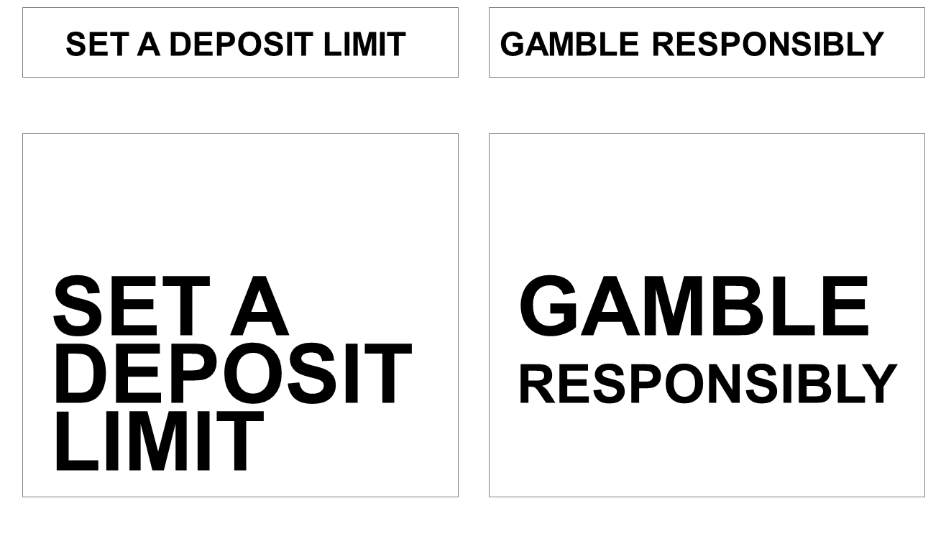 | CLARITY  Design elements:  Black text on white background, uniform font and style (capitals and bold)  Intention behind design:  Simple and clear presentation with no distracting elements
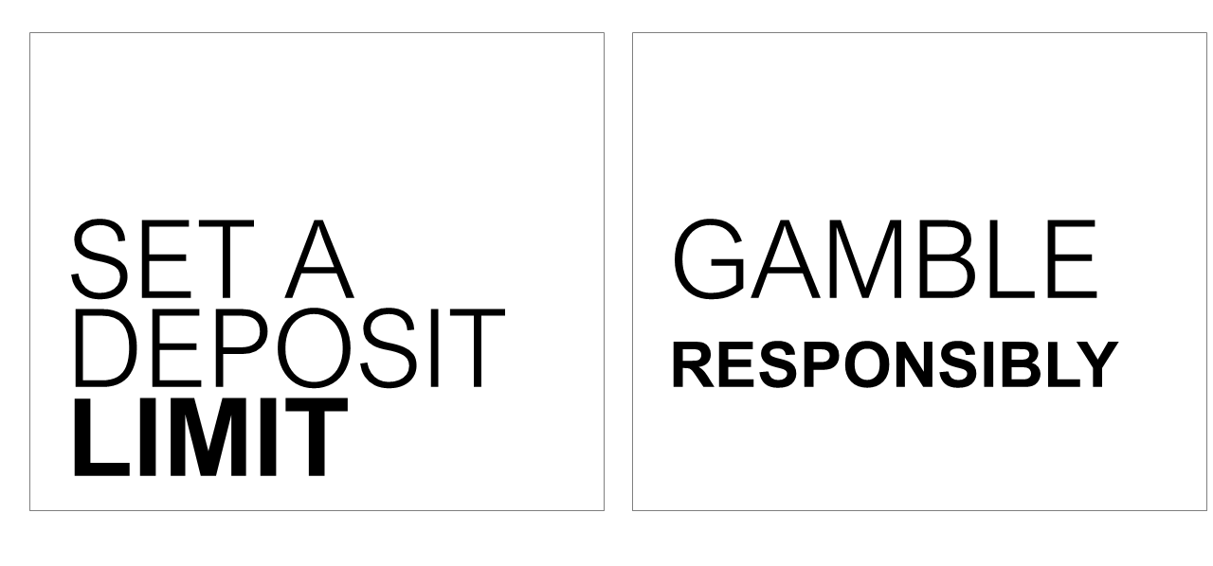 | EMPHASIS  Design elements:  Specific word bolded, uniform font and consistent black text on white background  Intention behind design:  Emphasis of a specific word to draw attention
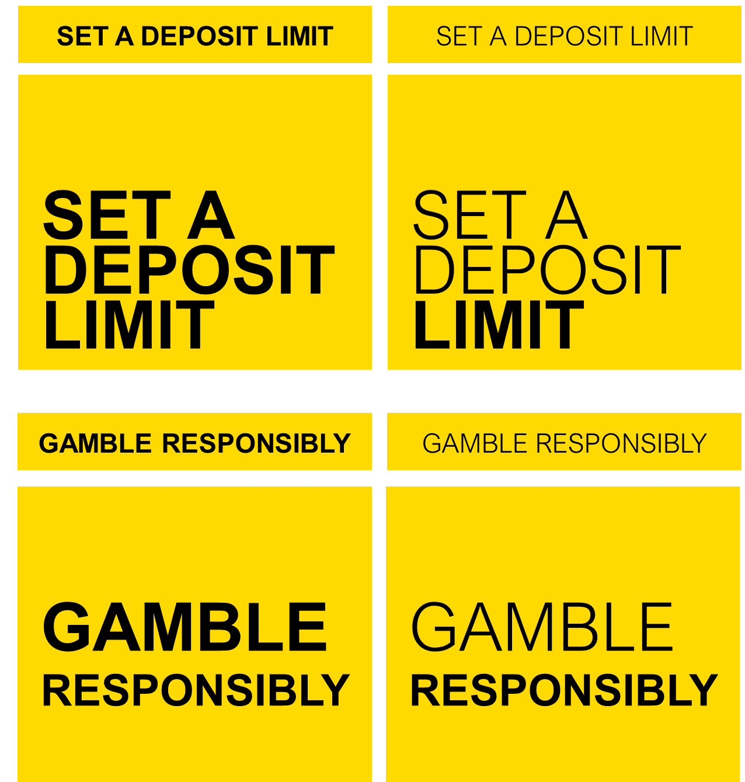 | COLOUR  Design elements:  Introduction of bold background colour, uniform font and style (capitals and bold)  Intention behind design:  Catch viewers eye with coloured background and promote tagline standout with contrasting background and text colours
REALISM
Design elements:
Tagline shown in situ in a mocked-up gambling advertisement. Tagline presented in white font, small print, near the bottom of the ad
Intention behind design:
Mirror the placement and presentation of current gambling harm reduction messages
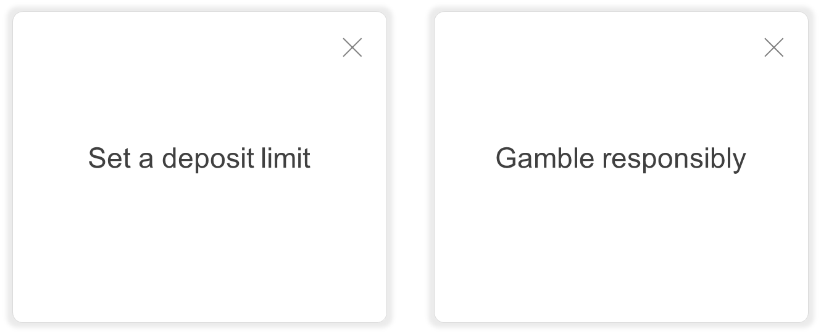 | INTERACTIVE  Design elements:  Tagline presented as a pop-up box, simple plain text on white background  Intention behind design:  Show tagline in standard tick-box that viewers are familiar with and are used to interacting with (e.g. needing to actively close the window for the message to close)
Given the claimed importance of tagline location and timing and perceived efficacy of tailoring in this manner, the expected application of each tagline was validated in the quantitative phase to understand potential online and land-based environments in which to present the tagline for maximum impact.

The selection of multiple taglines was considered a favourable option to communicate the message and demonstrate the government’s seriousness in engaging consumers and the broader community with the message
In the minds of participants, the ‘Gamble responsibly’ tagline was felt to lack impact with some wondering if it was intended to do more than merely “tick a box” for both government and industry. There were no objections to replacing the current tagline with several warning messages and some felt that this would help to demonstrate the government’s commitment to communicating about the harms of online wagering.
“If people just see one everywhere, they think it’s a box-ticking exercise and the government doesn’t really care. But if there’s lots of different ones you chose it’s like a little bit more thought has been put into it and it’s been tackled from multiple angles and that makes people think it’s a bit more serious.” (Low/moderate risk First Nations male, 18-35, Regional QLD)
The taglines tested did not appear at conflict with one another, and therefore it was felt that having several taglines which had slightly different messaging approaches and ideas could help to engage a broader range of consumers. Additionally, given some taglines were considered particularly relevant for specific moments in the consumer wagering journey (for example, before confirming a bet), the support for multiple taglines was heightened to draw the attention of the consumer at different points in time where they might have strongest relevance. Further, many discussed the value of seeing a mix of taglines across and within different contexts where the ‘gamble responsibly’ tagline is currently shown and claimed that it would reduce the likelihood of them ‘tuning out’ of the message in a short space of time.
“You’d want these messages to be seen several times so that they sink in for people. If I saw one of the messages just in an ad I probably wouldn’t do much about it because I’m not actually gambling then. But then if I saw another message, or even the same message, in the [betting] app every time I went to bet then it would start to sink in.” (High risk male, 18-35)
Should there be several effective taglines, there is opportunity to proceed with a suite of messages, provided that none of the taglines are conflicting in their message. It is recommended that such a suite of taglines be rotated across and within channels/platforms to help to reduce consumer fatigue to the message over time. This could be in the form of one tagline in market at a time and rotating the message after a given period, or alternatively, running several messages in market at one time each in different channels (for example, in advertising versus within the betting app), rotated with other messages from the suite after a given period.

Phase II Quantitative insights: selection of final tagline(s)
Discussion of the qualitative findings resulted in ten taglines taken forward to be tested in the quantitative message testing. In no particular order:
- Chances are you’re about to lose
- The odds are stacked against you
- If in doubt opt out
- Tired of that losing feeling?
- Think. Is this a bet you really want to place?
- 92% of people set limits. Do you?
- Betting’s better with boundaries
- Imagine what you could be buying instead
- You win some. You lose more
- What are you prepared to lose today?
Each tagline was evaluated on a range of 17 different performance diagnostics. These diagnostics have been grouped into the following themes to allow the research team to a) identify a refined set of top performing messages, and b) assess the relative strengths and weaknesses of the tagline.
Salience and potential cut through | Rational response | Potential impact on taking action | Emotional reaction (Positive) | Emotional reaction (Negative)
It grabs my attention | It changes how I think about gambling in general | It makes me want to talk to others about gambling | It speaks to me on a personal level | I don't like this message
It is memorable | I believe what is being said in this message | It makes me reconsider my spend or time limits while I'm playing | It makes me feel  empowered | This message goes too far
 | It reminds me that I can seek help if I need it | It makes me reconsider whether I really want to place this bet or play this game |  | It makes me feel uncomfortable
 | It makes me think about what I could lose | It suggests to me that I should stop betting or playing altogether
 | It reminds me that I don't control the odds | It suggests that I should cut back my gambling activity
While analysis was conducted across all key sub-groups of interest where possible across the taglines, for the purposes of strategic guidance the analysis detailed in this report focuses on performance of all consumers, online wagerers, moderate-risk gamblers and problem (high-risk) gamblers. Across the board, we note that ratings were consistently stronger among problem gamblers compared to the other key audiences. As a result, each theme speaks to multiple ‘winning’ taglines to ensure that performance across all key audiences was taken into consideration. For the purposes of selecting the final suite of taglines, researchers analysed differences which at times may only be marginal.

Salience and potential cut through
Firstly, the research team considered how well these taglines grabbed attention and were memorable.

This analysis, as shown in Figure 61, revealed two standout performers on salience and potential cut through – ‘Chances are you’re about to lose’ and ‘Imagine what you could be buying instead’, both of which were strong among all key consumer audiences, particularly moderate-risk gamblers.
Figure 61 - Tagline ratings (7-10 agreement) - SALIENCE AND POTENTIAL CUT-THROUGH AVERAGES
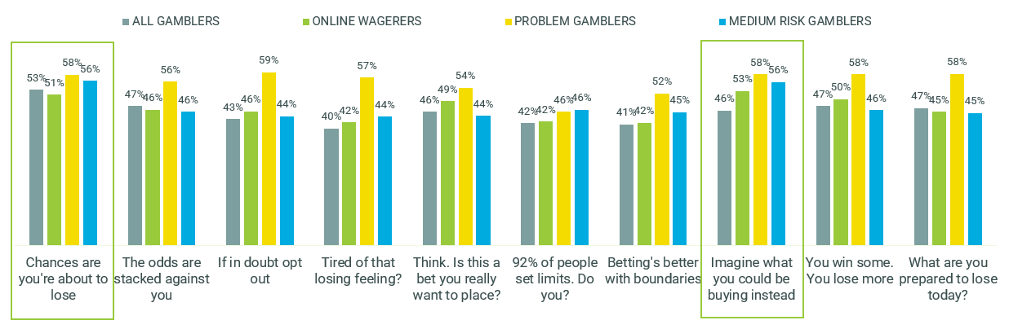
E2. We'd now like you to think about how well each of the below applies to this message. For each, please indicate on a scale from 0 to 10, where 0 means you feel that it doesn't apply at all to this message and 10 means you feel that it applies extremely well.
MESSAGE TESTING SURVEY: All gamblers n=445-457 per tagline, Online wagerers n=125-154 per tagline, Problem gamblers n=80-110 per tagline, Moderate risk n=70-89 per tagline

Salience and memorability were considered individually among the aforementioned top two performers, as well as ‘What are you prepared to lose today?’ which performed well on salience in the qualitative interviews. The following findings illustrated in

Figure 62 highlight how different taglines performed more strongly on salience across the various audiences, while a message deemed ‘attention-grabbing’ was not necessarily considered ‘memorable’:
- Moderate-risk gamblers found ‘Chances are you’re about to lose’ and ‘Imagine what you could be buying instead’ almost equally attention-grabbing, while ‘Chances are you’re about to lose’ performed slightly better than the other taglines on memorability.
- Performance of these taglines on attracting attention was less distinct among broader online wagerers, while ‘Imagine what you could be buying instead’ appeared to be more memorable.
- ‘What are you prepared to lose today?’ was rated the strongest at attracting attention among problem gamblers, but was deemed less memorable than the other taglines.

Figure 62 - Tagline ratings (7-10 agreement) - SALIENCE AND POTENTIAL CUT-THROUGH -Individual diagnostics on key performers
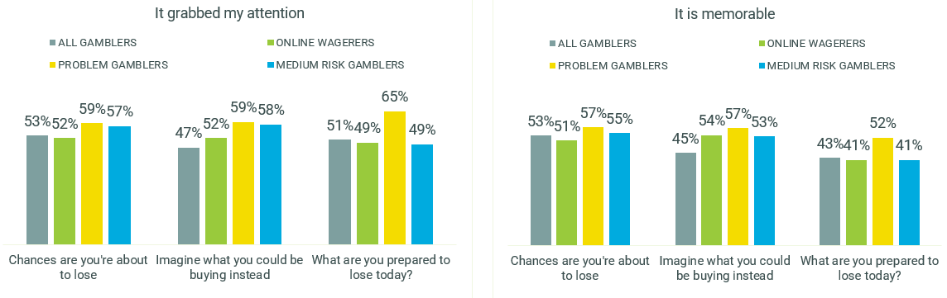
E2. We'd now like you to think about how well each of the below applies to this message. For each, please indicate on a scale from 0 to 10, where 0 means you feel that it doesn't apply at all to this message and 10 means you feel that it applies extremely well.
MESSAGE TESTING SURVEY: All gamblers n=445-457 per tagline, Online wagerers n=125-154 per tagline, Problem gamblers n=80-110 per tagline, Moderate risk n=70-89 per tagline

Rational response
Secondly, the research team considered these taglines’ ability to elicit a more rational response: that is, to change how consumers think about gambling, cause them to think about how much they could lose, remind them that they can seek help if they need it, and remind them that they do not control the odds. The taglines were also tested for their general believability. When we took into account performance with all audiences, there were three stand-outs as shown in Figure 63 - ‘Chances are you’re about to lose’ which achieved the strongest rational response among moderate-risk gamblers, ‘You win some. You lose more.’ which achieved a solid response among both online wagerers and problem gamblers, and ‘What are you prepared to lose today?’ which achieved the strongest response among problem gamblers.

Figure 63 - Tagline ratings (7-10 agreement) - RATIONAL RESPONSE AVERAGES
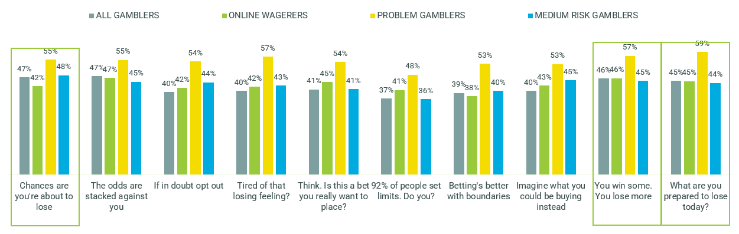
E2. We'd now like you to think about how well each of the below applies to this message. For each, please indicate on a scale from 0 to 10, where 0 means you feel that it doesn't apply at all to this message and 10 means you feel that it applies extremely well.
MESSAGE TESTING SURVEY: All gamblers n=445-457 per tagline, Online wagerers n=125-154 per tagline, Problem gamblers n=80-110 per tagline, Moderate risk n=70-89 per tagline

We again considered the individual elements of rational response for top performers at
Figure 64, along with ‘Think. Is this a bet you really want to place?’ which tested well qualitatively in terms of creating a rational internal dialogue. The following highlighted how these various taglines triggered different rational responses.
- Taglines that were most effective at changing how consumers think about gambling differed by audience: ‘Think. Is this a bet you really want to place?’ was most likely to cause online wagerers to think differently about gambling; ‘You win some. You lose more.’ and ‘What are you prepared to lose today?’ performed best among problem gamblers; ‘Imagine what you could be buying instead’ performed best among moderate-risk gamblers; and ‘Chances are you’re about to lose’ among all gamblers, including land-based gamblers.
- On believability, ‘Think. Is this a bet you really want to place?’ was for the most part weaker than the other taglines, aside from ‘Chances are you’re about to lose’ which was weaker among online wagerers.
- ‘Chances are you’re about to lose’ was consistently stronger on reminding consumers that they do not control the odds, which may point to a particular effectiveness against the strategic mindset.
- ‘What are you prepared to lose today’ was consistently stronger on making consumers think about what they could lose.
- In terms of these taglines’ ability to be reminders to seek help, ‘Think. Is this a bet you really want to place?’ and ‘You win some. You lose more.’ were stronger among online wagerers and moderate-risk gamblers. ‘You win some. You lose more.’ and ‘What are you prepared to lose today?’ were stronger among problem gamblers.

Figure 64 - Tagline ratings (7-10 agreement) – RATIONAL RESPONSE - Individual diagnostics on key performers
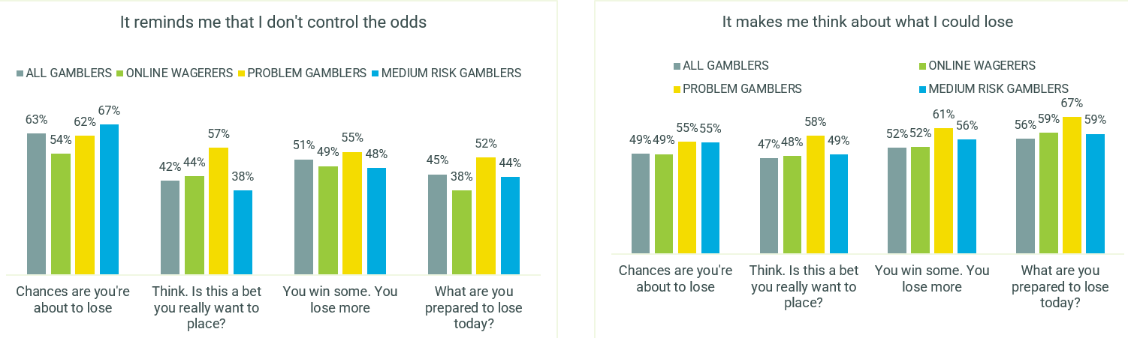
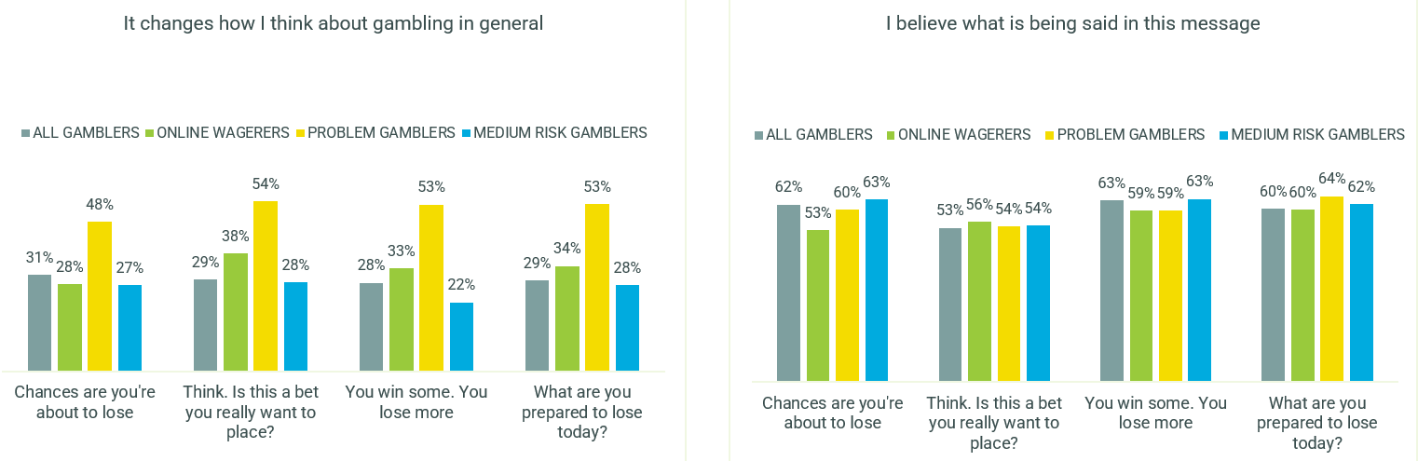
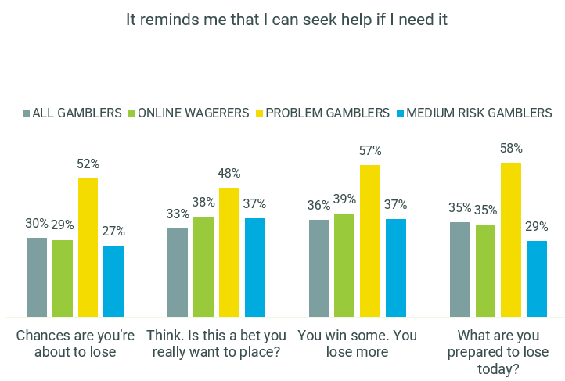
E2. We'd now like you to think about how well each of the below applies to this message. For each, please indicate on a scale from 0 to 10, where 0 means you feel that it doesn't apply at all to this message and 10 means you feel that it applies extremely well.
MESSAGE TESTING SURVEY: All gamblers n=445-457 per tagline, Online wagerers n=125-154 per tagline, Problem gamblers n=80-110 per tagline, Moderate risk n=70-89 per tagline

Potential impact on taking action
It was essential to understand the potential impact these taglines will have on action among consumers, in terms of wanting to talk to others, reconsidering spend or time limits, reconsidering whether this was a bet they really wanted to place, thinking about whether they should stop altogether and likely influence on reducing their gambling activity. Figure 65 shows how, rather than being uniform, ability to influence action differed by tagline across the different audiences.

- ‘Chances are you’re about to lose’ was the strongest at potentially eliciting action among moderate-risk gamblers, but it was not as strong among problem gamblers and online wagerers.
- ‘Think. Is this a bet you really want to place?’ achieved the strongest potential action among online wagerers.
- ‘What are you prepared to lose today?’ was the strongest among problem gamblers.
- ‘Imagine what you could be buying instead’ did well to potentially capture both online wagerers and moderate-risk gamblers.
Figure 65 - Tagline ratings (7-10 agreement) - POTENTIAL IMPACT ON ACTION AVERAGES
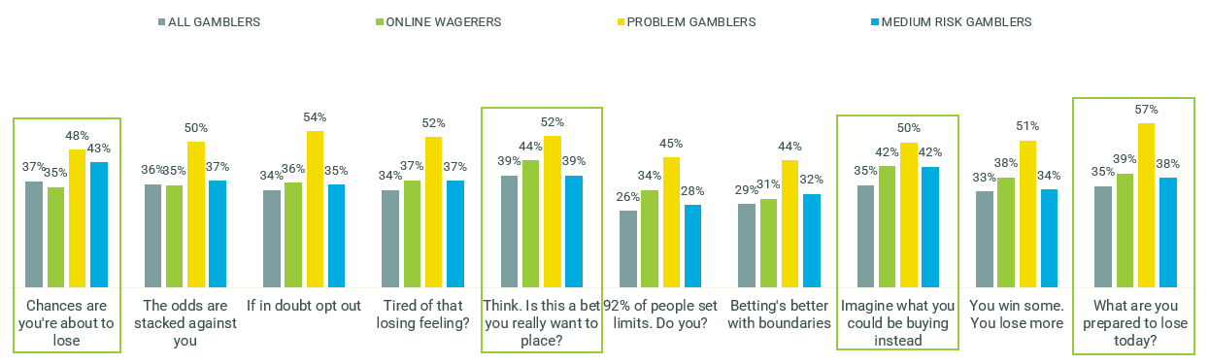
E2. We'd now like you to think about how well each of the below applies to this message. For each, please indicate on a scale from 0 to 10, where 0 means you feel that it doesn't apply at all to this message and 10 means you feel that it applies extremely well.
MESSAGE TESTING SURVEY: All gamblers n=445-457 per tagline, Online wagerers n=125-154 per tagline, Problem gamblers n=80-110 per tagline, Moderate risk n=70-89 per tagline

We again considered the individual elements of potential impact on action among these top performers:
- ‘What are you prepared to lose today?’ was strongest in making problem gamblers want to reconsider their limits, while there was less distinction between the top messages on this aspect among moderate-risk gamblers and online wagerers.
- In a similar vein among problem gamblers, ‘What are you prepared to lose today?’ was the strongest at making them reconsider whether they wanted to place a bet, while for online wagerers and moderate risk gamblers the more direct ‘Think. Is this a bet you really want to place?’ was the most compelling.
- ‘Chances are you’re about to lose’ was most likely to make moderate risk gamblers consider stopping altogether, while ‘Imagine what you could be buying instead’ did this for online wagerers, while the top taglines were less distinct among problem gamblers on this aspect.
For each of the consumer audiences, there were a couple of different key taglines that worked to compel consumers to consider reducing their gambling activity, again highlighting how various taglines could work to effect different behavioural levers.
- The taglines were relatively limited in making moderate-risk gamblers want to talk to others, compared to online wagerers who were most compelled by ‘Think. Is this a bet you really want to place?’, and problem gamblers who were most compelled by ‘What are you prepared to lose today?

Figure 66 - Tagline ratings (7-10 agreement) – POTENTIAL IMPACT ON ACTION - Individual diagnostics on key performers
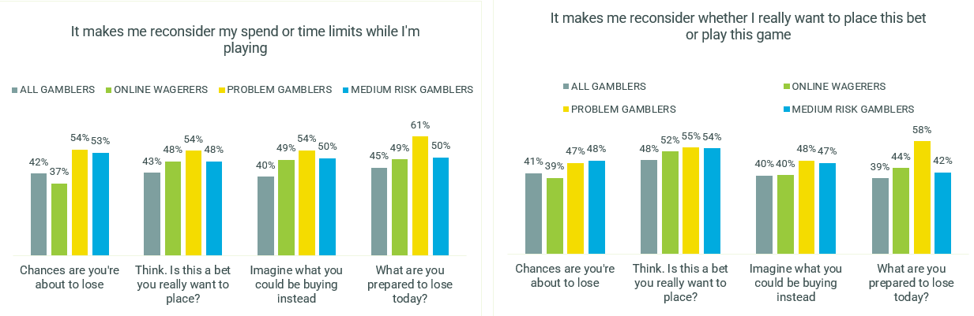
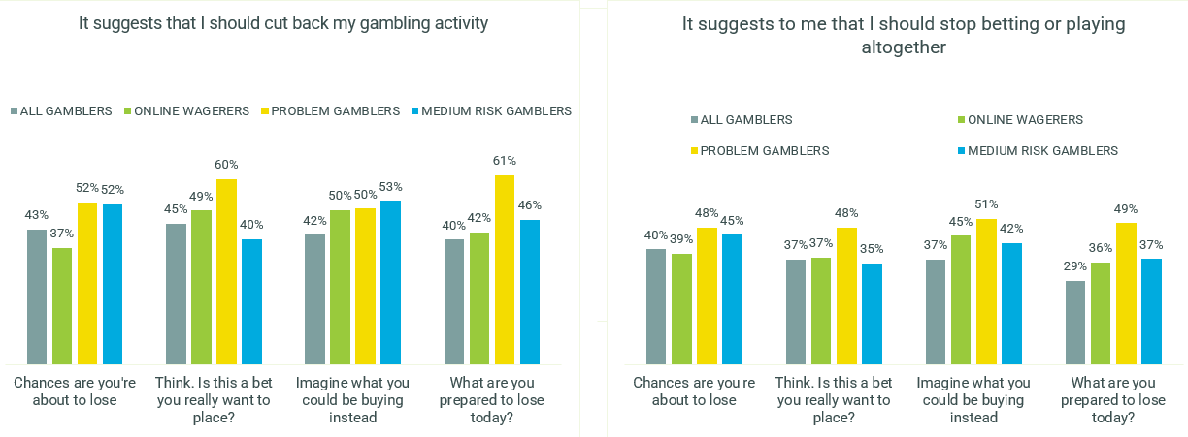
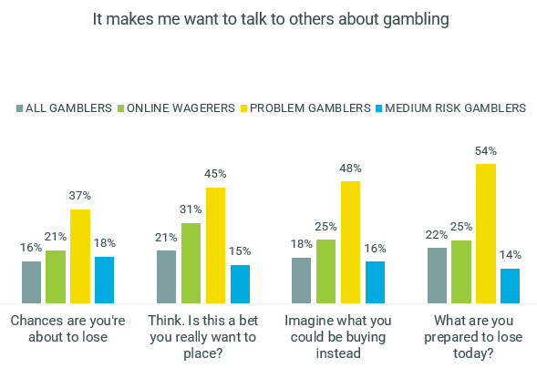
E2. We'd now like you to think about how well each of the below applies to this message. For each, please indicate on a scale from 0 to 10, where 0 means you feel that it doesn't apply at all to this message and 10 means you feel that it applies extremely well.
MESSAGE TESTING SURVEY: All gamblers n=445-457 per tagline, Online wagerers n=125-154 per tagline, Problem gamblers n=80-110 per tagline, Moderate risk n=70-89 per tagline

Emotional reaction (Positive)
Positive emotional response, in terms of these taglines resonating on a personal level and leaving consumers feeling empowered, was relatively limited among online wagerers and moderate-risk gamblers compared to problem gamblers, as seen in Figure 67. ‘What are you prepared to lose today?’ achieved stronger positive reactions among most audiences aside from the moderate-risk gamblers. The strongest positive reaction among moderate-risk gamblers was for the normative message ‘92% of people set limits. Do you?’ however the reaction among the other audiences was not as strong.

Figure 67 - Tagline ratings (7-10 agreement) - EMOTIONAL REACTION (POSITIVE) AVERAGES
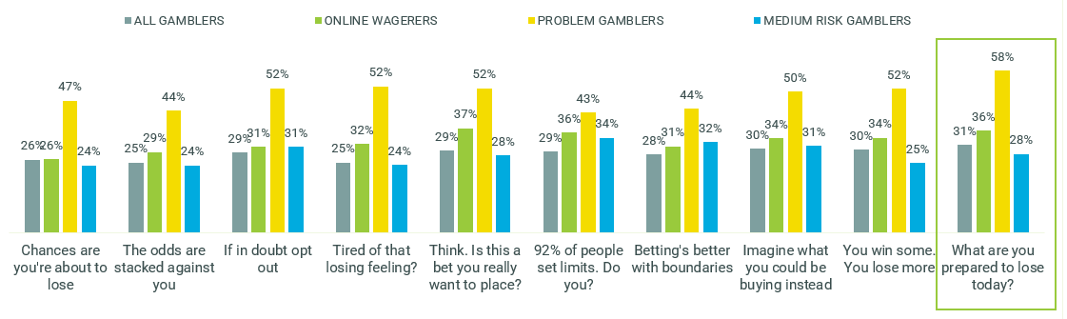
E2. We'd now like you to think about how well each of the below applies to this message. For each, please indicate on a scale from 0 to 10, where 0 means you feel that it doesn't apply at all to this message and 10 means you feel that it applies extremely well.
MESSAGE TESTING SURVEY: All gamblers n=445-457 per tagline, Online wagerers n=125-154 per tagline, Problem gamblers n=80-110 per tagline, Moderate risk n=70-89 per tagline
‘What are you prepared to lose today?’ was the tagline that spoke to all consumer audiences at the strongest personal level – this appeared to have been the case for problem gamblers and online wagerers and was among the stronger taglines for moderate-risk gamblers.
Figure 68 - Tagline ratings (7-10 agreement) – EMOTIONAL REACTION (POSITIVE) – Personal relevance
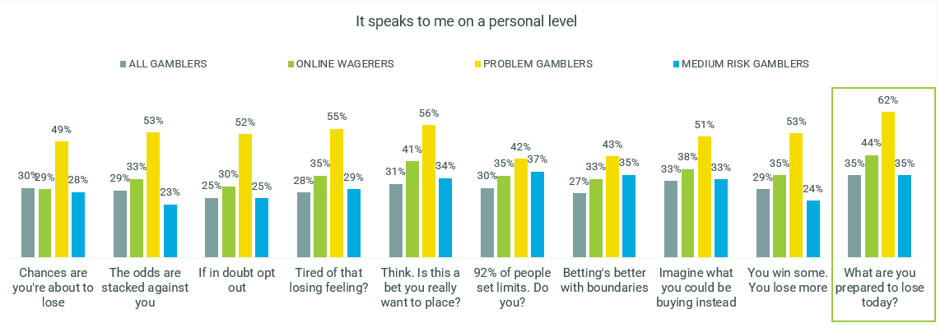
E2. We'd now like you to think about how well each of the below applies to this message. For each, please indicate on a scale from 0 to 10, where 0 means you feel that it doesn't apply at all to this message and 10 means you feel that it applies extremely well.
MESSAGE TESTING SURVEY: All gamblers n=445-457 per tagline, Online wagerers n=125-154 per tagline, Problem gamblers n=80-110 per tagline, Moderate risk n=70-89 per tagline

Emotional reaction (Negative)
When considering negative emotional reactions such as not liking the tagline, feeling that the message goes too far and leaving the consumer feeling uncomfortable, one of the top performing taglines across some of the previous elements, ‘Chances are you’re about to lose’ elicited a stronger negative reaction among online wagerers and moderate-risk gamblers, as seen in

Figure 69.

Figure 69 - Tagline ratings (7-10 agreement) - EMOTIONAL REACTION (NEGATIVE) AVERAGES
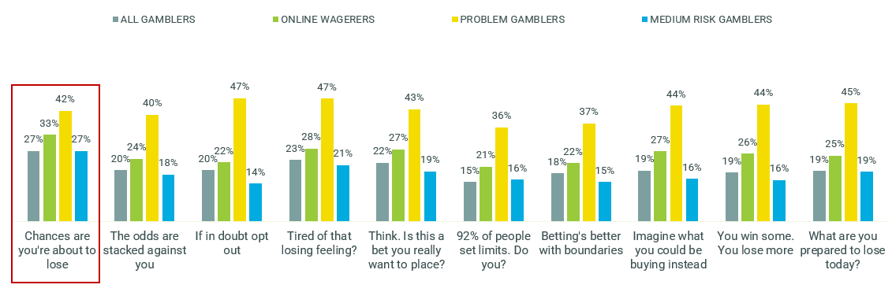
E2. We'd now like you to think about how well each of the below applies to this message. For each, please indicate on a scale from 0 to 10, where 0 means you feel that it doesn't apply at all to this message and 10 means you feel that it applies extremely well.
MESSAGE TESTING SURVEY: All gamblers n=445-457 per tagline, Online wagerers n=125-154 per tagline, Problem gamblers n=80-110 per tagline, Moderate risk n=70-89 per tagline
However, a negative reaction may not necessarily be an undesirable response in this context. Figure 70 shows that there was a positive correlation between salience and potential cut-through and the negative reaction of a tagline, suggesting that a confronting or challenging tagline may stand out. This correlation was seen across all key cohorts, but was particularly strong among problem gamblers, and relatively modest among online wagerers and moderate-risk gamblers.

Figure 70 - Tagline ratings (7-10 agreement) – Correlations between salience/cut-through and negative emotional reaction
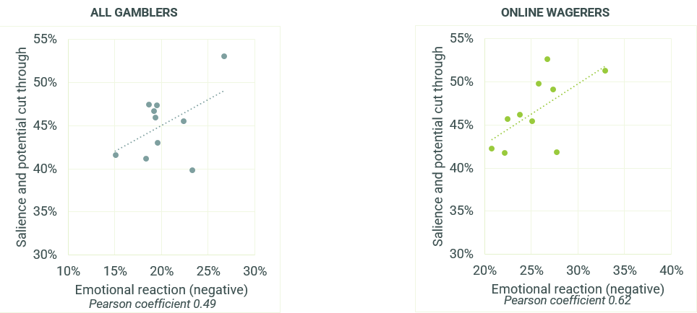

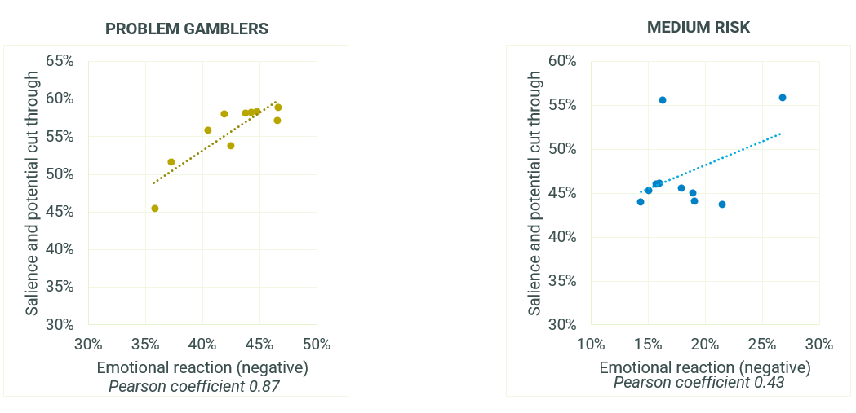
E2. We'd now like you to think about how well each of the below applies to this message. For each, please indicate on a scale from 0 to 10, where 0 means you feel that it doesn't apply at all to this message and 10 means you feel that it applies extremely well.
MESSAGE TESTING SURVEY: All gamblers n=445-457 per tagline, Online wagerers n=125-154 per tagline, Problem gamblers n=80-110 per tagline, Moderate risk n=70-89 per tagline

Selecting the top performing taglines
The results across these various rating themes, in particular the difference in performance across the key audiences, indicates that a single ‘cover-all’ tagline could not be identified. Instead, a set of five taglines that perform well on various attributes among the various audiences were identified (listed here in no particular order).
 | Strengths | Considerations
Chances are you're about to lose. | - Did well on salience and potential cut-through among most audiences, particularly moderate-risk gamblers.  - Achieved a stronger rational response among moderate-risk gamblers.  - Stronger at potentially eliciting action among moderate-risk gamblers. | - Not as strong at eliciting action among problem gamblers and online wagerers.  - Potential risk around stronger negative emotional reaction – however this is not necessarily deemed as a weakness.
Think. Is this a bet you really want to place? | - Achieved stronger potential action among online wagerers. | - May have to work harder to be salient and cut through.
Imagine what you could be buying instead. | - Did well on salience and potential cut through among most audiences, particularly moderate-risk gamblers.  - Did well to potentially capture potential action among both online wagerers and moderate risk gamblers. | - Not the strongest performer among problem gamblers.
You win some. You lose more | - Achieved a solid rational response among both online wagerers and problem gamblers. | - May have to work harder to be salient and cut through.  - Lukewarm in terms of emotional reaction (both positive and negative).
What are you prepared to lose today? | - Achieved a stronger rational response and stronger potential action among problem gamblers.  - Achieved stronger positive results among most audiences aside from the moderate-risk gamblers. | - May have to work harder to be salient and cut through.  - Not the strongest performer among moderate-risk gamblers.

Performance of taglines among First Nations and CALD audiences
While the following results in Figure 71 need to be treated with caution due to low sample size, tagline performance results among FIRST NATIONS audiences suggest that while two of the stronger performers (‘If in doubt, opt out’ and ‘Tired of that losing feeling?’) were not in the final recommended top five, two of these top 5 messages perform well. ‘Imagine what you could be buying instead’ did well to cut through, influence potential action and elicit a strong positive emotional response, while ‘What are you prepared to lose today?’ also performed well on influencing action and eliciting a positive emotional action. The other three messages achieved more of a lukewarm performance among First Nations audiences but were by no means the weakest.
Figure 71 - Summary of tagline performance – First Nations audiences - Tagline ratings (7-10 agreement) – THEME AVERAGES
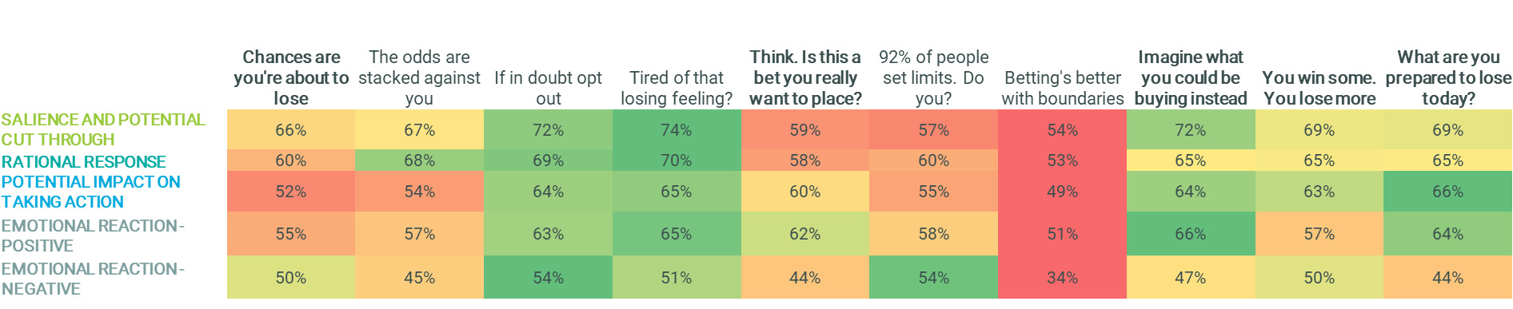
E2. We'd now like you to think about how well each of the below applies to this message. For each, please indicate on a scale from 0 to 10, where 0 means you feel that it doesn't apply at all to this message and 10 means you feel that it applies extremely well.
MESSAGE TESTING SURVEY: First Nations audiences n=20-34 *PLEASE TREAT THESE RESULTS WITH CAUTION DUE TO LOW BASE SIZE
Among CALD audiences (Figure 72), ‘Chances are you’re about to lose’ was one of the stronger performing taglines, rating particularly well on cut through, rational response and influencing potential action. ‘Think. Is this a bet you really want to place?’ also achieved solid performance on potential impact and positive emotional reaction. Similar to the First Nations audiences, the other three top five messages also rated strongly.
Figure 72 - Summary of tagline performance – CALD audiences - Tagline ratings (7-10 agreement) – THEME AVERAGES
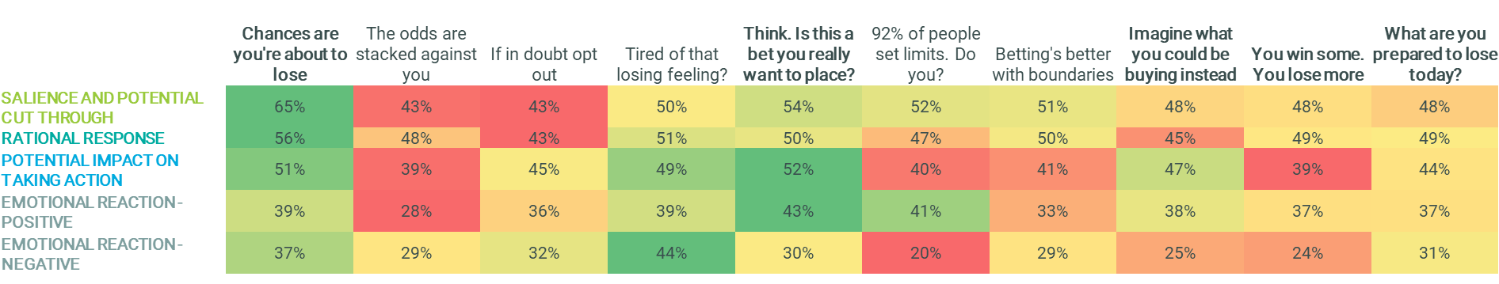
E2. We'd now like you to think about how well each of the below applies to this message. For each, please indicate on a scale from 0 to 10, where 0 means you feel that it doesn't apply at all to this message and 10 means you feel that it applies extremely well.
MESSAGE TESTING SURVEY: CALD audiences n=63-79
Tagline applications
After rating these taglines, respondents were then asked to imagine where they would most expect to see them, selecting from a variety of applications both in-app and outside the online environment. The following analysis highlights that taglines were not consistently envisioned across the various audiences. Given that this was a slightly abstract concept for respondents to imagine (particularly in the context of an online survey) generally there were no stark differences across tagline and application, which highlighted the need for a range or rotation of taglines to be able to apply across a various range of situations.

Figure 73 shows that among all consumers broadly, ‘What are you prepared to lose today?’’ was consistently imagined across the most applications. ‘Think. Is this a bet you really want to place?’ was most strongly aligned with confirming or placing a bet on a betting app. ‘You win some. You lose more.’ tended to be seen as aligned with advertising and broadcasting applications.
Figure 73 - Message applications – top 5 taglines - ALL GAMBLERS
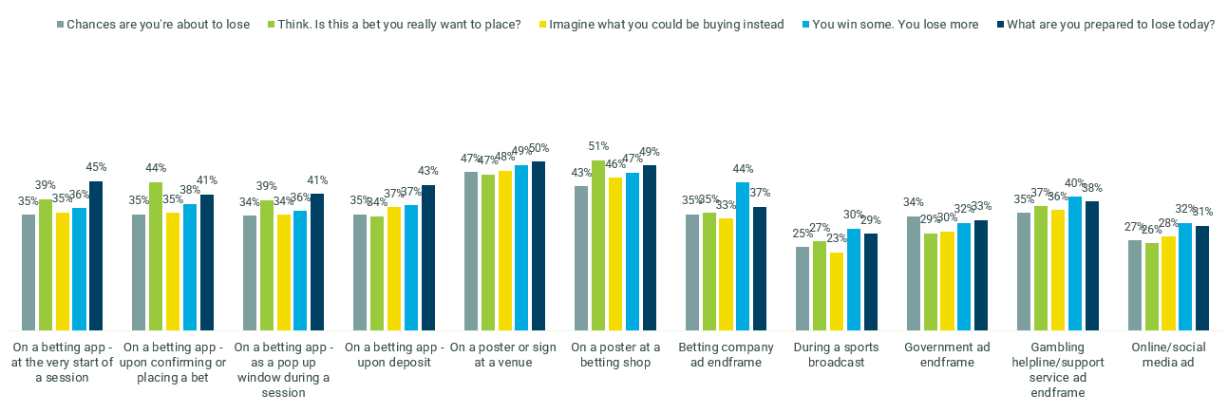
E3. Thinking about where you usually see messages while you're betting or playing - where would you expect to see this message specifically?
MESSAGE TESTING SURVEY: All gamblers n=445-457 per tagline
As seen in Figure 74, ‘Chances are you’re about to lose’ was perhaps the least imagined consistently across all applications for online wagerers. ‘You win some. You lose more.’ was more aligned with most betting app applications, as was ‘What are you prepared to lose today?’ to a slightly lesser extent. ‘Imagine what you could be buying instead’ skewed more towards a wider range of messaging applications.
Figure 74 - Message applications – top 5 taglines - ONLINE WAGERERS
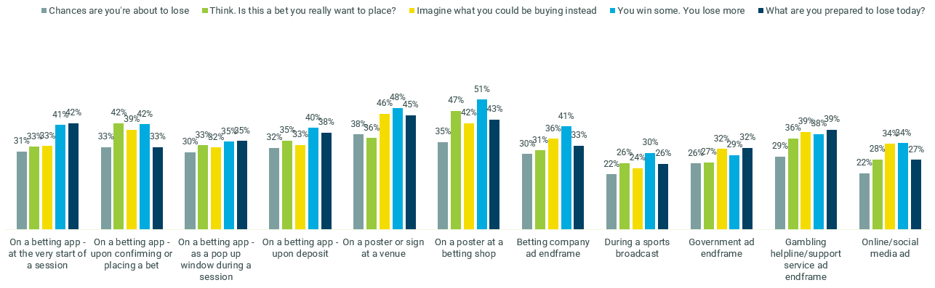
E3. Thinking about where you usually see messages while you're betting or playing - where would you expect to see this message specifically?
MESSAGE TESTING SURVEY: Online wagerers n=125-154 per tagline
Among problem gamblers in
Figure 75, ‘Think. Is this a bet you really want to place?’ and ‘You win some. You lose more.’ were seen as being better-placed in betting app settings. ‘You win some. You lose more.’ and ‘What are you prepared to lose today?’ also skewed towards a range of advertising applications.
Figure 75 - Message applications – top 5 taglines - PROBLEM GAMBLERS
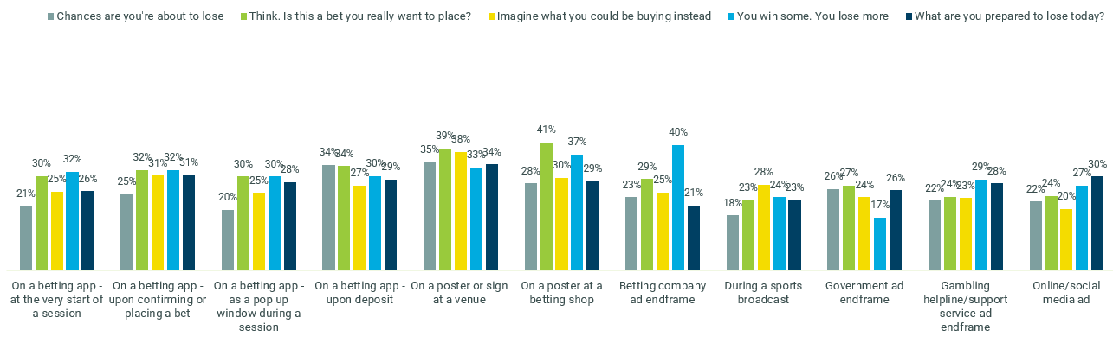
E3. Thinking about where you usually see messages while you're betting or playing - where would you expect to see this message specifically?
MESSAGE TESTING SURVEY: Problem gamblers n=80-110 per tagline

Among moderate-risk gamblers in Figure 76, ‘What are you prepared to lose today?’ was envisioned as belonging in most betting app applications, as was ‘Think. Is this a bet you really want to place?’ to a slightly lesser extent.
Figure 76 - Message applications – top 5 taglines - MODERATE RISK GAMBLERS
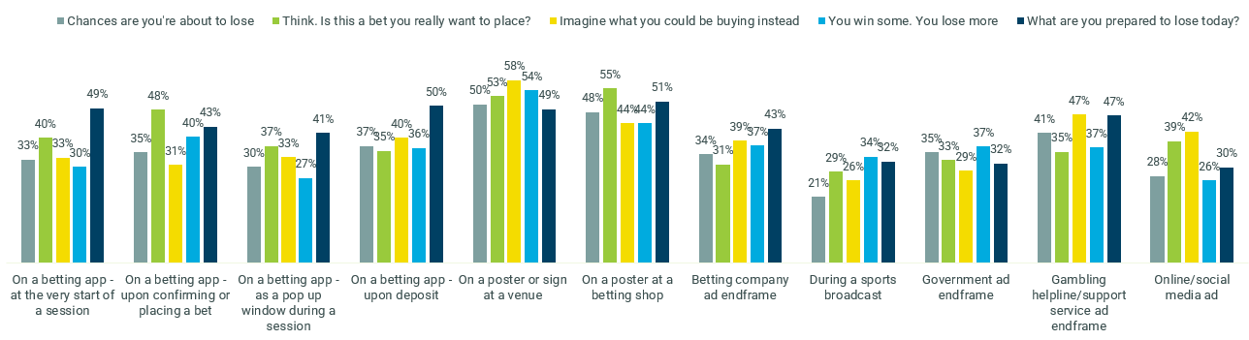
E3. Thinking about where you usually see messages while you're betting or playing - where would you expect to see this message specifically?
MESSAGE TESTING SURVEY: Moderate risk n=70-89 per tagline

Testing of presentation and layout
In order to gain some initial insights into how presentation and format could be used to optimise the effectiveness of these taglines, the research team conducted a heatmapping exercise in this survey, using the following mocked-up examples, across two taglines: ‘Set a deposit limit’ and ‘Gamble responsibly’ to isolate any potential message effects from the evaluation of the presentation and format.
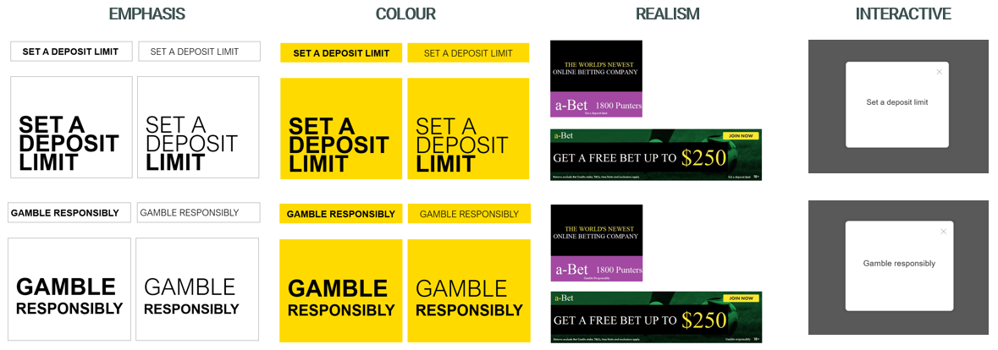
Each application was tested monadically (i.e. respondents were split into evenly matched cells to solely test one layout) and respondents were asked to click on the areas of these layouts which stood out the most to them. The resulting outputs were heatmaps that demonstrated which features had more potential to draw attention than others. While the following results were specifically among online wagerers, the outputs were almost identical among the broader gambler group.
The resulting heatmaps among online wagerers in Figure 77 suggested that taglines will not be noticed if included as small subtext in an betting ad, the current representation of messaging to reduce gambling harm. The pop-up did well to focus attention particularly towards the last few words of the taglines with minimal frills. In the basic online banner styles, bolding the full taglines successfully captured attention.
Figure 77 - Presentation and format heat maps - ONLINE WAGERERS
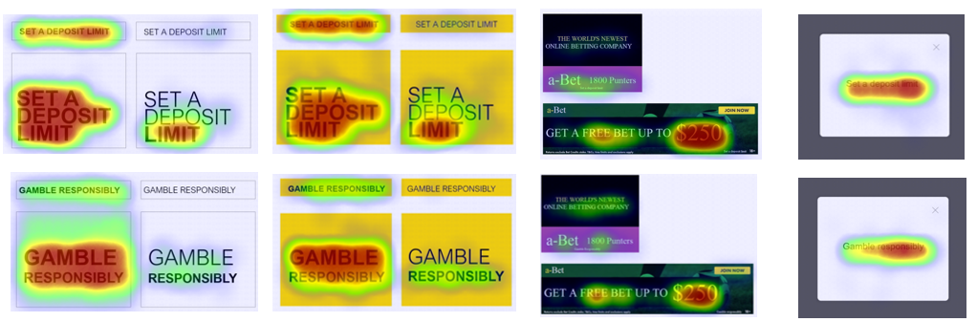
F1. Firstly, we'd like you to take a look at this image an click the areas that stand out to you the most. You can select as many or as few areas of this image as you like.
MESSAGE TESTING SURVEY: Online wagerers n=104-130 per layout

When asked to rate these formats against a small range of diagnostics as seen in Error! Reference source not found., the basic white online display banner layout performed best at attracting attention, being easy to read, and being applicable across multiple settings. The yellow version was not as attention-grabbing but was deemed the strongest at bringing all formatting and layout elements together nicely. While perhaps the most disruptive format, the pop-ups performed the weakest on the suitability, size and salience.
Figure 78 - Layout diagnostics - ONLINE WAGERERS
The tagline is easy to read | 58% | 56% | 45% | 46%
The size of the tagline grabs my attention | 43% | 37% | 31% | 20%
The tagline grabs my attention | 42% | 38% | 36% | 30%
This could work well across different types of gambling settings | 42% | 36% | 25% | 33%
The presentation of the tagline suits the message | 38% | 29% | 25% | 19%
Everything works well together to make me notice the message | 26% | 34% | 18% | 25%
I don't think I'd even notice this | 13% | 8% | 18% | 26%
F2. Which of the following do you think applies to this image? *Colour coding is conditional formatting only and not indicative of significant differences.
MESSAGE TESTING SURVEY: Online wagerers n=104-130 per layout
These findings suggested two key implications for presentation and layout. First, that a basic white format with uniformed bolding is a particularly effective way to both disrupt and focus attention on the tagline. And secondly, that including taglines in the ‘Terms and conditions’ areas of industry ads gains very little attention and could partly explain why the ‘Gamble Responsibly’ tagline has been struggling to be top of mind among consumers

Conclusions & recommendations
- Prominent biases, heuristics, and habits of those who engage in online wagering behaviour severely limited the self-assessment of and reflection on consumers’ gambling-related behaviours
There was a distinct separation between one’s own gambling behaviour and the perception of ‘problem gambling’, even among those who exhibited attitudes or behaviours that were harmful according to the PGSI. This translated to people distancing themselves from words, attitudes, beliefs, and behaviours communicated through the message territories and taglines that they believed applied to ‘other’ people who ‘needed’ such messages (due to their behaviour constituting a problem).
In most cases, this separation was not intentional or reflective – a genuine cognitive dissonance existed. As such, self-exclusion from the messages was one of the primary challenges to identifying successful taglines: people did not see the tagline as relevant or speaking to them personally.
This challenge was exacerbated by the fact that consumers could simultaneously agree with the truth underpinning a tagline (and therefore agree that it was believable) yet self-exclude from the message due to perceived irrelevance at a personal level, even in cases where taglines were designed specifically to speak to human insights and reflect a personal mindset and behaviour in relation to online wagering.
It was evident that a strong foundational truth alone was not enough for a tagline to be effective at prompting people to reflect on their own behaviour. Personal relevance in partnership with believability was critical to effective messaging that intercepted consumers’ rational decision-making process.
- Taglines that were most effective performed on multiple fronts to address the challenge of behaviour change
Influencing change in complex behaviours and cluttered environments such as online gambling requires a multifaceted approach to evaluating efficacy. Efficacy was evaluated on several dimensions of equal importance:

Salience and attention
Taglines that resonated were successful at initiating engagement and increased the likelihood that the message would be read. Successful taglines had a level of memorability, whether that was a new way of speaking about the issue, impressive word play or a hard-hitting phrase, and most claimed that these taglines would remain memorable in the following days, weeks, and months.

Rational response
Beyond catching attention, successful taglines prompted consumers to stop and think about what the message was saying to them. This led them to consider the message’s believability and subsequently reminded them of a truth or fact that was no longer top-of-mind (for example, that losing is a realistic outcome of betting).

Behavioural response
Taglines that elicited a reconsideration of behaviour and intercepted rational decision-making were considered highly effective. Ultimately this was the intended outcome of the taglines: to reduce behaviours that might lead to consumer harm.

Emotional response
Personal relevance was critical to unlocking the efficacy of a tagline. Given the high tendency for consumers to self-exclude from messages, any tagline that did not hold personal relevance for the target audience was not deemed successful.
- Of the human insights gleaned in relation to online wagering, there is strong potential for three ‘truths’ to be used to promote safer online wagering. These aligned to the Confidence, Loss and Limits message territories.
Consumers readily identified the feeling of mounting optimism and confidence experienced in the lead-up to placing a bet. Taglines that reframed the idea of confidence and sowed the seed of doubt in the minds of consumers, making them question whether it was a bet they should place and reminding them of the anxiety or worry they experience, had high believability and personal relevance. These messages were most effective when delivered in a matter-of-fact tone as they were felt to be ‘unarguable’ – the tone prompted an internal reflection rather than an external judgement.
A near exclusive focus on winning (and projection of spending the winnings) consumed the mind of consumers in the moments leading up to placing a bet, and significantly diminished any thoughts of losing as a possible outcome. Framing gambling harm reduction messages around the idea of loss was effective as it brought to light the reality of losing as a real outcome – a fact that is both recognised as a general truth and aligned to their own experience.
When consumers set a limit or parameters before starting a gambling session, they found it easier to stick to their budget. Messages that supported this behaviour by directing consumers to a limit-setting tool were effective at prompting rational, behavioural, and emotional responses. In setting a limit, consumers would be less likely to go beyond their financial or emotional limits and thus could participate in online wagering in a safer way.

- There are five taglines with the greatest potential to engage consumers. It is recommended that the DSS proceed with all five taglines and present them on rotation over time to reduce message fatigue.
Recommended taglines
It is recommended that the DSS proceed with all five taglines as a complete suite of messages (no priority given to any tagline).
Taglines | Leading strengths | Salience & potential cut through | Rational response | Potential impact on taking action | Emotional reaction | Application
Chances are you're about to lose. | Relevant across situations, no matter the amount bet or type of betting activity.  Speaks to two insights: undermines confidence and highlights loss as a possible outcome. | Strong Performance | Strong Performance | Strong Performance | Moderate Performance | Could be presented in a range of settings, online and land-based.  Has potential as a stand alone message as its own campaign.
Think. Is this a bet you really want to place? | Primes the reader to reflect and take action.  Feels accessible as the tagline reflects the internal dialogue of consumers when they are wagering online. Tonally it is supportive and not stigmatising.  Most successful at changing how online wagerers and high-risk consumer think about gambling | Moderate Performance | Strong Performance | Strong Performance | Strong Performance | Thought to be most effective if presented during a session (e.g. when confirming or placing a bet).
You win some. You lose more. | Triggers rational thought and helps them to see the truth for themselves (they are prompted to tally their winnings and losses).  Highly believable across all audiences. | Moderate Performance | Strong Performance | Moderate Performance | Moderate Performance | Present the tagline as a single line of text with a full stop between the two parts of the sentence.  Could be presented in a range of settings, online and land-based.
What are you prepared to lose today? | Speaks to consumers on two levels: reminds them of the reality of loss as an outcome and encourages them to set limits to support safe online gambling behaviours. It encourages the uptake of deposit limit tool.  Catches attention and engages them one step further to reflect on their decision. Tonally it is supportive and not stigmatising. | Strong Performance | Strong Performance | Strong Performance | Strong Performance | Support with the by-line: Set a deposit limit  Could be presented in a range of settings, online and land-based.  Thought to be most effective if presented at the start of a session or when depositing money into the online account.
Imagine what you could be buying instead. | A new way of talking; reframing the focus on alternative ways the money bet could be spent.  Most successful at changing how medium-risk think about gambling | Strong Performance | Moderate Performance | Strong Performance | Strong Performance | Could be presented in a range of settings, online and land-based.  Thought to be most effective if presented when depositing money or chasing a loss.
Key: Strong performance Moderate performance Weak performance

There is real potential for the suite of taglines to engage the broader consumer audience: those with a range of mindsets, behaviours, risk levels and across online and land-based formats. Within the suite of taglines there are messages that are effective with each consumer audience. Furthermore, no significant differences in tagline efficacy was found between states and territories suggesting that a consistent suite of taglines can be implemented nationwide.
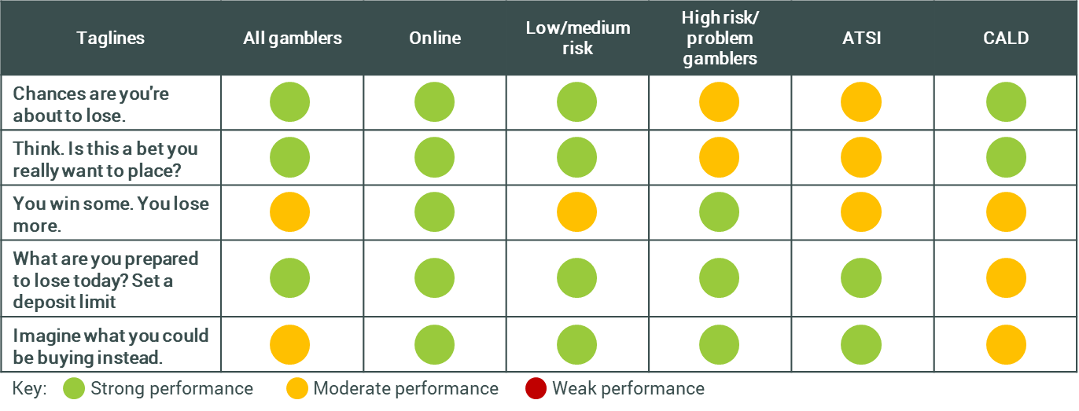
Note: All gamblers includes land-based gamblers

Recommended application and presence in market
The leading taglines all have the potential to be effective if presented in a range of settings and environments. It is recommended that all five taglines are rotated over a period of time, and there is scope to present more than one tagline in market at the same time in different environments. This is because the messages speak to different truths and thus do not detract from other taglines.
Four of the five taglines were considered suitable and anticipated to have impact if presented across any application or setting, online or land-based: ‘Chances are you’re about to lose’, ‘You win some. You lose more.’, ‘What are you prepared to lose today? Set a deposit limit.’ and ‘Imagine what you could be buying instead’. It is recommended these options are utilised across all applications, settings, or environments.
There is strong consumer appetite for any of the five of the taglines to accompany industry advertising, such as television, radio, and print advertising. Consumers anticipate that inclusion of any of these taglines would be unwelcomed by industry, however they do not regard this as a deterrent and claim that these taglines replacing ‘Gamble responsibly’ in advertising would be effective: catching attention and engaging them with the message if presented in the recommended presentation format.
The timing of messages and relevance of the tagline to specific moments in the online gambling session was considered across audiences as critical for maximum cut-through and impact. It was felt that the online environment would facilitate even greater tailoring to individuals so that taglines presented could be most relevant to each person. For example, this could be based on the events within a session or selected in advance by the individual in relation to time or budget thresholds they have set for themselves when in a rational state of mind.
It is recommended that the specific locations and moments for the taglines to be presented within the betting app are:
- At the start of a session (e.g. when the app is opened)
- When going to confirm or place a bet
- When confirming how much money to deposit into their betting account
- As randomised or periodic popup windows during a session
- When a specific series of events is ‘triggered’ (e.g. after the fifth loss within a session or a certain amount of money bet)
Three of the five taglines are likely to have strongest traction at intercepting consumers at different stages of the playing experience, including within the online betting platform. Presenting the taglines ‘Think. Is this a bet you really want to place?’, ‘What are you prepared to lose today? Set a deposit limit.’ and ‘Imagine what you could be buying instead’ on rotation within the app during the online betting experience, or in land-based venues (for example on the playing floor, or elsewhere in the venue such as the lavatory stalls) has potential to maximise the impact these taglines have by prompting conscious decision making at crucial decision points during a session.
There is an opportunity to apply the call to action by-line ‘set a deposit limit’ to other taglines in the suite, such as ‘You win some. You lose more.’ to encourage the uptake of harm minimisation tools that consumers deem supportive and palatable. The inclusion of this call to action by-line to multiple taglines tested throughout the process was consistently positively received and motivating to consumers.

Recommended presentation and format
The presentation of the tagline should, at a minimum, be in capital letters, shown in a clear uniform font, and presented in isolation (on a separate screen to other text, especially in the case of betting advertisements). The font size needs to be legible on the screen it is presented on and should cover at least a third of the space if shown on its own screen. Emphasising specific words with bold text has merit to direct consumers’ attention to specific words or ideas and has proven efficacy at focussing consumers’ attention.
Utilisation of emphasis is not recommended as the default presentation for the five recommended taglines, but this could be revisited by the DSS in time to help re-engage consumers with the message.
Guidelines for the most effective presentation of the taglines specifically in relation to industry advertising were informed by consumers’ reflection on and evaluation of the presentation of the current ‘Gamble responsibly’ tagline in different settings, and the quantitative testing of presentation formats. In advertising formats tagline should, where reasonable, be separated or delineated from any gambling advertising content, for example:
- In television advertising the tagline would appear in a frame on its own, centred text, without any other text relating to the gambling advertisement present
- In print advertising the tagline would be in legible sized font (at least the same size font as the advertisement’s key message), with white space around the tagline. It would not be positioned in the terms and conditions section of the advertisement (bottom of the ad)
- In radio advertising the tagline would be orated at the same tempo as the advertisement, not quickened
Engagement with the tagline through a click-box (where a viewer must minimise the tagline to continue with the gambling session) is recommended within betting apps, betting websites, or online advertising (e.g. banner ads) to create an environmental interruption which could cause reflection on behaviour; in-situ or longitudinal studies (outside the scope of this program of research) could validate this.
- Tagline messages must work in conjunction with other protection measures to promote real and meaningful behaviour change
It is important to reiterate that whilst a well-designed tagline can intercept heuristics, biases and habits and engage conscious decision-making processes in consumers who participate in online wagering, decisions are never made free of context, and consumers are always subject to a wide range of influences. Tagline messages that target the individual work most effectively when operating in conjunction with changes on the macro level, such as legislation, other social and structural supports, influence from peer and social groups, and the wider community (for more detail, refer to Literature Review in Appendix 1).
When it comes to gambling, messaging is just one piece of a complex puzzle, as demonstrated by the NCPF in which the development and communication of messages aimed to reduce harm as a result of online wagering is one out of the ten measures within the framework. Environmental changes, peer norms and social pressure, and possible structural or legislative changes also playing a substantial role in encouraging behaviour change. Public policymakers hoping to reduce gambling harm must view messaging as an essential weapon in their arsenal, but not the ‘silver bullet’ which will single-handedly reduce gambling harm.
Focusing on the eighth measure of the NCPF (messaging), the current research has progressed the DSS’s action to deliver to this objective. The five taglines that were informed by and developed out of extensive consumer research, and have been validated on a national scale, are a real opportunity to enhance current harm reduction messaging, change some of the beliefs and attitudes held in relation to online wagering, challenge misconceptions and norms, and to target individuals at the moment of decision-making in a way other measures and interventions cannot

Appendix: Literature review
Consistent Gambling Messaging Insights Research
Literature Review, Hall & Partners, March 2021

Key findings of the literature review and its implications for the upcoming research
The Department of Social Services (DSS) has commissioned Hall & Partners to conduct qualitative and quantitative research into beliefs, behaviours and attitudes among regular online wagerers of a range of risk profiles, in order to develop new messaging aimed at reducing gambling harm.
This literature review details several key findings with important implications for the upcoming research. These findings have been incorporated into the design of the research protocols and will be used to continue to inform the development of new messaging territories and taglines for testing with online wagerers and other gamblers.
In summary, the major findings include:
- Messages aimed at reducing gambling harm are often most effective when targeted to individuals of different demographic groups, risk profiles, or behavioural profiles.
- As a result of this, the development of a number of taglines may be necessary in order to best target different groups, as different messages, tones and techniques will likely resonate with different groups.
- Messaging which appeals to personal responsibility and which leaves the locus of control with the individual has been traditionally used to target gamblers, but limited success has been seen in this area – and this is borne out by the evidence that the current ‘Gamble Responsibly’ tagline in the Commonwealth of Australia has been unsuccessful.
- Further research is needed in some areas, particularly in understanding the impact of positive or encouraging messaging, and in understanding the effectiveness of shock tactics or warning messaging in gambling behaviour specifically.
- Another area with limited research is in understanding the best positioning, text type, colour, size, repetition and other imaging factors in intercepting at-risk gamblers at the time of decision-making. While this is a small focus of the research scope for the Hall & Partners project, it is also a rigorous one, so academic modelling is needed.

Introduction: the place for messaging in social marketing and behaviour change
As part of the National Consumer Protection Framework (NCPF) for online wagering, the DSS is looking to develop and implement new consistent gambling messages (the eighth measure of the NCPF) to replace the current ‘Gamble Responsibly’ tagline, which has been found to be ineffective at raising awareness and preventing or reducing gambling harm.
This literature review details an overview of existing messaging in Australia and worldwide. As well, it investigates the limitations and effectiveness of different messaging techniques (territories) in preventing gambling harm.

The role of messaging in reducing gambling harm
While governments and public policy makers understand that messaging is an essential component of influencing behaviour, we must also acknowledge that it is just one component of a comprehensive behaviour change program.
It is clear from the social psychology literature that people do not change their behaviour simply because they have the correct information: all classic behaviour change models demonstrate that an individual’s beliefs and attitudes (seen in Fig. 1) are the critical intervening factors between knowledge/awareness and behavioural intentions. In addition, even after desirable behavioural intentions have been formed, intervening heuristics (mental short-cuts), habits, unconscious biases and environmental influences can still get in the way of desirable behaviour.
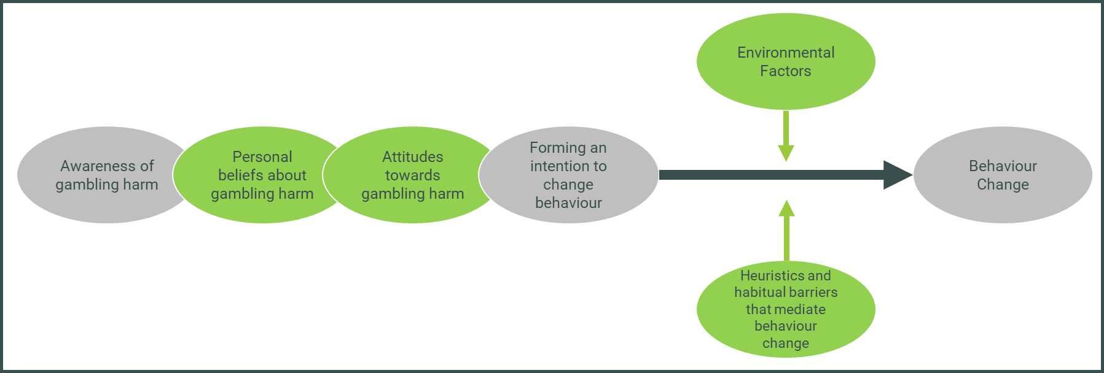
(Fig. 1.) The Behaviour change journey with regard to gambling behaviour, adapted from Ajzen and Fishbein’s Theory of Reasoned Action (1980)
A well-designed tagline can go some way towards intercepting these heuristics, biases and habits, and engaging conscious decision-making processes at a point when they might otherwise be disengaged. However, decisions are never made free of context, and an individual is always subject to a wide range of influences. While marketing and communications target the individual, they work most effectively when operating in conjunction with changes on the macro level (shown in Fig. 2), such as legislation, and influence from peer and social groups and the wider community (the inner rectangles in this model).

Social & Structural
- Resources & Services
- Policies & Legislation
- Guidance & protocols
- Political leadership
- Gender norms
- Religious & cultural norms.
- Media & technology
- Socio economic factors
Community
Leadership, access to information, social
capital, collective efficacy
Family & Peer Networks
Peer influence, spousal communications,
partner & family influence, social support
Individual
Knowledge, skills, benefits & values,
self-efficacy, perceived norms, perceived risk,
emotion
(Fig. 2.) Influences on an individual, adapted from Bronfenbrenner’s model of Ecological Model of Influences (1979)
We have seen this with other legal but highly addictive behaviours such as smoking, where a combination of legislative changes (for example, plain packaging), taxes, environmental controls (such as reducing smoking in public places), changing social norms, and hard-hitting social marketing campaigns have reduced rates of smoking in adults in Australia from 25% in 1991 to 11.6% in 2019.
Gambling differs from many other addictive behaviours due to the incentive of possibly increasing wealth, a powerful deterrent to behaviour change for many people at risk of gambling harm. But it is not simply the promise of making money which encourages gambling behaviour. Indeed, in the case of online wagering in particular, the peer group was found to play a substantial part, and much has been written about the influence of the environment on gamblers who play Electronic Gaming Machines (EGMs).
We can therefore see that when it comes to gambling, messaging is just one piece of a complex puzzle, with environmental changes, peer norms and social pressure, and possible structural or legislative changes also playing a substantial role in encouraging behaviour change. Public policymakers hoping to reduce gambling harm must view messaging as an essential weapon in their arsenal, but not the ‘silver bullet’ which will single-handedly reduce gambling harm. However, we also see from the Ajzen and Fishbein model (Fig. 1) that in order to intend to change, people must first be aware of the issue and then hold sufficiently motivating beliefs and attitudes. Messaging is an opportunity to change some of these beliefs and attitudes, to challenge misconceptions and norms, and to target individuals at the moment of decision-making in a way other changes cannot.

The National Consumer Protection Framework for online wagering
The NCPF has acknowledged the various influences on behaviour change by introducing a suite of measures, of which messaging is but one.
A 2017 meta-analysis by the Victorian Responsible Gambling Foundation (VRGF) concluded that action into gambling harm should take into account the stigmatising tone of some gambling messages, and called for change in regulation and messaging, with its first recommendation being to introduce a national framework which assists in the national regulation of gambling advertising.
The NCPF Baseline Report, released in 2019, states that messaging needs to facilitate conscious decision-making at the point where people engage in online wagering, and correct misperceptions about individuals’ own gambling behaviour. Messaging must also inform consumers about harmful gambling behaviours and remove stigma associated with consumer protection tools and gambling help services in order to encourage their uptake.
These are all appropriate areas for messaging to target, as they are within the realm of control of the individual. Importantly, messaging has the advantage (over some other measures) of targeting the individual at the point of their decision-making and offering an opportunity to intercept the behaviour.
Other measures among the ten included in the NCPF include those in legislative and regulatory spaces, such as restricting payday lenders and inducements, prohibitions on lines of credit, and streamlining the verification of customers’ identity.
In this way, we can see that the NCPF acknowledges that regulatory, legislative, social and environmental changes all have a role to play in targeting gambling harm, with messaging working alongside these to improve outcomes.

A note on the literature considered for review
In this review, we have focused on research into the effectiveness of different messages aimed at reducing gambling harm. Gambling harm is an area of much research, with a thorough understanding of the psychological, social, economic and physical drivers to gambling comprising much of this. However, while messaging to target gambling behaviours has been implemented by public policymakers across the world for some time, it remains an area of study with many gaps.
A number of areas for further exploration have been identified here, and it is important to note that the research Hall & Partners is conducting in 2021 will go some small way towards addressing some of these gaps (particularly, gaining an understanding of textual elements such as positioning, size, and font, and qualitative comparison of different messaging types), but still more research is needed to fully understand the success of various methods and techniques of messaging.
For example, research conducted in 2018 by Gainsbury et al. for BMC Public Health showed that different groups of gamblers (for example, segmented by age, frequency or risk profile) have differing preferences for message types, which suggested that tailored messages would be more effective in promoting the use of consumer protection tools. As Gainsbury et al. wrote, “There appears to be adequate evidence … to warrant customization of messages for young adults, older adults, skill-game gamblers, and frequent gamblers.”
Australia is not alone in struggling with the best way to communicate gambling harm: jurisdictions across the world have faced difficulty when choosing the best message to prevent harm. Tone, word choice, font size and colour, positioning of the message on the screen, and timing of the message all have a role to play in intercepting gamblers and encouraging conscious decision-making. When investigating the approach of different jurisdictions, we found four main methods or ‘territories’ for messaging: educative, negative, warning, and self-appraisal.
An interrogation of the literature found that no single territory was more successful at reducing gambling harm, and indeed, one element which remains consistent across the literature is the understanding that messages should be tailored to different audiences – and indeed, that there may be a need to target different audiences through different messages in the same campaign. This ties in with the general hypothesis, held by State and Territory gambling authorities as well as DSS, that more than one tagline may be required to replace the ‘Gamble Responsibly’ tagline. This fits what we already know about gambling behaviours, which often have a complex set of motivators which differ by individual.

Limitations of the ‘Gamble Responsibly’ tagline
Despite extensive research into its origins, the genesis and development of the ‘Gamble Responsibly’ tagline in Australia remains poorly understood.
It seems likely that its origin was in response to Commonwealth and State legislation, some of which state that mandatory warnings against gambling harm must be included on gambling platforms. The primary Commonwealth legislation concerning online wagering regulation is the Interactive Gambling Act 2001, which does not explicitly state that a ‘Gamble Responsibly’ message must be included in online wagering platforms. However, this is supplemented by state-level rulings such as the Gambling Regulation Act 2003 in Victoria which requires any form of gambling advertising to include a statement which relates to problem gambling, and the Northern Territory Code of Practice for Responsible Online Gambling 2019 which mandates that online gambling operators need to ensure their webpage outlines their procedures, policies, and commitment to responsible gambling practices, including a ‘Gamble Responsibly’ message. The South Australian Gambling Codes of Practice Notice 2013 also states that messaging on TV needs to include the gambling helpline 1800 858 858 and the need to ‘gamble responsibly.’
As a result of these differences by jurisdiction, we see that different states have different ‘Gamble Responsibly’ messages. Some, such as South Australia, include a multi-component message such as ‘Know when to stop. Don’t go over the top. Gamble responsibly’, while many jurisdictions have instead kept to the simpler ‘Gamble Responsibly’ tagline.
The Australian Communication and Media Authority (ACMA) also has specific guidelines around gambling advertising during live sport streamed over the internet and broadcast TV which direct watchers towards online wagering platforms. In addition, the advertising self-regulation body Australian Association of National Advertisers (AANA) has a wagering advertising code. It states that gambling advertising cannot contain content that emphasises the connection between gambling and alcohol, makes exaggerated claims, or suggests that gambling is a means of achieving success, but stops short of insisting that gambling advertising contains a ‘Gamble Responsibly’ message.
Alongside the uncertainty as to its genesis, there is little evidence that ‘Gamble Responsibly’ is an effective message. Indeed, the concept of responsible gambling has been supported and encouraged by the gambling industry for decades. The message of ‘responsible gambling’ is discussed in full in this review, but in brief, it leaves the onus on the individual to make sensible, rational choices. Studies into the effectiveness of messaging around ‘responsible gambling’ have consistently found that this type of messaging is ineffective in reducing gambling harm. Indeed, among low level gamblers in particular, Mizerski et al. (2012) found that there is some evidence that responsible gambling messages can even increase gambling behaviours among this audience.
The message ‘Gamble Responsibly’ has little support from the general public, with 70% of respondents to a 2019 YouGov survey stating that they believed the tagline had “no effect whatsoever”, and only 3% stating that they believed the message was effective. Indeed, prevalence rates of gambling within the community do not appear to have reduced in correlation with the introduction of this message, with a study by the VRGF finding that the prevalence of problem gambling in the community remained largely unchanged from 2014 to 2018-2019.
A study by Newall in 2019 found that campaigns which focus on responsible gambling are by far the most popular responses by the gambling industry to address potential concerns around gambling-related harm. Indeed, much of the research which supports the promotion of ‘responsible gambling’ over other messaging methods has been commissioned by industry peak bodies or private consulting firms commissioned by the gambling industry. This includes prevalence studies, which sometimes report statistics of problem gamblers as a proportion of the general population, rather than as a proportion of regular gamblers, misrepresenting the statistic and encouraging the belief that the vast majority of gamblers do so ‘responsibly.’ The limitations of such studies have been documented widely, including in Australian Productivity Commission reports in 1999 and 2010 and in a more recent study by Australian National University researcher Francis Markham and Southern Cross University researcher Martin Young in 2016, which found that “prevalence studies now function primarily as a device for the political legitimation of the gambling industries and the governments that support them.”
Another consideration is the competitive environment in which the ‘Gamble Responsibly’ tagline is usually viewed. The VRGF has conducted numerous studies to understand the effectiveness of messages such as ‘Gamble Responsibly’, resulting in a 2017 meta-analysis of three studies into the impact of gambling warning messages on advertising perceptions. This report found that in an unregulated environment, messages aimed at reducing gambling harm also come up against counter-messages aimed at increasing gambling behaviour. It was found that the absence of a consistent and strict legislative framework around gambling resulted in gambling advertisers being responsible for self-regulating, leading to harm reduction messages being ‘drowned out’ by other messages encouraging gambling behaviour.
In this way we can see that even if ‘Gamble Responsibly’ was an effective message, it would be difficult to obtain cut-through in an environment where pro-gambling messages and incentives fight for the attention of the viewer.

The risk of an ineffective message
While one might anticipate that the risk of an ineffective message is that no reduction in instances of gambling harm will be seen, research suggests that the consequences can be even more severe.
Across the literature there have been several examples of studies which found that ineffective messages have not only led to no reduction in gambling harm, but have in fact driven inadvertent responses to gambling behaviours such as increased intention to participate or spend.
For example, The Canadian Responsible Gambling Council (CRGC) developed their messaging strategy around the idea of ‘chasing losses’. This led to the development of the slogan “perseverance doesn’t pay,” with the message focusing on a common identifiable trait in problem gamblers: the tendency to continue gambling to make up for losses. However, evaluation of the success of this message was found to be lacking, with research finding that negative labelling of problem gamblers such as this led to stigmatisation, which inadvertently drove an increase in gambling spending.
A study by Armstrong et al. in 2018 used a simulated study to investigate different messaging types and their effectiveness. The research found that positive self-appraisal messages (of which the ‘Gamble Responsibly’ message is an example), led to increased gambling persistence. The study concluded that messages must be tailored or ‘framed’ for specific cohorts, and that failure to do so may be counterproductive for the very people who are most at risk. The results of this study tie in with the hypothesis held by State and Territories gambling authorities as well as DSS, that ‘Gamble Responsibly’ might be best replaced by more than one tagline, perhaps to target different cohorts.
Findings from this study are consistent with conclusions by Mizerski et al. (2012) that suggest that inadequate messages are likely to contribute to rather than minimise gambling harm. It was hypothesised by the authors that this might be because the messages increase the salience of gambling within the community, thereby acting as a reminder to gamble and a reinforcement of social norms around gambling.

How is a message evaluated for efficacy?
Of course, one challenge in understanding efficacy of different messages is in choosing the metric by which efficacy can best be measured. Choosing a suitable method for this can provide a better understanding of the impact on reducing gambling harm and give a clearer picture on the limitations of individual studies, as well as inform our own evaluation metrics when the time comes to understand efficacy.
One study, conducted by Mouneyrac et al. in 2017, evaluated gambling messages on their communicative value and preventive value. In this study, the communicative value of a message was measured by the extent to which the message can improve comprehension, the ease of its retrieval, and its perceived relevance to the context. The preventive value of a message was regarded as its ability to modify attitudes and/or behaviours.
Not surprisingly, the study identifies a link between communicative and preventive values: a message that communicates well is considered more preventive than a message that communicates badly. However, the study also raises the point that many prevention gambling messages communicate well (and achieve memorability and cut-through), but do not test well on a preventive metric. The likelihood of an overall impact on behaviour change would therefore be limited and might also contribute to mixed results in research into the efficacy of taglines.
For the research study conducted by Hall & Partners, the implications of this are twofold: we must choose the best available metrics for evaluating efficacy in both the qualitative and quantitative phases, and must also develop strategies to disentangle the influence of testing several competing messages in succession.

Factors that influence messaging effectiveness in this space
Much of the research into responsible gambling messages to date has looked to categorise existing messages by theme, purpose (territory) or tone to better understand efficacy. It is broadly observed that the behaviour of gambling, as with other public health behaviours, is complex with several levers offering different opportunities to resonate with consumers. Insights have proven to be mixed across research studies, which highlights the complexity of the issue. Additionally, as previously mentioned, studies have revealed that there are other factors beyond message design which impact the cut-through and prevention potential of messages, such as player demographics and gambling behaviour.
A number of factors have been found to influence message effectiveness on reducing gambling harm and promoting prevention, some which will be explored in detail in the following chapters. These include:
- Message purpose
- Message tone
- The role of call to action
- The role of grouped messages
- Demographic player factors such as age, socio-economic demographics, education
- Other player factors such as risk level
- Gambling factors: for example, type of game (skilled based or not), platform or format
- Language used, particularly whether individuals identify with the language (for example, use of the word player compared to gambler)

Messaging territories
Like all advertising and communication messages, gambling messages are designed with an intention to speak to people in a certain way and elicit a type of response. The way that different messages achieve this can be evaluated and grouped by their intended purpose or theme. In marketing and advertising, this is sometimes referred to as “message territories.” Across the literature, we found messages were commonly grouped by purpose, with four key groups emerging:
- Messages which promote “responsible gambling”, of which ‘Gamble Responsibly’ is a clear example;
- Messages which are informative or educative;
- Messages which are warning or corrective; and
- Messages which encourage self-evaluation
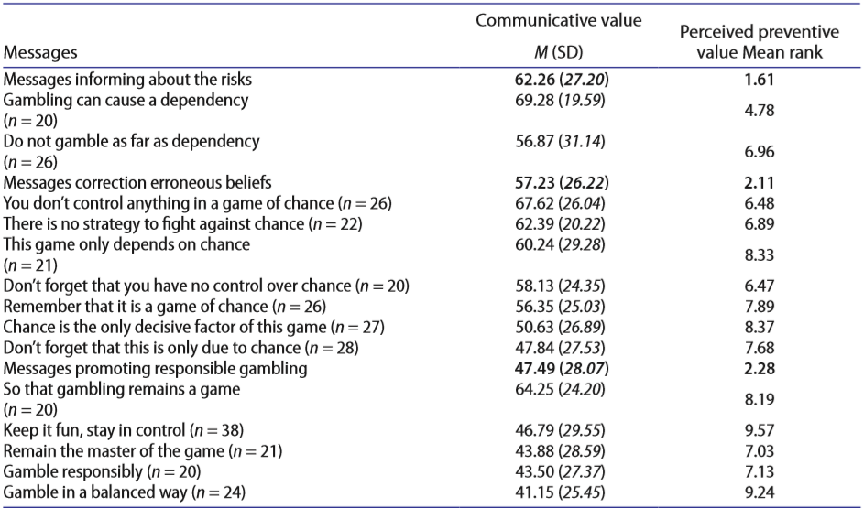
(Fig. 3), Some examples of different messages; Mouneyrac et al (2017) European RG Messages and Creative Messages
Across jurisdictions, messages tended to be either social or personal in nature. This is a core finding of the literature review, and the difference in efficacy between the two does not appear to have been widely evaluated. We do know that social norms often play a large part in gambling behaviour, and this appears to be particularly the case for online wagerers, indicating that a social message may work well here.
One study, by Heirene and Gainsbury for the International Association of Gaming Regulators in 2018, found in a live study with a robust (n=4200) sample that messaging regarding consumer protection tools was more effective when it contained a social message than a personal one (for example, a personal message might say, “Deposit limits are a great way to manage your spending,” while a social message focuses on the group, for example, “Most people who use deposit limits find they help them manage their spending.”). However, a 2013 study by Celio and Lisman which looked at land-based gambling among college students at Brown University demonstrated that personalised normative feedback lowered high-risk behaviours. Further research is needed to determine the best language to be used.
These territories illustrate different ways to tap into a human truth, belief or attitude which can then be leveraged to encourage a shift in behaviour. The implications of this for the upcoming research are significant: working with our creative partner to develop our own territories, we may use these as a beginning. In addition, we may develop a social and personal message for each territory in order to test efficacy of these different approaches.

Promoting responsible gambling
As mentioned in the discussion of the ‘Gamble Responsibly’ tagline, messages which seek to promote responsible gambling typically appeal to the viewer’s ability to take personal responsibility to control their own behaviour. This is predicated on the assumption that people can self-identify their behaviour and make a rational decision to cease behaviour or carry out the call to action. The overestimation of an individual in their ability to control events is a manifestation of psychologist Langer’s 1975 concept ‘the illusion of control.’
This type of message has been popular across jurisdictions: for example ‘Gamble Responsibly’ has been used in Spain as well as Australia; ‘Keep it fun, stay in control’ and ‘When the fun stops, stop’ have been used in the UK; ‘Remain the master of the game’ was introduced in France, and the message ‘So gambling remains a game’ has run in Switzerland.
However, there is evidence to show that the intention may not have the desired effect. As demonstrated with the ‘Gamble Responsibly’ tagline, few jurisdictions have seen efficacy when these messages are evaluated. In South Africa, for example, it was found that messaging was more effective when it alluded to the negative consequences of gambling than when the onus was put on the gambler to know their own limits. The tagline ‘Winners Know When to Stop,’ a responsible gambling message, attached to betting ads in South Africa was found to be an unclear message, and it was instead recommended that it be replaced with the tagline ‘A Gambling Problem Hurts,’ which falls more under the ‘warning or corrective’ messaging territory. Similarly, in the UK the message ‘When the fun stops, stop’, was also found to be ineffective in leading to more responsible gambling behaviours: a case study on this particular example is given below.
The key critique is that these messages are ambiguous and do not contain a concrete call-to-action. The hypothesis is that this ambiguity may cause gamblers to generate the wrong associations with what ‘gambling responsibly’ means - for example, to believe that at-risk behaviour is responsible, particularly if environmental or social influences indicate that it is.
Unfortunately, we know that gambling behaviour, like many behaviours and particularly those driven by addiction, often involves emotional or automatic triggers which bypass conscious decision-making. As previously discussed, the environment, cultural and social norms, and habits and mental short-cuts known as heuristics all play a role in the decision to gamble, and in subsequent decisions to continue gambling once a session has begun. As detailed in Fig. 2., the individual is subject to many pressures and influences in making decisions which mean the idea of making responsible, rational decisions can seem simplistic at best.
Parke et al. found in a 2015 study that such messaging allowed gamblers to believe they could control their own risky behaviours and self-impose limits when they self-identified as no longer behaving responsibly. Obviously, the implications of this are that while such messages may be gratifying as they appeal to the individual’s belief in their ability to make their own decisions, they do not take into account the various environmental, societal and automatic influences on behaviour.
At this stage, there is limited evidence of their efficacy despite the support of such messages in the community. Mouneyrac and colleagues showed in a European study evaluating messages to reduce gambling harm that they have both limited communicative and preventive value relative to other types of messages.
It is proposed in some of the literature that while the upside might be neutral, there is even a risk that such messages might increase gambling behaviour. Under worst-case intake conditions, Mouneyrac and colleagues argued that these messages could act as gambling promotion messages – that is, they could actually encourage behaviour rather than prevent it. There is a need for further research to understand whether individuals rely on the illusion of control to interpret messages promoting responsible gambling, and this will be explored in the qualitative and quantitative components of Phase I of the Hall & Partners research.
Additionally, when the communicative value of ‘gamble responsibly’ messages were studied, it was found that they presented a challenge. A meta-study by Parke et al. in 2015 that reviewed advertising in gambling research concluded that gambling was portrayed as a positive, normal social activity, and hypothesised that messages within these adverts promoting ‘responsible gambling’ would most likely be dismissed.
One particular message which has been widely evaluated is the UK responsible gambling campaign ‘When the Fun stops, stop,’ which was developed by the industry-funded Senet Group in 2015. This message incorporated several different message types, including ‘warning’, but the tagline ‘When the Fun stops’ was found in evaluation to imply that the gambling journey was primarily fun, and that the time to stop is when the ‘fun’ ends.
The strategy behind the development of this message focused on the gambling experience and the changing emotions of a gambler during a session. Through preliminary and limited focus group studies, the Senet Group found that gambling-related harm was most likely to occur when the ‘fun’ element of gambling ends: that is, the emotional indicator that one was no longer having ‘fun’ was the primary indicator used to predict gambling harm.
The ‘When the fun stops, stop’ message was evaluated by an independent review in 2019 by Newall et al through a controlled study of n=506 participants which showed that 37.8% of participants who did not see the label placed a bet, while 41.3% of those who saw the message placed a bet. Early results from the study therefore showed that the message actually resulted in an increased probability of gambling. In addition, the study found that responsible gambling messages, that is, those which appeal to personal responsibility and the illusion of control, are not effective.
There is also a hypothesis that the emphasis on the word fun in the visual presentation drew attention to the word ‘fun’, which subliminally reinforced this element of the message to the detriment of the prevention of gambling harm. Further research into elements of visual presentation is needed to gain an understanding of the impact of font, size, colour and presentation on the screen.
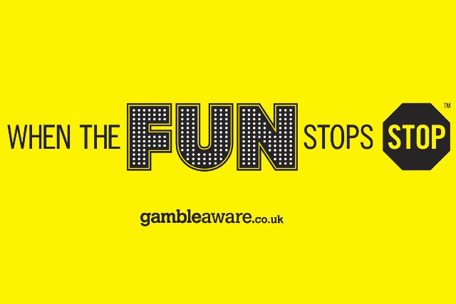
(Fig. 4.) ‘When the fun stops, stop’ UK message.

Informational or Educational
Another messaging territory is one that uses an informational or educational tone. Messages of this nature are developed on the idea that irrational or unfounded beliefs are the cause of problem gambling behaviour. As such, the messages seek to provide information to gamblers to correct these thoughts or beliefs, in the hypothesis that, armed with the correct information, they will make informed choices (that is, stop gambling before they are at risk of harm). Such messages rely on rational processing of the message and rational application of this to behaviour.
Messages of this type often speak to the probability, or lack thereof, of winning, or how outcomes are determined, in the assumption that individuals will be less likely to gamble if they know their true likelihood of winning. Efficacy of these messages, it is hypothesised, is dependent on the gamblers’ ability to make informed decisions about their behaviour if presented with rational evidence. However, as we know, decision-making is not always rational; indeed, Nobel Prize-winning psychologist Daniel Kahnemann posits that just 2% of our decisions are made rationally, while the remaining 98% are made using fast, automatic processes.
A key point here is that there is substantial evidence to show that informational advertising is effective at breaking down erroneous beliefs, but that it has limited impact on behaviour change. This is supported by the field of behavioural economics and other psychological phenomena which indicate that behaviour change, as we saw in Fig. 1., is dependent on a number of factors, some of which are outside the individual’s rational awareness. Gainsbury et al.’s 2018 meta-review of literature summarised that there may be some impact on the influence of informative or educative messages in shifting irrational beliefs about gambling, but the extension to shifting behaviour is not yet supported by empirical evidence. Additional research conducted by Williams and Connolly in 2006 suggests that this is due to cognitive biases, where a systematic error in thinking leads to adverse decision-making. In the context of gambling, this could mean that people can understand the low probability of winning yet simultaneously believe they have a chance to win, and that both those realities may hold true for that individual.
Mouneyrac et al.’s 2017 evaluation of actual campaign messages across multiple European jurisdictions identified the use of messages that fall into this category: either specifically informing on the risks, or educational messages to correct erroneous beliefs commonly held by gamblers. The study defined erroneous beliefs as ‘false representations of the cause of an event,’ with this commonly relating to misconceptions and overestimations on the chance and possibility of winning, and an illusion of control caused by a perceived ability to control random events.
Some example messages in this category are ‘Remember that it is a game of chance’ and the Italian Lottomatica message ‘Gambling can cause a dependency,’ which is designed to make people aware of the risks of harm and addiction which may occur from excessive gambling. The Mouneyrac and colleagues study found that informative statements had high communicative value and effectively communicated preventative intentions. These results are consistent with the literature, which shows that these messages both increase knowledge of the risks of gambling and correct erroneous beliefs. Thus, these types of messages appropriately broadcast preventive intentions. The literature in this space encourages further research on the use of these messages, particularly as a potential replacement for ‘Gamble responsibly.’
One way to encourage behaviour change may be to pair a message informing gamblers of the risks with behavioural strategies to combat these. For example, a ‘bet regret’ campaign in the UK, which focused on education regarding online wagering, was found to have a positive impact when it combined the tagline with behavioural strategies such as ‘tapping out’ and taking a break to curb impulsive bets on phone apps. This supports the theory that such messages are effective at breaking down misconceptions, but require supporting materials or strategies to influence behaviour change.

Warning or Corrective
Warning messages aim to raise the profile of the potential harm caused by the behaviour by communicating the undesirable outcome of excessive or inappropriate use. These messages are crafted to evoke an emotional response to the communication, often seeking to elicit a fear or anxiety that is intended to make the viewer realise that what they are doing is wrong, and persuade them to take the desired action (e.g. stopping or reducing the behaviour). Its use is notable in public health campaigns, such as alcohol, tobacco and driving harm reduction (for example “smoking kills” “smoking causes…”) and is often accompanied by shock imagery to further elicit the emotional response.
There is currently limited research into the impact of warning messages specifically targeted to curb harmful online gambling behaviours, however, research on the efficacy of warning messages across the public health domain is equivocal: there is some evidence to suggest they can play a role in catching the attention of the viewer and be memorable, however, there is limited evidence of these messages translating to desired behaviour change. Despite their prevalence in public health campaigns, it is recommended that warning messages are used cautiously.
Overall, the use of warning messages poses an interesting challenge in relation to responsible gambling: this is a category where players (particularly recreational, low frequency, or lower end of the risk severity index) tend to underestimate their own exposure to harm and may find it difficult to identify with the behaviour of ‘problem gambling’ communicated in the message and think of their participation as ‘not the same, harmful or problematic as what is being warned against.’
The literature identifies a key watch out: warning or corrective messages may cause unintended consequences. When the viewer does not identify with the message nor finds the context personally relevant, there is a risk that they will ignore, reject or deny the message (inhibiting cut through) and may have the inadvertent response of increased participation in the behaviour. A seminal study conducted by Janis and Feshbach (1953) explored the impact of anxiety-arousing topics and identified three main types of emotional reactions: inattentiveness (a defensive tendency to avoid thoughts related to the topic), aggressiveness (a defensive tendency to become aggressive towards the communicator, likely in the form of rejecting the arguments), and defensive avoidances (attempts reduce exposure to the communication, causing anxiety, generally in the form of failing to recall the message, losing interest in the topic, denying or minimising the importance of the threat). Subsequent decades of research have substantiated this work and further identified how messages that utilise a warning archetype can overcome these response hurdles. Synthesising the literature, it is broadly agreed that in order to combat the emotional reactions identified by Janis and Feshbach (1953) warning or corrective messages may have the most chance of being effective if paired with messages that either a) assure readers of their capability to perform the recommended action (self-efficacy) or b) that performing the intended action will result in a positive outcome.
Tone plays a role in how messages are received by viewers (as discussed in detail under Message tone) and has important implications for warning messages. Given that the majority of messages within this territory present with negative tonality, it can be hypothesised that the combination of content and tone create a barrier to engagement for many.
Despite the broad critiques of warning messages that seek to alarm, a study conducted by the Hong Kong Polytechnic University (2012) suggests that this style of message may be more effective in some jurisdictions more than others. Evaluation of Hong Kong’s phrases such as ‘Don’t gamble your family away’ and ‘Don’t gamble your life away’ are found to highlight the risk and consequences of gambling. Such messages are more memorable among Hong Kong society and look to be effective.

Self-Appraisal or Self Evaluation
Self-appraisal or evaluative messages encourage the viewer to reflect on their behaviour and take appropriate action. They appeal to the idea that individuals are more likely to act if they have come up with conclusion themselves rather being told what to do, as self-generated arguments are received more convincingly than information offered by external sources.
In communicating public health behaviours broadly, self-appraisal styled messages are found to be more effective than warning messages or those that place the responsibility on the individual. The literature concludes that this is because:
- Self-appraisal or evaluative messages tend to be softer in proposition, provoking a thought or suggesting an outcome to draw the viewers’ attention to the behaviour without coming across as accusatory. It is thought that this enhances the persuasiveness of the message and reduces the likelihood of viewers evoking feelings of resentment (as can often be the case with messages that promote responsible gambling).
- They help to promote behaviour change, typically by posing a question that aims to intercept players during gambling activity. The intention is to create a circuit break and prompt the viewer to momentarily re-evaluate their behaviour by appealing to their conscious decision making. For example, a self-appraisal or evaluative message may ask, ‘Have you spent more than you intended?’ or ‘Do you know how long you have been playing for?’.
- Self-appraisal messages do a better job at accommodating the cognitive dissonance common in gambling behaviour: it is observed that knowledge of the game’s probabilities has limited influence on actual participation, meaning informational messages often fall short at attempting to intercept and change behaviour.
There are several studies conducted in situ (on EGMs) and via simulations set up in laboratory settings that support the use of self-appraisal or evaluative messages for their ability to help viewers generate more realistic thoughts about the probability of winning, increase their likelihood of taking a break during a session, and reduce the duration of their participation in simulated gambling sessions (in the current session and in a session two weeks later).
Whilst there is some promise for self-appraisal messages to play a role in reducing gambling harm, the main limitation of research to date with respect to the current research commissioned by the DSS is that the findings have not been applied to the online gambling setting. Most studies are conducted within simulated environments and evaluate this style of message in the context of EGMs or land-based platforms.
There have been attempts to further evaluate the effectiveness of self-appraisal style messages by assessing response across different audiences. It was theorised by Monaghan and Blaszczynski (2010, cited in Armstrong & Rockloff, 2018) in their study on message content of responsible gambling that the message territory presented to gamblers should change from informative to self-monitoring to self-evaluating depending on changes in player risk. It is hypothesised that those who are at lower risk of problem gambling would be more receptive to positive and informative messages, whereas moderate to severe risk gamblers would respond more to challenging or negative self-monitoring or self-evaluating messages.
The evidence to support this theory is mixed. Hare (2016, cited in Armstrong et al. 2018) and Mizerski et al. (2012) find there is a difference in the gambling intensity of players across risk severity indexes as a result of being presented messages that vary in territory and tone. By contrast, Armstrong et al. (2018) find this not to be the case. Instead their research indicates that the effectiveness of self-appraisal messages is not more impactful among higher risk players, and it is revealed that there are other factors that may better account for the variation in message response across players (e.g. gender).
The extent to which self-appraisal messages are received by different audiences appears to be influenced by tonality of the message. Research by Armstrong and colleagues (2018) proports that the message framing or tone (e.g. positive, challenging or negative) is a large determinant to message response. Furthermore, there is evidence to suggest that different tones are more effective with different audiences, and thus is unlikely to be universal for all gamblers (see section on message tone for more detail).
Whilst it seems that there is support from the research community for self-appraisal and evaluation messages to help address gambling behaviours that may lead to harm, it is clear that the development of such messages should explore and evaluate tailored articulations to different audiences, particularly nuances in tonality, if they are to be effective across audiences (e.g. gender, risk level, playing platform).

Other factors influencing message efficacy
In addition to messaging territories, the literature review highlights other factors that appear to contribute to engagement and response to messages seeking to minimise gambling-related harm. Similar to the territories, studies have found mixed results in relation to some of these factors, however many areas have not yet been deeply explored to establish a firm viewpoint on the best ways to communicate to different audiences on these dimensions. The diversity in findings further reiterates the need for a messaging strategy that feels consistent in its positioning, but that can be tailored to different audiences, taking into account their unique characteristics, behaviours and self-perceived relationship to gambling, to maximise message efficacy.

Message tone
Tonality of prevention messages in public health has also been a focus of research in determining reception to and efficacy of communications. Whilst some messaging territories gravitate to certain tones (for example, warning messages typically adopt a negative tone), other territories can be framed as positive or encouraging, negative, or challenging. There is currently limited evidence on which combination of territory and tone will be most effective for different audiences, however it does bring to light the need to consider and develop messages with both of these factors in mind.
Broadly, the literature suggests that messages with a positive framing or tonality are more likely to encourage positive response to the message and negative messages are least likely to elicit the desired engagement and response. For example, Gainsbury and colleagues (2018) support the point of view that positive messages were more likely to be persuasive at encouraging harm reduction behaviours, and in their own study found that younger adults were particularly sensitive when it came to the framing for gambling reduction messages, rejecting messages that adopted a judgemental or negative tone as the inference was that the individual was to blame for not behaving more desirably.
However, there are some studies that suggest it is not so binary. Armstrong et al. (2018) found that males and females responded differently to messages with positive and negative framing. Among males, positively-framed self-monitoring messages were found to enable persistent gambling behaviours (that is, males continued to play the simulation for longer periods of time after seeing the message, compared to messages that took on an alternate tone). Self-monitoring messages that were framed as a challenge had the strongest impact among this audience at reducing length of session following the message. By contrast, females exhibited greatest resistance to negatively framed messages (particularly those that were self-evaluative), resulting in persistent gambling behaviours.
There are theories about how message tone should be designed to reflect the different risk severity levels of gamblers (as identified by the PGSI), for example as cited in Armstrong et al. (2018). Armstrong suggested that recreational or non-problem gamblers would respond better to messages framed in a positive tone which are designed to help players safeguard against irrational beliefs and inspire protective behaviours, however there is currently limited empirical evidence to support the theory that gamblers of different risk levels will find the tonality of some messages more persuasive than others. This suggests that risk severity may not be the key factor that drives nuance in tailored message design, but it would be ill-advised to exclude this possibility without further research.

Gambling activity and perceptions of skill
There is evidence to suggest that the type of game gamblers play impacts the types of messages that resonate. This is particularly the case for skill-based games where direct communications and the incorporation of messages can speak to tools or resources to keep track of the amount they are betting. It is thought that these types of messages help to break down illusions of control about gamblers’ skill by reminding them of the element of chance in gambling. This theory, that players of different gambling products may receive messages differently due to differing perceptions in ability or skill to influence their odds of winning, is supported by evidence but it is acknowledged that further investigation is required.

Incorporating messages with tools and resources
Gainsbury and colleagues (2018) designed messages that coupled responsible gambling messages with a call to action directing the viewer to a responsible gambling tool (i.e. Play Summary tool, Limit Setting tool, Player Assessment Quiz, Odds Knowledge Quiz, and Responsible Gambling Tips). The intention was to prompt viewers with an appropriate behavioural response, however findings between subgroups suggest that younger adults may interpret this as an invitation to upskill or improve their understanding of how to beat the odds (especially in regards to the quizzes or list). Other audiences were positive to the self-assessment tests and limit setting tools, particularly frequent gamblers, suggesting there may be value in incorporating a direct link to tools in conjunction with messages to encourage harm minimisation behaviours with some audiences.

Presentation and format
Limited research is identified that explores the role of presentation and format on the efficacy of messages in the online environment. However, research conducted by the Central Queensland University gives us some understanding of features that engage viewers with responsible gambling messages on screen during televised sports matches. It was found that the responsible gambling message that received most attention (captured using eye tracking technology) was the presentation where contrasting background and visible, as opposed to the messages that were presented on naturalistic background with no contrast. The authors of this study call for further research into the presentation of these messages, including size, duration of text to examine the impacts on cut through.

Summary of key insights & implications for the research project
- There is no definitive conclusion over the most effective message to minimise gambling harm through encouragement of positive behaviours. However, there is consensus that tailored messages may be more effective in encouraging behaviour change. Message development should strive for a messaging strategy that is consistent and memorable in its overall positioning, but that can be tailored to different audiences, taking into account their unique characteristics, behaviours and self-perceived relationship to gambling, to maximise the potential to be effective. Within the message territories developed to be tested, there should be iterations that frame the message in a social and personal context to understand is these articulations have different resonance.
- Message efficacy should be viewed through multiple lenses: achieving salience or communicative value is not enough to drive behaviour change, as evidenced by the majority of gambling prevention messages in market across jurisdictions. Messages must also be evaluated against their preventative value: the ability to shift attitudes, mindsets, and behaviours in a positive direction. Evaluating efficacy holistically is paramount to identifying messages with the greatest potential for State and Territories gambling authorities as well as the DSS to take forward.
- The downside of ineffective messaging (that is, inadvertently encouraging behaviours that increase gambling harm) is a significant threat. Development of messages needs to consider the risk potential of specific messages to fuel or contribute to erroneous beliefs or promote gambling behaviours, and testing needs to evaluate both the positive impact (e.g. cut-through, persuasion, relevance) and negative outcomes of taglines developed.
- There are green shoots through the literature that suggest packaging messages could enhance engagement and persuasion. Whilst there is limited research dedicated to understanding this currently, there is research that shows heightened appetite for messages coupled with a call to action directing consumers to tools. This provides signs of optimism to further explore this approach. Additionally, the various strengths of different message territories (for example, informative and educational messages can help to correct erroneous beliefs but are found to have limited impact on behaviour, whereas self-appraisal messages are found to have greater potential at minimising harmful behaviours but are subject to quick dismissal if there is no perceived relevance) suggest that packaged messages might work to achieve efficacy in a holistic sense. Message development and design should extend to experimenting with message combinations and testing the combined value of the message to provide guidance on messages that can be successfully used in isolation, or those that should be coupled for greatest impact.
- Messages that present a negative tonality are generally found to be least persuasive despite having strong cut-through. The potential risk of unintended negative consequences (that is, increased participation in gambling behaviours) and outright rejection of the message indicates that development of messages should look to adopt a different tone (perhaps positive or challenging) if they are to be successfully persuasive in the context of gambling where irrational beliefs, unconscious decision-making and the illusion of control are common.
- Presentation and format for responsible gambling messages is a largely unexplored area for online gambling platforms. Any insight gleaned in this area will contribute broadly to the knowledge base and provide direction for the roll out of the DSS’ new tagline(s).

Reference List
Australian Association of National Advertisers (2021). Wagering Advertising Code. Available at <https://aana.com.au/self-regulation/codes-guidelines/wagering-code/? [Accessed 15 March 2021].
Armstrong, T., Donaldson, P., Langham, E., Rockloff, M. and Browne, M., (2018). Exploring the Effectiveness of an Intelligent Messages Framework for Developing Warning Messages to Reduce Gambling Intensity. Journal of Gambling Issues, (38), pp.67-83.
Mouneyrac, A., Le Floch, V., Lemercier, C., Py, J., Roumegue, M. (2017), Promoting responsible gambling via prevention messages: Insights from the evaluation of actual European messages. International Gambling Studies, Taylor & Francis (Routledge), 2017, 17 (3), pp.426-441.
Australian Gambling Research Centre, (2019a). National Consumer Protection Framework for Online Wagering: Baseline study. Melbourne: Australian Institute of Family Studies.
Australian Gambling Research Centre, (2019b). Weighing up the odds: Sports betting and young men. Melbourne: Australian Institute for Family Studies.
Australian Government Productivity Commission, (1999), Australian’s Gambling Industries Inquiry Report
Australian Government Productivity Commission, (2010), Australian’s Gambling Industries Inquiry Report
Australian Institute of Health and Welfare, (2019). National Drug Strategy Household Survey, 2019.
Bjerg O., (2010), Problem gambling in poker: money, rationality and control in a skill-based social game. Int Gambl Stud. 10:239–54.
Boyce, J. (2019, June), The Lie of Responsible Gambling, The Monthly, Essays
Celio, M. and Lisman, S. A. (2013, December) Examining the Efficacy of a Personalized Normative Feedback Intervention to Reduce College Student Gambling, Journal of American College Health 62(3).
Fort Hare Solutions & Socio-Econometrix Services, Towards a policy framework for an effective responsible gambling program: An evaluation of responsible gambling messages, platforms utilised and the cost effectiveness of the programme, South African Responsible Gambling Foundation & Eastern Cape Gambling and Betting Board, 2014-2015
Gainsbury, S., Abarbanel, B., Philander, K. and Butler, J., (2018). Strategies to customize responsible gambling messages: a review and focus group study. BMC Public Health, 18(1).
Gainsbury S, Aro D, Ball D, Tobar C, Russell A., (2015), Optimal content for warning messages to enhance consumer decision making and reduce problem gambling. J Bus Res. 68:2093–101
Hastings G, Stead M, Webb J., (2004), Fear appeals in social marketing: strategic and ethical reasons for concern. Psychology & Marketing. 21(11):961–986.
Heirene, R. and Gainsbury, S., (2018). How can we improve consumer protection in online gambling?. [online] International Association of Gambling Regulators. Available at: <https://www.iagr.org/industry-news/how-can-we-improve-consumer-protection-online-gambling> [Accessed 16 March 2021].
Ho, K. (2019). Most Australians Believe 'Gamble Responsibly' Has No Effect. [online] YouGov. Available at: <https://au.yougov.com/news/2019/12/02/most-australians-believe-gamble-responsibly-has-no/> [Accessed 12 March 2021].
Hong Kong Polytechnic University, Department of Applied Social Sciences, (2012), The Study on Hong Kong People’s Participation in Gambling Activities
Janis IL, Feshbach S., (1953), Effects of fear-arousing communications. J Abnorm Soc Psychol. 48(1):78–92.
Johns, R. J., Dale, N, Lubna Alam, S & Keating, B, (2017) Impact of gambling warning messages on advertising perceptions, Victorian Responsible Gambling Foundation, Melbourne.
Kahneman, D. (2011) Thinking Fast and Slow, Penguin, New York.
Langer, E. J. (1975). The illusion of control. Journal of personality and social psychology, 32, 311–328.
Lole, L., Li, E., Russell, A., Greer, N., Thorne, H. and Hing, N., (2019). Are sports bettors looking at responsible gambling messages? An eye-tracking study on wagering advertisements. Journal of Behavioral Addictions, 8(3), pp.499-507.
Markham F, Young M. Commentary on Dowling et al. (2016): Is it time to stop conducting problem gambling prevalence studies? Addiction. 2016 Mar;111(3):436-7.
Mizerski, R., Lee, A., Sadeque, S., Jolley, W., Wang, S., Jiang, J., & Osborne, C. (2012, January). Boomerang effects of gambling warnings exposed to non-problem gamblers. In ANZMAC 2012: Proceedings of Australian & New Zealand Marketing Academy (pp. 1-7). ANZMAC
Monaghan, S., Blaszczynski, A. (2010). Impact of Mode of Display and Message Content of Responsible Gambling Signs for Electronic Gaming Machines on Regular Gamblers. Gambling Studies 26. pp. 67–88.
Monaghan, S. M & Blaszczynski, A. (2010b), 'Electronic gaming machine warning messages: information versus self evaluation', Journal of Psychology: Interdisciplinary and Applied, vol. 144, no. 1, pp. 83-96.
Mouneyrac, A., Le Floch, V., Lemercier, C., Py, J., & Roumegue, M. (2017). Promoting responsible gambling via prevention messages: insights from the evaluation of actual European messages. International Gambling Studies, pp. 1-16.
National Drug Strategy Household Survey, 2019.
Newall, P. W. S., Walasek, L., Singmann, H., & Ludvig, E. A. (2019). Testing a gambling warning label’s effect on behavior. https://doi.org/10.31234/osf.io/dxfkj
Parke, A., Harris, A., Parkes, J., Rigbye, J., & Blaszczynski, A. (2015a). Facilitating player control in gambling. The Journal of Gambling Business and Economics, 8, 36–51.
Parke A, Harris A, Parke J, Rigbye J, Blaszczynski A. (2015b), Responsible marketing and advertising in gambling: a critical review. The Journal of Gambling Business and Economics. 8(3):21–35.
Responsible Gambling Council, (2021), Available at <http://stopthechase.ca/> [Accessed 11 March 2021].
Rockloff, M, Browne, M, Hing, N, Thorne, H, Russell, A, Greer, N, Tran, K, Brook, K & Sproston, K 2020, Victorian population gambling and health study 2018–2019, Victorian Responsible Gambling Foundation, Melbourne.
Rockloff, M., Thorne, H., Goodwin, B., Moskovsky, N., Langham, E., Browne, M., Donaldson, P., Li, E., Rose, J. (2019). EGM Environments that contribute to excess consumption and harm, report by Central Queensland University’s Experimental Gambling Research Laboratory for the Victorian Responsible Gambling Foundation
Steenbergh, T. A., Whelan, J. P., Meyers, A. W., May, R. K., & Floyd, K. (2004). Impact of warning and brief intervention messages on knowledge of gambling risk, irrational beliefs and behaviour. International Gambling Studies, 4, 3–16.
Williams RJ, Connolly D., (2006), Does learning about the mathematics of gambling change gambling behavior? Psychol Addict Behav. 20:62–8.
Witte K, Allen M., (2000), A meta-analysis of fear appeals: implications for effective public health campaigns. Health Educ Behav. 27(5):591–615.
Gambling Tagline Testing Research
Department of Social Services
Hall & Partners
MEL: +61 (0)3 9868 6200
SYD: +61 (0)2 9925 7450
info@hallandpartners.net.au
hallandpartners.com/au

National Drug Strategy Household Survey, 2019.
Weighing Up The Odds: Sports Betting and Young Men: Research Summary, Australian Institute of Family Studies: Australian Gambling Research Centre, 2019b, p. 3.
Rockloff, M et al, EGM Environments that contribute to excess consumption and harm, report by Central Queensland University’s Experimental Gambling Research Laboratory for the Victorian Responsible Gambling Foundation, 2019.
Johns, R., et al. Impact of gambling warning messages on advertising perceptions, Victorian Responsible Gambling Foundation, 2017, p. 4.
National Consumer Protection Framework Baseline Report, 2019a, p. 100.
Darnton, A. (2008). Practical Guide: An overview of behaviour change models and their uses: Government Social Research (GSR) Behaviour Change Knowledge review. UK Government
Weighing Up The Odds: Sports Betting and Young Men: Research Summary, Australian Institute of Family Studies: Australian Gambling Research Centre, 2018, p. 3.
Ibid.
Weighing Up The Odds: Sports Betting and Young Men: Research Summary, Australian Institute of Family Studies: Australian Gambling Research Centre, 2018, p. 3.
National Drug Strategy Household Survey, 2019.
Weighing Up The Odds: Sports Betting and Young Men: Research Summary, Australian Institute of Family Studies: Australian Gambling Research Centre, 2019b, p. 3.
Rockloff, M et al, EGM Environments that contribute to excess consumption and harm, report by Central Queensland University’s Experimental Gambling Research Laboratory for the Victorian Responsible Gambling Foundation, 2019.
Johns, R., et al. Impact of gambling warning messages on advertising perceptions, Victorian Responsible Gambling Foundation, 2017, p. 4.
National Consumer Protection Framework Baseline Report, 2019a, p. 100.
Gainsbury et al., ‘Strategies to Customise Responsible Gambling Messages: A Review and Focus Group Study’, BMC Public Health, 2018, p. 4.
Ibid.
Australian Association of National Advertisers, Wagering Advertising Code, 2021
Mizerski et al., Boomerang effects of gambling warnings exposed to non-problem gamblers, 2012, p. 6
Ho, K. Most Australians Believe 'Gamble Responsibly' Has No Effect, 2019
Rockloff, M. et al., Victorian population gambling and health study 2018–2019, Victorian Responsible Gambling Foundation, 2020, p. 27.
Newall et al 2019, p.3
Boyce, J., ‘The Lie of Responsible Gambling’, June 2019, The Monthly, Essays
Australian Productivity Commission, Australia’s Gambling Industies, 1999
Australian Productivity Commission, Inquiry Report – Gambling, 2010
Markham & Young, ‘Commentary on Downer et al, (2016): Is it time to stop conducting problem gambling prevalence studies?’, 2016
Johns, R., et al. Impact of gambling warning messages on advertising perceptions, Victorian Responsible Gambling Foundation, 2017, p. 4.
Ibid
Responsible Gambling Council, 2021
Armstrong et al. Exploring the effectiveness of an intelligent messages framework for developing warning messages to reduce gambling intensity, 2018
Ibid
Mizerski et al., Boomerang effects of gambling warnings exposed to non-problem gamblers, 2012, p. 6
Mouneyrac et al., Promoting responsible gambling via prevention messages: Insights from the evaluation of actual European messages, 2017 p. 429
Heirene & Gainsbury, How can we improve consumer protection in online gambling?, 2018.
Celio and Lisman, Examining the Efficacy of a Personalized Normative Feedback Intervention to Reduce College Student Gambling, 2013.
Mouneyrac et al., Promoting responsible gambling via prevention messages: Insights from the evaluation of actual European messages, 2017 p. 429
Langer, E. J., The illusion of control, 1975
Mouneyrac et al., Promoting responsible gambling via prevention messages: Insights from the evaluation of actual European messages, 2017 p. 432
Fort Hare Solutions & Socio-Econometrix Services, Towards a policy framework for an effective responsible gambling program: An evaluation of responsible gambling messages, platforms utilised and the cost effectiveness of the programme, South African Responsible Gambling Foundation & Eastern Cape Gambling and Betting Board, 2014-2015, p. 6
Ibid.
Newall et al., Testing a gambling warning label’s effect on behavior, 2019, pp. 12-13
Parke et al., Facilitating player control in gambling, 2015a.
Newall et al., Testing a gambling warning label’s effect on behavior, 2019, p. 12.
Mouneyrac et al., Promoting responsible gambling via prevention messages: Insights from the evaluation of actual European messages, 2017
Ibid
Parke et al., Responsible marketing and advertising in gambling: a critical review, 2015
Newall et al., Testing a gambling warning label’s effect on behavior, 2019, p. 12.
Gainsbury et al., ‘Strategies to Customise Responsible Gambling Messages: A Review and Focus Group Study’, BMC Public Health, 2018, pp. 429-430
Gainsbury et al., ‘Strategies to Customise Responsible Gambling Messages: A Review and Focus Group Study’, BMC Public Health, 2018, pp 435-436
Kahneman, Thinking Fast and Slow, 2011.
Gainsbury et al., ‘Strategies to Customise Responsible Gambling Messages: A Review and Focus Group Study’, BMC Public Health, 2018, pp 435-436
Williams & Connolly, Does learning about the mathematics of gambling change gambling behavior?, 2006
Mouneyrac et al., Promoting responsible gambling via prevention messages: Insights from the evaluation of actual European messages, 2017, p. 427
Steenbergh et al., Impact of warning and brief intervention messages on knowledge of gambling risk, irrational beliefs and behaviour, 2004
Ibid.
Monaghan & Blaszczynski, Pre-print of:'Electronic gaming machine warning messages: information versus self evaluation', 2010b, pp. 3-4
Ibid
Hastings et al., Fear appeals in social marketing: strategic and ethical reasons for concern, 2004
Janis & Feshbach, Effects of fear-arousing communications, 1953
Witte & Allen, A meta-analysis of fear appeals: implications for effective public health campaigns, 2000
Monaghan & Blaszczynski, Pre-print of:'Electronic gaming machine warning messages: information versus self evaluation', 2010b
Hong Kong Polytechnic University, The Study on Hong Kong People’s Participation in Gambling Activities, 2012
Gainsbury et al., ‘Strategies to Customise Responsible Gambling Messages: A Review and Focus Group Study’, BMC Public Health, 2018,
Monaghan & Blaszczynski, Pre-print of:'Electronic gaming machine warning messages: information versus self evaluation', 2010b, p. 16
Williams & Connolly, Does learning about the mathematics of gambling change gambling behavior?, 2000 Newall et al., Testing a gambling warning label’s effect on behavior, 2019
Monaghan & Blaszczynski, Impact of mode of display and message content of responsible gambling signs for electronic gaming machines on regular gamblers, 2010
Gainsbury et al., Optimal content for warning messages to enhance consumer decision making and reduce problem gambling, 2015, pp. 2098-2099
Monaghan & Blaszczynski, 'Electronic gaming machine warning messages: information versus self evaluation', 2010b
Mizerski et al., Boomerang effects of gambling warnings exposed to non-problem gamblers, 2012, p. 6
Armstrong et al. Exploring the effectiveness of an intelligent messages framework for developing warning messages to reduce gambling intensity, 2018
Ibid
Gainsbury et al., ‘Strategies to Customise Responsible Gambling Messages: A Review and Focus Group Study’, 2018, p.7-8
Armstrong et al. Exploring the effectiveness of an intelligent messages framework for developing warning messages to reduce gambling intensity, 2018, p. 78
Armstrong et al. Exploring the effectiveness of an intelligent messages framework for developing warning messages to reduce gambling intensity, 2018, p. 70-71
Gainsbury et al., ‘Strategies to Customise Responsible Gambling Messages: A Review and Focus Group Study’, 2018, p.8
Bjerg, Problem gambling in poker: money, rationality and control in a skill-based social game, 2010
Gainsbury et al., ‘Strategies to Customise Responsible Gambling Messages: A Review and Focus Group Study’, 2018, p.8
Lole et al. ‘Are sports bettors looking at responsible gambling messages? An eye-tracking study on wagering advertisements.’ 2019, p.504

