Children and Family Intensive Support
Newsletter 2
NOVEMBER 2022

Welcome
Welcome to the second edition of the Children and Family Intensive Support (CaFIS) newsletter. The purpose of the CaFIS newsletter is to update providers on recent developments, feature good news stories and highlight achievements by providers.
The CaFIS newsletters will be published a few times a year when there is news to share. If you would like to share some information in the newsletter or a good news story, please send content to your Funding Arrangement Manager or email familiescoord@dss.gov.au.
The Department of Social Services (the department) website contains a number of useful resources for CaFIS providers including:
- Activity Work Plan template
- Critical Incident Report form
- CaFIS Operational Guidelines.

CaFIS Operational guidelines feedback
Every provider should have a copy of the CaFIS Operational Guidelines. You can also see the latest version of the guidelines on the department’s website here.
The Guidelines outline the key elements of service delivery and seek to clarify policy and process questions that may arise during the delivery of CaFIS.
The department makes updates to the Guidelines annually. Please email familiescoord@dss.gov.au if you have feedback and suggestions to update the Guidelines.

Community of Practice
The department would like to hear from service providers on the way that they would like to see the first CaFIS community of practice held in 2023. Ways to hold this community of practice could be through short online sessions, face to face or another format. Please contact familiescoord@dss.gov.au if you have any suggestions.

CaFIS Referrals
CaFIS is available to families with children aged 0-18 years of age where there are multiple intersecting vulnerabilities and a need for support and escalating concerns for the children.

Referrals for CaFIS can be accepted from:
- individuals and families
- community members, for example, where community leaders/Elders request support
- the child protection authority
- government and non-government organisations, for example, health services, police, schools and early childhood centres.
Centralised case coordination is outside the scope of the program. However, CaFIS providers should be a proactive contributor to regional and local interagency collaboration, planning, case management and co-ordination.
Following a referral from any source, an initial assessment should be undertaken to determine if the client family is eligible and whether your organisation has capacity to accept the referral. If not accepting the referral, you should ensure that clients are referred to an appropriate service in a timely manner.
More information on referrals is in section 5.2 of the CaFIS Operational Guidelines.

Australian Institute of Family Studies (AIFS)
Child protection topic
AIFS has develop a selection of resources related to Child Protection to support providers to access evidence:
- Australian child protection legislation
This resource sheet provides a brief overview of chid protection legislation across state and territory jurisdictions in Australia.
- Working together to keep children and families safe
This policy and practice paper focuses on building collaborations between child protection and child and family welfare practitioners, who often work together to keep children and families safe.
- Australian legal definitions: When is a child in need of protection?
This resource sheet provides a guide on legal definitions of when a child is in need of protection for each Australian jurisdiction.

CaFIS service providers may also like to access the CaFIS capacity building tool 2B – Sharing Information in Relation to Child Safety and Wellbeing for the Northern Territory and South Australia.

Australian Centre FOR child protection
The Australian Centre for Child Protection (ACCP) is Australia’s premier research centre for the prevention of child abuse and neglect, leading a public health approach to child protection research.
ACCP publishes useful information about:
Safety in the reunification of families who experience family and domestic violence
First-hand accounts of families
First-hand accounts of practitioners
Slow Down & Listen: A practice brief on improving children’s and young people’s safety during periods of violence, separation and reunification
To stay in touch with ACCP for the latest news on their research, projects and publications, you can subscribe here.

Data EXchange (DEX)
How the department uses DEX data and why this data is important
- The department uses DEX data to monitor and report the effectiveness of grant programs and inform future policy and decisions of the Australian Government.
- DEX data helps the department understand what is being done, how well it is being done and whether the department and service providers are meeting expectations.
- For service providers, DEX data indicates the performance and impact of their grant activities. Providers can use this data to inform best practice and evaluations, and gather evidence on the effectiveness of their activities.
How to grant DEX access to staff
The department has published a guide on how providers grant DEX access to staff. Please contact the Data Exchange Helpdesk if you require further assistance.

cAfis Data 2021-2022
The 2021-2022 annual report data for the department is now available. We would like to share with CaFIS providers the overall CaFIS data from 1 November 2021 to 30 June 2022.
Organisations | 12
Sites | 35
Individual Clients | 343
Indigenous Clients | 334
CALD Clients | 4
Clients with Disability | 24

CaFIS Indivdual client demographics

Age Range
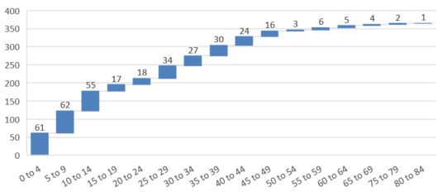

Session type
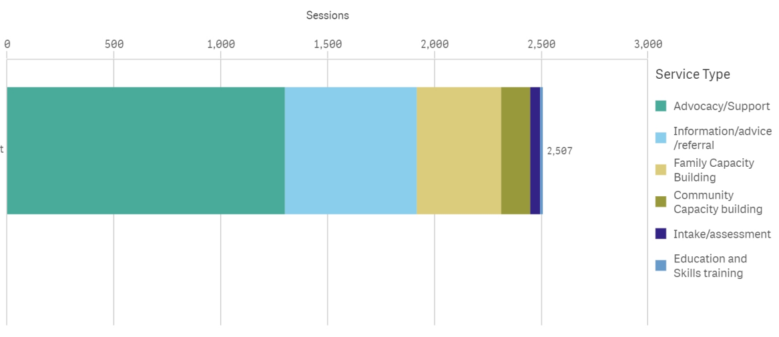

Children and Family Intensive Support (CaFIS)
As at September 2022
Providers and Locations

- Laynhapuy Homelands Aboriginal Corporation
Gapuwiyak, Yirrkala, Laynhapuy Homelands

- Mala'la Health Service Aboriginal Corporation
Maningrida

- Save the Children Australia
Wadeye

- Larrakia Nation Aboriginal Corporation
Palmerston, Gurdorrka, Kulaluk
Darwin – includes Knuckey Lagoon, Bagot, Minmarama Park

- Yugul Mangi Development Aboriginal Corporation
Ngukurr

- Katherine West Health Board Aboriginal Corporation
Lajamanu, Kalkarinji

- Kalano Community Association Inc
Katherine, Mataranka, Beswick, Barunga, Binjari, Rockhole

- Anyinginyi Health Aboriginal Corporation
Tennant Creek

- Central Australian Aboriginal Congress Aboriginal Corporation
Alice Springs

- Waltja Tjutangku Palyapayi
Ti Tree, Laramba, Engawala, Bonya, Atitjere, Utopia (Urapuntja)

- Ngaanyatjarra Pitjantjatjara Yankunytjatjara Women's Council Aboriginal Corporation
Apatula (Finke), Imanpa, Mutitjulu, Kaltukatjara (Docker River), Amata, Mimili, Pukatja, Indulkana

- Warlpiri Youth Development Aboriginal Corporation
Yuendumu

Map of CaFIS Locations

