NDIS National Workforce Plan: 2021-2025 – quarterly update – October 2021
Planned implementation timeline
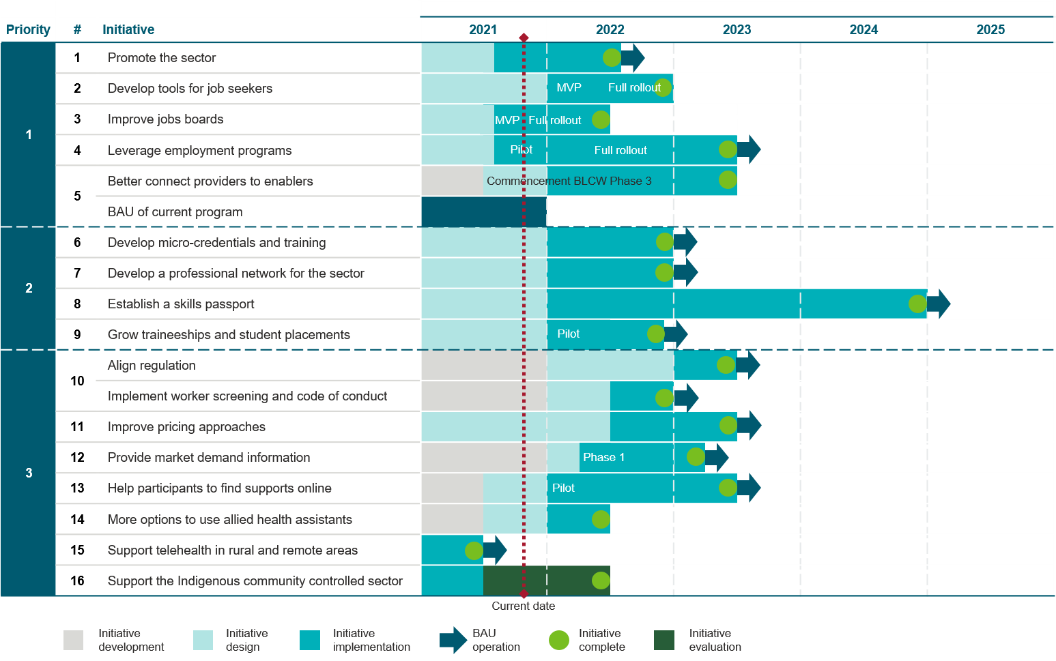
Achievements and next steps
Initiative | Achievements | Next steps
- Promote opportunities in the care and support sector.  Funding:  2020-21  $13.3 million  2021-22 (extension)  $9.8 million  Total  $23.1 million | A Life Changing Life campaign launched on 15 August 2021 on TV, social, digital channels and is currently in market.  Communication activities will continue throughout the second half of 2021 to promote the care and support workforce.  These activities were informed by extensive stakeholder consultation and emphasise the benefits of working in the sector through real stories of the positive connections between workers and the people they support.  The first (of four) SEEK webinars was hosted on 9 September 2021.  The Department of Social Services (the department) worked closely with key stakeholders, particularly those in the care and support sector, ahead of commencement of these communication activities to ensure awareness was raised around complementary activities conducted by the sector. | Implement feedback from user-testing reports and other stakeholders (such as Aged Care Workforce Industry Council) to campaign website https://www.careandsupportjobs.gov.au/.  Commence Aboriginal and Torres Strait Islander targeted public relations and engagement.  Commence phased Culturally and Linguistically Diverse targeted public relations and engagement.  Implement Cultural Literacy webinar for employers.  Implement Year13 and Junkee partnerships.  Ongoing public relations activities, including development of more case studies, media outreach to regional areas, stakeholder communications and follow-ups.
- Develop a simple and accessible online tool for job seekers to self-assess their suitability for new roles based on values, attributes, skills and experience. | The department is working with the National Careers Institute on the development of an online tool.  The department has mapped existing government online tools. | Conduct extensive user testing to ensure the online tool is fit for purpose.  Launch the online tool.
- Improve effectiveness of jobs boards to match job seekers to vacancies in the sector. | A targeted, pre-filled JobActive jobs board was developed and published on the https://www.careandsupportjobs.gov.au/. This directs job seekers to jobs in the care and support sector.  Through the communications campaign partnership with SEEK, targeted jobs boards for aged care, disability and veterans’ support have been developed and published on https://www.careandsupportjobs.gov.au/.  The DESE JobHubs jobs board was updated to include a care and support tile. | Analyse data on usage of https://www.careandsupportjobs.gov.au/, JobActive website and SEEK job boards to identify if further enhancements to the Jobs Boards are required.
- Leverage employment programs to ensure suitable job seekers can find work in the sector. | To increase the reach of the A Life Changing Life campaign, and improve linkages to employment services programs, the department briefed the following networks prior to commencement of the campaign:  - Employment Liaison Officers,  - Employment Facilitators, and  - National Careers Institute – Career Practitioners. | Ongoing consultation with program owners to determine the scope of trials into:  - Disability Employment Services  - Community Development Program  - New Employment Services Model
- Better connect NDIS and care and support providers to employment and training providers and workers.  Funding:  $16.9 million (2021-22 to 2022-23) | From 1 July 2021, the Boosting the Local Care Workforce (BLCW) program expanded its remit to the broader care and support sector to include aged and veterans’ care in addition to its current NDIS focus. This expansion also focuses on workforce, including connecting training and employment services providers to care and support providers. | BLCW coordinators continue to host and co-host workshops and events to support workers and providers across the care and support sector, with a focus on workforce attraction, retention and organisational strategy.
- Develop micro-credentials and update nationally recognised training to improve the quality of supports and enhance career pathways. | The Human Services Skills Organisation will lead the consultation and co-design process and the department will procure an organisation to provide specialist support of this activity.  A Request of Tender to engage an organisation to undertake stakeholder consultations with carers and participants and their families to map skill requirements and inform development of guidance on curriculum topics, content and assessment was provided to three members of the DESE Research Services Panel, tenders closed on 22 July 2021. | Finalise procurement process and commence consultation and co-design process.  It is anticipated that guidance on topics and content for micro-credentials will be made available to Registered Training Organisations in the second half of 2022.
- Support the sector to develop a Care and Support Worker Professional Network. | Procurement is underway to conduct a desktop review, environmental scan, stakeholder consultations, and detailed report to inform a pilot of professional networks to support more workers in the sector to connect with peers and with peer support to share and promote good practice. | Finalise procurement process and commence consultation and co-design process.  A pilot of professional networks will be undertaken in 2022, in close collaboration with the sector.
- Work with the sector to establish a skills passport. | Procurement underway to conduct a desktop review, environmental scan, stakeholder consultations, and detailed report to ensure the care and support national skills passport meets the needs of employees, employers and participants. | Finalise procurement process and commence consultation and co-design process.
- Support the sector to grow the number of traineeships and student placements, working closely with education institutions and professional bodies. | The department is undertaking consultations with disability support providers, the allied health sector, universities and other disability stakeholders to define barriers to student placements and options to inform strategy development. | The department will work across governments to leverage initiatives such as JobTrainer to further support traineeships and student placements.  The BLCW program will develop case studies and business strategy models for allied health student placements.  The department will host a roundtable with allied health stakeholders on student placement model funding options.
- Improve alignment of provider regulation and worker screening across the care and support sector.  Funding:  $12.3 million (2021-22 to 2022-23) | The Department of Health has established a cross-agency taskforce with the department and the Department of Veterans’ Affairs to lead the implementation of regulatory alignment and worker screening initiatives. Streams of work have been established and departmental leads agreed.  Aged care legislation has changed to recognise NDIS worker screening clearances. This makes it easier for aged care providers and workers (staff and volunteers) that support NDIS participants. Information is being disseminated on the changes and enforcement.  Legislation drafted for changes to the Aged Care Act to allow for care and support worker screening and a care and support code of conduct.  Minister for NDIS agreed to scope and approach to NDIS Quality and Safeguard Framework Review. | Finalise consultation and engagement strategy and phase one engagement with the sector.  Engage with states and territories on nationally consistent worker screening.  Establish the Framework Review Working Group and undertake procurement of a review specialist.
- Continue to improve NDIS pricing approaches to ensure effective operation of the market, including in thin markets. | The department is conducting a project on pricing for the effective operation of the NDIS market by identifying potential options for price and payment arrangements to improve outcomes for participants while supporting longer-term sustainability. | Release public consultation paper. Prepare for targeted consultations, including in advance of public release.
- Provide market demand information across the care and support sector to help identify new business opportunities.  Funding:  $2.4 million | The department and Department of Health hosted supply and demand modelling workshops in September 2021 to progress detailed project scoping and planning. | Investigate options for a Memorandum of Understanding with the Department of Health to consolidate market supply and demand analytics projects under one contract.  Source an ICT supplier to design and build a Care and Support Sector Demand Map (NDIS and aged care).
- Support participants to find more of the services and supports they need online. | The department has mapped the current services and supports available online in the care and support sector. | Investigate integration into current and future digital projects with National Disability Insurance Agency (NDIA). Potential projects include:  - Digital Partnership Program  - provider finder through MyPlace  Investigate integration in MyPlace App Pilot with NDIA.
- Explore options to support allied health professionals to work alongside allied health assistants and support workers to increase capacity to respond to participants’ needs. | The department has commenced consultations with key stakeholders – in particular the allied health services workforce, professional bodies and participants – to guide the development of options to educate workers on roles, responsibilities and effective multi-disciplinary support models. | Engage with the Department of Health and NDIS Quality and Safeguards Commission to seek consensus on regulatory guidance for the allied health workforce.  Brief the Human Services Skills Organisation and consultants procured to deliver the micro-credentials project on the need for training development to support allied health professionals, allied health assistants and disability support workers to work in teams to support participants.  Engage with allied health assistants’ representative groups to explore challenges and options for future development.  Options to inform the safe and efficient delivery of allied health services to NDIS participants, including through development of tailored micro-credentials, are intended to be delivered in the first half of 2022.
- Enable allied health professionals in rural and remote areas to access professional support for case conferencing via telehealth. This enables a local allied health professional in regional and remote areas access specialist support from other allied health professionals where it helps support the NDIS participant. | NDIA has agreed to allow providers to charge for case conferencing for professional support via telehealth to support NDIS participants. | The department and NDIA are working with key stakeholders, particularly those in rural and remote areas, to highlight the availability of this service option.
- Help build the Aboriginal and Torres Strait Islander community controlled sector to enhance culturally safe NDIS services.  Funding:  $5.9 million (NDIS Ready) | 57 Aboriginal Community Controlled Health Organisations and Aboriginal Community Controlled Organisations across Australia will receive Indigenous Business Support Funding grants, worth $22,000 each. The grants will enable organisations to address challenges in registering and delivering NDIS services, including engaging business and technical advice to develop better systems to deliver NDIS services. The funding will also provide an opportunity for organisations to scope future Aboriginal-led disability solutions within Aboriginal and Torres Strait Islander communities. | Explore opportunities for future projects to build the community controlled sector through the Sector Strengthening Plan on Disability and through the Closing the Gap National Agreement.

