Statement of Continued Commitment:

National Disability Strategy 2010-2020

For a decade, the National Disability Strategy has provided a policy framework for disability reform and inclusive policy and program design across Australia. The Strategy was set to expire in 2020, and be replaced with a new Strategy to take us into the next decade.
We are living through a once in a lifetime event that has challenged us, and brought us together. The impact of COVID-19 has been wide reaching. The development of the new Strategy has been restricted by current events, while we paused community engagement to ensure people with disability could safely have their say.
We want to keep working with people with disability, their families and supporters, as we develop the new Strategy.
In 2019, around 3,000 people with disability, their families and carers, advocacy organisations, peak bodies and service providers took part in the first stage of community engagement and consultation around Australia.
A common and important message we heard during consultations was: nothing about us, without us. It is clear people with disability need to be involved in all aspects of designing the new Strategy. However, further conversations with people with disability about the new Strategy have been delayed due to COVID-19.
The delay in consultations will not have any direct impact on the provision of services for people with disability. However, the delay in consultations will impact when we will be able to release the new Strategy.
The Commonwealth Government and state, territory and local governments remain committed to development of a new Strategy and believe it is essential that people with disability have a real and robust opportunity to have their say on the Strategy and contribute to its development. Our aim is to ensure people with disability get this opportunity at a time that is appropriate for them.
It is anticipated the new Strategy will be released in mid-2021. Through this Statement of Continued Commitment, all governments agree to continue their efforts in implementing the principles of the current Strategy until the new Strategy is released, and to upholding the United Nations Convention of the Rights of Persons with Disabilities.
States and territories continue to express their commitment to the Strategy through their state and territory disability plans. The Commonwealth Government and state, territory and local governments will continue to implement existing activities, and develop new activities. Above all, governments will continue taking a unified, national approach to improving the lives of people with disability and to achieving the vision of the Strategy, that of an inclusive Australian society.

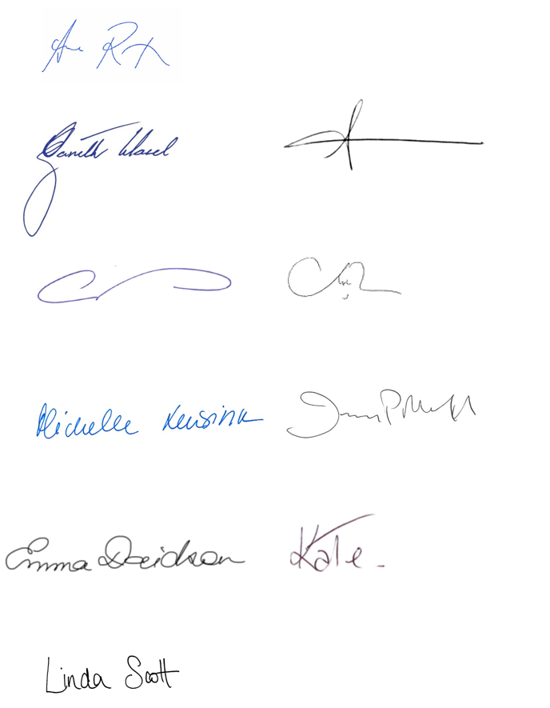
Endorsed on 4 December 2020 by:
Senator the Hon. Anne Ruston
Minister for Families and Social Services, Australian Government
The Hon. Gareth Ward MP  Minister for Families, Communities and Disability Services,  New South Wales | The Hon. Luke Donnellan MP  Minister for Disability, Ageing and Carers,  Victoria
The Hon. Craig Crawford MP  Minister for Seniors and Disability Services and Minister for Aboriginal and Torres Strait Islander Partnerships, Queensland | The Hon. Stephen Dawson MLC  Minister for Disability Services,  Western Australia
The Hon. Michelle Lensink MLC  Minister for Human Services,  South Australia | The Hon. Jeremy Rockliff MP  Minister for Disability Services and Community Development,  Tasmania
Emma Davidson MLA  Minister for Disability,  Australian Capital Territory | The Hon. Kate Worden MLA  Minister for Disabilities,  Northern Territory
Councillor Linda Scott
President, Australian Local Government Association

