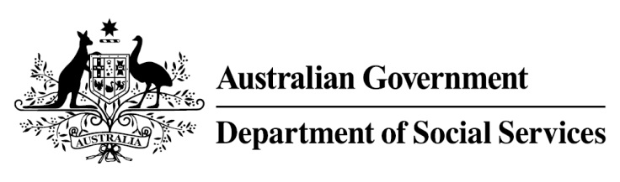

Try, Test and Learn Fund

Initiative: Warra Warra Kanyi (‘Caring for people’ in Warlpiri language)
Location: Northern Territory

Fast facts
Priority group: Other
Participant numbers: 75
Locations: Yuendumu and Lajamanu
Trial period: 18 months
Total funding: $1.46 million
Service provider: Warlpiri Youth Development Aboriginal Corporation
Potential future saving: This project is one that supports participants who for the purposes of the Try, Test and Learn Fund are classified as an ‘other’ group at risk of long-term welfare dependence, or are a sub-group of a priority group. This group of people was identified through the provider’s experience in working with vulnerable people, and other research. To date, potential future savings for this group have not been calculated using the Priority Investment Approach model. Such a calculation may be possible once we have data on participants in this project if an appropriate comparison group can be identified.

What are we trying to achieve?
To improve the health and wellbeing of Indigenous people, aged between 12 and 35 years, living in two remote Warlpiri communities to assist them to become more resilient, engaged and productive. The project will test whether higher levels of social and emotional wellbeing will lead to improved education and employment outcomes.

What is Warra Warra Kanyi?
Through Warra Warra Kanyi, participants receive intensive case management to address the reasons that have led them to become disengaged from education and employment. The case managers are community members, who are supported by experienced practitioners. Through this bi-cultural model, the project will work with participants to provide them with the skills and supports needed to improve their psychological, emotional and physical wellbeing.
Warra Warra Kanyi has been successfully operating for a decade in Yuendumu. This project will enable the approach to be continued, clearly documented, and rolled out to Lajamanu community, where no case management services currently exist.

What does the evidence tell us?
Young unemployed Indigenous people face a variety of barriers to further education and employment, particularly those living in very remote areas.
Indigenous people living in very remote areas are 1.4 times more likely to be unemployed and 1.5 times more likely to receive government allowances as their main income source than Indigenous people living in major cities (AIHW, Australia’s Welfare, 2017).

How is this initiative new and innovative?
This project will test the scaling up of a bi-cultural approach to delivering services, in a remote Indigenous community where no such services currently exist. The approach embeds systems and skills that reduce the risk of welfare dependence. It also helps to develop skills in the educational, emotional and psychological domains of Warlpiri life that increase employability and the likelihood of maintaining employment.
Using insights from the Priority Investment Approach, the $96.1 million Try, Test and Learn Fund is gathering evidence on new or innovative approaches to addressing barriers to work.
The Try, Test and Learn Fund will help achieve the objectives of welfare reform — that is, to develop a modern welfare system that increases the capacity of individuals, reduces the risk of welfare dependency and maintains a strong welfare safety net.

