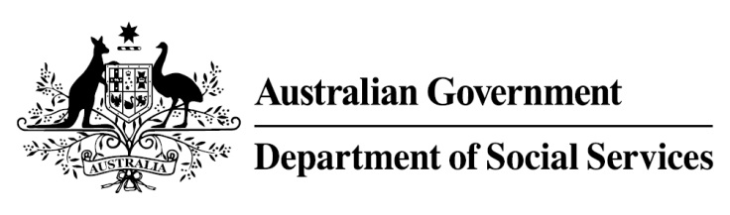

Try, Test and Learn Fund

Initiative: Meeting the Youth Gap

Location: Northern Territory

What are we trying to achieve?

Fast facts
Priority group: At-risk young people
Participant numbers: 30
Location: Central Desert region
Trial period: 13 months
Total funding: $1 million
Service provider: Tangentyere Council Aboriginal Corporation
Potential future saving: This project is one that supports participants who for the purposes of the Try, Test and Learn Fund are classified as an ‘other’ group at risk of long-term welfare dependence, or are a sub-group of a priority group. This group of people was identified through the provider’s experience in working with vulnerable people, and other research. To date, potential future savings for this group have not been calculated using the Priority Investment Approach model. Such a calculation may be possible once we have data on participants in this project if an appropriate comparison group can be identified.
To increase the employability and life skills of Indigenous young people living in the Central Desert region, by providing on-the-job training and paid work experience as youth workers as a pathway to available jobs in the region.

What is Meeting the Youth Gap?
Through this project, participants are provided paid work for up to 12 months within one of two organisations delivering youth services in Warlpiri communities in the Central Desert region. Participants, who are local Indigenous young people, work alongside senior youth workers, providing the support that youth workers would ordinarily deliver. This involves activities central to these young people’s lives: sport, music, computers, new media and cultural activities.
The project will be flexible and responsive to the challenges faced by Indigenous young people, allowing them to fit work experience around cultural commitments, for example. Participants are also provided professional development training that they complete at their own pace. Topics include financial literacy, mental health, alcohol and other drugs challenges, and personal goals and aspirations. Participants will gain the skills, knowledge and experience required to fill available positions in the region enabling a new generation of local employed young people.

What does the evidence tell us?
- Young unemployed Indigenous people face a variety of barriers to further education and employment, particularly those living in very remote areas.
- Indigenous people living in very remote areas are 1.4 times more likely to be unemployed and 1.5 times more likely to receive government allowances as their main income source than Indigenous people living in major cities (AIHW, Australia’s Welfare, 2017).

How is this initiative new and innovative?
The project will test whether flexible, meaningful work, specialised training and support will improve the confidence, life skills and employability of young Indigenous people in remote communities.
Using insights from the Priority Investment Approach, the $96.1 million Try, Test and Learn Fund is gathering evidence on new or innovative approaches to addressing barriers to work.
The Try, Test and Learn Fund will help achieve the objectives of welfare reform—that is, to develop a modern welfare system that increases the capacity of individuals, reduces the risk of welfare dependency and maintains a strong welfare safety net.

