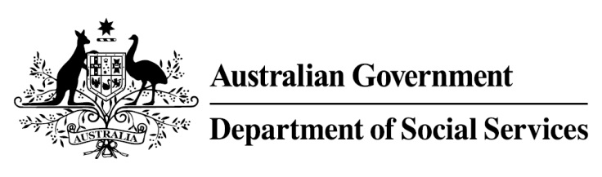

Try, Test and Learn Fund

Initiative: Community Voices

Location: Queensland and Tasmania

What are we trying to achieve?

The project aims to support young people at risk of long-term welfare dependence to develop informal social connections and professional networks that could assist them to find employment.

Fast facts
Priority group: At-risk young people
Participant numbers: 120
Location: Logan, Queensland and North-West Tasmania
Trial period: 17 months
Total funding: $1 million
Service provider: WISE Employment Ltd
Potential future saving: If around 20 per cent of participants move off income support because of this project, the savings to the welfare system are likely to outweigh the costs of the project.

What is Community Voices?

This project establishes two community choirs comprising at-risk young people and other members of the community. Choir rehearsals will be held once a week and there will be quarterly community performances. The project will also provide activities that help participants to form new and valuable social networks.
During the break at weekly rehearsals, participants will have an opportunity to create ‘wish lists’. For example, participants could ask other choir members for assistance with work experience opportunities or help with their resume. Outside of rehearsals, participants will also have access to individual case management and referrals to assist with a range of psychosocial barriers, education, employment planning and other support including access to training funds.

What does the evidence tell us?
- The barriers to further education and employment for young unemployed people are varied. While some will face minimal barriers to engaging in further education or taking up employment opportunities, others will face a number of challenges to making a successful transition.
- If nothing changes, 42 per cent of 16-21 year olds currently receiving with Youth Allowance (other) or Disability Support Pension with mental health as the primary condition will be receiving income support payments in 10 years, and 33 per cent will be receiving income support payments in 20 years.

How is this initiative new and innovative?
Community Voices uses community choir as the mechanism for providing young people with access to informal social networks. There is some evidence that community singing helps to relieve anxiety and stress, and increases trust, self-confidence and social skills. This project will trial whether the combination of singing, socialising and case management support can lead to improved educational and employment outcomes for at-risk young people.
Using insights from the Priority Investment Approach, the $96.1 million Try, Test and Learn Fund is gathering evidence on new or innovative approaches to addressing barriers to work.
The Try, Test and Learn Fund will help achieve the objectives of welfare reform—that is, to develop a modern welfare system that increases the capacity of individuals, reduces the risk of welfare dependency and maintains a strong welfare safety net.

