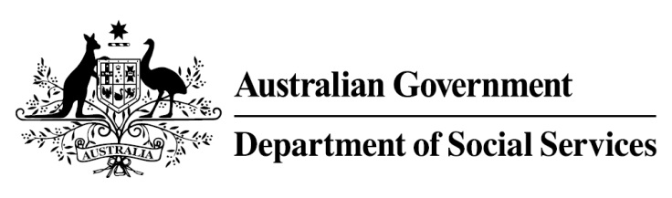

Try, Test and Learn Fund

Initiative: Resilience through Inspiration and Determination leading to Employment (RIDE)
Location: Adelaide and Hobart

What are we trying to achieve?

Fast facts
Priority group: At-risk young people
Participant numbers: 144
Locations: Adelaide North, Christie Downs and Seaford (Adelaide), and Hobart
Trial period: 18 months
Total funding: $1.5 million
Service provider: MAS National
Potential future saving: If around 25 per cent of participants move off income support because of this project, the savings to the welfare system are likely to outweigh the costs of the project.
Encourage unemployed young people who have serious barriers to employment—including young people who have had experience with the youth justice system—onto pathways towards education, social engagement and work through a mix of vocational and non-vocational workshops.

What is RIDE?
For two days a week, over 15 weeks, the project works with small groups of
at-risk young people, supporting each of them to overcome barriers to social participation, education and employment. It does this by combining a fun, physically and mentally challenging activity (that is, mountain bike and BMX riding) with vocational and non-vocational training.
The training includes workplace visits, team-building, job-search techniques, financial literacy training, career counselling, nutrition, mental health strategies and the completion of two vocational modules in work health and safety and team effectiveness. Participants can download a smartphone application that ‘gamifies’ their experience and encourages their engagement in the project.
What does the evidence tell us?
- Young unemployed people face a variety of barriers to further education and employment. While some will face minimal barriers to engaging in further education or taking up employment opportunities, others will face a number of challenges to making a successful transition.
- If nothing changes, 42 per cent of 16-21 year olds currently receiving Youth Allowance (other) or Disability Support Pension with mental health as the primary condition will be receiving income support payments in 10 years, and 33 per cent will be receiving income support payments in 20 years.
How is this initiative new and innovative?
The unusual combination of an engaging physical activity together with training to enhance participants’ ability and motivation to engage in education, training or employment; the theory being that this will help these young people (who can be particularly difficult to engage) to overcome their barriers.
Using insights from the Priority Investment Approach, the $96.1 million Try, Test and Learn Fund is gathering evidence on new or innovative approaches to addressing barriers to work.
The Try, Test and Learn Fund will help achieve the objectives of welfare reform—that is, to develop a modern welfare system that increases the capacity of individuals, reduces the risk of welfare dependency and maintains a strong welfare safety net.

