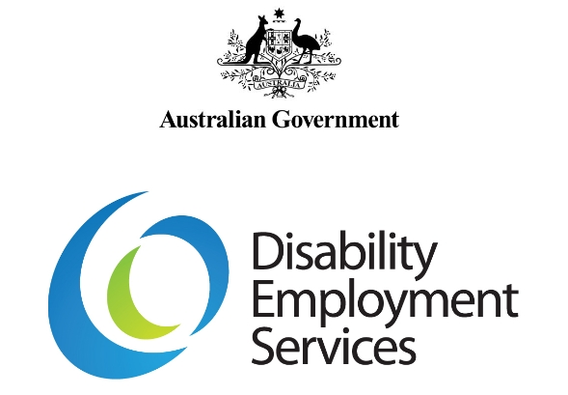
2018 DES Employment Verification Guidelines
V 1.0
Disclaimer
This document is not a stand-alone document and does not contain the entirety of Disability Employment Services Providers' obligations. It should be read in conjunction with the Disability Employment Services Grant Agreement and any relevant guidelines or reference material issued by the Department of Social Services under or in connection with the Disability Employment Services Grant Agreement.

Table of Contents
Table of Contents 2
Document Change History 3
Background 3
Disability Employment Services Grant Agreement Clauses: 3
Reference documents relevant to this guideline: 3
Explanatory Note: 3
2018 DES Employment Verification Guidelines

Document Change History
Version | Effective Date | End Date | Change & Location
1.0 | 3 December 2018 |  | Original Document

Background
These Guidelines outline the Disability Employment Service (DES) Provider’s responsibilities and required actions for the Participants that require the employment verification for the Ongoing Support performance measure of the 2018 DES Performance Framework.

Employment verification for the Ongoing Support performance measure applies six weeks following an eligible DES-Employment Support Service (DES-ESS) Provider exit as an Independent Worker.

Flow Chart: DES-ESS Ongoing Support – employment verification

Step | Action
1. | DES Participant included in the Ongoing Support denominator
2. | Six weeks following a Provider initiated Independent Worker exit the Participant reaches the employment verification date
3. | Employment Status Verified from existing departmental information or DES Provider supplied information
4. | Star Rating calculation
Note: This should not be read as a stand-alone document, please refer to the Disability
Employment Services Grant Agreement.

Disability Employment Services Grant Agreement Clauses:
Clause 15 – Provider’s Conduct

Reference documents relevant to this guideline:
DES Employment Verification (Star Ratings) Technical Information
2018 DES Star Ratings Methodology Advice
DES Documentary Evidence for Claims for Payments Guidelines

Explanatory Note:
All capitalised terms have the same meaning as in the Disability Employment Services Grant Agreement.

In this document, “must” means that compliance is mandatory and “should” mean that compliance represents best practice.

Employment Verification – Ongoing Support

Who is Responsible: | What is Required:
1. DES Provider  Participant is included in the Ongoing Support measure denominator and is exited as an Independent Worker | A DES Provider supports the Participant in the Ongoing Support phase and meets the requirements to be included in the Ongoing Support measure denominator. Refer to the ‘DES Star Ratings Methodology Advice’ document for information regarding the denominator business rules.  Where the DES Provider determines that the Participant is able to work independently without any further support, the DES Provider will exit the Participant from the programme.
2. DSS  Employment Verification date | For Participants who are included in the denominator of the Ongoing Support performance measure the employment verification date will be set to six weeks (42 days) after the DES Provider initiated Independent Worker exit of a Participant.
3a. DSS  Employment Verification from existing data sources | The Employment Services System will check applicable existing  departmental or Department of Human Service’s data to verify if the Participant is in employment at the employment verification date. At the employment verification date if one of these conditions is met the Participant’s employment status will automatically be verified:  DES-ESS:  • The Participant has declared earnings for employment to the Department of Human Services in the fortnight that includes the employment verification date  • An Ongoing Support Assessment recommends an exit as an Independent Worker (only applies to Participants already in the denominator of the measure).
3b. DES Provider  Provider declaration of employment status (DES-ESS only) | Where a DES-ESS Participant does not meet the condition described in 3a, the DES Provider will be notified of the requirement to declare in the Employment Services System that the Participant was still employed at the employment verification date.  If the DES Provider records that the Participant is in employment at the employment verification date, the DES Provider must retain documentary evidence to support this.  Consistent with the ‘Documentary Evidence for Claims Payment Guidelines’ document in ‘Section 3: Outcome Fees - Full Outcome and Pathway Outcome (based on Employment)’, the Documentary Evidence required to support the verification of employment at the six week date will be:  A file note or a signed and dated written statement or email from the Employer or Participant (including where the Participant is self- employed) and must contain (unless otherwise specified by DSS) the following:  • the name of the Employer  • the period of Employment  • name of the person who confirmed the Employment details (that is either the Participant or person within the Employer organisation) and their contact details and  • the date the information contained in the file note was confirmed and the name of the DES Provider’s staff member who recorded the information.  or  A payslip with dates that includes the date of when the 6 week date occurs.
4. DSS  Star Rating calculation | The department will calculate the number of eligible Participants that either need to be retained or removed from the numerator of the Ongoing Support performance measure numerator. The Ongoing Support measure will contribute 15 per cent to the DES-ESS Star Rating calculation and is not anticipated to form part of the calculations until March 2019.

