Cashless Debit Card
Information for businesses

The Cashless Debit Card looks and operates like any regular bank card, however, it restricts the purchase of alcohol, gambling products and some gift cards and cannot be used to withdraw cash.

Will my business need to do anything to accept the Cashless Debit Card?
You will not need to opt-in to accept the Cashless Debit Card and most businesses will not need to change anything to accept the card. The card will work at all businesses that accept EFTPOS nationwide except for businesses that primarily sell takeaway alcohol or gambling products.

I am a business owner who does not have EFTPOS facilities.
There are low-cost options available for businesses that do not have EFTPOS facilities and the Department of Social Services (DSS) can discuss these further with you and your staff.

Will the Cashless Debit Card work in my bottle shop?
No, businesses that primarily sell restricted goods, such as bottle shops and casinos are blocked from accepting the card nation-wide.

What happens if I sell alcohol and/or gambling products as well as other products?
If your business sells both restricted and non-restricted goods you may be contacted by DSS to discuss options for accepting the Cashless Debit Card, including entering into a Merchant Agreement.

DSS staff may also discuss blocking the use of the Cashless Debit Card at specific terminals that are dedicated to the purchase of restricted goods only.

Does the Government monitor compliance with the Merchant Agreement?
Fraud analysis will be undertaken by the card provider, Indue, to identify non-compliant behaviour. Indue will notify DSS of any non-compliance.

I own a café that mostly sells food, but some alcohol, how will this card affect me?
The Cashless Debit Card is a Visa debit card that operates like a normal bankcard. You will be able to accept the card without any further action.

Will my staff require additional training?
No, staff will not require additional training, however, DSS can provide assistance for business specific queries.

Just like any other bankcard, those with a Cashless Debit Card can simply insert a card, select "CR" (Credit), "SAV" (Savings) or "CHQ" (Cheque), then they will be prompted to enter their PIN. The transaction will be processed just like any other transaction. The transaction will be declined if there is no money in the account or if the purchase is for a restricted item. Note that the Visa payWave option is not available on the Cashless Debit Card.

How will the Cashless Debit Card benefit my business and me?
Businesses are an integral part of the Cashless Debit Card program and the restriction of alcohol, gambling and illegal drugs ensures that more money can be spent locally. These restrictions also contribute significantly to the reduction of community level social harm.

As Cashless Debit Card participants also have access to an unrestricted 20 per cent of their payment, they can still buy second-hand goods and shop at local markets.

Where can I find out more? Go to dss.gov.au/cashlessdebitcard
Or contact the Department of Social Services on 1800 252 604 or at cashlessdebitcard@dss.gov.au

GET THE FACTS

The Cashless Debit Card is just like a
regular bank card – use the card to:

- pay rent or mortgage
- pay bills
- pay for medical appointments
- pay electricity bills
- pay car registration
- buy groceries
- check balance and transaction history for free

Did you know?
- Medicare rebates can still go into your
regular bank account

The Cashless Debit Card cannot be used to buy alcohol, gambling products, some gift cards or to withdraw cash.

People on the Cashless Debit Card receive:

- 20 per cent of their welfare payment into their regular bank account
- 80 per cent of their welfare payment onto their Cashless Debit Card
- 100 per cent of lump sum payments from Centrelink (e.g. Family Tax Benefit) are placed onto the Cashless Debit Card
Did you know?
- Centrepay and Rent Deduction Scheme stay the same
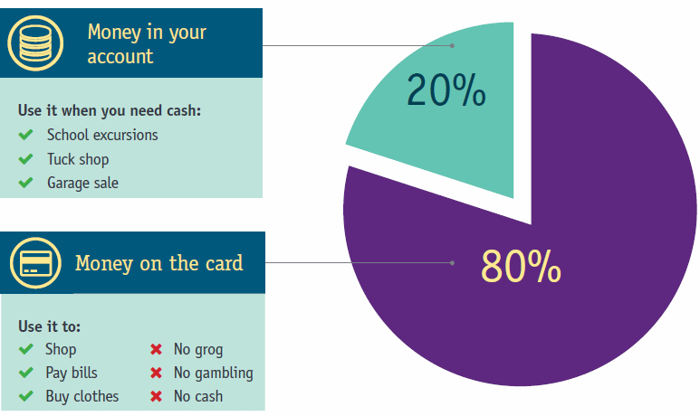

Where can I find out more? Go to dss.gov.au/cashlessdebitcard
Or contact the Department of Social Services on 1800 252 604 or at cashlessdebitcard@dss.gov.au

