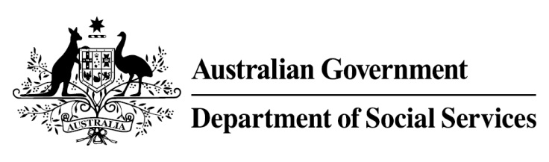

Try, Test and Learn Fund

  - Y4Y Youth Force
Using insights from the Priority Investment Approach, the $96.1 million Try, Test and Learn Fund will deliver evidence-based policies that improve peoples’ lives.
The Try, Test and Learn Fund will help achieve the objectives of welfare reform—that is, to develop a modern welfare system that increases the capacity of individuals, reduces the risk of welfare dependency and maintains a strong welfare safety net.

What does the evidence tell us?

Fast facts
- Priority group: Unemployed former students
- Recipient numbers: 80
- Locations: Melbourne, Perth, and Hobart
- Trial period: 24 months
- Total funding: $1.4 million
- Co-designer: Whitelion Australia
- Service provider: Whitelion will be invited to apply for funding
- Potential future saving: The purpose of these initiatives is to test whether an intervention works to reduce long-term reliance on welfare. It is not possible to predict success rates in advance—this is the purpose of testing new approaches. If 20 per cent of participants (17) move off welfare, the savings to the welfare system are likely to outweigh the costs
- 22 per cent of all current 17-19 year olds receiving student payments are expected to be on income support in 10 years.
- From 2003 to 2012, there were 7,160 vocational or university students who started receiving a student payment aged 17 to 19; then experienced more than 12 months on unemployment payments; and were receiving unemployment payments in 2015-16. On average, all of these former young students who transitioned directly to unemployment payments are expected to receive income support in 33 years of their future lifetimes.
- If nothing changes for these former young students, 39 per cent will be receiving income support payments in 10 years, and 30 per cent will be receiving income support payments in 20 years.

What is Y4Y Youth Force?
A digital platform will connect unemployed former students with short-term employment opportunities in the task-based (gig) economy. Jobs could include gardening, driving and delivery, catering and hospitality and child minding. These jobs will help participants build work experience and give them the confidence to take the next step into long-term employment.
At the onset, participants will receive two weeks of general skills training (for example, time management, IT skills and customer service) and additional sector-specific training by request (for example, administration work and gardening).
A Y4Y Youth Force hub will provide a central location for participants to meet and interact with support staff, and borrow shared resources, such as tools.

What are we trying to achieve?
Development of the capacity of participants to engage with the emerging task-based economy. This will also facilitate the development of work skills and real experience and portfolio development; the result of which is longer-term employment opportunities. It may also stimulate interest in further education.

How is this initiative new and innovative?
This initiative will provide evidence on the effectiveness of supporting young people to access short-term work through the task-based economy, as a way to supporting their longer-term engagement in work.

How will this initiative be evaluated?
This initiative will be tracked using a range of evaluation methods, such as surveys, participant interviews and actuarial analysis.

