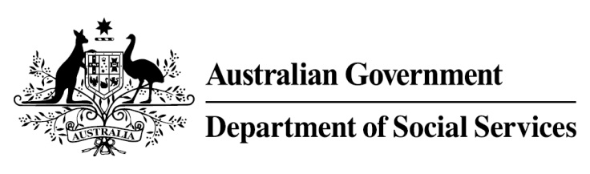

Try, Test and Learn Fund

  - Strengthening students’ resilience
Using insights from the Priority Investment Approach, the $96.1 million Try, Test and Learn Fund will deliver evidence-based policies that improve peoples’ lives.
The Try, Test and Learn Fund will help achieve the objectives of welfare reform—that is, to develop a modern welfare system that increases the capacity of individuals, reduces the risk of welfare dependency and maintains a strong welfare safety net.

What does the evidence tell us?

Fast facts
- Priority group: Young students
- Recipient numbers: 10,000
- Locations: Sydney, and regional New South Wales (precise locations will be negotiated with education institutions after the grant agreements are in place)
- Trial period: 24 months
- Total funding: $1.3 million
- Co-designers: Behavioural Insights Team Australia, and Behavioural Economics Team Australia
- Service provider: Behavioural Insights Team Australia will be invited to apply for funding as part of a consortium
- Potential future saving: The purpose of these initiatives is to test whether an intervention works to reduce long-term reliance on welfare. It is not possible to predict success rates in advance—this is the purpose of testing new approaches. Due to the low cost per participant, if even a small group of participants move off welfare, the savings to the welfare system are likely to outweigh the costs
- 22 per cent of all current 17-19 year olds receiving student payments are expected to be on income support in 10 years.
- From 2003 to 2012, there were 7,160 vocational or university students who started receiving a student payment aged 17 to 19; then experienced more than 12 months on unemployment payments; and were receiving unemployment payments in 2015-16. On average, all of these former young students who transitioned directly to unemployment payments are expected to receive income support in 33 years of their future lifetimes.
- If nothing changes for these former young students, 39 per cent will be receiving income support payments in 10 years, and 30 per cent will be receiving income support payments in 20 years.

What is Strengthening students’ resilience?
A mobile app and website will encourage students to set individualised short and long term goals, build study support networks and connect with on-site advisers.
Once their goals are set, a messaging service will provide nudge text messages to assist students to achieve their set goals. The content of the text messages will be based on behavioural insights and will be designed to help the students stay motivated.

What are we trying to achieve?
Increased attendance and reduced drop-out rates amongst participants, by equipping them with the skills to complete their studies. The goal is to improve lives through improving students’ employability.

How is this initiative new and innovative?
This trial will be the first of its type in Australia. It will provide evidence on the effectiveness of using behaviourally-informed text messages and technology to improve student participation and engagement in Australia.

How will this initiative be evaluated?
This initiative will be tracked using a range of evaluation methods, such as surveys, participant interviews and actuarial analysis.

