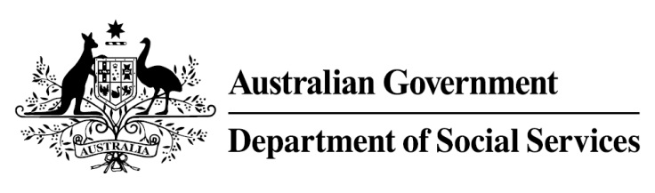

Try, Test and Learn Fund

  - My Maintenance Crew
Using insights from the Priority Investment Approach, the $96.1 million Try, Test and Learn Fund will deliver evidence-based policies that improve peoples’ lives.
The Try, Test and Learn Fund will help achieve the objectives of welfare reform—that is, to develop a modern welfare system that increases the capacity of individuals, reduces the risk of welfare dependency and maintains a strong welfare safety net.

What does the evidence tell us?

Fast facts
- Priority group: Unemployed former students
- Recipient numbers: 125
- Location: Greater Geelong region
- Trial period: 2.5 years
- Total funding: $2.3 million
- Co-designer: Diversitat
- Service providers: Diversitat will be invited to apply for funding
- Potential future saving: The purpose of these initiatives is to test whether an intervention works to reduce long-term reliance on welfare. It is not possible to predict success rates in advance—this is the purpose of testing new approaches. If 23 per cent of participants (29) move off welfare, the savings to the welfare system are likely to outweigh the costs
- 22 per cent of all current 17-19 year olds receiving student payments are expected to be on income support in 10 years.
- From 2003 to 2012, there were 7,160 vocational or university students who started receiving a student payment aged 17 to 19; then experienced more than 12 months on unemployment payments; and were receiving unemployment payments in 2015-16. On average, all of these former young students who transitioned directly to unemployment payments are expected to receive income support in 33 years of their future lifetimes.
- If nothing changes for these former young students, 39 per cent will be receiving income support payments in 10 years, and 30 per cent will be receiving income support payments in 20 years.

What is My Maintenance Crew?
This initiative will develop a new social enterprise that offers work in event clean-up and maintenance services to unemployed former students. Such a service will address unmet demand in the greater Geelong region.
Participants will be offered skills training, personal development opportunities, mentoring and counselling.
With a particular focus on ‘hands-on’ vocations, participants will be directly matched with available jobs and will develop the skills and knowledge required to provide event clean-up and maintenance services via the social enterprise, or on completion of the program, as independent contractors in these markets.

What are we trying to achieve?
Participants will gain employment, income, experience and connections in a part of the economy that is expected to provide ongoing employment prospects.
This experience will improve participants’ employability and, potentially ongoing employment in the mainstream economy.

How is this initiative new and innovative?
This initiative combines real-world learning augmented by virtual reality technology to help participants understand effective work practices.
It also offers the opportunity of gaining real experience through the development of a social enterprise that targets an existing gap.

How will this initiative be evaluated?
This initiative will be tracked using a range of evaluation methods, such as surveys, participant interviews and actuarial analysis.

