Evaluating the trial of the National Disability Insurance Scheme: Evaluation Framework

Plain language version of the Executive Summary

April 2014

How is the National Disability Insurance Scheme going so far?
In July 2013, the National Disability Insurance Scheme started in some parts of Australia.
The National Disability Insurance Scheme is usually called the NDIS.
It is a new way of providing care and support to people with disability in Australia.
So far, the NDIS has started as a trial in these places:
- some parts of NSW
- some parts of Victoria
- the ACT
- for certain age groups in South Australia
- for certain age groups in Tasmania.
The National Institute of Labour Studies (NILS) wrote this document. We are part of Flinders University.
The Australian Government Department of Social Services (DSS) has asked us to do some research. They want to find out how the NDIS is going so far.
We call this kind of research an evaluation.
The evaluation will help DSS understand which parts of the NDIS trial are working well, and which parts are not working well. This will help to make sure that the NDIS is even better when it starts in other parts of Australia over the coming months and years.
People who are experts in research and in working with people with disability will do the evaluation work.

We are looking at:
- how the NDIS changes the lives of people with disability and their families and carers
- the changes that are taking place in the disability sector
- areas of the health, mental health and education sectors that are relevant to the NDIS.

Background and planning
DSS has some important requirements for the evaluation of the NDIS trial. We will use these requirements to develop the framework for the evaluation and to plan how we will do our work.
DSS wants us to make sure that the NDIS is meeting the goals and objectives that it was created to achieve. At the moment, we are working out how we can measure this.
DSS has also asked us a set of questions that they would like us to find the answers to. We will do this using surveys and interviews.

Important considerations
In developing the framework for the evaluation, we must consider the following important aspects:
- The five trial sites are all different from each other.
- The five trial sites will introduce the NDIS in different ways and at different times.
- We need to compare the trial sites with a site where the NDIS is not currently available – we call this a comparison site.
- The NDIS may later be introduced in a comparison site.
- It may be difficult to collect information in some remote areas, especially in South Australia.
- A range of different people may join the NDIS, including people with different communication needs, children and young people, Aboriginal and Torres Strait Islander people, and people from different cultures.
- We must listen to the experiences of both the disability and mainstream sectors.
- We must also listen to the experiences of service users and disability workers.
- The research must meet ethical standards. We always consider people's needs when carrying out our research.

Challenges we will face
As we develop the evaluation framework and carry out the research, we will face certain challenges. These include:
- The phased trial of the NDIS. The way the trial has been set up, some people in the trial sites will join the NDIS before others do. This will be challenging for us because new people will be coming into the NDIS during the time we are conducting our research.
- There is no baseline data for the evaluation. Before the NDIS started, no information was collected that is similar to our research. This means we don't have data that we can measure against.
- Variations in how the NDIS is introduced in each trial site. Because each site is so different, and because the NDIS is new and still changing in each area, our research will need to be flexible. We will need to adapt to these changes where possible.

How the evaluation will work
The evaluation will occur in three phases, over a three year period.
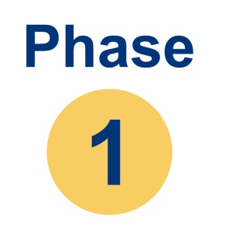 | Phase 1 is from May 2013 to July 2014.
During Phase 1, we will plan the evaluation. We will also make a plan to help people to know that the evaluation is happening. We want to encourage people to take part – particularly people who are already using the NDIS. The researchers will also decide which other people that they would like to talk to about the NDIS.
We will develop survey and interview questions. Large numbers of people will be asked to complete short surveys. Other people will take part in interviews, which will be longer and more detailed than the surveys.
We will hold the first round of surveys and interviews with:
- people with disability and their families and carers
- disability services and their workers
- mainstream services.
We will then analyse all of the information we have collected throughout Phase 1.

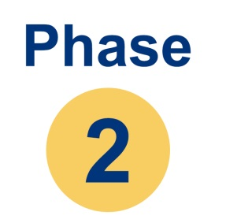 | Phase 2 is from July 2014 to June 2015.

During Phase 2, we will continue analysing all the data we collected during Phase 1. We will write a report on our findings by October 2014.
In April 2015, a further report will discuss the parts of the NDIS that work well and the parts that do not work well.
Interviews will continue throughout Phase 2. Planning will also start for a second round of surveys of people with disability and their families and carers. We will also plan the next round of surveys and interviews for the disability and mainstream sectors.

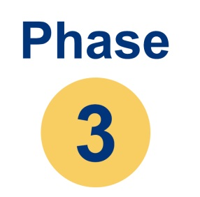 | Phase 3 is from July 2015 to June 2016.

During Phase 3, the final rounds of surveys and interviews will take place. We will look at how the NDIS has changed the lives of people with disability and their families and carers. We will also look at how the NDIS has changed the disability and mainstream sectors. We will then present our final report on the findings of the evaluation by June 2016.

