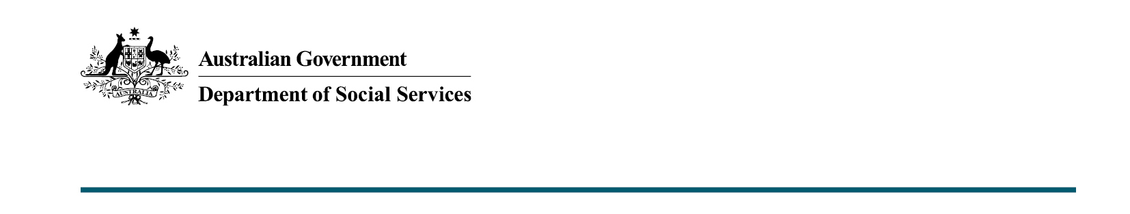

Support for Older Australians
  - 2022-23 October Budget

What was announced in the 2022-23 October Budget?
Subject to the passage of legislation, the 2022-23 October Budget provides measures to help relieve cost of living pressures for Older Australians by providing more than 50,000 additional self-funded retirees access to the Commonwealth Seniors Health Card.
Measures also support pensioners wanting to downsize their homes, in an effort to minimise the burden on older Australians, and free up housing stock for younger families.

More access to the Commonwealth Seniors Health Card
Pending passage of legislation, the income limits for the Commonwealth Seniors Health Card will increase from:
- $61,284 to $90,000 for singles
- $98,054 to $144,000 for couples (combined)
More than 44,000 newly eligible card holders are expected to benefit in the first year of implementation, projected to increase to 52,000 card holders by 2026-27.
Older Australians can use their Commonwealth Seniors Health Card to access cheaper medicines under the Pharmaceutical Benefits Scheme (PBS), bulk billed doctor visits, and the concessional thresholds of the PBS and Extended Medicare safety nets.

Helping pensioners to downsize
Pending passage of legislation, pensioners and other income support recipients will also benefit through assistance to measures when they downsize their family homes.
From 1 January 2023, the assets test exemption for principal home sale proceeds will be extended from up to 12 months to up to 24 months, allowing more time for people to complete the sale and repurchase of a new principal home without the proceeds affecting their payment rate through the assets test. In addition, only the lower deeming rate (0.25 per cent) will be used to calculate income earned from principal home sale proceeds while they are asset test exempt.

Deeming freeze to help pensioners
The Australian Government will freeze social security deeming rates at their current levels for 2 years. The lower deeming rate will remain frozen at 0.25 per cent, and the upper rate will remain at 2.25 per cent for the next two years, to 30 June 2024.
Since 1 July this year, the lower deeming rate has applied to financial investments up to the threshold amount of $56,400 for singles and $93,600 for couples.

Boosting workforce participation by age pensioners
On 1 December 2022, subject to passage of legislation, eligible pensioners will have their Work Bonus Income Bank credited with $4,000 until 30 June 2023. The maximum Work Bonus Income Bank will also increase from $7,800 to $11,800 until 30 June 2023.
This increases the amount these pensioners will be able to earn from work (on top of their pension income free area) by an additional $4,000 before their pension begins to reduce.

Key Facts
- Older Australians will benefit from raising the income limits for the Commonwealth Seniors Health Card.
- The asset test exemption for older Australians looking to downsize their family home will be extended by 12 months to up to 24 months, and income on the exempt sale proceeds will be calculated using the lower deeming rate only.
- Social security deeming rates will be frozen at their current levels for 2 years to
30 June 2024.
- Pensioners over Age Pension age will have their Work Bonus Income Bank topped-up by $4,000, increasing the amount they can earn from work before their pension beings to reduce.

More information
For more information about this measure and other Department of Social Services’ Budget measures, visit the Department of Social Services website (dss.gov.au).
For information about the 2022-23 October Budget, visit the Australian Government budget website (budget.gov.au).

