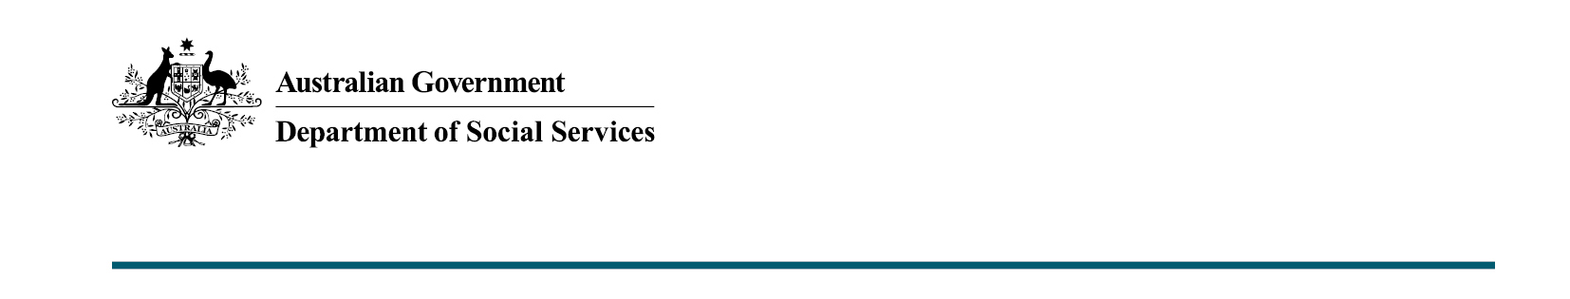

Increased support for the National Redress Scheme
  - 2022-23 October Budget

What was announced in the 2022-23 October Budget?
Additional funding of $15 million in 2022-23 will be provided to support the National Redress Scheme (the Scheme) to continue to deliver outcomes for survivors. The additional funding will support the Scheme to deliver a timely, trauma-informed, accessible Redress Scheme that supports and recognises survivors of institutional child sexual abuse.

Increased funding for the Scheme
Since March 2022 the Scheme has experienced a significant influx in applications reflecting improved processes for applying. Additional funding will support the Scheme to continue to deliver outcomes for survivors and improve both the predictability of application processing timeframes and the quality and consistency of outcomes.
Funding to commence the ten year Scheme was first announced as part of the 2017-18 Budget. To date the Scheme has received over 20,000 applications from survivors of institutional child sexual abuse, and has delivered almost 11,000 outcomes to survivors, with payments totalling around $845 million.

Key Facts
- The additional $15 million funding will assist the Department of Social Services to continue to deliver the Scheme.
- Funding will support the Scheme to respond to the significant increase in applications seen throughout 2022 and to continue to deliver a trauma-informed, survivor focused Scheme.

More information
For more information about this measure and other Department of Social Services’ Budget measures, visit the Department of Social Services website (dss.gov.au).
For information about the 2022-23 October Budget, visit the Australian Government budget website (budget.gov.au).
For more information about the Scheme, visit the Scheme website (nationalredress.gov.au/)

