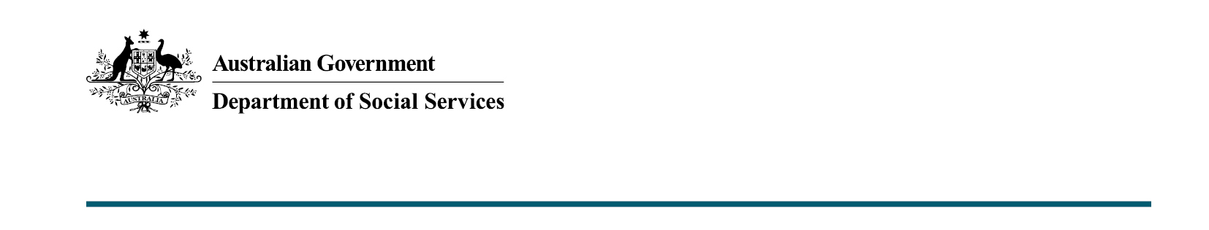

Boosting Parental Leave to Enhance Economic Security, Support and Flexibility for Australia’s Families
  - 2022-23 October Budget

What was announced in the 2022-23 October Budget?

The Australian Government will boost the Paid Parental Leave (PPL) scheme by increasing the length of the scheme to 26-weeks, and increasing gender equality and the flexibility of payments under the scheme. The changes will encourage greater shared care of newborn and recently adopted children.

Expanding the Paid Parental Leave scheme to 26 weeks by 2026
The Government is investing $531.6 million over four years from 2022-23 to modernise the Paid Parental Leave scheme and promote a more equal distribution of paid and unpaid work within households.
The scheme will be progressively expanded, with 2 weeks added each year, to provide a total of 26 weeks of Parental Leave Pay (PLP) by 1 July 2026. This will deliver greater flexibility for families, and support both parents to spend more time with their
newborn children.
Introducing gender-neutral claiming to allow either parent to claim first
To improve gender equality and make it easier for families to share care, the current requirement that primary claimants of PLP must be the birth parent will be removed.
This will allow families to decide who will claim first and how they will share the entitlement, making the process easier for families and removing the presumption that birth mothers will be the default primary carer.
Fathers and partners who meet the residency requirements will also be supported to receive PPL in circumstances where the birth mother does not meet the newly arrived resident’s waiting period requirements.
To support families and incentivise both parents to access PPL, the reformed PPL scheme will reserve a dedicated ‘use it or lose it’ portion for each parent.
The changes will also legislate features announced as part of the 2022-23 March Budget, also commencing from 1 July 2023, including:
- introducing a family income limit of $350,000 adjusted taxable income in addition to the existing individual income limit ($156,647 from 1 July 2022), and
- increasing the flexibility of PLP so the entire entitlement can be taken in blocks as small as one day at a time, with periods of work in between, within two years from the date of birth or adoption.
Key Facts
- The Government is investing $531.6 million to modernise the PPL scheme and promote a more equal distribution of paid and unpaid work within households.
- The scheme will progressively expand over time to provide a total of 26 weeks of PLP allowing for greater flexibility for families to spend more time with their new children.
- Introducing gender-neutral claiming to allow either parent to claim first.
The Women’s Economic Equality Taskforce, chaired by Sam Mostyn AO, will assist in the finalisation of the changes to the scheme to ensure that the final model supports women’s economic participation and gender equality, including the period of concurrence and the most appropriate proportion of ‘use it or lose it’ weeks.

More information
For more information about this measure and other Department of Social Services’ Budget measures, visit the Department of Social Services website (dss.gov.au).
For information about the 2022-23 October Budget, visit the Australian Government budget website (budget.gov.au).

