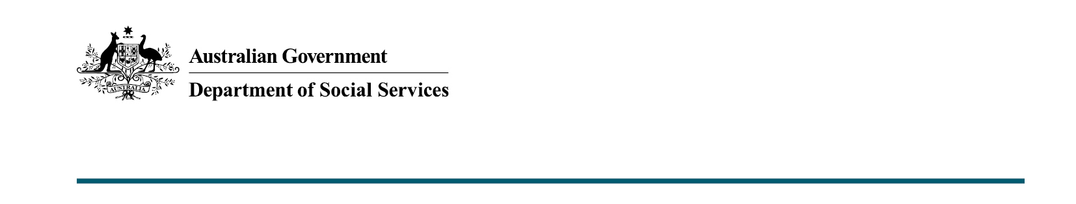

Investing in our children
  - 2022-23 October Budget

What was announced in the 2022-23 October Budget?
The 2022-23 October Budget invests $4.2 million to develop a whole-of-Commonwealth Early Years Strategy and $12.4 million to help families learn and grow with playgroups and toy libraries across Australia. This includes funding to pilot First Nations playgroup activities at 10 new locations across Australia by partnering with Aboriginal Community-Controlled Organisations.

Early Years Strategy
The whole-of-Commonwealth Early Years Strategy will set out the Government’s vision to best support Australia’s children and their families in the early years. The Strategy development will take an integrated approach to the early years and will increase accountability for the wellbeing, education and development of Australia’s children.
The development of the Strategy will be informed through comprehensive stakeholder engagement and consultation. Engagement will include academics, relevant service providers, peak bodies, First Nations leaders, and a diverse representation of children and their families.

Helping families learn and grow with playgroups
This $12.4 million over 4 years will provide increased support for playgroups and toy libraries across Australia. Playgroups and toy libraries provide accessible and affordable spaces, resources and opportunities for children to play together and for parents and carers to seek social and parenting support, particularly in regional and remote communities.
Part of this funding will be used to deliver a pilot program to test approaches to First Nations playgroups at 10 new locations. This pilot will be delivered in partnership with Aboriginal Community-Controlled Organisations.

Key Facts
- $4.2 million over 18 months to 2023-24 will support the development of a whole-of-Commonwealth Early Years Strategy, taking an integrated approach to the early years.
- Playgroups and toy libraries will be supported with an investment of $12.4 million over 4 years.

More information
For more information about this measure and other Department of Social Services’ Budget measures, visit the Department of Social Services website (dss.gov.au).
For information about the 2022-23 Budget, visit the Australian Government budget website (budget.gov.au).

