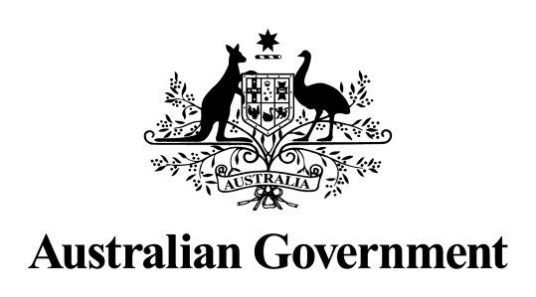

Australian Government response to the Senate Community Affairs References Committee report: Inquiry into Centrelink’s Compliance Program
Fifth Interim Report

October 2022

Introduction
The Australian Government (the Government) welcomes the Fifth Interim Report of the Inquiry into Centrelink’s Income Compliance Program or ‘Robodebt’ by the Senate Community Affairs References Committee.
The Government thanks the Chair, Deputy Chair, Members, Substitute Members, Participating Members and Former Members for conducting the Inquiry and for its Fifth Interim Report. These thanks are also extended to the Secretariat of the Committee.
The Government also thanks individuals and organisations who contributed to the inquiry, providing insights into their experiences and issues surrounding the ‘Robodebt’ scheme.
A Royal Commission into the ‘Robodebt’ scheme was announced on 25 August 2022 and will be led by the Honourable Catherine Ena Holmes AC SC.
The Royal Commission will examine the establishment, design and implementation of the scheme, the use of third party debt collectors under this scheme, responses to concerns raised about the scheme following its implementation and the intended and actual outcomes of the scheme.
Other areas of focus include who was responsible for its design and establishment and what advice informed it; the handling of complaints about the scheme; the impact on individuals and their families; and measures needed to prevent a recurrence of any failures in public administration.

The full Terms of Reference can be found on the Royal Commission’s website: (https://robodebt.royalcommission.gov.au)

The Government has allocated $30 million to conducting this Royal Commission and the final report will be delivered to the Governor-General His Excellency General the Honourable David Hurley AC DSC (Retd) by 18 April 2023.

Inquiry into the into Centrelink’s Compliance Program
Recommendations made by the Committee in the Fifth Interim Report
Recommendation 1
2.41 The committee recommends that Services Australia distributes the settlement sum in accordance with the Implementation Plan for Distribution Scheme, as a matter of priority.

Agree
Government Response
Services Australia will distribute the settlement sum in accordance with the Orders of the Court.

Recommendation 2
2.42 The committee recommends that following the finalisation of the Implementation Plan for Settlement Distribution Scheme, Services Australia publicly release the following data:
- the number of class action Group Members in each category;
- the total value of the debts of Group Members, broken down by category; and
- the average share of the settlement sum eligible Group Members received.

Agree
Government Response
The parties to the class action will report to the Court on the implementation of the Settlement Distribution Scheme which will then become a matter of public record.

Recommendation 3
3.33 The committee recommends that the Senate adopt the following resolution.
1. That the Senate notes that the Senate Community Affairs References Committee has
rejected the Minister for Government Services' explanation regarding public interest
immunity claims on several occasions.
2. That there be laid on the table by the Minister for Government Services, by no later than
1pm on Wednesday, 24 November 2021:
- revised responses to all questions relating to legal advice and the Income Compliance Program which have been subject to rejected claims of public interest immunity during the Community Affairs References Committee’s inquiry into Centrelink’s compliance program; and
- a copy of the Executive Minute to the Minister for Social Services, dated
12 February 2015, as referenced in the Commonwealth Ombudsman’s April 2017 report into Centrelink’s automated debt raising and recovery system; or
- a letter confirming that the above responses relating to legal advice and the Executive Minute will be provided in camera to the Senate Community Affairs References Committee by no later than 2pm on that same day.
3. In the event that the Minister again fails to table these documents:
- the Senate requires the Minister to attend the Senate at the conclusion of question time on Wednesday 24 November 2021 to provide an explanation of the Minister’s failure to table the documents.
- at the conclusion of the Minister’s explanation, or in the event that the Minister fails to provide an explanation, any senator may move to take note of the explanation or the failure to provide an explanation;
- any motion under the above paragraph may be debated for no longer than
60 minutes and have precedence over all other business until determined, and senators may speak to the motion for no more than 10 minutes each.

Noted
Government Response
The Government notes this recommendation is a matter for the Senate.

