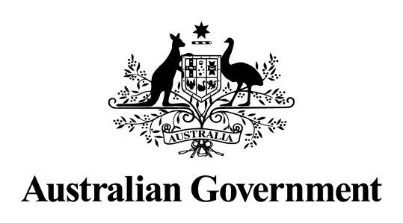
Australian Government response to the Senate Community Affairs References Committee Final Report:
Accountability and justice: Why we need a Royal Commission into Robodebt

October 2022

Introduction
The Australian Government (the Government) welcomes the Final Report (Accountability and justice: Why we need a Royal Commission into Robodebt) of the Senate Community Affairs References Committee (the Committee) Inquiry into Centrelink’s Income Compliance Program or ‘Robodebt.’
The Government thanks those individuals and organisations who shared their stories with the Committee through either attending one of the 10 public hearings of the Committee, or via the 78 submissions received by the Committee.
The Government also thanks all Members and former Members of the Committee, including the Secretariat for their hard work and dedication to the issue.

Accountability and justice: Why we need a Royal Commission into Robodebt

Recommendation made by the Committee in the Final Report
Recommendation 1
2.53 The committee recommends that the Commonwealth Government establishes a Royal Commission into the Income Compliance Program.

Agree
Government Response
A Royal Commission into the ‘Robodebt’ scheme was announced on 25 August 2022 and will be led by the Honourable Catherine Ena Holmes AC SC.

The Royal Commission will examine the design, implementation and establishment of the scheme, the use of third party debt collectors under this scheme, responses to concerns raised about the scheme following its implementation and the intended and actual outcomes of the scheme.
Other areas of focus include who was responsible for its design and establishment and what advice informed it; the handling of complaints about the scheme; the impact on individuals and their families; and measures needed to prevent a recurrence of any failures in public administration.

The full Terms of Reference can be found on the Royal Commission’s website: (https://robodebt.royalcommission.gov.au)

The Government has allocated $30 million to conducting this Royal Commission and the final report will be delivered to the Governor General His Excellency General the Honourable David Hurley AC DSC (Retd) by 18 April 2023.

