Disability Gateway
process and outcomes evaluation report
Commonwealth Department of Social Services
Final REPORT

10 June 2022

CONTENTS
Executive summary i
Disability Gateway i
The evaluation i
Key findings i
Suggestions for improving data v
1. Disability Gateway vii
1.1 Target audience vii
1.2 Components of the Disability Gateway vii
1.3 Objectives vii
1.4 Program logic viii
2. The evaluation ix
2.1 Purpose ix
2.2 Key evaluation questions ix
2.3 Reporting 2
3. Appropriateness 7
3.1 How well is the Disability Gateway project focusing on the needs of people with disability, their families and carers? 7
3.2 What are the rates and identifiable trends for access to the Disability Gateway by people with disability, their families and carers? 7
3.3 What are the barriers to access? 24
4. Efficiency 36
4.1 To what extent has the Disability Gateway delivered services as intended? 36
4.2 How efficient has the program been in the delivery of services? 37
4.3 Have there been any innovations or adaptations from the original design or implementation plan? Could these be further developed or adapted/ adopted? 39
5. Effectiveness 40
5.1 How satisfied are Gateway users? 40
5.2 To what extent do people with disability, their families and carers view the Disability Gateway as a trusted information source and relevant to their needs? 48
5.3 To what extent has the Disability Gateway improved outcomes for people with disability, their families and carers? 53
5.4 Who among users of the Disability Gateway has benefited most, in what ways, and under what circumstances? 62
5.5 Has the Disability Gateway delivered value to other disability organisations in supporting people with disability? 63
5.6 What were the particular features of the Disability Gateway and/or its implementation context that made a difference? 65
5.7 What unintended outcomes (positive or negative, direct or indirect) did the Disability Gateway produce? 70
5.8 To what extent is the Disability Gateway on track to meet its objectives? 70
Appendix 1 Website analytics 71
Appendix 2 Additional tables 74
A2.1 Telephony data 74
A2.2 Customer satisfaction survey 75
A2.3 Survey of people with disability, their families and carers 88
A2.4 Contact centre CRM data 122

Tables and figures

Tables
Table 1. Key evaluation questions 9
Table 2. People for whom users of the Disability Gateway are finding information 12
Table 3. Information topics that users were seeking 13
Table 4. Number of times survey respondents have used the Disability Gateway 14
Table 5. Most common referral websites – new users 17
Table 6. Reasons for calling the Disbaility Gateway 22
Table 7. Available information on repeat callers 23
Table 8. Number of interactions per enquiry 23
Table 9. Time needed to resolve enquiries 24
Table 10. Factors that make the website hard to use among those shown the website in the survey of people with disability, their families and carers 27
Table 11. Proportion of detailed enquiries by region in comparison to SDAC 32
Region 32
Table 12. Reasons for finding the Disability Gateway easy to deal with 43
Table 13. Reasons for not finding the Disability Gateway easy to deal with 45
Table 14. Reasons for using the Disability Gateway to find information among Gateway users 49
Table 15. Factors making the information on the Disability Gateway website hard to understand for People who were shown the website in the survey of people with disability, their families and carers 51
Table 16. Users who would go elsewhere to find information about disability supports and services 56
Table 17. Usefulness of the information from the website in comparison to the contact centre 67
Table 18. Use of the Disability Gateway 89
Table 19. Use of the Disability Gateway website and contact centre 89
Table 20. Users experiences of using the Disability Gateway website 89
Table 21. Overall satisfaction with Disability Gateway service 90
Table 22. Amount of information users were looking for received from the Disability Gateway 90

Figures
Figure 1. Program Logic for the Disability Gateway viii
Figure 2. Awareness of the Disability Gateway, and how survey respondents heard about the Disability Gateway 8
Figure 3. How people heard about the Disability Gateway, by age range 9
Figure 4. Awareness and use of the Disability Gateway 11
Figure 5. Summary of website analytics 15
Figure 6. New users vs. Users over time 16
Figure 7. Page views vs. pages/ session over time 16
Figure 8. Traffic sources of new users 17
Figure 9. Call volumes by call types 18
Figure 10. Number of enquiries over time 19
Figure 11. Number of enquiries by call type 20
Figure 12. Characteristics of contact centre callers 21
Figure 13. User experiences of using the Disability Gateway website 26
Figure 14. Overview of website ease of use survey results 29
Figure 15. Contact centre wait times and abandonment rates 31
Figure 16. Age of callers with detailed enquiries compared with SDAC 33
Figure 17. Overall satisfaction with the Disability Gateway service 40
Figure 18. Overall satisfaction with the Disability Gateway by channel used 41
Figure 19. Perceptions of the Disability Gateway 41
Figure 20. User agreement that the disability Gateway was easy to deal with 42
Figure 21. User experiences of using the Disability Gateway contact centre 43
Figure 22. Likelihood of recommending the Disability Gateway to a friend or colleague 46
Figure 23. Changes in NPS score by month 47
Figure 24. Views on the information received from the Disability Gateway website or contact centre (people who had used the Disability Gateway prior to the survey of people with disability, their families and carers) 48
Figure 25. Views on the Disability Gateway website among people who were shown the website in the survey of people with disability, their families and carers 50
Figure 26. Amount of information users were looking for received from the Disability Gateway 54
Figure 27. Awareness of information received from the Disability Gateway 54
Figure 28. Amount of information users were looking for received from the Disability Gateway, by service used 55
Figure 29. Impact of the information found through the Disability Gateway on users and/or the person that they care for 58
Figure 30. Circumstances SCOREs for contact centre clients before and after their enquiry was addressed, by domain of the primary issue of the call 60

Executive summary

Disability Gateway
The Department of Social Services (the Department) has designed, developed and implemented the Disability Gateway to meet the Government’s 2019 election campaign commitment to ‘provide $45 million over three years to establish a national disability information gateway’. The Disability Gateway consists of a contact centre, which the Benevolent Society (TBS) has been contracted to deliver, and a website, which collates existing information about supports for people with disability. Both components were released in January 2021.
The Disability Gateway has three objectives:
- Provides a single point of information on disability services and supports
- Assists people with disability to navigate current support systems
- Enables choice and control.

The evaluation
In August 2021, the Department contracted ARTD to deliver a process and outcomes evaluation of the Disability Gateway. This is the final report of the evaluation. It updates the analysis of existing data (website analytics, website ease of use survey, TBS’ contact centre data and customer satisfaction survey) and provides new data obtained through the survey of and interviews with people with disability, their families and carers, and interviews with disability organisations and service providers (referred to as disability organisations). We have data to assess the appropriateness, efficiency, and effectiveness of the service. However, given the online research panel was our only recruitment source for the survey of people with disability, their families and carers, it is likely respondents are more connected and likely to have their needs met through online and phone services compared to all current or potential Disability Gateway users. Additionally, people with disability, their families and carers and disability organisations interviewed are not representative of all users, but provide insights into the experiences behind the quantitative data. Finally, there are limitations to some of the administrative data, which are noted where relevant in the findings.

Key findings
Appropriateness
Design to meet the needs of people with disability, their families and carers: The Disability Gateway design was informed by research with people with disability, their families and carers, user testing and a Reference Group of disability organisations. This reflected the need for an accessible central source of information about supports across all levels of government. In early development, where identified refinements were in-scope, these were taken up. The Department, TBS and Services Australia continue to gather feedback from service users and make enhancements to the Disability Gateway based on this feedback to better meet the needs of people with disability, their families and carers.
Access trends: Of those who completed the survey of people with disability, their families and carers, 42% had heard of the Disability Gateway (mostly via word of mouth and social media). Half of those who had heard of the Disability Gateway had used it to find information or services.
Website users have continued to increase over time since the mass communications campaign began on 4 July 2021, with peaks in early December 2021 and January 2022, and higher usage in late March 2022 when the new Disability Gateway/ COVID-19 supports TV ad began. The proportion of new users in each state has remained unchanged. Paid search continued to be the most common avenue through which new users accessed the website, with Disability Gateway ads placed on other websites also serving as a common avenue for new users in this period, and the Facebook mobile app the most common referral website. The most viewed pages remain the Homepage, Search, Aids and Equipment, Income and Finance, and Employment.
The TBS contact centre handled 22,623 enquiries from 27 January 2021 to 31 March 2022 – most of which have been light touch calls. The number of enquiries increased gradually between January and July 2021. From August 2021 to February 2022, there were over 2,000 enquiries a month (with the exception of lower enquiries during December, most likely due to the holiday period, which is consistent with the pattern for other information and help lines we have evaluated). A large number of calls throughout the period were related to COVID-19, with these calls peaking in January and February of 2022. The most common call topics for contact centre enquiries differ from those explored by website users, which may suggest the website and contact centre are meeting different needs. While feedback from disability organisations supports this finding, there is insufficient evidence from the survey and interviews with people with disability, their families and carers to draw this conclusion.
Barriers to access: Findings from the survey of people with disability, their families and carers suggest the Disability Gateway website is easy to use – only 4% of respondents who had used the website prior to the survey and 4% of those who used the Disability Gateway in responding to the survey did not find the website easy to use.
Wait times and abandonment rates for the contact centre are also important to accessibility. Telephony data indicates that wait time and abandonment rates for clients calling the Disability Gateway contact centre remain low. In January and February of 2022 there was a dip in the proportion of calls handled by a contact centre staff member, in the context of higher overall call volumes, but this returned to previous high levels in March 2022.
It is more difficult to draw strong conclusions about accessibility of the website and contact centre for different demographic groups. Our survey found that people of different ages, Aboriginal and Torres Strait Islander people, people from CALD backgrounds, and people from regional, rural and remote areas are using the Disability Gateway. However, as the survey was conducted through an online panel, survey respondents may not be representative of all people with disability, or these demographic groups. Additionally, demographic data for the contact centre is limited to the small proportion of detailed calls. Some disability organisations, including an intellectual disability peak, noted the Disability Gateway website may be less accessible for people with intellectual disability. Some also noted it would be less accessible for those who are less computer literate (e.g. older people). However, they felt the multiple channels for accessing the Disability Gateway supported accessibility for people with different needs.
People with disability, their families and carers and disability organisations made some suggestions for improving access, including: providing greater synthesis of information on the website, in place of links to other websites (which may be inaccessible); improving the search functionality of the website, including allowing people to filter information (which Services Australia is currently undertaking); making accessibility features and features for CALD communities more prominent and easier to find on the website; and extending contact centre hours.
Efficiency
Delivery as intended: The Disability Gateway is delivering services as intended. The key project outputs and deliverables articulated in the Project Plan are complete or on track for completion.
Efficiency to enable quality delivery: The delivery timeline has aligned closely with the intended timeline due to extensive planning and clear phases, as well as an incremental approach. MOUs and regular meetings between project partners support this. Requirements, such as eligibility criteria for services to be included on the Disability Gateway, regular review of information on the website, close monitoring of feedback, dedicated resourcing and training for staff support the quality of information and service connections.
Refinements: Project partners have refined the Disability Gateway’s offering in response to changes in its operating climate. Key examples of this include the text messages sent to Disability Support Pension recipients to advise them that the Disability Gateway could assist them with COVID-19 information and, more recently, the additional information provided on the website about disaster support in response to the NSW and Queensland floods emergency. This approach to ongoing delivery will be continued in the next contract.
Effectiveness
Satisfaction: Overall, people with disability and carers who had used the Disability Gateway website and/or contact centre were satisfied with it (81% agree or strongly agree, from the survey of people with disability, their families and carers), consistent with contact centre customer satisfaction survey respondents (74% were satisfied with the services they received). Feedback from the minority who felt they did not get the information they needed or had been referred on suggests there may be a mismatch between expectations of some users and intent of the Disability Gateway, with some seeking the Disability Gateway to provide all relevant information on the site itself.
Trusted and relevant source of information: The majority of respondents to the survey of people with disability, their families and carers who had used the Disability Gateway viewed it as a trusted source of information (79% agree or strongly agree). The majority of respondents also reported that the information they received was relevant, up to date, and easy to understand. Those who viewed the website for the first time in the survey of people with disability, their families and carers also agreed that the Disability Gateway website was trustworthy (76% agree or strongly agree), up to date (75% agree or strongly agree) and easy for them to understand (78% agree or strongly agree). These respondents also said they would use the Disability Gateway to look for information in the future (87% agree or tend to agree).
Interviewees noted they viewed the website as a trusted information source, partly because it was a government website, but mostly because the amount of information available or the qualities of the staff member they had spoken to on the phone had made them trust the information they were receiving.
Disability organisations expressed mixed views on whether the Disability Gateway was a trusted source of information. While five viewed the Disability Gateway as a trusted source of information – largely as a result of the genuine relationship-building work TBS has been doing – one noted having heard concern about a ‘non-disability organisation’ winning the contract and the ‘perceived conflict of interest’ of them being a NDIS early childhood early intervention provider. Four others trusted some aspects and not others – for example, a couple trusted the information but wanted to know more about the vetting process for services on the Disability Gateway.
Improved outcomes for people with disability, their families and carers: Most respondents to the survey of people with disability, their families and carers who had accessed the Disability Gateway reported finding some (53%) or all (39%) of the information they were looking for, and commonly, this information was new to them (50% agree and 28% strongly agree).
Nearly two-thirds (65%) of respondents reported using the information or services they had found. While this was only a small number of individuals (n=59), the vast majority of these indicated this had made a difference to them and/or the person they care for in improving access to support and information, increasing connections and improving confidence to make decisions about supports and services. Interviews supported this.
Of the people with disability and carers who did not use the Disability Gateway, nearly half (46%) reported that they usually went somewhere else to find information about disability supports and services – the most common place being Google or the internet, which suggests while there are alternative sources to the Disability Gateway, these are of a different nature.
Who has benefited most: We found no meaningful differences in outcomes between subgroups (i.e. age range, language spoken at home, relationship to the NDIS, or remoteness) in the survey of people with disability, their families and carers. However, small sample sizes in some subgroups of interest impacted our ability to detect differences between these groups of interest.
Features that made a difference: Respondents to the survey of people with disability, their families and carers who had used the Disability Gateway found the most useful aspects to be the easy-to-use website and all the information being easy to understand and in one place. Nearly half (46%) of respondents who had used both the contact centre and website felt the website provided more useful information. While some people with disability, families and carers we interviewed valued the website, most found their experience with the contact centre most valuable – though this may be because most interviewees were those who had had a positive experience with the contact centre.
Disability organisations who had used both channels were more positive about the contact centre as they felt that the contact centre was able to provide more detailed information for specific requests and was better able to assist people to navigate the system.
The people with disability, their families and carers we interviewed felt the accessibility of the website, and friendliness, understanding and helpfulness of contact centre staff, and their willingness to go above and beyond to find the answer to people’s questions were the most distinguishing features of the Disability Gateway. Some people with disability, their families and carers and disability organisations also felt the breadth of information and ability to access it all in one place, the information being broken down by state and easy to understand and navigate, and the fact it isn’t NDIS-specific, distinguish the Disability Gateway from other sources of information. Additionally, they felt it was a good place to start for people who are new to disability or don’t know what services are available to them.
Value for disability organisations: In addition to benefiting people with disability, their family and carers, some disability organisations we spoke to found the Disability Gateway to be a valuable resource to use in their role or to support their clients with disability. Other organisations, however, felt it added little value to them because they found the information too general or they felt the website was not accessible for their clients. Regardless of how valuable disability organisations found the Disability Gateway, all continue to use other sources of information depending on which source best meets the needs of their clients – the most common being the knowledge, information and resources within their organisation, or the connections they already had.

Suggestions for improving data
The quantitative analysis conducted for this evaluation has highlighted several opportunities for improvements that could be made to data collection.
There is limited information about service user demographics and difference in experience and outcomes by demographics. For the majority of the evaluation period, TBS did not collect demographic data for most calls. From mid-February 2022 TBS changed data collection processes for ‘light touch’ calls to allow the same demographic data to be collected from all individual callers. This will allow for a clearer understanding of the demographic profile of contact centre clients to emerge over time; however, this change in data collection processes limits the ability for ‘light touch’ calls to be accurately distinguished from more detailed calls. As it has been established that these are distinct cohorts of clients, with different enquiries, it is important to be able to understand differences in experience and outcomes for these groups. It would be valuable for future analysis to ensure that ‘light touch’ and detailed calls are able to be identified in the CRM data.
The TBS customer satisfaction survey has a low response rate (12.8% of those who consented to participate in the survey, 1.2% of all contact centre enquiries), and only one-in-five (19.8%) of clients who consented for their personal information to be recorded consented to participate in the survey. This means that findings from the customer satisfaction survey may not be representative of all clients. The survey response rate could be improved through revising and streamlining the questions included in the customer satisfaction survey, or through considering including a brief question (‘Would you recommend the service to others?') to be asked of ‘light touch’ clients. It may also be useful for TBS to explore why a high proportion of clients who call the contact centre do not consent to their personal information to be recorded, or to be sent the customer satisfaction survey.

Disability Gateway
During the 2019 election campaign, the Government made a commitment to ‘provide $45 million over three years to establish a national disability information gateway’. The Department of Social Services (the Department) has designed, developed and implemented the National Disability Information Gateway (the Disability Gateway) to fulfil this commitment.

Target audience
The primary target audience for the Disability Gateway is people with disability, their families and carers. A secondary audience is other disability organisations (such as peak bodies and service providers) who may use the Disability Gateway to support people with disability.

Components of the Disability Gateway
The Disability Gateway is an information service consisting of a website and contact centre to assist people with disability and their families to locate and access local services. On 27 January 2021, the contact centre commenced operations and the website opened in Beta for public feedback.

The website
Services Australia is responsible for the development and implementation of the Disability Gateway website.

The contact centre
On 23 December 2020, the Department executed a contract with The Benevolent Society (TBS) as the successful tenderer to set up and administer the Disability Gateway contact centre.
TBS set up rapidly to be operational and open for calls by 27 January 2021. Since then, they have iteratively enhanced and refined the Customer Relationship Management (CRM) system and established a customer satisfaction survey process, run by a third-party organisation.
TBS has the capacity to rapidly scale up services by moving resources internally from other similar services (e.g. the Carer Gateway) in the short-term or bringing on additional contact centre staff for longer-term requirements.

Objectives
There are three key objectives for the Disability Gateway:
- Provides a single point of information on disability services and supports: The intent is for the Disability Gateway to collate information on the full range of services and supports available into a single, convenient, and easy-to-use portal. It is designed to link to existing content rather than create new content, with a focus on providing a single point of information. Currently, information is fragmented and difficult to navigate, with services spanning multiple sectors including health, housing, employment, transport and disability.

- Assists people with disability to navigate current support systems: The Disability Gateway intends to provide a single contact point for people with disability to access information and connect to a wide array of supports currently available, including those that sit outside the Social Services portfolio. People with disability have the choice of accessing information through the website and/or the contact centre.

- Enables choice and control: Choice and control is a core value of the Government’s engagement with people with disability. A person with disability can only exercise choice and control when they are fully informed about the services available to them. The Disability Gateway provides people with disability (and their families and carers) information covering the breadth of services and supports and allows them to connect with services of their choice.

Program logic
The Department developed a program logic for the Disability Gateway during its development phase and refined this over time. Following ARTD’s engagement in August 2021, we held a planning workshop with the Department, during which we discussed adding some detail to the program logic to further articulate the short- and medium-term outcomes. This refined version of the program logic is presented in Figure 1 below.
- Program Logic for the Disability Gateway
P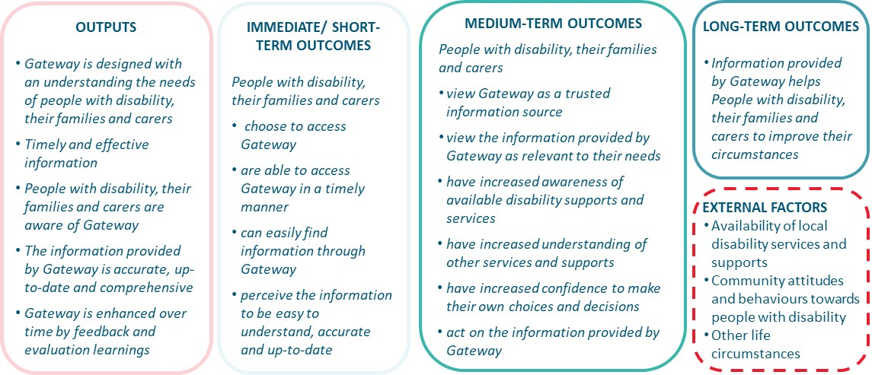

The evaluation
On 30 August 2021, the Department engaged ARTD Consultants to evaluate the Disability Gateway during its initial delivery phase.

Purpose
The key objective of the evaluation is to inform any improvements and refinements to the Disability Gateway for its next period of delivery, by assessing its establishment, operation and performance.

Key evaluation questions
Key evaluation questions were identified in the Request for Tender and these have since been refined collaboratively between ARTD and the Department (see Table 1). They are structured around the themes of appropriateness, efficiency and effectiveness. The effectiveness questions align with the intended outcomes articulated in the program logic.

- Key evaluation questions
Appropriateness
1a. How well is the Disability Gateway focusing on the needs of people with disability, their families and carers?
1b. What are the rates and identifiable trends for access to the Disability Gateway by people with disability, their families and carers?
1c. What are the barriers to access?
Efficiency
2. To what extent has the Disability Gateway delivered services as intended?
3. How efficient has the program been in the delivery of services; i.e. to what extent has the relationship between inputs and outputs been timely, cost-effective and to expected standards?
4a. Have there been any innovations or adaptations from the original design or implementation plan?
4b. Could these be further developed or adapted/ adopted?
Effectiveness
5. To what extent is the Disability Gateway viewed by people with disability, their families and carers as:
a. A trusted information source?
b. Relevant to them and their needs?
6. To what extent has the Disability Gateway:
a. Improved people with disability, their families and carers' access to information about supports and services?
b. Increased people with disability, their families and carers' confidence to make choices and decisions?
c. Improved people with disability, their families and carers' circumstances?
7. Who among users of the Disability Gateway has benefited most, in what ways, and under what circumstances?
8. What were the particular features of the Disability Gateway and/or its implementation context that made a difference?
9. Has the Disability Gateway delivered value to other disability organisations in supporting people with disability?
10. To what extent is the Disability Gateway on track to meet its objectives?
11. What unintended outcomes (positive or negative, direct or indirect) did the Disability Gateway produce?

Reporting
The evaluation is providing iterative feedback through progress reports. This is the third report of the evaluation, reporting on process and outcomes. The final evaluation report will be delivered in June 2022.

Methods
The table below outlines the methods used for this report.
Source/ method | Notes
Google Analytics data analysis | - Website data for the period 27 January 2021 to 31 March 2022.
Gateway website ease of use survey analysis | - The evaluation team analysed website ease of use survey data for the period 27 January 2021 to 31 March 2022 (n=61).  - Nine responses were excluded from analysis due to missing or poor-quality data.  - The results may not be representative of all users as respondents are more likely to be those who are either very satisfied or those who have issues with the website, and some of those with navigation issues may not access the survey.
Contact centre customer satisfaction survey analysis | - TBS provided the evaluation team with an extract containing de-identified data for the period 22 June 2021 to 31 March 2022.  - There are 281 responses, which is sufficient to conduct cross-tabulations against relevant characteristics.  - The number of responses month to month vary substantially.  - Not all clients complete the survey. 19.8% of enquiries where the client consented for their personal information to be recorded consented to participate in the survey (11.8% of all calls). Of those who consented to participate in the survey, 12.8% completed the survey (1.2% of total calls). This low response rate means that findings may be subject to non-response bias, that is, they may not be representative of all clients.
Contact centre CRM data analysis | - TBS provided the evaluation team with an extract containing de-identified data relating to all contact centre contacts for the period 27 January 2021 to 31 March 2022.  - Demographic data is only collected for detailed calls. The characteristics of those with short contacts are unknown.  - There are issues with the quality of the ‘Date of Birth’ variable, so age data is unreliable.  - Initial and subsequent Client Circumstances SCOREs (Standard Client Outcomes Reporting) are not collected for all calls. As these are only collected from a small subset of callers, this is unlikely to be representative of all callers’ outcomes.  - Agents ask clients directly about their current circumstances when there is an opportunity to do so, however if there is no opportunity for this, agents may make their own assessment based on the changes in the client’s circumstance. Client Circumstances SCOREs inferred by agents are less reliable than when clients directly assess their circumstances.  - As many fields are not compulsory, many items have missing data.  - From 18 February 2022 onwards TBS stopped using a separate CRM form to record information from ‘light-touch’ calls. After this date all individual calls (light-touch and detailed) were recorded using the same form. As a result of this change, we have had to use an alternate approach proposed by TBS to identify ‘light-touch’ calls after this point: categorising callers who did not consent for their data to be recorded as ‘light-touch’ calls and those who gave consent for their data to be recorded as detailed calls. But prior to the change in data collection, 23% of ‘light-touch’ calls consented for their data to be recorded, and 19% of detailed calls did not consent to their data being recorded. This means that consent for data to be recorded is able to correctly identify most, but not all calls as either ‘light-touch’ or detailed.
Contact centre phone system data analysis | - TBS provided the evaluation team with an extract containing phone system metrics for contacts from October 2021 to March 2022.  - Metrics included: calls entering the queue, handled, abandoned and wait-times.
Survey of people with disability, their families and carers | - ARTD designed this survey for the evaluation.  - The survey was distributed through The Online Research Unit and their people with disability and carers panel from 21 February to 14 March 2022 (n=532). It is possible that the survey respondents are not representative of all people with disability and carers; as members of an online research panel, they are more likely to be connected to online information sources.  - Pearson's chi-square tests of statistical significance (p < .05) have been used to identify whether any observed differences in response patterns between groups were due to chance. We have only reported group differences that were statistically significant (p < .05). Due to smaller sample sizes in some demographic groups, we did not have the statistical power to detect smaller group differences.
Interviews with disability organisations and service providers (referred to as disability organisations) | - The aim was to interview 30 disability organisations.  - We contacted 35 disability organisations – 9 did not respond after multiple contacts and 11 declined to participate due to: floods, lack of experience with the Disability Gateway, lack of capacity, insufficient knowledge of how their community is using the Disability Gateway, unwilling to participate, or had already participated in an interview about the Disability Gateway (not with ARTD).  - Interviews were conducted from 1 March to 6 April 2022 (n=15).  - We interviewed 15 disability organisations:  - TBS partnerships contacts (disability organisations, ECEI providers, LACs, DES/ employment providers, others) (n=6)  - Disability Gateway Reference Group members (n=6)  - TBS partnerships and Disability Gateway Reference Group (n=3)  - Interviews are not intended to be representative of all disability organisations but to provide insights into perceptions of engagement with the Disability Gateway across the sector. Disability organisations contacted had diverse views and were able to provide these insights.
Interviews with people with disability, their families and carers | - The aim was to interview 50 people with disability with experience of the Disability Gateway identified through ARTD’s independent survey. As insufficient numbers were identified this way, additional interviewees were recruited by TBS staff, who asked participants if they consented to the interview at the end of their call.  - We contacted 38 people: 24 agreed to interviews, 11 did not answer after multiple attempts to contact them and 3 were not interested in participating.  - Interviews were conducted from 16 March to 2 May 2022 (n=24).  - We interviewed 14 people with disability and 10 family members and carers. 11 were recruited through the survey of people with disability, their families and carers, and 13 through TBS.  - While we were not able to interview the intended number of users, there were a sufficient number of interviews to reach saturation – where consistent themes were emerging.  - As recruitment was through TBS, most interviewees were those that had a positive experience with the contact centre, and therefore may not be representative of all service users.  - Interviewees were generally regular users of the Disability Gateway (i.e. they had accessed it at least a few times prior to the interview), so they may also have a different perspective to one-off users.
Interviews with project partners | - The aim was to interview representatives from the Department, TBS and Services Australia. We conducted interviews with all three partners, including:  - 3 interviews with the Department  - 3 interviews with TBS.  - We also received a written response to the interview guide from Services Australia.

Confidence in the findings
Overall, we have sufficient data on to answer all questions about appropriateness, efficiency and effectiveness. However, there are some limitations to data sources.

Light touch call numbers
TBS changes to data records from mid-February 2022 mean there are differences in how ‘light-touch’ calls are counted before and after this date, so changes in numbers should be interpreted with caution.

Limited demographic data
There is limited information about service user demographics and differences in experiences and outcomes by demographics. TBS does not collect demographic data for most calls. While our survey of people with disability, their families and carers supplements this, it is likely that respondents – recruited through an online research panel – are more connected and more likely to have their needs met through online and phone services compared to all current and potential users of the Disability Gateway. Furthermore, given the small number of respondents from different demographic groups who had used the Disability Gateway, our ability to detect differences in experiences and outcomes among demographic groups is limited.

Low customer satisfaction survey response rate
The low response rate to the TBS customer satisfaction survey limits confidence in this data source; however, when triangulated with our survey of people with disability, their families and carers, this increases our confidence in findings about user satisfaction.

representativeness of Disability GAteway users in the surveys and interviews
Our survey of people with disability, their families and carers is more likely to provide accurate data on usability than the website ease of use survey, which is likely to be completed by website users that are either very satisfied or who have issues with the website, and some of those with navigation issues may not access the survey. However, it’s possible that neither capture the perspective of those less comfortable with accessing online resources.
As half of the people with disability and family members interviewed were recruited through TBS at the end of their phone call, most interviewees had contacted the contact centre rather than using the website and had a positive experience. Interview data should be interpreted with this in mind. However, there were sufficient numbers who had used each channel in the survey, so we can confidently assess people with disability, their families and carers’ experience of each channel.

Representativeness of disability organisations
Disability organisations interviewed are not representative of all disability organisations using the Disability Gateway and do not cover all disability groups. Their views should be taken as indicative only, and considered alongside other feedback from people with disability, their families and carers.

Appropriateness

How well is the Disability Gateway project focusing on the needs of people with disability, their families and carers?
The Department conducted a scoping and design phase during 2019. The project team commissioned research with disability organisations, people with disability and their families and carers, and established a Reference Group of disability organisations to provide advice. Key insights from the research included a need for a central source of information about supports across all levels of government, that accessibility be a guiding principle and that information needs to be trustworthy.
In early development, where identified refinements were in-scope, these were taken up (as described in our initial evaluation report). Services Australia made refinements to the Beta version of the website based on pilot testing.
The Department, TBS and Services Australia continue to gather feedback from users and make enhancements to the Disability Gateway to ensure it is meeting the needs of its users.
However, the evaluation has heard some indications that the Disability Gateway may better meet the needs of some people with disability than others in terms of its accessibility and the nature of the information it provides (as described in the following sections).

What are the rates and identifiable trends for access to the Disability Gateway by people with disability, their families and carers?
In this section, we draw on four different data sources to understand awareness and access to the Disability Gateway: Google analytics; contact centre CRM data; data from the survey of people with disability, their families and carers; and interviews with people with disability, their families and carers, and disability organisations.

Reported awareness of the Disability Gateway

People with disability, their families and carers
Of the respondents to the survey of people with disability, their families and carers, 42% were aware of the Disability Gateway (Figure 2). Respondents had most frequently heard about the Disability Gateway through friends and family (40%), with social media (23%) and support workers (22%) the next most common sources (see Figure 2). Of the 16 survey respondents who reported hearing about the Disability Gateway through other sources, 10 had heard about the Disability Gateway from TV. The Department noted they are also starting to see referrals from My Aged Care providers and NDIS providers.
- Awareness of the Disability Gateway, and how survey respondents heard about the Disability Gateway
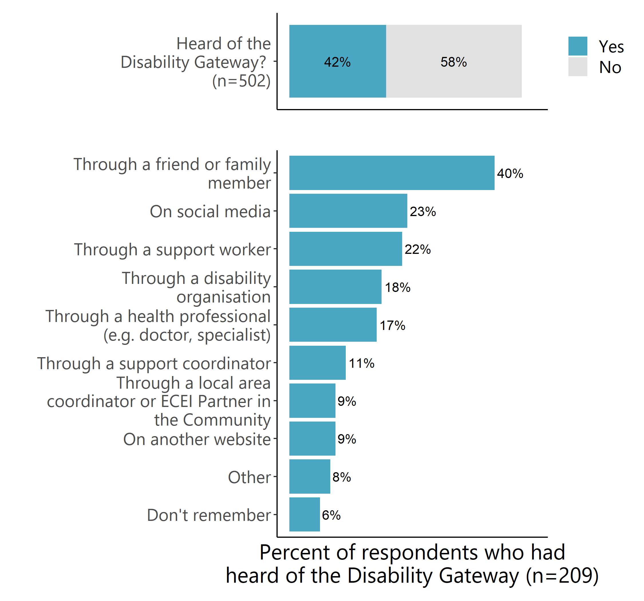Source: Survey of people with disability, their families and carers (March 2022). Note: Multiple responses were allowed, percentages do not sum to 100%.
There were different levels of awareness of the Disability Gateway among demographic groups (see Appendix A2.3 for detailed tables):
- People aged between 25-65 were more likely to have heard of the Disability Gateway (47%) than younger (18-24 years; 28%) or older (65+ years; 31%) individuals.
- People who spoke a language other than English at home were more likely to have heard of the Disability Gateway (51%) than English speakers (40%).
- There were no differences in awareness between respondents from metropolitan, regional, and rural and remote areas.
People of different ages generally reported hearing about the Disability Gateway in similar ways (Figure 3). The only statistically significant difference was in the proportion of respondents who heard about the Disability Gateway through social media – with individuals aged 25–65 least likely to have heard about the Disability Gateway this way (19%) compared to 18–24-year-olds (41%) and those 65 and older (35%).
- How people heard about the Disability Gateway, by age range

Source: Survey of people with disability, their families and carers (March 2022). Note: *Statistically significant group differences at p < .05 are shown.

Suggestions made by people with disability, family and carer interviewees to improve awareness of the Disability Gateway
- Build awareness of the service not just for people with disability but also their families and carers, and particularly for people who don’t have a NDIS plan.
- Promote the service through disability organisations, and Centrelink and the NDIS (where people with disability and their carers require more support in navigating the complex processes required to access funding).
- Promote stories of how other people with disability have used the Disability Gateway.

If people are new to the NDIS and have no idea, then the Disability Gateway is a great place to go to help guide you through the process. Most people would contact the NDIS directly but it’s so complicated and you get stuck in loopholes like we did… A lot of people from CALD communities who have a disability are on Centrelink so it’s a good area to advertise there too. They have carer payments but don’t know they can get extra support. (Family/ carer interviewee)

Disability organisations
Most disability organisations interviewed had themselves heard about the Disability Gateway through The Benevolent Society’s partnerships team or their involvement on the Reference Group.
To varying degrees, most were promoting it to their communities through word of mouth, social media, or their organisation’s newsletters and website – consistent with people with disability and their families and carers reporting they heard about the Disability Gateway this way. One disability organisation stated that they did not actively promote the Disability Gateway because they found that it was often not relevant to their clients.
Disability organisations interviewed had mixed perceptions about people with disability's awareness of the Disability Gateway – ranging from not well known to moderate awareness. Some felt that awareness of the Disability Gateway website was higher than the contact centre (which is consistent with higher usage of the website among our survey respondents).
Disability organisation suggestions for improving awareness of the Disability Gateway
Disability organisations made the following suggestions for improving awareness of the Disability Gateway, all of which the Department are already undertaking.
- Engage in ongoing promotion to build more awareness, including reminding Reference Group members to promote to their communities.
- Consider greater promotion of the contact centre so people know the Disability Gateway is not just a website.
- Develop and distribute promotional materials tailored to different communities or settings (e.g. educational settings, GPs).
- Use stories from different types of users about what they used the Disability Gateway for and how the information has helped them to promote the service.

Reported usage of the Disability Gateway

People with disability, their families and carers
Among those who had heard of the Disability Gateway in our survey of people with disability, their families and carers, half (51%) had used the Disability Gateway to find information or services (Figure 4).
Usage by channel: Users were more likely to have accessed the website than called the contact centre. Nearly two-thirds of Gateway users (62%) in our sample reported using both the website and the contact centre, with around one third only using the website. Very few (4%) had used the contact centre without also using the website. The Google Analytics and CRM data (see Sections 3.2.3 and 3.2.4) indicates that our survey sample is skewed towards users of the contact centre.
- Awareness and use of the Disability Gateway
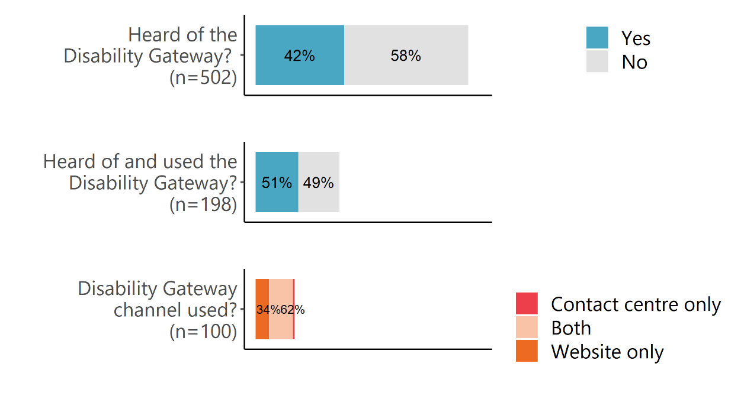
Source: Survey of people with disability, their families and carers (March 2022). Note: ‘Don’t know’ responses are not shown and have been excluded from calculation of proportions of total responses. Values below 5% are not shown in this figure.
Differences by demographics: The proportion of people who have used the Disability Gateway differed across groups of interest in our survey of people with disability, their families and carers. Of those who had heard about the Disability Gateway:
- younger people were more likely to have used the Disability Gateway (88%) than those aged 25–64 (49%) and those aged 65 or older (40%)
- people who spoke a language other than English at home were more likely to have used the Disability Gateway (70%) than English speakers (46%)
- there was no difference in Gateway use by gender or remoteness (see Appendix A2.3 for detailed tables).

People who spoke a language other than English at home were more likely to have used the contact centre (81%) than English speakers (56%). Similarly high proportions of these groups had used the Disability Gateway website (non-English: 89%; English: 90%); however, as noted previously, the online panel recruitment process may result in respondents who spoke a language other than English at home who were not representative of broader CALD communities. There were no other group differences in website or contact centre usage.
Reasons for use: Two-thirds of people with disability, their families and carers survey respondents reported using the Disability Gateway to find information for family members or someone they cared for (Table 2). They also frequently used the Disability Gateway to find information for themselves (43%). A very small proportion of respondents were looking to find information to assist them in their job caring for someone, which is expected given this survey was of people with disability, their families and carers (and the only people responding as professionals would have been those who were also people with disability or their family members/ carers).
- People for whom users of the Disability Gateway are finding information
Did you use the Disability Gateway to find information for… (n=101) | %
For other family or someone I care for | 67%
Myself | 43%
For my job caring for someone | 4%
None of the above | 0%
Source: Survey of people with disability, their families and carers (March 2022). Note: Multiple responses were allowed, percentages do not sum to 100%. Only asked of respondents who have used the Disability Gateway.
Respondents to the survey of people with disability, their families and carers reported accessing the Disability Gateway to find information about a broad range of topics (Table 3). Aids and equipment (37%), health and wellbeing (35%) were the most common topics, followed by everyday living (30%) and COVID-19 (29%). This is consistent with website data (see Section 3.2.3), in which aids and equipment was the most common topic page viewed by users, and the CRM data (see Section 3.2.4), which found that most common domain for detailed contact centre enquiries related to physical health. This suggests consistency between the interests of our respondents and Gateway users overall.

- Information topics that users were seeking
What topics were you trying to find information about? (n=94) | %
Aids and equipment | 37%
Health and wellbeing | 35%
Everyday living | 30%
COVID-19 | 29%
The National Disability Strategy Hub | 21%
Safety and help | 18%
Education | 18%
Employment | 18%
Ask Izzy search | 15%
Emergency contacts | 14%
Housing | 14%
Income and finance | 13%
Rights and legal | 9%
Transport | 9%
Leisure | 6%
No specific topic | 4%
Other | 1%
Source: Survey of people with disability, their families and carers (March 2022). Note: multiple responses were allowed, percentages do not sum to 100%. Only asked of respondents who have used the Disability Gateway.
Due to the small numbers of respondents in key subgroups of interest who had reported using the Disability Gateway in the survey of people with disability, their families and carers, we were unable to confidently detect meaningful differences in the topics survey respondents searched for across demographic groups (see Appendix A2.3 for topics respondents to the people with disability, their families and carers survey searched for across demographic groups).
Number of uses: Of the respondents to the survey of people with disability, their families and carers who reported using the Disability Gateway, the majority (59%) reported using the Disability Gateway – either the website or contact centre – two or three times, with 30% only using the Disability Gateway once (Table 4).
- Number of times survey respondents have used the Disability Gateway
Number of times the Disability Gateway was used | n | %
Once | 27 | 30%
Two or three times | 54 | 59%
More than three times | 10 | 11%
Total | 91 | 100%
Missing | 10
Source: Survey of people with disability, their families and carers (March 2022). Note: only asked of respondents who had used of the Disability Gateway.
Feedback from the people with disability, their families and carers we interviewed was broadly consistent with these patterns.

Disability organisations
Disability organisations interviewed had engaged with the Disability Gateway in various ways – most had referred their clients to the Disability Gateway, some were on the Reference Group, and some used the Disability Gateway themselves, or directed other staff to it.
Disability organisations most commonly used the Disability Gateway to help the people they’re supporting by directly referring them to the website or contact centre. Two mentioned that they were able to refer their clients to the Disability Gateway to help them find local COVID-19 vaccination or testing clinics. Two others reported that clients they referred to the Disability Gateway reported finding useful information and resources. However, one disability organisation explained that they had stopped referring people to the Disability Gateway because the contact centre staff were suggesting their clients contact their organisation after they had already explained that they were not able to support them, and they saw this as potentially damaging to the organisation’s reputation.
Some disability organisations had also used the Disability Gateway as a source of information for services and supports they could pass on to their clients. The information disability organisation interviewees searched for largely depended on their role and the needs of their clients. Some reported that they use the Disability Gateway to search for specific topics, such as advocacy, legal information and services, income and finance, housing, and employment. Others reported using or referring people to the website to find information about COVID-19. A small number of disability organisation interviewees accessed the Disability Gateway to find information to support clients with specific and complex issues, or to find more general information.
A few disability organisations also said that they have referred their colleagues to the Disability Gateway. One mentioned that they used the contact centre as an ‘advisor’ that they could call for information.
In contrast, disability organisations who provided a reason for not using the Disability Gateway reported that the information was too general or that the website was not accessible for their clients. One disability organisation said they didn’t find the website useful for themselves and they didn’t think it would be particularly useful for people with disability, as the links on the website take people to websites they would know about anyway (e.g. Centrelink).

Website usage
The infographic below provides a summary of website analytics from 27 January 2021 to 31 March 2022. We discuss each element in more detail in subsequent sections.
- Summary of website analytics
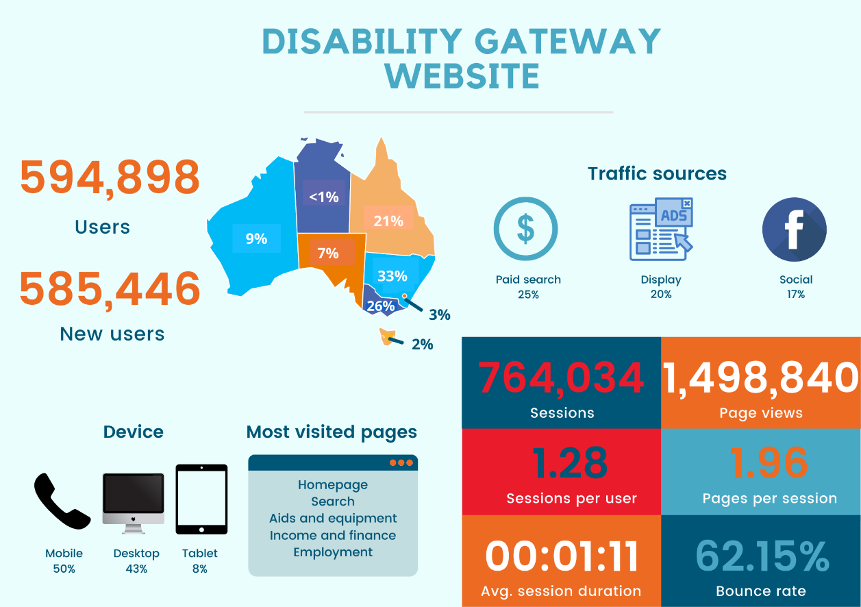
Source: Google Analytics (27 January 2021–31 March 2022).

Overview
In the period 27 January 2021 to 31 March 2022, there were 594,898 users of the Disability Gateway website, the vast majority (585,446) of whom were new (first time) users. The largest proportion of new users were concentrated in New South Wales (33%), Victoria (26%) and Queensland (21%). This was followed by Western Australia (9%), South Australia (7%), Australian Capital Territory (3%), Tasmania (2%) and the Northern Territory (<1%). This is broadly representative of the Australian population. See Appendix 1 for a detailed breakdown of user acquisition and behaviour.

Usage over time
Since the start of the mass communications campaign for the Disability Gateway (on 4 July 2021) user numbers increased and have remained higher and relatively stable (between roughly 1,500 and 3,500 per day), with some peaks in early November, December and, in particular, January (see Figure 6). The spike in early January did not coincide with when the COVID-19 texts were sent out on 28 January 2022. However, the increase in traffic in late March coincided with when the new 15 second Disability Gateway/ COVID-19 supports TV ad began on 20 March 2022.
- New users vs. Users over time
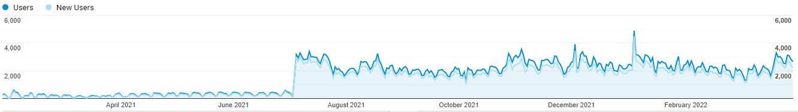
Source: Google Analytics (27 January 2021–31 March 2022).
Page views followed a similar pattern to users and new users, rising sharply on 4 July 2021 to 5,513. They have continued at this heightened level (between roughly 3,000 and 6,000 per day). As with users and new users, the increase in page views at the end of March 2022 may have been a result of the new TV ad.
Pages per session have fallen gradually, from 4.58 pages on 27 January 2021 to around 1–2 pages from September 2021 to 31 March 2022 (see Figure 7). This may be evidence of people using the search function to navigate directly to the page they seek, or landing on the page they seek by clicking on an ad. It could also be due to ongoing improvements to website navigation.
- Page views vs. pages/ session over time
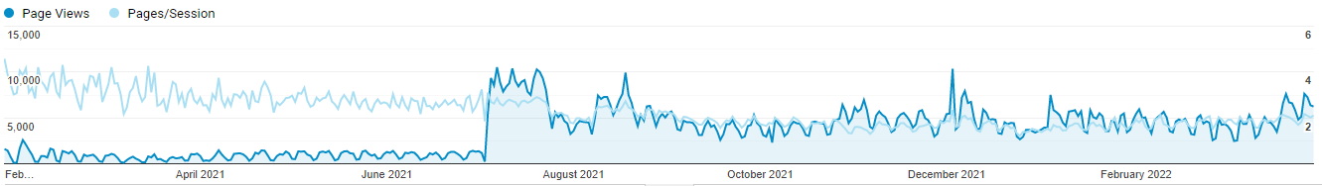
Source: Google Analytics (27 January 2021–31 March 2022).

Sources of traffic
Consistent with the last report, the majority of new users accessed the Disability Gateway website through a paid search (n=148,359, 25%). This was followed by display (n=119,090, 20%), social media (n=100,448, 17%) and organic (or unpaid) search (n=78,817, 13%) (Figure 8).
- Traffic sources of new users

Source: Google Analytics (27 January 2021–31 March 2022).
Of the referral websites – that is, the websites on which users have clicked a link to access the Disability Gateway website – m.facebook.com continues to be the most common by far among new users (n=90,942, 76%) (see Table 5 below).
- Most common referral websites – new users
Link | New users
 | N | %
m.facebook.com | 90,942 | 76%
l.facebook.com* | 5,537 | 5%
dss.gov.au | 3,862 | 3%
ndis.gov.au | 2,934 | 2%
health.gov.au | 1,656 | 1%
linkedin.com | 1,637 | 1%
myagedcare.gov.au | 963 | 1%
healthdirect.gov.au | 762 | 1%
Source: Google Analytics (27 January 2021–31 March 2022). Note: * Facebook desktop.

Interaction with the website
Users engaged in a total of 764,034 sessions (1.28 sessions per user) that, on average, lasted 1 minute and 11 seconds and consisted of 2 pages. The website had a bounce rate of 62.15%.
Fifty percent (n=379,013) of sessions occurred on a mobile device, 43% (n=327,563) on a desktop and 8% (n=57,458) on a tablet.
Page views: The Disability Gateway Homepage continues to have the highest number of page views (n=657,058, 44%), 560,281 of which were unique page views. This is followed by the Search page (n=39,069, 3%), the Aids and equipment page (n=34,339, 2%), Income and finance page (n=33,388, 2%) and the Employment page (n=26,289, 2%).
Outbound links: Only a small percentage of users clicked on outbound links. The Bureau of Meteorology website was the most commonly clicked on link on the website (n=52,789, 6%). This was followed by the link to the NDIS website (n=36,113, 4%), the Carer Gateway website (n=33,473, 4%), and the ‘LAC Partners in the Community’ page of the NDIS website (n=28,361, 3%).
Downloads: The ‘COVID-19 vaccine side effects you might have after your vaccine’ document (n=11,726, 36%) was by far the most commonly downloaded resource. This was followed by Australia's Disability Strategy 2021-2031 (n=3,419, 10%) and the Australia’s Disability Strategy 2021–2031 factsheet (n=1,110, 3%).
Refer to Appendix 1 for detailed tables regarding page views, outbound links and downloads.

Contact centre usage
The contact centre records information about callers through their CRM database. A unique caller may make multiple enquiries (each enquiry representing one topic). Each enquiry may involve multiple calls to and from the contact centre to resolve (see Figure 9). We use this terminology to describe contact centre activities in this section.
- Call volumes by call types
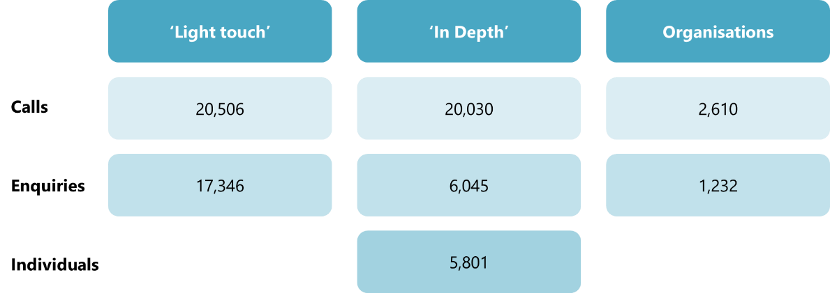
Source: CRM data (27 January 2021–31 March 2022).

Overall number of enquiries
The contact centre has handled 22,623 enquiries since opening in January 2021 to 31 March 2022. The number of enquiries increased gradually between January and July 2021, and remained relatively steady, until a slight decline seen in December 2021 which is likely driven by the holiday period. This is consistent with the pattern for other information and help lines we have previously evaluated. There was a steady increase in the number of enquiries across January and February 2022; however, this peak had declined by March 2022. Over this period, a large proportion of calls throughout the period were related to COVID-19, with the volume of calls relating to COVID-19 peaking in January and February of 2022 (see Figure 10 below). DSS conducted two text message campaigns to Disability Support Pension recipients, advising them to contact the Disability Gateway to assist them if they require a COVID-19 vaccination or booster. The first campaign ran from 11 October to 30 November 2021, and the second campaign ran from 28 January to 4 March 2022. The second campaign aligns with the increased numbers of enquiries related to COVID-19.
Note that due to the structure of the data, we are unable to provide statistics on the number of unique individuals making the calls at this overall level.
- Number of enquiries over time
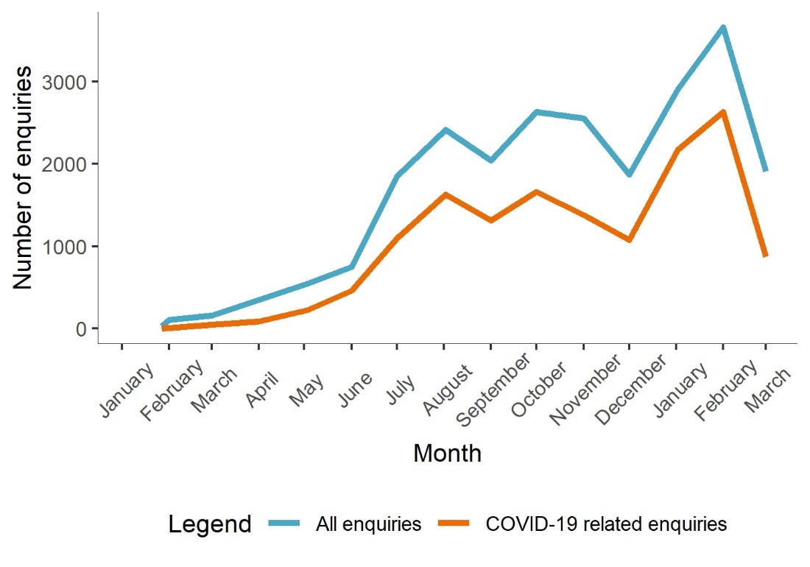
Source: CRM data (27 January 2021–31 March 2022).
From July 2021 the bulk of enquiries were ‘light-touch’ calls. The number of ‘light-touch’ calls remained high throughout the second half of 2021, with a decrease seen in December 2021, consistent with the holiday period. Following this, there was a notable increase in the number of ‘light-touch’ calls in January and February of 2022. Mid-way through February 2022 TBS changed the way ‘light-touch’ calls were recorded, using the same form to collect information regarding ‘light-touch’ and ‘detailed’ calls. As a result of this it is unclear whether there was actually a lower number of ‘light-touch’ calls in March 2022.
The number of ‘detailed’ enquiries each month has continued to increase over time, with a notable peak in February 2022, when the number of overall calls peaked.
- Number of enquiries by call type
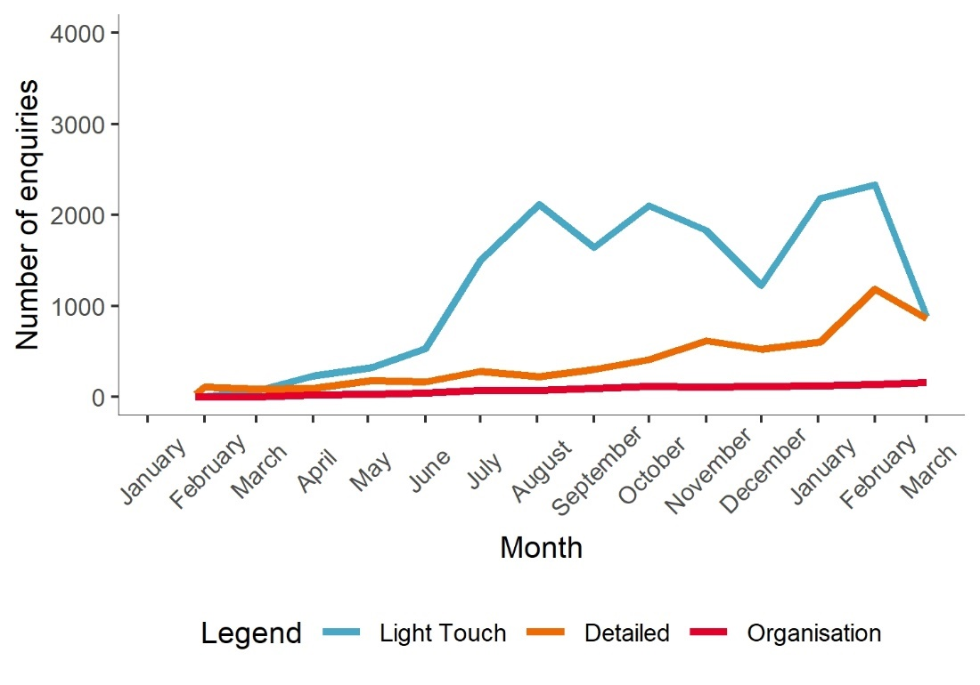
Source: CRM data (27 January 2021–31 March 2022).

Who is contacting the service with detailed enquiries?
Detailed demographic data is only routinely available for individuals who had ‘detailed’ enquiries with the Disability Gateway.
Nearly three quarters (72%) of detailed enquiries were made by a person on behalf of themselves. Nearly one quarter (24%) of detailed enquiries were made by family. Very few enquiries were made by carers, friends, nominees, or doctors.
While people of all different disability types are represented among those making ‘detailed’ enquiries, there are higher proportions of these enquiries from people with physical or intellectual disability. Figure 12 outlines the demographic characteristics of individuals who had detailed calls with the Disability Gateway. Additional detail regarding the demographics of contact centre callers is provided in Appendix 2. Comparisons against the population of people with disabilities are discussed in Section 3.3.3.
- Characteristics of contact centre callers
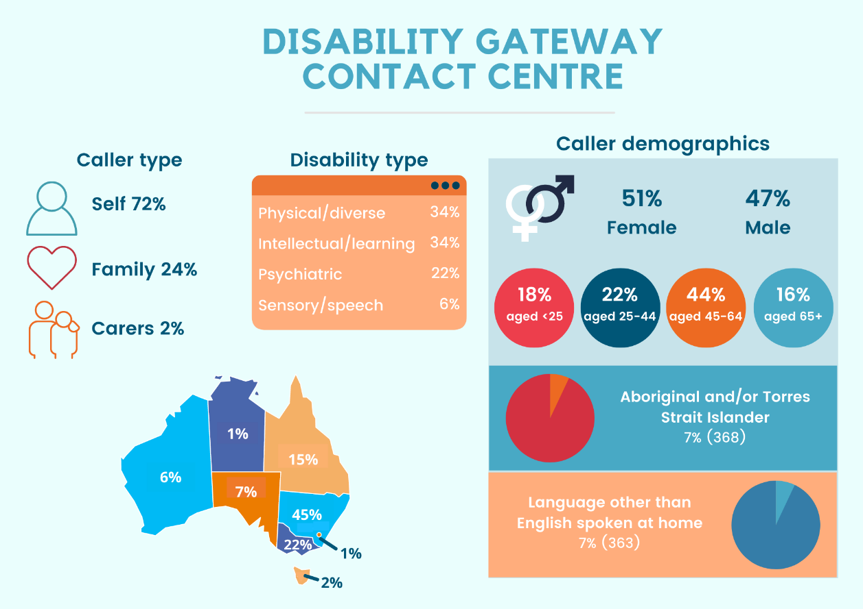Source: CRM Data (27 January 2021–31 March 2022). Note: other caller types not shown include friends (1%) and nominees/ doctors (1%).

Reasons for contacting the service with a detailed enquiry
For ‘detailed’ enquiries, contact centre staff collect information on the primary reason for the call as well as whether it is COVID-19-related. The most common (primary) reasons underlying detailed enquiries made in the last year were physical health (34%) and personal and family safety (21%) (see Table 6). COVID-19 related calls were more likely to be about physical health and personal and family safety than non-COVID-19 related calls. As Figure 10 shows, a large proportion of calls to the Disability Gateway related to COVID-19 are driving the overall patterns in primary contact reasons.
- Reasons for calling the Disbaility Gateway
Primary contact reason | Total | Not COVID-19 related | COVID-19 related
 | n=24,561 | n=9,572 | n=14,989
Physical health | 34% | 10% | 50%
Personal and family safety | 21% | 9% | 28%
Community participation and networks | 15% | 28% | 6%
Material well-being and basic necessities | 10% | 14% | 7%
Mental health Wellbeing | 5% | 9% | 2%
Financial resilience | 4% | 8% | 1%
Housing | 3% | 8% | 0%
Employment | 2% | 4% | 0%
Family functioning | 1% | 2% | 0%
Education skills and training | 1% | 2% | 0%
Age-appropriate development | 0% | 1% | 0%
None | 0% | 0% | 0%
Other | 5% | 5% | 4%
Source: CRM Data (27 January 2021–31 March 2022)

Callers making multiple enquiries
Calculating the number of callers making multiple enquiries is only possible for ‘detailed’ calls or callers from organisations. We are unable to calculate the number of callers who have made a ‘detailed’ call followed by a ‘light-touch’ call or vice vera, or multiple ‘light-touch’ calls.
Of those making ‘detailed’ calls or making calls from an organisation, the vast majority made only one of these calls (Table 7).
From our survey results, we know the proportion of repeat users of the Disability Gateway is higher (70%) when taking into account both website and contact centre usage (see Section 3.2.2).
- Available information on repeat callers
 | Individual | Organisation
Number of enquiries | n=5,724 | n=967
One | 98% | 87%
Two | 2% | 8%
Three or more | <1% | 5%
Source: CRM Data (27 January 2021 – 31 March 2022)

Interactions and time involved in handling an enquiry
A single enquiry may require multiple interactions to resolve. Information on the number of interactions (calls to or from the contact centre) is captured in the CRM for all call types.
Roughly three-quarters (77%) of all enquiries were resolved within a single call, and 90% within three calls. However, a small proportion of enquiries appear more complex with 1% of enquiries taking more than 15 calls to resolve (Table 8). The proportion of complex enquiries has remained steady across the two progress reports and the process evaluation report, suggesting that there has not been a notable increase in the complexity of calls over time.
- Number of interactions per enquiry
Number of calls (n=21,350, missing=3,273) | Cumulative proportion of enquiries resolved
One | 77%
Two | 85%
Three | 90%
Four | 92%
Five | 94%
Ten | 98%
Fifteen | 100%
Source: CRM Data (27 January 2021–31 March 2022). Note: Three per cent of enquires were resolved with zero interactions. As this likely reflects data quality issues, and enquiries that were unable to be matched to the tasks dataset, these enquires are not shown as part of this analysis.

The CRM also captures information on additional research or investigations undertaken by the contact centre staff member. So, for each enquiry there are multiple tasks recorded (inbound calls, outbound calls, research conducted and any additional work), as well as time spent on those tasks. Call duration is recorded directly from the telephony system, while time spent on other tasks related to an enquiry are estimated by staff.
The time required to resolve enquiries varies significantly – half of all enquiries took less than 20 minutes, and approximately two thirds (68%) took less than half an hour to resolve. Some enquiries appear to be more complex, with 14% taking more than one hour to resolve (Table 9). This is consistent with findings from our second progress report and progress evaluation report, suggesting that there has not been a notable change in the time required to resolve enquiries over time. This suggests that these more complicated queries are quite specific to individual clients and require tailored research or investigations by contact centre staff. Disability organisations have noted that the individualised responses to complicated queries is a valuable aspect of the contact centre.
- Time needed to resolve enquiries
Time spent (n=21,275, missing 3,348) | Proportion of enquiries resolved | Cumulative proportion of enquiries resolved
Less than 5 minutes | 6% | 6%
5–9 minutes | 16% | 22%
10–19 minutes | 27% | 50%
20–29 minutes | 19% | 68%
30–59 minutes | 18% | 86%
At least 1 hour but less than 2 hours | 9% | 95%
At least 2 hours but less than 4 hours | 3% | 98%
Four hours or more | 2% | 100%
Source: CRM Data (27 January 2021–31 March 2022).

What are the barriers to access?
This section draws on data five sources to identify barriers to access: the survey of people with disability, their families and carers; interviews with people with disability, their families and carers, and disability organisations; website accessibility survey: and contact centre CRM and population data.

Accessibility measures
As people with disability are one of the key target groups of the website, accessibility was a critical consideration in its design. As noted in Section 3.1, people with disability, their families and carers and a Disability organisation Reference Group were engaged to ensure the needs of people with different types of disability were considered in the design.
The Disability Gateway is accessible through multiple channels (website and call centre) and operates outside of business hours.
Website: The Disability Gateway is WCAG 2.0 compliant and meets the government mandate for website accessibility. The Disability Gateway also delivers information through various modes and methods to ensure it is accessible to people with different needs, including:
- in-built ‘Read speaker’ controls to listen to spoken audio of the page content
- in-built ‘Easy read’ toggle to change the layout and content of the page to be easier to read and understand
- introductory videos for the website and each ‘area of life’, containing a transcript and Auslan interpreters
- translated resources available to website users from culturally and linguistically diverse backgrounds
- access to interpreter services and the National Relay Service.

In addition to people with disability, their families and carers, Services Australia engaged with diverse groups of people to ensure the website meets different needs, including:
- people located all over Australia, including regional and remote areas
- Aboriginal and Torres Strait Islander people
- culturally and linguistically diverse
- migrants and refugees
- LGBTQI+ people
- vulnerable or marginalised backgrounds.

The website is structured by the ‘areas of life’ to allow users to select information based on their needs, and improvements are being made as identified. For example, the Department is currently working to improve the search functionality of the website to be more in line with user expectations and has changed the state buttons to an interactive map.
Contact centre: The contact centre is tailored to meet different needs by employing diverse staff (i.e. people with lived experience; people of different ages, ethnicities, genders; people with different professional and life experience) and training them to use human-centred approaches, as well as access to interpreter services and the National Relay Service.
The TBS partnerships team also engages disability specific organisations to ensure the content and way the information is provided is accessible for different cohorts. Accessible feedback mechanisms are built into the service to ensure it is continuously improved to be accessible for all.

Accessibility of the website
Data from the survey of people with disability, their families and carers is positive about the accessibility of the website. However, because participants are part of an online recruitment panel, they may be more comfortable with online platforms than the broader population of people with disability. Of the respondents that had used the Disability Gateway, only 4% disagreed or strongly disagreed with the statement ‘I found the website easy to use’ (Figure 13). Among this small minority, the most common difficulty identified was navigating to topics they clicked on (n=5). They were only a bit less positive that the person they support would find the website easy to use.
- User experiences of using the Disability Gateway website
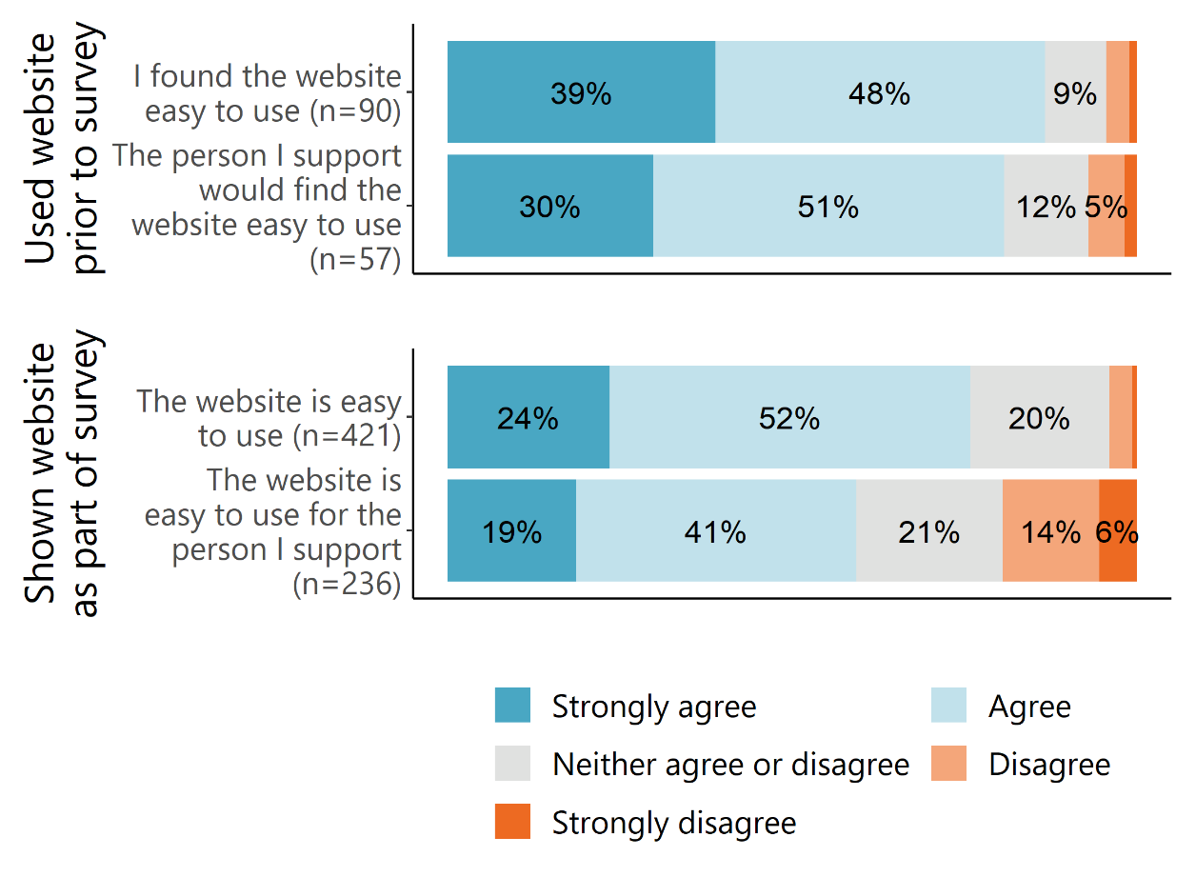Source: Survey of people with disability, their families and carers (March 2022).
Respondents who hadn’t used the Disability Gateway prior to the survey were asked to briefly use the website and were asked about their impressions. Only 4% of these disagreed or strongly disagreed that the website was easy to use. Among this small minority, the most common factor that made the website hard to use was difficulty moving between pages (33%), followed by links not working (25%) (Table 10). Those who identified other reasons the site was hard to navigate most commonly explained that this was because the person they were using it for had issues with computer literacy (n=10). This may explain why these respondents were more likely to disagree that the website was easy to use for the person they support (20% disagree or strongly disagree) compared to users of the Disability Gateway (7% disagree or strongly disagree).
- Factors that make the website hard to use among those shown the website in the survey of people with disability, their families and carers
What makes the website hard to use? (n=57) | %
It was hard to move between pages | 33%
It didn’t take me to topics I clicked on | 25%
Other | 47%
Source: Survey of people with disability, their families and carers (March 2022). Note: only asked of respondents shown the Disability Gateway website as part of the survey of people with disability, their families and carers, who disagreed or strongly disagreed that the website was easy to use. Multiple responses were allowed, percentages do not sum to 100%.
Consistent with this, many people we interviewed also found the website easy to use. There weren’t differences between people with disability and family members/ carers and family members/ carers generally felt the person they support would find the website easy to use; however, two felt the person they support would find it hard because they don’t regularly use technology.

Interviewees said the icons and videos helped to navigate and explain the text, and a few added that it was easier to navigate than other websites. A few also felt the layout of the website was accessible – specifically, they liked that the information was categorised by areas of life, and that it didn’t have too much information, but rather provided links to other sites if you wanted more information.

I think it does a good balance in terms of aggregating up all the services, and then providing you with links to go and find what it is that you’re after. (Family/ carer interviewee)
It didn't answer the questions I wanted, it at least gave you links to other places that could give you answers. And I think that's probably the best way to do it, because otherwise the website would be too overwhelming. (Family/ carer interviewee)
However, some people with disability and family members/ carers said they expected more detailed information rather than a number of links to other sites and one added, ‘And then with some of them when you clicked on links it didn't really take you to a specific part of that other website, either. It only took you to the sort of homepage and so it was like, well, I could have sort of started there anyway.’

One family/ carer felt that while it was mostly easy to use and he had found the information he was looking for, it had taken him a long time as he wasn’t able to filter the information. This was echoed by a person with disability who said they had found the website hard to navigate because you can’t search by disability type.

Sometimes I get overwhelmed with the amount of information. I don’t know which option is correct. If I read more, I could get more information, but it would be good if you could have sort of filter based on personal situation or scenario, like disability type, age, what sort of help you need, that would limit the information available on the page. It was all there but I didn’t know which one [i.e. link] to choose. (Family/ carer interviewee)
I just found the search button and typed in ‘guest services’ and it’s coming up with healthcare services but I can’t look for specific services for different disabilities. There’s a lot of searching involved. I’m at the point where I’m about to go ‘forget it’ and give up. (Person with disability interviewee)
One family member/ carer pointed out that it was easy to click on the wrong website when searching for the Disability Gateway on Google because it isn’t the first site that appears and the other search results appear very similar.

Website ease of use survey data – which likely reflects the views of those having more difficulties with the site (but are able to navigate to the survey) or those who are very satisfied - suggests accessibility issues for some users. Of the 61 respondents, over a third agreed with the statements ‘I found this website very awkward to use’ (37%) and ‘I found this website unnecessarily complex’ (35%) (see Figure 14).

A similar proportion disagreed with the statements ‘I would imagine that most people would learn how to use the website very quickly’ (40%) and ‘I felt very confident using this website’ (37%).
- Overview of website ease of use survey results
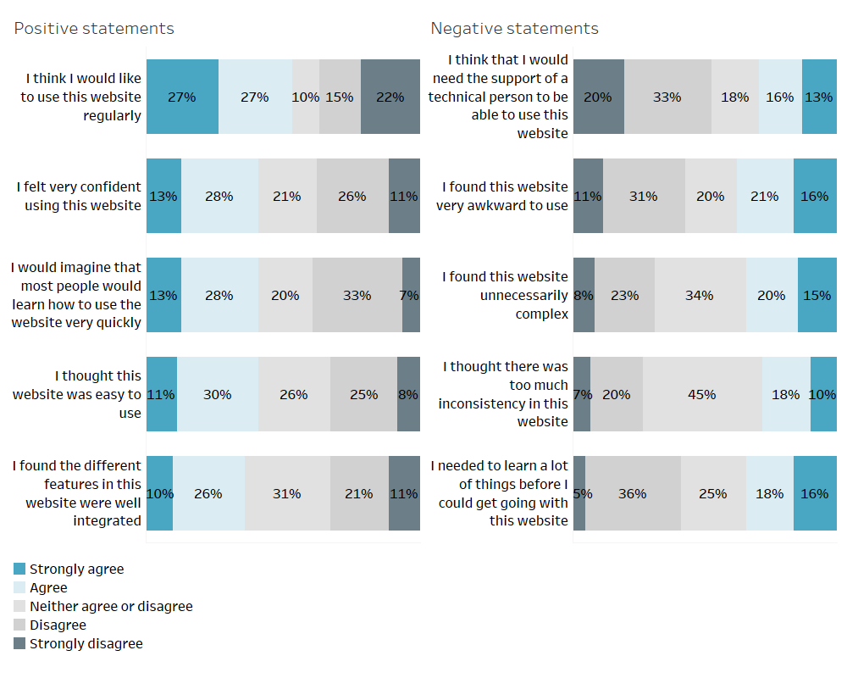
Source: Website ease of use survey data (27 January 2021–31 March 2022).
Suggestions made by people with disability, their families and carers interviewed to improve the accessibility of the website
- More consideration of the links provided under each area of life to ensure they are relevant and helpful.
- Provide more information on the website, as opposed to linking to other websites, or provide more information about the links on the website to ensure people with disability have a better sense of whether it will be useful to them and know what to expect once they’ve clicked on the link.
- Make information available in other languages and in different formats (e.g. Easy Read, Listen) more prominent and easier to find on the Disability Gateway.
- Consider developing videos in other languages and translating the website into other languages as opposed to having to contact a translating service.
- Consider offering the ability to search by disability type on the website.
- Minimise the amount of scrolling required by having the areas of life as tabs along the top or down the left-hand side of the homepage with drop down menus, so users do not need to scroll as much. Also consider having drop down menus for the tabs that are currently along the top of the website (i.e. Home, About us, etc.).
- Allow people to search by region before they drill down into the areas of life.

Accessibility of the contact centre

Wait time and abandonment rate
Phone system data indicates the proportion of calls handled by an agent declined from 99% in December 2021 to 89% in February 2022 but improved to 98% in March 2022. The proportion of calls abandoned concurrently increased from 1% in December 2021 to 4% in February 2022 but reduced in March 2022 (Figure 15). This has occurred in the context of higher overall call volumes that peaked in February 2022 and began to decline in March 2022. The number of voicemails, voluntary hang ups and involuntary queue drop-outs also followed this same pattern over this period, which may indicate the increased use of voicemail in handling increased call volumes. Nevertheless, wait time and abandonment rates remain low.
- Contact centre wait times and abandonment rates
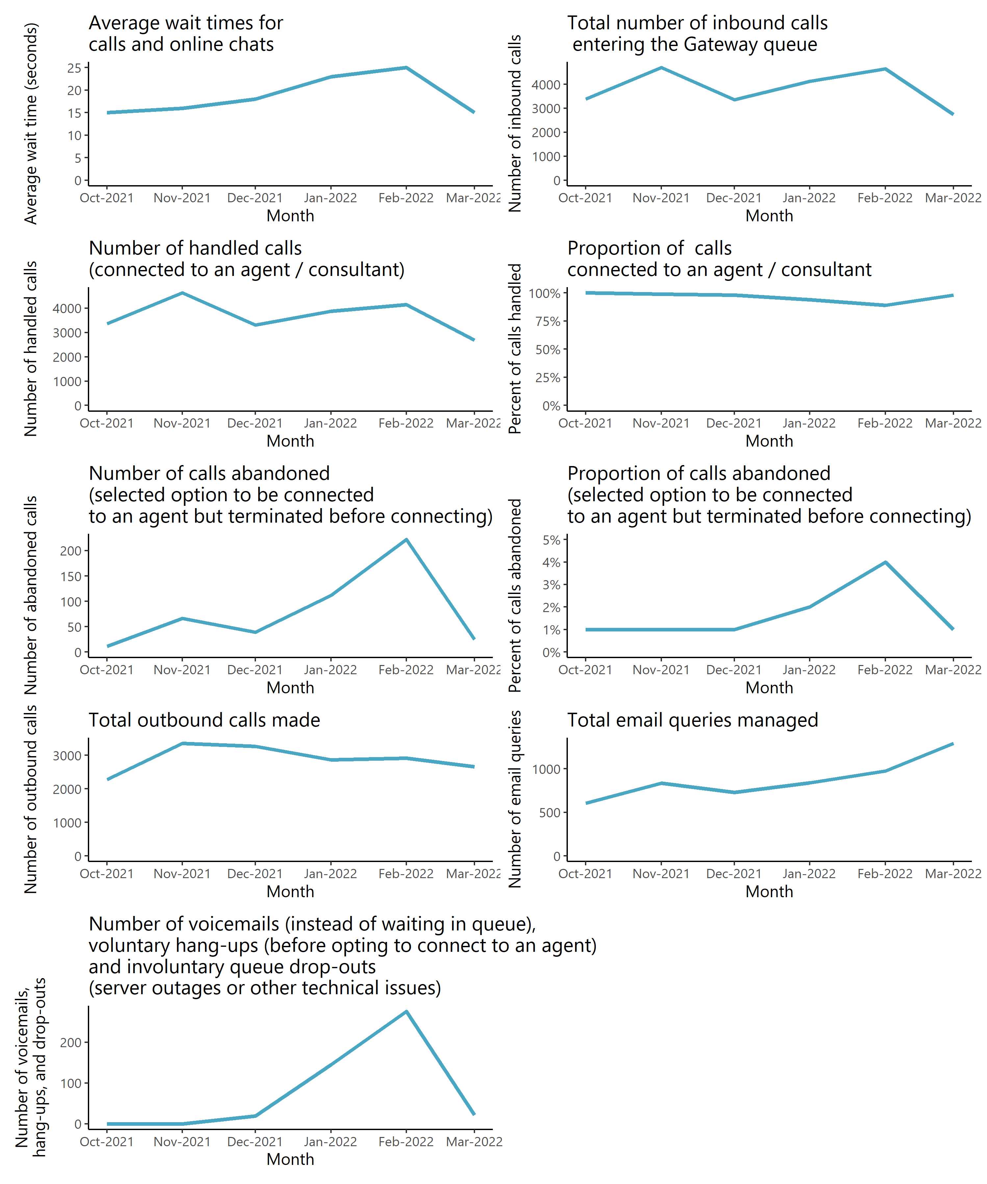
Source: Aggregate metrics supplied by TBS via email (dated 11 February 2022, 15 February 2022, 3 March 2022, 14 April 2022).

Access by key demographics
It is difficult to accurately assess access by demographic groups given the limited enquiries this data is available for. In order to gauge potential access barriers among specific subgroups, we compared the age, gender, disability type and location of the callers to the Disability Gateway (who are making detailed enquiries) to data collected through the Survey of Disability, Ageing and Carers (SDAC) survey. .
The proportion of detailed calls to the contact centre that were made from NSW is higher than the proportion of Australian people with disability who are living in NSW as measured by the SDAC (45% compared to 32%). Callers from Queensland, Victoria and Western Australia are underrepresented.
- Proportion of detailed enquiries by region in comparison to SDAC
Region | Detailed enquiries to Disability Gateway – proportion by region (%) | People with disability living in Australia as measured by SDAC– proportion by region (%)
 | (n=21,453, missing=673) | (n=~24.5m)
New South Wales | 45% | 32%
Victoria | 22% | 26%
Queensland | 15% | 20%
South Australia | 7% | 7%
Western Australia | 6% | 10%
Tasmania | 2% | 2%
Northern Territory | 1% | 1%
Australian Capital Territory | 1% | 2%
Source: CRM data (27 January 2021–31 March 2022); SDAC Survey Data (2018).
The proportion of older callers (aged 55–64) is disproportionately higher than the proportion with disability in that category, and the youngest group of callers (under 15) are underrepresented.

- Age of callers with detailed enquiries compared with SDAC

Source: CRM data (27 January 2021–31 March 2022); SDAC Survey Data (2018).
It is difficult to directly compare the disability types of individuals contacting the Disability Gateway with detailed enquiries to the wider population of people with disability due to differences in definitions between the sources; however, for some disability types we were able to observe differences between callers and prevalence in the community.
- According to SDAC, for 77% of people with disability their main form of disability is physical. Although physical/diverse disability was the most common disability type for individuals accessing the contact centre with detailed enquiries, at 34% this is much lower than the prevalence of this disability type in the community.
In contrast to this, 34% of people accessing the contact centre had an intellectual or learning disability. This is much higher than the proportion of people with disability with intellectual and developmental disability as assessed by the SDAC (6.5%).
This suggests that people with different disability types may be accessing the Disability Gateway in different ways. That people with intellectual or learning disability appear to be making more detailed enquiries to the contact centre than the prevalence of this disability type in the community suggests that the contact centre may be more well suited to address their needs
Other trends regarding contact centre access to note include:
- There are no differences in individuals accessing the contact centre by gender compared with SDAC.
- It is difficult to assess how representative Aboriginal and Torres Strait Islander Disability Gateway users are of the wider population of Aboriginal and Torres Strait Islanders with disabilities due to the SDAC methodology.

TBS points out that while the service is reaching its target audiences, reach is still growing through different promotional campaigns, and while the organisation does have a First Nations Engagement Strategy, time and more on the ground community engagement is needed to reach remote and Aboriginal and Torres Strait Islander communities – which will now be more possible with reduced COVID-19 restrictions.

Disability organisation perspectives of accessibility
Some disability organisations spoke of the accessibility of the Disability Gateway. Three disability organisations commented that it was positive the Disability Gateway was accessible through different channels – one particularly liking that the contact centre was open before and after business hours for people with disability and carers who work.
I think that the digital age is here, and it's not going to go anywhere. But we cannot ignore the fact that some people may want to call somebody and just have a call and get information right away. That is the nature of inclusive services. (Disability organisation interviewee)
I think the Disability Gateway without the phone support wouldn't be anywhere near as good. Because I think that people are assuming that - and I'm not talking just people with disability, I'm talking anybody- most people would like to speak with somebody if they’ve got a particular issue. (Disability organisation interviewee)
Other positive comments about the website from disability organisation interviewees, which were broadly consistent with the positive comments made by people with disability, their families and carers we interviewed, included that:
- it is less confusing than the NDIS website
- navigation is improving over time
- it does not feel overwhelming
- it has various accessibility features built into the site
- it uses inclusive imagery
- the information is clearly structured using the areas of life.

I think for a person with a disability who can use the internet, I would think it’s fairly well structured. In terms of the ‘areas of life’, it’s good and clear, the images are good, like the cash with ‘income and finance’, ‘housing’ with the house. It's really good there. And then, for example, when you click on ‘Aids and equipment’, and you see there, there's a video with a gentleman. We can also click on the ‘read transcript’, things like that are really good. So if you've got a particular barrier, there's a way around it. (Disability organisation interviewee)
However, four disability organisations (including one intellectual disability peak and an organisation who was relaying concerns another intellectual disability peak had raised) felt the Disability Gateway website was not accessible for people with intellectual disability. A few other disability organisations commented that the website wouldn’t be as accessible for people who aren’t as computer literate (e.g. older people). Some felt this was acceptable because a website can never be designed to be 100% accessible for everyone – although it highlights the value of the Disability Gateway having multiple access channels.
Disability organisation suggestions to improve access (some based on feedback from their clients)
- Synthesise the information on the website as opposed to linking to external sources so users can more easily find the information they are searching for and are not being directed to inaccessible websites.
- Improve the search functionality of the website so that: related terms (e.g. amputee and prosthetic) elicit results that are similar and offer information or services in every state in which they are available; and the link to the relevant organisation(s) is the first result that appears, as opposed to their newsletter or links to various programs the organisation(s) offers to reduce complexity.
- Consider a page for national organisations, as opposed to putting a link to them under the states in which they are available, to ensure users know they can access these organisations for information even if it doesn’t offer services in their state.
- Provide more visual aids and more interesting formatting that helps to distinguish the Disability Gateway from other government websites.
- Consider additional channels for accessing the service, such as text or email, to cater to more communication preferences.
- Extend contact centre hours to weekends for people who are unable to call during the week.
- Consider warm referrals to better support people with disability connect to services and ensure that the organisation you are referring to can in fact assist the person.
- Enable people from CALD communities to find the information in their language more easily.
- Consider developing an app.

Efficiency

To what extent has the Disability Gateway delivered services as intended?
Since its inception, the Disability Gateway has delivered services as intended – that is, everything that has been scheduled has been delivered. According to Services Australia, TBS and the Department, this has largely been enabled by:
- extensive planning
- a well-designed service model based on input from and testing with:
  - people with disability, their families and carers from diverse groups
  - disability organisations on the Disability Gateway Reference Group and staff with different knowledge and experience across the Department
  - different departments within TBS (e.g. IT team, representatives from ops groups, the project team, subject matter experts)
- the nature of the project – i.e. a unique, challenging project staff knew would make a difference to people – driving commitment and passion among staff
- robust feedback mechanisms from service users and front-line staff, and processes for using the feedback to make continuous improvements to service design and delivery
- an innovative knowledge management system that streamlines and ensures consistency in service delivery
- strong Senior Executive Service support and the ability to bring in contractors as required
- a close, collaborative relationship between the Department, TBS and Services Australia, including weekly meetings
- TBS’ flexibility, responsiveness and ability to adapt their service delivery (e.g. set up staff to deliver the service from home during COVID-19 lockdowns and respond to increased demand following Centrelink messaging)
- leveraging TBS’ existing support centre infrastructure, resourcing (e.g. well-equipped frontline staff and support teams) and national reach
- adequate resources for ensuring the information is up to date and staff are abreast of the latest developments, and that data is captured accurately.

However, according to representatives from the Department, there have also been a few challenges in implementation, including balancing the views of Disability Reference Group members with those expressed by the people with disability, their families and carers, who were consulted in the design phase. There was also the challenge of giving equal voice to Reference Group members and value to their knowledge of the cohorts they represent, while managing their expectations of what the Disability Gateway, as a government asset, could realistically offer. Over time though, TBS is finding that disability organisations’ expectations are more aligned with what the Disability Gateway can offer, and this will continue to improve through greater disability organisation engagement.

The Department has also had to establish a new working relationship with Services Australia when they transitioned to being the Disability Gateway’s IT service provider in place of the Department’s IT section. As a large, separate entity with different processes, representatives from the Department found there were increases in the time taken to update and make changes to the Disability Gateway website, and an additional administrative burden for project staff and the Branch Manager (who is required to sign off on all changes regardless of size). Services Australia’s regular Change Advisory Board (CAB) ensures changes are implemented in a timely manner and adhere to best practice change release processes.
TBS also identified that COVID-19 proved challenging to implementation because it caused sporadic influxes of calls, which were hard to plan for, and they had to stay up to date with constantly changing information (which service users would have questions about within minutes of announcements). However, this was overcome by bringing staff together to share and learn, registering for alerts from Government departments and services, and having a dedicated team of people to manage the information. With everything being done remotely during COVID-19, TBS felt the service had moved beyond being an information service and was providing more in-depth support.

How efficient has the program been in the delivery of services?

Timeliness
The delivery timeline has aligned closely with the intended timeline due to extensive planning and clear phases – including the soft release of website in August 2020 and user testing, the release of the contact centre and improved website in January 2021, and the evaluation commencing in mid-2021.

Delivery of services to expected standards
From the outset, the Disability Gateway has been developed and delivered incrementally, evolving through ongoing changes based on feedback from and testing with users and disability organisations, engagement in promotional activities, the development of partnerships with organisations in the sector, and responsiveness to changing circumstances.
The Disability Gateway will continue to evolve once the current contract ends on 30 June 2022 as the Department engages in further promotion and relationship-building activities and partners continue to respond to feedback and changing circumstances. This will ensure the Disability Gateway upholds its key principles of being authoritative, accessible and current as circumstances change.

Ensuring quality
As the Disability Gateway has evolved, all services have had to meet the criteria outlined in the eligibility matrix created for the project. If it meets this criteria, Services Australia builds it for the website, and it is then approved by the Department before being added to the Disability Gateway. The only services on the Disability Gateway are those that have quality and safeguards in place – that is, they meet the standards of the Quality and Safeguards Commission, contract management, the Australian Securities Commission or the Charities Commission. If an organisation asks to be on the Disability Gateway and hasn’t met these standards, the Department suggests they contact Infoxchange to go on Ask Izzy, which has its own eligibility criteria and enables listing of local services.
Services Australia’s approach to user testing of the website also considered the Digital Transformation Agency’s (DTAs) Digital Service Standard, a set of best-practice principles for designing and delivering government services and adopted methods from previous projects conducted by the Services Australia UX Team, including the DSS Evidence Portal and the Carer Gateway website. To ensure the information on the website is up to date and accurate, ongoing feedback collected through the online feedback form is monitored and critical errors are escalated for correction. Weekly project meetings with the Department are also used as a forum to discuss ongoing enhancements and content updates.
Services Australia also uses the system usability scale (SUS), a simple survey that provides a high-level score for the usability of a product, to benchmark the user experience and see usability trends over time.
TBS also has two small teams dedicated to ensuring the information built into the CRM system and resources (e.g. referral catalogues and resource manuals dedicated to particular topics) used by contact centre staff meets the standards and is up to date. Staff are given dedicated time off the phones to read through the information, undertake professional development and participate in roundtables to ensure they are up to date with the latest developments. TBS has also developed guides and built autocorrect features into the CRM system to ensure data is captured accurately and conducts case studies in team meetings and regular call monitoring to ensure quality of the calls.

Contract management
To ensure all project partners are clear on their role and responsibilities, there are MOUs in place and contracts allow for provisions should unforeseen issues arise. Services Australia has forward planning processes the Department must comply with, and the Department has extensive guidelines for TBS to run the service. The Department also has fortnightly meetings and regular communication in between meetings with key project partners, and less regular contact with other accessibility partners (e.g. National Ethnic Disability Alliance to translate information, Information Access Group to develop Easy Read materials, Marmalade to produce Auslan videos).

Cost-effectiveness
We cannot independently gauge the extent to which the Disability Gateway has been cost-effective because we do not have access to detailed costs data. However, when procuring the service provider to set up and administer the contact centre, the procurement panel did a suite of work to determine the best value for money to deliver the service. Cabinet also made the decision that the service was good value for money when approving the procurement.

Have there been any innovations or adaptations from the original design or implementation plan? Could these be further developed or adapted/ adopted?
The Department and TBS have refined the Disability Gateway’s offering in response to changes in its operating climate. For example, as part of the response to COVID-19, the Department started sending text messages to Disability Support Pension recipients to advise them that the Disability Gateway could assist them with COVID-19 information. More recently, they have added information to the website about disaster support in response to the NSW and Queensland floods emergency.
These changes have not required modifications to the original contract. We note that the Department does not consider these refinements to be innovations or adaptations. However, TBS sees the knowledge management system developed for the service as being very innovative, in that it gathers information from different partnership sources in one system so that when users call the Disability Gateway, the staff member can enter in search terms and be presented with a range of sources they can choose from to best answer the user’s question. This not only reduces pressure on frontline staff, but also helps to ensure consistency in service delivery. The system also connects to client demographic data to better tailor information and identify gaps in information or referral pathways.
Additionally, Services Australia sees the structure and accessibility features of the Disability Gateway website as particularly innovative, and improvements to the searching functionality and introduction of filters as necessary adaptations going forward.

Effectiveness

How satisfied are Gateway users?

Overall satisfaction
Overall, respondents to our survey of people with disability, their families and carers who had used the Disability Gateway were satisfied with the service (81% agree or strongly agree) (Figure 17).
- Overall satisfaction with the Disability Gateway service
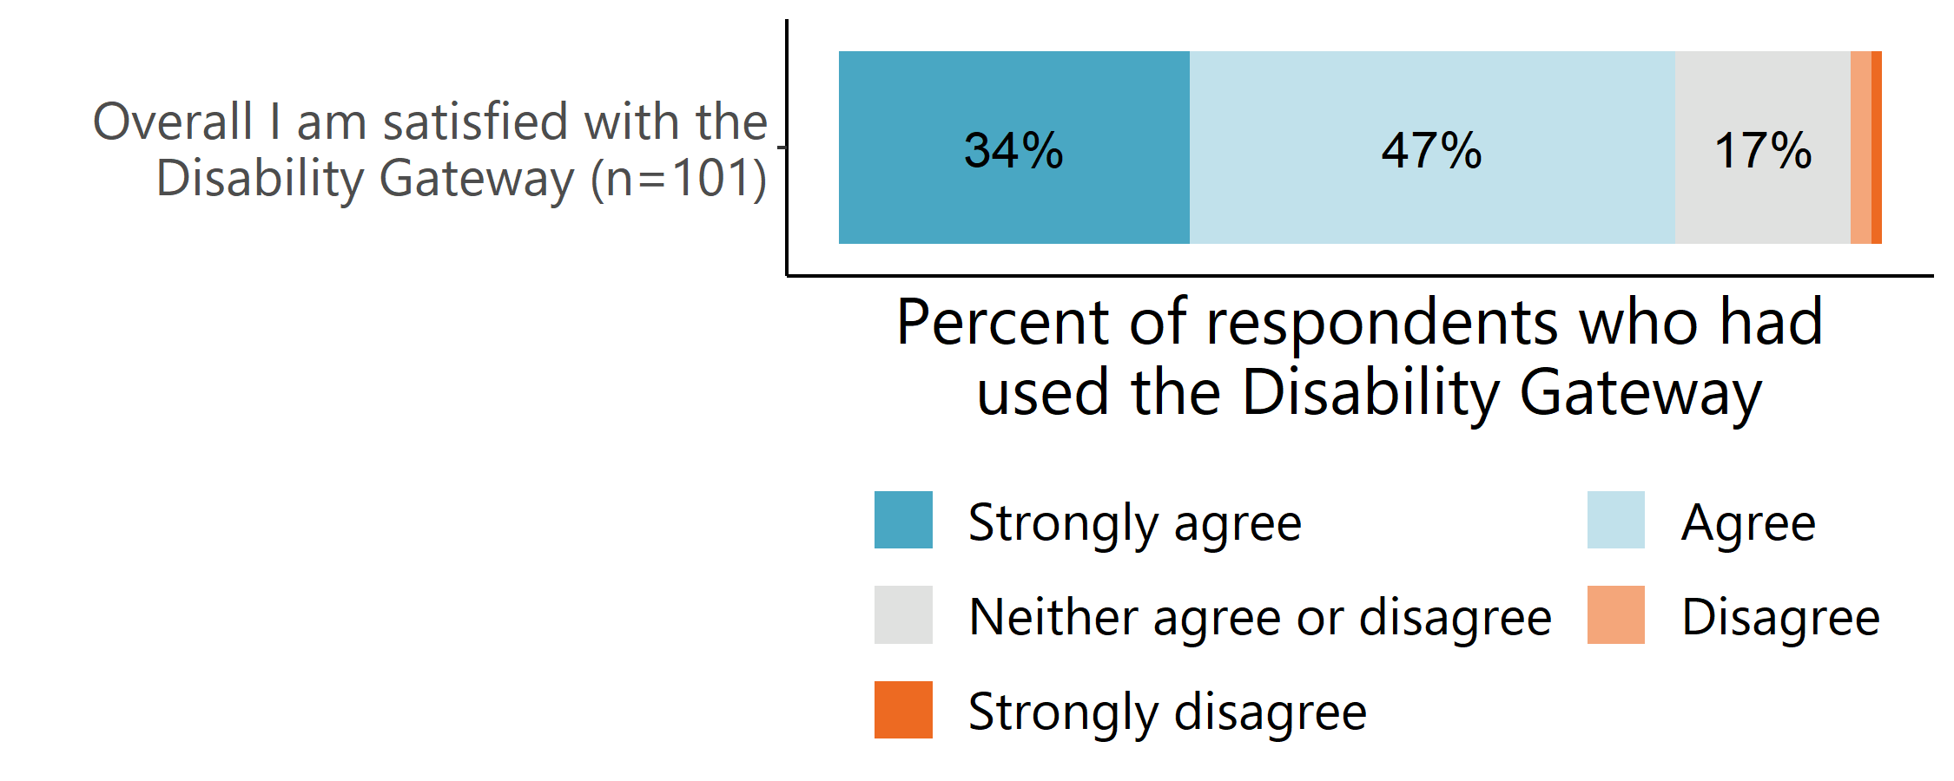
Source: Survey of people with disability, their families and carers (March 2022).
Respondents who had used both the Disability Gateway website and the contact centre reported higher levels of overall satisfaction with the Disability Gateway compared to respondents who had only used the website (Figure 18). Only a small number had used the contact centre only, so it is not appropriate to explore differences in their level of satisfaction.
- Overall satisfaction with the Disability Gateway by channel used
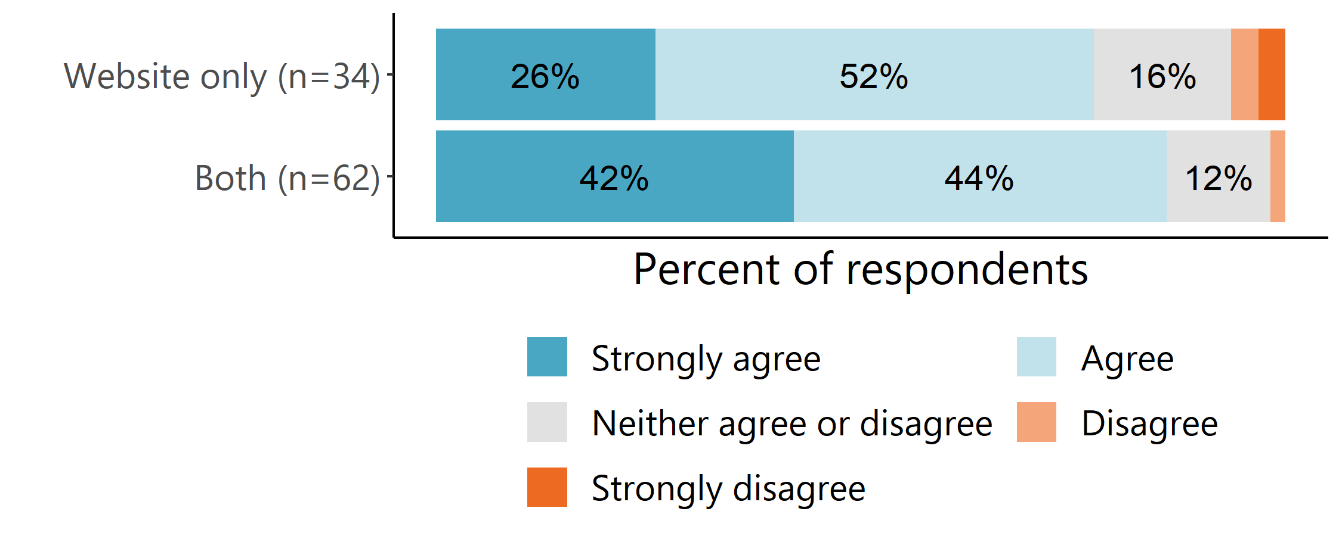
Source: Survey of people with disability, their families and carers (March 2022). Note: A very small proportion of Gateway users (4%) reported only using the contact centre. These respondents have been excluded from this analysis.
Consistent with these results, respondents to the TBS customer satisfaction survey – who are commenting on their experience with the contact centre – were also satisfied with the service (74% agree or strongly agree) (Figure 19).
- Perceptions of the Disability Gateway

Source: Customer Satisfaction Survey data (22 June 2021–31 March 2022). Note: values below 5% are not labelled in the figure.

All of the people with disability, families and carers we interviewed who commented on the qualities of contact centre staff and their ability to understand callers’ needs were also satisfied with the Disability Gateway.
I found them very good in terms of understanding the issues, and being realistic in terms of, ‘Well, these are the next steps, we’ll triage the call to the right area,’ to then who will talk to you about what your needs are in more detail. (Family/ carer interviewee)
[The Disability Gateway] is a very kind service and understanding of the situations people find difficult. And [they make you feel like] if you do need help, its ok to seek help. They’re almost like a counsellor – they’re really listening, they show a human side, they ask questions and want to know more. Sometimes [with other services] you can’t explain your situation. (Person with disability interviewee)

Ease of dealing with the contact centre
TBS customer satisfaction survey respondents were also very positive about how easy the Disability Gateway was to deal with (Figure 20). When asked to rate how easy the Disability Gateway was to deal with during their most recent experience on a scale of 1-10, 70% of respondents gave the Disability Gateway the highest rating (10 – strongly agree), with over 90% of respondents giving a rating of 5 or above. Reasons for these ratings are explored in Section 5.5.1.
- User agreement that the disability Gateway was easy to deal with

Source: Customer Satisfaction Survey data (22 June 2021–31 March 2022).
Among those who found the Disability Gateway easy to deal with, the most common reasons were because the contact centre staff had been understanding, professional and helpful (Table 12).
Genuinely nice guy on the phone - he wasn't sure of the answer to my question and said as much, however followed up with colleagues and got back to me that day - great customer service and great to get the return call with the information I was after. (Customer satisfaction survey respondent)
- Reasons for finding the Disability Gateway easy to deal with
Definition | n | %
The operator was understanding, professional and helpful | 98 | 57%
The information provided was helpful | 23 | 13%
I would recommend this service, or the experience was positive overall | 22 | 13%
Comment about a specific operator | 20 | 12%
The response was quick, or the operator got back to me quickly | 10 | 6%
Total | 173 | 100%
Source: Customer Satisfaction Survey (March 2022). Note: Only shown to respondents who reported that they found the Disability Gateway easy to deal with. A small number of respondents who made no comment (n=4) or a negative comment about their experience with the Disability Gateway (n=5) were excluded from this analysis.
This sentiment was echoed by respondents to the survey of people with disability, their families and carers who had used the contact centre, the vast majority of whom reported feeling comfortable talking to the contact centre staff, and that the contact centre staff understood their needs (Figure 21).
- User experiences of using the Disability Gateway contact centre
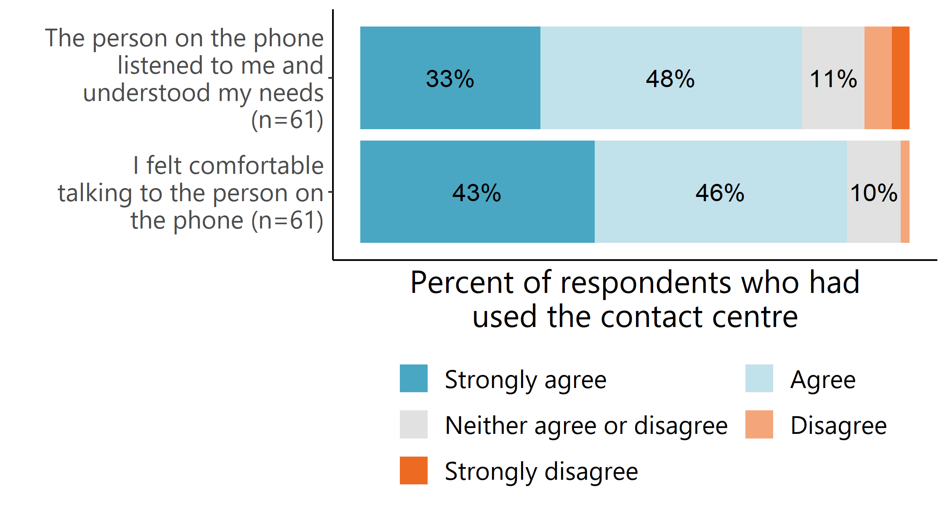
Source: Survey of people with disability, their families and carers (March 2022). Note: only asked of respondents who had used the contact centre.
People with disability, their families and carers we interviewed also commented positively on contact centre staff. They felt the staff were friendly, polite, knowledgeable and understanding of their situation. They also described the staff as being patient, taking the time to listen to them, giving them all the information they needed and, if they didn’t know the answer, doing some additional searching to find out.

He was really helpful and understanding. He understood what I needed. It was a very specific thing, and it didn’t faze him at all. He was very sympathetic. I talked to him for a while, and he was interested in finding out a bit more. It felt like more than just a receptionist answering the phone – he had a full discussion with me. And he rang me back once or twice a month later to check in. I really respect when someone says what they say they’re going to do. (Person with disability interviewee)
She has studied my case, she called me back, she thought about three options, I choose the best I think it is… without her sensitivity and that kindness and consideration, you know, I wouldn’t be seated. I would have kept my son at home on and on because I don’t know where I get the booster. But now [that my son has his booster shot], I can sit down, relax. (Family/ carer interviewee)
The 3 people with disability, family and carer interviewees who required a follow-up call to answer their questions were positive about the contact centre staff doing further research to answer their questions and promptly calling them back. One even noted that the contact centre staff member had persisted even after he missed their call 3 times
He [contact centre staff member] said he’d get back to me, and he did! Within half an hour. I can't speak any more highly of them. Because everyone else, just treats you like a number. (Family/ carer interviewee)
Relief after seeking respite
One family member of a person with disability, was seeking assistance to organise living arrangements for the person they care for. After ‘exhausting every other avenue’ and having ‘no idea and no avenues’, they called the Disability Gateway contact centre for help with their situation.
They appreciated the qualities of the contact centre staff member:
They are human. They’re empathetic, they understand what you want to do. They try and get you the best results.
They also appreciated that the contact centre staff member gathered relevant information and rang them back within half an hour.
I called him. Pretty much I was at my wit’s end, I was stuttering, I was crying a little bit. because I didn’t know what to do. I also suffer from anxiety. He calmed me down and said, ‘Tell me the whole story.’ I told him the story and he said, ‘Yep, cool. We can do this. I don't know about this thing, but I'll call you back.’ He called me back. I feel very reassured.
The contact centre staff member arranged for someone to visit the family to walk them through the process of arranging respite. After six days, they were able to access respite, and they felt immensely relieved.
It’s taken a massive load off my shoulders.
This family member thinks the Disability Gateway is ‘invaluable’ and a ‘great service’, stating, ‘it saved me a whole lot of heartache.’

On the other hand, the most common reasons TBS customer satisfaction survey respondents who did not find the Disability Gateway easy to deal with gave were that they did not receive help, were not provided with information that addressed their needs or were referred on to different services (Table 13). Some of these individuals noted that they would have liked more support from the Disability Gateway to address their issues, which suggests they were seeking support outside the remit of the Disability Gateway.
- Reasons for not finding the Disability Gateway easy to deal with
Definition | n | %
Did not receive help, were not provided with enough information or were referred on to different services | 22 | 61%
The operator could have engaged with the caller’s enquiry differently | 6 | 17%
Specific comment about a personal issue | 5 | 14%
Too hard to use | 3 | 8%
Total | 39 | 100%
Source: Customer Satisfaction Survey (March 2022). Note: only shown to respondents who reported that they did not find the Disability Gateway easy to deal with. A small number of respondents (n=3) who made a positive comment about the Disability Gateway were excluded from this analysis.
A small number of respondents (n=5) highlighted difficulties obtaining the information they were seeking regarding COVID-19 vaccinations impacting their experience of the Disability Gateway.
Have your people have the required information accessible. My question was about how to get help with a disabled person to get a vaccine at home. I waited 20 minutes on hold to be directed to a website. (Customer satisfaction survey respondent)
I thought I was going to be helped to resolve my issue but I needed to do it myself. A very nice employee called me twice to see how I was going but I felt overwhelmed as I needed to resolve the problem myself. I would have like some help. (Customer satisfaction survey respondent)
Only one person with disability we interviewed had an issue with the support they had received through the contact centre. They reported that the contact centre referred them to a service, but it was the wrong area of the organisation. However, the service was able to refer them to the area that could help them, so, according to them, it had not been a significant inconvenience. However, this supports the need for warm referrals, which the contact centre is already undertaking.

Likelihood to recommend the contact centre
When asked to rate how likely they were to recommend the Disability Gateway to a friend or colleague, 69% of TBS survey respondents were categorised as promoters using the Net Promotor Strategy (NPS) methodology, 10% were passive, and 21% were detractors (Figure 22) resulting in a net promotor score of 48%. Scores above zero are considered good, and according to Bain & Co, the source of the NPS methodology, scores above 50 are considered excellent. This indicates that the Disability Gateway is performing very well regarding customer satisfaction.
- Likelihood of recommending the Disability Gateway to a friend or colleague
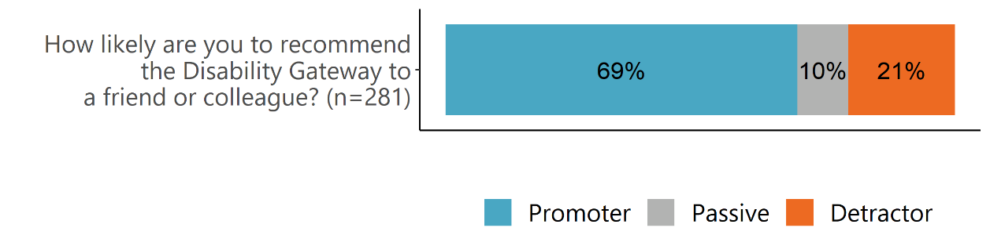Source: Customer Satisfaction Survey data (22 June 2021–31 March 2022). Note: 9-10 promotors; 7-8 passives; 0-6 detractors.
Satisfaction – as measured through NPS score – remained high from June to December 2021, with some fluctuation from month to month (Figure 23). However, there was a notable decline in customer satisfaction in January 2022, which was the only month in which more Customer Satisfaction Survey respondents were detractors than promoters. Weekly reports from January 2022 indicate that many enquiries relating to COVID-19 were regarding the availability of and access to rapid antigen tests (RAT); and TBS noted that the shortage of RATs and limited information that the contact centre was able to provide regarding the availability of these tests was a major source of frustration and dissatisfaction for callers in this time period – which may explain the decline in satisfaction for this month. Following this, satisfaction rebounded, and in February and March 2022 NPS scores were over 50, which is considered to reflect excellent client satisfaction.
- Changes in NPS score by month
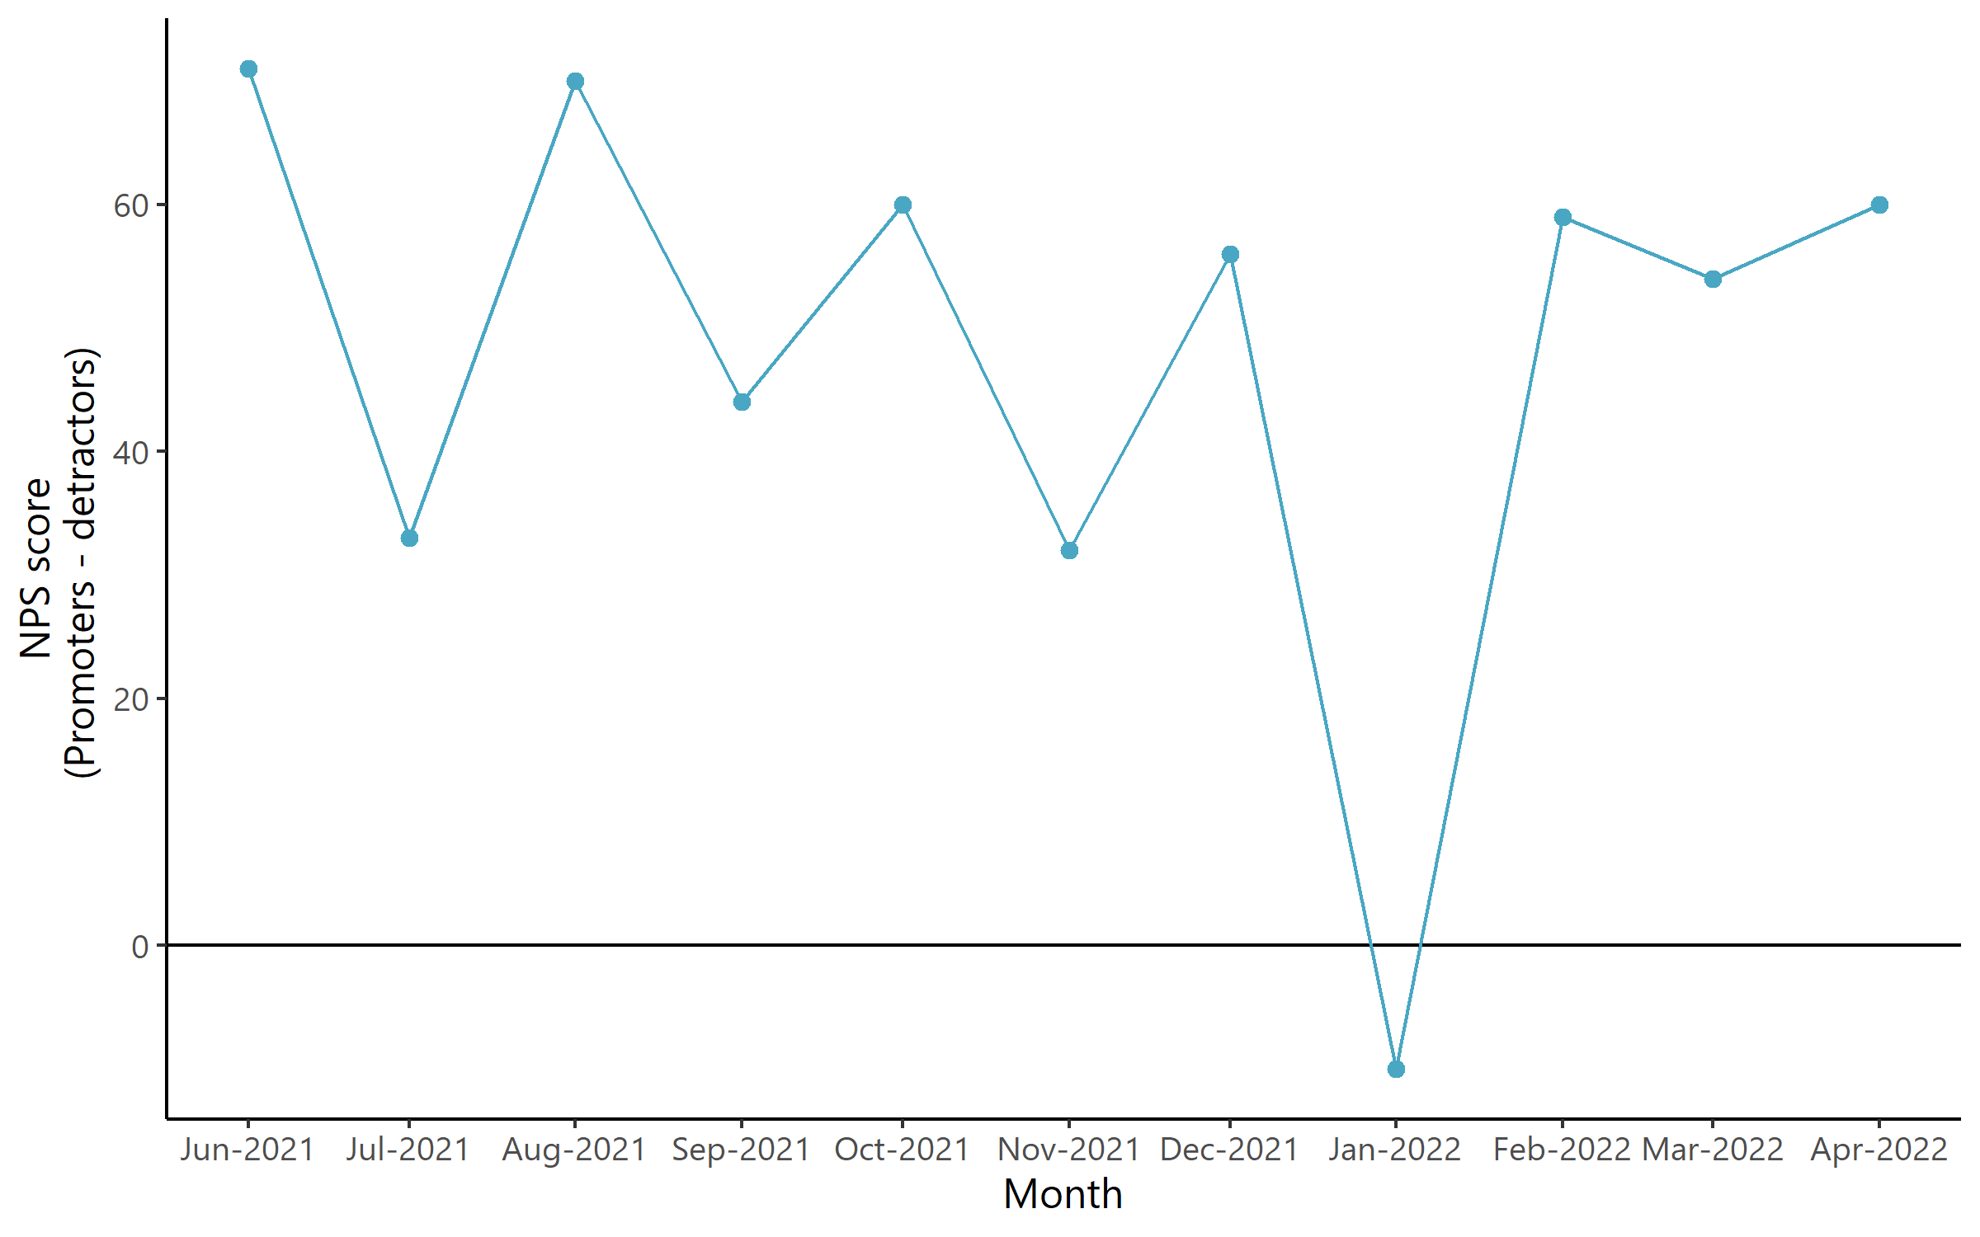
Source: Customer Satisfaction Survey data (22 June 2021–28 Feb 2022). Note: 9-10 promotors; 7-8 passives; 0-6 detractors. NPS score is calculated as the proportion of detractors subtracted from the proportion of promoters across the time period of interest.

Reaching out for help around the home
One person with disability first heard about the Disability Gateway from their GP, who called the Disability Gateway contact centre to do a warm referral. The GP informed the contact centre staff member that the person with disability was seeking assistance to install a range of supports around their home.
When they got home, the person with disability rang the Disability Gateway phone number. The contact centre staff member had prepared information for them and arranged for an occupational therapist to visit their home. The person with disability valued the empathy of the contact centre staff – ‘I just felt like they put out their hands [and said], “We’re here to help you, we’ve been waiting for you to ask.”’
After receiving assistance from the Disability Gateway, the person with disability feels that the support has taken the stress away from them and now say that they would ‘100%’ recommend the Disability Gateway to anybody who asked.

To what extent do people with disability, their families and carers view the Disability Gateway as a trusted information source and relevant to their needs?

Perspective of Disability Gateway users
The majority of respondents to the survey of people with disability, their families and carers who had used the Disability Gateway viewed it as a trusted source of information (79% agree or strongly agree) (Figure 24).
- Views on the information received from the Disability Gateway website or contact centre (people who had used the Disability Gateway prior to the survey of people with disability, their families and carers)

Source: Survey of people with disability, their families and carers (March 2022). Note: neither agree nor disagree, disagree, and strongly disagree responses are not shown in this figure. Only asked of respondents who had used the Disability Gateway prior to taking the survey.

When asked why they decided to use the Disability Gateway to find information about supports and services they were looking for, survey respondents identified trust as a key reason – specifically, they trusted it as a government resource (52%) or it was recommended to them by a person or organisation they trust (45%) (Table 14).
- Reasons for using the Disability Gateway to find information among Gateway users
Why did you decide to use the Disability Gateway to  find this information? (n=94) | Yes (%)
It is a government resource | 52%
Recommended by a person/organisation I trust | 45%
All the information I need is in one place | 31%
It is easy to use | 18%
Other | 1%
Source: Survey of people with disability, their families and carers (March 2022). Note: only shown to respondents who have used the Disability Gateway.
Consistent with this, almost all of the people with disability, their families and carers we interviewed felt the Disability Gateway was a trusted information source. Among those who commented on this, some explained they trusted the Disability Gateway because it was a government website, but the key theme from interviews was that the amount of information available or the qualities of the staff member they had spoken to on the phone had made them trust the information they were receiving.
Just the mannerisms, the voice. They didn’t make you feel stupid because you didn’t know. I know it’s on the phone, and I do like reading people's faces and stuff, but I felt comfortable. It takes a lot for me to feel comfortable with people that I can't see. But I do feel that with them. (Person with disability interviewee)
One family member/ carer interviewed said they didn’t trust the website because it was in ‘Beta mode’, which they interpreted as it still being in its experimental phase.
The majority of respondents to the survey of people with disability, their family and carers also reported that the information they received was relevant, up to date, and easy to understand (Figure 25). This was supported by interviewees – most of whom felt the information was up to date and easy to understand, largely due to the videos and accessibility features (e.g. Easy Read) built into the website. Only one family member/ carer we interviewed felt the person they support wouldn’t understand the information because they couldn’t read English.
Among the small number of survey respondents who felt that the information on the Disability Gateway was not easy to understand (n=7), the most common reason for this was the volume of information (n=4).
Some interviewees also commented that they planned to use the Disability Gateway in the future should questions arise or as they enter a new phase (e.g. once they are approved for the NDIS and can begin accessing services).
Suggestions by people with disability, their families and carers to improve website content
The following are one-off suggestions for improving website content.
- When searching for education, ensure it is clear that people can access a support person at TAFE who they can contact if they have any issues or special requirements.
- List events where people can go to connect with others and learn new information.

I think also, having events listed, so obviously, online events, or face-to-face events, where people can get support. Whether it be just community catchups or something like that, just have the links where people can learn and people can get information from that as well. People can meet other people. That would be cool. Like, like a social centre. (Family/ carer interviewee)

Perspective of those shown the Disability Gateway through the survey
Those who were shown the Disability Gateway website for the first time in the survey of people with disability, their families and carers also agreed that it was trustworthy (72% agree or strongly agree), up to date (75% agree or strongly agree) and easy for them to understand (78% agree or strongly agree) (Figure 25). Though, the strength of trust in the information was lower than among those who had previously accessed the Disability Gateway.
- Views on the Disability Gateway website among people who were shown the website in the survey of people with disability, their families and carers

Source: Survey of people with disability, their families and carers (March 2022). Note: neither agree nor disagree, disagree, and strongly disagree responses are not shown in this figure. Only asked of respondents who had not heard of the Disability Gateway or had heard of the but not used the Disability Gateway.
Positively, most of this group said they would use the Disability Gateway to look for information in future (87% agree or strongly agree), and 54% of website ease of use survey respondents also agreed they ‘would like to use this website regularly’ – suggesting perceived relevance to them.
Those who reported that they wouldn’t use the Disability Gateway website to look for information in the future (n=28) reported various reasons why – most commonly (n=7) because they felt government departments and services didn’t care about them.
Among those who reported difficulties understanding information, the most commonly identified issue was the volume of information on the website (Table 15). Other reasons included that the person they support does not have the computer literacy for them to navigate and understand the website information (n=6), and that the information wasn’t relevant to them or the person that they care for (n=3).
- Factors making the information on the Disability Gateway website hard to understand for People who were shown the website in the survey of people with disability, their families and carers
What makes the information hard to understand? (n=58) | Yes (%)
There was too much information | 43%
Other | 34%
There weren’t enough headings | 21%
The language was difficult and confusing | 10%
Source: Survey of people with disability, their families and carers (March 2022). Note: only asked of respondents who had not heard of the Disability Gateway or had heard of the but not used the Disability Gateway. Multiple responses were allowed, percentages do not sum to 100%.

Perspective of disability organisations
Five disability organisations said they viewed the service as a trusted source of information – largely as a result of the genuine relationship-building work TBS has been doing.
They were great to deal with, well organised, really professional, really clear, simplified information, could answer questions. We were just like, ‘wow’… He said, ‘any questions you’ve got, just feel free to call me, I’m happy to come to more network meetings or send you information’. He had a fantastic, refreshing energy. And was very keen to work closely together and, effectively, not regular meetings for the sake of doing that. (Disability organisation interviewee)
One disability organisation who wasn’t aware that TBS operated the contact centre commented that the service seemed really impartial. However, another disability organisation felt there had been ‘sector concern’ about TBS winning the contract because they are ‘not a disability organisation’ and because of the ‘perceived conflict of interest’ with them being a NDIS early childhood early intervention provider.
Three disability organisations had mixed views about whether the Disability Gateway is a trusted source of information. One felt that while people generally trusted the information, greater transparency about the vetting process for including services on the Disability Gateway would be appreciated as it would give disability organisations more confidence in referring their clients. The other two felt that while they had concerns about the website, the work TBS had been doing to reach out to organisations and promote the service had improved their trust in the Disability Gateway.
It was really helpful when the Disability Gateway team reached out to have a chat about the services they provide. Because we were kind of sceptical after some of our involvement in the development and some of our unhappiness about the website, were a bit sceptical about what would happen when someone called up the Disability Gateway. And I have to say, after meeting with the team there and having some really good discussions, I felt much more positive about the potential for what they were doing and their approach. (Disability organisation interviewee)
Two disability organisations felt that while it was important for the Government to provide disability-related information, many people with disability, their families and carers distrust government so it is important to have independent, trusted sources (e.g. disability organisations) to complement the Disability Gateway (reflecting the comments of some of those shown the Disability Gateway in our survey of people with disability, their families and carers).
It's a government-based information source. It's not an independent source. And, you know, it's fair to say that a lot of people don't trust government information sources. They want to hear it from a trusted advisor, an organisation or an individual that they feel comfortable with and can feel confident in what they're getting taught. So, I think that's always the tension. And don't get me wrong, I think governments have to still maintain and put out information sources. But you can't diminish the role of the independent, trusted advisor and trusted source. (Disability organisation interviewee)
Three disability organisations provided feedback about the volume of information available on the Disability Gateway. Two indicated the website did not have too many words, so it was ‘easy to use’; and another said the website had the right amount of information.
Four disability organisations commented that information on the Disability Gateway was up to date. One said this is because ‘centralised places like the Disability Gateway, because of their purpose, and how they position themselves, have a good way of keeping a grasp of all different system changes and things.’ Another commented that while the information on the website was up to date, ensuring the websites it links to are kept up to date may be a challenge.
Disability organisations had mixed opinions on the extent to which the information on the Disability Gateway website is easy to understand. Some (n=5) disability organisations felt the information was simple and accessible for all or at least most people and avoided jargon. One disability organisation particularly liked that the various sections of the website had been labelled ‘areas of life’ as it seemed to encompass more than just support and, therefore, felt more empowering for people with disability.
However, some disability organisations made suggestions for improving the accessibility of the information. Two felt the information available on the website was designed from a ‘government’ perspective, rather than from the perspective of people with disability and did not include the person-first language a person with disability would find accessible. Another felt that while the information on the Disability Gateway was accessible, the information the Disability Gateway links to is not. Disability organisations were particularly concerned by the accessibility of the information for people with intellectual disabilities (See Chapter 3 for more suggestions around improving the accessibility of the website).
It’s just a depot of information and terminology that resonates with government, rather than resonating with real people, with employers, with service providers, that may not be across things as much as - you know, under terminology that government use. (Disability organisation interviewee)
Disability organisation suggestions for improving website content
- Make the website more user-centred by using first-person language and explicitly answering questions such as, ‘If I just acquired a disability, where do I go?’, and ‘I'm about to leave school, how do I find a job?’, as these are the types of questions that people with disability would be looking for answers to.
- Tailor Easy Read material to the information people with different disability types would want or need as opposed to a direct translation of the Plain English text.
- Embed rights throughout all areas of life so people know what their rights are in every circumstance as opposed to having a separate section on rights.
- Make the information more accessible to young people.
- Provide information about relinquishing care.
- Provide information for the LGBTQIA+ disability community.
- Provide more information on relationships, reproduction and raising children.

To what extent has the Disability Gateway improved outcomes for people with disability, their families and carers?

Improving access to information
Available evidence indicates the Disability Gateway is improving access to information.

Perspectives of Disability Gateway users
People with disability, their families and carers survey respondents who had used the Disability Gateway had generally found at least some of the information they were looking for – with 53% getting some and 39% all of the information they were looking for (Figure 26).
- Amount of information users were looking for received from the Disability Gateway
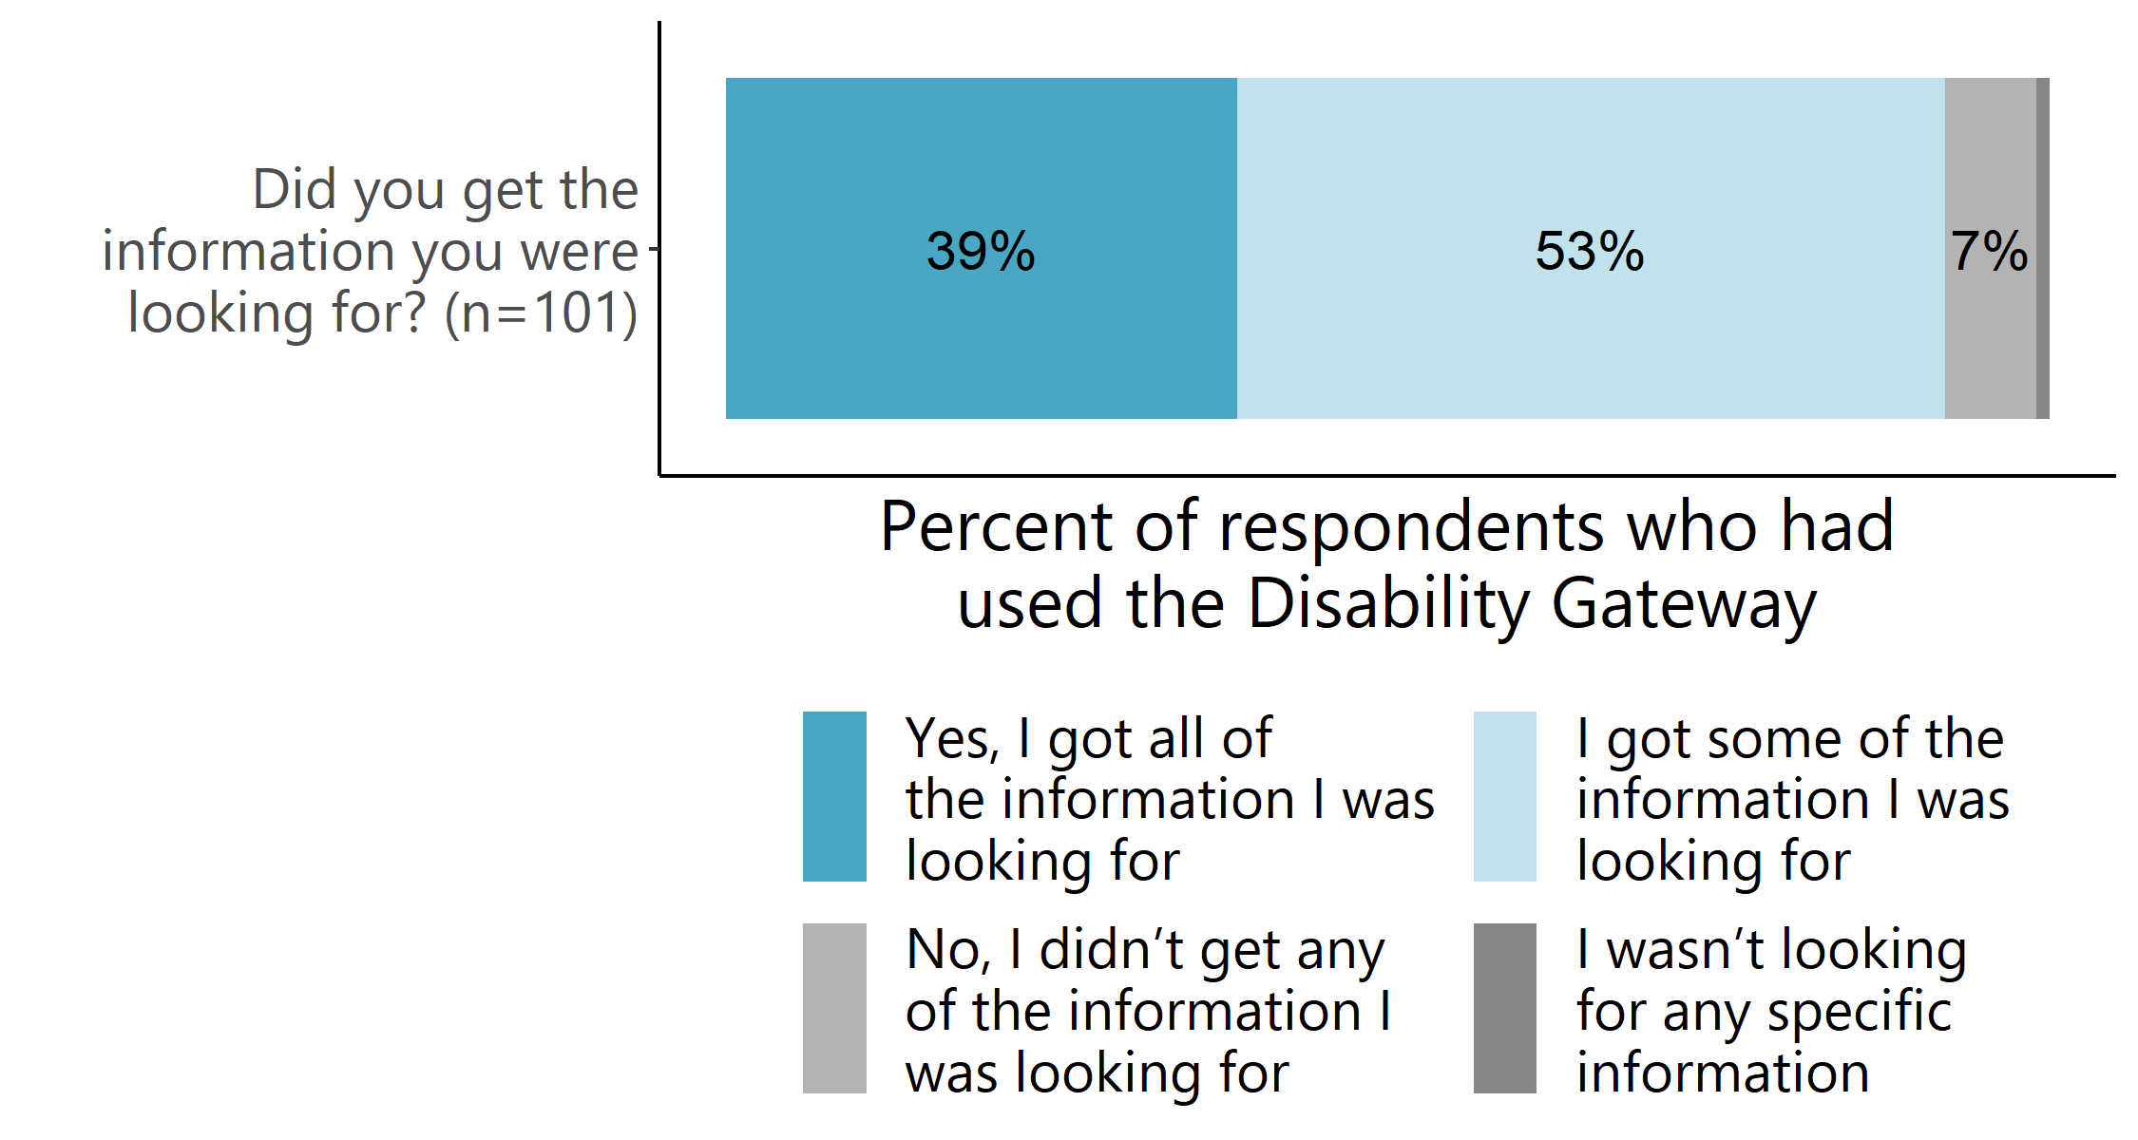
Source: Survey of people with disability, their families and carers (March 2022). Note: only asked of respondents who had used the Disability Gateway.
Respondents also commonly found that the information they received from the website, or the contact centre was new to them (50% agree; 28% strongly agree). (Figure 27).
- Awareness of information received from the Disability Gateway
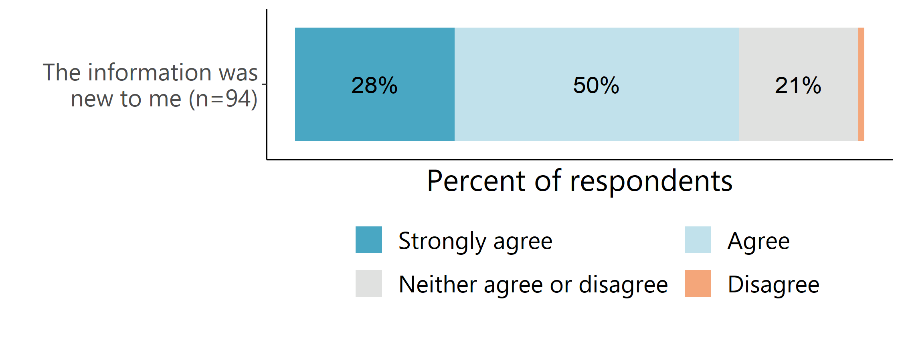
Source: Survey of people with disability, their families and carers (March 2022). Note: only asked of respondents who had used the Disability Gateway.
Respondents who had used both the contact centre and the website were substantially more likely to report that they got all of the information they were looking for from the Disability Gateway compared to those who had only used the website (Figure 28). This may reflect the additional research or investigations that contact centre staff undertake for ‘detailed’ enquiries (see Section 3.2.4 for further detail regarding the additional interactions between callers and contact centre staff).
- Amount of information users were looking for received from the Disability Gateway, by service used
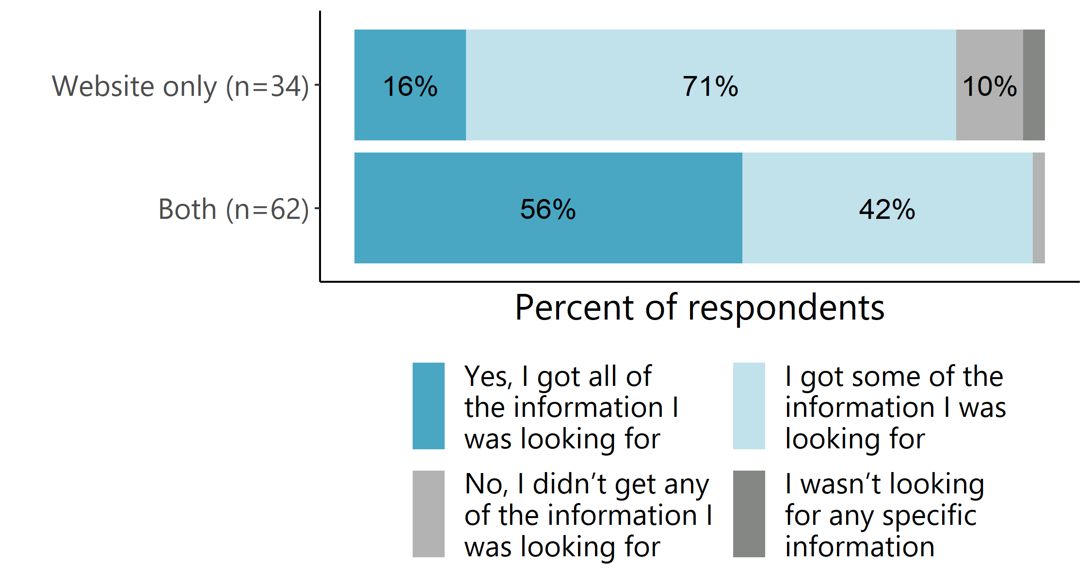
Source: Survey of people with disability, their families and carers (March 2022). Note: a very small proportion of Disability Gateway users (4%) reported only using the contact centre. These respondents have been excluded from this analysis.
A very small proportion of respondents to the people with disability, their families and carers survey didn’t get any of the information they were looking for. These respondents reported looking for information on a variety of topics including accessible housing, NDIS support, and support for specific conditions.
Interviews with people with disability, their families and carers support the survey data – most said the Disability Gateway answered their questions and was mostly or entirely new to them. A few people said what they liked most was that the contact centre provided practical advice they could implement, for example, about knowing where to get a vaccination, housing options, and eligibility for NDIS funding. As one family member/ carer said, ‘I was clueless, and she gave me all numbers where to call… she gave me details of places I can get information.’
One family member/ carer we spoke to said they were looking for information for themselves as a carer, but they found the website was more tailored towards people with disability, which reflects that there is also a Carer Gateway for carers. This person also said the contact centre staff member initially referred them to the wrong person, although this was rectified. And a couple of other family members/ carers said the information on the Disability Gateway was too general for their needs and they wanted specific information rather than suggestions of websites to visit, ‘it’s all very general and increases your knowledge, but doesn't actually get you a solution.’
One family member/ carer had mixed feelings about whether the Disability Gateway website answered their question, saying that although the links on the website refer you to useful sites, they questioned the extent to which those sites can provide specific answers or just general information.
Among the people with disability, families and carers we interviewed, most said the Disability Gateway website and/or contact centre provided the right amount of information for their needs. Some elaborated, ‘It was basic, but it was what I needed’; ‘The person was quite engaged, which worked for me because I wanted a lot of information that day, so I think it was the perfect amount of information I needed.’
A couple of family members/ carers said they were a little overwhelmed by the amount of information on the website, with one saying it was confusing to know which option was correct, and suggesting there is a need for ‘some sort of filter based on personal situation or scenario’.
A few people with disability and family members/ carers said there was not enough information on the Disability Gateway website for their needs as most of the information was contained on other websites the Disability Gateway linked to.

Other sources of information
For those who did not use the Disability Gateway, nearly half of the respondents to the survey of people with disability, their families and carers (46%) reported that they usually go somewhere else to find information about disability supports and services (Table 16).
- Users who would go elsewhere to find information about disability supports and services
Usually go somewhere else to find information/ support | n | %
Yes | 182 | 46%
No | 212 | 54%
Total | 394 | 100%
Missing | 37
Source: Survey of people with disability, their families and carers (March 2022). Note: only asked of respondents who hadn’t heard of the Disability Gateway, or those who had heard of but not used the Disability Gateway.
Nearly half of those who went elsewhere to find information about disability supports and services reported that they usually used Google/ the internet (n=66). Other common sources of information included doctors and health professionals, the NDIS, and government department websites.
This is broadly consistent with interviewees, who, in addition to the Disability Gateway, most commonly went to Government websites – such as Centrelink, Services Australia, Carers Gateway, My Aged Care and state departments (e.g. Housing SA, Qld Health). Other common sources of information among interviewees included the NDIS website or phone line, disability-specific organisations, health care professionals (e.g. GPs, allied health professionals), and Google. A smaller number said they relied on their friends or support coordinator for information. One interviewee said they’d go to the local council for support.
This indicates there are other sources of information for people with disability, families and carers, but these are different in nature to what the Disability Gateway provides. The distinguishing features of the Disability Gateway are explored in Section 5.6.

Using the information
Nearly two-thirds (65%) of respondents to the survey of people with disability, their families and carers who had used they Gateway reported using the information or services they found through the Disability Gateway; however, this is a relatively small number of survey respondents. The most common reported use was to assist a family/ friend/ person with disability (n=8).
Respondents to the people with disability, their families and carers survey who hadn’t used the information or services they found reported a variety of reasons for this, including feeling like they/ the person they support didn’t currently need the information and services (n=4), that the services were too costly (n=3) or would take too long to access (n=3). Others reported that using the information or services they found seemed too hard (n=3).
Consistent with the survey data, most of the people with disability, families and carers we interviewed had used the information they received from the Disability Gateway – to contact or access supports and services (n=7), get themselves or the person they care for vaccinated (n=5) and apply for the NDIS (n=1).

I found [a DES provider] through the Disability Gateway website, and I've actually applied through [them] and I’m having continuous interviews for a job through them. (Person with disability interviewee)
When the [contact centre staff member] that rang me told me where to go [to get a vaccination], I went down to the chemist down the road, and they said they’d book me in for both my vaccinations and the booster too. (Person with disability interviewee)

[The contact centre staff member] gave me specific instructions for how to apply for the NDIS. I called that number and was directly connected to the exact portal in the NDIS that I needed. The application had to be done verbally because my uncle can’t speak English, and I got straight through to this and got an interpreter. I didn’t have to be passed around because I knew exactly what to ask for [as a result of calling the Disability Gateway]. (Family/ carer interviewee)
Among our interviewees, there was a substantially higher usage rate among families and carers than people with disability. This is because people with disability said they:
- needed to apply for the NDIS before they could access the services recommended by the Disability Gateway
- hadn’t had the time to act on the information
- felt like the information and services, while not currently required, would be useful in the future.

The one family member/ carer interviewed who hadn’t used the information explained that it was because the person they cared for wasn’t comfortable using the Disability Gateway as a source of information because none of their peers had used it. This highlights the importance trust and word of mouth play in people’s use of different information sources, including the Disability Gateway.

Improving confidence and circumstances
While there were only a small number of people with disability, their families and carers who have used the information or services they found through the Disability Gateway, the vast majority of these reported that this had made a difference to them and/or the person they care for in improving access to support and information, increasing connections and improving confidence to make decisions about supports and services (Figure 29). Sixty-seven per cent of contact centre customer satisfaction survey respondents also felt they were ‘better able to deal with the issues I sought help with’.
- Impact of the information found through the Disability Gateway on users and/or the person that they care for

Source: Survey of people with disability, their families and carers (March 2022). Note: Neither agree nor disagree, disagree, and strongly disagree responses are not shown in this figure. Only asked of respondents who had used the Disability Gateway.
We are also able to examine the impact that the Disability Gateway contact centre has had on clients’ circumstances through changes in the Circumstances SCORE collected by TBS agents, before and after the Disability Gateway contact centre addressed their enquiry. On face value the SCORE results are very positive. Across all domains, the majority of clients initially reported that these issues were having a negative or moderately negative impact on their independence, functioning and wellbeing. Following their interaction with the Disability Gateway, a very small proportion of clients reported the same issue as having a negative impact on their current circumstances (Figure 30). Callers with issues relating to personal and family safety saw the biggest improvement. To begin, 64% of these callers reported that the issue was having a negative impact on their independence, functioning and wellbeing. In contrast, amongst those followed-up after the enquiry was addressed, 41% had adequate and stable personal and family safety over the medium term.
However, there are significant limitations to this data. Only 11% of enquiries consent to follow-up, and where they do agree to follow-up, the data recorded may be the response of the person with disability or the TBS staff member’s judgement (where they could not ask the question directly), so this data may over-estimate impact.

- Circumstances SCOREs for contact centre clients before and after their enquiry was addressed, by domain of the primary issue of the call
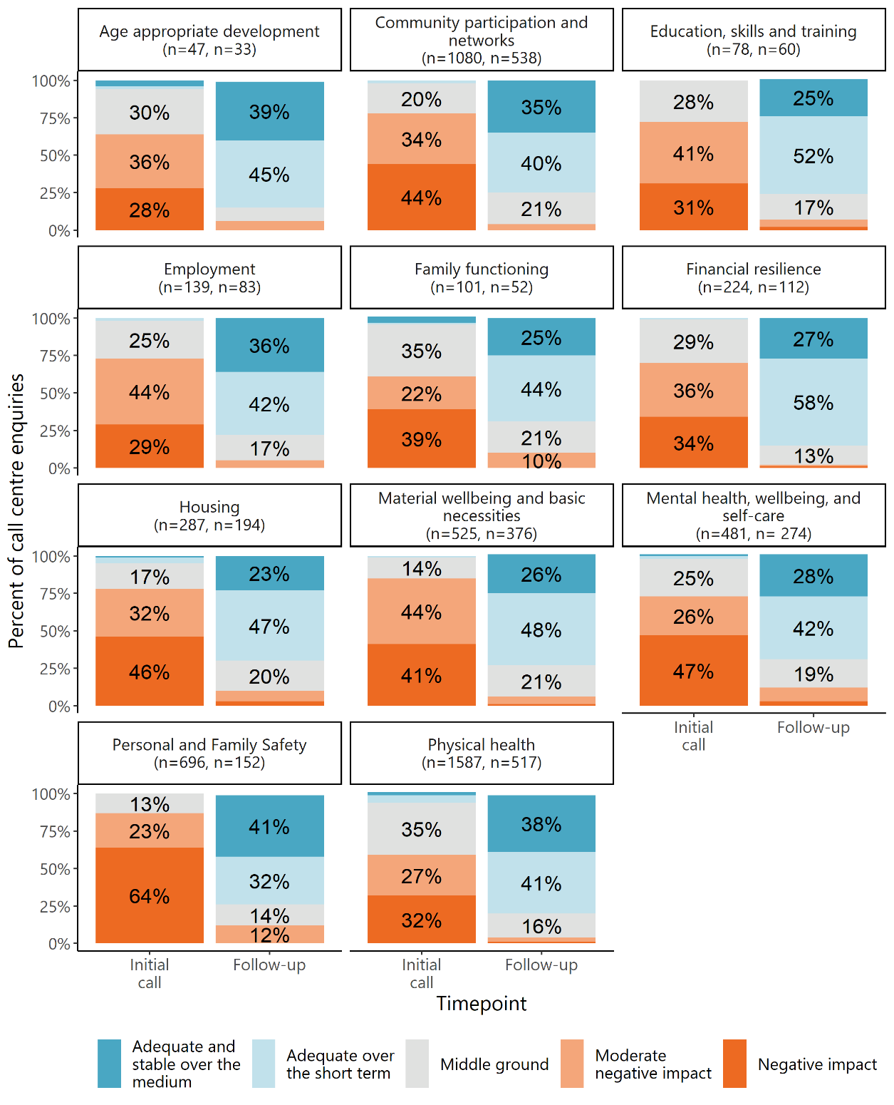
Source: CRM data (27 January 2021–31 March 2022). Note: Number of clients with initial and follow-up Circumstances SCOREs are shown for each domain. Labels under 10% are not shown in this figure.
Feeling better about things
One disability organisation reported that she typically tells clients who are parents that are new to the disability space to visit the Disability Gateway. Often, they are feeling quite overwhelmed, but report feeling better about things as a result of the useful resources and actions they found on the Disability Gateway website.
Most interviewees who had used the information or services they found through the Disability Gateway also reported that they experienced positive outcomes and felt supported as a result of accessing the Disability Gateway. Most mentioned that the support and assistance provided by the Disability Gateway helped them and/or the person they care for by easing their worry or stress.

[The difference before and after I accessed the Disability Gateway] is night and day. Mum got care; she’s looked after. I don’t have to stress. She’s in a nice, clean place where she’s taken care of. It’s taken a massive load off my shoulders. (Family/ carer interviewee)
It’s made me feel more at peace that something’s happening. It’s given me some certainty that I have people going into bat for me. My mental wellbeing is better, my wife and I were very stressed about it before. (Person with disability interviewee)
Help finding legal support
One person with disability was referred to the Disability Gateway when seeking support for an issue about their rights. Feeling ‘lost’, they rang the contact centre to explain their situation. The contact centre staff member referred them to Legal Aid and gave them advice about what to do next.
The person with disability described the staff member they spoke to as friendly, and ‘sympathetic and understanding’. They appreciated the ‘human element’ of the Disability Gateway, particularly when the contact centre staff member rang them back several times to check in on them after the initial phone call. The person with disability is currently receiving assistance from a lawyer from Legal Aid and now feels ‘more at peace’ and that his mental wellbeing is better. He feels that contacting the Disability Gateway has eased his and his partner’s stress and says he will ‘definitely use the Disability Gateway again in the future’.

Some also felt that accessing the Disability Gateway gave them the confidence to make informed decisions and plan their next steps.
Now we know exactly the steps we need to take. I like a structure to follow, and it’s made it so much easier for us and will allow [the person I support] to access the supports he needs early on. Rather than trying to find information and work out what to do, I know that through a phone call [to the Disability Gateway], I can find out exactly what I need to do. (Family/ carer interviewee)
Finding information about NDIS planning
One person felt ‘overwhelmed’ and that they ‘had no clue [about] where to go or what we were doing,’ when searching for information about the NDIS for their family member who has a disability. After some searching, they came across the Disability Gateway website and called the contact centre.
The contact centre staff gave them ‘reliable information’ about NDIS planning and spoke to them about their options. They appreciated that the contact centre staff member was ‘lovely’, ‘very patient’ and ‘willing to answer all questions.’
They felt that the information from the Disability Gateway was ‘exactly what [they] needed’ and the family now feel that they know their options and what their next steps will be and will call the Disability Gateway contact centre for information in the future.

Others reported that the Disability Gateway provided them with knowledge about where to find information, supports and services (e.g. advocacy and NDIS planning), or connected them to supports and services (e.g. social events for people with disability and organisations and supports for small businesses). A few mentioned feeling reassured knowing that the Disability Gateway was a resource they could call or visit for information when needed.
I haven't used anything so far, it’s just for the future, what's available and all that sort of stuff… It is good to know that it's there and there’s a phone number you can call to find out more and to follow up and things… You never know what you need when you need it. And what I need now is different to what I needed five years ago. (Person with disability interviewee)
Getting a COVID-19 vaccination
One disability organisation reported hearing positive reports from their clients about the assistance they received from the Disability Gateway contact centre around finding an accessible vaccination clinic. They had called to find out where there was a vaccination clinic that was accommodating of people with disability and would be able to address their accessibility issues, and as a result of the call, had made an appointment.

Who among users of the Disability Gateway has benefited most, in what ways, and under what circumstances?
There were high levels of satisfaction with the Disability Gateway service across all demographic groups explored in the survey of people with disability, their families and carers. There were no differences in satisfaction with the Disability Gateway based on age range, language spoken at home, relationship to the NDIS, or remoteness. There were also no meaningful differences between these groups being able to find the information they were looking for and reported impacts on the user and/or the person they care for (see Appendix A2.3 for detailed tables). However, the small sample sizes in some demographic groups means that the lack of group differences in satisfaction and access should be interpreted with caution. There may be some differences across different demographic groups that were not evident in the available data but could be detected with larger numbers of respondents in subgroups of interest.
In general, disability organisations identified that the Disability Gateway is best designed to meet the needs of people with disability, their families and carers who need support beyond what their organisation can provide, those who are new to disability (e.g. they acquire a disability later in life or their child is recently diagnosed with a disability) or require general disability-related information, those with complex needs or comorbidities, and those who are not eligible for NDIS support.
We seem to have a lot of people calling in who don't quite fit any system, or like them, sit across a few. And I just recommended [the] Gateway, it seemed to be a good approach when they knew about a lot of services and were happy to do a bit of digging and where they could also, like in that family situation, consider the disability in terms of both the carer and the care recipient. (Disability organisation interviewee)
We tell them about the Disability Gateway if we think that this person might need a little bit of extra hand holding, because my understanding is the Disability Gateway can do a little bit more - a series of sessions on the phone to support someone to get access a service. (Disability organisation interviewee)
So they're typically, parents that are new to the disability space or feeling quite overwhelmed. And then I'll let them know about the Disability Gateway. And they’re like, ‘That website was amazing. I got some great resources and some actions, and I feel a little bit better about things now.’ (Disability organisation interviewee)
I think I see the Disability Gateway as a general service and there to step in when the person might need some extra hand holding to get through to another point. (Disability organisation interviewee)
Supporting people with complex needs
One disability organisation had a client with complex needs who was both a carer and person with disability. This disability organisation called up the Disability Gateway to find very specific information that she was struggling to find for this client. The contact centre staff member asked some ‘really good’ questions to better understand the client’s circumstances and needs and went away to source more information. The disability organisation found this to be particularly unique in a service – ‘I don't think I've ever been able to, you know, farm off some research time’.
The contact centre staff member followed up with the information the following week, and as the client’s circumstances had changed slightly, they were in regular contact over the next few weeks to determine the best support. In the end, there was no support that existed that exactly met the client’s needs; however, the contact centre staff member showed extensive knowledge of the complexities of the disability system and found the closest available solution, which the disability organisation had not been able to find in her own searches. The disability organisation now says the Disability Gateway would now be her first point of call.

Others felt that the Disability Gateway would not be an appropriate source of support for those with an intellectual disability, those in immediate crisis or those looking for services that specialised in supporting particular disability types – for example, occupational therapists that specialised in autism.

Has the Disability Gateway delivered value to other disability organisations in supporting people with disability?

Whether the information provided has met disability organisation needs
The extent to which disability organisations found the Disability Gateway valuable to them in supporting people with disability was varied and largely depended on:
- how accessible they felt it was for their communities
- how relevant they felt the information was to their communities
- how much they knew about and had used the Disability Gateway
- their knowledge of disability and the sector.
Disability organisations who had used the Disability Gateway had mixed feedback about whether the information answered their questions and the usefulness of the information. Two disability organisations were positive. One had received feedback that clients who they had referred to the Disability Gateway had found some useful resources; another said the information they found on the Disability Gateway answered their questions.
A small number of disability organisations said the information on the website did not answer their questions or did not fully address them, or did not answer the questions of people they had referred. A couple said the information on the Disability Gateway was ‘too generic’, and not tailored to people with specific disabilities. Two disability-specific providers said that although the Disability Gateway provides links to services and supports their clients may need, it does not provide information about whether these services specialise in particular disabilities (for example, physiotherapists who specialise in treating people with a specific disability) and this is what people want to know.
One disability organisation said that their experience was that the Disability Gateway didn’t give people useful advice or the right advice regarding services, and their staff sometimes ended up educating the contact centre staff. Another accessed the Disability Gateway website to find information relevant to non-public schools, but only information about public schools was available. They also noted: ‘I think that drilling down into local would be really useful’, while the information on the site is state-based.
Disability organisation suggestions for improving sector engagement with the Disability Gateway
- Offer greater transparency about the vetting process for including services on the Disability Gateway, particularly for disability organisations so they feel more confident to refer their clients.
- Distribute short annual or six-monthly reports on Gateway usage to Reference Group members so they can get a sense of whether the communities they represent are using the Disability Gateway – noting, Reference Group members could use this information to prompt and gather feedback from their communities.
- Network with disability peaks to tap into their information and enable more tailored information.
- Consider simplifying the spreadsheet provided to organisations to share information about their programs and services.
- Provide disability organisations more opportunities and ways to provide feedback.

Other sources of information
Regardless of whether disability organisations used or didn’t use the Disability Gateway, all are using or referring clients to other sources of information, depending on what best meets their needs. Of the other sources of information disability organisations use, many noted that they would typically draw on their own organisation’s knowledge, resources, information and connections to link the person in with the right supports and services for them (whether they be internal or external). These disability organisations said it was unlikely they would refer a person to a resource with generic information (like the Disability Gateway), where they would have to do the searching for themselves if it was something they were able to assist them with – or that they would provide the link to the Disability Gateway website as a secondary resource should they ever need any general information. However, there were a few disability organisations who had less knowledge of disability who said the Disability Gateway would be their first point of call for questions that weren’t specific to the type of support they offered.
I think you'll find with all of the disease groups… the first point of call will be our own services and support organisations. And then after that, I guess, if people are aware that they're available, you have got My Aged Care, you have got the Carer Gateway, the Disability Gateway. (Disability organisation interviewee)
Depending on the individual and their request, some of the other sources of information disability organisations listed included:
- IDEAS (before the Disability Gateway existed)
- NDIS and other government websites
- Google
- Ask Izzy (which is embedded in the Disability Gateway)
- Advocacy Finder
- MyCareSpace
- Clickability
- Wayfinder Hub
- the labour market portal or ABS for statistics
- Councils
- the Ombudsman, Australian Human Rights Commission or Transport Accident Commission for different types of complaints
- an allied health professional or GP
- Raising Children Network
- Autism Connect
- Job Access.

What were the particular features of the Disability Gateway and/or its implementation context that made a difference?

Perspective of Disability Gateway users

What people found most valuable
When asked what they found most valuable about the Disability Gateway, respondents to the survey of people with disability, their families and carers most commonly said the website was easy to navigate (n=24). Other things they found most useful was that the information was easy to understand (n=11) and in one place (n=7).
Accessing the Disability Gateway website
Having heard about the Disability Gateway through a friend, one carer of a person with disability went onto the Disability Gateway website to see what support it could provide.
The carer liked how easy it was to navigate to the information they needed and appreciated how the pictures and videos made the website more accessible. They found the information from the website useful - ‘It's just a really good way for me to access everything I need or have to know straight upfront on a simple website, what is available and what support can I get.’ Although they knew about mental health services such as Beyond Blue and Lifeline, seeing these services mentioned on the Disability Gateway prompted the carer to use them.
Having revisited the Disability Gateway website multiple times, the carer will continue to use the Disability Gateway for information and support - ‘it’s everything that you potentially might need, and you probably might not need right now, but in the future, so it's just nice to have a site that lists everything, that's really simple and clear.’

Interviewees differed slightly in that those who had used both channels felt their experience with the contact centre had been the most valuable aspect of the Disability Gateway. However, the channel they preferred to use ultimately depended on how they preferred to receive information, the wait times they had experienced when calling the contact centre and their experiences with other support lines.
I like to use the website just because it's a little bit quicker to access information. I have rung before as well – I do find it a little bit difficult, especially when you're waiting for longer than 10 or so minutes. So, I do prefer the website. (Family/ carer interviewee)
I haven’t tried to ring the number because when ringing government agencies the waiting time is extremely long and crazy. So, I prefer look into the website, explore myself. Also checking with friends is much better than checking with agencies. (Family/ carer interviewee)
Among interviewees, there were no differences in what people with disability and family members or carers valued most about the Disability Gateway.

The value of the contact centre compared to the website
Among respondents to the survey of people with disability, their families and carers who had used both the Disability Gateway website and contact centre, nearly half (46%) found the information on the website more useful, while over a third (35%) found the information from the contact centre more useful (Table 17). When asked to identify why they found one channel more useful than the other, those who found the website more useful most frequently noted that the website information was easier to understand than the information from the contact centre (n=5). Those who found the contact centre more useful most commonly reported that it was because the staff listened and provided good information (n=6).
- Usefulness of the information from the website in comparison to the contact centre
 | n | Proportion (%)
The information I got from the website was more useful | 26 | 46%
The information I got from the 1800 number was more useful | 20 | 35%
They were both equally useful | 11 | 19%
Total | 57 | 100%
Source: Survey of people with disability, their families and carers (March 2022). Note: only asked of respondents who had used both the website and contact centre.

Differences between the Disability Gateway and other sources
The people with disability, families and carers we interviewed felt the accessibility of the Disability Gateway was its most distinguishing feature – in particular, the website catered to people with different types of disability, had pictures and videos to support the text and was easier to use than other Government sites, and the contact centre was more responsive and provided simpler advice than other Government phone lines (e.g. Centrelink, the NDIS).
I found I got to general areas pretty quickly. And that's just in comparison to other government sites or other sites where it does take a while to find something. I did find it pretty easy. And like I said before, the pictograms actually help a lot with finding it and finding information that you need. (Family/ carer interviewee)
Another distinguishing feature commonly identified by interviewees was the friendliness, understanding and helpfulness of contact centre staff, and their willingness to go above and beyond to find the answer to people’s questions. A few interviewees noted that they had contacted other services for assistance and the Disability Gateway was the only service able to find a solution.
You will call them and you will know that they will help you in some way. That is my experience. But they won't give you a general answer, they won’t just take it down and that's it. (Family/ carer interviewee)
He had all the connections, you know, that was a good thing. It's like, okay, I don't have to ring up someone afterwards. You know, he was going to do the research for me and get back to me. That was like a relief that someone might get somewhere, he might have better connections than I might. (Family/ carer interviewee)
Other differences noted by a small number of interviewees were that there is a broad range of information specifically for people with disability, their families and carers and links to different services all in the one place, the information is broken down by state and easy to understand and navigate, it isn’t NDIS specific, and that it is a good place to start for people who don’t know what services are available to them.
The range of options. You've got housing, employment, aids and equipment, transport. You've pretty much got everything covered that any disability person would need. The range of services. That's good. And leisure activities, as well… I don't have to search around for it. It's all in one place. (Person with disability interviewee)
A couple of interviewees felt the Disability Gateway wasn’t particularly different to other sources of information that exist.

Perspective of disability organisations
Similar to people with disability, their families and carers, disability organisations felt the most valuable aspects of the Disability Gateway were that it:
- is a centralised resource with variety of up to date, holistic, disability-related information
- caters to wide range of people, including:
  - those outside the NDIS of My Aged Care
  - people with disability and carers
- is useful to direct people to for more general disability-related information and referrals
- is an impartial service
- offers information by state.

The most commonly noted (n=10) distinguishing feature of the Disability Gateway among disability organisations was that it is a ‘centralised resource’ or ‘one-stop shop’ that houses all disability-related information in one place.
It’s probably just how varied the information is. If you're looking at it, there’s everything from income and employment, transport, leisure, education. There's just such a wealth of knowledge… they don't have to go to several different areas. It's centralised, there's so many different areas, they can get it in one point, one website. (Disability organisation interviewee)
In my head, I see the Disability Gateway as like an umbrella, and special services operating below it with specialist information. (Disability organisation interviewee)
Other disability organisations (n=5) made comparisons between the general information the Disability Gateway provides, and the specific type of support provided by their organisations to illustrate the main differences between the Disability Gateway and other sources of information. For example, one disability organisation described the Disability Gateway as a ‘low contact, high volume’ service (i.e. has less in-depth information on more topics), which, while needed, was different to their own organisation, which they saw as ‘low volume, high contact’ (i.e. has deeper knowledge on specific topics). Another saw their organisation as providing emotional support, while the Disability Gateway had more knowledge on Australia-wide disability specific referrals should their clients require them. Another said:
There would be times we would use websites like the Disability Gateway ourselves to help. We go to a lot of other websites to glean information, so we might go to the Disability Gateway to glean as much information as we can to give to that caller. So it's not necessarily- I don't see it as us versus them or them versus us in terms of the information we provide. I see it as a collaboration where we’re the specialist expertise experts in the [disability type] community, we have a huge amount of wealth of knowledge in that space, but we definitely can make use of the Disability Gateway for people that we might be struggling to help make a connection. And also for additional information that... the Disability Gateway might have on their website. Or we could potentially even contact them… (Disability organisation interviewee)
One disability organisation commented that one of the key differences between the Disability Gateway and other sources of information was that the information on the Disability Gateway was organised by state, which could be useful for quickly finding information in states where they might not typically operate.
I think what the Disability Gateway does well, is it brings together links to all the Commonwealth programs and state programs. (Disability organisation interviewee)
Another disability organisation felt their experience using the contact centre distinguished the Disability Gateway from other services in that it felt ‘fresh’ and ‘new’ and went above and beyond to assist them.
It was definitely nice energy. And I know that's maybe an odd point to make, but not all services you get a good energy from. It felt like a ‘fresh’ service, I suppose I'm saying. It felt new and they were excited, and they were keen to network and show themselves and take feedback. I think the lady asked me at the end, ‘Was that helpful? Were there any other questions the carer had?’ They haven't just sent the information and ticked the box, they were going, ‘was that meaningful?’ And that's also refreshing. So definitely seemed like a new thing. (Disability organisation interviewee)
One disability organisation was also impressed by how inquisitive the Disability Gateway staff were when they called up to find information for a caller – they asked for detailed information and prompted for further information about the organisation should anyone require their support in future.
[My colleagues] did say to me they’ve had two phone calls from staff at The Benevolent Society, who called specifically because they wanted specific information about providers. And they were fantastic. They wanted really detailed information, and they called [my organisation], the only national peak body, and they were terrific, and were able to get that information directly from [us]. And consequently, they also asked for some additional information about [what we do], so that was terrific. (Disability organisation interviewee)
While a couple of disability organisations said that the best channel for accessing the Disability Gateway would largely depend on people’s communication preferences and what worked best for them, those who had used both the website and contact centre were more positive about the latter. In general, they felt that the contact centre was able to provide more detailed information for specific requests and did a better job of assisting people to navigate the system.
If someone came to us and said, ‘I've got a very specific question. Would I find that information on the Disability Gateway?’ I’m probably more inclined to go, ‘I would ring it first as opposed to looking through the website, where you’re probably not going to get that detail.’ (Disability organisation interviewee)

What unintended outcomes (positive or negative, direct or indirect) did the Disability Gateway produce?
One unexpected outcome described by the Department was that people are calling up the contact centre because they can’t get through to Centrelink, the Carer Gateway or My Aged Care. This means that contact centre staff are dealing with an unexpected number of non-disability related calls which they are having to refer on.
No other disability organisations raised unexpected outcomes.

To what extent is the Disability Gateway on track to meet its objectives?
Available data suggests the Disability Gateway is on track to provide a single point of information, help people navigate available supports, and enable choice and control. Although as the Disability Gateway collates information from other sources and can only link to available information – not all of which is as accessible as the information on the Disability Gateway – and services – which can be limited, particularly, in certain areas – this limits the extent to which it can support choice and control.
- Website analytics
Demographic |  | Acquisition |  |  | Behaviour
 |  | Users | New users | Sessions | Bounce rate | Pages/ session | Avg session duration
 | Total | 594,898 | 585,446 | 764,034 | 62.15% | 1.96 | 00:01:11
Gender | Female | 97,575  (63.66%) | 97,575  (63.66%) | 97,575  (63.66%) | 97,575  (63.66%) | 97,575  (63.66%) | 97,575  (63.66%)
 | Male | 55,699  (36.34%) | 55,699  (36.34%) | 55,699  (36.34%) | 55,699  (36.34%) | 55,699  (36.34%) | 55,699  (36.34%)
Age | 18-24 | 21,815  (14.84%) | 21,083  (14.89%) | 27,826  (15.01%) | 50.88% | 2.36 | 00:01:39
 | 25-34 | 34,121  (23.20%) | 32,934  (23.26%) | 43,773  (23.62%) | 49.44% | 2.44 | 00:01:40
 | 35-44 | 29,049  (19.75%) | 27,719  (19.58%) | 36,432  (19.66%) | 51.73% | 2.32 | 00:01:32
 | 45-54 | 24,847  (16.90%) | 23,843  (16.84%) | 31,328  (16.90%) | 49.91% | 2.46 | 00:01:38
 | 55-64 | 19,968  (13.58%) | 19,319  (13.65%) | 24,815  (13.39%) | 51.17% | 2.38 | 00:01:35
 | 65+ | 17,247  (11.73%) | 16,665  (11.77%) | 21,164  (11.42%) | 54.33% | 2.28 | 00:01:30
Location | NSW | 187,703  (32.96%) | 184,980  (33.02%) | 245,753  (33.47%) | 64.27% | 1.95 | 00:01:11
 | Vic | 148,711  (26.12%) | 145,392  (25.95%) | 190,692  (25.97%) | 61.40% | 1.94 | 00:01:11
 | Qld | 117,810  (20.69%) | 115,438  (20.61%) | 150,199  (20.46%) | 61.63% | 1.91 | 00:01:08
 | WA | 47,748  (8.39%) | 47,665  (8.51%) | 59,714  (8.13%) | 58.54% | 2.05 | 00:01:15
 | SA | 41,160  (7.23%) | 40,856  (7.29%) | 51,571  (7.02%) | 56.25% | 2.04 | 00:01:16
 | ACT | 15,106  (2.65%) | 14,755  (2.63%) | 21,945  (2.99%) | 54.34% | 2.79 | 00:01:54
 | Tas | 9,073  (1.59%) | 9,060  (1.62%) | 11,841  (1.61%) | 56.59% | 2.01 | 00:01:20
 | NT | 1,502  (0.26%) | 1,471  (0.26%) | 1,860  (0.25%) | 56.40% | 2.09 | 00:01:26
Source: Google Analytics (27 January 2021–31 March 2022). Note: Google Analytics collects demographic information primarily from people who are logged into a Google account as well as from additional third-party cookies and app data.

- Most viewed pages
Page | Page views | Unique page views | Avg. time on page | Entrances | Bounce rate | % Exit
Welcome to the Disability Gateway | 657,058  (43.84%) | 560,281  (46.12%) | 00:01:10 | 551,788  (72.42%) | 70.11% | 70.48%
Search | 39,069  (2.61%) | 26,093  (2.15%) | 00:00:39 | 1,618  (0.21%) | 52.36% | 19.94%
Aids and equipment | 34,339  (2.29%) | 26,845  (2.21%) | 00:00:45 | 7,877  (1.03%) | 43.14% | 31.11%
Income and finance | 33,388  (2.23%) | 24,682  (2.03%) | 00:00:43 | 7,398  (0.97%) | 27.37% | 21.50%
Employment | 26,289  (1.75%) | 21,585  (1.78%) | 00:00:59 | 8,017  (1.05%) | 37.27% | 34.95%
Housing | 24,612  (1.64%) | 19,234  (1.58%) | 00:00:51 | 6,345  (0.83%) | 25.66% | 26.80%
About us | 23,583  (1.57%) | 18,378  (1.51%) | 00:01:48 | 4,534  (0.60%) | 59.52% | 40.83%
Australia’s Disability Strategy Hub | 21,521  (1.44%) | 17,569  (1.45%) | 00:00:50 | 15,041  (1.97%) | 64.32% | 53.67%
Health and wellbeing | 18,397  (1.23%) | 14,535  (1.20%) | 00:00:40 | 1,922  (0.25%) | 41.62% | 20.10%
COVID-19 vaccines | 18,317  (1.22%) | 16,062  (1.32%) | 00:02:43 | 11,533  (1.51%) | 71.85% | 76.29%
Source: Google Analytics (27 January 2021–31 March 2022).

- Most popular links
Link | Total events
 | n | %
http://www.bom.gov.au/ | 52,789 | 6.28%
https://www.ndis.gov.au/ | 36,113 | 4.30%
https://www.carergateway.gov.au/ | 33,473 | 3.98%
https://www.ndis.gov.au/understanding/what-ndis/whos-rolling-out-ndis/lac-partners-community | 28,361 | 3.38%
https://www.myagedcare.gov.au/ | 23,493 | 2.80%
https://www.dva.gov.au/ | 21,769 | 2.59%
https://www.headtohealth.gov.au/ | 20,708 | 2.47%
https://disability.royalcommission.gov.au/ | 19,644 | 2.34%
https://www.minddog.org.au/ | 19,326 | 2.30%
https://www.australia.gov.au/ | 18,003 | 2.14%
Source: Google Analytics (27 January 2021–31 March 2022).
- Top downloads
Download | Total events
 | n | %
/sites/default/files/documents/2021-07/1541-covid-19-vaccine-side.pdf | 9,454 | 28.67%
/sites/default/files/documents/2021-11/1786-australias-disability.pdf | 3,419 | 10.37%
/sites/default/files/documents/2021-07/1536-covid-19-vaccine-side.docx | 2,272 | 6.89%
/sites/default/files/documents/2021-11/1766-strategy-factsheet.pdf | 1,110 | 3.37%
/sites/default/files/documents/2021-11/1796-summary-strategy-accessible.pdf | 1,092 | 3.31%
/sites/default/files/documents/2021-11/1781-australias-disability.docx | 1,054 | 3.20%
/sites/default/files/documents/2021-11/1791-summary-strategy-accessible.docx | 794 | 2.41%
/sites/default/files/documents/2021-02/226-disability organisation-kit-rev-feb-21-0.docx | 586 | 1.78%
/sites/default/files/documents/2021-11/1816-outcomes-framework.pdf | 575 | 1.74%
/sites/default/files/documents/2021-12/1906-easy-read-summary-strategy.pdf | 521 | 1.58%
Source: Google Analytics (27 January 2021–31 March 2022).

- Additional tables
  - Telephony data
- Contact centre wait times and abandonment rates
 | October 2021 | November 2021 | December 2021 | January 2022 | February 2022 | March 2022
Average wait times for calls and online chats | 15 seconds | 16 seconds | 18 seconds | 23 seconds | 25 seconds | 15 seconds
Total number of inbound calls entering the Disability Gateway queue | 3,378 | 4,696 | 3,362 | 4,131 | 4,646 | 2,732
Number of handled calls (connected to an agent/ consultant) | 3,367  (>99%) | 4,630  (99%) | 3,304  (99%) | 3,874  (94%) | 4,148  (89%) | 2,685  (98%)
Number of calls abandoned (selected option to be connected to an agent but terminated before connecting) | (11)  1% | (66)  1% | (39)  1% | (112)  2% | (222)  4% | (25)  1%
Total outbound calls made | 2,278 | 3,353 | 3,270 | 2,869 | 2,913 | 2,657
Total email queries managed | 605 | 835 | 728 | 838 | 976 | 1,290
Number of voicemails (instead of waiting in queue), voluntary hang-ups (before opting to connect to an agent) and involuntary queue drop-outs (server outages or other technical issues) | 0 | 0 | 19 | 145 | 276 | 22
Source: Aggregate metrics supplied by TBS via email (dated 11 February 2022, 15 February 2022, 3 March 2022, 14 April 2022).

  - Customer satisfaction survey
- Who did you contact the Disability gateway for?
 | n | %
For myself | 78 | 52%
On behalf of family or friends | 50 | 34%
As a service provider | 21 | 14%
Total | 149 | 100%
Not Seen | 132
Source: Customer Satisfaction Survey (March 2022).

- Respondent experiences of the Disability Gateway
 | The Disability Gateway listened to me and understood my issues |  | I am satisfied with the services I have received |  | I am better able to deal with the issues that I sought help with
 | n | % | n | % | n | %
Strongly agree | 221 | 79% | 181 | 64% | 153 | 54%
Agree | 23 | 8% | 28 | 10% | 35 | 12%
Neutral | 10 | 4% | 24 | 9% | 32 | 11%
Disagree | 6 | 2% | 17 | 6% | 17 | 6%
Strongly Disagree | 21 | 7% | 31 | 11% | 44 | 16%
Total | 281 | 100% | 281 | 100% | 281 | 100%
Source: Customer Satisfaction Survey (March 2022).

- likelihood of respondent recommending disability gateway as a source of information on services to help people with disbaility and their family, friends and carers find the support they need in australia
 | n | %
0 - Highly unlikely | 17 | 7%
1 | 5 | 2%
2 | 2 | 1%
3 | 3 | 1%
4 | 4 | 2%
5 | 11 | 5%
6 | 7 | 3%
7 | 6 | 2%
8 | 19 | 8%
9 | 18 | 7%
10 - Highly likely | 150 | 62%
Total | 242 | 100%
Not Seen | 39
Source: Customer Satisfaction Survey (March 2022).

- likelihood of respondent recommending disability gateway as a way to access information to support NDIS service providers in their delivery of services to people with disability and their family, friends and carers
 | n | %
0 - Highly unlikely | 1 | 3%
1 | 0 | 0%
2 | 2 | 5%
3 | 2 | 5%
4 | 1 | 3%
5 | 4 | 10%
6 | 0 | 0%
7 | 2 | 5%
8 | 1 | 3%
9 | 3 | 8%
10 - Highly likely | 23 | 59%
Total | 39 | 100%
Not Seen | 242
Source: Customer Satisfaction Survey (March 2022).

- To what extent do you agree with the following statement: the Disability gateway is easy to deal with
 | n | %
0 - Strongly disagree | 15 | 5%
1 | 3 | 1%
2 | 3 | 1%
3 | 4 | 1%
4 | 0 | 0%
5 | 11 | 4%
6 | 3 | 1%
7 | 11 | 4%
8 | 16 | 6%
9 | 19 | 7%
10 - Strongly agree | 196 | 70%
Total | 281 | 100%
Source: Customer Satisfaction Survey (March 2022).
- Respondent demographics: Type of household currently living in
 | n | %
Couple family without children at home | 48 | 20%
Couple family with dependent children at home | 46 | 19%
One-parent family with dependent children at home | 27 | 11%
Couple family with children at home but are not dependent | 13 | 5%
One-parent family with children at home but are not dependent | 10 | 4%
Group household member | 18 | 7%
Person living alone | 68 | 28%
Other (e.g. non-private dwelling, nursing home) | 12 | 5%
Total | 242 | 100%
Not Seen | 39
Source: Customer Satisfaction Survey (March 2022).

- Respondent demographics: Current main ooccupational activity
 | n | %
Full Time White Collar (e.g. manager, professional, community/personal service worker, clerical/administrative worker, sales worker) | 24 | 10%
Part Time or Casual White Collar (e.g. manager, professional, community/personal service worker, clerical/administrative worker, sales worker) | 25 | 10%
Full Time Blue Collar (e.g. technician/trades worker, machinery operator/driver, labourer, hospitality worker) | 8 | 3%
Part Time or Casual Blue Collar (e.g. technician/trades worker, machinery operator/driver, labourer, hospitality worker) | 8 | 3%
Unemployed, but looking for work | 8 | 3%
Student | 3 | 1%
Long-term health issue | 70 | 29%
Home duties | 7 | 3%
Caring for children | 6 | 2%
Caring for ill or disabled person | 30 | 12%
Retired | 37 | 15%
Other reason for not being in labour force | 12 | 5%
Voluntarily not in labour force | 4 | 2%
Total | 242 | 100%
Not Seen | 39
Source: Customer Satisfaction Survey (March 2022).

- Are you eligible for NDIS?
 | n | %
Yes | 85 | 35%
No | 86 | 36%
Unsure | 71 | 29%
Total | 242 | 100%
Not Seen | 39
Source: Customer Satisfaction Survey (March 2022).
- are you currently an ndis participant?
 | N | %
Yes | 67 | 79%
No | 18 | 21%
Total | 85 | 100%
Not Seen | 196
Source: Customer Satisfaction Survey (March 2022).

- How long have you been an NDIS participant?
 | n | %
Less than a month | 2 | 3%
1-3 months | 5 | 7%
4-6 months | 2 | 3%
7-12 months | 6 | 9%
1-2 years | 17 | 25%
3-5 years | 30 | 45%
6 years or more | 5 | 7%
Total | 67 | 100%
Not Seen | 214
Source: Customer Satisfaction Survey (March 2022).
- Respondent demographics: Do you identify as a member of the LGBTQIA+ Community?
 | n | %
Yes | 15 | 6%
No | 227 | 94%
Total | 242 | 100%
Not Seen | 39
Source: Customer Satisfaction Survey (March 2022).
- Respondent demographics: are you of Aboriginal and/or torres straight islander origin?
 | n | %
Yes | 5 | 2%
No | 237 | 98%
Total | 242 | 100%
Not Seen | 39
Source: Customer Satisfaction Survey (March 2022).
- Respondent demographics: What cultural background or ethnicity do you identify with
 | n | %
Australian | 194 | 80%
English | 52 | 21%
Irish | 17 | 7%
Scottish | 18 | 7%
Chinese | 5 | 2%
Italian | 10 | 4%
German | 9 | 4%
Indian | 6 | 2%
Greek | 4 | 2%
Dutch | 2 | 1%
Filipino | 0 | 0%
Lebanese | 2 | 1%
Sudanese | 0 | 0%
Other (please specify) | 22 | 9%
Prefer not to say | 4 | 2%
Total | 242 | 100%
Not Seen | 39
Source: Customer Satisfaction Survey (March 2022).

- Respondent demographics: Which language do you mainly speak at home
 | n | %
English | 223 | 92%
Mandarin | 1 | 0%
Arabic | 0 | 0%
Cantonese | 1 | 0%
Vietnamese | 1 | 0%
Italian | 0 | 0%
Greek | 1 | 0%
Hindi | 2 | 1%
Spanish | 0 | 0%
Punjabi | 1 | 0%
Filipino | 1 | 0%
Australian Indigenous Languages | 0 | 0%
Other (please specify) | 10 | 4%
Prefer not to say | 1 | 0%
Total | 242 | 100%
Not Seen | 39
Source: Customer Satisfaction Survey (March 2022).

- respondent demographics: Which of the below apply to you
 | n | %
I’ve had a disability since birth | 20 | 8%
My disability occurred after birth, but is not recent (over 3 years ago) | 64 | 26%
I acquired a disability recently (within the last 3 years) | 21 | 9%
I have just become a carer within the last 3 months for someone with a disability | 0 | 0%
I have been a carer for 4 to 12 months for someone with a disability | 5 | 2%
I have been a carer for more than 12 months for someone with a disability | 69 | 29%
None of the above | 63 | 26%
Total | 242 | 100%
Not Seen | 39
Source: Customer Satisfaction Survey (March 2022).
- The Disability Gateway listened and understood my issues, by NDIS status

 | Eligible for NDIS |  | Ineligible for NDIS |  | Unsure
The Disability Gateway listened to me and understood my issues | n | % | n | % | n | %
Strongly Agree | 67 | 79% | 71 | 83% | 52 | 73%
Agree | 4 | 5% | 6 | 7% | 8 | 11%
Neither | 4 | 5% | 1 | 1% | 3 | 4%
Disagree | 1 | 1% | 2 | 2% | 2 | 3%
Strongly Disagree | 9 | 11% | 6 | 7% | 6 | 8%
Total | 85 | 100% | 86 | 100% | 71 | 100%
Source: Customer Satisfaction Survey (March 2022).

- I am satisfied with the services i have received, by NDIS status
 | Eligible for NDIS |  | Ineligible for NDIS |  | Unsure
I am satisfied with the services I have received | n | % | n | % | n | %
Strongly Agree | 53 | 62% | 62 | 72% | 43 | 61%
Agree | 8 | 9% | 9 | 10% | 6 | 8%
Neither | 7 | 8% | 6 | 7% | 7 | 10%
Disagree | 7 | 8% | 1 | 1% | 5 | 7%
Strongly Disagree | 10 | 12% | 8 | 9% | 10 | 14%
Total | 85 | 100% | 86 | 100% | 71 | 100%
Source: Customer Satisfaction Survey (March 2022).
- I am better able to deal with the issues I sought help with, by NDIS status
 | Eligible for NDIS |  | Ineligible for NDIS |  | Unsure |  | Missing
I am better able to deal with the issues I sought help with | n | % | n | % | n | % | n | %
Strongly Agree | 44 | 54% | 52 | 63% | 27 | 43% | 19 | 54%
Agree | 8 | 10% | 10 | 12% | 10 | 16% | 6 | 17%
Neither | 13 | 16% | 6 | 7% | 9 | 14% | 3 | 9%
Disagree | 3 | 4% | 4 | 5% | 6 | 10% | 3 | 9%
Strongly Disagree | 13 | 16% | 10 | 12% | 11 | 17% | 4 | 11%
Total | 81 | 100% | 82 | 100% | 63 | 100% | 35 | 100%
Source: Customer Satisfaction Survey (March 2022).

- The Disability Gateway listened to me and understood my issues, for people with disability and carers
 | Person with disability |  | Carer |  | Neither
The Disability Gateway listened to me and understood my issues | n | % | n | % | n | %
Strongly Agree | 83 | 79% | 57 | 77% | 50 | 79%
Agree | 7 | 7% | 4 | 5% | 7 | 11%
Neutral | 3 | 3% | 3 | 4% | 2 | 3%
Disagree | 4 | 4% | 1 | 1% | 0 | 0%
Strongly Disagree | 8 | 8% | 9 | 12% | 4 | 6%
Total | 105 | 100% | 74 | 100% | 63 | 100%
Source: Customer Satisfaction Survey (March 2022).
- Satisfaction with services received, for people with disability and carers
 | Person with disability |  | Carer |  | Neither
I am satisfied with the services I have received | n | % | n | % | n | %
Strongly Agree | 71 | 68% | 43 | 58% | 44 | 70%
Agree | 9 | 9% | 6 | 8% | 8 | 13%
Neutral | 7 | 7% | 9 | 12% | 4 | 6%
Disagree | 6 | 6% | 5 | 7% | 2 | 3%
Strongly Disagree | 12 | 11% | 11 | 15% | 5 | 8%
Total | 105 | 100% | 74 | 100% | 63 | 100%
Source: Customer Satisfaction Survey (March 2022).

- Ability to deal with issues that i sought help with, for people with disability and carers
 | Person with disability |  | Carer |  | Neither
I am better able to deal with the issues I sought help with | n | % | n | % | n | %
Strongly Agree | 55 | 52% | 38 | 51% | 39 | 62%
Agree | 14 | 13% | 7 | 9% | 8 | 13%
Neutral | 13 | 12% | 11 | 15% | 5 | 8%
Disagree | 4 | 4% | 4 | 5% | 5 | 8%
Strongly Disagree | 19 | 18% | 14 | 19% | 6 | 10%
Total | 105 | 100% | 74 | 100% | 63 | 100%
Source: Customer Satisfaction Survey (March 2022).

  - Survey of people with disability, their families and carers
- Awareness of the Disability Gateway
Heard of Disability Gateway previously | n | Proportion (%)
Yes | 209 | 42%
No | 293 | 58%
Total | 502 | 100%
Don’t know | 30
Source: Survey of people with disability, their families and carers (March 2022).
- How people heard about the Disability Gateway
How did you hear about the Disability Gateway?  (n=209) | %
Through a friend or family member | 40%
On social media | 23%
Through a support worker | 22%
Through a disability organisation | 18%
Health professional (doctor, specialist) | 17%
Through a support coordinator | 11%
Another website | 9%
Via a Community partner or ECEI | 9%
Other | 8%
Don’t remember | 6%
Source: Survey of people with disability, their families and carers (March 2022). Note: respondents could select more than one source, percentages do not sum to 100%.

- Use of the Disability Gateway
Used Disability Gateway? | n | Proportion (%)
Yes | 101 | 51%
No | 97 | 49%
Total | 198 | 100%
Missing | 11
Source: Survey of people with disability, their families and carers (March 2022). Note: only asked of respondents who had heard of the Disability Gateway.
- Use of the Disability Gateway website and contact centre
 | Website |  | 1800 number
Used the Disability Gateway service? | n | % | n | %
Yes | 90 | 90% | 61 | 62%
No | 10 | 10% | 37 | 38%
Total | 100 | 100% | 98 | 100%
Missing | 1 |  | 3
Source: Survey of people with disability, their families and carers (March 2022). Note: only asked of respondents who had used the Disability Gateway.
- Users experiences of using the Disability Gateway website
Respondent type | Experience of the website | Strongly Agree | Agree | Neither agree nor disagree | Disagree | Strongly Disagree
Used the website prior to the survey | I found the website easy to use (n=90) | 39% | 48% | 9% | 3% | 1%
 | I feel the person I support would find it easy to use (n=57) | 30% | 51% | 12% | 5% | 2%
Shown the website as part of the survey | The website is easy to use (n=421) | 24% | 52% | 20% | 3% | 1%
 | The website is easy to use for the person I support (n=236) | 19% | 41% | 21% | 14% | 6%
Source: Survey of people with disability, their families and carers (March 2022).
- Factors that make the website hard to use among those shown the website in the survey of people with disability, their families and carers
What makes the website hard to use? (n=57) | %
It was hard to move between pages | 33%
It didn’t take me to topics I clicked on | 25%
Other | 47%
Source: Survey of people with disability, their families and carers (March 2022). Note: only asked of respondents shown the Disability Gateway website as part of the survey of people with disability, their families and carers, who disagreed or strongly disagreed that the website was easy to use.
- Overall satisfaction with Disability Gateway service
Overall, I am satisfied with the Disability Gateway | n | %
Strongly Agree | 34 | 34%
Agree | 47 | 47%
Neither agree nor disagree | 17 | 17%
Disagree | 2 | 2%
Strongly Disagree | 1 | 1%
Total | 101 | 100%
Source: Survey of people with disability, their families and carers (March 2022).
- Amount of information users were looking for received from the Disability Gateway
Did you get the information you were looking for? | n | %
Yes, I got all of the information I was looking for | 39 | 39%
I got some of the information I was looking for | 54 | 53%
No, I didn’t get any of the information I was looking for | 7 | 7%
I wasn’t looking for any specific information | 1 | 1%
Total | 101 | 100%
Source: Survey of people with disability, their families and carers (March 2022). Note: only asked of respondents who had used the Disability Gateway.
- Use of the information and/or services found through the Disability Gateway
Used information/services since using the Disability Gateway | n | Proportion (%)
Yes | 59 | 65%
No | 32 | 35%
Total | 91 | 100%
Missing | 10
Source: Survey of people with disability, their families and carers (March 2022). Note: only asked of respondents who had used the Disability Gateway.
- Users experiences of using the Disability Gateway contact centre
Experience of the contact centre | Strongly Agree | Agree | Neither agree nor disagree | Disagree | Strongly Disagree
I felt comfortable talking to the person on the phone (n=61) | 43% | 46% | 10% | 2% | 0%
I feel the person I spoke with understood my needs (n=61) | 33% | 48% | 11% | 5% | 3%
Source: Survey of people with disability, their families and carers (March 2022). Note: only asked of respondents who had used the contact centre.
- Are you a..?
Are you… (n=431) | Yes | No
A carer or family member of a person with disability | 58% | 42%
A person with disability | 46% | 54%
A professional who supports a person with disability or carer | 3% | 97%
None of the above | 0% | 100%
Source: Survey of people with disability, their families and carers (March 2022).
- What type of disability do you have?
What type of disability do you have? (n=243) | Yes | No
Physical disability | 52% | 48%
Psychosocial disability | 21% | 79%
Deaf or hard of hearing | 13% | 87%
Autism spectrum disorder | 9% | 91%
Other | 9% | 91%
Acquired brain injury | 9% | 91%
Vision impairment | 8% | 92%
Prefer not to say | 8% | 92%
Intellectual disability | 7% | 93%
Source: Survey of people with disability, their families and carers (March 2022).

- Characteristics of survey participants
Characteristic |  | Proportion (%)
 |  | n = 532
Gender | Male | 48%
 | Female | 51%
 | Non-binary | 2%
 | Prefer to self-describe (please specify) | 0%
Age | 18 to 24 | 12%
 | 25 to 34 | 22%
 | 35 to 44 | 17%
 | 45 to 54 | 15%
 | 55 to 64 | 18%
 | 65 to 74 | 12%
 | 75 and over | 5%
Aboriginal and Torres Strait Islander Status | Yes | 5%
 | No | 94%
 | Prefer not to say | 1%
 | Missing | 2
Country of Birth | Australia | 78%
 | England | 6%
 | India | 3%
 | China | 2%
 | Other | 11%
Language spoken at home | English | 84%
 | Australian Indigenous Languages | 2%
 | Cantonese | 2%
 | Hindi | 2%
 | Arabic | 1%
 | Italian | 1%
 | Mandarin | 1%
 | Other | 7%
 | Missing | 2
State or Territory | Australian Capital Territory | 2%
 | New South Wales | 29%
 | Northern Territory | 0%
 | Queensland | 20%
 | South Australia | 8%
 | Tasmania | 2%
 | Victoria | 30%
 | Western Australia | 10%
Metro vs Regional | Metropolitan area | 68%
 | Regional area | 23%
 | Rural and remote area | 8%
 | Prefer not to say | 1%
 | Missing | 1
Source: Survey of people with disability, their families and carers (March 2022).
- How is the ndis relevant to you?
How is the NDIS relevant to you? (n=532) | Yes | No
The NDIS is not relevant to me or my situation | 40% | 60%
One or more of the people I care for are participants | 24% | 76%
I am waiting to access the NDIS | 16% | 84%
I am an NDIS participant | 13% | 87%
One or more of the people I care for are waiting to access the NDIS | 10% | 90%
Source: Survey of people with disability, their families and carers (March 2022).

- What makes the website hard to use (prior users)?
What makes the website hard to use? (n=7) | n
It didn’t take me to topics I clicked on | 5
It was hard to move between pages | 2
Other | 0
Source: Survey of people with disability, their families and carers (March 2022). Note: only asked of those who had used the website and disagreed that they found the website easy to use.
- How much do you agree or disagree with the following statements about the information you got from the website or person you spoke to from the Disability Gateway?
How much do you agree or disagree with the following statements about the information you got from the website or person you spoke to from the Disability Gateway? | Strongly Agree | Agree | Neither agree nor disagree | Disagree | Strongly Disagree
I feel I can trust the information (n=94) | 35% | 44% | 16% | 5% | 0%
The information was up-to-date (n=93) | 33% | 43% | 19% | 3% | 1%
The information was easy to understand (n=94) | 30% | 53% | 13% | 4% | 0%
The information was new to me (n=94) | 28% | 50% | 21% | 1% | 0%
The information was relevant to me (n=94) | 27% | 54% | 14% | 5% | 0%
The information is easy to understand for the person I support (n=60) | 22% | 52% | 22% | 5% | 0%
Source: Survey of people with disability, their families and carers (March 2022). Note: only asked of those who had used the Disability Gateway.
- What makes the information hard to understand?
What makes the information hard to understand? (n=7) | Yes
There was too much information | 57%
Language was difficult and confusing | 29%
There weren’t enough headings | 14%
Other | 0%
Source: Survey of people with disability, their families and carers (March 2022). Note: only asked of those who had used the Disability Gateway and disagreed that the information was easy to understand.
- How much do you agree or disagree with the following statements about the difference this information has made to you/ the person you care for?
How much do you agree or disagree with the following statements about the difference this information has made to you/ the person you care for? | Strongly Agree | Agree | Neither agree nor disagree | Disagree | Strongly Disagree
I see the person I care for is now receiving the support they need (n=33) | 48% | 42% | 6% | 3% | 0%
I am now receiving the support I need (n=29) | 45% | 41% | 10% | 3% | 0%
I know more about the issue I wanted information about (n=59) | 44% | 51% | 5% | 0% | 0%
I am connected to other people in a similar situation to me (n=58) | 40% | 43% | 14% | 2% | 2%
I feel more confident to make decisions about supports and services (n=59) | 39% | 44% | 12% | 5% | 0%
I feel better able to support the person I care for (n=34) | 38% | 56% | 6% | 0% | 0%
I know how to access more support if I need it (n=59) | 36% | 59% | 3% | 2% | 0%
I feel like I can support myself better (n=30) | 33% | 53% | 10% | 3% | 0%
I the person I care for is connected to others in similar situations n=34) | 29% | 62% | 6% | 3% | 0%
Source: Survey of people with disability, their families and carers (March 2022). Note: only asked of respondents who had used the Disability Gateway.

- Now that you have seen the Disability Gateway website, how much do you agree or disagree with the following statements?
Now that you have seen the Disability Gateway website, how much do you agree or disagree with the following statements? | Strongly Agree | Agree | Neither agree nor disagree | Disagree | Strongly Disagree
The website is somewhere I would look for information in the future (n=413) | 24% | 53% | 16% | 4% | 3%
The website is easy to use (n=421) | 24% | 52% | 20% | 3% | 1%
The website has information that was easy to understand (n=421) | 22% | 56% | 17% | 5% | 1%
The website has information on the Disability Gateway I can trust (n=414) | 21% | 51% | 21% | 4% | 2%
The website has up-to-date information (n=394) | 20% | 55% | 22% | 2% | 1%
The website is easy to use for the person I support (n=236) | 19% | 41% | 21% | 14% | 6%
The website has info that is easy for the person I support to understand (n=237) | 19% | 47% | 16% | 15% | 3%
Source: Survey of people with disability, their families and carers (March 2022). Note: only asked of respondents who had not heard of the Disability Gateway or had heard of but not used the Disability Gateway.

Gender crosstabs
- have you used the disabiity gateway (e.g. to find information or services)?
Used Disability Gateway | Male |  | Female |  | Non-binary
 | n | % | n | % | n | %
Yes | 59 | 53% | 41 | 48% | 1 | 100%
Total | 111 |  | 86 |  | 1
Missing | 142 |  | 183 |  | 8
Source: Survey of people with disability, their families and carers (March 2022). Note: only asked of those who have heard of the Disability Gateway.

Age crosstabs
- Before today, had you heard of the disability gateway?
Heard of Disability Gateway | 18-24 |  | 25-64 |  | 65 and over
 | n | % | n | % | n | %
Yes ** | 17 | 28% | 166 | 47% | 26 | 31%
Total | 61 |  | 356 |  | 85
Unsure | 1 |  | 23 |  | 6
Source: Survey of people with disability, their families and carers (March 2022). Note: ** significant group difference, p < .01.
- How did you hear about the disability gateway?
How did you hear about the Disability Gateway? | 18-24 (n=62) |  | 25-64 (n=379) |  | 65 and over (n=91)
 | n | % | n | % | n | %
Through a friend or family member | 9 | 53% | 67 | 40% | 8 | 31%
Through a support worker | 5 | 29% | 34 | 20% | 6 | 23%
Via a Community partner or ECEI | 2 | 12% | 14 | 8% | 2 | 8%
Through a support coordinator | 2 | 12% | 17 | 10% | 3 | 12%
Health professional (doctor, specialist) | 1 | 6% | 29 | 17% | 6 | 23%
Through a disability organisation | 2 | 12% | 28 | 17% | 7 | 27%
On social media * | 7 | 41% | 32 | 19% | 9 | 35%
Another website | 1 | 6% | 13 | 8% | 5 | 19%
Other | 0 | 0% | 16 | 10% | 0 | 0%
Don’t remember | 0 | 0% | 10 | 6% | 2 | 8%
Total | 17 |  | 166 |  | 26
Missing | 45 |  | 213 |  | 65
Source: Survey of people with disability, their families and carers (March 2022). Note: only asked of those who had heard of the Disability Gateway. * significant group difference, p < .05.

- Have you used the disability gateway (e.g. to find information or services)?
Used Disability Gateway? | 18-24 |  | 25-64 |  | 65 and over
 | n | % | n | % | n | %
Yes ** | 14 | 88% | 77 | 49% | 10 | 40%
Total | 16 | 100% | 157 | 100% | 25 | 100%
Missing | 1 |  | 9 |  | 1
Source: Survey of people with disability, their families and carers (March 2022). Note: only asked of respondents who have heard of the Disability Gateway. ** significant group difference, p < .01.
- Have you contacted the disability gateway by calling the contact centre?
Contacted Disability gateway using the 1800 number? | 18-24 |  | 25-64 |  | 65 and over
 | n | % | n | % | n | %
Yes | 7 | 54% | 49 | 65% | 5 | 50%
Total | 13 | 100% | 75 | 100% | 10 | 100%
Missing | 1 |  | 2 |  | 0
Source: Survey of people with disability, their families and carers (March 2022). Note: only asked of respondents who have used the Disability Gateway.
- Have you used the disability gateway website?
Used Disability Gateway website | 18-24 |  | 25-64 |  | 65 and over
 | n | % | n | % | n | %
Yes | 11 | 85% | 69 | 90% | 10 | 100%
Total | 13 | 100% | 77 | 100% | 10 | 100%
Missing | 1 |  | 0 |  | 0
Source: Survey of people with disability, their families and carers (March 2022). Note: only asked of respondents who have used the Disability Gateway.

- What topics were you trying to find information about?
Looking for information about: | 18-24 (n=14) |  | 25-64 (n =77) |  | 65 and over (n=10)
 | n | % | n | % | n | %
Aids and Equipment | 5 | 42% | 23 | 32% | 7 | 70%
Ask Izzy search | 4 | 33% | 9 | 13% | 1 | 10%
COVID-19 | 6 | 50% | 20 | 28% | 1 | 10%
Education | 3 | 25% | 13 | 18% | 1 | 10%
Emergency contacts | 2 | 17% | 9 | 13% | 2 | 20%
Employment | 3 | 25% | 14 | 19% | 0 | 0%
Everyday living | 2 | 17% | 20 | 28% | 6 | 60%
Health and wellbeing | 2 | 17% | 26 | 36% | 5 | 50%
Housing | 2 | 17% | 11 | 15% | 0 | 0%
Income and finance * | 4 | 33% | 8 | 11% | 0 | 0%
Leisure | 0 | 0% | 5 | 7% | 1 | 10%
The National Disability Strategy Hub | 0 | 0% | 16 | 22% | 4 | 40%
Rights and legal | 0 | 0% | 7 | 10% | 1 | 10%
Safety and help | 2 | 17% | 11 | 15% | 4 | 40%
Transport | 1 | 8% | 6 | 8% | 1 | 10%
Other | 0 | 0% | 1 | 1% | 0 | 0%
No specific topic | 1 | 8% | 3 | 4% | 0 | 0%
Source: Survey of people with disability, their families and carers (March 2022). Note: only asked of respondents who have used the Disability Gateway. * significant group difference, p < .01.
- Overall satisfaction with the disability gateway website
Overall, I am satisfied with the Disability Gateway | Strongly Agree | Agree | Neither agree nor disagree | Disagree | Strongly Disagree
18-24 (n=14) | 29% | 50% | 21% | 0% | 0%
25-64 (n=77) | 36% | 45% | 14% | 3% | 1%
65 and over (n=10) | 20% | 50% | 30% | 0% | 0%
Source: Survey of people with disability, their families and carers (March 2022). Note: only asked of respondents who had used the Disability Gateway.
- How much do you agree or disagree with the following statements about the person you spoke to when you called the Disability Gateway’s information line?
 | Age | Strongly Agree | Agree | Neither agree nor disagree | Disagree | Strongly Disagree
I felt comfortable talking to the person on the phone | 18-24 (n=7) | 43% | 43% | 0% | 14% | 0%
 | 25-64 (n=49) | 43% | 45% | 12% | 0% | 0%
 | 65 and over (n=5) | 40% | 60% | 0% | 0% | 0%
I feel the person I spoke with understood my needs | 18-24 (n=7) | 14% | 57% | 14% | 14% | 0%
 | 25-64 (n=49) | 33% | 47% | 12% | 4% | 4%
 | 65 and over (n=5) | 60% | 40% | 0% | 0% | 0%
Source: Survey of people with disability, their families and carers (March 2022). Note: only asked of respondents who had used the Disability Gateway contact centre.
- How much do you agree or disagree with the following statements about the disability gateway website?
 | Age | Strongly Agree | Agree | Neither agree nor disagree | Disagree | Strongly Disagree
I found the website easy to use | 18-24 (n=11) | 64% | 27% | 0% | 9% | 0%
 | 25-64 (n=69) | 36% | 51% | 9% | 3% | 1%
 | 65 and over (n=10) | 30% | 50% | 20% | 0% | 0%
I feel the person I support would find it easy to use | 18-24 (n=7) | 29% | 43% | 29% | 0% | 0%
 | 25-64 (n=44) | 32% | 50% | 9% | 7% | 2%
 | 65 and over (n=6) | 17% | 67% | 17% | 0% | 0%
I found it easy to find relevant information for me on the website | 18-24 (n=11) | 36% | 55% | 9% | 0% | 0%
 | 25-64 (n=69) | 30% | 46% | 16% | 3% | 4%
 | 65 and over (n=10) | 10% | 60% | 20% | 10% | 0%
Source: Survey of people with disability, their families and carers (March 2022). Note: only asked of respondents who had used the Disability Gateway website.

- Did you get the information you were looking for?
Looking for information about: | 18-24 |  | 25-64 |  | 65 and over
 | n | % | n | % | n | %
Yes, I got all of the information I was looking for | 7 | 50% | 29 | 38% | 3 | 30%
I got some of the information I was looking for | 7 | 50% | 40 | 52% | 7 | 70%
No, I didn't get any of the information I was looking for | 0 | 0% | 7 | 9% | 0 | 0%
I wasn't looking for any specific information | 0 | 0% | 1 | 1% | 0 | 0%
Total | 14 | 100% | 77 | 100% | 10 | 100%
Source: Survey of people with disability, their families and carers (March 2022). Note: only asked of respondents who had used the Disability Gateway.

- How much so you agree or disagree with the following statements about the difference this information has made to you/the person you care for?
 | Age | Strongly Agree | Agree | Neither agree nor disagree | Disagree | Strongly Disagree
I know more about the issue I wanted information about * | 18-24 (n=8) | 63% | 13% | 25% | 0% | 0%
 | 25-64 (n=46) | 41% | 57% | 2% | 0% | 0%
 | 65 and over (n=5) | 40% | 60% | 0% | 0% | 0%
I feel more confident to make decisions about supports and services | 18-24 (n=8) | 50% | 13% | 38% | 0% | 0%
 | 25-64 (n=46) | 37% | 50% | 9% | 4% | 0%
 | 65 and over (n=5) | 40% | 40% | 0% | 20% | 0%
I know how to access more support if I need it | 18-24 (n=8) | 63% | 38% | 0% | 0% | 0%
 | 25-64 (n=46) | 33% | 61% | 4% | 2% | 0%
 | 65 and over (n=5) | 20% | 80% | 0% | 0% | 0%
I feel like I can support myself better | 18-24 (n=4) | 25% | 75% | 0% | 0% | 0%
 | 25-64 (n=23) | 39% | 48% | 9% | 4% | 0%
 | 65 and over (n=3) | 0% | 67% | 33% | 0% | 0%
I feel better able to support the person I care for | 18-24 (n=4) | 50% | 25% | 25% | 0% | 0%
 | 25-64 (n=27) | 37% | 59% | 4% | 0% | 0%
 | 65 and over (n=3) | 33% | 67% | 0% | 0% | 0%
I am connected to other people in a similar situation to me | 18-24 (n=8) | 50% | 38% | 13% | 0% | 0%
 | 25-64 (n=45) | 40% | 42% | 13% | 2% | 2%
 | 65 and over (n=5) | 20% | 60% | 20% | 0% | 0%
The person I care for is connected to others in similar situations | 18-24 (n=4) | 50% | 50% | 0% | 0% | 0%
 | 25-64 (n=27) | 26% | 67% | 4% | 4% | 0%
 | 65 and over (n=3) | 33% | 33% | 33% | 0% | 0%
I am now receiving the support I need | 18-24 (n=4) | 75% | 25% | 0% | 0% | 0%
 | 25-64 (n=22) | 41% | 41% | 14% | 5% | 0%
 | 65 and over (n=3) | 33% | 67% | 0% | 0% | 0%
The person I care for is now receiving the support they need | 18-24 (n=4) | 50% | 25% | 0% | 25% | 0%
 | 25-64 (n=26) | 50% | 42% | 8% | 0% | 0%
 | 65 and over (n=3) | 33% | 67% | 0% | 0% | 0%
Source: Survey of people with disability, their families and carers (March 2022). Note: only asked of respondents who have used the Disability Gateway. * significant group difference, p < .05.

Language spoken at home crosstabs
- before today, had you heard of the disability gateway?
Heard of Disability Gateway | English speaking (n=447) |  | Non-English speaking (n=85)
 | n | % | n | %
Yes ⁺ | 167 | 40% | 42 | 51%
Total | 420 |  | 82
Unsure | 27 |  | 3
Source: Survey of people with disability, their families and carers (March 2022) Note: ⁺ p = .05.
- How did you hear about the disability gateway?
How did you hear about the Disability Gateway? | English speaking (n=167) |  | Non-English speaking (n=42)
 | n | % | n | %
Through a friend or family member | 67 | 40% | 17 | 40%
Through a support worker ** | 29 | 17% | 16 | 38%
Via a Community partner or ECEI *** | 7 | 4% | 11 | 26%
Through a support coordinator * | 14 | 8% | 8 | 19%
Health professional (doctor, specialist) ** | 22 | 13% | 14 | 33%
Through a disability organisation | 29 | 17% | 8 | 19%
On social media | 37 | 22% | 11 | 26%
Another website | 16 | 10% | 3 | 7%
Other * | 16 | 10% | 0 | 0%
Don’t remember | 11 | 7% | 1 | 2%
Source: Survey of people with disability, their families and carers (March 2022). Note: only asked of respondents who had heard of the Disability Gateway. Significant group differences at * p < .05, ** p < .01, ***p < .001.

- have you used the disability gateway (e.g. to find information or services)?
Used Disability Gateway? | English speaking |  | Non-English speaking
 | n | % | n | %
Yes ** | 73 | 46% | 28 | 70%
Total | 158 | 100% | 40 | 100%
Missing | 9 |  | 2
Source: Survey of people with disability, their families and carers (March 2022). Note: only asked of respondents who had heard of the Disability Gateway. ** Significant group difference at p < .01.
- Have you contacted the disability gateway by calling the contact centre?
Contacted Disability gateway using the 1800 number? | English speaking |  | Non-English speaking
 | n | % | n | %
Yes * | 40 | 56% | 21 | 81%
Total | 72 | 100% | 26 | 100%
Missing | 1 |  | 2
Source: Survey of people with disability, their families and carers (March 2022). Note: only asked of respondents who had used the Disability Gateway. * significant group difference at p < .05.
- have you used the disability gateway website?
Used Disability Gateway website | English speaking |  | Non-English speaking
 | n | % | n | %
Yes | 66 | 90% | 24 | 89%
Total | 73 | 100% | 27 | 100%
Missing | 0 |  | 1
Source: Survey of people with disability, their families and carers (March 2022). Note: only asked of respondents who had used the Disability Gateway.

- What topics were you trying to find information about?
Looking for information about: | English speaking (n=73) |  | Non-English speaking (n=21)
 | n | % | n | %
Aids and Equipment | 24 | 35% | 11 | 44%
Ask Izzy search | 8 | 12% | 6 | 24%
COVID-19 | 19 | 28% | 8 | 32%
Education | 12 | 17% | 5 | 20%
Emergency contacts * | 6 | 9% | 7 | 28%
Employment | 12 | 17% | 5 | 20%
Everyday living | 21 | 30% | 7 | 28%
Health and wellbeing | 24 | 35% | 9 | 36%
Housing | 8 | 12% | 5 | 20%
Income and finance | 8 | 12% | 4 | 16%
Leisure | 3 | 4% | 3 | 12%
The National Disability Strategy Hub | 13 | 19% | 7 | 28%
Rights and legal *** | 1 | 1% | 7 | 28%
Safety and help | 13 | 19% | 4 | 16%
Transport | 6 | 9% | 2 | 8%
Other | 1 | 1% | 0 | 0%
No specific topic | 3 | 4% | 1 | 4%
Source: Survey of people with disability, their families and carers (March 2022). Note: only asked of respondents who had used the Disability Gateway. Significant group differences at *p < .05 and ***p < .001.
- overall satisfaction with the disability gateway website?
 |  | Strongly Agree | Agree | Neither agree nor disagree | Disagree | Strongly Disagree
Overall, I am satisfied with the Disability Gateway | English speaking (n=73) | 34% | 45% | 16% | 3% | 1%
 | Non-English speaking (n=28) | 32% | 50% | 18% | 0% | 0%
Source: Survey of people with disability, their families and carers (March 2022). Note: only asked of respondents who had used the Disability Gateway.
- How much do you agree or disagree with the following statements about the person you spoke to when you called the disability gateway’s information line?
 |  | Strongly Agree | Agree | Neither agree nor disagree | Disagree | Strongly Disagree
I felt comfortable talking to the person on the phone | English speaking (n=40) | 48% | 40% | 10% | 1% | 0%
 | Non-English speaking (n=21) | 33% | 57% | 10% | 0% | 0%
I feel the person I spoke with understood my needs | English speaking (n=40) | 35% | 50% | 8% | 2% | 1%
 | Non-English speaking (n=21) | 29% | 43% | 19% | 1% | 1%
Source: Survey of people with disability, their families and carers (March 2022). Note: only asked of respondents who had used the Disability Gateway contact centre.
- How much do you agree or disagree with the following statements about the disbaility gateway website?
 |  | Strongly Agree | Agree | Neither agree nor disagree | Disagree | Strongly Disagree
I found the website easy to use | English speaking (n=66) | 39% | 48% | 9% | 2% | 2%
 | Non-English speaking (n=24) | 38% | 46% | 8% | 8% | 0%
I feel the person I support would find it easy to use | English speaking (n=40) | 30% | 45% | 15% | 8% | 3%
 | Non-English speaking (n=17) | 29% | 65% | 6% | 0% | 0%
I found it easy to find relevant information for me on the website | English speaking (n=66) | 32% | 48% | 14% | 3% | 3%
 | Non-English speaking (n=24) | 21% | 50% | 21% | 4% | 4%
Source: Survey of people with disability, their families and carers (March 2022). Note: only asked of respondents who had used the Disability Gateway website.

- did you get the information you were looking for?
 | English speaking |  | Non-English speaking
 | n | % | n | %
Yes, I got all of the information I was looking for | 27 | 37% | 12 | 43%
I got some of the information I was looking for | 41 | 56% | 13 | 46%
No, I didn’t get any of the information I was looking for | 4 | 5% | 3 | 11%
I wasn’t looking for any specific information | 1 | 1% | 0 | 0%
Total | 73 | 100% | 28 | 100%
Source: Survey of people with disability, their families and carers (March 2022). Note: only asked of respondents who had used the Disability Gateway.

- How much do you agree or disagree with the following statements about the difference this information has made to you/the person you care for?
 |  | Strongly Agree | Agree | Neither agree nor disagree | Disagree | Strongly Disagree
I know more about the issue I wanted information about | English speaking (n=41) | 49% | 44% | 7% | 0% | 0%
 | Non-English speaking (n=18) | 33% | 67% | 0% | 0% | 0%
I feel more confident to make decisions about supports and services | English speaking (n=41) | 41% | 44% | 7% | 7% | 0%
 | Non-English speaking (n=18) | 33% | 44% | 22% | 0% | 0%
I know how to access more support if I need it | English speaking (n=41) | 32% | 63% | 2% | 2% | 0%
 | Non-English speaking (n=18) | 44% | 50% | 6% | 0% | 0%
I feel like I can support myself better | English speaking (n=22) | 27% | 59% | 9% | 5% | 0%
 | Non-English speaking (n=8) | 50% | 38% | 13% | 0% | 0%
I feel better able to support the person I care for | English speaking (n=21) | 29% | 62% | 10% | 0% | 0%
 | Non-English speaking (n=13) | 54% | 46% | 0% | 0% | 0%
I am connected to other people in a similar situation to me | English speaking (n=40) | 43% | 35% | 18% | 3% | 3%
 | Non-English speaking (n=18) | 33% | 61% | 6% | 0% | 0%
The person I care for is connected to others in similar situations | English speaking (n=21) | 24% | 67% | 5% | 5% | 0%
 | Non-English speaking (n=13) | 38% | 54% | 8% | 0% | 0%
I am now receiving the support I need | English speaking (n=21) | 43% | 43% | 10% | 5% | 0%
 | Non-English speaking (n=8) | 50% | 38% | 13% | 0% | 0%
The person I care for is now receiving the support they need | English speaking (n=20) | 50% | 35% | 10% | 5% | 0%
 | Non-English speaking (n=13) | 46% | 54% | 0% | 0% | 0%
Source: Survey of people with disability, their families and carers (March 2022). Note: only asked of respondents who had used the Disability Gateway.

Region crosstabs
- before today had you heard of the disability gateway?
Heard of Disability Gateway | Metropolitan area) |  | Regional area |  | Rural and remote area
 | n | % | n | % | n | %
Yes | 144 | 42% | 48 | 42% | 15 | 38%
Total | 344 |  | 115 |  | 39
Unsure | 19 |  | 9 |  | 1
Source: Survey of people with disability, their families and carers (March 2022).
- How did you hear about the disability gateway?
How did you hear about the Disability Gateway? | Metropolitan area (n=144) |  | Regional area (n=48) |  | Rural and remote area (n=15)
 | n | % | n | % | n | %
Through a friend or family member | 64 | 44% | 16 | 33% | 3 | 20%
Through a support worker | 32 | 22% | 9 | 19% | 4 | 27%
Via a Community partner or ECEI | 13 | 9% | 2 | 4% | 3 | 20%
Through a support coordinator | 16 | 11% | 6 | 13% | 0 | 0%
Health professional (doctor, specialist) * | 31 | 22% | 3 | 6% | 2 | 13%
Through a disability organisation | 31 | 22% | 4 | 8% | 2 | 13%
On social media | 36 | 25% | 11 | 23% | 1 | 7%
Another website | 15 | 10% | 4 | 8% | 0 | 0%
Other | 11 | 8% | 2 | 4% | 3 | 20%
Don’t remember | 5 | 3% | 5 | 10% | 1 | 7%
Source: Survey of people with disability, their families and carers (March 2022) Note: only asked of respondents who had heard of the Disability Gateway. * significant group difference, p < .05.
- Have you used the disability gateway (e.g. to find information or services)?
Used Disability Gateway? | Metropolitan area |  | Regional area |  | Rural and remote area
 | n | % | n | % | n | %
Yes | 71 | 51% | 22 | 52% | 6 | 40%
Total | 139 | 100% | 42 | 100% | 15 | 100%
Missing | 2 |  | 6 |  | 0
Source: Survey of people with disability, their families and carers (March 2022). Note: only asked of respondents who had heard of the Disability Gateway.
- Have you contacted the disability gateway using the contact centre?
Contacted Disability gateway using the 1800 number? | Metropolitan area |  | Regional area |  | Rural and remote area
 | n | % | n | % | n | %
Yes | 42 | 60% | 15 | 75% | 3 | 50%
Total | 70 | 100% | 20 | 100% | 6 | 100%
Missing | 1 |  | 2 |  | 0
Source: Survey of people with disability, their families and carers (March 2022). Note: only asked of respondents who had used the Disability Gateway.
- have you used the disability gateway website?
Used Disability Gateway website | Metropolitan area |  | Regional area |  | Rural and remote area
 | n | % | n | % | n | %
Yes | 66 | 93% | 18 | 86% | 4 | 67%
Total | 71 | 100% | 21 | 100% | 6 | 100%
Missing | 0 |  | 1 |  | 0
Source: Survey of people with disability, their families and carers (March 2022). Note: only asked of respondents who had used the Disability Gateway.

- Which topics were you trying to find information about?
Looking for information about: | Metropolitan area (n=71) |  | Regional area (n=21) |  | Rural and remote area (n=6)
 | n | % | n | % | n | %
Aids and Equipment | 27 | 40% | 5 | 25% | 2 | 50%
Ask Izzy search | 12 | 18% | 1 | 5% | 1 | 25%
COVID-19 | 17 | 25% | 9 | 45% | 0 | 0%
Education | 14 | 21% | 3 | 15% | 0 | 0%
Emergency contacts | 9 | 13% | 3 | 15% | 1 | 25%
Employment | 15 | 22% | 2 | 10% | 0 | 0%
Everyday living | 22 | 32% | 5 | 25% | 1 | 25%
Health and wellbeing | 26 | 38% | 6 | 30% | 1 | 25%
Housing | 12 | 18% | 1 | 5% | 0 | 0%
Income and finance | 10 | 15% | 2 | 10% | 0 | 0%
Leisure | 6 | 9% | 0 | 0% | 0 | 0%
The National Disability Strategy Hub | 15 | 22% | 3 | 15% | 2 | 50%
Rights and legal | 7 | 10% | 1 | 5% | 0 | 0%
Safety and help | 14 | 21% | 2 | 10% | 1 | 25%
Transport | 6 | 9% | 2 | 10% | 0 | 0%
Other | 0 | 0% | 1 | 5% | 0 | 0%
No specific topic | 4 | 6% | 0 | 0% | 0 | 0%
Source: Survey of people with disability, their families and carers (March 2022). Note: only asked of respondents who have used the Disability Gateway.
- Overall satisfaction with disability gateway website
 |  | Strongly Agree | Agree | Neither agree nor disagree | Disagree | Strongly Disagree
Overall, I am satisfied with the Disability Gateway | Metropolitan area (n=71) | 34% | 48% | 15% | 3% | 0%
 | Regional area (n=22) | 36% | 45% | 14% | 0% | 5%
 | Rural and remote area (n=6) | 17% | 33% | 50% | 0% | 0%
Source: Survey of people with disability, their families and carers (March 2022). Note: only asked of respondents who have used the Disability Gateway.
- how much do you agree or disagree with the following statements about the person you spoke to when you called the disability gateway’s information line?
 |  | Strongly Agree | Agree | Neither agree nor disagree | Disagree | Strongly Disagree
I felt comfortable talking to the person on the phone* | Metropolitan area (n=42) | 31% | 55% | 14% | 0% | 0%
 | Regional area (n=15) | 73% | 20% | 0% | 0% | 0%
 | Rural and remote area (n=3) | 33% | 67% | 0% | 0% | 0%
I feel the person I spoke with understood my needs | Metropolitan area (n=42) | 29% | 50% | 14% | 5% | 2%
 | Regional area (n=15) | 40% | 47% | 0% | 7% | 7%
 | Rural and remote area (n=3) | 67% | 0% | 33% | 0% | 0%
Source: Survey of people with disability, their families and carers (March 2022). Note: only asked of respondents who had used the Disability Gateway contact centre. * significant group difference, p < .05.

- how much do you agree or disagree with the following statements about the disability gateway website?
 |  | Strongly Agree | Agree | Neither agree nor disagree | Disagree | Strongly Disagree
I found the website easy to use | Metropolitan area (n=66) | 33% | 55% | 9% | 3% | 0%
 | Regional area (n=18) | 56% | 22% | 11% | 6% | 6%
 | Rural and remote area (n=4) | 50% | 50% | 0% | 0% | 0%
I feel the person I support would find it easy to use | Metropolitan area (n=44) | 30% | 50% | 14% | 7% | 0%
 | Regional area (n=10) | 30% | 60% | 0% | 0% | 10%
 | Rural and remote area (n=3) | 33% | 33% | 33% | 0% | 0%
I found it easy to find relevant information for me on the website * | Metropolitan area (n=66) | 26% | 53% | 17% | 3% | 2%
 | Regional area (n=18) | 44% | 39% | 6% | 0% | 11%
 | Rural and remote area (n=4) | 0% | 25% | 50% | 25% | 0%
Source: Survey of people with disability, their families and carers (March 2022). Note: only asked of respondents who had used the Disability Gateway website. * significant group difference at p < .05.
- did you get the information you were looking for?
Got the information you were looking for? | Metropolitan area |  | Regional area |  | Rural and remote area
 | n | % | n | % | n | %
Yes, I got all of the information I was looking for | 28 | 39% | 10 | 45% | 1 | 17%
I got some of the information I was looking for | 39 | 55% | 9 | 41% | 4 | 67%
No, I didn’t get any of the information I was looking for | 3 | 4% | 3 | 14% | 1 | 17%
I wasn’t looking for any specific information | 1 | 1% | 0 | 0% | 0 | 0%
Total | 71 | 100% | 22 | 100% | 6 | 100%
Source: Survey of people with disability, their families and carers (March 2022). Note: only asked of respondents who had used the Disability Gateway.
- How much do you agree or disagree with the following statements about the difference this information has made to you/the person you care for?
 |  | Strongly Agree | Agree | Neither agree nor disagree | Disagree | Strongly Disagree
I know more about the issue I wanted information about * | Metropolitan area (n=42) | 36% | 60% | 5% | 0% | 0%
 | Regional area (n=12) | 67% | 33% | 0% | 0% | 0%
 | Rural and remote area (n=3) | 67% | 0% | 33% | 0% | 0%
I feel more confident to make decisions about supports and services | Metropolitan area (n=42) | 40% | 43% | 14% | 2% | 0%
 | Regional area (n=12) | 33% | 50% | 0% | 17% | 0%
 | Rural and remote area (n=3) | 33% | 33% | 33% | 0% | 0%
I know how to access more support if I need it | Metropolitan area (n=42) | 33% | 60% | 5% | 2% | 0%
 | Regional area (n=12) | 33% | 67% | 0% | 0% | 0%
 | Rural and remote area (n=3) | 67% | 33% | 0% | 0% | 0%
I feel like I can support myself better | Metropolitan area (n=20) | 40% | 45% | 10% | 5% | 0%
 | Regional area (n=7) | 29% | 57% | 14% | 0% | 0%
 | Rural and remote area (n=1) | 0% | 100% | 0% | 0% | 0%
I feel better able to support the person I care for | Metropolitan area (n=26) | 38% | 54% | 8% | 0% | 0%
 | Regional area (n=6) | 33% | 67% | 0% | 0% | 0%
 | Rural and remote area (n=2) | 50% | 50% | 0% | 0% | 0%
I am connected to other people in a similar situation to me | Metropolitan area (n=42) | 38% | 45% | 12% | 2% | 2%
 | Regional area (n=11) | 36% | 36% | 27% | 0% | 0%
 | Rural and remote area (n=3) | 67% | 33% | 0% | 0% | 0%
The person I care for is connected to others in similar situations | Metropolitan area (n=26) | 31% | 58% | 8% | 4% | 0%
 | Regional area (n=6) | 17% | 83% | 0% | 0% | 0%
 | Rural and remote area (n=2) | 50% | 50% | 0% | 0% | 0%
I am now receiving the support I need | Metropolitan area (n=19) | 42% | 47% | 5% | 5% | 0%
 | Regional area (n=7) | 43% | 43% | 14% | 0% | 0%
 | Rural and remote area (n=1) | 100% | 0% | 0% | 0% | 0%
The person I care for is now receiving the support they need ** | Metropolitan area (n=25) | 48% | 48% | 4% | 0% | 0%
 | Regional area (n=6) | 50% | 33% | 17% | 0% | 0%
 | Rural and remote area (n=2) | 50% | 0% | 0% | 50% | 0%
Source: Survey of people with disability, their families and carers (March 2022). Note: only asked of respondents who had used the Disability Gateway. Significant group differences at *p < .05 and **p < .01.

NDIS status crosstabs
- overall satisfaction with disability gateway service
 |  | Strongly Agree | Agree | Neither agree nor disagree | Disagree | Strongly Disagree
Overall, I am satisfied with the Disability Gateway | NDIS participant (n=53) | 34% | 51% | 11% | 4% | 0%
 | Waiting to access NDIS (n=33) | 33% | 48% | 15% | 0% | 3%
 | NDIS not relevant to me or my situation (n=15) | 33% | 27% | 40% | 0% | 0%
Source: Survey of people with disability, their families and carers (March 2022). Note: only asked of respondents who had used the Disability Gateway.

- Did you get the information you were looking for?
 | NDIS participant |  | Waiting to access NDIS |  | NDIS not relevant to me or my situation
 | n | % | n | % | n | %
Yes, I got all of the information I was looking for | 27 | 51% | 8 | 24% | 4 | 27%
I got some of the information I was looking for | 21 | 40% | 22 | 67% | 11 | 73%
No, I didn't get any of the information I was looking for | 4 | 8% | 3 | 9% | 0 | 0%
I wasn't looking for any specific information | 1 | 2% | 0 | 0% | 0 | 0%
Total | 53 | 100% | 33 | 100% | 15 | 100%
Source: Survey of people with disability, their families and carers (March 2022). Note: only asked of respondents who had used the Disability Gateway.

- How much do you agree or disagree with the following statements about the information you got from the website or person you spoke to from the disability gateway?
 |  | Strongly Agree | Agree | Neither agree nor disagree | Disagree | Strongly Disagree
The information was new to me | NDIS participant (n=49) | 31% | 49% | 18% | 2% | 0%
 | Waiting to access NDIS (n=30) | 23% | 57% | 20% | 0% | 0%
 | NDIS not relevant to me or my situation (n=15) | 27% | 40% | 33% | 0% | 0%
The information was easy to understand | NDIS participant (n=49) | 35% | 49% | 12% | 4% | 0%
 | Waiting to access NDIS (n=30) | 23% | 57% | 13% | 7% | 0%
 | NDIS not relevant to me or my situation (n=15) | 27% | 60% | 13% | 0% | 0%
The information is easy to understand for the person I support | NDIS participant (n=30) | 23% | 57% | 13% | 7% | 0%
 | Waiting to access NDIS (n=20) | 15% | 45% | 35% | 5% | 0%
 | NDIS not relevant to me or my situation (n=10) | 30% | 50% | 20% | 0% | 0%
I feel I can trust the information | NDIS participant (n=49) | 39% | 45% | 12% | 4% | 0%
 | Waiting to access NDIS (n=30) | 37% | 33% | 20% | 10% | 0%
 | NDIS not relevant to me or my situation (n=15) | 20% | 60% | 20% | 0% | 0%
The information was up-to-date | NDIS participant (n=49) | 37% | 39% | 18% | 4% | 2%
 | Waiting to access NDIS (n=30) | 30% | 50% | 17% | 3% | 0%
 | NDIS not relevant to me or my situation (n=15) | 29% | 43% | 29% | 0% | 0%
The information was relevant to me | NDIS participant (n=49) | 24% | 57% | 14% | 4% | 0%
 | Waiting to access NDIS (n=30) | 27% | 53% | 13% | 7% | 0%
 | NDIS not relevant to me or my situation (n=15) | 33% | 47% | 13% | 7% | 0%
Source: Survey of people with disability, their families and carers (March 2022). Note: only asked of respondents who had used the Disability Gateway.

- how much do you agree or disagree with the following statements about the difference this information has made to you/the person you care for?
 |  | Strongly Agree | Agree | Neither agree nor disagree | Disagree | Strongly Disagree
I know more about the issue I wanted information about | NDIS participant (n=36) | 44% | 47% | 8% | 0% | 0%
 | Waiting to access NDIS (n=15) | 40% | 60% | 0% | 0% | 0%
 | NDIS not relevant to me or my situation (n=8) | 50% | 50% | 0% | 0% | 0%
I feel more confident to make decisions about supports and services | NDIS participant (n=36) | 28% | 47% | 17% | 8% | 0%
 | Waiting to access NDIS (n=15) | 60% | 33% | 7% | 0% | 0%
 | NDIS not relevant to me or my situation (n=8) | 50% | 50% | 0% | 0% | 0%
I know how to access more support if I need it | NDIS participant (n=36) | 33% | 58% | 6% | 3% | 0%
 | Waiting to access NDIS (n=15) | 33% | 67% | 0% | 0% | 0%
 | NDIS not relevant to me or my situation (n=8) | 50% | 50% | 0% | 0% | 0%
I feel like I can support myself better | NDIS participant (n=18) | 33% | 44% | 17% | 6% | 0%
 | Waiting to access NDIS (n=7) | 29% | 71% | 0% | 0% | 0%
 | NDIS not relevant to me or my situation (n=5) | 40% | 60% | 0% | 0% | 0%
I feel better able to support the person I care for | NDIS participant (n=21) | 29% | 62% | 10% | 0% | 0%
 | Waiting to access NDIS (n=9) | 56% | 44% | 0% | 0% | 0%
 | NDIS not relevant to me or my situation (n=4) | 50% | 50% | 0% | 0% | 0%
I am connected to other people in a similar situation to me | NDIS participant (n=36) | 33% | 44% | 17% | 3% | 3%
 | Waiting to access NDIS (n=15) | 47% | 53% | 0% | 0% | 0%
 | NDIS not relevant to me or my situation (n=7) | 57% | 14% | 29% | 0% | 0%
The person I care for is connected to others in similar situations | NDIS participant (n=21) | 24% | 71% | 5% | 0% | 0%
 | Waiting to access NDIS (n=9) | 33% | 44% | 11% | 11% | 0%
 | NDIS not relevant to me or my situation (n=4) | 50% | 50% | 0% | 0% | 0%
I am now receiving the support I need | NDIS participant (n=18) | 50% | 39% | 6% | 6% | 0%
 | Waiting to access NDIS (n=6) | 33% | 33% | 33% | 0% | 0%
 | NDIS not relevant to me or my situation (n=5) | 40% | 60% | 0% | 0% | 0%
The person I care for is now receiving the support they need | NDIS participant (n=21) | 33% | 57% | 5% | 5% | 0%
 | Waiting to access NDIS (n=8) | 63% | 25% | 13% | 0% | 0%
 | NDIS not relevant to me or my situation (n=4) | 100% | 0% | 0% | 0% | 0%
Source: Survey of people with disability, their families and carers (March 2022). Note: only asked of respondents who had used the Disability Gateway.

  - Contact centre CRM data
- Characteristics of contact centre users
Characteristic |  | Proportion (%)
 |  | n = 6,030
Gender | Male | 47%
 | Female | 51%
 | Intersex/Non-binary | 0%
 | Not stated | 2%
Age | Less than 15 years old | 8%
 | 15 to 24 | 10%
 | 25 to 34 | 9%
 | 35 to 44 | 13%
 | 45 to 54 | 18%
 | 55 to 64 | 26%
 | More than 64 years old | 16%
 | Missing (N) | 606
Aboriginal and Torres Strait Islander Status | Aboriginal and/or Torres Strait Islander | 7%
 | Not Aboriginal and/or Torres Strait Islander | 93%
 | Missing (N) | 872
Country of Birth | Australia | 70%
 | Other | 30%
 | Missing (N) | 111
Language spoken at home | English | 93%
 | Other | 7%
 | Missing (N) | 1097
Disability type | Physical/diverse | 34%
 | Intellectual/learning | 34%
 | Psychiatric | 22%
 | Sensory/speech | 6%
 | None | 3%
 | Missing (N) | 5806
Caller type | Self | 72%
 | Family | 24%
 | Carers | 2%
 | Friends | 1%
 | Nominees/Doctors | 1%
 | Missing (N) | 161
Source: CRM Data (27 January 2021–31 March 2022).
- Initial and follow-up Client Circumstances SCOREs by domain
Circumstance | Initial scores |  | Follow-up scores
 | n | % | n | %
Age appropriate development
Negative impact | 13 | 28% | 0 | 0%
Moderate negative impact | 17 | 36% | 2 | 6%
Middle ground | 14 | 30% | 3 | 9%
Adequate over the short term | 1 | 2% | 15 | 45%
Adequate and stable over the medium | 2 | 4% | 13 | 39%
Community participation and networks
Negative impact | 472 | 44% | 2 | <1%
Moderate negative impact | 369 | 34% | 23 | 4%
Middle ground | 214 | 20% | 111 | 21%
Adequate over the short term | 20 | 2% | 215 | 40%
Adequate and stable over the medium | 5 | <1% | 187 | 35%
Education, skills and training
Negative impact | 24 | 31% | 1 | 2%
Moderate negative impact | 32 | 41% | 3 | 5%
Middle ground | 22 | 28% | 10 | 17%
Adequate over the short term | 0 | 0% | 31 | 52%
Adequate and stable over the medium | 0 | 0% | 15 | 25%
Employment
Negative impact | 40 | 29% | 0 | 0%
Moderate negative impact | 61 | 44% | 4 | 5%
Middle ground | 35 | 25% | 14 | 17%
Adequate over the short term | 3 | 2% | 35 | 42%
Adequate and stable over the medium | 0 | 0% | 30 | 36%
Family functioning
Negative impact | 39 | 39% | 0 | 0%
Moderate negative impact | 22 | 22% | 5 | 10%
Middle ground | 35 | 35% | 11 | 21%
Adequate over the short term | 1 | 1% | 23 | 44%
Adequate and stable over the medium | 4 | 4% | 13 | 25%
Financial resilience
Negative impact | 77 | 34% | 1 | 1%
Moderate negative impact | 81 | 36% | 1 | 1%
Middle ground | 64 | 29% | 15 | 13%
Adequate over the short term | 2 | 1% | 65 | 58%
Adequate and stable over the medium | 0 | 0% | 30 | 27%
Housing
Negative impact | 132 | 46% | 5 | 3%
Moderate negative impact | 92 | 32% | 13 | 7%
Middle ground | 49 | 17% | 39 | 20%
Adequate over the short term | 12 | 4% | 92 | 47%
Adequate and stable over the medium | 2 | 1% | 45 | 23%
Material wellbeing and basic necessities
Negative impact | 213 | 41% | 2 | 1%
Moderate negative impact | 230 | 44% | 18 | 5%
Middle ground | 75 | 14% | 79 | 21%
Adequate over the short term | 5 | 1% | 181 | 48%
Adequate and stable over the medium | 2 | <1% | 96 | 26%
Mental health, wellbeing, and self-care
Negative impact | 224 | 47% | 7 | 3%
Moderate negative impact | 126 | 26% | 25 | 9%
Middle ground | 119 | 25% | 52 | 19%
Adequate over the short term | 9 | 2% | 114 | 42%
Adequate and stable over the medium | 3 | 1% | 76 | 28%
Personal and Family Safety
Negative impact | 444 | 64%
Moderate negative impact | 159 | 23% | 18 | 12%
Middle ground | 88 | 13% | 22 | 14%
Adequate over the short term | 2 | <1% | 49 | 32%
Adequate and stable over the medium | 3 | <1% | 63 | 41%
Physical health
Negative impact | 505 | 32% | 6 | 1%
Moderate negative impact | 434 | 27% | 17 | 3%
Middle ground | 549 | 35% | 83 | 16%
Adequate over the short term | 72 | 5% | 212 | 41%
Adequate and stable over the medium | 27 | 2% | 199 | 38%
Source: CRM Data (27 January 2021–31 March 2022).

Call numbers appear larger in the Ministerial reports as they report calls as opposed to enquiries, and some enquiries take multiple calls to resolve. We have reported on enquiries as the data has been provided in a way that prevents us from tracking calls in specific date windows.
Response rate for total calls estimated as the number of responses divided by the number of unique enquiries, and response rate for those who consented to participate is the total number of responses divided by the number of unique enquiries where the individual consented to take part in the survey (22 June 2021–31 March 2022).
Reference group members consisted of: Amaze; Blind Citizens Australia; Carers Australia; Children and Young People Disability Australia; Deafness Forum of Australia; Department of Health; Down Syndrome Australia; Limbs 4 Life; MS Australia; National Disability Service; People with Disability Australia (PWDA); PWDA – Blind Ones Support Group; Physical Disability Australia; Women with Disabilities Australia.
While television was not a key place where survey respondents heard of the Disability Gateway, this may be because it was not listed as an option in the survey, or it is because it’s not where they first heard of it. A number of interviewees spoke of seeing the television ads – even if it wasn’t how they first heard of the Disability Gateway.
The higher levels of awareness of the Disability Gateway of people who spoke a language other than English at home may be an artefact of the CALD population recruited and engaged with the online panel. As the survey was conducted in English, this group may not be representative of the experiences of people from non-English speaking backgrounds more broadly.
Google Analytics collects this demographic information primarily from people who are logged into a Google account as well as from additional third-party cookies and app data.
Paid search is a marketing tactic in which advertisers pay search engines for ad placement on search engine results pages (SERPs) e.g. Google, Bing. Paid search works on a pay-per-click model, meaning that advertisers only pay when ads are clicked.
Display is traffic that found the website by clicking on an ad that you ran on another website.
Facebook mobile
The bounce rate represents the percentage of visitors who enter the site and then leave (‘bounce’) rather than continuing to view other pages within the same site. The bounce rate is calculated by counting the number of single page visits and dividing that by the total visits. It is then represented as a percentage of total visits.
A unique page view is an aggregate of page views that are generated by the same user during the same session. Therefore, if the user visits the same page multiple times, it will only be counted as one page view.
This is likely because users are directed to this website when they click the ‘Quick exit’ button on the Disability Gateway website.
Combined pdf and word document downloads.
As information from both ‘light-touch’ and ‘detailed’ calls were recorded using the same CRM form from 18 February 2022, as proposed by TBS, we have defined ‘light-touch’ calls as calls where there was no consent to store the caller’s information. This is the best available proxy but has limitations regarding accuracy as prior to the change in data collection, 23% of ‘light-touch’ calls consented for their information to be stored.
Combined ‘Agree’ and ‘Strongly agree’ responses.
Combined ‘Disagree’ and ‘Strongly disagree’ responses.
It was determined that this was not the best way to organise information in the design phase.
Survey of Disability, Ageing and Carers (SDAC), 2018
Some of this feedback suggests there is sometimes a mismatch between what people expect the Disability Gateway to provide, and what it intends to provide.
Note the Department is currently reviewing and testing key search terms to enable better search functionality for users. This will allow users to search by disability type or key search term, filter and select their state/territory, to enable those who wish to search for services by more direct means other than browsing available services.
Disability Gateway users can now contact the information service via email and a newly created 'Contact Us' web-form which allows users to request a contact through their preferred contact channel.
SCORE is a reporting tool required by the Department. It allows organisations to measure client outcomes in a way that is consistent and comparable across programs. The Circumstances SCORE consists of 11 outcome domains and a five-point rating scale that indicates the impact that issues in a particular domain have on client independence, functioning and wellbeing.
The Disability Gateway hosts Ask Izzy on the website to enable users to search for local services. This is because not all local services will meet the standards required to be included on the Disability Gateway.

