



Health OutcomeS International

Stafford House, Level 3, 25 Leigh Street, Adelaide, South Australia 5000ǀ

**P** 08 8363 3699 ǀ E info@hoi.com.au ǀ W www.hoi.com.au

Department of Social Services

Evaluation of the Revised Disability Support Pension (DSP) Assessment Process

Final Evaluation Report

27 November 2020

Contents

List of Abbreviations ii

Glossary iii

Executive Summary v

List of Recommendations ix

1 Introduction and Context 1

1.1 Purpose of the Disability Support Pension 1

1.2 Evaluation terms of reference 7

1.3 Evaluation methodology 7

1.4 Data analysis contained in this report 9

1.5 Purpose and structure of this report 10

2 Assessment of Appropriateness 11

2.1 Implementation according to policy intent 11

2.2 Eligibility criteria 12

2.3 Claimant advocate view of the appropriateness of the DSP application and assessment process 13

2.4 Governance, reporting and quality assurance 14

2.5 Summary of findings 15

3 Assessment of Effectiveness 17

3.1 Perception of improvement in processes related to policy objectives 17

3.2 Equity of access and complexity of assessment 20

3.3 Consistency of assessment 27

3.4 Value of transition period and risks 28

3.5 Outcomes and impacts of the revised DSP assessment process 29

3.6 Summary of findings 31

4 Assessment of Efficiency 33

4.1 National coverage 33

4.2 Timeliness of decision making and claims processing 34

4.3 Impact of the revised DSP assessment process 38

4.4 Impact on stakeholders and claimants 41

4.5 Summary of findings 41

5 Economic Analysis 44

5.1 Methodology 44

5.2 Scope of the expenditure impact analysis 45

5.3 Inputs and assumptions 45

5.4 Expenditure Impact Assessment 49

6 Conclusion 51

6.1 Conclusion 51

6.2 Summary of recommendations 52

Appendices

A Stakeholder Summary 53

B Stakeholders Consulted 65

C Data Analysis 66

D Alternative Supports Comparative Payments Table 91

List of Abbreviations

|  |  |
| --- | --- |
| ADE | Australian Disability Enterprises |
| ARO | Authorised Review Officer |
| ASB | Assessment Service Branch |
| CALD | Culturally and Linguistically Diverse |
| CDP | Community Development Program |
| CITW | Continuing inability to work |
| DSP | Disability Support Pension |
| DMA | Disability Medical Assessment |
| DSS | Department of Social Services |
| DES | Disability Employment Services |
| ESP | Employment service provider |
| FDTS | Fully diagnosed treated and stabilised |
| GCD | Government-contracted Doctor |
| HOI | Health Outcomes International |
| HPAU | Health Professional Advisory Unit |
| JCA | Job Capacity Assessment/Assessor |
| JSA | Job Services Australia |
| MAT | Medical Assessment Team |
| MMM | Modified Monash Model |
| NSA | Newstart Allowance (now JobSeeker Payment) |
| PMC | Prime Minister and Cabinet |
| PMT | Project Management Team |
| RJCP | Remote Jobs and Communities Program |
| TDR | Treating Doctor’s Report |
| THP | Treating Health Professional |

Glossary

The following glossary was based on the Guide to Social Security Law[1].

|  |  |
| --- | --- |
| Term | Description |
| Disability Medical Assessment | A DMA is an assessment conducted by a GCD following a JCA (Assessment) for the purpose of determining medical qualification for DSP. As part of the DMA, a GCD will review the medical evidence provided by a person in support of their DSP claim to verify whether the evidence demonstrates:   * that the medical condition/s are permanent for the purpose of DSP qualification; and * the level of functional impairment resulting from any permanent medical conditions.   *Note: JCAs (Assessor) also use medical evidence in their assessment prior to GCD.* |
| Government-contracted doctors | GCDs are contracted through Services Australia and conduct DMAs to assist in determining a person's medical eligibility for DSP. A GCD must be a registered and licensed medical practitioner, or where the DMA relates to a mental health condition, the DMA may be a registered clinical psychologist. GCDs must have full registration with the Australian Health Practitioner Regulation Agency. A clinical psychologist must be registered with the Australian Health Practitioner Regulation Authority, with an area of practice endorsed as clinical psychology by the Psychology Board of Australia. |
| Job Capacity Assessment | A JCA (Assessment) is a comprehensive assessment of an individual person's level of functional impairment and work capacity, usually conducted to assist in determining qualification for DSP. The assessment identifies a person's:   * level of functional impairment resulting from any permanent medical conditions; * baseline and with intervention work capacity (in hour bandwidths); and * barriers to finding and maintaining employment and any interventions/assistance that may be required to help improve their current work capacity.   A JCA (Assessment) can result in:   * referral of a person to employment or support services that meet their individual needs, including Jobactive (former JSA) providers, DES providers and CDP (former RJCP providers), or * referral of a person to a DMA. |
| Job Capacity Assessors | Job Capacity Assessors are medical, health and allied health professionals who are employed by Services Australia, including:   * accredited exercise physiologists; * registered physiotherapists; * registered nurses; * registered occupational therapists; * registered psychologists; * rehabilitation counsellors; * social workers; * speech pathologists.   Job Capacity Assessors:   * are registered or eligible for full registration with their relevant professional body and have mandatory accreditation or competency-based standards and * meet all relevant state or territory registration requirements. |

Executive Summary

Department of Social Services (DSS) engaged Health Outcomes International (HOI) in May 2020 to conduct an Evaluation of the Revised Disability Support Pension (DSP) Assessment Process.

1. Contextual understanding

The DSP provides financial support for people who have a physical, intellectual, or psychiatric condition that prevents them from working, or who are permanently blind.[2] To contextualise this evaluation relating to the volume of DSP claims lodged, this report contains analysis of the total number of DSP claims lodged (n=653,236) and finalised (n=630,301) by Services Australia in the period 1 July 2013 to 30 June 2019.

In addition to the changes under evaluation, a number of other policy reforms have been progressively implemented that have also been considered within the context of this evaluation.

Despite these other reforms, the intent of the 2015 changes under evaluation were to provide additional rigour to the DSP assessment process to improve and uphold the integrity of the welfare system. From 1 January 2015, a revised assessment process was initially implemented for claimants under 25 years of age and living in capital cities. Since that time these changes were gradually expanded to those aged under 35 years in March 2015 and were applied to all new DSP claims from 1 July 2015. Specifically, the applicant assessment process under evaluation was amended by: [3]

* the introduction of a Disability Medical Assessment (DMA) by an Australian Government-contracted Doctor (GCD); and
* replacing the requirements for a Treating Doctor’s Report (TDR) for new claims with existing medical evidence.
  1. Evaluation terms of reference and scope

The objectives of the evaluation were to build on the initial evaluation conducted by HOI in 2017 and provide a more comprehensive assessment of the effectiveness of the revised assessment process, using the additional data available from financial year 2015-2016 to financial year 2018-2019. In addition, to meet ANAO Recommendation 3(a) (see below), financial information provided by Services Australia was analysed to determine the cost-effectiveness of the revised assessment process.

*“That Social Services conduct a further review in 2019 of the efficacy of 2015 changes to the DSP claims process to require raw medical records or evidence and a DMA by a GCD. The review should include:*

*a) an assessment of both effectiveness (including cost-effectiveness) and efficiency; and*

*b) consultation with both internal and external stakeholders.”*

The evaluation was constrained to evaluating just the two changes fully implemented from 1 July 2015; that is: the implementation of GCDs to undertake a DMA, and the replacement of the former Treating Doctor’s Report (TDR) with medical evidence.

1. Evaluation Findings and stakeholder views
   1. Appropriateness

The following provides a summary of the key findings and stakeholder views related to the appropriateness of the revised DSP assessment process relating to the two 1 July 2015 changes.

* 1. The changes implemented in 2015, including use of medical evidence (in place of TDRs) and the GCDs were deemed to be consistent with the policy intent of improving the rigour and integrity of the DSP assessment process although some claimant advocates questioned the appropriateness and reasonableness of the broader DSP assessment system for the intended audience.
  2. The policy objectives were being met, but some stakeholders questioned the use of GCDs to check only positive JCA (Assessor) medical assessments and suggested that GCDs might be better utilised in reviewing JCA (Assessor) medical rejections as they were not overturning many JCA (Assessor) decisions presently.
  3. Consistent claimant advocate feedback suggested that the present application process involving the collection and collation of medical and other evidence was burdensome for many applicants for a range of logistical, financial, cultural, environmental or individual reasons.
  4. Despite the evaluation being focussed on the addition of GCDs and medical evidence in place of the TDR, disability advocates consistently mentioned the complex interconnected nature of the DSP assessment process and the impact of non-medical eligibility criteria convoluting a system that is already difficult to navigate.
  5. Robust process reporting and quality assurance (clinical governance) was in place between Services Australia and the contracted body (Sonic HealthPlus).
  + Stakeholders suggested that, following the introduction of the July 2015 measures, DSP program monitoring and reporting should be formalised and regular.
  + The GCD contracting body (currently Sonic HealthPlus) participates in a robust system of both process reporting and quality assurance checking, in conjunction with Services Australia.
  + Quality assurance of DMAs is undertaken through quarterly audits of ten randomly selected reports and supported by protocols of reporting.
  1. Effectiveness

The following provides a summary of the key findings and stakeholder views related to the effectiveness of the revised DSP assessment process relating to the two 1 July 2015 changes.

* 1. Stakeholders held mixed views about the effectiveness of the reform.
  + The volume and relevance of medical evidence being provided in some cases was an administrative burden for both JCAs (Assessors) and GCDs.
  + There was contention between JCAs (Assessors) and GCDs about the interpretation of Impairment Tables (functional impairment) for certain conditions (e.g. relating to stroke and use of global impairment or upper/lower limb tables).
  1. Advocates were of the view that the application process was considered unreasonably burdensome for many claimants for a range of reasons. There was also a view some applicants require significant support to complete the requisite administration and there is the assumption that they have an advocate or other person to help them with this process - which is not always the case. The view was the process at present is not necessarily appropriate or accessible for the ‘intended audience’.
  2. More claims were being rejected overall,[4] and a low number of JCA (Assessment) decisions were being overturned by GCDs.
  3. Services Australia conducts quality assessments that, in part, check the accuracy of the decision letters, and the extent to which applicants are contacted to explain the reasons behind the decision are not monitored. Claimant advocates generally communicated that the outcome letters were inappropriate and contained insufficient information to support next steps.
  4. Some stakeholders were concerned regarding both GCDs and JCAs (Assessors) understanding of fully diagnosed, treated and stabilised and the ability of JCAs (Assessors) to interpret medical evidence (see section ). There was also a view from some stakeholders that some GCDs do not understand the statutory definitions of the Impairment Tables, however there did appear to be a relatively national consistency in the process, supported by significant clinical governance and training for GCDs and the GCD Remoteness Strategy.
  5. The data analysis did not identify specific disability profiles, age, genders or locations that were significantly worse off with regard to assessment outcomes since the 1 July 2015 changes. The data reviewed reflects those that have entered and successfully navigated the assessment application process but does not capture those who have not been able to initiate or progress a claim for the DSP. Some stakeholders and advocates were concerned about certain cohorts that may have difficulty with the assessment process, such Aboriginal and Torres Strait Islander People, people from culturally and linguistically diverse backgrounds, homeless people, or those living in regional or remote communities. There may also be certain barriers to access (such as the involvement of GCDs and complexity of the process itself), that prevent particular cohorts from engaging with the system (see section 3.5).
  6. Of the stakeholders consulted, few offered an opinion with respect to the value of the transition period as most of those consulted had not been employed in relevant roles over that period of time. However, some conceded that the delays associated with gathering medical evidence may have been underestimated.
  7. Most unsuccessful applicants were identified as having been paid Newstart Allowance (NSA), now called JobSeeker Payment) following rejection and the most common reason for rejection was that the condition was not fully diagnosed treated and stabilised, also there was an increasing trend in ‘insufficient medical evidence’.
  8. Advocates suggested that those applicants who were rejected or were subjectively eligible but unable to navigate the process, ended up either on NSA, or with an increased reliance on charities and family/friends for other support. There was also a view that some claimants could be adversely affected health wise due to a DSP rejection.
  9. Efficiency

The following provides a summary of key findings and stakeholder views related to the efficiency of the revised DSP assessment process relating to the two 1 July 2015 changes.

* 1. The introduction of the DMA by a GCD was not intended to improve efficiency in time taken to determine eligibility.
  2. The average time[5] taken to grant a claim has increased from 60 days in 2014-15 to 117 days in 2018-19 and to reject a claim from 51 days to 64 days.
  3. Appropriate resources and guidelines supported efficiency and rigour of the assessment process.
  4. National coverage related to the GCDs is currently comprehensive according to the stakeholders consulted - especially since the increased utilisation of videoconferencing/telephone interviews since the emergence of COVID-19, although claimant advocates still maintained there were accessibility issues for applicants and claimants in rural/remote locations.
  5. Most exiting claimants end up on NSA (72%), but a large number cannot be determined (18%).
  6. There may be many reasons why an appeal may be protracted including customer decisions about when to appeal, and when to provide additional information.
  7. Stakeholders advised reviewing the medical evidence is time-consuming and duplicate documents also add to the administrative burden. It was suggested by some advocates and stakeholders that a TDR may be more appropriate for some claimants with certain conditions, but the data analysis did not indicate there are any disability types that are unduly disadvantaged by the process.
  8. Some stakeholders described that the introduction of checklist SA-478 is not being used consistently by treating doctors despite being available to provide guidance around medical evidence requirements.
  9. Some of the specific obstacles faced by claimants from the view of advocates included:
  + Lack of guides or checklists available to claimants to give to their THP about the DSP medical eligibility requirements.
  + Difficulty and cost of obtaining medical evidence from THPs since the phasing out of the TDR in early 2015.
  + Lack of understanding of Program of Support (POS) requirements, which is a compulsory DSP eligibility pre-requisite for those who do not meet the definition of severely impaired under the legislation (noting POS is out of scope for this evaluation).
  + General complexity of the claims process (particularly for those who are very unwell).
  1. Review processes are in place, but occasionally GCDs still seeing manifest claims, indicating the process could be improved.
  2. Cost effectiveness

The following provides a summary of key findings related to the cost-effectiveness of the revised DSP Assessment Process relating to the two 1 July 2015 changes.

* 1. A return of investment can be expressed as follows: for every $1.00 of additional assessment costs, there is an annual average saving over one year of $1.81 of Income Support payments avoided. The average additional cost of assessment per non-manifest claim is $380.44, whereas the average payments avoided is $689.23.
  2. The lifetime return on a single year (annualised impact) identifies that for every $1.00 of additional assessment costs, there are $5.70 of payment supports avoided (in 31 December 2019 dollars).

1. Conclusion

It is HOI’s assessment through the quantitative analysis of the data provided by Services Australia and qualitative analysis of feedback provided through the consultative process, that the revised DSP Assessment was

* 1. appropriate relating to the policy intent;
  2. effective in improving the integrity of the DSP in that GCDs are overturning some JCA (Assessment) medical decisions, but;
  3. the changes have increased the time to decision making.

The revised process was also assessed as cost-effective compared to pre-implementation of the 1 July 2015 changes. There are areas for improvement identified to streamline and improve the administration of the process for both JCAs (Assessors) and GCDs and the experience of claimants, with a focus on timely and appropriate feedback relating to decisions and support in the collection of medical evidence.

List of Recommendations

Based on our assessment of the specified research domains, we offer the following recommendations in relation to opportunities to improve the DSP assessment process.

|  |  |
| --- | --- |
| Recommendation 1 | *Consider introducing a new reporting template for THPs for use in conjunction with medical evidence to support greater consistency and relevance of information provided in regards to an application, and to reduce the burden of collating medical evidence for applicants.* |
| Recommendation 2 | *Consider using GCDs to also do DMAs on claims rejected by JCAs (Assessors) as being medically ineligible, to further improve accuracy of decisions.* |
| Recommendation 3 | *Participate in and benefit from shared learning and development work in relation to functional assessment tools or similar review mechanisms between clinical governance groups within the NDIS and DSP.* |
| Recommendation 4 | *Review procedures for communicating the outcome of a rejected DSP claim and the options available to an applicant, especially when medical records submitted for a DSP application are considered insufficient or do not meet the FDTS criteria and result in rejection of the application.* |
| Recommendation 5 | *Review the online application process and other associated instructions for THPs for accessibility of the intended audience.* |
| Recommendation 6 | *Review the online form and available resources for claimants and invite input from consumers.* |
| Recommendation 7 | *Consider using standard file naming conventions when uploading medical evidence for review by Assessors and GCDs, to support efficiency of the process and to assist with the identification of duplicated records.* |
| Recommendation 8 | *Consider extra support for THPs to assist them in preparing relevant, comprehensive medical documentation and to support applicants early in the application process.* |

# Introduction and Context

The Commonwealth Department of Social Services (the Department) engaged Health Outcomes International (HOI) in March 2020 to complete an evaluation of the revised assessment process for the Disability Support Pension (DSP).

## Purpose of the Disability Support Pension

“*Australia’s [social security] system includes cash transfer payments to individuals and families, and a range of support services funded or provided by all levels of government and by civil society (commercial and community organisations). The system is intended to help meet the costs of daily living, increase participation in work and social activities, and build individual and family functioning*.”[6] Social security is a right and to be considered appropriate, the system itself (including the application process to access social and economic support) needs to be accessible and meet the needs of its intended audience. [7]

The DSP provides financial support for people who have a physical, intellectual, or psychiatric condition that prevents them from working, or who are permanently blind.[8] The DSP also supports the premise that many people with disability appreciate the opportunity to participate in employment and can significantly benefit from this participation through the attainment of better income, higher living standards, improved health and wellbeing and social connectedness.[9] To contextualise this evaluation relating to the volume of DSP claims lodged, this report contains analysis of the total number of DSP claims lodged (n=653,236) and finalised (n=630,301) by Services Australia in the period 1 July 2013 to 30 June 2019:

* The volume of claims lodged each year is trending downwards. Claims lodged in the 2018-2019 financial year are 68% of the 2013-2014 financial year. Similarly, the volume of claims finalised also declined each year and tends to be consistently below lodgement volumes (except for the 2017-2018 financial year); and
* In the 2017-2018 financial year claims finalised grew 5.3% from the previous financial year. This increase of claims finalised coincides with the introduction of the Medical Assessment Team (MAT) which commenced in July 2017 – the impact of the implementation of this reform although out of scope for this evaluation, is described in the following section.

### Government reforms to the DSP

A number of policy reforms have been progressively implemented from 1 July 2014 in addition to full implementation of the measure under evaluation from 1 July 2015 as summarised below:

* 1. DSP review for recipients aged under 35 years. From 1 July 2014 the eligibility of existing DSP recipients aged under 35 years who were granted DSP between 1 January 2008 and 31 December 2011, prior to the introduction of the revised impairment tables, was reviewed (except for those granted on manifest grounds). DSP recipients were also assessed as to whether they had evidence of having actively participated in a Program of Support (POS). Depending on their circumstances, if they had not participated in a POS they would be required to do so, and payment would be contingent on this participation. The POS component of this measure commenced 5 January 2015.
  2. Compulsory participation requirements. Also from 1 July 2014, DSP recipients under age 35 with a work capacity of at least eight hours a week, were required to undertake a compulsory work focussed activity. Compulsory activities included connection with an employment service provider, education and training, or rehabilitation activities. Suspensions and cancellations applied if participation requirements had not been met.
  3. DSP Reduced Portability. From 1 January 2015, DSP recipients who travel overseas can generally only continue to receive payments for a maximum of four weeks overseas in any 12-month period, unless they have been granted indefinite portability. Payments will cease if recipients remain overseas longer than four weeks. This measure will be ongoing from 1 January 2015.
  4. Budget measure provided for DSP review. The 2016–17 Budget measure provided for 90,000 DSP recipients to have their continuing medical eligibility for the DSP reviewed (30,000 per year for three years).[10]
  5. Introduction of Medical Assessment Team (MAT). From 1 July 2017, MAT were introduced to streamline the DSP process with a focus on determining if an applicant is manifestly eligible or not and to more accurately determine referrals to JCA (Assessment), and determine if there is sufficient medical evidence to support an assessment of medical eligibility, whether that be manifest or FDTS or justifies referral to a JCA (Assessment).
  6. Assets test deeming rate thresholds. From 20 September 2017, the deeming provision thresholds for payments (which are means tested) was reset to $30,000 for singles and $50,000 for couples (for both pensioners and allowees). The current thresholds are $53,000 for singles, 88,000 for pensioner couples and $44,000 for members of allowee couples.[11] From 1 May 2020, the deeming rates dropped from 1.0% to 0.25% for the lower tier and 3% to 2.25% for the higher tier as part of the Australian Government’s response to coronavirus (COVID-19), announced 22 March 2020.[12]

### Policy intent of the revised changes

From 1 January 2015 a revised assessment process was initially implemented for claimants under 25 years of age and living in capital cities. Since that time these changes were gradually expanded to those aged under 35 years in March 2015 and now apply to all new DSP claims as at 1 July 2015. Specifically, the applicant assessment process under evaluation was amended by: [13]

* the introduction of a DMA by a GCD; and
* replacing the requirements for a TDR for new claims with existing medical evidence including raw medical records.

The intent of these changes was to provide additional rigour to the DSP assessment process to improve and uphold the integrity of the welfare system, in conjunction with the above reforms.

### Applying for DSP in the context of the revised process

Medical evidence to support the DSP assessment process since 1 July 2015 may include, but not be limited to:

* compensation reports;
* details of any current or planned treatment;
* hospital or outpatient records;
* medical history, medical imaging, operation or physical examination reports; or
* rehabilitation or other specialist reports.

Evidence specific to particular conditions was also required to assist the assessment process as specified in the underlying pre-existing Social Security legislation[14] and Impairment Tables[15]:

* 1. For permanent blindness, evidence is required from the claimant’s ophthalmologist or ophthalmic surgeon to determine eligibility.
  2. For DSP claims based on intellectual disability, formal IQ testing results or other information are required (e.g. enrolment in a school that provides tailored education for children with disability).
  3. For applications specific to mental health conditions, formal confirmation of the diagnosis by a clinical psychologist or psychiatrist is necessary.
  4. For claimants with hearing loss, diagnosis by an audiologist or an ENT specialist is required.[16]

#### Job Capacity Assessment and Assessors

Prior to 2015, Job Capacity Assessors (JCAs) engaged by Services Australia assessed whether claimants met the medical qualification criteria for DSP. Historically, these Job Capacity Assessments were informed by medical evidence obtained through the TDRs. Following the 2015 changes, the JCAs (Assessors) continue to assess the impairment, work capacity and POS requirements and medical evidence for those claimants. Since 1 July 2017 this happens after a preliminary assessment through the MAT process. If the JCA (Assessment) process indicates the claimant may medically qualify for DSP, they are referred to a GCD for a DMA.

#### Disability Medical Assessment

The DMA interview provides an independent review of medical evidence to determine medical eligibility. The DMA consists of an assessment of the claimant having regard to the evidence relating to the applicant’s medical history and current status that will:

* form a view on whether the diagnosis appears reasonable;
* form a view on whether the condition is fully diagnosed, treated and stabilised;
* form a view on whether the condition is permanent;
* affirm the JCA (Assessment) impairment rating using the Impairment Tables;[17] and
* resulting in the preparation of a report for consideration by the Services Australia Delegate who determines whether the claimant is eligible for DSP and payment should be granted. [18]

(over page) provides an illustrative overview of the current DSP application, MAT, JCA (Assessment) and DMA processes. Figure 1.2 provides a simplified flow chart from the November 2018 ANAO report for assessing medical eligibility only for the DSP as at 2017.

Figure .: Disability Support Pension - Claim Process Flowchart (provided as a separate A3 document)

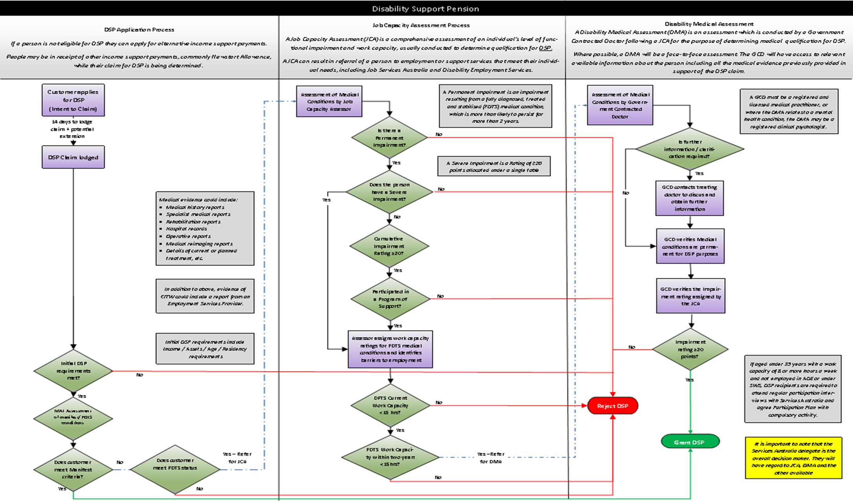

Figure .: Process for Assessing Medical Eligibility for DSP from ANAO report (2018)

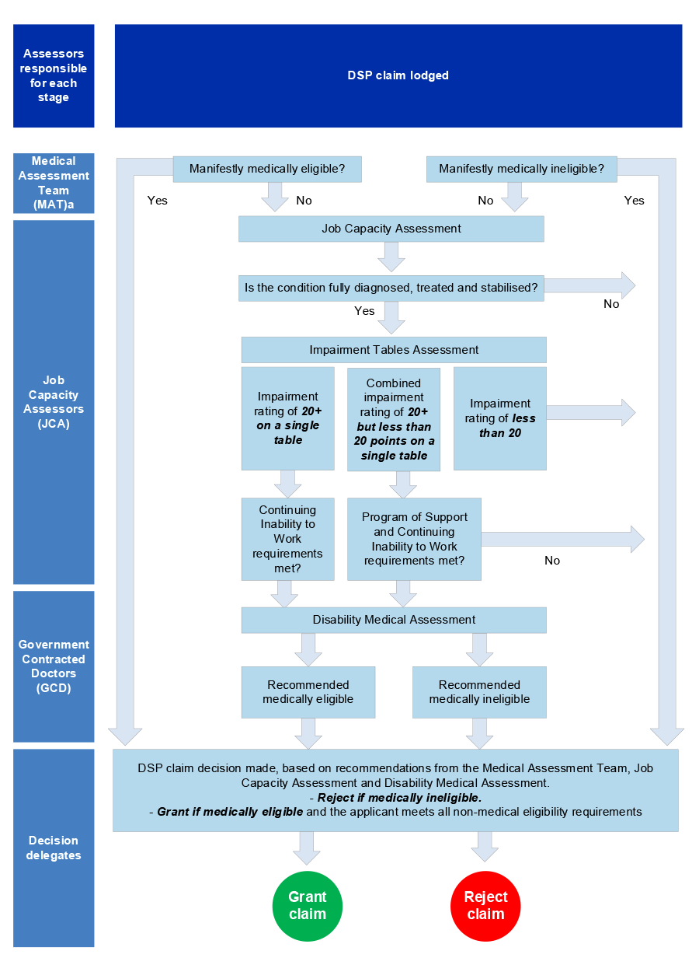

## Evaluation terms of reference

The objectives of the evaluation were to build on the initial evaluation conducted by HOI in 2017 and provide a more comprehensive picture of the effectiveness of the revised assessment process, using the additional data available from 2015-16 to 2018-19. In addition, to meet ANAO Recommendation 3 (November 2018), financial information provided by Services Australia was analysed to determine the cost-effectiveness of the revised assessment process:

*“That Social Services conduct a further review in 2019 of the efficacy of 2015 changes to the DSP claims process to require raw medical records or evidence and a DMA by a GCD. The review should include:*

*a) an assessment of both effectiveness (including cost-effectiveness) and efficiency; and*

*b) consultation with both internal and external stakeholders.”*

### Evaluation scope

The evaluation was constrained to evaluating just the two changes fully implemented from 1 July 2015; that is: the implementation of GCDs to undertake a DMA, and the replacement of the former Treating Doctor’s Report (TDR) with medical evidence.

*Notwithstanding the evaluation emphasis on these two changes, the impact of the other reforms cannot be completely excluded from HOI’s analysis. From this perspective HOI has addressed references to:*

* *the impact and appropriateness of evidence for specific Impairment Tables except in the context of gathering evidence by claimants;*
* *the appropriateness of the Social Security legislation including the requirement of evidence to fulfil the ‘fully diagnosed treated and stabilised’ (FDTS) legal definition; and*
* *other legislative impacts such as timing of feedback and back pay of claims gathered particularly through stakeholder consultation with consumer advocates. These issues have been highlighted as “Further considerations” – that are separate from “Opportunities for Improvement”.*

*HOI has attempted to constrain the effects of these other changes particularly in the cost-effectiveness assessment chapter. The broad methodology utilised by HOI is summarised below; whilst our method for the cost-effectiveness assessment is presented in* ***Chapter 5.***

## Evaluation methodology

A five-stage methodology was applied to address the specified evaluation objectives, as illustrated in , and subsequently expanded to include the main objectives and tasks.

Figure .: Methodological Overview

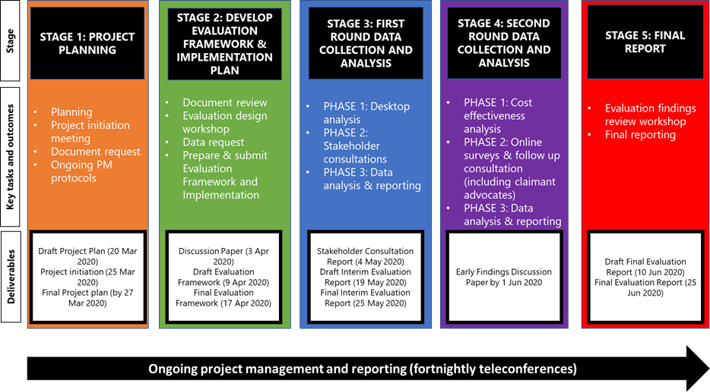

* 1. Stage 1 Project Planning: The objective of Stage 1 was to ensure a shared understanding between HOI and the Departments of Social Services (DSS) and Services Australia of the project objectives, the key stages and tasks and anticipated outcomes. The key tasks associated with this stage included:
  + Development and submission of a Project Plan;
  + Conduct of a project initiation meeting;
  + Collection of available documentation and data; and
  + Set up and agreement of ongoing project management protocols.
  1. Stage 2 Develop Evaluation Framework and Implementation Plan: The objective of Stage 2 was to design the Evaluation Framework and Implementation Plan to provide the architecture for the conduct of the evaluation. This was informed by a review of available documentation and data, and preliminary consultations with DSS and Services Australia staff. The key tasks associated with this stage included:
  + Conduct of documentation review and literature scan;
  + Development and dissemination of a Discussion Paper outlining the proposed evaluation framework and implementation plan;
  + Conduct of an evaluation design workshop with DSS and Services Australia; and
  + Development, refinement and submission of the Evaluation Framework and Implementation Plan (including program logic and evaluation matrix).
  1. Stage 3 First Round Data Collection and Analysis: The objective of Stage 3 was to complete an interim evaluation of the revised DSP assessment process during the transition period, in accordance with the agreed Evaluation Framework and Implementation Plan and was completed over three phases:
  + Phase 1: Desktop analysis of agreed extracted data relating to the two-year period prior to the 1 January 2015 transition period of the 2015 changes, up to and including 2018 – 2019 financial year data;
  + Phase 2: Conduct stakeholder consultation by telephone with nominated stakeholders (DSS, Services Australia, JCAs (Assessors) and GCDs – see **Appendix B** for a list of stakeholders consulted) and submission of a Stakeholder Consultation Report that contained a summary of findings; and
  + Phase 3: Data analysis, triangulation and reporting which resulted in submission of a Final Interim Evaluation Report containing a synthesis of activities in this stage to date.
  1. Stage 4: Second Round Data Collection and Analysis: This stage was completed over three phases similar to those conducted during Stage 3 of the project, however there was an increased emphasis on the cost-effectiveness analysis, impact of the changes and consultation with claimants’ representatives. This stage was to conclude with submission of an Early Findings Discussion Paper, but this deliverable was absorbed into the next stage (see Section ).
  2. Stage 5 Final Report: The objective of this stage was to draw together the information gained across the project in the form of a Final Evaluation Report. As part of this process, we will seek to test our evaluation findings and implications for future policy at a workshop with nominated Department representatives and other nominated stakeholders as agreed.

### Deviations from the proposed methodology

Due to significant COVID-19 related delays in accessing data for the conduct of the desktop analysis in Stages 3 and 4, the Early Findings Discussion Paper was absorbed and the future policy workshop was cancelled.

## Data analysis contained in this report

This report provides an analysis of DSP claims data for the period 1 July 2013 to 30 April 2020, triangulated against the stakeholder consultations and literature scan findings where appropriate*.*

It should be noted that HOI was provided with a supplementary dataset for claims finalised from 1 July 2018 to 30 April 2020. This data did not provide "claims in progress", but due to the inclusion of all claims finalised to April 2020, it is likely to report on all claims lodged in the financial year ended 30 June 2019 (per evaluation scope).

HOI has linked the supplementary dataset to the original claims dataset to prepare the analysis in **Appendix C** – the findings of which are referred to in the main body of this report

### Qualitative data limitations

* 1. Consultation challenges. HOI was unable to consult with anyone from the Administrative Appeals Tribunal (AAT) for their view of the impact of the introduction of GCDs and the requirement for medical evidence in place of TDRs, on the appeals aspect of the DSP assessment process.
  2. Survey responses. HOI gave stakeholders the option of completing an online survey in lieu of a telephone consultation to provide options for stakeholder engagement, noting the stress that Services Australia was under due to COVID-19. **Eleven participants completed the survey;** however, as eight survey participants also provided a telephone interview response, HOI has absorbed these limited responses into the stakeholder consultation findings (**Appendix A**) and has not analysed them separately due to the very low numbers and duplicated responses. Due to the limited responses this is not a representative sample of stakeholders.
  3. Commercial in confidence. HOI was unable to review a number of documents that would have contained rich information related to the evaluation, such as the GCD Remote Strategy, and the contract between Services Australia and Sonic HealthPlus.

## Purpose and structure of this report

This Draft Final Report presents a discussion of the findings from the data analysis (**refer Appendix C**), effectiveness and efficiency assessment and stakeholder consultations. A cost effectiveness assessment is discussed in **Chapter 5,** with an alternative support comparative payments table presented in **Appendix D**. A summary of the thematic analysis of stakeholder feedback has been included in **Appendix A**. The list of stakeholders that were consulted by telephone (or provided a written response) can be found in **Appendix B**.

The two changes under evaluation have been separated *where possible* for clarity throughout the report.

|  |  |
| --- | --- |
| Chapter 2 | This chapter provides an assessment of the appropriateness of the revised DSP assessment process changes. |
| Chapter 3 | This chapter provides and assessment of the effectiveness of the revised DSP assessment process changes. |
| Chapter 4 | This chapter provides and assessment of the efficiency of the revised DSP assessment process changes. |
| Chapter 5 | This chapter provides an assessment of the cost-effectiveness of the revised DSP assessment process |
| Chapter 6 | This chapter summarises the achievement of evaluation objectives and contains a consolidated list of HOI recommendations for consideration. |

# Assessment of Appropriateness

According to the agreed Evaluation Framework and Implementation Plan, the following questions relate to the assessment of the research domain appropriateness. This chapter presents a discussion of HOI's evaluation findings.

**Implementation according to policy intent**

* 1. Was the revised DSP assessment process implemented according to the policy intent?
  2. Were the changes in the revised DSP assessment process in accordance with underpinning legislation and policy?
  3. Were the objectives of the revised DSP assessment process met?

**Eligibility criteria**

* 1. To what extent have the revised DSP assessment processes supported the appropriate identification of eligible claimants?

**Governance, reporting and quality assurance**

* 1. What processes, procedures and reporting structures were established as part of the implementation of the revised DSP assessment process?
  2. What were the governance and oversight arrangements of the revised DSP and what were the reporting requirements of the revised DSP assessment process?
  3. Was there evidence of ongoing quality improvement or evaluation processes in place?
  4. How were the guidelines established for GCDs conducting DMAs to ensure consistency of the DSP assessment across Australia?

## Implementation according to policy intent

Stakeholders agreed that the revised DSP process had been implemented according to policy intent and the objectives had been met. Any issues related to accessibility appears balanced by the intent to ensure a decision made by Services Australia is ultimately correct and that claimants who can work, do work. The clinical integrity of the assessment process was improved by adding the requirement for a GCD to undertake the DMA. This removed potential bias by a treating doctor as well as validating positive JCA (Assessment) and MAT assessments. It should be noted that the introduction of the MAT was a 2017 change, and not subject to this evaluation.

An analysis of claims determined by a DMA is presented in . As a percentage of all claims finalised, DMA’s represented 16.6% of determinations in the first financial year post-implementation and has now risen to 25.4% of all claims in the 2018-2019 financial year.

As presented later in the context of the whole assessment process (Appendix Figure C.1), 94.2% of the claims subject to DMA were granted.

Stakeholders confirmed that the 2015 changes were priorities of the Government at the time and were implemented as policy changes, and not driven by changes to the underpinning Social Security legislation.

## Eligibility criteria

To be eligible for a DSP, applicants must meet both non-medical and medical criteria including:

* be aged between 16 years and Age Pension age; (currently 66 years)
* meet residency requirements;[19]
* meet income and assets tests;
* be manifestly qualified;
* be permanently blind;
* have a physical, intellectual, or psychiatric impairment which attracts at least 20 points under the impairment tables;
* be unable to work, or to be retrained for work, for 15 hours or more per week at or above the relevant minimum wage within the next 2 years because of their impairment;
* if assessed as having 20 points impairment rating across 2 or more Impairment Tables, having actively participated in a Program of Support.

A Program of Support (POS) is a program to be completed through an Employment Services Provider (ESP) for those claimants where the medical condition is rated as 20 points or above across two or more impairment tables (i.e. they do not have a 20 point rating on a single table). This Commonwealth Government funded program may include the following services or programs:

* Disability Employment Services (DES);
* Employment Services Providers (ESP);
* Community Development Program (CDP, formerly Remote Jobs and Communities Program (RJCP)) providers; or
* Australian Disability Enterprises (ADE).

Claimants who are in receipt of DSP may be required to participate in appropriate employment related activities if they are under 35 years of age; do not have a dependent child under six years of age; and are assessed as having a work capacity of eight or more hours per week. Through this activity a personalised Disability Support Pension Participation Plan is developed.

Very few stakeholders commented on the eligibility requirements in the context of the medical evidence and GCD components although concerns were expressed relating to the burden placed on the claimant to gather the appropriate evidence, especially for some vulnerable groups (people with mental illness, intellectual impairment or multiple conditions); many of whom are less likely to appeal. One stakeholder commented that the addition of the GCD process added no quality to determining if JCAs (Assessors) were accurately rejecting DSP claims based on the Social Security law as they did not review all claimants, but only those that passed the JCA (Assessor) medical assessment. Additionally, GCD’s did not consider all criteria involved in DSP eligibility, namely a client's continuing inability to work (CITW) or need to participate in a program of support (POS),which could make the difference between a client meeting or not meeting DSP criteria and explained some differences between GCD and JCA (Assessor) decision outcomes.

### Claimant advocate views on eligibility

Claimant advocates were also concerned that the overarching DSP assessment process remains overwhelming for some claimants to successfully navigate (such as people with poor mental health, intellectual impairment, low levels of literacy and those from non-English speaking background). Many claimants find the assessment application difficult to initiate independently and lack knowledge as to where to go for assistance with the process. Advocates were concerned any statistics relating to claims being processed will not reflect those that may be otherwise eligible for the DSP but have never initiated the process or failed to complete the application process.

Furthermore, although out of scope for this evaluation, a number of disability advocates with legal sector experience challenged the appropriateness of aspects of the underlying Social Security legislation relating to the definitions of “fully treated” and “stabilised”, particularly relating to claimants with terminal illnesses. Case studies were provided relating to raw medical evidence provided not meeting the “fully diagnosed” criteria, in addition to the client having capacity to work more than 15 hours per week, imposing significant delays and undue stress despite the claimant’s life expectancy being less than two years. Despite the Evaluation being focused on the addition of GCDs and the requirement for raw medical evidence in place of the TDR, disability advocates consistently highlighted the impact of non-medical eligibility criteria convoluting a system that was already difficult to navigate, noting these were out of scope of the evaluation.

## Claimant advocate view of the appropriateness of the DSP application and assessment process

Advocates suggested there are some clients who may be subjectively considered eligible for the DSP but will not seek such support due to stigma, shame or lack of insight into their own disability. Consistent feedback from advocates suggested that the present application process is unreasonably burdensome for many applicants for a range of logistical, financial, cultural, environmental or individual reasons. The process at present is not necessarily appropriate or accessible for the “intended audience”.

Advocates also suggested some claimants required significant support to complete the requisite administration and there is the assumption they have an advocate or other person who will help them with this process, which is not always the case. Thereby, advocates considered it was desirable for greater administrative support to initiate the process and complete the form. It was suggested by some advocates that there used to be greater access to a social worker or similar government staff to assist an applicant work through the process, but this support has significantly reduced (if available at all in some locations). There was a sense from advocacy agencies/bodies, that since the GCD process had been implemented, that they were increasingly being approached for help with gathering appropriate evidence for the application process, which was not always appropriate, efficient or available. Input into the assessment forms and information by disability advocacy groups or individuals with disability themselves may better ensure the content, structure and wording is appropriate for those for whom the system is designed. [20]

A number of advocates suggested the present DSP policy and assessment process is based on an outdated “medical model of disability” in contrast to more a contemporary perspective “social model of disability” through which a more holistic perspective regarding a person’s realistic opportunities to continue or obtain employment whilst managing a particular disability are considered. Advocates questioned how feasible is it that the person will find appropriate employment and maintain it over time?

Issues with reference to the eligibility criterion regarding was raised by many stakeholders as it impacted the collection of medical evidence by claimants and caused confusion for both claimants and treating health professional (THP). It was suggested by some advocates that particular mental and physical conditions fluctuate and although a person may be ‘stable’ at time of or around assessment this did not reflect their reality over the longer term. A longer-term perspective regarding stability was proposed by advocates as a mechanism to better determine this criterion. Reference to the receipt of “reasonable treatment” definition was generally positive in that health professionals are able to determine what is ‘reasonable’ in the context of the person’s circumstances. For example, although not able to afford specialist treatment nor have access to particular professional services in their location, applicants will be participating in some form of treatment, considered reasonable in regard to their available options.

It was suggested by advocates that increased stringency in assessment and approval processes may reduce the number of people accessing the DSP but whether this was appropriate or reasonable was questioned. For those who were unsuccessful, their alternative options were considered very limited. Some will seek support through an alternative income support payment such as JobSeeker whereas others will become increasingly reliant on family and community support (if available).[21]

## Governance, reporting and quality assurance

Stakeholders described that DSP program monitoring and reporting since the July 2015 measure was currently formalised and regular. Significant governance was implemented when the Measure was introduced, including a Prime Minister and Cabinet (PMC) Joint implementation Committee and Joint Working Groups between agencies (who were also on special working groups). Information reviewed included number of claims, processing times, claims underway, appeals and client demographic information. Data was routinely published and publicly available detailing outcomes of the DSP program; in particular recipient numbers and trends, expenditure, rates and duration of payment and information specific to age, gender, relationship status and Indigenous indicators.

The GCDs contracting body (currently Sonic HealthPlus) participates in a robust system of both process reporting and quality assurance in conjunction with Services Australia. Under contractual arrangements, Sonic HealthPlus provides regular and formalised reports to Services Australia and participates in ongoing quality review activities, including meetings. It was suggested by stakeholders that the quality of reporting had significantly improved over recent years and the working relationship with Sonic HealthPlus in particular, was productive and positive. The contract between Services Australia and Sonic HealthPlus is approaching review.

GCDs have ongoing access to Sonic HealthPlus Clinical Leads who provide mentoring and advice and are available to discuss cases before reports are submitted online to Services Australia. On their initial engagement, the first ten assessments carried out by a GCD are reviewed by an assigned mentor (additional reviews are undertaken as necessary).

Quality assurance of DMAs are undertaken through three-monthly audits of ten randomly selected reports and supported by protocols of reporting. Additional regular month-long reviews are based on target areas of clinical focus, such as a review of reports specific to a particular category within the Impairment Tables. They may also include a review of an assessment process such as telephone or video conference (especially more recently associated with COVID-19 restrictions). Quality Assurance for GCDs includes ongoing random quality reviews of pre-submission DMA reports as well as quarterly quality audit reviews of post-submission reports involving one-month targeted audit and two months of random audit. Target audit focus discussions based on quality themes/ needs are held with the provider and approved by Services Australia.

## Summary of findings and stakeholder views

The following is a summary of stakeholder views and key findings of our analysis of the appropriateness of the revised DSP assessment process.

* 1. The changes implemented in 2015, including use of medical evidence (in place of the TDR) and GCDs, were considered appropriate according to the policy intent of improving the rigour and integrity of the DSP assessment process.
  2. The policy objectives were being met, but some stakeholders questioned the use of GCDs to check only positive JCA (Assessor) medical assessments and suggested that GCDs might be better utilised in reviewing JCA (Assessment) medical rejections as they were not overturning many JCA (Assessment) decisions presently.
  3. Consistent stakeholder and claimant advocate feedback suggested that the present application process involving the collection and collation of medical and other evidence was burdensome for many applicants for a range of logistical, financial, cultural, environmental or personal reasons.
  4. Despite the evaluation being focused on the addition of GCDs and medical evidence in place of the TDR, disability advocates consistently mentioned the impact of non-medical eligibility criteria convoluting a system that was already difficult to navigate.
  5. Robust process reporting and quality assurance (clinical governance) was in place between Services Australia and the contracted body (Sonic HealthPlus).
  + Stakeholders suggested that DSP program monitoring and reporting following the July 2015 measures should be formalised and regular.
  + The GCD contracting body (currently Sonic HealthPlus) participates in a robust system of both process reporting and quality assurance in conjunction with Services Australia.
  + Quality assurance of DMAs is undertaken through three-monthly audits of ten randomly selected reports and supported by protocols of reporting.

### Opportunities for improvement

The following opportunities for improvement were identified by this evaluation:

#### Medical evidence replacing TDR

* 1. There is the potential to review the information provision process (TDR versus medical evidence) to establish improved effectiveness of data review; management; and specificity in the information that is used for decision-making purposes.
  2. Greater access to support and advocacy to participate in the assessment and appeal process (may include government staff in Services Australia Agent Offices or advocacy bodies to fill this role).
  3. Reintroduction of a Treating Doctors Report (TDR) or similar template (such as a questionnaire for each Impairment Table for the claimant’s THP) to ensure greater consistency of information provided to support an assessment application and to reduce the burden of collating medical evidence for applicants and their families.

#### GCD and DMA process

* 1. Rather than limiting the process to double checking favourable assessments, the DMA process should also focus on assisting vulnerable and disadvantaged claimants whose claims are rejected following a JCA (Assessment).

#### Further Considerations

* 1. A number of claimant advocates suggested that the POS should be reviewed.

### Recommendations

HOI makes the following recommendations based on our assessment of the appropriateness of the revised assessment process:

1. Consider introducing a new reporting template for THPs for use in conjunction with medical evidence to support greater consistency and relevance of information provided in regard to an application, and to reduce the burden of collating medical evidence for applicants.
2. Consider using GCDs to also do DMAs on claims rejected by JCAs (Assessors) as being medically ineligible, to further improve accuracy of decisions.
3. Participate in and benefit from shared learning and development work in relation to functional assessment tools or similar review mechanisms between clinical governance groups within the NDIS and DSP.

# Assessment of Effectiveness

According to the agreed Evaluation Framework and Implementation Plan, the following questions relate to the assessment of the research domain, effectiveness. This chapter presents a discussion of HOI's evaluation findings.

**Perception of improvement in process related to policy objectives**

* 1. Have the introduced changes improved the consistency and quality of the DSP assessment process and in what way?
  2. How satisfied are stakeholders with the revised assessment process?
  3. To what extent has the revised DSP process contributed to the ability to achieve consistency and equity in DSP claims assessment across Australia?

**Equity of access**

* 1. Is the application and assessment process appropriate and accessible for all potential applicants?
  2. Are there appropriate supports to enable applicants to participate in the assessment processes as needed?
  3. What is the demographic and disability profile of those with unsuccessful claims? Are there one or more groups of applicants who fare less well in the assessment for eligibility process?
  4. Are review/appeal outcome decisions communicated to applicants timely and clearly? Is there equity of access to these processes at present?

**Consistency of assessment**

* 1. Are all relevant Assessors and decision makers supported to deliver consistency and effectiveness in assessment and decision making?
  2. Are assessment specific resources and guidelines effectively supporting assessment efficiency, effectiveness, consistency and rigour?

**Value of transition period and risks**

* 1. What has been the value of including a transition period for the introduction of the revised DSP assessment process?
  2. Are there any risks as a result of implementation of the revised DSP assessment process that were not identified in the developmental stage?

**Outcomes and impacts of the revised DSP Assessment Process**

* 1. What are the known outcomes of those who are not considered eligible for the DSP? Do they seek alternative support?

## Perception of improvement in processes related to policy objectives

There was a view expressed by some stakeholders that more claims were being rejected over-all, and a low number of appeals overturned by the revised process (including low number of JCA (Assessor) decisions overturned by GCDs). This suggested that the revised assessment processes were working by providing a level of rigour ensuring the initial JCA (Assessor) decisions were correct and a small number of claimants that should not be on the DSP, were identified through the process. There was concern from some stakeholders that it was difficult to determine if this was attributable to the 2015 changes under review, or the result of other changes such as the introduction of the MAT.

Claimant advocates were generally unsupportive of the two changes in question for the following reasons:

* 1. The information captured through an independent assessment by a GCD unknown to the applicant was generally considered less appropriate to that of an applicant’s treating doctor/s who would have a greater understanding of their condition/s and ability to engage in and maintain paid employment.
  2. Claimant advocates were of the view it was considered unreasonably burdensome for some applicants and their families to understand; collect and provide the necessary evidence to support their application.

Figure 3.1 presents the pathway taken to decision (excluding appeals) for the 399,620 DSP determinations made (up until 30 April 2020) for claims lodged between 1 July 2015 to 30 June 2019. This identified that:

* 39.9% of claims are finalised at the initial assessment phase (incorporating the MAT from July 2017). 32.6% of all claims are rejected at this stage (76.1% of those as non-manifest). 7.3% of all claims are granted at this stage (of which 97.3% are manifest grants).
* JCAs (Assessors) undertake reviews on 60.1% of claims. Of these, 58.2% are rejected, 8.1% granted and the remaining 33.7% proceed to the DMA stage.
* Of the claims subject to DMA, 94.2% were granted.

Figure .: Claims finalised for claims lodged between 1 July 2015 and 30 June 2019, by assessment process (includes claim decisions up to 30 April 2020

provides information on claims finalised, granted, rejected etcetera


Appendix Figure C.2 presents the pathway taken to decision (excluding appeals) for the 182,378 DSP determinations made (up until 30 April 2020) for claims lodged between 1 July 2017 to 30 June 2019. In contrast to , this identifies:

* An increased proportion of claims determined at initial assessment, increasing to 44.4% from 39.9%; and
* A higher proportion of JCAs (Assessments) proceeding to the DMA stage (42.5% compared to 33.7%).

The effectiveness of the MAT implemented in 2017 was not subject to this evaluation but does imply that the introduction of the MAT into the assessment process has impacted the rate of claims proceeding to DMA from JCA (Assessment). The assumption is that earlier processing of assessment of medical evidence has improved the identification of claims with sufficient medical evidence to progress through the system to DMA by a GCD.

1. As demonstrated in Appendix Figure C.7, there was an identifiable change in the rejection rates from claims following the full implementation of the revised assessment process (1 July 2015). Claims lodged in the 2014-2015 financial year demonstrated a 64% rejection rate, which increased to 74% for claims lodged in the 2015-2016 financial year. There was a subsequent reduction in rejection rates, particularly from the 2017-2018 financial year, which Services Australia stakeholders have attributed to efforts to reduce ineligible claims being lodged, the implication being that a greater proportion of claims being lodged are bona fide, consequently increasing the percentage of claims granted.

### Mode of assessment and impact of ICT on process

JCAs (Assessors) and GCDs undergo distinct processes as part of the staged DSP assessment process. The GCD will undertake the DMA only once the JCA (Assessor) has assessed both medical and non-medical criteria (see for pathway). Most JCA (Assessor) and GCD medical assessments are conducted face-to-face as stipulated by the policy, but supported by video conferencing, telephone or a review of available medical evidence when necessary (e.g. supporting the GCD Remoteness Strategy etc.). Following the introduction of COVID-19 restrictions during early 2020, (outside of the evaluation scope) assessments by both JCAs (Assessors) and GCDs have been conducted primarily by telephone or video conference. The data analysed by HOI indicates a minor shift towards non-face to face methods, however, recent data has an increasing incidence of this field being left blank, making the data inconclusive.

JCAs (Assessors) and GCDs described issues with the ESSWeb system that on occasion can significantly impact on a JCAs (Assessors) ability to access or upload information specific to an assessment. This feedback was similarly conveyed from GCDs regarding their own ICT system. However, transition to an online application for the DSP has been largely well received by stakeholders, due to ease of information access and central management.

### Stakeholder satisfaction related to assessment processes

There were mixed views from JCAs (Assessors), GCDs and a number of other stakeholder groups relating to satisfaction of the revised processes. It was suggested by multiple stakeholder groups that the balance was not quite right and could benefit from a hybrid approach between the current assessment of medical documentation by both JCAs (Assessors) and GCDs and the previous TDR:

* the volume and relevance of medical evidence currently provided was viewed by some stakeholders as an administrative burden for JCAs (Assessors) and GCDs, which was further exacerbated through unclear labelling of files and duplicated evidence;
* interpretation of Impairment Tables (functional impairment) was contentious for certain conditions (such as stroke) between JCAs (Assessors) and GCDs using the medical evidence in the current process;
* many JCAs (Assessors) consulted professed a preference for the TDR - but this view depended on the JCA (Assessor) experience, noting not all JCAs (Assessors) consulted had worked over the evaluation period and some had never experienced the previous system; and
* Some GCDs consulted also expressed concerns relating to consent to share claimant information with THPs and experienced some resistance from THPs when contacted for further information (who challenged consent and privacy principles).

Claimant advocates expressed some confusion and criticism related to both the addition of a GCD into the process and gathering of medical evidence:

**Feedback relating to addition of GCDs from the perspective of advocates**

* the addition of the GCDs in the process was questioned as they asked the same questions as the JCAs (Assessors);
* the necessity of face to face consultations by GCDs for claimants who were very unwell;
* the cultural appropriateness of face to face interviews by GCDs for Indigenous claimants;
* the expense related to accessing a GCD for claimants in remote areas (who may also have to pay for accommodation, and fuel), although there were special allowances for remote cases and costs were reduced under Remote Strategies (i.e. through the use of Services Australia Agents and THP assessments); and
* reluctance and stress associated with undergoing an assessment with a GCD or other assessor with whom claimants were unfamiliar and the associated trust issues regarding sharing of confidential information with other Government departments.

**Feedback relating to medical evidence in place of TDR from the perspective of advocates**

* the expense of gathering evidence from specialists that their treating doctor may not necessarily support; and
* collating and gathering the requested medical evidence were logistically, financially and mentally challenging for some people who would likely be considered eligible for the DSP, resulting in withdrawal or non-progression if they find the process too overwhelming.

## Equity of access and complexity of assessment

This section presents a discussion of factors attributable to equity of access and assessment complexity.

### Geographical location

1. For some claimants, poor computer literacy or insufficient computer or internet access could impede their ability to initiate an assessment online, which may be complicated by geographical location and access to appropriate Assessors. Claimant advocates professed that some clients found it difficult to locate additional information or provide updated information for the next stage of the application process. Assessors and other departmental staff were required to be proactive and flexible in communication management.

HOI was not provided with the contractual arrangements for the GCD Remote Strategy, however Services Australia provided verbal information describing the role of Services Australia Agents and THP Assessments for remote communities. Special provisions can be applied, including the use of specialist assessments and provisional diagnoses, for Indigenous Australians in remote communities who have limited access to mainstream health services.[22]

and present the proportion of claims by location utilising the Modified Monash Model (MMM). The MMM is a classification system that measures remoteness and population size on a scale to define whether a location is a city, rural, remote or very remote. As presented, there has been a minimal variation on the claimant’s location over time supporting the implementation of strategies such as the GCD Remoteness Strategy. An analysis of claims granted over time, by MMM classification, are presented in Figure 3.2 and Figure 3.3. These analyses indicate, and support the previously noted, reduction in claims granted from the 2015-2016 financial year onwards (that is from full implementation of the revised process).

* post-implementation, granting rates were in a narrow range (between 26%-29%, three percentage points) across all MMM classifications; and
* in contrast, before implementation, a much broader range was evident (31%-42%, nine percentage points). In that period, “remote communities” had the lowest granting rate (31%) and large rural towns the highest (42%).

Figure .: Percentage of claims granted by MMM classification and financial year

Percentage of claims by city, rural, remote


Figure .: Percentage of claims granted by MMM classification in two-financial year periods

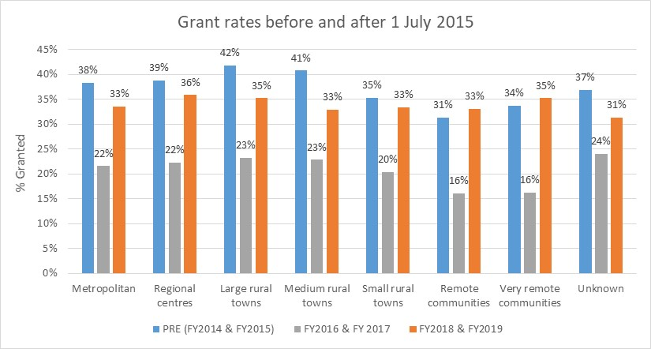

These findings conflict with many of the claimant advocate views that remote communities are unfairly disadvantaged by the current system.

### Claimant age, gender and disability type

Claimant age relating to equity of access was not discussed, with the exception of the qualification that it was important the DSP decision-making process was correct for very young claimants as they would typically stay on the welfare payment until they exited to the Age Pension or died. Graphical representation of the age of claimants is presented in , which identified the most represented aged group as 56-65 years old (36% of all claimants).

Figure .: Age of claimants since implementation (1 July 2015)

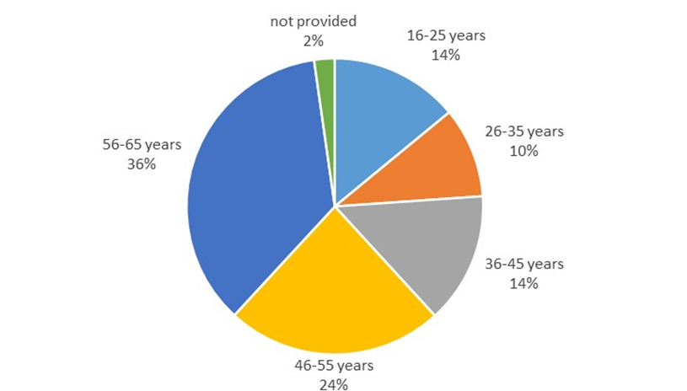

presents the rejection rate for each age group by financial year lodged. The new assessment process has impacted all age groups relatively equally. Of note, rejection rates in the 16-25 cohort are much lower than other age groups but this was also the case pre-implementation. Some claimant advocates suggested the reason for this was younger claimants were more likely to demonstrate severity of their impairment and they were more likely to present with psychosocial conditions. This is also supported by HOI’s analysis as psychological/psychiatric disability classifications represented the highest disability classification of claims over the evaluation period[23].

Table .: Claims rejection, pre and post implementation by age

|  |  |  |  |
| --- | --- | --- | --- |
| Claimed rejected | Pre-implementation | Post-implementation | Change  (%-points) |
| 16-25 years | 45% | 51% | 5% |
| 26-35 years | 67% | 73% | 6% |
| 36-45 years | 66% | 75% | 8% |
| 46-55 years | 65% | 73% | 8% |
| 56-65 years | 61% | 70% | 9% |
| All age groups | **61%** | **69%** | **8%** |

Claimant advocates did not highlight specific ages or genders as being more disadvantaged by the revised assessment process, except that older claimants (i.e. over 50 years) were more likely to have musculoskeletal conditions such as age degenerative osteoarthritis; which was impacted by POS requirements if sufficient functional impairment was not demonstrated and thus were more likely to be rejected. This assumption is supported by recent research conducted by Collie et al (2020). [24] HOI’s data analysis () presents psychological/psychiatric conditions as the most represented disability type, being 26% of claims across all financial years reviewed by the evaluation, with musculoskeletal conditions accounting for the second highest disability type claimed (at 24%). HOI’s data analysis also showed the new assessment process has impacted both gender rejection rates relatively equally over the evaluation period ().

The GCD or gathering of medical evidence cannot be attributed as specific barriers for any specific disability types, ages or genders from the data analysis as all disabilities have higher rejection rates post implementation of the 1 July 2015 changes (Appendix Figure C.30). The data does not support the claimant advocate view that implied certain disabilities are being more unfairly treated by the system at present – however it does not dispute that some disability types may not be entering the system at all due to capacity issues.

### Claimant capacity and complex cases

Both stakeholders and advocates suggested that some claimants also struggled with the DSP assessment processes due to factors relating to insight or capacity, insufficient formal diagnostic records or a limited understanding regarding what information is required. Clients with multiple health conditions, English as a second language, intellectual disability or poor mental health face additional challenges understanding the assessment stages or providing the requisite information in an appropriate form. Indigenous clients may not attend meetings due to cultural inconsistencies, and those that are homeless are also difficult to engage and had difficulty with the process. It was also difficult to determine health conditions that did not clearly align with criteria defined in the associated Social Security legislation.

Processes in place to support claimant’s participation in the assessment process per the GCD Remote Strategy included:

* support the provider to progress a referral;
* negotiate different assessment channels;
* THP assessment can be done with a claimant's personal doctor and occurs for those in prison, psychiatric confinement and hospitalisation (GCD has a conversation with the treating doctor to reduce the difficulty obtaining information);
* agents in remote areas can be set up to pass messages to claimants (such as a Services Australia Agent’s Office);
* referrals can be fast tracked for terminal claimants;
* claimants can appoint a 'nominee' to speak on their behalf (could be a family member or treating health professional); and
* involvement of Services Australia Agents without Indigenous interpreters as required (and occurs in the claimant’s community).

### Unsuccessful claims

Stakeholders consulted were unaware of the outcome of claimants that they had processed (as reviews were undertaken by another assessor) and it was also the view from some stakeholders that claims could also be rejected on non-medical grounds (and thus irrelevant to the scope of this evaluation). Some stakeholders reported that certain conditions were more difficult to assess with medical records evidence, potentially resulting in unsuccessful claims due to not meeting the eligibility criteria. Cohorts of claimants commonly cited they may have more difficulty with the process, included culturally and linguistically diverse (CALD), homeless and Indigenous claimants. This was supported during consultations with claimant advocates, where health issues identified as prevalent within these cohorts included:

* mental health conditions;
* intellectual conditions; and
* psychosocial disabilities.

However, as previously mentioned and illustrated in Figure 3.5, HOI’s data analysis indicated that all disabilities have higher rejection rates post implementation of the 1 July 2015 changes.

Figure .: Rejection rate by disability pre and post 1 July 2015

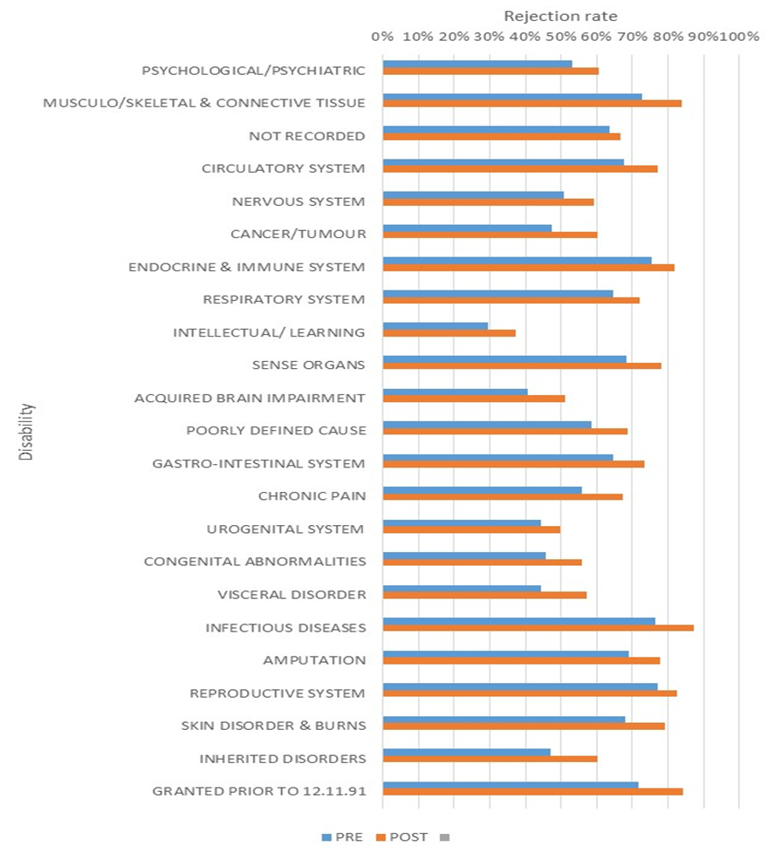

presents the change in rejection for each disability classification, in addition to the average change across all disability types. This finding supports some recent research conducted by Collie et al (2020)[25] and claimant advocate views suggested that people whose primary medical condition was a musculoskeletal or circulatory system disorder demonstrated greater declines in DSP receipt and grant rates, but these increases were minimal compared to the other disability types.

### Timeliness and communication of decisions

One stakeholder suggested that the beginning of the process may be quicker as a result of the changes, at the expense of the appeals and review end. There is no time limit for a claimant to initiate an appeal, however performance measures applied once a claimant lodges an appeal and if a claimant does not initiate their appeal within 13 weeks of being advised of the adverse decision, they are potentially disadvantaged under Social Security Law relating to back-payment of claims, because in this scenario if the appeal is successful, it can only be back-dated to the day they sought a review. HOI was unable to consult with a representative from the Administrative Appeals Tribunal (AAT) to further explore the appeals process, despite numerous attempts to arrange a consultation.

Stakeholders that had a role in HPAU, appeals and reviews processes that were consulted had mixed views about the value of the medical records evidence:

* Stakeholders involved in HPAU considered accessibility to the medical records made their job easier to facilitate decision-making;
* the volume of medical evidence with duplicative information was unclearly labelled and was an administrative burden; and
* insufficient or inappropriate medical evidence to support the finding of FDTS were the main reasons for the appeal process. These findings were supported by the evaluation ().

#### **Monitoring of communication of results**

Services Australia does not monitor if its officers are communicating the results of access decisions to DSP applicants in a timely manner.[26] An example of a decision letter was not provided to HOI for review, but stakeholder consultation with claimant advocates supported that DSP decision letters contained only generic text on the reason for the decision, which required claimants to follow up if they required further information. Services Australia representatives described a follow up process in place involving sending a generic rejection letter with content as appropriate. For instance, if a claim is rejected due to an insufficient impairment rating – then appeal rights are in the letter. Attempts are made to contact customers by telephone, but these are often unsuccessful. Communication details are included to enable claimants to contact a Services Australia Service Centre, and an outbound call is arranged to discuss the decision with the Delegate. However, there was a view from a stakeholder that if medical non-eligibility was the reason for rejection, a health professional may be a more appropriate agent to convey this information. In recent times, SMS reminders have been introduced and have resulted in an increase in engagement with post-rejection letters. Notwithstanding, Services Australia does conduct quality reviews that, in part, check the accuracy of the decision letters, but the extent to which applicants are contacted to explain the reasons behind the decision is not monitored. Services Australia is currently trialling revised procedures aimed at improving the provision of information to applicants about the reasons for decisions. [27]

### Claimant experience of the feedback process

Claimant advocates reported extensive delays for cohorts of claimants who lacked the capacity to navigate the appeal system and gather evidence to support their appeal. Responses from Services Australia relating to queries from advocates about the progress of DSP appeals lodged have been met with answers such as: “*there is no timeframe for the review to be completed… the customer is receiving JobSeeker payment so they’re not in hardship*”[28]

ARO decisions varied in relation to the quality of information included in the written decision. While some ARO decision letters provided a detailed explanation of why a decision had been made, with relevant legislation, facts and considerations, explained; others cited “lack of evidence” with no information to assist the applicant and their doctors to understand the basis for the decision and determine what evidence may support further appeal. There was a view expressed by claimant advocates that many AROs did not consider DSP eligibility in its entirety and stopped as soon as one qualification criterion was not met. For instance, if a claimant could not generate 20 Impairment Table points, the ARO did not consider or give information about inability to work. The claimant would then have no understanding of how to proceed if they were able to provide evidence to support an increased impairment rating, and no idea of what other evidence they could provide to the AAT relating to work capacity. This lack of clarity results in unnecessary and costly appeals to the AAT, with delays while obtaining medical evidence that may not be relevant

## Consistency of assessment

There is a broad range of resources and activities to support Assessors in their role. All JCA (Assessor) and GCD staff participated in training at commencement of their employment/engagement. Reporting is guided by operational documents, protocols and an online system of information recording. Although differences exist with type or quality of information uploaded into these reports at times, they are all underpinned by set reporting questions. JCAs (Assessors) are provided with guidelines to assist them to undertake their assessments, navigate the online platform and complete the reporting appropriately. JCAs (Assessors) are also able to discuss complex assessments within peer support groups (physical and non-physical assessor groups). This group also has access to subject matter experts within the Health Professional Advisory Unit (HPAU) to assist with the review of medical evidence. The HPAU is a team of health professionals, including medical practitioners, who are available to provide medical advice and opinions to assist in determining a person's eligibility for DSP for new claims, reviews and appeal assessments.

GCDs are also provided with guidelines to assist them to undertake assessments, navigate the platform and complete the reporting appropriately. GCDs are able to discuss complex assessments with a Regional GCD/Mentor. The Lead GCD is also able to discuss complex assessments with the Services Australia Clinical Governance Manager to support consistency of assessment from a GCD perspective.

### GCD training and clinical governance

To fulfil the role of a GCD, the person must possess a current medical practitioner or clinical psychologist qualification and be fully registered to practice with the Australian Health Practitioner Registration Authority (AHPRA) with no notations, suspensions, or conditions and Professional Indemnity Insurance to AHPRA standards. They must not be involved with any investigations or disciplinary proceedings in Australia or overseas and must successfully complete the online GCD training.

GCDs undertake a range of orientation and training, including a four-hour online course (facilitated by Sonic HealthPlus) to support and induct new medical practitioners. The online course comprises of three modules providing information on the conduct of DMAs, the use of legislative instruments and policy guidelines to assess medical eligibility for DSP. At the conclusion of this training, medical practitioners are required to undertake an online assessment to determine their understanding of the key concepts presented.

Learning outcomes include:

* applying the relevant use of legislative instruments and policy guidelines to assess medical conditions for the purpose of the Disability Support Pension (DSP);
* demonstrating an understanding of the APS Code of Conduct as set out in the Public Service Act 1999 and the APS Code of Ethics;
* utilising a systematic approach to assessments and completing the relevant report for Services Australia; and
* defining and utilising legislation and policy to assess medical conditions and make recommendations in relation to DSP eligibility.

Training is further supported through access to a short video (VOD) developed to assist GCDs to undertake medical assessments, comprising scripted scenarios and role plays. The first DMA report prepared following training is a mock report for which an assigned mentor will provide feedback. GCDs have ongoing access to Sonic HealthPlus Clinical Leads, who provide mentoring and advice and are available to discuss cases before online submission of reports. No GCDs interviewed conveyed that they did not have the skills or understanding of the Social Security legislation and Impairment Tables to undertake the DMA process within their contractual obligations.

GCDs also receive a regular news publication, the *GCD News*, through which assessment and reporting tips, audit results and other information of interest to GCDs is disseminated. Some GCDs advised they did not regularly review these items.

Assessment specific guidelines were considered appropriate and effective. The Clinical Governance Manager has a productive working relationship with Sonic HealthPlus. The guidelines and assessment resources are well managed and updated, with several channels used to disseminate. Other stakeholders reported there were appropriate resources and guidelines to support efficiency and rigour of the assessment process with the utilisation of the report-writing guide, and availability of Impairment Tables which provide specific case study examples. Also praised were the quality of reviews, webinars and Interdepartmental collegiality (between DSS, Services Australia and legal teams). Doctors receive remuneration as recognition for their time when needed for further telephone clarification / information by Assessors. The guidelines appear to be regularly reviewed, but some stakeholders mentioned issues relating to the short turn-around time allocated for feedback as it affected their ability to provide comprehensive feedback on occasion.

Despite the significant resources available to Assessors, there were concerns from some stakeholders regarding:

* both GCD and JCAs (Assessors) understanding of fully diagnosed, treated and stabilised in the context that this was a legal definition (and not a treating doctor’s expert opinion);
* the ability of JCAs (Assessors) with varied allied health backgrounds to interpret medical evidence into a functional impairment (lack of medical literacy to interpret the medical records); and
* some JCAs (Assessors) questioned GCDs understanding of the statutory definitions of the Impairment Tables.

## Value of transition period and risks

Of the stakeholders consulted, few offered an opinion with respect to the value of the transition period as most of those consulted had not been employed in relevant roles at that time. Some stakeholders considered the revisions to the DSP were driven through quickly by Government priority, due to the perception that the DSP was being granted to ineligible claimants who were rorting the system. The limited roll-out during the transition period from 1 January 2015 for claimants under 25 years of age and living in capital cities, and gradually expanded to those aged under 35 years in March 2015, was necessary to implement the change quickly and meet capacity at the time.

HOI was not provided the initial risk assessment for the change, and very few stakeholders could comment on this aspect either as they were not in their current positions when the initial changes were introduced. Of the stakeholders who provided feedback, there was a perception that no risks were overlooked, as it was expected that the revised process would take longer and not be more efficient, but that the intention was to improve the integrity of the social welfare system and thus it was more important that the correct decision was made. Conversely, some stakeholders expressed that the extent of delays associated with the collection of medical evidence relating to claims may have been underestimated. One stakeholder suggested the effects of the COVID-19 virus currently affecting the mode of assessments (allowing telephone and video conference assessments as opposed to face to face, as policy directed, should have been implemented in the first instance). Over the last three years, telephone assessment consultations have been introduced, in addition to more frequent video conferencing. The ongoing repercussions of people continuing to be wary of face to face consultations after the pandemic has settled warrants ongoing future consideration. Many GCDs consulted supported these alternative modes of assessment to improve accessibility for a range of applicants and reduce the burden on carers/family members/advocates incurred by the need to transport applicants to appointments requiring long commutes.

## Outcomes and impacts of the revised DSP assessment process

HOI’s analysis identifies that most (72%, Table 3.2) of unsuccessful claimants were identified as having been paid NSA (now known as JobSeeker) following rejection (data identifies payment made two weeks after rejections). The next most common category (18% of unsuccessful claimants) was “not recorded”, followed by the Youth Allowance (4%). The age of a claimant was important as successful claimants typically stayed on the DSP until they became of Age Pension age, which was potentially a large long-term taxpayer spend. Alternative reasons for exiting the DSP included:

* asset tested/ income tested out;
* upon review;
* might transfer to another payment (e.g. Carer Payment); or
* may have found suitable work.

Table .: Identified outcomes for unsuccessful claimants

|  |  |  |
| --- | --- | --- |
| Since 1 July 2015 | Rejected claims | % of total |
| Newstart Allowance (now known as JobSeeker) | 196,879 | 72% |
| Not recorded (claimant was not on a payment following rejection) | 48,289 | 18% |
| Youth Allowance | 11,207 | 4% |
| Parenting Payment Single | 3,386 | 1% |
| Carer Payment | 4,482 | 2% |
| Disability Support Pension | 3,340 | 1% |
| Sickness Allowance | 2,411 | 1% |
| Parenting Payment Partnered | 2,047 | 1% |
| Widow Allowance | 1,048 | 0% |
| Austudy | 596 | 0% |
| Age Pension | 479 | 0% |
| Special Benefit | 242 | 0% |
| Partner Allowance | 50 | 0% |
| Wife Pension | 41 | 0% |
| Work for the Dole | 32 | 0% |
| Bereavement Allowance | 31 | 0% |
| TOTAL | **274,560** | **100%** |

#### Reason for rejection

presents the most common recorded reason for the rejection of claims raised between 1 July 2013 and 30 June 2019, presented by financial year. The most common reason for rejection is that the condition was not fully diagnosed, treated and stabilised, currently 53.6% of rejections. This has grown significantly since the introduction of the MAT in July 2017 and is the more common assessment rather than the 20 points impaired, which has reduced to now represent 17.1% of rejections. In the 2018-2019 financial year it is noted that insufficient medical evidence increased to represent 6.6% of rejections. Claimant advocates also stated views that claimants found it difficult to gather the required medical evidence to satisfy the criteria of FDTS, due to not understanding the requirements, or their THP not understanding the requirements or unwillingness or inability to provide the required evidence.

#### Claimant views relating to outcome of rejected or ineligible DSP claimants

Advocates described the current system as imposing fundamental systemic barriers to accessing DSP for particular cohorts of people with disability (e.g. access to Centrelink Offices due to remoteness, access to technology, access to doctors for appointment, access to advocacy networks). Advocates claimed outcomes of those rejected for DSP (through medical ineligibility or otherwise), or do not even start the process include:

* surviving on NSA/JobSeeker, with periods of non-payment due to challenges complying with mutual obligations;
* periods of hospitalisation;[29] and
* increased reliance on charities and family/friends for other support.[30]

These outcomes – although cannot be solely attributed to rejection of DSP - could add pressure on these systems from an economic and resource perspective.

Inability to provide the requisite medical evidence can lead to long delays and can impact mutual obligation requirements (through otherwise DSP eligible claimants being unable to look for work or undertake a POS) resulting in compliance failures and cancellation of their NSA (now known as JobSeeker), putting additional undue hardship on an already vulnerable cohort.

A number of specific case studies were provided for the purposes of the evaluation by one disability advocate organisation – the organisation has stated their response is available on request and is intended for online publication.[31]

## Summary of findings and stakeholder views

The following is a summary of stakeholder views and key findings of our analysis of effectiveness of the DSP assessment process:

* 1. There were mixed views about the effectiveness of the reform from both stakeholders and advocates.
  + The volume and relevance of medical evidence provided in some cases is an administrative burden for both JCAs (Assessors) and GCDs.
  + Interpretation of Impairment Tables (functional impairment) was contentious for certain conditions between JCAs (Assessors) and GCDs (such as between tables used to assess functional impairment for stroke).
  1. Advocates claimed the application process is unreasonably burdensome for many claimants for a range of reasons. Some applicants require significant support to complete the requisite administration and there is the assumption they have an advocate or other person to help them with this process, which is not always the case. The process at present is not necessarily appropriate or accessible for the ‘intended audience’.
  2. More claims were being rejected overall, and a low number of JCA (Assessment) decisions were being overturned by GCDs
  3. Services Australia conducts quality reviews that, in part, check the accuracy of the decision letters, but also the extent to which applicants are contacted to explain the reasons behind the decision is not monitored. Claimant advocates generally communicated that the outcome letters were inappropriate and contained insufficient information to support next steps.
  4. There were concerns from stakeholders around both GCDs and JCAs (Assessors) understanding of what constitutes “fully diagnosed, treated and stabilised” and the ability of JCAs (Assessors) to interpret medical evidence, yet there was also a view that GCDs did not understand the statutory definitions of the Impairment Tables. However, there did appear to be relative national consistency in the process, supported by significant clinical governance and training for GCDs and the GCD Remoteness Strategy.
  5. The data analysis did not identify specific disability profiles, age, genders or locations that were significantly worse off with regard to assessment outcomes since the 1 July 2015 changes. However, it is important to note the data reviewed reflects those that have entered and successfully navigated the application process but does not capture those who have been unable to initiate or progress a claim for the DSP. Some stakeholders and advocates were concerned about certain cohorts that may have difficulty with the assessment process, such as, Aboriginal and Torres Strait Islander People, people from culturally and linguistically diverse backgrounds, homeless people, or those living in regional or remote communities.
  6. Advocates claimed that there may be certain barriers to access (such as the involvement of GCDs and complexity of the process itself that prevents particular cohorts from engaging in the system at all).
  7. Of the stakeholders consulted, few offered an opinion with respect to the value of the transition period as most of those consulted had not been employed in relevant roles over that period of time. However, some conceded that the delays associated with gathering medical evidence may have been underestimated.
  8. Most unsuccessful applicants were identified as having been paid NSA (now known as JobSeeker) following rejection and the most common reason for rejection was that the condition was not fully diagnosed, treated and stabilised and there was an increasing trend in ‘insufficient medical evidence’.
  9. Advocates suggested that those applicants who were rejected or were subjectively eligible but unable to navigate the process, ended up either on NSA (now known as JobSeeker), in hospital or with an increased reliance on charities and family/friends for other support.

### Opportunities for improvement

The following opportunities for improvement were identified by this evaluation:

#### Medical evidence replacing TDR

* 1. Alternative support to assist applicants gather requisite medical evidence and otherwise navigate the DSP process.
  2. Support for health professionals, such as GPs, to prepare necessary paperwork and/or reporting for an applicant and increase motivation of THPs to participate in the process with greater diligence.
  3. The feedback process (including letters) should be reviewed for clarity, including options and next steps for claimants to undertake to clarify decisions.
  4. Improved communication of feedback of the DSP outcome should be delivered by an appropriate agent, for example, medical outcomes such as insufficient medical evidence or evidence not being fully diagnosed, treated and stabilised could be delivered by a medical professional.

#### GCD and DMA process

* 1. The process of consent and data sharing between Services Australia, NDIS, GCDs and THPs should be reviewed with the objective of streamlining processes and reducing the duplication of data reporting.
  2. Although already in practice and utilised by some GCDs, videoconferencing should be used by GCDs more frequently in lieu of face-to-face consultations, where appropriate and preferred.

#### Further Considerations

* 1. Review reference to, or definition of, ‘fully stabilised’ in eligibility criteria and associated legislation and policy.
  2. Amend the legislation and policy to allow for those who appeal the decision to reject their DSP claim to be deemed eligible for DSP on any date between the time of claim and a review determination.

### Recommendations

HOI makes the following recommendations based on our assessment of the effectiveness of the revised assessment process:

1. Review procedures for communicating the outcome of a rejected DSP claim and the options available to an applicant, especially when medical records submitted for a DSP application are considered insufficient or do not meet the FDTS criteria and result in rejection of the application.
2. Review the online application process and other associated instructions for THPs for accessibility of the intended audience.

# Assessment of Efficiency

According to the agreed Evaluation Framework and Implementation Plan, the following questions relate to the assessment of the research domain efficiency. This chapter presents discussion regarding HOI's findings.

**National coverage**

* 1. To what extent is the national coverage in relation to DMAs being undertaken by GCDs? Is this timely and efficient?

**Timeliness of decision-making and claims processing**

* 1. How has the revised DSP assessment process impacted timeliness of claims decisions? What has contributed to the changes in claims processing timeframes?
  2. Have changes to the medical evidence requirements improved efficiency and timeliness of assessments?
  3. Are there particular phases or types of assessment that incur greater delays in processing?
  4. Has the introduction of an online application process improved efficiency or effectiveness?

**Manifest claims**

* 1. Has the revised assessment process impacted in any way on the way manifest claims are identified, assessed and processed?

**Impact of the revised DSP assessment process**

* 1. What has been the impact of the revised process on DSP claims lodged, assessment processes, referrals made, claims granted, and appeals lodged?
  2. Has the introduction of the revised DSP process had sufficient impact to justify the change?

**Impact on stakeholders and claimants**

* 1. Are there cohorts where the impact has been sufficient to warrant continuation of the process for that group?
  2. To what extent have the changes to the DSP assessment process impacted stakeholders and claimants?
  3. Are current review processes efficiently monitoring change in eligibility circumstances?

## National coverage

National coverage or consistency was not reported as a concern by any stakeholders interviewed except there was some variability in experience by both GCDs and JCAs (Assessors) in general and the use of checklist SA-478 seemed to be variably communicated to treating doctors. There was a broad view from stakeholders that there were processes in place to accommodate rural/remote accessibility issues, and these were outlined in the GCD Remote Strategy that seemed to be variably communicated to claimants such as:

* use of telephone/video consult;
* THP Assessments can be done with a claimant’s personal doctor (GCDs to communicate directly to claimant’s doctor or community nurse in the case of remote communities);
* Agents in remote areas could be set up to pass messages to claimants (such as a Services Australia Agent Office); and
* claimants can appoint a nominee to act on their behalf.

Coverage was perceived by stakeholders to have improved with the increased utilisation of tele-video conferencing for assessments since COVID-19, which had particularly benefited claimants in rural/remote areas who now did not have to travel long distances to undertake face-to-face appointments. However, videoconferencing has been available for DMA’s since the start of the program in 2015 and Customers are not expected to travel long distances to access a DMA. If a GCD is more than 60-minute commute, they are offered a teleconference of videoconference by existing processes. Despite this more recent process change to utilise video and teleconference with greater frequency, stakeholders considered that the hierarchy of assessment by JCAs (Assessors) and GCDs was different, with GCDs more focussed on video conference and THP assessment after face to face, rather than file assessment. Only one stakeholder indicated a potential ongoing issue with cultural appropriateness relating to Indigenous claimants that may not attend appointments (or arrive very early, or very late), but they also did not indicate that telephone consultation or videoconference improved engagement with this cohort in general either.

Claimant advocates emphasised that claimants living in regional, rural and remote communities faced barriers accessing Services Australia services, in addition to health and support services in general. Claimant advocates expressed that navigating the DSP assessment process and the appeals system was considered significantly more challenging for people outside of metropolitan areas, and organising/obtaining medical reports was almost impossible for some. Despite the special circumstances that applied to these cases, claimant advocates believed that DSP claimants from regional and rural areas were disadvantaged by requirements to obtain current medical reports for each and every condition. This was compounded by the following challenges:

* access to specialists that only visited these areas infrequently; and
* inability or unwillingness by a medical professional to provide a report required for DSP purposes, especially if the applicant was not fee-paying.

In contrast, HOI’s analysis of claims granted by location indicated that post-implementation of the 1 July 2015 changes, grant rates were in a narrow range across all MMM classifications (); indicating no locations were particularly disadvantaged by the revised system, however remote and very remote locations were starting to show longer decision times (2-4 weeks longer) ().

Claimant advocates acknowledged that, although efforts were made by Services Australia to locate a specialist within a reasonable distance to the applicant to facilitate the gathering of medical evidence, many applicants were still unable to attend these appointments due to transport or mobility restrictions associated with their disability. There was a view from some advocates that although telephone or video conferencing were options in these cases (consistent with Services Australia description of process above), the claimant often had to request these services, and had to have access to the technology and skills to facilitate video conferencing as an alternative.

## Timeliness of decision making and claims processing

This section seeks to assess the impact of revised DSP assessment processes on timeliness of claims decisions and associated processing timeframes.

Stakeholders had mixed views related to their perception of timeliness of claim decisions but noted there were timelines and KPIs in place. Many stakeholders considered the process had never been timely and the introduction of the DMA by GCDs was not intended to improve efficiency related to time taken to determine eligibility. It was understood that the revised process added to the effectiveness or accuracy of DSP decision making. Rather than looking at the cost incurred by these reviews in isolation, they were better considered regarding their ability to accurately identify those applicants who were eligible for the DSP. This is particularly the case in that claimants who successfully receive the DSP tend to remain in receipt of this payment until eligible for the Age Pension. Further, it was considered that the revision of the DSP assessment in 2015, was introduced to improve rigour or integrity of the overall program, rather than a means to improve efficiency of process.

It was suggested by some stakeholders that JCAs (Assessors) undertook on average five DSP assessments a week, but this varied with demand. The time necessary to complete assessments also varied, depending on quality and quantity of documentation provided and complexity of client circumstances or health conditions. Individual assessment and reporting ranged from 1.5 to 4 hours (but could take longer for particular clients for a range of reasons). *This time did not qualify as time taken assessing medical evidence as there was significant variability in types of claims (based on variation of disability/impairment) and level of documentation supplied.*

Some stakeholders perceived that claim decisions had become timelier over the last 6-12 months e.g. claims submitted in early March 2020 had been completed and referred – and all assessments were up to date. However, the majority of stakeholders were of the view that since the 2015 changes, there was a four to six-week delay using the new process due to the assessment of medical evidence (as information was often missing and needed to be followed up) and appeals could take up to 18 months to finalise. HOI’s analysis of the duration to reach a claim determination () demonstrates there was an increase in the average number of days taken from claims lodged to completion after 1 July 2015. Claims lodged in the 2016-2017 financial year demonstrated the longest average times to grant (145 days) or reject (105 days). However, timeframes have reduced in the last two financial years for claims finalised post DMA and Initial Assessment ().

Thus, the time taken to finalise claims has increased significantly since implementation of the 1 July 2015 changes, with broadly equal impact across disability type, MMM and decision type.

### Duration of process

An analysis of the duration to reach a claim determination () demonstrates there was an increase in the average number of days taken from grants lodged after 1 July 2015. Grants lodged in the 2016-2017 financial year demonstrated the longest average times to grant (145 days) or reject (105 days) broadly supporting stakeholder views that since the revised process, claims were taking longer to process. Rejection timeframes have also increased, but not to the same extent. *The data provided to HOI did not enable analysis of the time taken to specifically analyse the medical evidence by JCAs (Assessors) or GCDs.*

The introduction of medical evidence and the difference in assessment times could only reasonably be responded to by JCAs (Assessors), as the GCDs never had to use a TDR. Both GCD and Assessors (including those from ARO and the HPAU) reported that reviewing the medical evidence was time-consuming and report duplicates also added to the administrative burden. This was compounded as files were not labelled intuitively and GCDs or JCAs (Assessors) had to open each file to find specific evidence or there was an unusual demand on the ICT as has occurred with increased client activity associated with COVID-19.

Figure .: Claim duration (days to determine claims, by claim outcome and financial year)

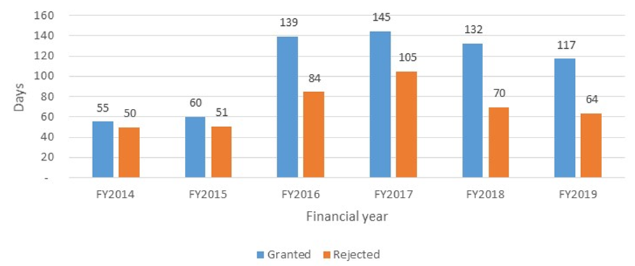

Complex cases, including claimants with multiple conditions, by their very nature were submitted with copious amounts of supporting evidence. Medical evidence required scanning of multiple documents into one scan; which resulted in significant scrolling when being reviewed. Delays in assessment also occurred if a claimant’s financial arrangements needed investigation.

### Appeals

Claimants can appeal the decision on their DSP application to the Authorised Review Officer (ARO) or subsequently to the Administrative Appeals Tribunal (AAT), if the original decision was upheld and the claimant wished to pursue the appeal further. Should a claimant require a review due to insufficient or inappropriate medical evidence, the gathering of further medical evidence introduces further delays into the process. A second and subsequent assessment may be required by an Assessor if the evidence is materially different. If this new assessment recommends a grant, then a DMA is also required. Every time new evidence is supplied, all the evidence needs to be assessed again in the context of the previous claim. An analysis of appeals decided is presented in , illustrating the volume of appeals by financial year, based on the year of the original decision. ARO appeals are the most common, with only 14% of claims proceeding beyond the ARO to either the AAT Level 1 or AAT Level 2.

Figure .: Volume of appeals by financial year

Appeals to ARO, AAT1 and AAT2 from Financial Year 2014 to 2019


Further, there was no time limit on appeals once they had been initiated – although internal KPIs that were not provided to HOI may be available to refute this statement. As a result, the entire processes could be very protracted through the claimant not appealing in a timely way (or having issues gathering appropriate/ relevant medical evidence). Appeals (AAT1 to DSS) to AAT2 (Federal Court) could be associated with a 12-18-month delay.

A summary of the analysis of outcomes of the three appeal processes indicates:

* 75% of ARO appeals are unsuccessful, with the original decision being affirmed, noting that the rate of decisions affirmed has reduced in recent years, with an offsetting increase in "set aside" outcomes (Appendix Table C.6);
* similarly, 74% of AAT (Level 1) appeals are unsuccessful, with the original and ARO decisions being affirmed, noting that the rate of decisions affirmed has remained relatively consistent (Appendix Table C.7); and
* in contrast, 41% of appeals are withdrawn at AAT Level 2 (noting this increased to 63% in the 2018-2019 financial year), 25% set aside.

The findings show that nearly half of appeals are withdrawn at AAT Level 2. Claimant advocates consulted suggested the expense and stress of this process was often overwhelming for clients – especially if they did not have legal representation, noting appeals can be withdrawn for a number of reasons.

HOI was unable to consult with a representative from the Attorney General’s Department relating to appeals.

### Manifest claims

In certain circumstances, a claim for DSP can be granted manifestly. That is, based on medical evidence alone, the claimant is considered eligible for DSP without the need for a JCA (Assessment) or DMA, subject to meeting all other eligibility criteria.

Manifest determinations as a proportion of all claims have increased since 1 July 2015 ():

* 1. Manifest grants have increased from 20% of all claims granted in the 2014-2015 financial year to 33% in the 2018-2109 financial year; and
  2. Manifest rejections have increased from 13% of all claims rejected in the 2014-2015 financial year to 20% in the 2018-2109 financial year. Of note, manifest rejections decreased to 7% in the first financial year following the implementation of the revised assessment process. Stakeholders and Services Australia indicated that replacement of the TDR with medical evidence made it more difficult to assess manifest rejections, and marginal claims often continued to be assessed rather than manifestly rejected in that year.

Figure .: Manifest grants as a percentage of all granted claims, by financial year

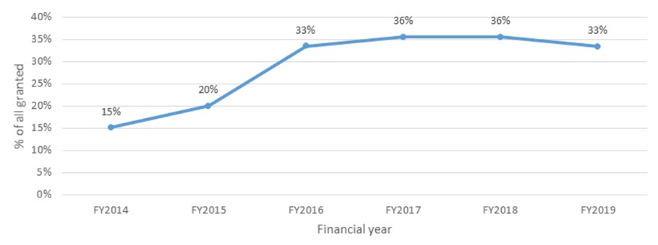

Figure .: Manifest rejections as a percentage of all rejected claims, by financial year

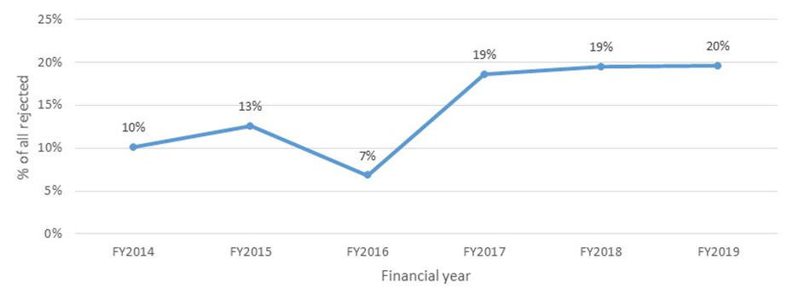

#### Reasons for this increase in manifest claims

Of the stakeholders consulted there was very little feedback relating to the impact of the revised DSP changes on manifest claims with some GCDs indicating they had never encountered a manifestly eligible claimant (as by definition those that were manifestly eligible did not require a DMA). The introduction of the MAT (a 2017 change) was supported as streamlining the identification of manifestly eligible DSP claimants. The percentage of claimants not identified as manifestly eligible by the MAT that were assessed by GCDs was considered to be a very low percentage. Reasons for a GCD making a manifest decision included:

* sometimes the medical evidence was not available or provided;
* there was not a good understanding of the condition (unusual); or
* related to conditions that had different classifications in the Impairment Tables e.g. motor neurone disease.

Of those GCDs that mentioned they had assessed claimants that were manifestly eligible the incidence appeared very rare and related to claimants that had become manifestly eligible through the protracted process (e.g. prognosis changed to terminal) – which does indicate that there could be the opportunity to improve monitoring of changing eligibility criteria over the assessment process.

## Impact of the revised DSP assessment process

Many stakeholders did not comment on the impact of the revised DSP assessment process, preferring to allow the data “to tell the story”, however, the impact of the GCD and medical evidence can be broadly separated.

Of the stakeholders that discussed the impact of the reforms, there was the perception that the addition of the GCD added extra cost; convoluted the process; and GCDs were not overturning many JCA (Assessor) decisions (which indicated the previous process was working). However, there was also a view expressed by a stakeholder that just having GCDs at the end of the process may change JCAs (Assessors) behaviour, but this was difficult to determine.

Changes to the reporting requirements and replacement of the TDR with medical evidence information was described in terms of strength and weaknesses by both stakeholders and advocates. Access to and review of a range of medical historical documentation was considered useful in undertaking an objective and holistic assessment. In contrast, the former TDRs were seen as more time efficient in the support of assessment decisions, as they were designed to provide information specific to the DSP process. Although clients may provide a broad range of evidential material, it varied in quality and relevance. The information necessary to make an informed decision is not always that which is provided, but one piece of evidence can be the difference between a claim being accepted and rejected. Claimants will refer to the Medical Evidence Checklist available but may tick items on this sheet that are not necessarily provided. In an effort to support the assessment process, many clients will provide a large volume of superfluous information, which is time consuming to manage and review.

It was suggested by some advocates that the former TDR was a very effective and efficient source of information when completed appropriately by the referring doctor. There is some support from advocates for the re-introduction of a similar single reporting function, albeit with revisions and modifications from its original form.

Stakeholders conceded it was also difficult to separate the post 2015 changes, (especially the role of MAT introduced in 2017), and issues relating to the Impairment Tables around evidence and descriptions for certain conditions – both of which were out of scope for this evaluation.

### Claimant advocate views of the impact of the application process

Views around the impact of GCDs and medical evidence from claimant advocates were generally not positive.

**Feedback relating to addition of GCDs**

As commented previously, advocates suggest there was a preference for the return of the TDR in some capacity. This was not only due to challenges seeking and providing the relevant medical evidence for some applicants but also reluctance and stress associated with undergoing an assessment with a GCD or other assessor with whom they were unfamiliar. This was particularly the case for people with complex mental health issues, multiple disabilities or conditions that can fluctuate in the degree in which they affect a person’s ability to manage their lives independently. Although some clients will have long-standing care relationships with their GP or other health professional, the information obtained through a single assessment with a GCD was given precedence over that of other health professionals. Additionally, consultations identified trust issues regarding sharing of confidential information with other government departments.

**Feedback relating to medical evidence in place of TDR**

Advocates claim collating and gathering the required medical evidence was logistically, financially and mentally challenging for some people who regarded themselves as eligible for the DSP. For some people, the process was simply beyond their capacity to comprehend and manage and not all individuals had formal records of diagnosis or assessments to submit as part of the necessary medical evidence. Particular applicants for whom the assessment process may be more challenging, according to claimant advocates, included those with multiple disabilities, from CALD backgrounds, Indigenous applicants, and people with mental health issues and/or intellectual disabilities. Discrepancies in how particular disabilities are defined or assessed between government bodies was considered problematic.

Advocates suggested, from a professional perspective, the TDR (or similar) can provide structure and better consistency in information necessary to support an assessment decision. It was reported by stakeholders and advocates that quality or quantity of information can vary significantly. Further to this was reference to the time necessary for a GP or other professional to prepare a summary or similar letter for a DSP applicant. Advocates indicated lack of support from Medicare to undertake this assistance by GPs was a barrier to willingness to prepare this paperwork and affected the quality of the evidence cited and provided. It was suggested by advocates that GPs and other health professionals thought many applicants needed tangible support to undertake the application process and it was considered reasonable that such time and effort by GPs and health professionals was financially compensated. Advocates thought applicants were rarely in a position to be able to pay for the preparation of the necessary paperwork, and responsibility will fall to family, advocates or GPs to prepare without reimbursement for their time.

A number of stakeholders requested greater clarity in information provided to clients regarding non-successful application or appeal process outcomes. It is important that such decisions are explained specifically to individuals and in a way that is appropriate to the applicant to avoid any ambiguity or confusion. Many claimant advocates reported claimants received ‘generic letters’ with no explanation of unsuccessful outcomes. Services Australia have indicated that there is a feedback process in place, but it was challenging to contact claimants to discuss the decision.

The information provided on the website (including checklists and templates) was considered useful for some applicants and health professionals. It was also noted the Impairment Tables and eligibility guidelines provided valuable guidance for health professionals in their role. Although not appropriate for all applicants, the online web form does streamline the question process by directing people to respond to only those questions specific to their application (which is less clear on the hard copy form).

### Claims finalised

An analysis of the total number of claims lodged (n=653,236) and claims finalised (n=630,301) in the period 1 July 2013 to 30 June 2019 is illustrated in Figure 4.5. The evaluation has excluded from the analysis data for claims finalised where the claim was lodged before 1 July 2013 (n=24,516).

* The volume of claims lodged each year is trending downwards, Claims lodged in the 2018-2019 financial year are 68% of the 2013-2014 financial year. Similarly, the volume of claims finalised also declined each year and tends to be consistently below lodgement volumes (except for the 2017-2018 financial year); and
* In the 2017-2018 financial year claims finalised grew 5.3% from the previous financial year. This increase in the number of claims finalised coincides with the introduction of the MAT, which commenced in July 2017.

Figure .: Claims lodged and finalised by financial year

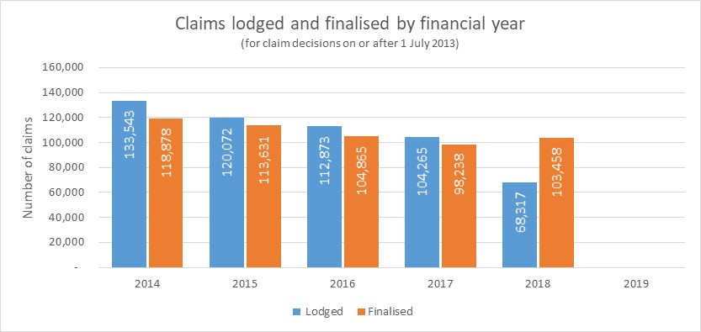

presents an analysis of unique claimants and indicates that many claimants submit multiple applications. By way of illustration, 100,357 claimants have made two claims in the six-year period; three claimants have lodged 12 claims; and 317,606 claimants lodged a single claim. There was a view that behaviour involving excessive claims (such as in incidence of a claimant making 12 claims) could be due to the release of the claimants from mutual obligation aspects for other payments while a claim was lodged.

As illustrated in , 31% of claimants (140,266 people) made multiple claims in the period. Multiple claims represent 51% of the claims lodged and determined in the period (). Another view to explain why many claimants made multiple claims, was the initial claim was premature or that their condition was not ‘fully diagnosed, treated and stabilised’ – which was consistent with the main reason for DSP rejections.

## Impact on stakeholders and claimants

DSP applicants and recipients are able to submit online feedback or complaints through a range of government webpages, including the Commonwealth Ombudsman. They are also able to initiate an appeal process in response to a claim decision. Beyond these mechanisms, there appears to be no specific and ongoing process in place to collect information on client experience of the DSP assessment process. This is considered to be a gap in the monitoring of the DSP process at present from the perspective of advocates.

In HOI’s consultations, the following themes were raised by claimant advocates:

* The 2015 changes to the DSP medical assessment process have made it more difficult for claimants to obtain the information they need to demonstrate that they meet the criteria to medically qualify for DSP.
* Some of the specific obstacles faced by claimants included:
  + Lack of guides or checklists available to claimants to give to their THP about the DSP medical eligibility requirements. This means THPs often rely on another source of information to enable them to understand those requirements and provide medical evidence relevant to the person’s claim. Uncertainty about the required medical evidence may result in the provision of insufficient medical evidence. Claimants may be required to return to the THPs to seek further evidence, resulting in delays and additional expense to claimants.
  + Difficulty and cost of obtaining medical evidence from THPs since the phasing out of the TDR. There can be long waiting lists for specialist appointments and the cost can be prohibitive.
  + Lack of understanding of the Program of Support (POS) requirements; a compulsory DSP eligibility requirement for those who do not meet the definition of severely impaired under the legislation (noting POS was out of scope for this evaluation).
  + General complexity of the claims process (particularly for those who are very unwell).

Advocates suggested claimants sought information regarding the DSP from a range of sources, most commonly Services Australia. Resources have been developed by a range of advocacy and peak body groups (such as the “*DSP & Me Guide*” produced by the Victorian Disability Resource Centre), to support DSP claimants.

## Summary of findings and stakeholder views

The following is a summary of stakeholder views and key findings pertaining to the analysis of the efficiency of the revised DSP assessment process.

* 1. Stakeholders considered the introduction of the DMA by a GCD was not intended to improve efficiency related to time taken to determine eligibility.
  2. Stakeholders suggested appropriate resources and guidelines supported efficiency and rigour of the assessment process.
  3. National coverage related to the GCDs is currently comprehensive according to the stakeholders consulted - especially since the increased frequency of videoconferencing/telephone interviews since COVID-19, although claimant advocates still maintain that there are accessibility issues for claimants in rural/remote locations.
  4. Most exiting claimants/recipients ended up on the Age Pension, but a large number could also not be determined.
  5. There was no time limit to finalise appeals once the process was initiated, thus the entire process could sometimes be very protracted.
  6. Reviewing the medical evidence was time-consuming and duplicate documentation also added to the administrative burden. It was suggested by some stakeholders that a TDR may be more appropriate for some claimants with certain conditions, but the data analysis did not indicate any disability types that were unduly disadvantaged by the process.
  7. Stakeholders suggested the introduction section of checklist SA-478 was not used consistently by treating doctors, despite being available to provide guidance around medical evidence requirements.
  8. Specific barriers experienced by claimants included:
  + Lack of guidance material or checklists available to claimants to give to their THP about the DSP medical eligibility requirements.
  + Difficulty and cost of obtaining medical evidence from THPs since phasing out of the TDR.
  + Lack of understanding of the Program of Support (POS) requirements; which is a compulsory DSP eligibility requirement for those who do not meet the definition of severely impaired under the legislation (noting POS was out of scope for this evaluation).
  + General complexity of the claims process (particularly for those who are very unwell).
  1. Review processes were in place, but occasionally GCDs were still seeing manifest claims; an indication that the process could be improved.

### Opportunities for improvement

The following opportunities for improvement were identified by this evaluation:

#### Medical evidence replacing TDR

* 1. The online form process was generally considered appropriate by stakeholders, but it could be further improved to support accessibility and efficiency – particularly in the uploading of medical evidence.

#### GCD and the DMA process

* 1. Files uploaded for review by a GCD should be identified in such a way that the content is clear (including the date uploaded).

#### Further considerations

* 1. There was benefit from increased input from consumers relating to the entire DSP process.
  2. Through the consultative process, although it was recognised the policy intent and processes were not synonymous between the National Disability Insurance Scheme (NDIS) and the DSP, it was also suggested by a stakeholder that there were benefits in sharing learning and development work in relation to viable and effective functional assessment tools or mechanisms between clinical governance groups within the NDIS and the DSP. The NDIS group had been undertaking a range of work specific to diagnostic tools and assessments such as that for autism. Sharing this information could maximise the benefits of this work, improve consistency and reduce duplication of effort.

### Recommendations

HOI makes the following recommendations based on our assessment of the efficiency of the revised assessment process:

1. Review the online form and available resources for claimants and invite input from consumers.
2. Consider using standard file naming conventions when uploading medical evidence for review by Assessors and GCDs, to support efficiency of the process and to assist with the identification of duplicated records.

# Economic Analysis

DSP provides financial support to approximately three-quarters of a million Australians every year. As this is a significant percentage of the Government’s social security expenditure, recent ANAO reviews have sought to understand the value, or cost-effectiveness, of the 2015 changes.

This chapter provides an assessment of the cost-effectiveness of the revised DSP assessment process implemented 1 July 2015.

## Methodology

The evaluation explored the change in costs consequential to the revised assessment implemented from 1 July 2015, relative to the support costs avoided due to rejected claims. In economic analysis terms, what needs to be understood is the net “expenditure-impact” of the change.

The economic analysis (expenditure-impact analysis) is a key output of the evaluation, and this chapter presents the inputs, assumptions, and relevant analysis and economic impact assessment.

At a summary level, the economic analysis is presented as:

* 1. The net (changes in costs relative to DSP savings from rejections) quantum of dollars for the activities to date; and
  2. A return on investment presented as a multiplier of the investment made, that is “.for each additional dollar incurred (as a result of the new assessment process), $X.X of DSP were avoided (for claims that would otherwise have been granted through the prior assessment process)”.

The Evaluation Framework presented the full methodology for the economic analysis. In summary, the evaluation took a staged approach, as follows:

* 1. Gather Requirements.
  2. Develop the structure (architecture) of the economic analysis model and test.
  3. Determine outputs, apply the industry knowledge and validate.
  4. Output finalisation and presentation.

Figure .: Overview of economic analysis methodology

A key component of the “gather requirements” stage was the conduct of the Economic Analysis Workshop with DSS and Services Australia representatives on the 17th May 2020. This workshop established the basis for the evaluation (including the “expenditure impact” approach and defined key elements on the scope and data requirements).

## Scope of the expenditure impact analysis

The mode of economic analysis to best assess value for money varies, principally dependant on the activity being assessed and the availability of data and other resources. The type of analysis completed needs to be ‘fit for purpose’. It is often not possible or necessary to identify and quantify all costs and all outcomes, and the units of measurement often make it difficult to quantify and compare these.

As a significant cost of Government, recent ANAO reviews have sought to understand the value, or cost-effectiveness, of the 2015 changes. The 2015 changes implemented revised assessment measures requiring DSP applicants to submit original medical records (as opposed to the TDR) and be referred for a DMA by a GCD in some circumstances. The ANAO notes (Auditor-General Report No.13 2018–19) that the *“…Social Services Implementation Plan for the 2015 changes identified a range of benefits and ‘dis-benefits’. A potential ‘dis-benefit’ identified by Social Services was that the measure might increase the cost of the program budget, as the cost of employing Government-contracted doctors would outweigh any potential savings from rejected claims*”.

An expenditure-impact analysis or budget-impact analysis is an economic assessment that estimates the financial consequences of adopting a new intervention or process. This form of economic analysis was determined to be most appropriate to meet the needs of the evaluation.

Other types of analysis, such as cost-effectiveness, require an assessment of claimant outcomes (for instance, disability-adjusted life-years). This type of analysis is not appropriate for this review as a quantitative measure is not currently being utilised to assess the broader health, psychological or wellbeing outcomes of claimants. While this expenditure impact analysis will not seek to quantify these broader health outcomes, the evaluation sought qualitative data through the planned stakeholder consultations.

The evaluation has addressed the following questions:

* 1. To what extent have the **costs of assessing DSP claims** changed as a result of the revised assessment process?
  2. To what extent have **income support payments to claimants been avoided or reduced** (through rejected claims) or delayed as a result of the revised assessment process?

The expenditure-impact analysis *has not*:

* assessed costs or economic impacts at a societal level (i.e. the broader economic or social costs and impact of not receiving a DSP);
* incorporated the costs of implementation (training/ communication/ software costs etc.). These are “sunk costs”. The economic analysis will, instead, focus on the recurrent expenditure impacts of the revised assessment process; or
* assessed the change in the costs of appeals taken to the Administrative Appeals Tribunal (AAT).

## Inputs and assumptions

The expenditure-impact analysis has sought data from several sources. However, the primary dataset was the claims dataset held by Services Australia. This dataset enabled analysis of all claims lodged and finalised in the period 1 July 2013 to 30 June 2019. The dataset did not include any claims lodged in the period for which a decision was still outstanding at the date of extraction (claims finalised on or before 30 April 2020 were included in the extract). While these “claims in progress” have been excluded, this will not have a material impact on the evaluation findings.

presents the inputs and assumptions used to determine the change in the costs to assess DSP claims.

Table .: Inputs and Assumptions – costs of assessing DSP claims

|  |  |
| --- | --- |
| Input or measure | Description and source |
| Costs of GCD | Inputs   * The value of annual payments made to the contracted provider of GCD services was provided to the evaluation for the four financial years ended 30 June 2019. * Costs excluded CPI and were indexed by the evaluation to be presented in 31 December 2019 dollars.   *Source: Services Australia* |
| Additional workforce costs to review medical evidence (instead of TDR) | Additional workforce costs were calculated as the additional time required through the JCA (Assessor) to assess medical evidence, rather than assessing a TDR. These costs were calculated as:   * Additional JCA (Assessor) hours required per non-manifest claim * Multiplied by the number of claimants assessed per annum * Multiplied by the relevant hourly rate, inclusive of labour on-costs   Inputs   * The evaluation extracted the number of non-manifest claims from the Services Australia DSP payment dataset. Source: Services Australia * The evaluation extracted the number of unique claimants from the Services Australia DSP payment dataset. Source: Services Australia * Hourly rate of pay for JCAs (Assessors) was determined from the Department of Social Services Enterprise Agreements 2018 to 2021. This agreement commenced operation on 21 January 2019. Classification APS6-3, and the “12 months after commencement” increment. *Source: Publicly available*[32]   Assumptions   * Quantitative data was not available to determine the additional labour hours required to complete the JCA (Assessment). Consultation indicated that the additional time required was in the range of 1.5 to 4.0 hours per claim. The expenditure impact analysis has assumed an additional 2.5 hours per JCA (Assessment). *Source: Assumption developed through consultation*. * Labour on-costs, inclusive of superannuation, workers compensation, annual leave and long service leave, were applied at a loading a 1.239 to the hourly JCA (Assessor) costs. |
| Process implementation/ training/ communication/ software costs | **Excluded**   * Costs of implementation have been excluded. The Economic Analysis workshop limited scope to recurrent costs only |
| Appeal costs | **Excluded**   * ARO and AAT costs are in a separate budget/program. The Economic Analysis workshop limited scope to recurrent Services Australia costs only. |
| Costs or economic impacts at a societal level, | **Excluded** |
| Cost indexation | * All costs were indexed, to be presented in 31 December 2019 dollars.   *Source: Australian Bureau of Statistics, 6401.0 Consumer Price Index, All Groups, Australia.[33]* |

presents the inputs and assumptions used to determine the support costs avoided as a result of the change.

Table .: Inputs and Assumptions – support payments avoided

|  |  |
| --- | --- |
| Input or measure | Data source & items |
| Change in rejection rate attributed to the revised assessment processes | As presented earlier in the report, data was provided to enable an analysis of two financial years before 1 July 2015, and four financial years subsequent. While there was an initial and significant reduction in the proportion of claims granted, there has been some variation over the four years. The last two years have shown a rise in the proportion of claims granted. Consultation with Services Australia indicated this could be the result of efforts to educate potential DSP applicants and providing more meaningful guidance on the application process. It was hypothesised that this may have reduced the volume of claims lodged, with a bias towards those claims that would have been clearly ineligible. If these types of claims were to cease being lodged, claims that are lodged would now demonstrate a higher proportion granted. In a period of declined claim volumes, this would result in higher granting rates.  The impacts discussed above are unable to be validated or estimated. No other impacts have been identified that could explain the more recent increase in grant rates. The evaluation concluded that the full four-year claims experience post-implementation should be included in the expenditure-impact assessment.  Inputs   * Claims granted pre-implementation: 38.937% * Claims granted, four financial years post-implementation: 30.408%   *Source: DSP payment dataset. Services Australia* |
| Subsequent payment benefit for rejected claims | For each rejected claim, Services Australia DSP data recorded the social security payment received by the applicant in the two weeks following the rejection decision. This analysis is presented earlier in the report in . For instance, 71.7% of rejected applicants subsequently received NSA.  Newstart Allowance stopped on 20 March 2020. JobSeeker Payment is now the principal income support payment for people between age 22 and Age Pension age. However, the evaluation has completed its assessments based on the pre-JobSeeker introduction and therefore excludes the COVID-19 supplement). The effective date of the expenditure impact assessment is 31 December 2019.  Inputs   * Subsequent DSS payments and benefits for DSP rejected claimants * Source: DSP payment dataset. Services Australia   Assumptions   * There are 17.6% of rejected claimants for whom a subsequent benefit was not recorded. These have been assumed to have been in receipt of NSA (now known as JobSeeker).   *Source: Assumption developed through consultation.* |
| Value of claims (both DSP and alternative social benefits) | Input  Payment rates and tables are publicly available for the DSP and alternative social security payments. For all payments, the evaluation used a common criterion (where available) of:   * Single * No children * Living away from home * Inclusive of all relevant supplements and allowances * At the full rate at 1 January 2020 (irrespective of potential reductions for income testing etc.)   *Source: Publicly available*[34]  Assumption   * Data from DSS indicates the full DSP has a fortnightly payment rate (on the basis above) of $933.40. Approximately 85% of DSP recipients are paid the full rate, with the remaining 15% receiving a lower rate of payment. The average payment for DSP recipients is $886.59, being 95% of the full payment rate. * Data for the equivalent average payment was not sourced for alternative social security payments. To ensure comparability, the evaluation used the full payment rate for the expenditure-impact assessment. |
| Time spent on DSP, to determine payment-years avoided | Inputs   * The average time on DSP = 711 weeks (13.7 years). * Consultation indicated that recipients exit the DSP for two primary reasons: - they either transition to the Age Pension at the relevant qualifying age (currently 66 years), or an early exit through death. * The most common alternative payment is NSA (now known as JobSeeker Payment). The average time recipient received NSA (now known as Jobseeker Payment) is 164 weeks (3.1 years). Consultation indicated it is common for people exiting NSA (now known as JobSeeker Payment) commence on either the DSP or Age Pension. * For this reason, the evaluation’s assessment of future payments avoided has been limited to the average NSA (now known as JobSeeker Payment) duration of 164 weeks.   *Source: Publicly available[35]* |
| Administrative savings (labour workforce costs) from the reduction in claims lodged | **Excluded**  The reduction in claims lodged commenced before the new assessment process. Attribution is unlikely. |
| Savings from longer timeframes to grant DSP to successful claimants. | **Excluded**  Claimants often receive NSA (now known as JobSeeker Payment) while awaiting a decision on their claim for DSP. However, it is most common, once a claimant is successful, that the DSP effective date is unaffected by the assessment delays, and as a consequence, there are no payments or costs avoided from these delays. |

## Expenditure Impact Assessment

The section presents the outputs of the Expenditure Impact analysis in three parts:

* The net (changes in costs relative to DSP savings from rejections) quantum of dollars for the activities to date (expenditure impact to date).
* A return on investment presented as a multiplier of the investment made.
* Determination of a breakeven point for the change in claims granted.

Adopting the methodology, inputs and assumptions outlined above, and presenting the findings in 31 December 2019 dollars, the average annual impact (of the first four financial years) of the revised DSP assessment process had a favourable annualised expenditure impact of $27.4 million per annum. This is summarised in .

Table .: Annual impact of the revised DSP in 31 December 2019 dollars

|  |  |
| --- | --- |
|  | $ |
| Changes in costs to assess claims (annualised impact) |  |
| Non-manifest claims assessed (on average) | 88,574 |
| Additional assessment costs (JCAs (Assessors) and GCDs) | **$33,696,592** |
|  |  |
| Payments avoided (annualised impact) |  |
| Rejected claimants that transitioned to NSA (now known as JobSeeker Payment) | $55,972,869 |
| Rejected claimants that transitioned to all other payments | $5,074,934 |
| Total payments avoided | **$61,047,803** |
| Net favourable/(unfavourable) expenditure impact | **$27,351,211** |

This represents a return of investment that can be expressed as follows: that for every $1.00 of additional assessment costs, there are $1.81 of payment supports avoided (based on a single average year, annualised). The average additional costs of assessment per non-manifest claim is $380.44, whereas the average payments avoided is $689.23.

These calculations are based on a reduction in claims granted on 8.53 percentage points. HOI has modelled the breakeven point for these data, and a reduction on claims granted of 4.71 percentage points would have been cost neutral (i.e. breakeven), on a single year, annualised basis.

However, these calculations do not consider the future payments avoided for each claim rejected. The analysis in above assumes 52.14 weeks of payments avoided. A lifetime assessment of payments avoided, utilising the 164-week payment duration presented in the assumptions table, yields a much more favourable result.

The lifetime return on a single year (annualised impact) identifies that for every $1.00 of additional assessment costs, there are $5.70 of payment supports avoided (in 31 December 2019 dollars). This calculation is presented in the table below.

Table .: Annualised impact

|  |  |  |  |  |
| --- | --- | --- | --- | --- |
|  | Claims | Costs | Payments Avoided | Weeks |
| Year 1 | 88,574 | $33,696,592 | $61,047,803 | 52.14 |
| Year 2 |  | - | $61,047,803 | 52.14 |
| Year 3 |  | - | $61,047,803 | 52.14 |
| Year 4 |  | - | $8,864,442 | 7.57 |
| TOTAL |  | **$33,696,592** | **$192,007,851** | **164.00** |
| Return on investment |  | **$5.70** | |  |

The breakeven point for these data is a reduction on claims granted of 1.497 percentage points would have been cost neutral (i.e. breakeven), on a unique claimant lifetime basis.

### Opportunities for improvement

The following opportunities for improvement were identified by this evaluation:

#### GCDs and the DMA process

* 1. GCDs could be more optimally used such as in the review of JCA (Assessor) medical eligibility rejected claims instead of affirming JCA (Assessor) recommendations as they were currently, only overturning a very small proportion of JCA (Assessor) recommendations.

### Recommendations

HOI makes the following recommendations based on our assessment of the cost-effectiveness of the revised assessment process:

1. Consider extra support and resources for THPs to assist them in preparing relevant, comprehensive medical documentation and to support applicants early in the application process..

# Conclusion

This chapter synthesises all of the evaluation findings and includes a list of recommendations to improve the revised DSP assessment process.

## Conclusion

Through the implementation of the evaluation, HOI met the terms of reference of the evaluation, which built on the initial evaluation conducted by HOI in 2017 and provided a more comprehensive picture of the effectiveness of the revised assessment process, using the additional data available from financial year 2015-2016 to 2018-2019. In addition, to meet ANAO Recommendation 3 (November 2018), financial information provided by Services Australia was analysed to determine the cost-effectiveness of the revised assessment process:

*That Social Services conduct a further review in 2019 of the efficacy of 2015 changes to the DSP claims process to require raw medical records or evidence and a DMA by a GCD. The review should include:*

*a) an assessment of both effectiveness (including cost-effectiveness) and efficiency; and*

*b) consultation with both internal and external stakeholders.*

It is HOI’s assessment through the analysis of both data provided by Services Australia and consultation with internal and external stakeholders, that the revised DSP assessment process implemented by Services Australia, comprising:

* the implementation of GCDs and;
* the replacement of the TDR with medical evidence;

was appropriate relating to the policy intent and effective in improving the integrity of the DSP in that GCDs were overturning some JCA (Assessor) medical eligibility recommendations, but the changes had increased the time of decision making. The revised process was assessed as cost-effective compared to pre-implementation of the 1 July 2015 changes. Areas for improvement were identified to streamline the administration of the process for both JCAs (Assessors) and GCDs and the experience of claimants. Improvements for claimants were focussed on timely and appropriate feedback relating to decisions and support in the collection of medical evidence.

Claimant advocates were invited to participate in the consultation process and provided feedback that the process of collection and collation of medical evidence was a logistical, expensive, onerous and stressful process for some claimants and potential claimants. Advocates professed a preference for the return of the TDR in some capacity to reduce the burden on claimants and clarify the evidence expectations expected from both treating health professionals and the claimant themselves. Some claimant advocates expressed that some claimants were uncomfortable seeing a GCD, and their treating doctor was best placed to understand the nuances of their condition, especially relating to stigmatised disabilities such as mental health conditions and there were concerns with sharing their medical history with other Government departments.

A number of other Government reforms have been implemented over the evaluation period and have been included for context where appropriate in this report. Reference to the impact of JCA (Assessor) and GCD interpretation of the Impairment Tables (currently under internal review) and the underlying Social Security legislation; have been mentioned where relevant but were out of scope for this evaluation.

## Summary of recommendations

provides a consolidated list of all HOI recommendations.

Table .:Recommendations for consideration

|  |  |
| --- | --- |
| Recommendation 1 | *Consider introducing a new reporting template for THPs for use in conjunction with medical evidence to support greater consistency and relevance of information provided in regards to an application, and to reduce the burden of collating medical evidence for applicants.* |
| Recommendation 2 | *Consider using GCDs to also do DMAs on claims rejected by JCAs (Assessors) as being medically ineligible, to further improve accuracy of decisions.* |
| Recommendation 3 | *Participate in and benefit from shared learning and development work in relation to functional assessment tools or similar review mechanisms between clinical governance groups within the NDIS and DSP.* |
| Recommendation 4 | *Review procedures for communicating the outcome of a rejected DSP claim and the options available to an applicant, especially when medical records submitted for a DSP application are considered insufficient or do not meet the FDTS criteria and result in rejection of the application.* |
| Recommendation 5 | *Review the online application process and other associated instructions for THPs for accessibility of the intended audience.* |
| Recommendation 6 | *Review the online form and available resources for claimants and invite input from consumers.* |
| Recommendation 7 | *Consider using standard file naming conventions when uploading medical evidence for review by Assessors and GCDs, to support efficiency of the process and to assist with the identification of duplicated records.* |
| Recommendation 8 | *Consider extra support for THPs to assist them in preparing relevant, comprehensive medical documentation and to support applicants early in the application process.* |

###### Stakeholder Summary

The purpose of this Stakeholder Consultation Report is to present preliminary issues identified through the Stage 3 consultation phase (completed to date). As indicated in the agreed Project Plan, the objective of these consultations was to obtain stakeholder feedback on the DSP assessment process. Stage 4 consultations and survey responses have been integrated into this Appendix. A list of stakeholders consulted can be found in **Appendix B.**

***Note: An online survey was also developed for the purpose of giving stakeholders options to provide their input into the consultation process. As only 11 participants completed the online survey and it was apparent that seven of these responses were from the same stakeholders that also provided verbal responses – HOI has integrated the feedback where relevant into this section without qualifying the source.***

Stage 3 consultation methodology

The purpose of the stakeholder consultations was to obtain feedback from nominated stakeholders with respect to:

* the context, development and implementation of the DSP assessment reforms;
* barriers and enablers to implementation; and
* the extent to which reforms were contributing to provision of additional rigour and consistency in the DSP assessment process.

Between 27 April and 8 May 2020, twenty-five stakeholders participated in a thirty-minute telephone consultation with a HOI consultant and four of these stakeholders provided a written response addressing the questions provided in the Stakeholder Consultation Paper. Six nominations declined (or were unable to be contacted).

The issues relating to cost-effectiveness and impacts of the reform, and opportunities for improvement were discussed in the Stage 4 consultations between 25 May and 29 May 2020, with DSS, Services Australia, and Disability Advocates. Five stakeholders (who also participated in the Stage 3 consultation process) and nine claimant advocate organisations participated in this process (as indicated in **Appendix B**). The Administrative Appeals Tribunal (AAT) was invited to provide their feedback on the appeals process but were unable to nominate an appropriate representative, and a further nine disability advocacy organisations were also invited to consult but either declined or were unable to be contacted. Thus, over the total evaluation period, 44 individuals provided input into the evaluation.

This appendix provides a summary of the main themes highlighted by stakeholder groups through the consultative process.

Themes identified by DSS

This section provides a summary of the emergent themes either identified by DSS or reported through other stakeholders.

appropriateness of the reforms

The following issues/comments were identified through consultation to date.

* 1. More claims were being rejected overall. This was a likely outcome if the measure was operating as intended.
  2. The revised DSP process had been implemented according to policy intent and the objectives had been met. There was now added rigour to the process by adding the GCD assessment and removing the level of bias from a treating doctor report (TDR) and validating JCA (Assessment) and the MAT.
  3. A Steering Committee was set up between then DHS and DSS to monitor caseloads when the revised process was implemented. Operation of GCDs was part of 'usual business'.

effectiveness of the reforms

The following issues/comments were identified through the consultations to date.

* 1. Stakeholders have told DSS, as summarised below:
  + **Some JCAs (Assessors) supported the GCD process as increasing their accountability** whilst others thought it was an additional layer;
  + **Views were different for remote JCAs (Assessors)**, as the process had to accommodate remoteness/ and access issues to specialists; and
  + **Stakeholders suggested generally, claimants did not understand the process**, they thought the process was duplicative (having the same questions asked by JCAs (Assessors) and GCDs) and gathering medical evidence was a burden.
  1. Impairment Tables could be interpreted differently but adding a GCD to verify medical assessment by JCAs (Assessors) did provide a level of rigour to the process and not many GCD recommendations overturned a JCA (Assessment) recommendation (not visible in appeals/tribunals).
  2. Low number of appeals being overturned. Most appeals were not due to GCD assessments i.e. ARO/HPAU were not overturning many GCD decisions.
  3. There were no unexpected risks identified; however, most people consulted were not aware of the risks that were initially identified. It was expected that the process would take longer and result in more claims rejected.
  4. The value of the transition period was not able to be assessed, as many of the people consulted had not been in their positions when the transition period was in effect. It was implemented quickly, and the short period and limited eligibility were probably to meet capacity at the time.
  5. Stakeholders suggested claimants with mental health/psychosocial disability may find the process more difficult to navigate due to their reduced capacity and increased stress associated with the process; which may exacerbate conditions. Claimants found it challenging to obtain evidence to justify the requirement for their condition to be fully diagnosed, treated and stabilised.

efficiency of the reforms

The following issues/comments were identified through the consultations completed to date.

* 1. The introduction of the DMA was not suggested to improve efficiency in terms of time to determine eligibility. However, it was understood that this process added to the effectiveness or accuracy of DSP decision making. Rather than looking at the cost incurred by these reviews in isolation, they were better considered regarding their ability to accurately identify those applicants who were not eligible for the DSP; thereby a longer-term financial impact in that sense. Further, it was considered that the revision of the DSP assessment in 2015, was introduced to improve rigour or integrity of the overall program, rather than a means to improve efficiency of process. In this regard, it was considered successful by some stakeholders.
  2. There was no time limit on appeals; as a result, processes could be very protracted through the claimant not appealing in a timely way (or having issues gathering appropriate/relevant evidence). Appeals (AAT1 to DSS) to AAT2 (Federal Court) could be associated with a 12-18-month delay.
  3. Claimants that were unsuccessful (depending on their age), ended up on NSA (now known as JobSeeker Payment) or the Age Pension, or 'dropped out' completely. The age of a claimant was important as successful claimants typically stayed on the DSP until they reach the Age Pension qualification age, which was potentially a large long-term taxpayer spend. Alternative reasons for exiting the DSP included:
  + asset tested/income tested out;
  + upon review;
  + might transfer to another payment (e.g. Carer Payment); or
  + may have found suitable work.
  1. There were timelines in place for processing, but there was a perception from stakeholders of a 4-6-week delay using the new process due to the assessment of medical evidence (if evidence was missing and needed to be followed up).
  2. Stakeholders have told DSS in relation to the loss of TDR in the current process:
  + **Some JCAs (Assessors) thought medical evidence was better** but excessive volume or irrelevant information provided could be an issue.
  + Some preferred that they could then make their own decisions, however, there was a view that some JCAs (Assessors) preferred the TDR.
  + **Doctors preferred the TDR as they could detail the person's actual problem** - but there was often not alignment with medical terminology against the Social Security legislation/Impairment Tables.
  + There were mixed views in remote communities.
  1. There was a perception from stakeholders that the addition of the GCD process added extra cost; convoluted the process; and they were not overturning many JCA (Assessment) decisions (which indicated the previous process was working). However, there was also a view that just having the GCD at the end of the process could change JCA (Assessor) behaviour, by making their decisions more accountable.

Themes identified by Services Australia

This section provides a summary of emergent themes identified by Services Australia from consultations.

appropriateness of the reforms

The following issues/comments were identified through the consultations to date.

* 1. The revised process was modelled on the previous job capacity assessment process in consultation with assessment services and medical practitioners' part of the Agency. Medical personnel liaised with policy experts to align the GCD process with DSS guides and Impairment Tables.
  2. There is ongoing review to ensure training protocols for GCDs are current and consistent with policy and practice in addition to the JCA (Assessment)
  3. The GCD contracting body (Sonic HealthPlus) participates in a robust system of both process reporting and quality assurance in conjunction with Services Australia. Under contractual arrangements, Sonic HealthPlus provides regular and formalised reports to Services Australia and participates in ongoing quality review activities, including meetings. It was suggested that the quality of reporting has significantly improved over recent years and the working relationship with Sonic HealthPlus is productive and positive.
  4. GCDs have ongoing access to Sonic HealthPlus. Clinical Leads provide mentoring and advice and are available to discuss cases before reports are submitted online to Services Australia. On initial engagement, the first ten cases assessed in this role are reviewed by an assigned mentor (additional reviews are undertaken as necessary).
  5. Training of GCDs occurred and was disseminated through two main mechanisms:
  + The Clinical Governance Manager communicated Impairment Table content to JCAs (Assessors) and GCDs through training packages; and
  + Lead Clinical Governance Manager at Sonic HealthPlus, and Lead GCDs communicated to regions and networks.
  + Induction training and refresher training provided through the Services Australia Clinical Governance Manager via Online learning, VOD, Mentoring and Group Teleconference. Additional targeted training is provided through the Services Australia Clinical Governance Manager or Clinical Lead GCD via Mentoring and/or Group Teleconference.
  1. There was a broad range of resources and activities to support Assessors in their role. All JCA (Assessor) and GCD staff participated in training at commencement of their employment/engagement. Reporting is guided by operational documents, protocols and an online system of information recording. Although differences exist with type or quality of information uploaded into these reports at times, they are underpinned by set reporting questions.
  2. GCDs are provided with guideline documents to assist them to undertake their assessments, navigate the online platform and complete the reporting appropriately. GCDs have access to their Regional GCD’s/Lead GCD.
  3. JCAs (Assessors) are provided with a guideline document to assist them undertake their assessments, navigate the online platform and complete the reporting appropriately. JCAs (Assessors) are able to discuss complex assessments within peer support groups (physical and non-physical assessor groups). This group also has access to subject matter experts within the Health Professional Advisory Unit (HPAU).
  4. GCDs undertake a range of orientation and training, including a four-hour online course (facilitated by Sonic HealthPlus) to support and induct new medical practitioners. The online course is divided into three modules and provides information on the conduct of DMAs, the use of legislative instruments, and policy guidelines to assess medical eligibility for DSP. At the conclusion of the training, medical practitioners are asked to undertake an online assessment to determine their understanding of the key concepts presented.
  5. DMAs were introduced as an integrity measure (to ensure the right people were getting the right payment as once DSP was granted, they mostly continued to receive it until eligible for the Age Pension).
  6. Quality assurance of DMAs is undertaken through three-monthly audits of randomly selected reports and supported by protocols of reporting. Additional regular month-long reviews are based on target areas of clinical focus, such as a review of reports specific to a particular category within the Impairment Tables. They may also include a review of an assessment process such as telephone or video conference.
  7. In addition to the initial 10 DMA reports quality reviewed, quality assurance for GCDs is made up of ongoing random quality reviews of pre-submission DMA reports as well as quarterly quality audit reviews of post-submission reports involving one-month targeted audit and two months of random audit. Target audit focus is discussed with the provider and approved by Services Australia, based on quality themes/needs.

effectiveness of the reforms

The following issues/comments were identified through consultations.

* 1. There was a view that the DMA was demonstrated to be effective as although only a few DMAs changed the decision of a JCA (Assessment), which indicated the JCA (Assessor) decision was usually correct anyway.
  2. Some stakeholders had more contentious views around the removal of TDR which had taken longer to adjust to, as opposed to the addition of the GCD:
  + JCAs (Assessors) thought the TDR was useful but depended on their experience and expertise.
  + GCDs would not have known any different as they were a new part of the process.
  + From an Agency perspective (Delegate) – the process appeared relatively fluid. The Agency received a highly detailed report with more information than they had before to inform their decision on eligibility.
  1. There is a risk some vulnerable people will find it more difficult to navigate the system, as such there are processes in place to support claimants per the GCD Remote Strategy included:
  + Support the provider to progress a referral;
  + Negotiate different assessment channels;
  + Video and telephone to be used for those in prison and since COVID-19;
  + Treating Health Professional Assessment can be done with a claimant's personal doctor (GCD has a conversation with the doctor);
  + Agents in remote areas can be set up to pass messages to claimants (such as a Services Australia Agent Office);
  + Referrals can be fast tracked for terminal claimants.
  + Claimants can appoint a 'nominee' to speak on their behalf (could be a family member or treating health professional).
  1. Cohorts that have difficulty with the process include CALD and homeless cohorts. CALD claimants can be suspicious with private numbers, and not understand the difference between Sonic HealthPlus, Centrelink, Services Australia) but there are feedback mechanisms in place to follow up; and homeless claimants could be difficult to engage (no address or phone number for communication, nor access or means to visit and engage specialists to gather medical evidence).
  2. Assessment specific guidelines were appropriate and effective. Clinical Governance Manager had a close relationship with Sonic HealthPlus. The guidelines and assessment resources were well managed and updated with several channels used to disseminate.
  3. The provisions required to deal with the pandemic were not originally identified as a risk, especially relating to the fact that the policy specifically stated assessments did not need to occur face to face. Telephone and Video Conference facilities have always been available, but the frequency and priority have changed due to COVID-19 more recently. The ongoing repercussions of people continuing to be wary of face-to-face consultations after the pandemic has settled warrants ongoing future consideration.

efficiency of the reforms

The following issues/comments have been broadly identified through consultation to date.

* 1. National coverage related to GCDs was currently comprehensive. Especially since telephone was being used nationally due to COVID-19.
  2. Reporting from GCDs was usually within two days. They are only followed up if a report is missing for a week (due to GCD having to follow up missing medical information).
  3. Claims processes have been automated. Claims can be granted on the same day (if all correct and no errors from a medical perspective).
  + Referral to DMA was automated. Only DMA if eligible for DSP. JCAs (Assessors) submit report so referral created at that point i.e. the claim can be set up to auto grant once all DSP eligibility criteria are satisfied.
  1. The changes to the DSP have probably not increased processing time efficiency overall. As the TDR is no longer there, if the claimants haven’t provided medical evidence then the JCA (Assessor), or the GCD, had to find it which involved extra follow up and this could delay the process. Through the delay, if the claimant was not already on a payment (then considered critical – and prioritised so receiving something) or were placed on NSA (now known as JobSeeker Payment) through the process.
  2. Another source of delays related to when ICT were unable to manage the workload. As evidenced by the increased claimant activity during the COVID-19 pandemic.
  3. The impact on manifest claims was minimal as they did not need a DMA. There was only a very small proportion of claimants that could become manifestly eligible through the process when they were assessed by a GCD (such as terminally ill patients).

Themes identified by JCAs (Assessors)

This section provides a summary of emergent themes identified by Job Capacity Assessors (JCAs) including the views of those in the Health Professional Advisory Unit (HPAU), and Medical Assessment Team (MAT).

effectiveness of the reforms

The following issues/comments were identified through consultations to date.

* 1. Many claimants were unaware of the whole DSP assessment process. Part of the JCA (Assessor) role involved discussion with the customer about the process after the JCA (Assessment) and many consumers were unaware of the whole process – particularly with respect to the follow up processes / recommendation review following the JCA (Assessment).
  2. Some claimants were still submitting handwritten applications. Some claimants may have limited reading/writing ability, experience challenges with accessing a computer and at times may not have a good support service in Centrelink offices to assist in navigating the system which can provide challenges with accessibility (especially in rural and remote areas).
  3. Introduction of the MAT provided a timelier decision for claimants. Claimants were advised sooner if a claim is rejected and provided with appeal information. Previously information/documentation provided by the claimant was variable (result of treating doctors report (TDR) no longer utilised). The claimant information supplied was perceived as improving due to the introduction of the ‘checklist’ which outlined the required information the health professional was required to provide in support of a claimant's application.
  4. Variability / discrepancy in rigour of MAT Assessors. Some referrals were processed with comprehensive medical information compared to others with very limited information. This can be an issue when the customer is suicidal, and a psychiatrist follow-up is required, or the condition of a person is rapidly declining (delays in timeframe and multiple referrals).
  5. Some conditions were more challenging to assess with the Impairment Tables than others. The functional impairment levels could be variable for those that have had a stroke, multiple sclerosis, cerebral palsy and Parkinson’s disease as evidence was required around the level of functional impairment that may be a cause of contention between JCAs (Assessors) and GCDs.
  6. Equity of access was supported through the introduction of the online system (from mid-2019) which has allowed claimants in rural/remote areas, as well as those in hospital to submit their claim online (not requiring them to come into an office) and claims that were processed through the MAT were assessed on a 1st in 1st served approach.
  7. There was a view that the front end of the process was statistically more rapid with the revised DSP. It was noted that rapid processing of claims occurred since the establishment of the MAT, however potentially extended processing time of claim to another branch of the organisation, for example, appeals and reviews are taking longer because of having to audit the medical evidence.
  8. Internal mechanism for quality assurance has been improved (Quality Team). Effective communication occurred with the Team leaders; statistics were often provided on number of assessments etc and staff provided with opportunities for professional development through acting in senior positions (if desired). The Quality Team's role was to check the assessment reports (quality check). These reports were reviewed to ensure report meets required standards and may be asked to be refined/adjusted to ensure they were nationally consistent and current (e.g. assessment report undertaken in Victoria should be the same as assessment report in Queensland). This occurred on a random sampling basis, but all new Assessors were reviewed until confident of their competence.
  9. Concerns regarding GCDs understanding the fully diagnosed, treated and stabilised (FDTS) component of the process. Where significant improvement was not likely to occur within 24 months the condition was considered FDTS even though the claimant did not have specific treatment.
  10. The Health Professional Advisory Unit (HPAU) is a team of health professionals, including medical practitioners, in Centrelink Offices who were available to provide medical advice and opinions to assist in determining a person's eligibility for DSP for new claims, reviews and appeal assessments.
  11. Generally, with the exception of Manifest, High Priority and AAT 'Legal' referrals the HPAU are not subject to the same time constraints applied to other areas, such as JCAs (Assessors) and GCDs (being allocated 90 minutes for reporting).’
  12. Some concern about vulnerable claimants and their capacity to navigate the system and collect their own medical evidence. Some claimants may be eligible but lacked the capacity to appeal.

efficiency of the reforms

The following issues/comments were identified through the consultative process to date.

* 1. Appropriate resources and guidelines were provided to support efficiency and rigour of assessment process with the utilisation of the report writing guide, available Impairment Tables, which provide specific case study examples, quality reviews, webinars, great team of colleagues from a wide range of disciplines. In addition, the doctor payments ($80) provided recognition of the input of doctors for their time when needed further telephone clarification / information.
  2. Job Capacity Assessors undertook on average five DSP assessments a week, but this varied with demand. The time necessary to complete assessments varied on quality and quantity of documentation provided and complexity of client circumstances or health conditions. Individual assessment and reporting ranged from 1.5 to 4 hours (but could take longer for particular clients for a range of reasons).
  3. There were a small number of health staff who participated in both Job Capacity Assessments and Medical Assessment Teams first stage application reviews. An understanding of both roles was suggested to be beneficial in the effectiveness of each. Experience in the role of JCA (Assessor) could help better determine appropriateness to proceed to a JCA (Assessment) and the requirements to do so.
  4. Where more evidence was required for a review, some claimants provided the original evidence resulting in duplications and administrative inefficiency (same document can be uploaded onto CustomerFirst multiple times). The documents uploaded were not profiled so every file needed to be opened individually to determine its contents.
  5. HPAU gives major feedback related to Guidelines but were mostly contacted late in the process and were required to turn-around feedback very quickly. More time allowed may allow for more valuable feedback.
  6. Could be greater collaboration between Assessment Service Branch (ASB), DSS, and legal. Better collaboration earlier could improve efficiencies when Guides required updating.
  7. The MAT had been effective at identifying manifestly eligible claims (could be processed within a day) but there was still a small percentage that were not identified. Sometimes the medical evidence was not available or provided, or there was not a good understanding of the condition (unusual) or related to conditions that had different classifications e.g. motor neurone disease. Kidney failure and/or dialysis (often at end stage of life) were not captured in manifest claims which should be reviewed.
  8. The introduction of the "checklist SA 478” had improved timeliness of claims. This checklist provided health professionals with a list of information needed for claim assessment (e.g. diagnosis, treatment and prognosis).
  9. There was the perception that claims decisions were becoming timelier the last 6-12 months E.g. claims submitted in early March had been completed and referred - all assessments were up to date.
  10. Claims referred to JCAs (Assessors) were more likely to be granted and when an appeal progressed to the ARO for review, more decisions were being upheld (indicating the process was working).
  11. Delays in assessment may occur if customer financial arrangements needed to be investigated (e.g. customer had shares / runs a business). In addition, sometimes errors with Centrelink can delay the process.
  12. There was a view that 45% of claims assessed by MAT were referred to JCA (Assessment). The balance was considered manifestly eligible (thus not requiring JCA (Assessment)) or medically ineligible. Noting the data shows 55.7% of claims assessed by the MAT were referred to a JCA assessment (refer Appendix figure C.2).
  13. Most assessment referred are supported (fewer rejections from MAT). Assessors have a 10-working day turnaround time for assessments (but these could be completed on the same day).

Themes identified by GCD

This section provides an overview of the emergent themes identified by Government-Contracted Doctor (GCD) consultations.

effectiveness of the reforms

The following issues/comments were identified through the consultative process.

* 1. There was a view that GCDs provided another opportunity to improve the accuracy of grant decisions based on application of the Impairment Tables. The GCD process however added no quality to determining if JCAs (Assessors) were accurately rejecting DSP claims based on the Social Security law as they did not review this cohort of individuals. Additionally, they did not consider all eligibility criteria involved in DSP eligibility namely a client’s continuing inability to work [CITW] or need to participate in a program of support [POS] which could make the difference between a client meeting or not meeting DSP criteria and explains some differences between GCD and JCA (Assessment) decision outcome. However, while GCDs do not assess all eligibility criteria for DSP, neither do JCAs (Assessors) i.e. non-medical (age, residency status, income/assets).
  2. There was a view that the extra documentation expectations had probably introduced national consistency. Forced to be accountable by referencing reports and documenting specific impairments (why and where got the information), but there was also a view that this had always been done.
  3. There was a general view that it was rare a GCD would identify a manifest claim that had passed through the MAT process (MAT process seemed effective). Conditions that were highlighted to potentially be missed included those associated with cancer (terminal), and some neurodegenerative conditions (e.g. multiple sclerosis (MS)).
  4. The long- process could potentially worsen a condition (especially mental illness). Claimants were often frustrated by the time they get to the GCD and the lengthy process could worsen their condition. Claimants just wanted to know if they will get the DSP but GCD did not make that decision.
  5. Specialists could be hard to access in some areas (remote). Claimants were often unaware of the concessions associated with remoteness (GCD and JCA (Assessment)).
  6. Claimants thought the extra GCD process was unnecessary as they were asked the same questions, face to face. The face to face component was difficult for some claimants. Family members needed to take annual leave, and the claimants themselves may be very unwell. Undertaking a face to face appointment was not considered necessary for the purpose of the assessment (or could be done videoconferencing). However, there was a view that GCDs do make significant use of video conferencing when available/relevant.
  7. Technical reasons could result in appeal. The Appeals process has been implemented for claimants that should have qualified the first time e.g. people with MS have had to apply twice for technical reasons relating to interpretation of functional impairment and the Impairment Tables.
  8. Supports such as provision of information/ application guides would be appreciated by claimants as there was a lack of knowledge by most applicants about the process, medical evidence, and medical literacy (including the most appropriate professional to get evidence from), resulting in gathering evidence from the wrong type of health/allied health professional. However, "nominees" could be appointed to assist claimants with the process.
  9. Claimants did not understand the process, or why they had to get so much evidence. The evidence gathering to meet the Social Security legislation could also be expensive for claimants e.g. their GP may not require that they need a specialist, but the strict rules require an ophthalmologist report for vision issues, audiologist for hearing (Table 11). It could cost a claimant $300 to see a specialist for a 10-minute appointment to fulfil the fully diagnosed aspect of the assessment. This could be unfair and not change the outcome (DSP may still not be granted on other grounds).
  10. Lack of information about process for applicants. There was of a view that available information about the process is insufficient or difficult for applicants to access– especially those who have no prior experience with similar government application processes.
  11. GCDs did not tend to see those that were unsuccessful or were told of the outcome of claims. Most met the medical criteria (very low rate of people not meeting medical criteria as saw JCA (Assessor) first).
  12. Lack of evidence (quantity) did not seem to be an issue. The Department was reasonably good at making allowances for evidence for those in remote areas or those with no regular GP but those that have multiple conditions could end up not meeting criteria (not enough points) through particular technicalities (multiple Tables having to be used which impacted on participation in a POS).
  13. Overturning a JCAs (Assessors) decision was difficult. E.g. If a claimant had a stroke affecting arms and legs, it could be assessed as arm and leg weakness (two separate Tables) OR global weakness (one Table), despite no functional difference between cases. If assessed by Table 1 (global weakness) 20 points could be accrued, but if two separate Tables are used (Table three and four), the 20 points on one table will not be met, and the claimant would have to undergo a POS. If a GCD tried to overturn a JCAs (Assessors) decision, there was a view that there could be push back/resistance from Department.
  14. Variability in Assessors and decision makers. Assessors and decision makers were not consistent in their decisions and there was a view that some JCAs (Assessors) did not understand how to interpret a functional impairment from the medical evidence provided (lack of medical literacy).
  15. Guidelines were enough but some assessments took a lengthy time to complete (30 minutes – 3 hours to write a report). There was a view that in some cases, the report was of no material value and did not affect the outcome. Not reflective of how GCDs were paid (in terms of time spent).
  16. Claimants could be assessed for up to 10 conditions. Spread of points was allocated by JCA (Assessor), but claimants could meet the point allocation with two conditions sometimes so the other conditions assessed still had to be reviewed by a GCD, but it may not affect the outcome.
  17. Process was very intensive and involved essentially re-writing the JCA (Assessment) report. If claimants had met the points, there was not going to be an appeal, so the extra effort required to find the evidence to support the JCA (Assessor) allocation changed nothing to Centrelink’s outcome.
  18. Allocation of points affected POS work criteria. If assigned 20 points in one Table – the claimant will get the DSP based on medical requirement, if 10 points were distributed across two table, this affected POS work criteria.

efficiency of the reforms

The following issues/comments were identified through the consultative process to date.

* 1. Judgement calls were made, and there was a sense that ultimately it depended on whose judgement call was most valued.
  2. Variability to wait times. Wait times seemed acceptable, but variability was due to complex cases.
  3. Manifest claims were rarely seen by GCD.
  4. The review process should consider long-standing, existing conditions. Some claimant conditions should not require reviews. E.g. Spinal cord injury acquired 12 years ago will not improve, but the most the GCD can put is 10+ years.
  5. There could be better guidance for treating doctors to ensure that only relevant medical evidence was provided to improve efficiency of assessment by JCAs (Assessors) and GCDs.

Themes identified by Disability Advocates

appropriateness of the reforms

The following issues/comments were identified by disability advocates:

* 1. Some clients are subjectively considered eligible for the DSP but will not seek such support due to stigma, shame or lack of insight into their own disability. Consistent feedback suggests that the present application process is unreasonably burdensome for many applicants for a range of logistical, financial, cultural, environmental or personal reasons. The process at present is not necessarily appropriate or accessible for the ‘target audience’.
  2. Some applicants require significant support to complete the requisite administration and there is the assumption that they have an advocate or other person who will help them with this process which is not always the case. Thereby, greater administrative support to initiate the process and complete the form is desirable. It was suggested that there used to be greater access to social work or similar government staff to assist an applicant work through the process, but this support has significantly reduced (if available at all). Advocacy agencies/bodies are being approached for help with this application process, which is not always appropriate, efficient or available. Input into the assessment forms and information by disability advocacy groups or persons with a disability themselves may better ensure the content, structure and wording is appropriate for those for whom the system is designed.
  3. A number of stakeholders suggested that the present DSP policy and assessment process is based on an outdated “medical model of disability” in contrast to more a contemporary perspective “social model of disability” through which a more holistic perspective regarding a person’s realistic opportunities to continue or obtain employment whilst managing a particular disability are considered. How feasible is it that the person will find appropriate employment and maintain it over time?
  4. Issues with reference to the eligibility criterion regarding ‘stability’ was raised by many stakeholders. It was suggested that particular mental and physical conditions fluctuate and although a person may be ‘stable’ at time of or around assessment this did not reflect their reality over the longer term.
  5. A longer-term perspective regarding stability was proposed as a mechanism to better determine this criterion. Reference to the receipt of ‘reasonable treatment’ definition was generally positive in that health professionals are able to determine what is ‘reasonable’ in the context of the person’s circumstances. For example, although not able to afford specialist treatment nor have access to particular professional services in their location, applicants will be participating in some form of treatment, considered reasonable in regard to their options.
  6. It was suggested that increased stringency in assessment and approval processes may indeed reduce the number of people accessing the DSP but whether this was appropriate or reasonable was questioned. For those who are unsuccessful, their alternative options are very limited. Some sought support through an alternative income support payment such as JobSeeker Payment, whereas others became increasingly reliant on family and community support (if available).

effectiveness of the reforms

The following issues/comments were identified by disability advocates.

* 1. Some people regarded by claimant advocates as eligible for the DSP found collating and gathering the requested medical evidence was logistically, financially and mentally challenging. For some people this was simply beyond their capacity to comprehend and manage this process and not all individuals will have formal records of diagnosis or assessments to submit as part of the necessary medical evidence. Particular applicants for which the assessment process may be more challenging include those with multiple disabilities, from culturally and linguistically diverse backgrounds, Aboriginal and Torres Strait Islander people, and people with mental health issues and/or intellectual disabilities. Discrepancies between Services Australia and other government bodies assessment or definition of particular disabilities was problematic.
  2. There was a preference for the return of the TDR in some capacity and removing the need for a DMA from a GCD. This was not only due to challenges seeking and providing the relevant raw medical evidence for some applicants but also reluctance and stress associated with undergoing an assessment with a GCD or other assessor with whom they were unfamiliar. In particular, this can be the case for people with complex mental health issues, multiple disabilities or conditions that could fluctuate in the degree in which they affect a person’s ability to manage their lives independently.
  3. Although some clients may have long-standing care relationships with their GP or other health professional, the information obtained through a single assessment with a GCD takes precedence over that of other health professionals. Further to this are trust issues regarding sharing of confidential information with other Government departments.

efficiency of the reforms

The following issues/comments were identified by disability advocates

* 1. From a professional perspective, the TDR (or similar) could provide structure and better consistency in information necessary to support assessments decisions. It was reported that quality or quantity of information could vary significantly at present. Further to this was reference to the time necessary for a GP or other professional to prepare a summary or similar letter for a DSP applicant.
  2. Lack of support to undertake this assistance by GPs was a barrier to willingness to prepare this paperwork and impacts on the quality of the evidence cited and provided. GPs and other health professionals noted that many applicants need tangible support to participate in the present application process and considered it reasonable that such time and effort should be recompensed. Applicants are rarely in a position to be able to pay for the preparation of the necessary paperwork, and responsibility for payment for these services will fall to family, advocates or for GPs to prepare without reimbursement for their time.
  3. A number of stakeholders requested greater clarity in the information provided to clients regarding non-successful applications or appeal process outcomes. It was important that such decisions were explained specifically to each person and in a way that is appropriate to the applicant, to avoid any ambiguity or confusion. Some stakeholders reported clients receiving ‘generic letters’ with no explanation of why their claim was refused.
  4. The information provided on the website (including checklists and templates) was considered useful for some applicants and health professionals. It was suggested the Impairment Tables and eligibility guidelines provided valuable guidance for health professionals in their role. Although not appropriate for all applicants, the online web form did streamline the question process by directing people to respond to only those questions specific to their application (which was less clear on the hard copy form).

###### Stakeholders Consulted

Stakeholder names have been removed for privacy purposes.

###### Data Analysis

HOI previously supplied a preliminary analysis of DSP claims data for the period 1 July 2013 to 30 June 2018 in the evaluation's Interim Report in May 2020.

The Interim Report identified that the dataset provided at that time excluded the following data elements:

* 1. Data for claims finalised in the financial year ended 30 June 2019.
  2. "Claims in progress".

HOI was subsequently provided with a supplementary dataset that provided data for claims finalised from 1 July 2018 to 30 April 2020. This data did not provide "claims in progress", but due to the inclusion of all claims finalised to April 2020, it is likely to report on all claims lodged in the financial year ended 30 June 2019.

HOI has merged the supplementary dataset to the original claims dataset to prepare the analysis in this appendix – the findings of which are included in the main body of the report.

Flow (post 1 July 2015)

Appendix Figure C.1 presents the pathway taken to decision (excluding appeals) for the 399,620 DSP determinations made (up until 30 April 2020) for claims lodged between 1 July 2015 to 30 June 2019. This identified that:

* 39.9% of claims are finalised at the initial assessment phase (incorporating the MAT from July 2017). 32.6% of all claims are rejected at this stage (76.1% of those as non-manifest). 7.3% of all claims are granted at this stage (of which 97.3% are manifest grants).
* JCAs (Assessments) were undertaken on 60.1% of claims. Of these 58.2% were rejected, 8.1% were granted and 33.7% were referred for a DMA;
* Of the claims referred to DMA, 94.2% were accepted.

Appendix Figure .: Claims finalised for claims lodged between 1 July 2015 and 30 June 2019, by assessment process (includes claim decisions up to 30 April 2020)

comprises nine small tables detailing claims decisions by number and percentage

Flow (post 1 July 2017, introduction of MAT)

Appendix Figure C.2 presents the pathway taken to decision (excluding appeals) for the 182,378 DSP determinations made (up until 30 April 2020) for claims lodged between 1 July 2017 to 30 June 2019. In contrast to , this identifies:

* An increased proportion of claims determined at initial assessment, increasing to 44.4% from 39.9%
* A higher proportion of JCA (Assessment) proceeding to the DMA stage (42.5% compared to 33.7%);

Appendix Figure .: Claims finalised for claims lodged between 1 July 2017 and 30 June 2019, by assessment process (includes claim decisions up to 30 April 2020)

Comprises nine small tables showing claims finalised by decision and number and percentage for each decision

Volumes

An analysis of the total number of claims lodged (n=653,236) and claims finalised (n=630,301) in the period 1 July 2013 to 30 June 2019 is illustrated in Appendix Figure C.3. The evaluation has excluded from the analysis data for claims finalised where the claim was lodged before 1 July 2013 (n=24,516). Key observations:

* The volume of claims lodged each year is trending downwards, Claims lodged in the 2018-2019 financial year are 68% of the 2013-2014 financial year. Similarly, the volume of claims finalised also declined each year and tends to be consistently below lodgement volumes (except for the 2017- 2018 financial year); and
* In the 2017-2018 financial year, claims finalised grew 5.3% from the previous financial year. This increase of claims finalised coincides with the introduction of the MAT, which commenced in July 2017.

Appendix Figure .: Claims lodged and finalised by financial year (for claims where the determination was made after 1 July 2013, and the claim was lodged between 1 July 2013 and 30 June 2019)

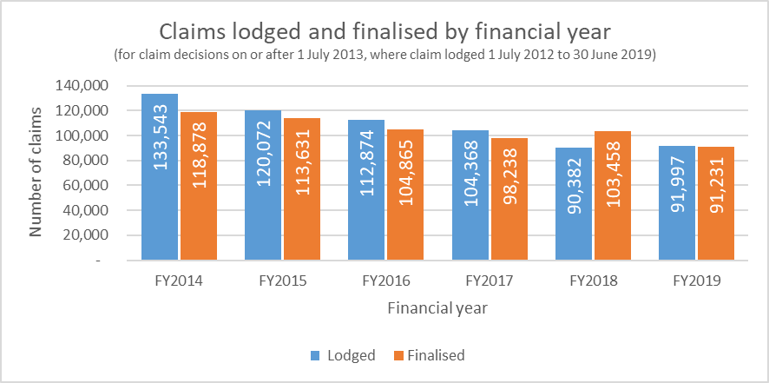

An analysis of the number and proportion of claims determined by a DMA is presented in . DMAs represented 16.6% of determinations for claims lodged in the first financial year post implementation and has increased to 25.4% of all claims lodged in the 2018-2019 financial year.

Appendix Figure .: Claims subject to DMA by financial year lodged

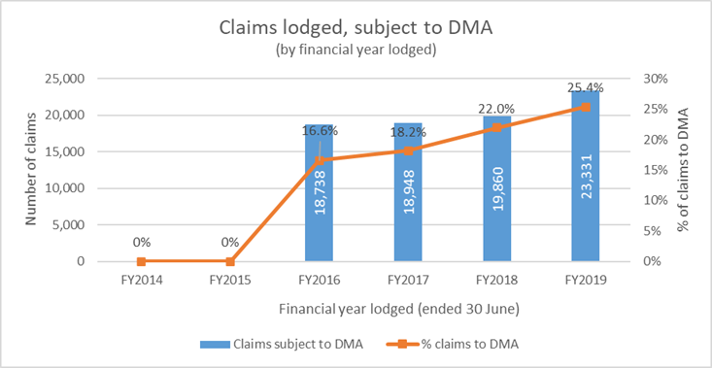

Claims patterns (seasonality)

An analysis of claims lodged by month, for claims lodged between 1 July 2013 and 30 June 2019 (where the claim was finalised before 30 April 2020) is presented in . This demonstrated a relatively consistent decline in claims lodged, reduced at a rate of approximately 2% per month.

Appendix Figure .: Claims lodged by month (where the claim was finalised by 30 April 2020)

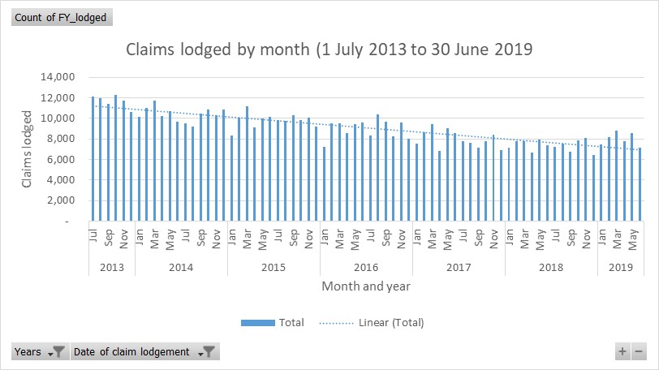

An analysis of average claims lodged by month, for claims lodged between 1 July 2013 and 30 June 2019 (where the claim was finalised before 30 April 2020) is provided in .

Appendix Figure .: Average claim volumes by month

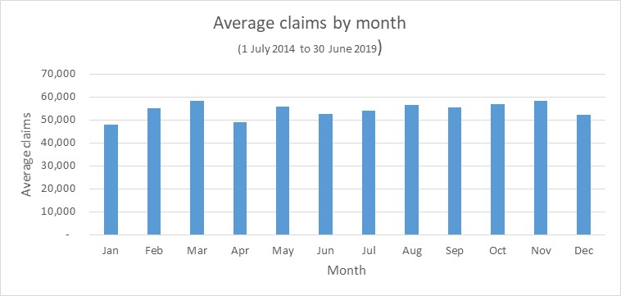

Claim-grant rates

As demonstrated in Appendix Figure C.7, there was an identifiable change in the rejection rates from claims following the full implementation of the revised assessment process (1 July 2015). Claims lodged in the 2014-2105 financial year demonstrated a 64% rejection rate, which increased to 74% for claims lodged in the 2015-2016 financial year. There has a subsequent reduction in rejection rates, particularly from the 2017-2108 financial year, which Services Australia have attributed to efforts to reduced ineligible claims being lodged, the implication being that a greater proportion of claims are being lodged are bona fide, consequently increasing the number of claims granted.

Appendix Figure .: Claims granted and rejected, by financial year lodged) for claim decisions on or after 1 July 2013, for claims lodged 1 July 2013 to 30 June 2019)

Shows claims granted and rejected for each year from 2014 to 2019. Each bar shows two percentages which together total 100 percent. At the bottom of each bar is the percentage granted and above it, in the same bar is the pecentage rejected.


presents a waterfall chart illustration the change in claims granted between the two financial years immediately preceding the change in assessment process (1 July 2013 - 30 June 2015) relative to the four financial years subsequent to the change (1 July 2015 to 30 June 2019). Claims granted, as a percentage of all claims lodged, has reduced by 7.5 percentage points.

Appendix Figure .: Percentage of claims granted, pre and post implementation

This chart shows, as a percentage, claims granted before and after implementation of the revised assessment process, and the overall decrease in the number of claims granted.


Similarly, presents a waterfall chart illustration the change in claims granted in two year blocks and illustrates a variation in the claims granted experience.

Appendix Figure .: Percentage of claims granted over six year, in 2-year time periods

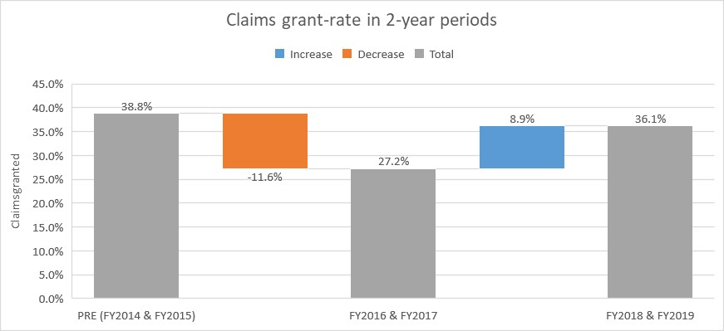

Appendix Figure C.10 presents the number of claims granted (by financial year lodged). Of the claims lodged in the 2018-2109 financial year, 34,618 were granted. This is a 20.9% reduction on the equivalent number in the financial year immediately preceding the change (43,758 claims granted, 2014-2015 financial year).

Appendix Figure .: Claims granted by financial year lodged

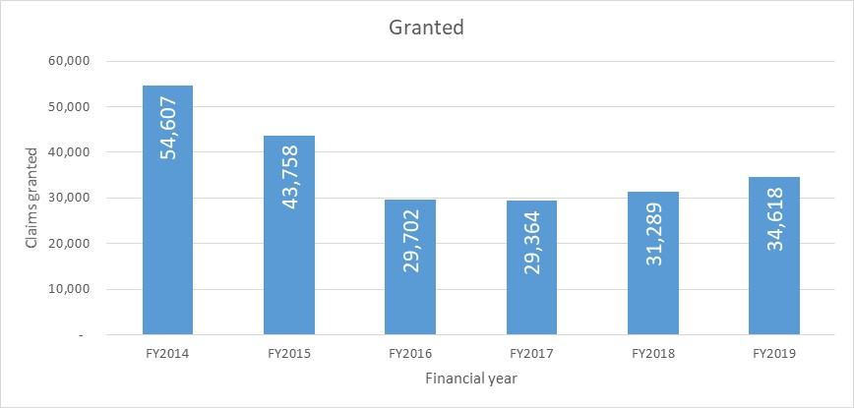

, presents the percentage of claims granted by stage finalised presented for the relevant financial year that the claim was lodged. The proportion of claims that GCDs assess as granted is increasing, similarly for the JCA (Assessment) process (since the 2016-2017 financial year). The rates of claims that the JCAs (Assessments) determined as granted dropped significantly with the introduction of the new assessment process on 1 July 2015.

Appendix Figure .: Grant rates by stage finalised and financial year lodged

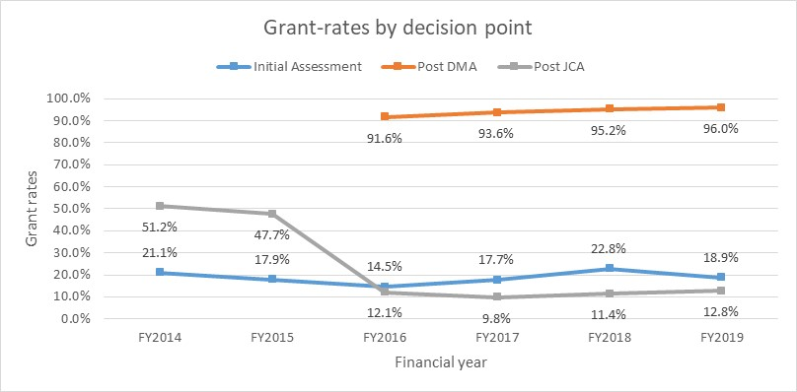

Multiple claimants

presents an analysis of unique claimants and indicates that many claimants make multiple applications. By way of illustration, 100,357 claimants have made 2 claims in the six-year period; three claimants have lodged 12 claims; and 317,606 claimants lodged a single claim.

As illustrated in , 31% of claimants (140,266 people) made multiple claims in the period. Multiple claims represent 51% of the claims lodged and determined in the period ().

Appendix Figure .: Multiple claims by unique claimants

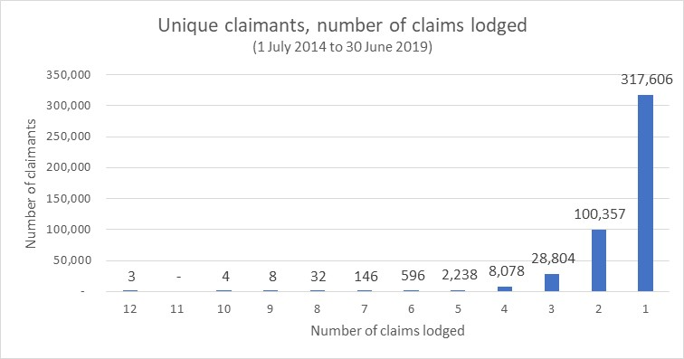

Appendix Figure .: Number of unique claimant, by frequency

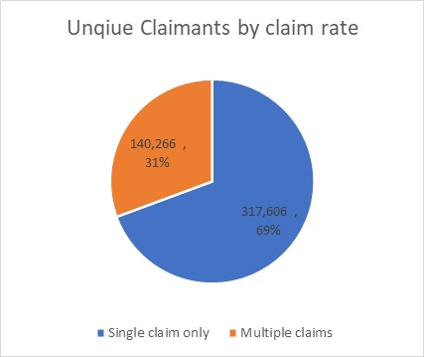

Appendix Figure .: Claim volumes for single and multiple claimants

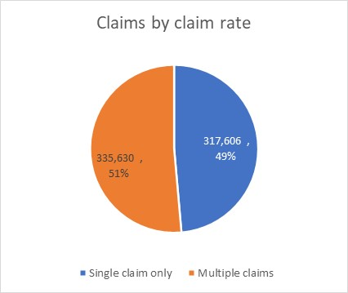

presents an analysis of claims raised per unique claimant by financial year. This indicates little variation, as a consequence of the new assessment process.

Appendix Figure .: Claims lodged per unique claimant by financial year lodged

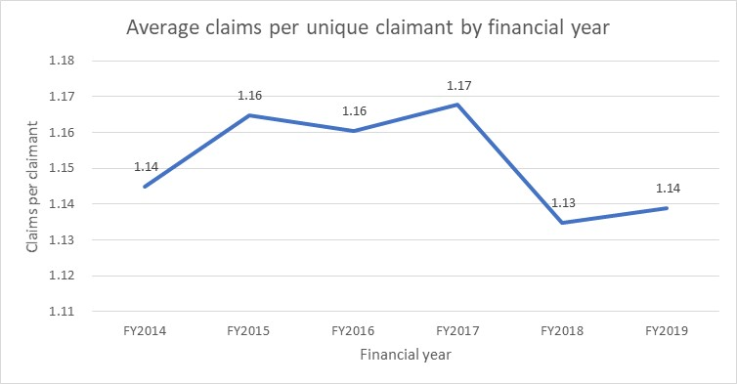

Spatial

and below present the proportion of claims by location utilising the Modified Monash Model (MMM). The MMM is a classification system that measures remoteness and population size on a scale to define whether a location is a city, rural, remote or very remote. As presented there has been a minimal variation on the claimant’s location over time. An analysis of claims granted over time, by MMM classification, are presented in Appendix Figure C.17 and Appendix Figure C.18 over page. These analyses indicate, and support the previously noted, reduction in claims granted from the 2015-2016 financial year onwards (that is from full implementation of the revised process).

Appendix Table .: Proportion of claims by location by MMM classification

|  |  |  |  |  |  |  |
| --- | --- | --- | --- | --- | --- | --- |
| MMM Classification | FY2014 | FY2015 | FY2016 | FY2017 | FY2018 | FY2019 |
| Metropolitan | 63% | 62% | 62% | 62% | 63% | 63% |
| Regional centres | 9% | 9% | 9% | 10% | 9% | 10% |
| Large rural towns | 13% | 13% | 13% | 13% | 13% | 12% |
| Medium rural towns | 12% | 12% | 12% | 11% | 11% | 12% |
| Small rural towns | 2% | 2% | 2% | 2% | 2% | 2% |
| Remote communities | 1% | 1% | 1% | 2% | 1% | 1% |
| Very remote communities | 0% | 0% | 0% | 0% | 0% | 0% |
| Unknown | 0% | 0% | 0% | 0% | 0% | 0% |
| TOTAL | **100%** | **99%** | **99%** | **100%** | **99%** | **100%** |

Appendix Figure .: Proportion of claims by location by MMM classification

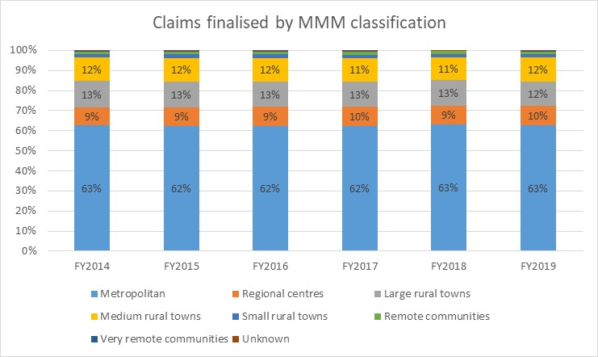

and present analysis of claims granted by MMM, indicating that:

* post-implementation, granting rates were in a narrow range (between 26%-29%, three percentage points) across all MMM classifications; and
* in contrast, before implementation, a much broader range was evident (31%-42%, nine percentage points). In that period, “remote communities” had the lowest granting rate (31%) and large rural towns the highest (42%).

Appendix Figure .: Percentage of claims granted by MMM classification and financial year

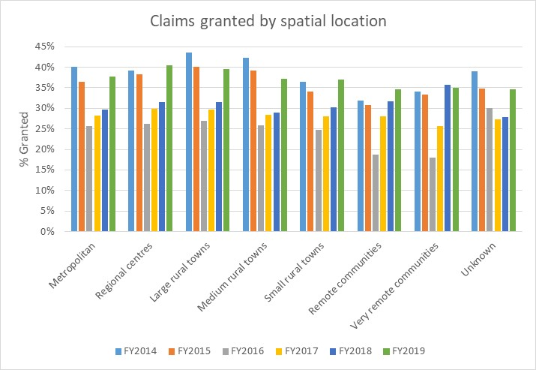

Appendix Figure .: Percentage of claims granted by MMM classification in two-financial year periods

depicts the percentage of claims by location classification, grouped into two financial year periods, being 
2014-2015, 2016-2017 and 2018-2019. Each location classification has three bars, one for each financial year grouping

Time taken

An analysis of the duration to reach a claim determination () demonstrates that there was an increase in the average number of days taken from grants lodged after 1 July 2015. While the average times to grant and reject claims increased in the two years from implementation, the average claim time dropped in 2018 and further again in 2019. Claims lodged in the 2016-2017 financial year demonstrated the longest average times to grant (145 days) or reject (105 days).

Appendix Figure .: Days to determine claims, by claim outcome and financial year lodged

Depicts the number of days to determine claims. It shows the number of days taken to grant or reject claims by financial year, from 2014 to 2019



presents a similar analysis, presenting the average days taken to finalise manifest claims. Timeframes have increased, however the difference in time taken the grant or reject manifest claims is much smaller than for claims overall.

Appendix Figure .: Days to determine manifest claims, by claim outcome and financial year lodged)

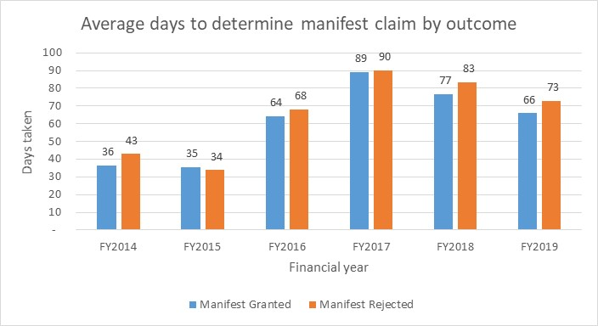

presents the average days taken to finalise claims by stage finalised presented by financial year lodged. Claim timeframes have reduced in the last two financial years for claims finalised post DMA and Initial Assessment.

Appendix Figure .: Days to determine claims, by stage finalised and financial year lodged

Depicts the number of days taken to determine the outcome of a claim by the financial year lodged, from 2014 to 2019. It shows the number of days for the initial assessment, post Job Capacity Assesssment and from 2016 onwards, by post Disability Medical Assessment.


presents the average days taken to finalise claims by MMM classification. This indicates that:

* Time taken to finalise claims has increased significantly since implementation, with broadly equal impact across disability type, MMM and decision type.
* Remote and Very Remote are starting to show longer decision times (2-4 weeks longer).

Appendix Figure .: Days taken to finalise claims by MMM, by financial year lodged

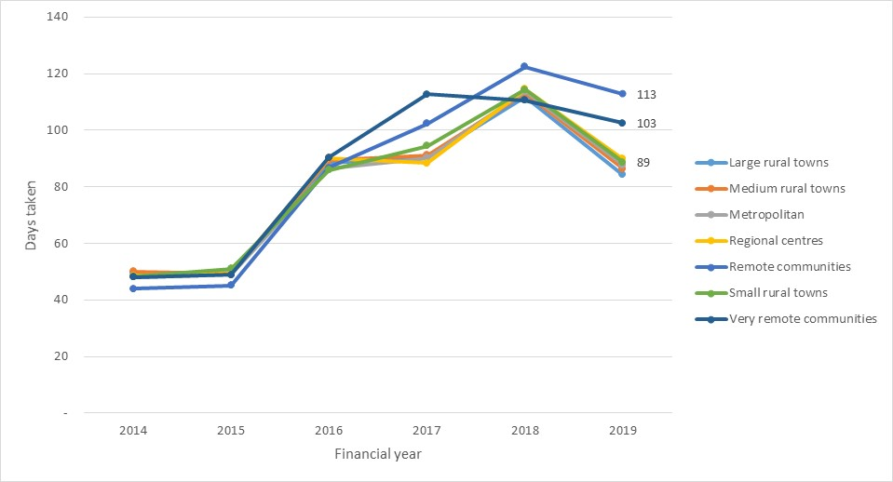

Manifest Claims

Manifest determinations as a proportion of all claims have increased since 1 July 2015 ():

* Manifest grants have increased from 20% of all claims granted in the 2014-2015 financial year to 33% in the 2018-2109 financial year (); and
* Manifest rejections have increased from 13% of all claims rejected in the 2014-2015 financial year to 20% in the 2018-2109 financial year (). Of note, manifest rejections decreased to 7% in the first financial year following the implementation of the revised assessment process. Stakeholders and Services Australia indicated that replacement of the TDR with medical evidence did make it more difficult to assess manifest rejections, and marginal claims often continued to be assessed rather than manifestly rejected in that year.

Appendix Figure .: Manifest granted, and manifest rejected as a % of all claims by financial year lodged

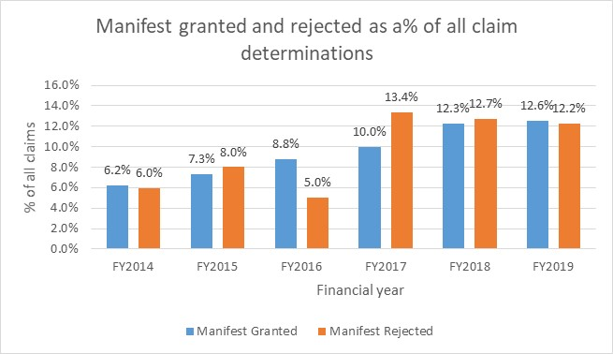

Appendix Figure .: Proportion of manifest grant claims as a % of all granted claims by financial year lodged

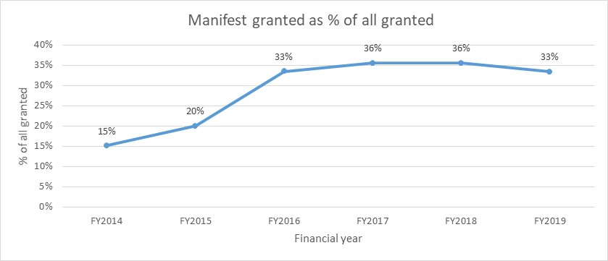

Appendix Figure .: Proportion of manifest rejected claims as a % of all rejected claims by financial year lodged

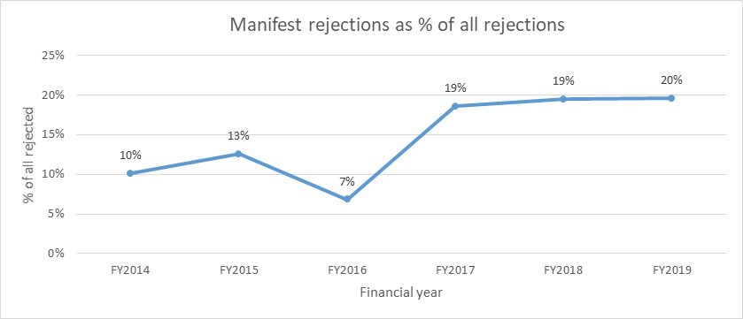

Age

Graphical representation of the age of claimants is presented in , which identified the most represented aged group as 56-65 years old (36% of all claimants).

Appendix Figure .: Age of claimants as a proportion of all DSP claimant analysed

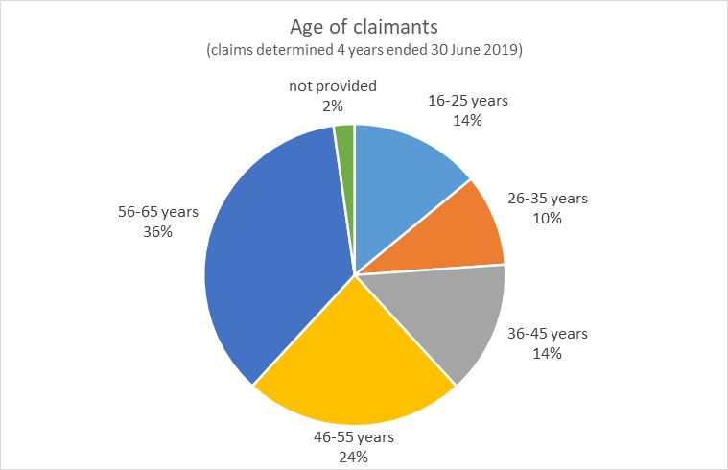

over page presents the rejection rate for each age group by financial year lodged. The new assessment process has impacted all age groups relatively equally. Of note, rejection rates in the 16-25 cohort are much lower than other age groups.

Appendix Table .: Claims rejection, pre and post implementation by age

|  |  |  |  |
| --- | --- | --- | --- |
| Claimed rejected | Pre-implementation | Post-implementation | Change  (%-points) |
| 16-25 years | 45% | 51% | 5% |
| 26-35 years | 67% | 73% | 6% |
| 36-45 years | 66% | 75% | 8% |
| 46-55 years | 65% | 73% | 8% |
| 56-65 years | 61% | 70% | 9% |
| All age groups | **61%** | **69%** | **8%** |

Appendix Figure .: Rejection rates by age group by financial year lodged

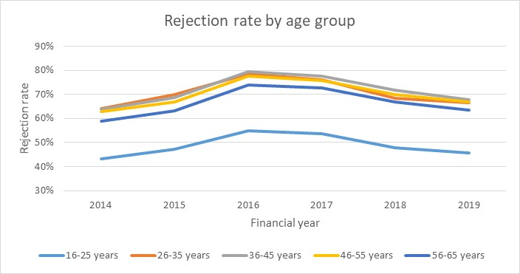

Gender

presents proportions of claimants by gender, with male claimants representing approximately 53% of claimants across the six financial-year period.

Appendix Figure .: Claimants by gender by financial year lodged

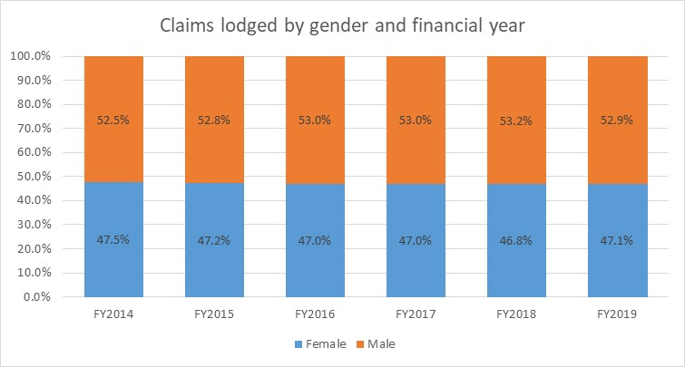

presents the rejection rate by gender by financial year lodged. The new assessment process has impacted both gender rejection rates relatively equally.

Appendix Figure .: Rejection rate by gender by financial year lodged

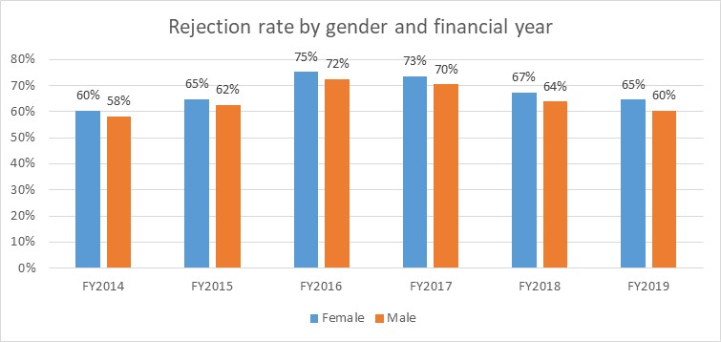

Disability type

presents an analysis of the proportion of claims by disability. Psychological/Psychiatric is the most represented, being 26% of claims across all financial years reviewed by the evaluation. The incidence of "not recorded" is increasing in the dataset.

Appendix Table .: Proportion of claims by disability and financial year

|  |  |  |  |  |  |  |  |
| --- | --- | --- | --- | --- | --- | --- | --- |
| Disability | FY2014 | FY2015 | FY2016 | FY2017 | FY2018 | FY2019 | ALL YEARS |
| Psychological/Psychiatric | 27% | 25% | 25% | 25% | 25% | 26% | **26%** |
| Musculoskeletal & Connective Tissue | 28% | 26% | 24% | 22% | 20% | 18% | **24%** |
| Not Recorded | 12% | 15% | 16% | 20% | 27% | 29% | **19%** |
| Circulatory System | 6% | 6% | 6% | 6% | 4% | 4% | **5%** |
| Nervous System | 4% | 4% | 5% | 5% | 4% | 4% | **4%** |
| Cancer/Tumour | 3% | 3% | 3% | 3% | 2% | 2% | **3%** |
| Endocrine & Immune System | 3% | 3% | 3% | 3% | 2% | 2% | **3%** |
| Respiratory System | 3% | 3% | 3% | 3% | 2% | 2% | **3%** |
| Intellectual/ Learning | 3% | 3% | 2% | 2% | 2% | 2% | **3%** |
| Sense Organs | 2% | 2% | 2% | 2% | 2% | 2% | **2%** |
| Acquired Brain Impairment | 2% | 2% | 2% | 2% | 2% | 2% | **2%** |
| Poorly Defined Cause | 2% | 1% | 1% | 1% | 1% | 1% | **1%** |
| Gastro-Intestinal System | 1% | 1% | 2% | 1% | 1% | 1% | **1%** |
| Chronic Pain | 1% | 1% | 1% | 1% | 1% | 1% | **1%** |
| Urogenital System | 1% | 1% | 1% | 1% | 1% | 1% | **1%** |
| Congenital Abnormalities | 1% | 1% | 1% | 1% | 1% | 1% | **1%** |
| Visceral Disorder | 1% | 1% | 1% | 1% | 1% | 1% | **1%** |
| Other (Individually less than 1%) | 1% | 1% | 1% | 1% | 1% | 1% | **1%** |
| TOTAL | **101%** | **100%** | **99%** | **100%** | **99%** | **100%** | **101%** |

Appendix Figure C.30 presents the rejection rate, both pre and post implementation for each disability classification. All disabilities have higher rejection dates post implementation of the 1 July 2015 changes.

Appendix Figure .: Rejection rate by disability pre and post 1 July 2015

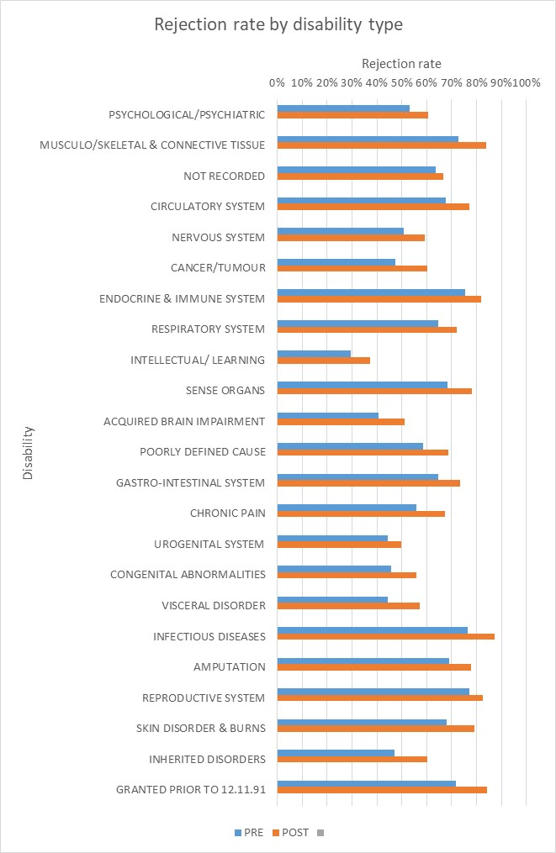

presents the change in rejection for each disability classification, in addition to the average change across all disability types.

Appendix Figure .: Comparison of rejection rate by disability pre and post 1 July 2015 to the average change in rejection rate

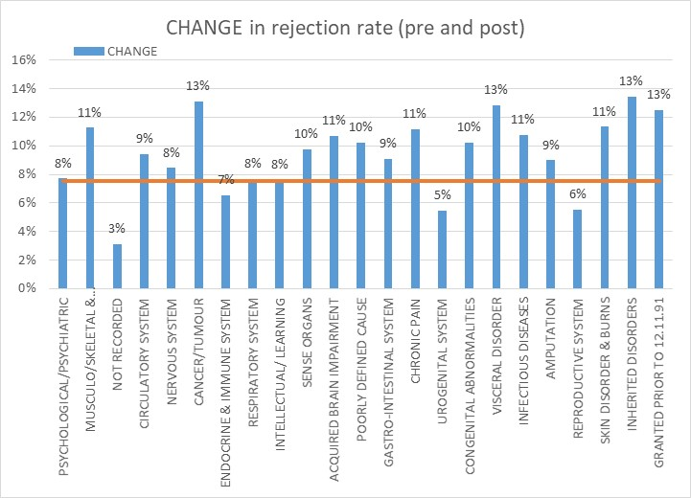

presents the days taken to finalise claims for each disability classification, by financial year lodged. All disabilities have demonstrated increases in the time taken to finalised claims.

Appendix Table .: Days taken by disability type

|  |  |  |  |  |  |  |
| --- | --- | --- | --- | --- | --- | --- |
| Disability Classification | FY2014 | FY2015 | FY2016 | FY2017 | FY2018 | FY2019 |
| Psychological/Psychiatric | 54 | 60 | 115 | 133 | 109 | 100 |
| Musculoskeletal & Connective Tissue | 53 | 54 | 96 | 118 | 90 | 82 |
| Not recorded | 39 | 34 | 62 | 77 | 58 | 52 |
| Circulatory System | 53 | 56 | 99 | 120 | 102 | 98 |
| Nervous System | 56 | 60 | 116 | 132 | 122 | 110 |
| Cancer/Tumour | 52 | 54 | 96 | 112 | 101 | 96 |
| Endocrine & Immune System | 53 | 55 | 94 | 117 | 96 | 89 |
| Respiratory System | 52 | 55 | 102 | 121 | 101 | 95 |
| Intellectual/ Learning | 58 | 70 | 118 | 146 | 125 | 113 |
| Sense Organs | 54 | 58 | 99 | 122 | 100 | 94 |
| Acquired Brain Impairment | 60 | 64 | 126 | 139 | 132 | 119 |
| Poorly Defined Cause | 55 | 61 | 109 | 128 | 110 | 105 |
| Gastro-Intestinal System | 54 | 57 | 102 | 120 | 93 | 95 |
| Chronic Pain | 55 | 57 | 109 | 131 | 116 | 109 |
| Urogenital System | 54 | 59 | 125 | 140 | 125 | 119 |
| Congenital Abnormalities | 55 | 62 | 118 | 129 | 120 | 117 |
| Visceral Disorder | 51 | 55 | 115 | 122 | 111 | 105 |
| Infectious Diseases | 49 | 52 | 85 | 99 | 62 | 57 |
| Amputation | 54 | 55 | 106 | 124 | 108 | 97 |
| Reproductive System | 50 | 58 | 93 | 114 | 82 | 71 |
| Skin Disorder & Burns | 52 | 58 | 102 | 129 | 100 | 94 |
| Inherited Disorders | 54 | 60 | 114 | 150 | 110 | 108 |
| Granted Prior To 12.11.91 | 37 | 38 | 61 | 98 | 47 | 35 |
| Average days taken (all disability types) | **52** | **54** | **99** | **116** | **91** | **84** |

Stage finalised

presents an analysis of claims by the 'stage finalised". In the 2018-2109 financial year, 52% of claims are finalised following Initial Assessment. This stage has increased since the introduction of the MAT in July 2017 (i.e. the 2017-2018 financial year). The MAT has also led to the reduction (to 23%) of the JCA (Assessment) as a stage finalised, as the majority of manifest rejections now occur in the Initial Assessment stage.

Appendix Figure .: Claims lodged by 'stage finalised" by financial year

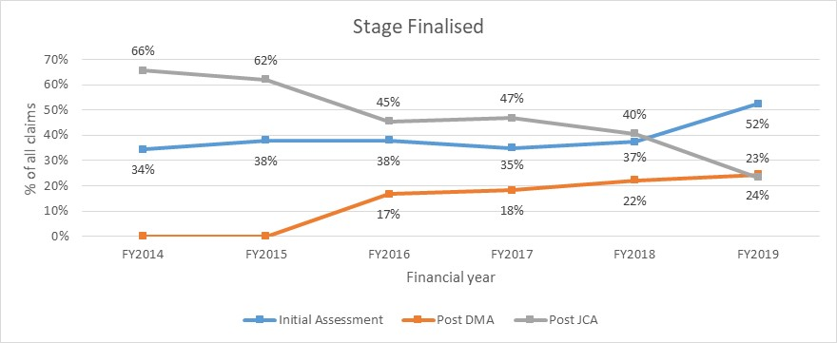

Method of DMA assessment

over page presents an analysis of the methods of assessment used by DMA. The data indicates a minor shift towards non-face to face methods however, recent data has an increasing incidence of this field being left blank, making these data inconclusive.

Appendix Figure .: Method of DMA assessment by financial year lodged

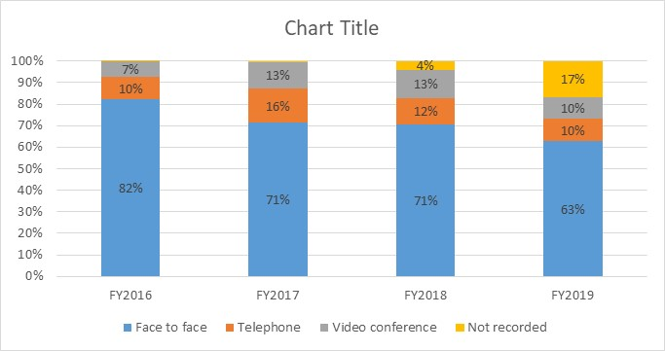

Alternative income support

presents the recorded income support accessed by unsuccessful claimants two weeks following their rejection. The data analyses data for claims lodged from 1 July 2015. This identifies that 72% of unsuccessful claimants were identified as having been paid NSA (now known as JobSeeker Payment) following rejection (data identifies payment made two weeks after rejections). The next most common category (18% of unsuccessful claimants) was “not recorded”, followed by the Youth Allowance (4%).

Appendix Table .: Identified alternative income support for unsuccessful claimants

|  |  |  |
| --- | --- | --- |
| Since 1 July 2015 | Rejected claims | % of total |
| NSA (now known as JobSeeker Payment) | 196,879 | 72% |
| Not recorded (claimant was not on a payment following rejection) | 48,289 | 18% |
| Youth Allowance | 11,207 | 4% |
| Parenting Payment Single | 3,386 | 1% |
| Carer Payment | 4,482 | 2% |
| Disability Support Pension | 3,340 | 1% |
| Sickness Allowance | 2,411 | 1% |
| Parenting Payment Partnered | 2,047 | 1% |
| Widow Allowance | 1,048 | 0% |
| Austudy | 596 | 0% |
| Age Pension | 479 | 0% |
| Special Benefit | 242 | 0% |
| Partner Allowance | 50 | 0% |
| Wife Pension | 41 | 0% |
| Work for the Dole | 32 | 0% |
| Bereavement Allowance | 31 | 0% |
| TOTAL | **274,560** | **100%** |

Reasons for rejection

presents the most common recorded reason for the rejection for claims raised between 1 July 2013 and 30 June 2019, presented by financial year. The most common reason for rejection is that the condition was not fully diagnosed, treated and stabilised, currently 53.6% of rejections. This has grown significantly since the introduction of the MAT in July 2017, and is more commonly assessed, rather than the 20 points impaired, which has reduced to now represent 17.1% of rejections. In the 2018-2019 financial year, it is noted that insufficient medical evidence increased to represent 6.6% of rejections.

Appendix Figure .: Rejection reason, as a % of all rejections, by financial year lodged

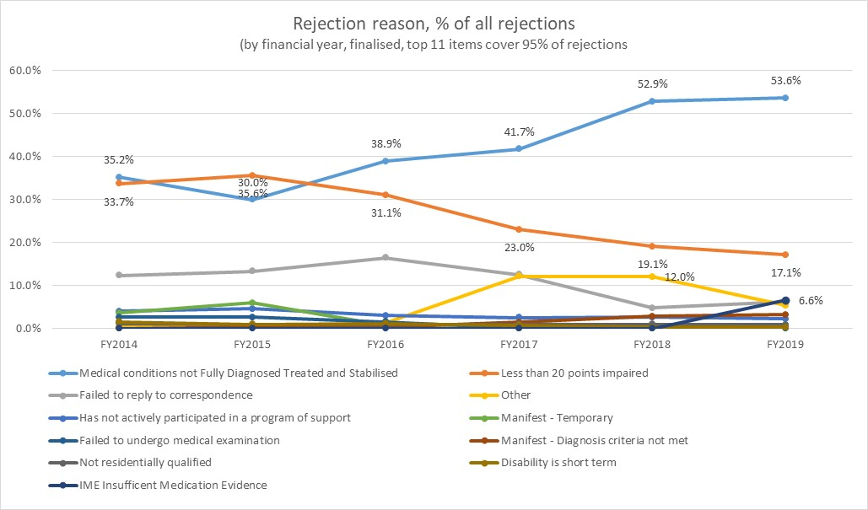

Appeal decisions (by year or original decision)

An analysis of appeals decided is presented in over page, illustrating the volume of appeals by financial year, based on the year of the original decision. ARO appeals are the most common, with only 14% of claims proceeding beyond the ARO to either the AAT Level 1 or AAT Level 2.

Appendix Figure .: Volume of appeals by financial year

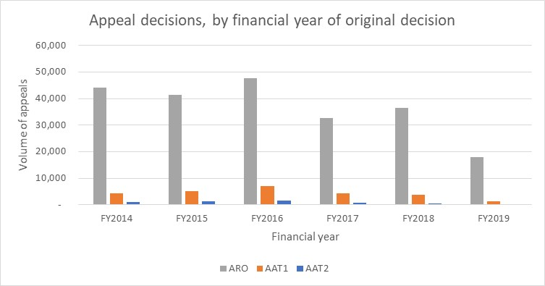

An analysis of outcomes of the ARO appeals are presented in , illustrating the volume of appeals by financial year, based on the year of the original decision. 75% of appeals are affirmed, noting that the rate of appeals affirmed has reduced in recent years, with an offsetting increase in "set aside" outcomes.

Appendix Table .: Summary of ARO outcomes for appeals decided

|  |  |  |  |  |  |  |  |
| --- | --- | --- | --- | --- | --- | --- | --- |
| ARO appeal outcome | FY2014 | FY2015 | FY2016 | FY2017 | FY2018 | FY2019 | ALL YEARS |
| Affirmed | 73.43% | 77.18% | 80.16% | 74.31% | 72.85% | 65.68% | **75.00%** |
| Set Aside | 8.63% | 8.43% | 7.60% | 14.53% | 17.57% | 16.36% | **11.36%** |
| Varied | 4.25% | 4.83% | 4.72% | 6.31% | 4.64% | 6.60% | **5.02%** |
| Withdrawn | 6.80% | 3.67% | 2.58% | 3.02% | 3.07% | 2.98% | **3.81%** |
| Set Aside, Internal Review | 5.52% | 4.47% | 3.62% | 1.13% | 0.00% | 0.00% | **2.90%** |
| Unknown | 0.01% | 0.01% | 0.02% | 0.12% | 1.73% | 8.18% | **0.98%** |
| Explained, Internal Review | 1.03% | 1.23% | 1.15% | 0.37% | 0.00% | 0.00% | **0.74%** |
| No Jurisdiction | 0.13% | 0.12% | 0.11% | 0.19% | 0.13% | 0.18% | **0.13%** |
| Varied, Internal Review | 0.19% | 0.05% | 0.04% | 0.02% | 0.00% | 0.00% | **0.06%** |
| Transferred Interstate | 0.00% | 0.00% | 0.00% | 0.00% | 0.00% | 0.01% | **0.00%** |
| Refer to ARO, Internal Review | 0.00% | 0.00% | 0.00% | 0.00% | 0.00% | 0.01% | **0.00%** |
| Grand Total | **100.00%** | **100.00%** | **100.00%** | **100.00%** | **100.00%** | **100.00%** | **100.00%** |

An analysis of outcomes of the AAT Level 1 appeals are presented in , illustrating the volume of appeals by financial year, based on the year of the original decision. 74% of appeals are affirmed, noting that the rate of appeals affirmed has remained relatively consistent.

Appendix Table .: Summary of AAT Level 1 outcomes for appeals decided

|  |  |  |  |  |  |  |  |
| --- | --- | --- | --- | --- | --- | --- | --- |
| AAT Level 1 | FY2014 | FY2015 | FY2016 | FY2017 | FY2018 | FY2019 | ALL YEARS |
| Affirmed | 76.8% | 75.3% | 72.7% | 72.3% | 74.2% | 71.0% | **74.0%** |
| Set Aside | 8.5% | 9.8% | 12.0% | 17.0% | 15.2% | 17.2% | **12.5%** |
| Set Aside and Remitted | 6.9% | 8.5% | 8.0% | 3.2% | 3.8% | 3.4% | **6.3%** |
| Withdrawn | 6.2% | 5.3% | 4.7% | 5.8% | 5.2% | 6.0% | **5.4%** |
| Dismissed for Non-appearance | 0.9% | 0.8% | 2.2% | 1.5% | 1.2% | 1.8% | **1.4%** |
| Varied | 0.6% | 0.2% | 0.3% | 0.2% | 0.3% | 0.4% | **0.3%** |
| No Jurisdiction | 0.1% | 0.1% | 0.0% | 0.0% | 0.0% | 0.1% | **0.1%** |
| Grand Total | **100.0%** | **100.0%** | **99.9%** | **100.0%** | **99.9%** | **99.9%** | **100.0%** |

An analysis of outcomes of the AAT Level 2 appeals are presented in , illustrating the volume of appeals by financial year, based on the year of the original decision. 41% of appeals are withdrawn (noting this increased to 63% in the 2018-2019 financial year), 25% set aside.

Appendix Table .: Summary of AAT Level 2 outcomes for appeals decided

|  |  |  |  |  |  |  |  |
| --- | --- | --- | --- | --- | --- | --- | --- |
| AAT Level 2 | FY2014 | FY2015 | FY2016 | FY2017 | FY2018 | FY2019 | Grand Total |
| Withdrawn | 41.6% | 43.5% | 39.2% | 39.3% | 39.8% | 63.3% | **40.9%** |
| Affirmed | 27.3% | 25.9% | 27.0% | 22.5% | 20.7% | 0.0% | **25.5%** |
| Consent Decision - Set Aside | 10.2% | 11.7% | 15.2% | 19.7% | 21.5% | 10.0% | **14.5%** |
| Dismissed for Non-appearance | 7.2% | 7.8% | 8.3% | 5.5% | 5.3% | 6.7% | **7.3%** |
| Set Aside | 5.9% | 3.8% | 4.0% | 3.4% | 2.7% | 3.3% | **4.1%** |
| Dismissed by Consent or Withdrawal S1285A | 2.7% | 3.6% | 3.3% | 5.6% | 4.0% | 13.3% | **3.7%** |
| Consent Decision - Varied | 1.4% | 1.1% | 1.6% | 2.3% | 5.0% | 3.3% | **1.8%** |
| Set Aside and Remitted | 1.3% | 1.3% | 0.5% | 0.5% | 0.0% | 0.0% | **0.8%** |
| Remitted by Consent | 1.8% | 0.8% | 0.5% | 0.6% | 0.0% | 0.0% | **0.8%** |
| Varied | 0.4% | 0.1% | 0.2% | 0.2% | 0.5% | 0.0% | **0.2%** |
| No Jurisdiction | 0.0% | 0.4% | 0.1% | 0.1% | 0.5% | 0.0% | **0.2%** |
| Delisted with Right of Reinst | 0.1% | 0.0% | 0.1% | 0.2% | 0.0% | 0.0% | **0.1%** |
| Grand Total | **100.0%** | **100.0%** | **100.0%** | **100.0%** | **100.0%** | **100.0%** | **100.0%** |

###### Alternative Supports Comparative Payments Table

|  |  |  |  |  |  |  |
| --- | --- | --- | --- | --- | --- | --- |
| Maximum rates used for: single, no children | Percentage of rejected DSP claimants | As at 1 January 2020 | | | | |
|  |  | **Basic** | **Pension Supplement** | **Energy Supplement** | **Utilities Allowance** | **TOTAL** |
| DSP (full rate, single, no children, over 21) |  | **$ 850.40** | **$ 68.90** | **$ 14.10** | **$ -** | **$ 933.40** |
| Average rate paid DSP |  |  |  |  |  | **$ 886.59** |
| NSA (Single, no children) | 71.71% | $ 559.00 | $ - | $ 8.80 | $ - | $ 567.80 |
| Not recorded (use NSA) | 17.59% | $ 559.00 | $ - | $ 8.80 | $ - | $ 567.80 |
| Youth Allowance (single, 18-24, no children, LAFH) | 4.08% | $ 462.50 | $ - | $ 7.00 | $ - | $ 469.50 |
| Parenting Payment Single | 1.23% | $ 780.70 | $ 23.90 | $ 12.00 | $ - | $ 816.60 |
| DSP (single, no children, over 21) | 1.63% | $ 850.40 | $ 68.90 | $ 14.10 | $ - | $ 933.40 |
| Carer Payment (single) | 1.22% | $ 850.40 | $ 68.90 | $ 14.10 | $ - | $ 933.40 |
| Sickness Allowance (single , no children) | 0.88% | $ 559.00 | $ - | $ 8.80 | $ - | $ 567.80 |
| Parenting Payment Partnered | 0.75% | $ 504.70 | $ - | $ 7.90 | $ - | $ 512.60 |
| Widow Allowance (single, no children, under age pension) | 0.38% | $ 559.00 | $ - | $ 8.80 | $ - | $ 567.80 |
| Austudy (single, no children) | 0.22% | $ 462.50 | $ - | $ 7.00 | $ - | $ 469.50 |
| Age Pension (single) | 0.17% | $ 850.40 | $ 68.90 | $ 14.10 | $ - | $ 933.40 |
| Special Benefit (use NSA) | 0.09% | $ 559.00 | $ - | $ 8.80 | $ - | $ 567.80 |
| Partner Allowance | 0.02% | $ 504.70 | $ - | $ 8.80 | $ 12.39 | $ 525.89 |
| Wife Pension | 0.01% | $ 624.00 | $ 68.90 | $ 10.60 | $ - | $ 703.50 |
| Work for the Dole | 0.01% | $ 559.00 | $ - | $ 8.80 | $ - | $ 567.80 |
| Bereavement Allowance (under Age Pension) | 0.01% | $ 850.40 | $ 68.90 | $ 14.10 | $ - | $ 933.40 |

1. Department of Social Services (2020) Guide to Social Policy Law, version 1.263, Australian Government, available at <http://guides.dss.gov.au/guide-social-security-law>
2. DHS (2015). *Disability Support Pension.* <http://www.humanservices.gov.au/customer/services/centrelink/disability-support-pension>.
3. DSS. (2015). *Request for Quotation Documentation: Under the Deed of Standing Offer for Social Policy Research and Evaluation Services for the provision of social policy research, evaluation, data investment and professional development services.* 
4. See Appendix Figure C.7
5. See Appendix Figure C.19
6. DSS (2014) A New System for Better Employment and Social Outcomes - Full version of the Interim Report [https://www.dss.gov.au/our-responsibilities/review-of-australia-s-welfare-system/a-new-system-for-better-employment-and-social-outcomes-full-version-of-the-interim-report [26](https://www.dss.gov.au/our-responsibilities/review-of-australia-s-welfare-system/a-new-system-for-better-employment-and-social-outcomes-full-version-of-the-interim-report%20%5b26) June 2020]
7. Right to social security. (n.d) Attorney General’s Department. [https://www.ag.gov.au/rights-and-protections/human-rights-and-anti-discrimination/human-rights-scrutiny/public-sector-guidance-sheets/right-social-security [26](https://www.ag.gov.au/rights-and-protections/human-rights-and-anti-discrimination/human-rights-scrutiny/public-sector-guidance-sheets/right-social-security%20%5b26) June 2020]
8. DHS (2015). *Disability Support Pension.* <http://www.humanservices.gov.au/customer/services/centrelink/disability-support-pension>.
9. DSS. (2014). *Disability Support Pension- Participation Requirements.* www.dss.gov.au
10. https://www.anao.gov.au/work/performance-audit/disability-support-pension-follow-audit.
11. DHS (2014). *Budget 2014-15: Disability and Carers.* www.Services Australia.gov.au
12. <https://www.servicesaustralia.gov.au/individuals/news/deeming-rates-are-lowering-1-may-2020>
13. DSS. (2015). *Request for Quotation Documentation: Under the Deed of Standing Offer for Social Policy Research and Evaluation Services for the provision of social policy research, evaluation, data investment and professional development services.* 
14. Social Security Act 1991 <https://www.legislation.gov.au/Details/C2020C00158> [26 June 2020].
15. Social Security (Tables for the Assessment of Work-related Impairment for Disability Support Pension) Determination 2011 [https://www.legislation.gov.au/Details/F2011L02716 [26](https://www.legislation.gov.au/Details/F2011L02716%20%5b26) June 2020].
16. DHS. (2015). *Disability Support Pension.* <http://www.humanservices.gov.au/customer/services/centrelink/disability-support-pension>.
17. New applicants to DSP have their level of disability assessed using Impairment Tables. The Tables were revised in 2012 and are considered an appropriate way of assessing disability, consistent with contemporary medical and rehabilitation practice. Importantly, they have a focus on functional ability and consider what people are able to do.
18. <https://www.anao.gov.au/work/performance-audit/disability-support-pension-follow-audit>
19. An applicant will need to have been an Australian resident for a continuous period of at least 10 years, or for a number of periods that total more than 10 years, with 1 of the periods being at least 5 years, unless: they are a refugee or former refugee; the inability to work or permanent blindness happened while they were an Australian resident; or they were a dependent child of an Australian resident at the time their inability to work or permanent blindness happened and they became an Australian resident while you were a dependent child.
20. Cassidy K (n.d) DSP & Me: Your Guide to the Disability Support Pension. Disability Resource Centre Presentation.
21. Collie A, Sheehan L and McAllister A. (2019).The Health of Disability Support Pension and Newstart Allowance Recipients: Analysis of National Health Survey Data. Insurance Work and Health Group, School of Public Health and Preventive Medicine, Monash University.
22. Neave C (2016) Department of Human Services: Accessibility of Disability Support Pension for remote Indigenous Australians. Report No. 05/2016. [https://nacchocommunique.files.wordpress.com/2016/12/accessibility-of-dsp-for-remote-indigenous-australians_final-report.pdf [26](https://nacchocommunique.files.wordpress.com/2016/12/accessibility-of-dsp-for-remote-indigenous-australians_final-report.pdf%20%5b26) June 2020].
23. See Appendix Figure C.12
24. Collie A, Sheehan LR, Lane TJ (2020) Changes in access to Australian disability support benefits during a period of social welfare reform. MedRxIv doi.org/10.1101/2020.04.30.20041210 https://www.medrxiv.org/content/10.1101/2020.04.30.20041210v1 [26 June 2020].
25. Collie A, Sheehan LR, Lane TJ (2020) Changes in access to Australian disability support benefits during a period of social welfare reform. MedRxIv doi.org/10.1101/2020.04.30.20041210 https://www.medrxiv.org/content/10.1101/2020.04.30.20041210v1 [26 June 2020].
26. ANAO (2018) Disability Support Pension Follow-On Audit. [https://www.anao.gov.au/work/performance-audit/disability-support-pension-follow-audit [26](https://www.anao.gov.au/work/performance-audit/disability-support-pension-follow-audit%20%5b26) June 2020].
27. ANAO (2018) Disability Support Pension Follow-On Audit. [https://www.anao.gov.au/work/performance-audit/disability-support-pension-follow-audit [26](https://www.anao.gov.au/work/performance-audit/disability-support-pension-follow-audit%20%5b26) June 2020].
28. Written advocate response – EJA.
29. Economic Justice Australia prepared a written response with a number of case studies that can be provided or included as an appendix.
30. Collie A, Sheehan L and McAllister A. (2019).The Health of Disability Support Pension and Newstart Allowance Recipients: Analysis of National Health Survey Data. Insurance Work and Health Group, School of Public Health and Preventive Medicine, Monash University.
31. Economic Justice Australia prepared a written response with a number of case studies that can be provided or included as an appendix.
32. • <https://www.dss.gov.au/careers/department-of-social-services-enterprise-agreement-2018-to-2021>
33. <https://www.abs.gov.au/AUSSTATS/abs@.nsf/Lookup/6401.0Main+Features1March%202020?OpenDocument>
34. <https://www.servicesaustralia.gov.au/sites/default/files/co029-2001-v2.pdf>
35. <https://data.gov.au/data/dataset/dss-payment-demographic-data>