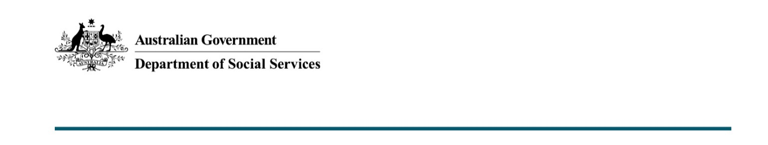

Social Media Policy: making online public comments
Policy No: | DSSCorp-031
Purpose: | This policy provides guidance for employees in their personal use of social media and outlines protocols for using social media for official departmental business.
Category: | Communications
Applicable to: | This policy applies to all staff.
Relevant Authority: | Australian Public Service Commission (APSC)  Public Service Act 1999  Work Health and Safety Act 2011
Related Documents: | APS Code of Conduct  APS Values  Making public comment on social media: A guide for employees - APSC  Secretary’s Procedures  ICT Acceptable Use Policy  Bullying and Harassment Policy  Risk Management Framework  Web Accessibility
Policy Statement: | The department is committed to ensuring employees understand the Social Media Policy and expectations of them when making public comment both in their professional and personal lives. This guide complements the official guidance from the APSC. In instances where there is conflict or lack of clarity, the APSC guide takes precedence.
Approved by: | Group Manager, Corporate Group
Review Date: | March 2022
Policy Owner: | Communication Services Branch
First Issued: | December 2014
Document Change Control: | September 2019 – added clarity on employee obligations.  January 2020 – minor edits following Workplace Consultative Forum consultation.  August 2020 – reviewed and updated.  January 2021 – reviewed and updated.

Policy
The policy provides guidance for employees when using social media personally or making public comment online, and outlines protocols for using social media to undertake official departmental business.
This policy applies to all departmental employees, including employees on secondment to the department, employees on leave, non-ongoing employees and contractors. Managers should ensure their employees are aware of and understand this policy.
This policy should be read in conjunction with the Australian Public Service Commission’s (APSC) publication Social media guidance for Australian Public Service employees and agencies and the department’s Social Media Terms of Use. In instances where there is conflict or lack of clarity, the APSC guide takes precedence.

Personal use of social media and making public comment online
Under the APS Code of Conduct (the Code), employees must behave at all times in a way that upholds the APS Values and Employment Principles. This means we must not behave in a way that calls into question our capacity to act apolitically and impartially.
See the APSC’s Making public comment on social media: A guide for APS employees, and general Do’s and Don’ts when engaging online, for more information.

Access to social media at work
Access to social media sites (e.g. Facebook and Twitter) on the department’s ICT resources is provided to employees on the condition that they abide by the department’s ICT Code of Conduct. Reasonable personal use is permitted, however use of the department’s ICT resources for private purposes must be undertaken in accordance with the ICT Acceptable Use Policy.

Privacy
Personal information about individuals cannot be provided to third-parties without their consent. The email address of your colleagues or stakeholders and other identifiable information must be treated with discretion and care. Employees must not upload contact details from departmental (Outlook) contacts when using, or prompted by, external social networking sites.

Official use of social media
The same high standards of conduct and behaviour expected of public servants also apply when participating on departmental social media channels.
Departmental employees are not authorised to speak on behalf of the department unless specifically authorised to do—this is generally limited to staff in the Communication Services Branch who manage the department’s official social media accounts.
Accessibility
The department is committed to social inclusion and provides support for people with disability.
Where possible, content on official departmental social media accounts should also be made available in an alternative accessible format. This alternative may be represented on the department’s internet site, however given the online interaction inherent in social media, it may also be appropriate to refer individuals to telephone or face-to-face channels.
Recordkeeping
Information that provides evidence of business activity or decision is a public record. All departmental employees have an obligation to ensure that key decisions and events are recorded in a way that captures the important features of a discussion or decision, presents a faithful and accurate account and can be easily retrieved when needed.
Social media platforms are often provided by third-party providers and are not official recordkeeping systems. In managing content in departmental social media accounts, you must keep records in accordance with the Recordkeeping Policy, ensuring appropriate records are created and captured for all the business functions, activities and transactions.
Employees are required to appropriately classify and store information as set out in the department’s Records Management Policy.

Sanctions for non-compliance
As an employee of the APS your behaviour, both in and out of the workplace, must be consistent with the APS Values, the Code and the department’s ICT Acceptable Use policy.
A failure to comply with this Policy may constitute a breach of the Code.
If an employee is found to have breached the Code , the Secretary (or delegate) may determine that it is appropriate to impose sanctions. Section 15(1) of the Act provides for the following sanctions:
- termination of employment
- reduction in classification
- reassignment of duties
- reduction in salary
- deductions from salary, by way of fine
- reprimand.

Frequently asked questions
See the Frequently Asked Questions published in the Making public comment on social media: A guide for employees – APSC document.

More information
If you have any concerns about your personal use of social media, please talk to your manager.
If you have any questions about the APSC guidance, please contact the Ethics Advisory Service on (02) 6202 3737 or email Ethics@apsc.gov.au.

