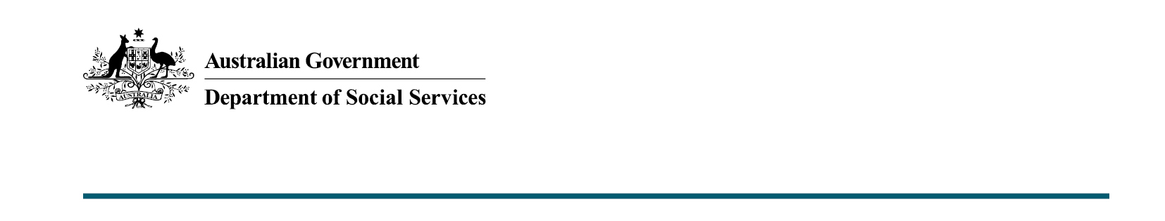

Supporting social and community services sector workers
Budget 2020-21

The Government is providing
$132.6 million from 2020-21
to support social services impacted by the cessation of the Social and Community Services Special Account.

What was announced in the Budget 2020-21?
The Government will provide ongoing funding for frontline service providers impacted by the legislated cessation of the Social and Community Services Special Account.
The additional funding will increase the base funding for Department of Social Services grants currently receiving Social and Community Services Wage Supplementation through the Special Account.
This will apply to grants from July 2021.
The funding for these grants will ensure wage costs, which have increased in line with the 2011 Fair Work Australia decision, continue to be met.

Attracting and retaining a workforce that delivers critical frontline social services to vulnerable Australians
It is important that social and community services are able to attract and retain a workforce that delivers critical frontline social services to vulnerable Australians – especially during recent times with bushfires and the coronavirus.
The Social and Community Services Wage Supplementation was a temporary measure intended to support the implementation of Fair Work Australia’s decision to grant an Equal Remuneration Order to increase wages for low paid workers in the community services sector.
Since 2012, a number of Commonwealth programs reliant on Social and Community Services Wage Supplementation have been redesigned, or transitioned to new funding arrangements, eliminating the need for supplementation.
Around $330 million of the Social and Community Services Wage Supplementation related to transitioning disability services will be paid through the National Disability Insurance Scheme.

This funding will sustain employment and wages of women, in the sector, particularly in regional and remote areas
Women represent 84 per cent of the 500,000 Australians employed in the social services sector.
These jobs include social workers, disability advocates and financial counsellors who provide support to Indigenous, culturally and linguistically diverse communities, women and children experiencing domestic and family violence, children and young people experiencing abuse and neglect, and individuals and families with disabilities, chronic medical conditions or mental illness.
This measure forms a key part of the Women’s Economic Security Statement.

Key facts
The Government has agreed to increase base funding for programs impacted by the cessation of Social and Community Services Wage Supplementation on
30 June 2021, including the following provided through the Department of Social Services:
- Commonwealth Financial Counselling Services and National Debt Helpline
- Financial Crisis and Material Aid: Emergency Relief services
- Family and Relationship Services Specialised Family Violence Services
- Communities for Children Facilitating Partners
- Children and Parenting Support Services
- Reconnect Program
- Intensive Family Support Services
- National Find and Connect
- Family Mental Health Support Services – Community Mental Health, Early Intervention for Children, Young People and their Families
- National Disability Advocacy Program.
This will support more than 460 organisations, under around 720 grant agreements, delivering services to around one million people across Australia.

More information
For more information about this measure and other Department of Social Services’ Budget measures, visit the Department of Social Services website (dss.gov.au).
For information about the Budget 2020-21, visit the Australian Government budget website (budget.gov.au).

