# How to order communication and promotional productsStrengthening Information, Linkages and Capacity Building (ILC)

A national strategy towards 2022

December 2018

Contents

Strengthening Information, Linkages and Capacity Building (ILC) 1

Purpose 3

1. Strengthening Australian communities 3

2. The ILC story so far 4

3. Why is ILC changing? 4

4. What’s new about ILC? 5

5. A progressive rollout 8

Glossary 10

## Purpose

This document provides information about the future direction of Information, Linkages and Capacity Building (ILC) under the National Disability Insurance Scheme (NDIS). It explains why the NDIA is changing the approach to ILC investment, and how and when new programs will be implemented.

## 1. Strengthening Australian communities

The NDIS is designed to help people with a significant and permanent disability be more independent and engage more socially and economically. Founded on insurance principles, every Australian eligible for the Scheme who is under the age of 65 at the time they join the Scheme is covered by the NDIS.

The NDIS exists within the broader framework of the National Disability Strategy to help participants live an ordinary life. While an individual’s NDIS plan lies at the core of the Scheme, the way a participant interacts with family, friends and the community, mainstream services, and NDIS Partners in the Communities (including both Local Area Co-ordinators and the Early Childhood Early Intervention Partners), helps them engage socially and economically. ILC therefore plays a very important role, as outlined in the diagram below.

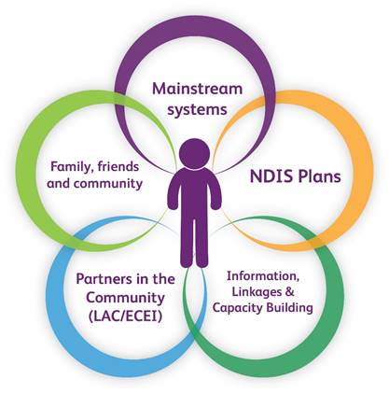

But ILC does so much more. It also provides information and capacity building supports for all people with disability, regardless of whether they are eligible for the Scheme. In that regard, ILC also helps people who are not eligible for an individual NDIS plan benefit from a more inclusive, accessible and connected Australia.

It does this by playing a significant part in building the capacity of:

* individuals – making sure people with disability and their families have the skills, resources and confidence they need to participate in and contribute to community.
* communities – making sure mainstream services and community organisations become more inclusive of people with disability.

ILC also helps prevent, reduce or delay the need for people with disabilities to access specialist disability services by improving their access to community and mainstream services. It does this by building the skills and capabilities of individuals to participate and contribute to the community and economy. By so doing, the additional benefit is that it improves the sustainability of the Scheme.

## 2. The ILC story so far

The NDIA began implementing the ILC Policy agreed by the Council of Australian Governments (COAG) Minister’s Disability Reform Council (DRC) in 2015.

As states and territories transitioned to the NDIS, ILC initially focused on a series of state based and national grant opportunities. These grant opportunities were designed to support the staged move to a national approach in 2019-20. So far, these processes have allocated 222 grants totalling $85.9 million (GST ex.) to organisations across Australia to deliver a wide range of ILC activities.

ILC grants are designed to complement the role of [Local Area Coordinators](https://www.ndis.gov.au/communities/local-area-coordination) (LACs) and Early Childhood Early Intervention (ECEI) Partners, who work closely with people in the community, including those with or without an individual plan. LACs are the local face of ILC, connecting people with disability to their local community, services and programs. A similar role is played for children and young people by the NDIA’s ECEI Partners.

## 3. Why is ILC changing?

Both the NDIS and ILC is a world first. Much is being learned as the Scheme is rolled out.

Learnings are being incorporated based on advice from partners as well as from international evidence of what is effective and what does not offer the same advantages.

The core feedback that has been received is as follows:

* Annual grants are administratively burdensome
* One year grants provide too short a time to make a difference
* A more strategic approach should be taken
* Programs should be nationally scalable
* Outcomes from programs should be measurable
* The capability of the organisations involved in the ILC program should be enhanced.

This has led to the ILC program being refocussed as outlined in the chart below.

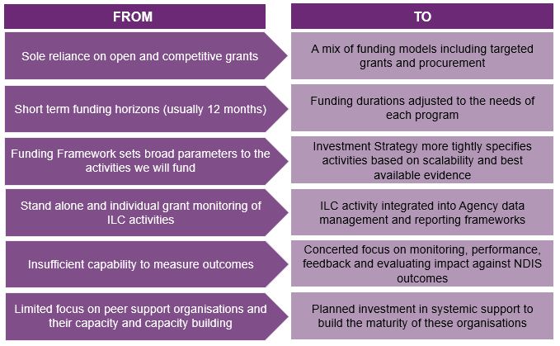

But while the NDIA is responding to this feedback, other things will remain the same. That will include a sharpened focus on organisations run by and for people with disability and ongoing focus on priority groups within the community. These groups include people from: Aboriginal and Torres Strait Islander communities; culturally and linguistically diverse communities; rural and remote areas; and LGBTIQ+ communities. We are committed to building an ILC that works for these groups through using tailored approaches to engagement and commissioning where required. The NDIA will also be continuing to work collaboratively with the Commonwealth, State and Territory Governments to ensure their valuable experience informs future investment.

## 4. What’s new about ILC?

In response to this feedback from the sector, the NDIA is adopting a more strategic approach by specifying, funding and delivering four programs that are consistent with the ILC Policy and outcomes framework.

This will involve a shift from short term grants to mostly three year investments in delivering each program.

A clear purpose, including investment principles and objectives, have been set to guide the next phase of implementing ILC.

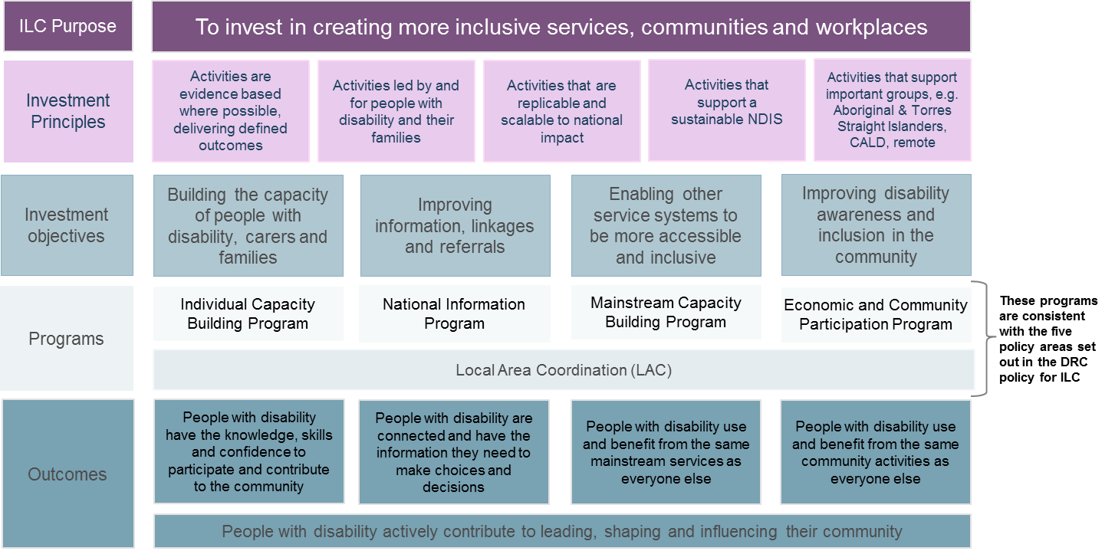

The four discrete, but complementary programs that will be progressively implemented from the 2019-20 FY are:

* **Individual Capacity Building Program:** enabling systematic, nationwide access to peer support, mentoring and other skills building for people with disability, carers and families. A national network of organisations run by and for people with disability, Disabled People Organisation and Families Organisations (DPOs/FOs), will be established and supported to deliver this program. The recent 2018-19 grant round targeting DPOs/FOs is designed to lay the foundations for this program. Ultimately, this program will help people with disability and their families/carers to improve their knowledge, skills and confidence to set and achieve their goals.

#### Example: Individual Capacity Building Program

|  |
| --- |
| Can provide support for people in particular circumstances. For example, people with a cognitive impairment and/or intellectual disability at risk of a custodial sentence can be assisted through provision of a specialised and intensive support model of mentoring, and capacity building targeting self-awareness, knowledge of rights, communication and leadership. |

* **National Information Program:** ensuring people with disability, their families and carers have access to up-to-date, relevant information linking them to supports and services in the community. A national program of high quality information products covering various disability types and support options will be funded, including from national diagnostically specific organisations and peak bodies, accessible through our Local Area Coordinators and the DPOs/FOs network. The program will enable people with disability, their families and carers to make better informed choices and decisions.

#### Example: National Information Program

|  |
| --- |
| The ILC National Information Program will be an avenue for providing quality information, targeting priority cohorts, such as information about autism and the services and supports available within their community for people with autism (particularly age 7+), their families and carers. This may include:   * independent, accessible, evidence-based information about diagnosis advice * service information * referrals to community and peer support   The information may be provided by phone, SMS, email and a web service, enabling people to get the information they need at a time and in a format that suits them, reducing the need for people to seek individual supports through the NDIS. |

* **Economic and Community Participation Program:** connecting people with disability to activities, employment and community supports and opportunities, helping communities and employers to be inclusive and responsive to people’s needs locally, and nationally.
* **Mainstream Capacity Building Program:** building the capacity, knowledge, skills, practices and cultures of mainstream services so they have the skills to meet the needs of people with disability through short term catalyst investments. Targeting access and improving use of mainstream services by people with disability, to improve life outcomes.

#### Example: Mainstream Capacity Building Program

|  |
| --- |
| An example of a national mainstream capacity building activity is one that facilitates conversations between mainstream services staff and people with an intellectual disability leading to improved inclusive behaviours and increased opportunities for participation of people with intellectual disability. |

This new approach to ILC investment is designed to ensure:

* There are alternative pathways to an ordinary life for people with a disability particularly by building the capacity of non-participants to achieve their goals outside of specialist disability services.
* People with disability, their family and carers have greater access to information and supports.
* People with disability, their family and carers build their knowledge, skills and confidence to participate in social and economic life.
* A more aligned service delivery system of ILC delivery, grounded in organisations run by and for people with disability and/or their families and carers.
* Strong collaboration across government and the sector that avoids duplication and maximises the NDIA’s investment in ILC.
* Improved measurement of reach and impact of the ILC strategy.

The investment principles and enhanced measurement and evaluation capability will enable the impact and effectiveness of these programs to be measured over time, so learnings and adjustments can be made. The implementation of programs with national reach that drive consistency of supports and experience will be balanced with programs that are responsive to the specific issue and needs of jurisdictions. While the methods for awarding funding under each program will change, a wide range of funding opportunities will be available.

In addition to the new programs, there will be a stronger focus on incremental improvements to ILC activities delivered and managed by Local Area Coordinators (LACs) and DPOs/FOs in their communities. The Strategy envisages LACs and DPOs/FOs working in a coordinated way, together with other ILC funded projects in their area to maximise the value of complementary investments and deliver the best ILC outcomes for people with disabilities.

The Strategy will be underpinned by a strengthened approach to monitoring and evaluation, with an early focus on the integration of ILC within established NDIA data management and reporting frameworks.

## 5. A progressive rollout

The four programs being used to deliver the ILC Investment Strategy will be progressively rolled out from July 2019, with funding opportunities available for applications from March 2019. Three important steps will be taken before the programs start rolling out:

i) Funding Rounds to Lay Foundations

To help the sector prepare for the implementation of the ILC Investment Strategy, the NDIA is running two “interim” funding rounds in late 2018 and early 2019.

The first round was launched in November 2018 and will build foundations for delivery of the Individual Capacity Building Program by providing initial funding to organisations meeting the criteria of Disabled Peoples Organisations and Families Organisations (DPOs/FOs).

Through this round, activities such as peer support groups and mentoring will be funded, as will activities that help DPOs/FOs build their capacity to deliver these activities.

The second interim funding round will focus on building capacity to improve economic participation, including employment opportunities for people with disability across Australia. This national round will help lay foundations for the economic and community participation program and will be announced shortly.

ii) Funding to help bridge the transition to the new approach to ILC investment

The NDIA recognises there are many people with disability participating in ILC-type programs whose funding is dependent on new opportunities within this Strategy.

To help address potential risks resulting from the timing of these opportunities, the NDIA has committed $26 million of funding to be allocated across all states and territories, to guard against gaps emerging. This funding will enable the extension of some existing programs beyond June 2019 so that an orderly transition is supported across jurisdictions.

iii) Progressive Rollout from July 2019

New funding opportunities will be available to organisations for each new ILC program during 2019-2020, with horizons to 2021-22. Our anticipated timelines are:

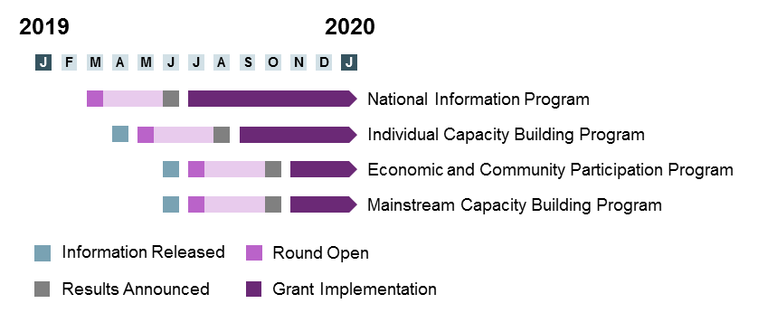

New program guidelines will provide more detail about all of the ILC programs, including the criteria that will be used to select organisations to deliver each program and more specific information on the activities to be funded. These will be available as early as practical in 2019.

National information sessions will be held after the Program Guidelines are released to ensure there is clarity regarding next steps.

For more information about ILC and the new investment approach, visit the [NDIS website](https://www.ndis.gov.au/communities/ilc-home.html) or [ILC Toolkit](https://ilctoolkit.ndis.gov.au/) or telephone 1800 800 110.

## Glossary

**Economic and Community Participation Program** refers to Inclusion related strategies targeting specific networks including employers, sports and recreation clubs and arts and culture leveraging the role of industry peaks.

**DPOs/FOs** are defined as organisations that are run by and for people with disability and/or families. These organisations have a minimum membership of 50% of people with disability and/or families on their board and/or staff.

**Evidence** refers to something that makes plain or clear, an indication or a sign, for example data collected through the Australian census in 2016 identified that Australian’s population was over 20 million people.

**Individual Capacity Building** Enable systematic access to peer support, mentoring and other skills building for people with disability, carers and families, delivered through the building and strengthened of a national network of c.200-300 Disabled Peoples and Families Organisations (DPOs/FOs)

**Mainstream** refers to universal services every Australian uses like doctors surgeries, sports clubs, community centres, transport and schools.

**National Information Program** refer to a national core of high quality disability information products covering different disability types and disability support options in a variety of formats (e.g. online and hardcopy resources), and actively disseminating these through the DPOs/FOs network and our LACs