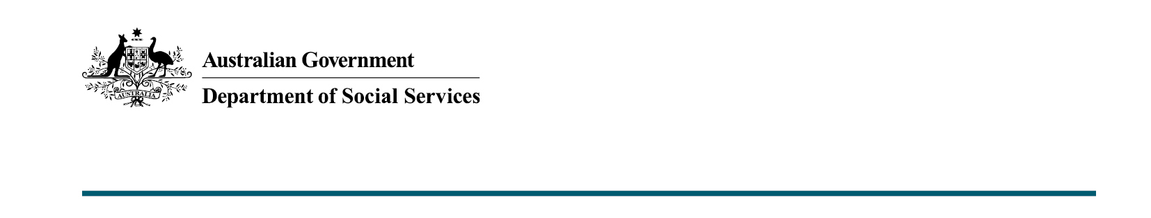
DSS XXXX.X.XX

Individual Placement and Support Trial (IPS)
Budget 2020-21

The Australian Government is committing $45.7 million over three years to extend the Individual Placement Support (IPS) Trial, which supports young people up to the age of 25 with a mental health condition to participate in the workforce.

What was announced in the Budget 2020-21?
The Individual Placement Support (IPS) Trial will be extended to include 26 new headspace sites, which will further support young people experiencing mild to moderate mental health conditions.
The funding boost of $45.7 million over three years aims to improve the educational and employment outcomes of young people aged up to 25 with mental health conditions.

Key facts
The IPS Trial was first announced in the 2015-16 Budget as part of the broader Youth Employment Strategy aimed at tackling high youth unemployment.
Since commencing in 2016, the trial has grown to include 24 selected headspace sites across the country.
These sites focus on areas with the most need, including disadvantaged local areas and areas with high unemployment rates across Australia.
To be eligible to participate in the Trial, people must:
- be a young person aged up to 25 years with a mental health condition
- be an eligible client of headspace in the participating Trial site
- have employment, education or training goals and be facing barriers to achieving these goals
- be willing to participate in the service and able to make an informed decision to participate.

More information
For more information about this measure and other Department of Social Services’ Budget measures, visit the Department of Social Services website (dss.gov.au).
For information about the Budget 2020-21, visit the Australian Government budget website (budget.gov.au).

