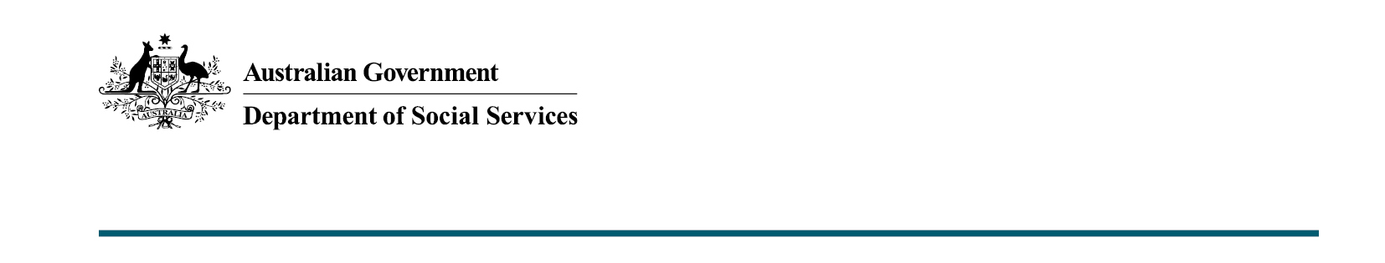

Improving programs that support older Australians
Budget 2020-21

The Australian Government is investing an additional $28.3 million in the Be Connected initiative to address social and economic isolation of older Australians and $9.6 million in the Pension Loans Scheme, while improving the in-community experience for an increasingly ageing population.

What was announced in the Budget 2020-21?

Be Connected – Digital Skills for Older Australians
The Australian Government wants all Australians to be able to access and benefit from digital services and information and is aiming to be one of the top three digital governments in the world by 2030.
Be Connected is contributing to the Government’s online safety efforts as well as contributing to ageing priorities, addressing social and economic isolation of older Australians, while improving the in-community experience for an increasingly ageing population.
The Australian Government will invest an additional $28.3 million to 30 June 2024, to build on the successful trial of the Be Connected initiative that has been implemented in collaboration with the eSafety Commissioner to get more older Australians digitally connected.
The trial established a network of some 3,000 local organisations and 9,800 digital mentors who have assisted more than 580,000 older Australians since October 2017, using online tools and resources hosted by the eSafety Commissioner.
The initiative offers a range of online and face-to-face learning options targeted at the needs of older Australians aged over 50 years. This can include group sessions or individual assistance.
Older Australians can learn the basics of smartphones and getting online, right through to banking and shopping online, accessing government services and safely using social media to stay connected with family and friends
See the range of online resources at www.beconnected.esafety.gov.au or find a network partner by calling 1300 795 897.

Why focus on older Australians?
Older Australians are less digitally connected and more vulnerable to online scams.
The Australian Bureau of Statistics (ABS) found that only 55 per cent of Australians aged over 65 access the internet regularly while 98 per cent of 25 to 34 year olds access the internet each week.
The ABS also found that 36 per cent of those aged over 55 years (2.3 million people) have been exposed to online scamming in the last year.

Enhancing the Pension Loans Scheme
The coronavirus pandemic has placed additional pressures on senior Australians, including self-funded retirees.
The Pension Loans Scheme supports financial independence and quality of life by enabling older Australians to generate additional retirement income by accessing the equity in their real estate assets.
The Government believes it is important for the scheme to meet the needs of today’s retirees as one of the supports for senior Australians, alongside the Age Pension and superannuation.
The Pension Loans Scheme will be enhanced to improve the customer experience, and make it easier for senior Australians to draw on their real estate assets to maximise their retirement incomes, if they want to.
The IT systems used by Services Australia to support delivery of the Pension Loans Scheme will be upgraded to improve the administrative and governance systems, and ensure Services Australia is able to accommodate growth in demand.

More information
For more information about this measure and other Department of Social Services’ Budget measures, visit the Department of Social Services website (dss.gov.au).
For information about the Budget 2020-21, visit the Australian Government budget website (budget.gov.au).

