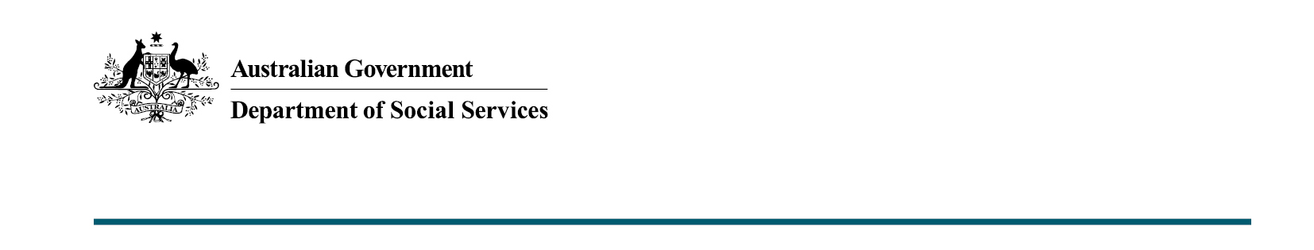

Improving programs that support Australian families
Budget 2020-21

The Australian Government recognises the value of investment in services and support to improve the wellbeing of vulnerable Australian families.

What was announced in the Budget 2020-21?
The Australian Government will invest $40.1 million over three years from
2021-22 to support frontline parenting services and $6.1 million to support forced adoption services for vulnerable Australian families and children.

Supporting frontline parenting services – Children and Parenting Support (CaPS)
The Australian Government is investing $40.1 million over three years in the Children and Parenting Support (CaPS) Additional Services program to support continued delivery of frontline parenting services for vulnerable Australian families and children, including at risk young parents and cohorts with additional or complex needs.
This is in addition to the more than $250 million per year that the Government already invests in families and children programs under the Families and Children Activity and Family Mental Health Support Services.
This investment demonstrates the Government’s commitment to Australian families and the frontline service providers that support the wellbeing of children and young people.
The CaPS Additional Services program operates as part of the broader CaPS program, which offers early intervention and prevention support to Australian children and families. The CaPS services are an integral part of a broader suite of early intervention programs offered by the Department of Social Services.
This additional money will provide continued support for specific cohorts such as at-risk young parents or families with additional and complex needs.
Support for these families early can play an important role in preventing a number of high cost problems, such as family breakdown, child neglect, family violence, substance abuse, mental illness and transition into school.

Key facts – CaPS
- This CaPS investment will support continued delivery of services to improve children’s development and wellbeing, and support the capacity of parents.
- CaPS delivers services such as in-home parenting and child support programs, including for regional and remote communities, specialist services for newly arrived migrants, mobile toy and parenting resources, therapeutic preschools, peer support, and playgroups.
- In 2019, 51,968 individual clients accessed some form of CaPS services. This includes particularly vulnerable clients such as at-risk families, women, Indigenous Australians, people from Culturally and Linguistically Diverse backgrounds, children, vulnerable parents, and carers. Almost half of all CaPS services are CaPS Additional Services.

Delivering specialist support – Forced Adoption Support Services (FASS)
The Australian Government will invest
$6.1 million over three years from 2021-22 to the Forced Adoption Support Services program (FASS) to ensure specialist support is provided to those who need it most.
The Government continues to deliver on its commitment to actions arising from the National Apology for Forced Adoptions, and the response to the Senate Inquiry into the Commonwealth Contribution to Former Forced Adoption Policies and Practices.
This investment will address key gaps identified in the Forced Adoption Support Services Post Implementation Review Final Report (2018) by:
- improving FASS providers’ capacity to deliver trauma-informed therapeutic counselling in line with commitments arising from the National Apology.
- delivering the Australian Psychological Society’s specialist forced adoption training for professionals working with people affected by forced adoption.
- helping build workforce capability and lead to improved referrals, responses and outcomes for FASS clients.

Key facts - FASS
- FASS provides support through trauma-informed casework, records tracing, mediation of family search and reunion, capacity-building opportunities, and counselling.
- Seven organisations provide coordinated and unique specialist support to people affected by past forced adoptions through a range of digital and face-to-face support activities.
- The Australian Government continues to work closely with those affected by forced adoption and states and territories to deliver ongoing assistance.

More information
For more information about this measure and other Department of Social Services’ Budget measures, visit the Department of Social Services website (dss.gov.au).
For information about the Budget 2020-21, visit the Australian Government budget website (budget.gov.au).

